Title: Blaenavon
Assignment Name: Blaenavon Field Report- Part 1
Student Name: Daniel Ramsey
Course Name and Number: Distinctiveness and Regeneration BMSP4005
Lecturer: Anthony Burns
Date: 13th March 2018

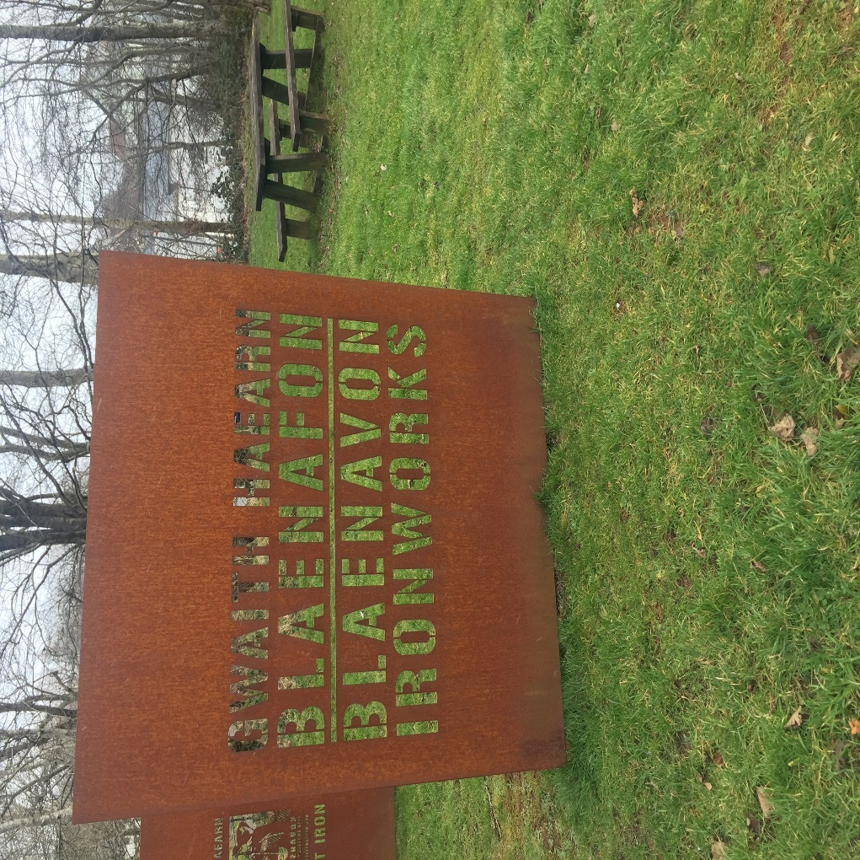

Abstract
As the scenery changed from built up areas to open landscape, it’s hard to believe that this vast plethora of marshland was once home to a bustling industry. An industry whose exportation capabilities were the greatest in the world (Minchinton, 2005). An industry that originated in these small Welsh towns, collectively known as the valleys, and within these valleys, what our very informative guide Ruth describes as “the heart of the industrial revolution” (Taylor-Davies, 2018) as illustrated by Minchinton (2005) “The development of industry in South Wales was to be based on its raw materials. Most important is coal”. This is a reflective paper on my experiences and personal insight of our field trip to Blaenavon Ironworks, the location at the forefront of the Industrial Revolution (gratuit, 2009).
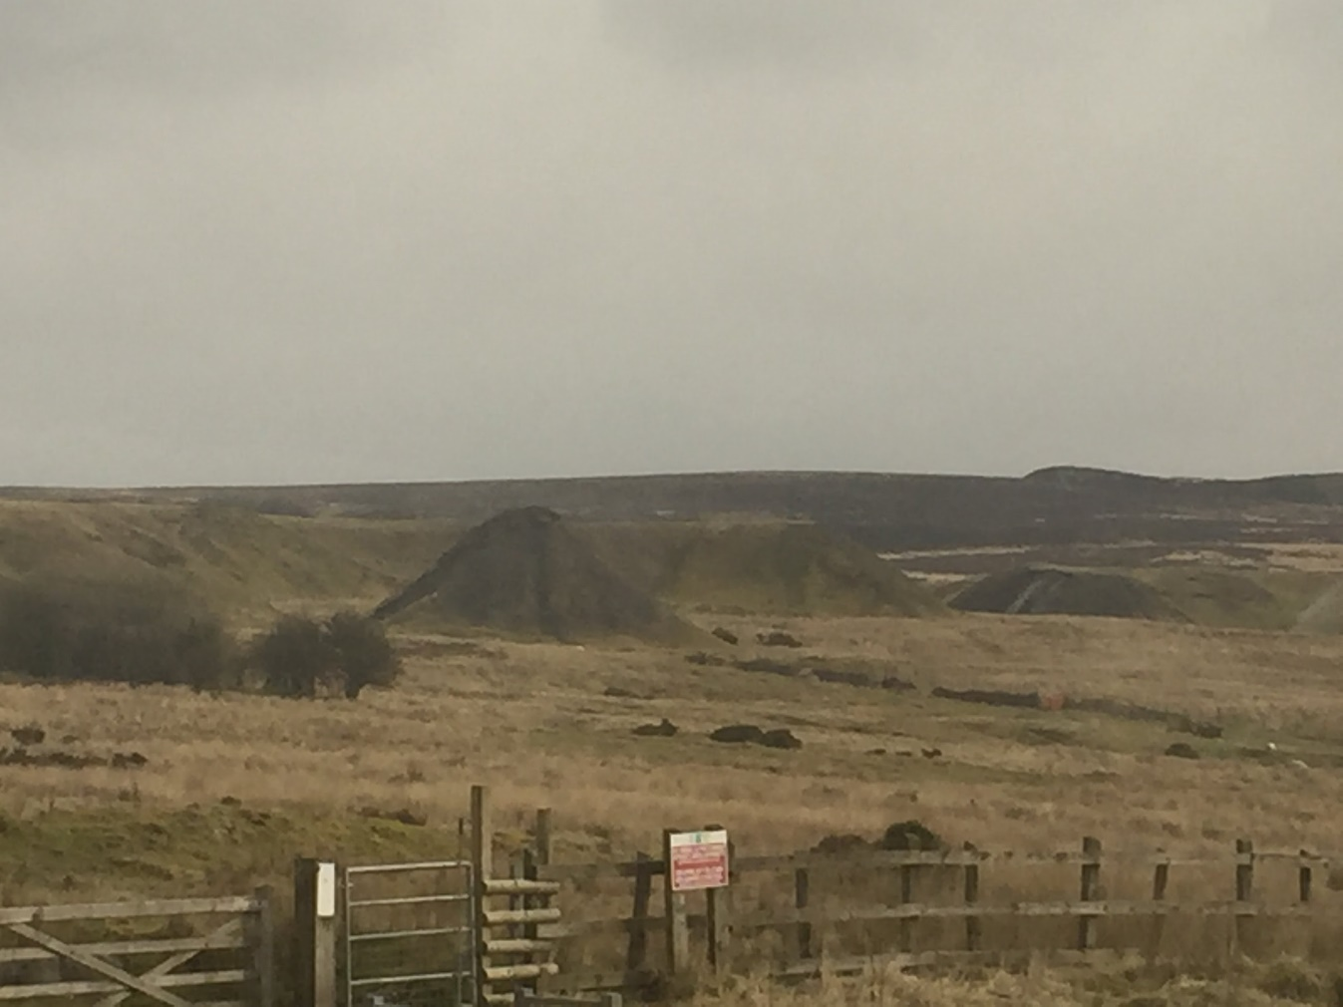

Arrival
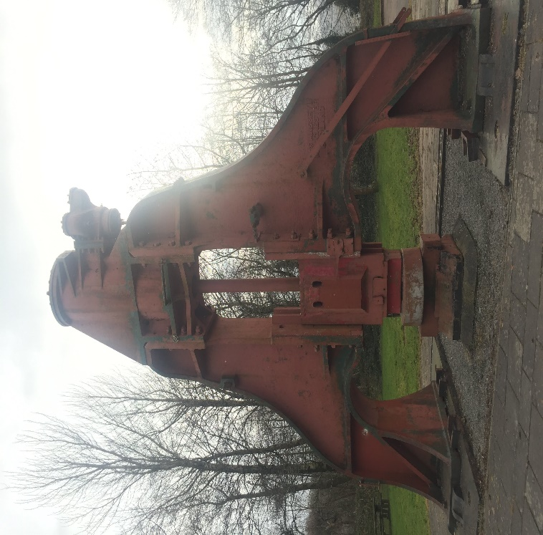
As we arrived at our destination, an empty car park greeted us. A car park dominated by what I now know to be an old coal press (pictured right). My initial thoughts were ones of confusion. For a World Heritage Site, one that is on par with the likes of The Taj Mahal and the Pyramids (Taylor-Davies, 2018), a site who’s Industrial Landscape was recognised by UNESCO in 2000 (World Heritage Site Status, 2018), now seemed forgotten. Much of the surrounding landscape, dumped on by industry. Where once there stood a fully operational viaduct, years of excessive waste material dumping has removed part of Blaenavon’s history and formed un-natural landscapes (Taylor-Davies, 2018).
Adjacent to the car park are the remains of the iron production lift and the ruins of the multiple furnaces where the process of producing pig iron took place (Taylor-Davies, 2018). Blaenavon was the first multi-furnace iron works and at its peak, 6 furnaces burnt at volcano temperature (Taylor-Davies, 2018). 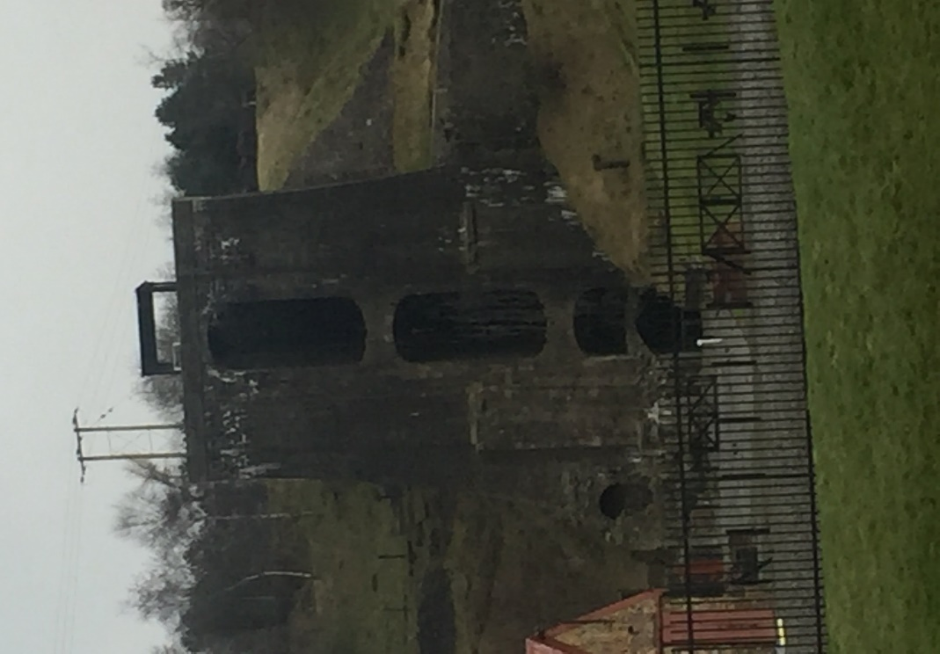
Apace to the iron work production site was a dainty row of houses known as “Stacks Square”. In the origin of production, occupation of said houses were for the iron works key workers (Beaudry & Symonds, 2010). As time progressed occupation of these houses were relinquished to the poorer working demography with good reason. I can only begin to imagine the pollution that secreted from these iron works. Pollution that would no doubt do unimaginable damage to one’s health and greatly reduce life expectancy.

The Journey Continues
As we ventured down into the valley, the near derelict iron masters house (Taylor-Davies, 2018), known as Ty Mawr, dominated the rapidly declining road. Built by the young iron master, Thomas Hopkins, to be expensive, elaborate and comfortable, it was in stark contrast to the inadequate housing that were inhabited by the workers (Taylor-Davies, 2018).
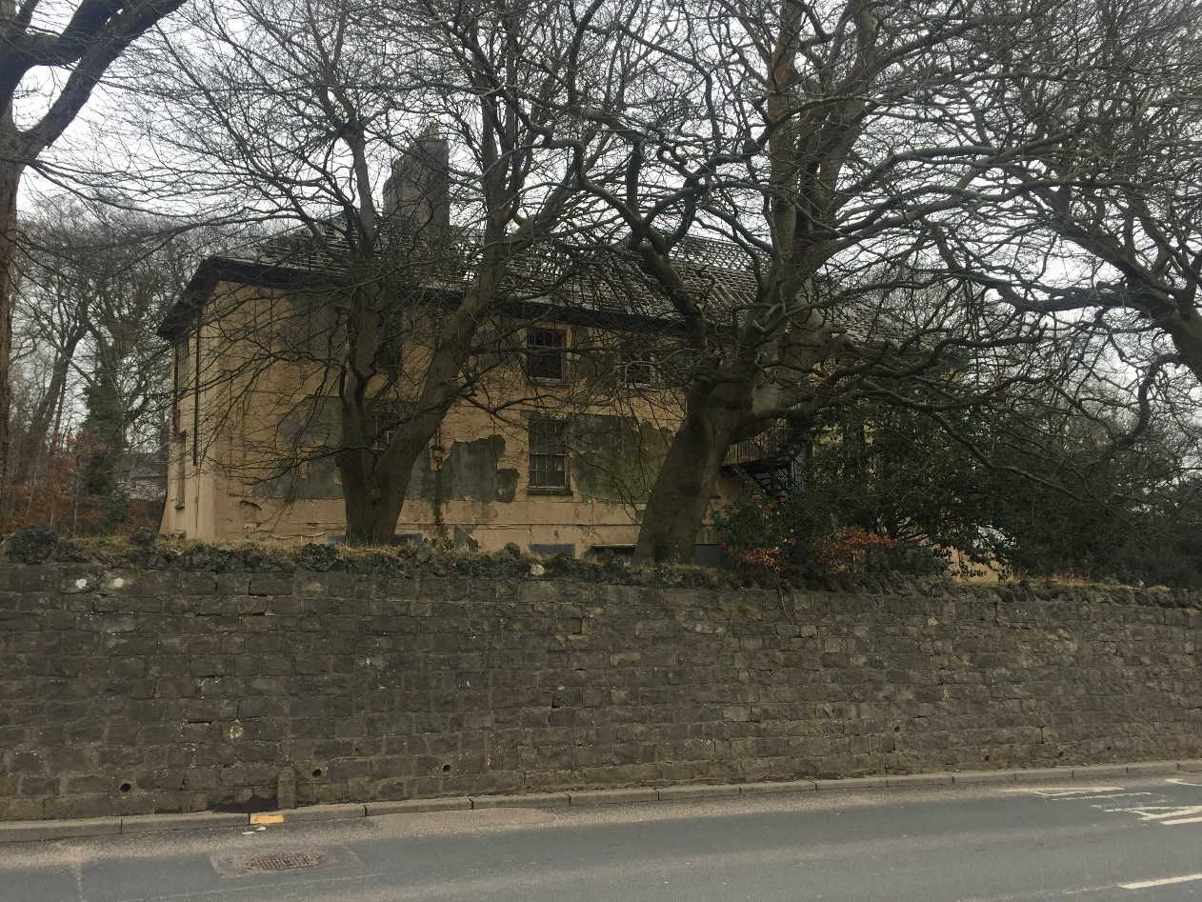
In the not so distance, slight signs of the new age were apparent. Newly built flats/houses and shop fronts would suggest a hive of activity upon entering the town itself, however, that was not the case. Blaenavon, in my eyes, can be described as a ghost town. At its peak, it was home to some 13,000 residents (Taylor-Davies, 2018) but it’s hard to imagine the hustle and bustle and hive of activity that once took place. Looking around, many churches capture the eyeline which suggests the Blaenavon of old held religion in high regards. Our guide informed us that at the height of the revolution, there were 18 places of worship, all of equal importance (Taylor-Davies, 2018). But none more significant than St Peters church, built by Samuel Hopkins and Thomas Hill in 1804 and the final resting place of Samuel Hopkins and Thomas Hill II (Matthews, 2016). Each tomb is testament the craftsmanship of days gone by with lids made from cast-iron (Taylor-Davies, 2018).
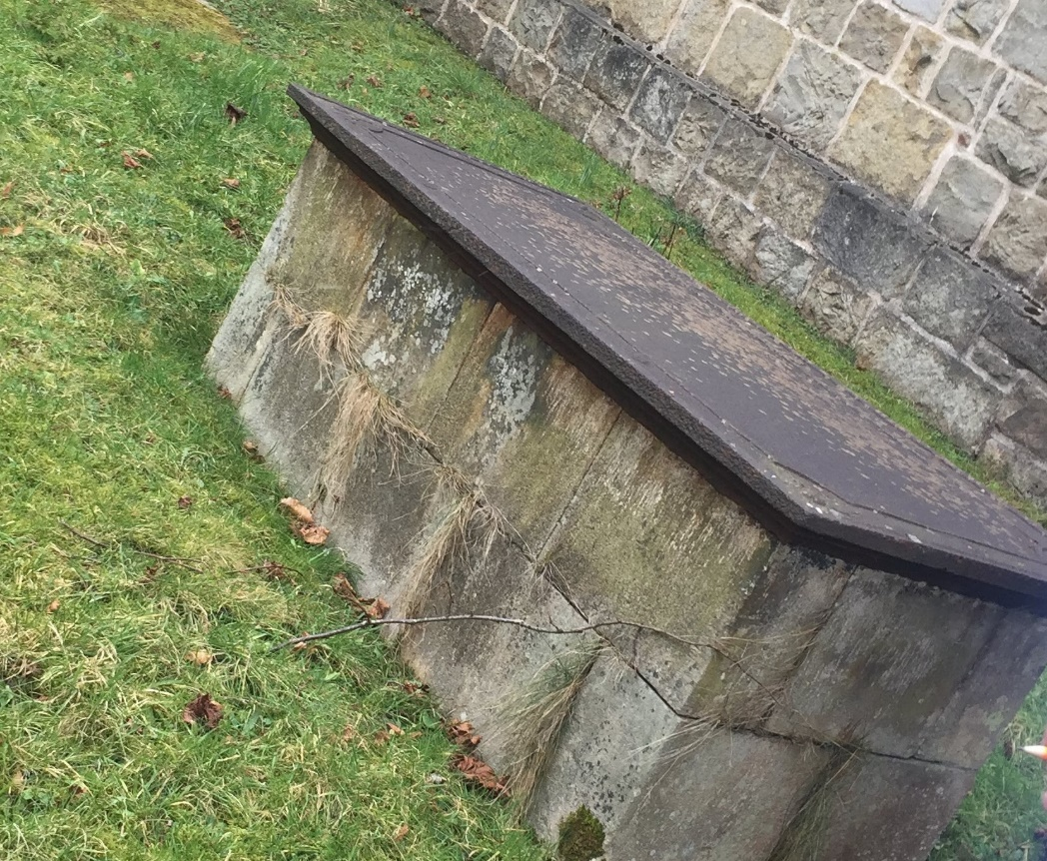

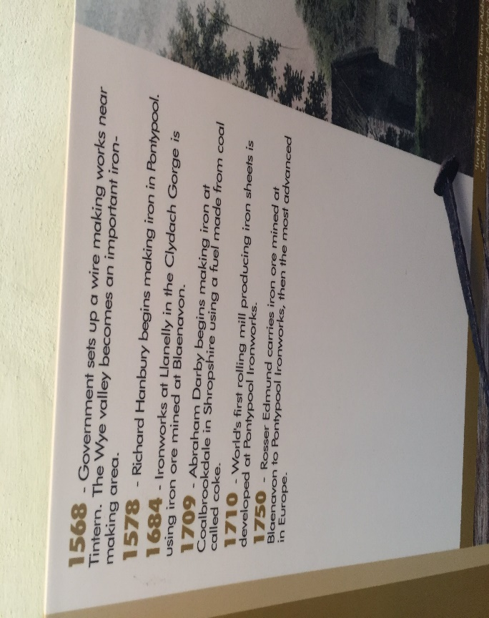
Our next stop was the Heritage Museum. From outside, a very unassuming building, but inside, Blaenavon’s history was laid out for all to see. Many interesting artefacts and games of days gone by were laid out to keep visitors occupied. The highlight in my eyes was the timeline that adorned the walls. The full history of Blaenavon dating from 1568, where the initial iron making process began, to 1997, when the first steps were taken to make Blaenavon a heritage site.

The Big Pit
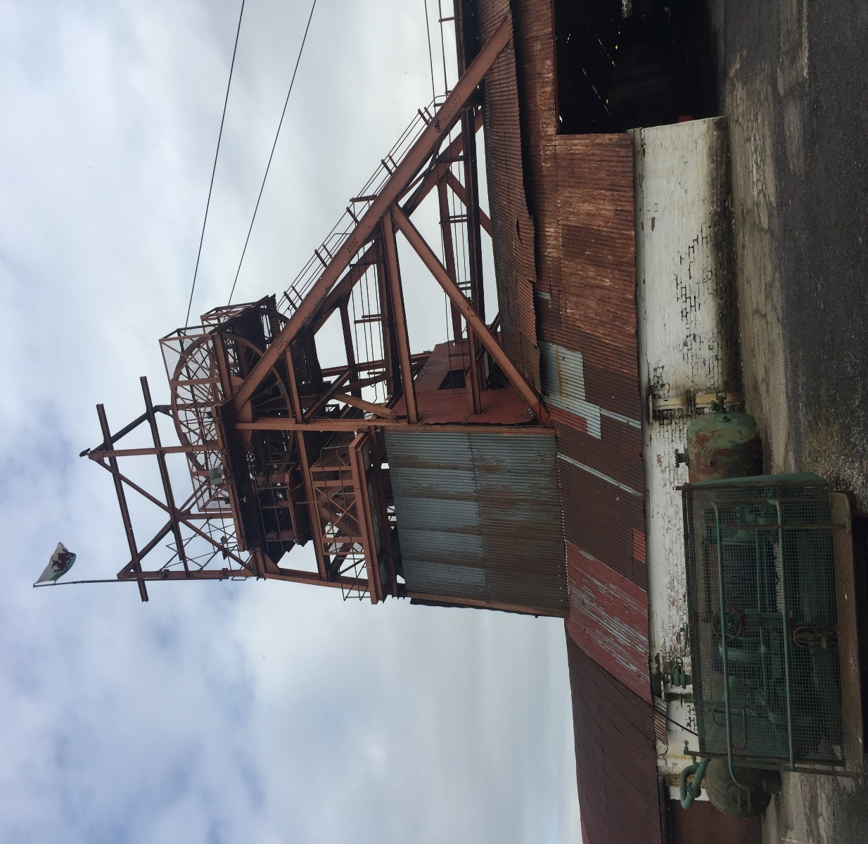
Our visit to Blaenavon culminated in the Big Pit adventure. Where the magic happened, where countless men sacrificed their lives to extract what is known as “black gold” (Burns, 2018). Upon arrival, we were informed of a breakage in the mechanical system which prevented the group from fulfilling our main aim of experiencing the mine itself. Despite this setback, a sense of excitement filled the group as we progressed. Small groups formed to explore various areas of the compound.
The Big Pit, to me, seemed a fascinating place. Each display with its own engaging story to tell. Each forming the history and status of this town. To further enhance our experience, we entered a virtual tour of the mine. An actor, who was cast as an ex miner, took us on a very informative tour of the evolution of the mining machines. He explained how, in the beginning, holes were bore into the rock which were then filled with dynamite, triggered, which in turn advanced the digging and exposed the coal. I found the working conditions of these miners quite alarming. Cramped conditions, little or no lighting and the constant threat of explosion were normality. Through these dark times, the virtual speaker informed us that one fundamental thing kept these gentlemen going. Comradery. It was apparent that these close, cramped conditions bought these men closer. Relying on each other for safety and well-being. The band of brother hood seemingly formed by these men is admirable to see. Through poor working conditions, came great friendship.

After Thought
My time in Blaenavon and The Big Pit was both insightful and informative. Blaenavon is steeped in rich history. To be attributed with being at the forefront of the industrial revolution, it is testament to what this small town has achieved. However, somehow, I feel that something is missing. The once bustling hive of activity seems to have disappeared and, in its place, an eerie shell of a former working town. The exhibits and displays that remain give you a percipient view into the lives and inner workings of this now sleepy former mining town but it still begs the question. What can be done to restore this town to its former glory?

References
Beaudry, M., & Symonds, J. (Eds.). (2010). Interpreting the Early Modern World: Transatlantic Perspectives (illustrated ed.). Springer Science & Business Media.
Burns, A. (2018, February). Coal Formation Lecture. Carmarthen, Wales.
gratuit. (2009). World Heritage Cultural Landscapes: A Handbook for Conservation and Management. UNESCO.
Matthews, N. (2016). The Hidden Heritage of St. Peter’s Churchyard. Retrieved from Blaenavon's Heritage: https://blaenavon.wordpress.com/2015/12/06/the-hidden-heritage-of-st-peters-churchyard/
Minchinton, W. E. (Ed.). (2005). Industrial South Wales 1750-1914: Essays in Welsh Economic History (Reprint ed.). Taylor & Francis. Retrieved from https://books.google.co.uk/books?id=hXD_AQAAQBAJ&pg=PR7&dq=Industrial+South+Wales+1750-1914:+Essays+in+Welsh+Economic+History&hl=en&sa=X&ved=0ahUKEwiqmou2mtvZAhUVM8AKHdf3A8MQ6AEIJzAA#v=onepage&q=Industrial%20South%20Wales%201750-1914%3A%20Essays%20in%20We
Taylor-Davies, R. (2018, February 6). Blaenavon Field Trip Guide. Blaenavon, South Wales, Wales.
World Heritage Site Status. (2018). Retrieved from Blaenavon World Heritage Site: http://www.visitblaenavon.co.uk/en/WorldHeritageSite/WorldHeritageSite.aspx

