Research Methods BMSW7004
Assignment 1 - Presentation
June 2025

Natalie Owens
2417672

Front Page
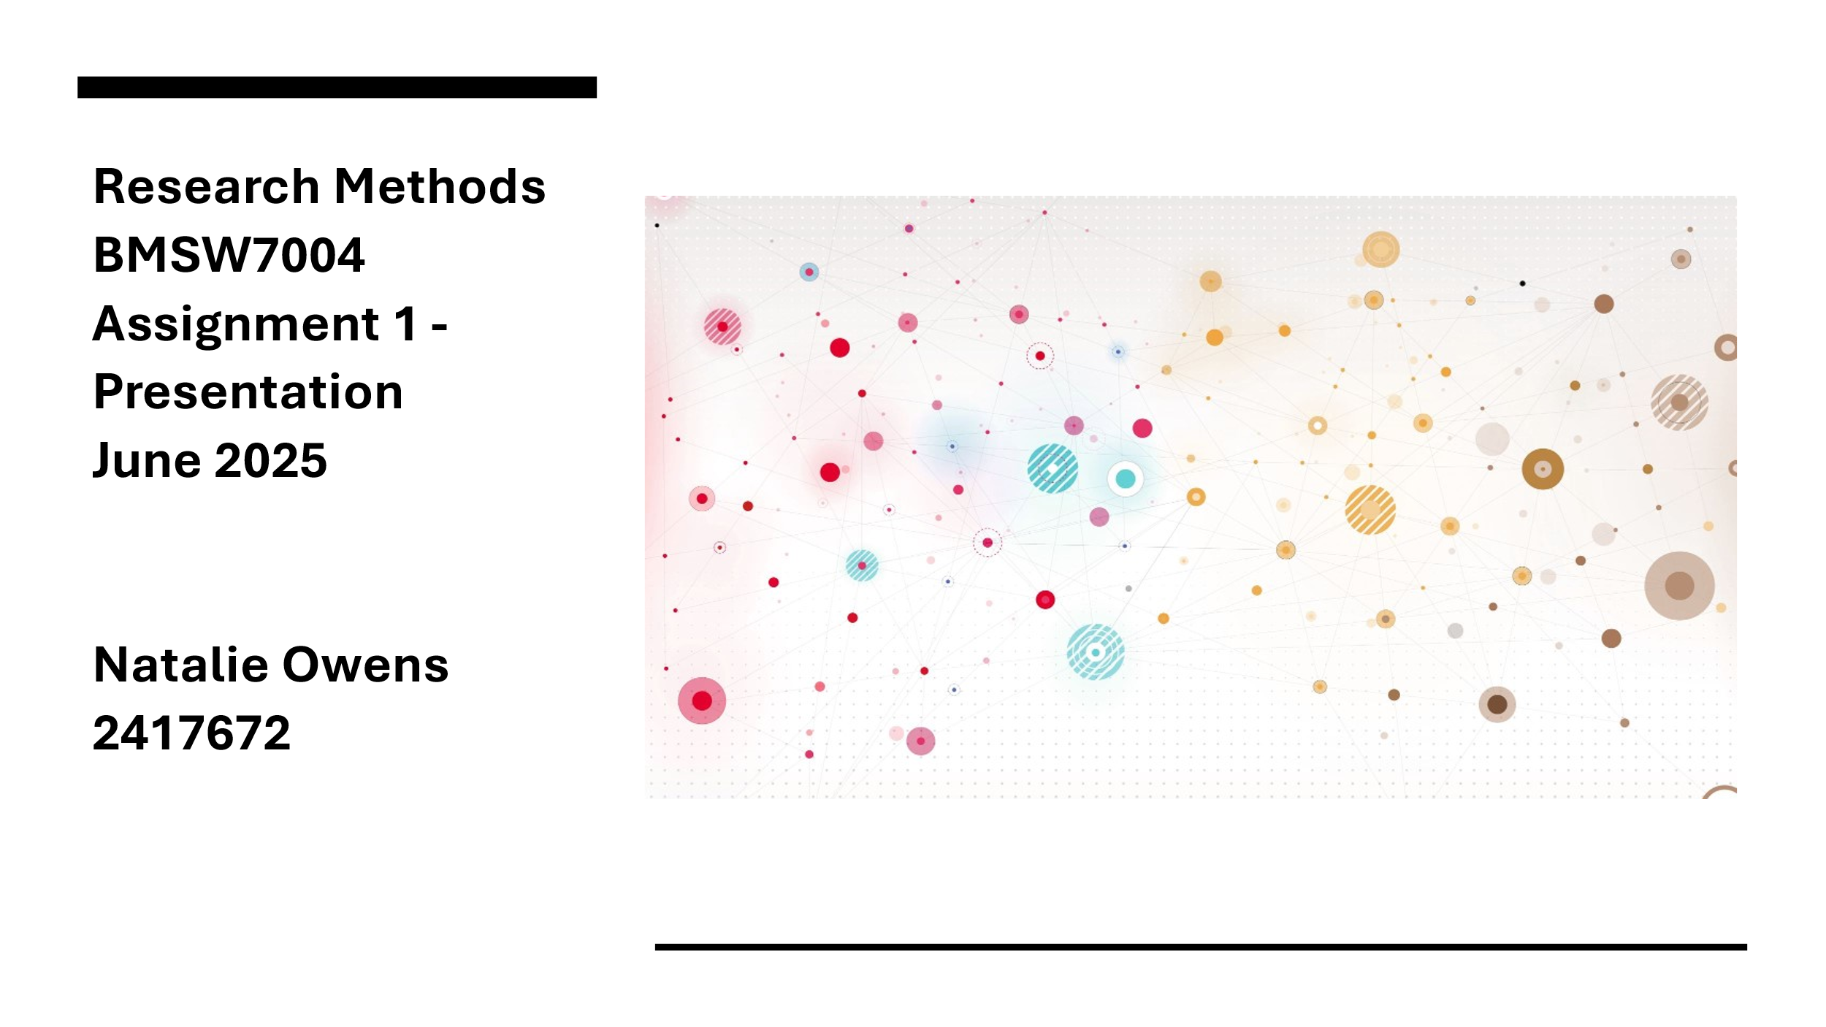

Hi, thanks for the time today. Apologies, I’ll probably speak a bit fast as I am a bit nervous. I have tried to put much of the detail on the slides as (although it doesn’t look as good) it helps me stay focused and bring a cohesive narrative. The references are on the accompanying document that has been submitted.

Title
Read slide
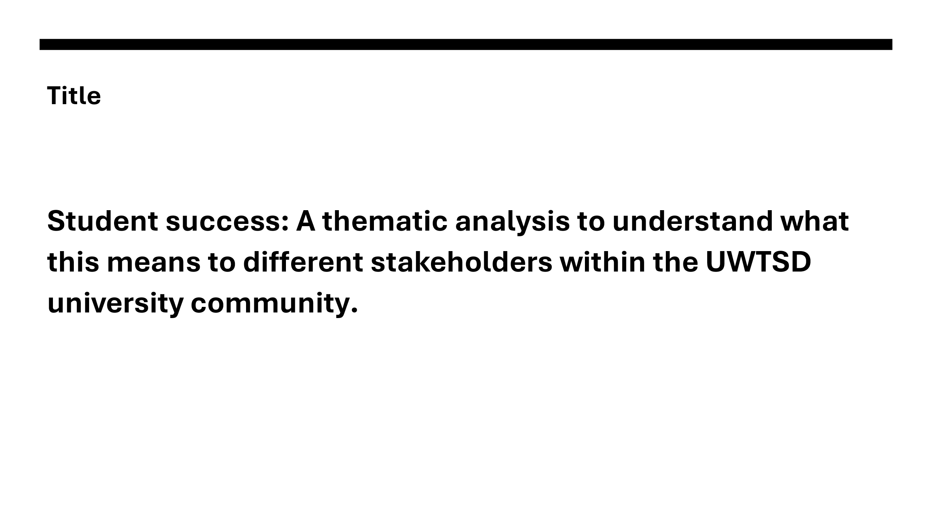

I’ve given the title much thought. It encapsulates where I am in my current role. I lead a team of Student Success Officers and we are beginning to envision what expansion looks like. I am currently writing a business case and as such have consulted the literature. I have discovered that there is still much discord in this field. I am passionate about under-represented voices and hope to develop a study which accurately and equally reflects all voices.

Research Aim
Read slide
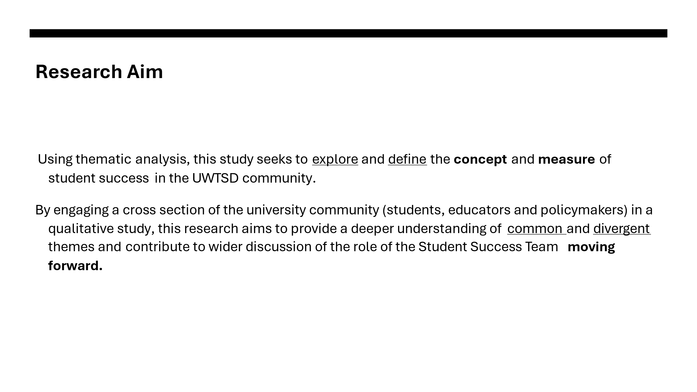
A scan of the literature suggests a scarcity of research which aims to understand the roles and voices of the main 3 stakeholders and even less which present the findings as equal contributions (Lowe, 2024).
There is also a constructivist aim for the research to encourage a shared language and vision so that further work in the university can move forward effectively.

Research Objectives
Read slide
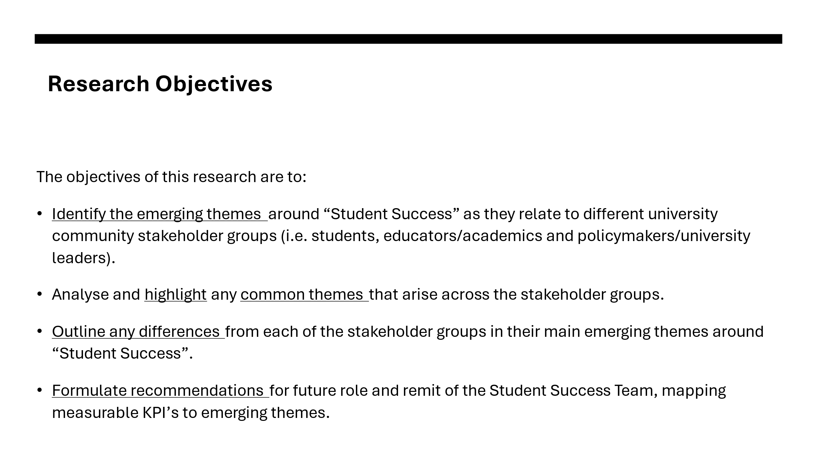
Research on student success may be dominated by those in power positions. For example, the researcher who defines success as part of a study or through university senior leaders/policy makers via their publications and strategies (e.g. Advance HE Student Success Framework, 2025). There is a notable lack of student voice, an aspect this study wishes to provide a platform for.
Moreover, measurement tools are usually linked to hard outcomes such as attainment, retention and progression (HE Professional, 2020). This is problematic as it fails to acknowledge the individual differences and the strategic focus on the individual institution. University of Wales Trinity Saint David focuses on employability and widening participation (UWTSD Annual Report: Equality and Diversity 2023/4) so it would be interesting to see if any of these themes translate to Student Success.

Research Methods

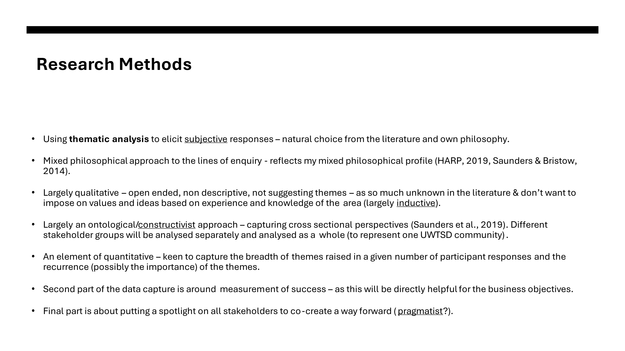
I looked into my own thoughts and values as a researcher and using Burrell & Morgan’s (1979) objective/subjective & regulation/change paradigm and terminology for each of the 4 domains and broadly recognise myself as a “radical humanist”.
Having read around research philosophy (e.g. Saunders & Bristow, 2014) and undertaken the HARP assessment (2012, 2019), I now further understand my philosophical position and how that links to the research. Scoring highly (but unsurprisingly) on Post Modernism, Pragmatism and Interpretivism questions, I accept that in undertaking this research, I would like for people’s views to be documented and considered, acknowledging that there likely isn’t one truth (as the world is socially constructed). However, I am resolute in the aim to tie this together pragmatically and systematically to improve people’s understanding of other stakeholder perspectives and move towards some institution-wide KPI’s for student success operation.
I argue that the study is deductive in that I would like to touch on the definition, measure and collaborative working as the three themes but after that I would say its naturally an inductive approach to thematic analysis as there is not enough research in this area to make assumptions or develop conclusions (Delve & Limpaecher, 2024; Braun & Clarke, 2006).
As part of this project timeline, I understand I will need to go through the University Ethics Board to seek approval and I will need to seek permission explicitly to make contact with the student sample (both these actions will take some time).

Rationale

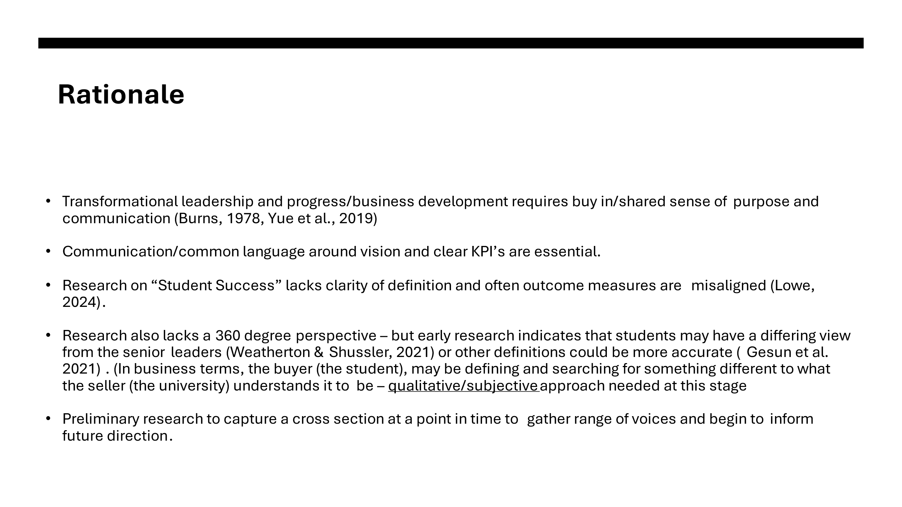
This work aligns closely to my current working situation. I lead a team of Student Success Officers and I am currently looking at changing operations to better fit the need of the business (the university) and the buyers (the students). Effective change requires transformational leadership (Burns, 1978). It is intended that this study serves as an enabler for further discussion between key stakeholders, to inform a baseline of commonly shared values or perspectives and form the foundations for a trusting working relationship (Yue, Men & Ferguson, 2019).
Whilst the area of Student Success is growing both in universities and in peer-reviewed journals there is still no common agreement over its definition and much less an agreement regarding measures of success (Lowe, 2024).
Moreover, very rarely are student co-creators in the student success definition. Early research suggests that some minority groups views of success can be the opposite of traditional views of student success. Some research (Weatherton & Schussler, 2021) has highlighted the potential power differences between different stakeholder groups and the call for more student voice research in this area. Also some newer research suggests that more holistic and broad terms of success should be considered (Gesun et al. 2021)
Business development requires clear vision and Key Performance Indicators. For this we need an agreement around the terminology. Amplifying students voices through research is in itself a pragmatic enabler activity as it re-addresses power dynamics and forms part of a consultation (Jensen et al. 2018, Deng et al. 2022). It is my opinion that subjective responses from a qualitative approach is the best way forward at this point in time.

Possible Questions
Given the literature and my position I suggest three main areas of enquiry.
Probing, open ended questions are created to elicit responses as I am aware that I am not in a position to know of all themes that will arise.
Read slides
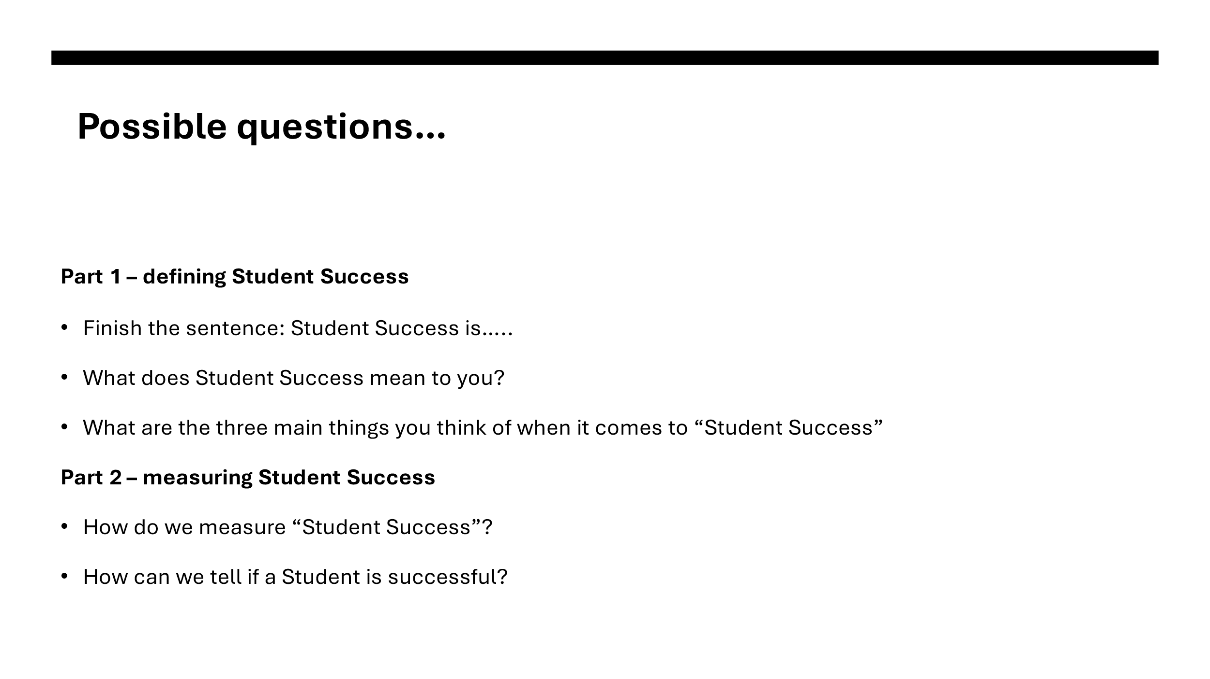
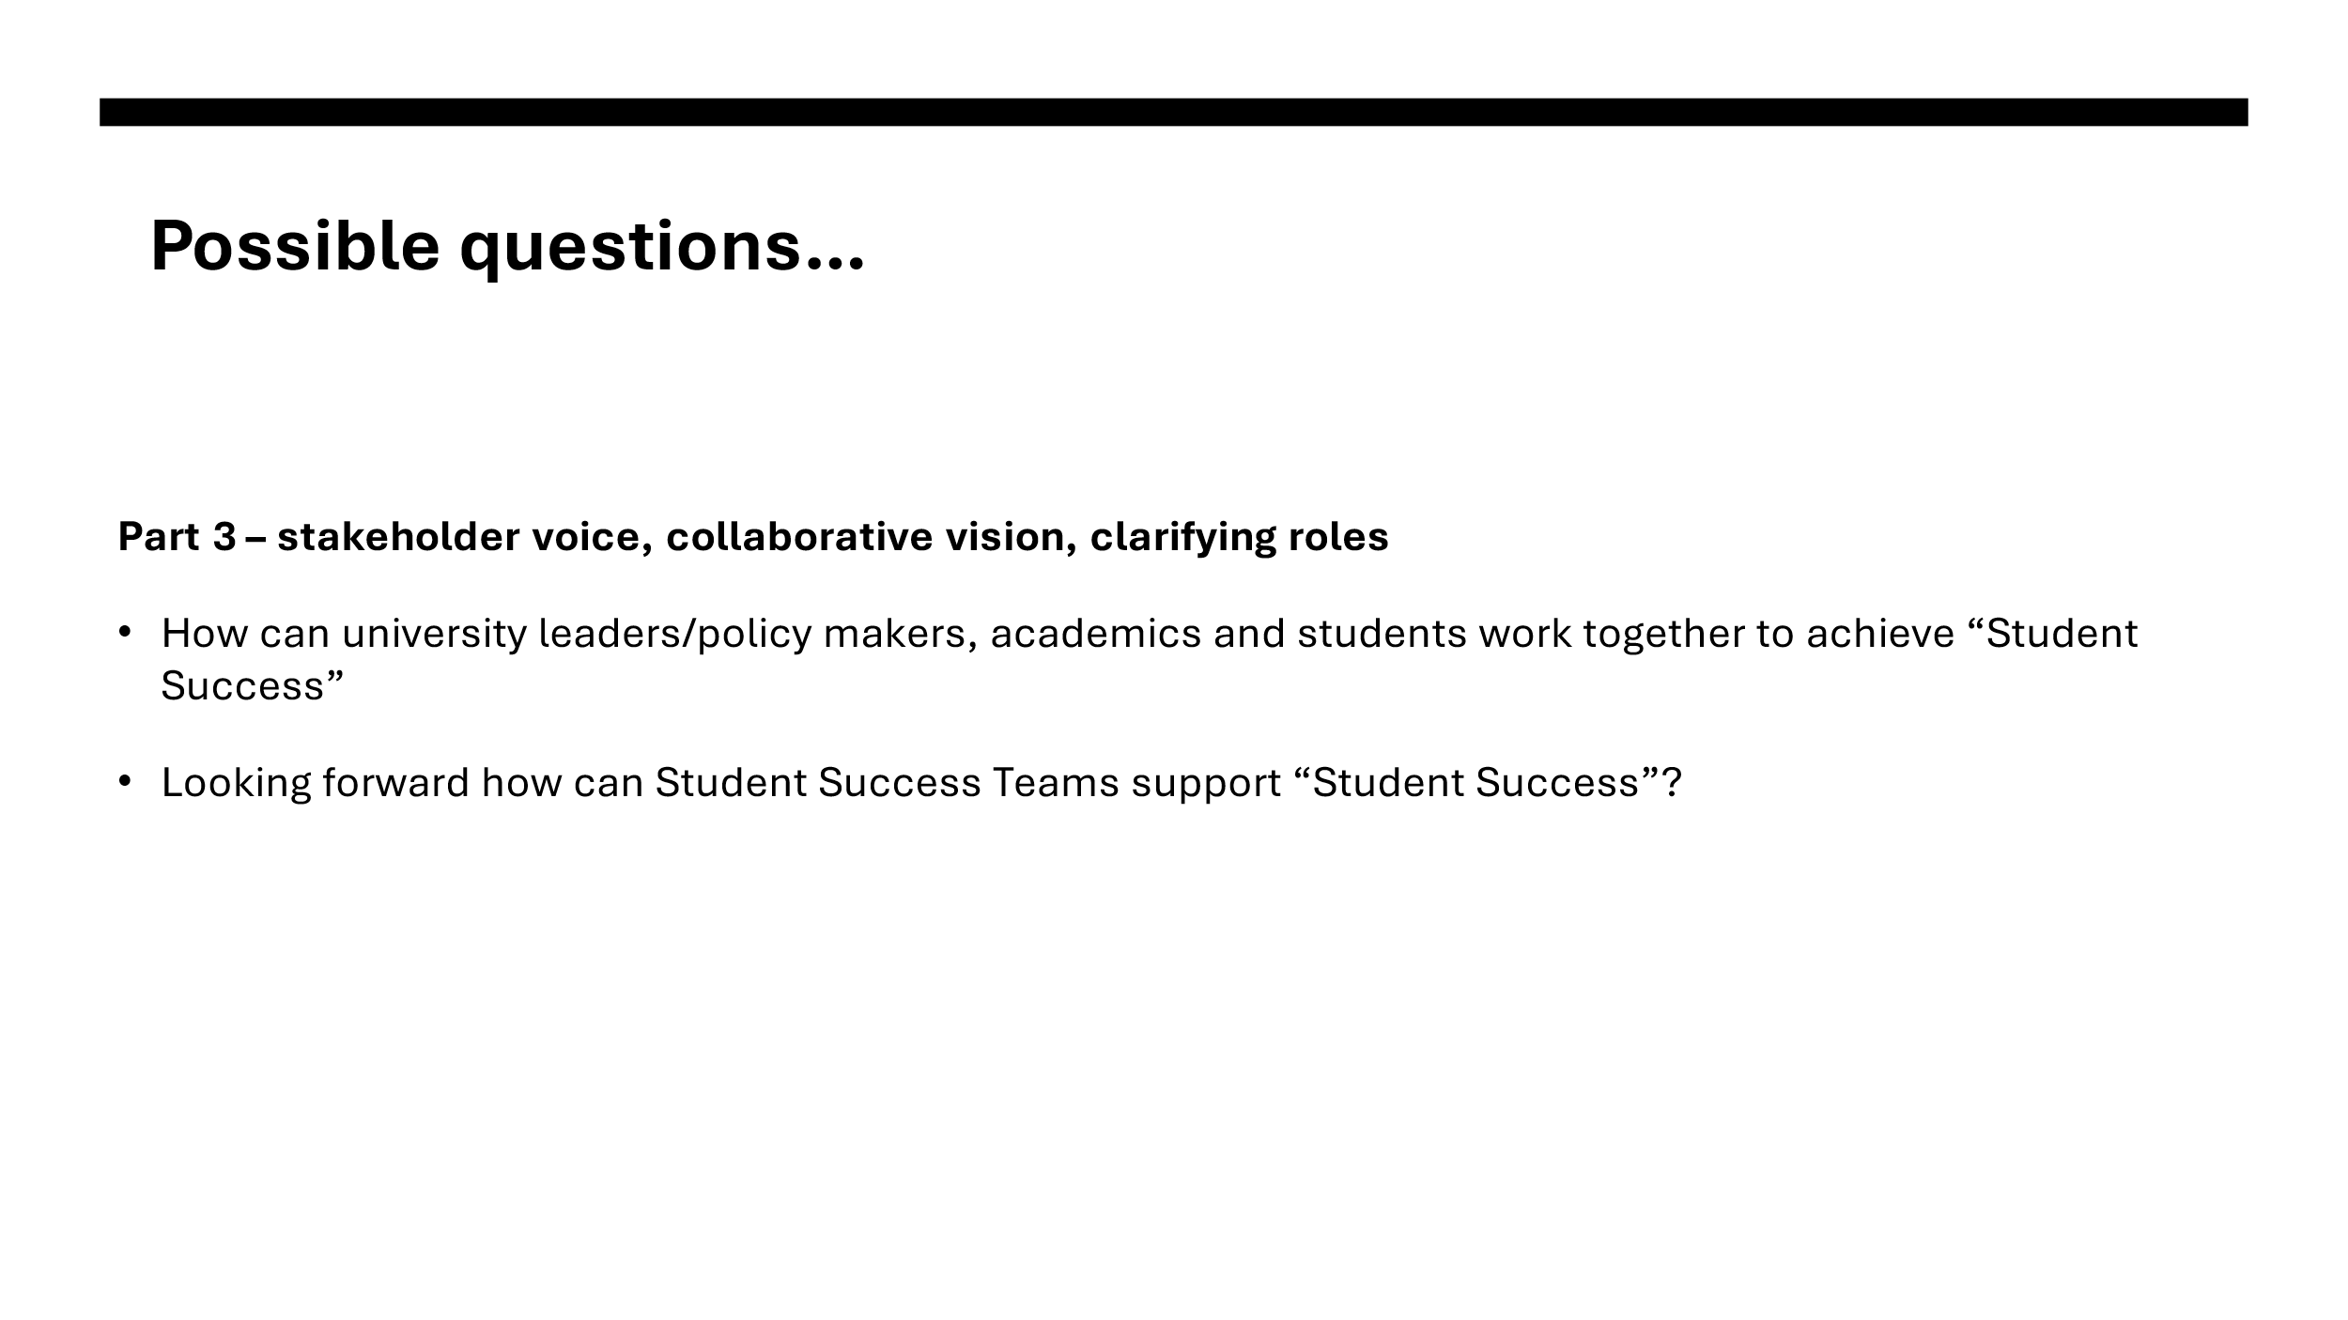
Sample

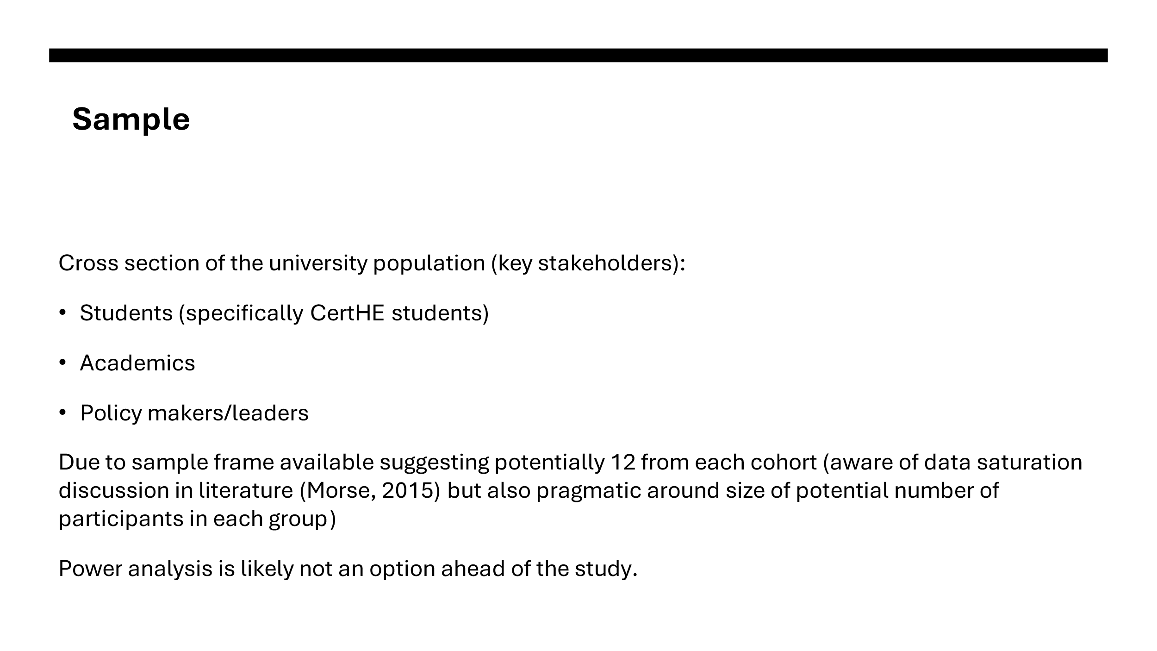
It is imperative for this study to gather perspectives from specific strands across the UWTSD community. In terms of the student sample pool, as the university community is diverse in nature (UWTSD, 2025), and in line with guidance (HE Professional, 2020), a smaller cohort, a CERT HE sample will be the focus. Academics and policy makers/leaders have also been noted as appropriate participants.
Braun & Clarke (2019) argue that data saturation may not be a realistic option due to restraints on resources and sample availability. A pragmatic way forward would be to carefully consider a sample size, which, based on the literature is approximately 12 in each group (Ahmed, 2025, Braun & Clarke, 2006).
In terms of power analysis, it is likely not an option due to the proposed structure of the study i.e. enabling multiple key stakeholder responses and the relatively small sample frame to choose from. Research suggests that having a small number of responses in one group means that having larger responses in another is likely to lead to diminishing returns (UCLA Advanced Research Computing, 2025). Therefore to promote equality, this study will close at 12 responses in each group. This study openly serves to start a university-wide discussion around themes. Once themes have been acknowledged, further studies could include a more objective, quantitative approach.

Analysis
Read slide
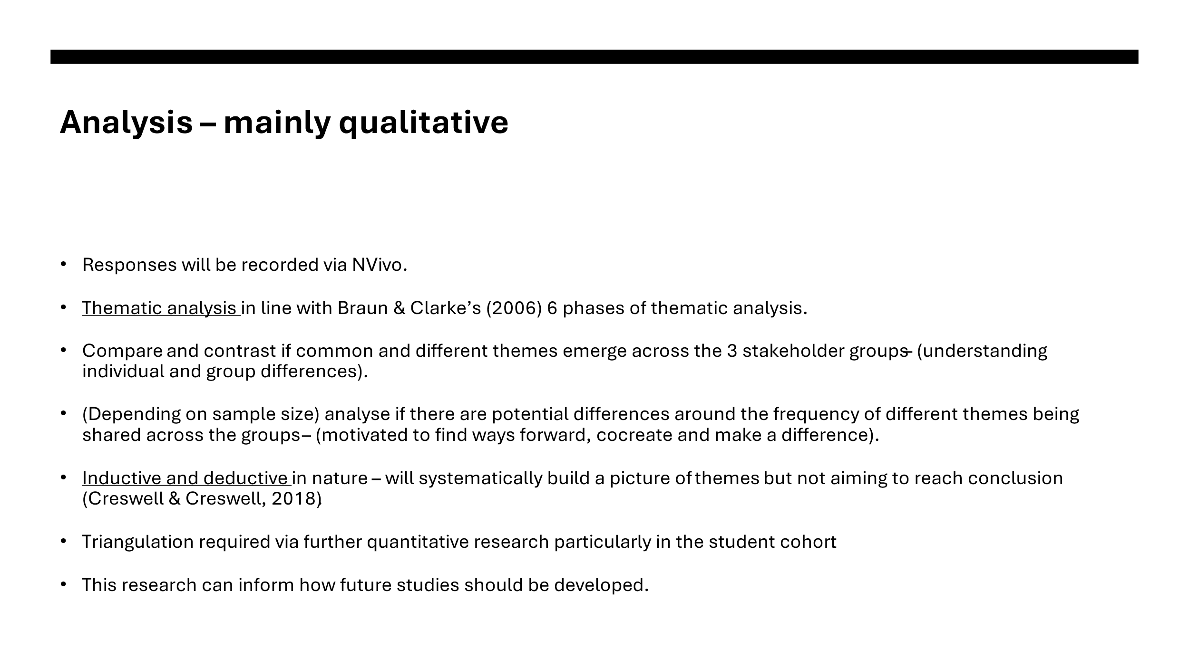
Thank you for listening.

References
Advance HE (2025) Framework for Student Access, Retention, Attainment and Progression. Available at: https://www.advance-he.ac.uk/knowledge-hub/framework-student-access-retention-attainment-and-progression (Accessed: 7 June 2025).
Ahmed, S., Mohammed, R., Nashwan, A., Ibrahim, R., Abdalla, A., Ameen, B. and Khdir, R. (2025). ‘Using thematic analysis in qualitative research’, Journal of Medicine Surgery and Public Health, 6. Available at https://doi.org/10.1016/j.glmedi.2025.100198 (Accessed 8 June 2025)
Braun, V. and Clarke, V. (2006) ‘Using thematic analysis in psychology’, Qualitative Research in Psychology, 3(2), pp. 77-101. Available at: https://doi.org/10.1191/1478088706qp063oa (Accessed: 6 June 2025).
Braun, V. and Clarke, V. (2019) ‘To saturate or not to saturate? Questioning data saturation as a useful concept for thematic analysis and sample-size rationales’, Qualitative Research in Sport, Exercise and Health, 13(2), pp. 201-216. Available at: https://doi.org/10.1080/2159676X.2019.1704846 (Accessed: 6 June 2025).
Burns, J.M. (1978) Leadership. New York: Harper & Row.
Burrell, G. and Morgan, G. (1979). Sociological Paradigms and Organisational Analysis: Elements of the Sociology of Corporate Life. London: Routledge. Available at: https://doi.org/10.4324/9781315242804 (Accessed: 6 June 2025).
Cresswell, J.W. and Creswell J.D. (2018) Research Design: Qualitative, Quantitative and Mixed Methods, Fifth Edition, Los Angeles: SAGE.
Delve, Ho, L., and Limpaecher, A. (2024). Inductive Thematic Analysis and Deductive Thematic Analysis in Qualitative Research. Available at: https://delvetool.com/blog/inductive-deductive-thematic-analysis (Accessed: 7 June 2025).
Deng, C., Gulseren, D., Isola, C., Grocutt, K., and Turner, N. (2022) ‘Transformational leadership effectiveness: an evidence-based primer’. Human Resource Development International, 26(5), pp. 627-641. Available at: https://doi.org/10.1080/13678868.2022.2135938 (Accessed: 6 June 2025).
Gesun, J. S., Major, J. Berger, E., Godwin, A, Jensen, K., Chen and Froiland, J. (2021). A Scoping Literature Review of Engineering Thriving to Redefine Student Success. Studies in Engineering Education, 2(2), pp. 19–41.
HE Professional (2020) Measuring Student Success in Higher Education. Available at: https://heprofessional.co.uk/edition/measuring-student-success-in-higher-education (Accessed: 7 June 2025).
Jensen, U.T., Moynihan, D.P. and Salomonsen, H.H. (2018) ‘Communicating the Vision: How Face-to-Face Dialogue Facilitates Transformational Leadership’. Public Admin Rev, 78(3), pp. 350-361. Available at: https://doi.org/10.1111/puar.12922 (Accessed: 6 June 2025).
Lowe, T. (2024) ‘What is the meaning of student success in higher education?’. The Buckingham Journal of Education, 4(2), pp. 91-102. Available at: https://www.ubplj.org/index.php/TBJE/article/view/2207 (Accessed: 6 June 2025).
Morse, J.M. (2015) ‘Data Were Saturated . . .’. Qualitative Health Research, 25(5), pp. 587-588. Available at: https://doi.org/10.1177/1049732315576699 (Accessed: 6 June 2025).
Saunders, M.N.K., and Bristow, A. (2014), ‘Heightening awareness of research philosophy: the development of a reflexive tool for use with students’. Developmental paper presented at the British Academy of Management Conference, Belfast, September.
Saunders, M.N.K., Bristow, A., Thornhill, A., and Lewis, P. (2019) Understanding research philosophy and approaches to theory development. 8th Edition. Harlow: Pearson Education.
UCLA Advanced Research Computing (2005) Introduction to Power Analysis. Available at: https://stats.oarc.ucla.edu/other/mult-pkg/seminars/intro-power/ (Accessed: 6 June 2025).
UWTSD (2025) Annual Report: Equality and Diversity 2023/4. Available at: https://www.google.com/url?sa=t&source=web&rct=j&opi=89978449&url=https://www.uwtsd.ac.uk/media/4852/download%3Fattachment&ved=2ahUKEwjc09OVvN-NAxWtSvEDHcdoBPwQFnoECBQQAQ&usg=AOvVaw1gxKe-b4REtlO5d7_j2HE7 (Accessed: 7 June 2025).
Weatherton, M., and Schussler, E. (2021) ‘Success for All? A Call to Re-examine How Student Success Is Defined in Higher Education’, CBE—Life Sciences Education, 20(1). Available at: https://doi.org/10.1187/cbe.20-09-0223 (Accessed: 6 June 2025).
Yue, C.A., Men, L.R., and Ferguson, M.A. (2019). ‘Bridging transformational leadership, transparent communication, and employee openness to change: The mediating role of trust’. Public Relations Review, 45(3). Available at: https://doi.org/10.1016/j.pubrev.2019.04.012 (Accessed: 6 June 2025).

