A Study of Factors Influencing HK Customers Selecting Mobile Network Provider in the Post-COVID-19 Era

A Thesis Submitted to The University of Wales TSD
for the Master of Business Administration

Table of Contents

Table of Contents.................................................................................................................P.2
List of Tables..............................................................................................................................P.5
List of Figures.............................................................................................................................P.7
Abstract.......................................................................................................................................P.8
Declaration..................................................................................................................................P.10
Acknowledgement......................................................................................................................P.13
1 Introduction............................................................................................................................. P.14
1.1 Research Background...............................................................................................P.14
1.1.1 Increased Reliance on Mobile Devices......................................................P.14
1.1.2 Greater Awareness of Digital Connectivity...............................................P.15
1.1.3 Economic Uncertainty................................................................................P.15
1.1.4 Changes in Consumer Behaviour...............................................................P.16
1.2 Research Drivers........................................................................................................P.16
1.2.1 Network Quality.........................................................................................P.17
1.2.2 Pricing...........................................................................................................P.17
1.2.3 Customer Service..........................................................................................P.17
1.2.4 Brand Reputation..........................................................................................P.17
1.3 Research Objective.......................................................................................................P.18
1.4 Research Question........................................................................................................P.19
1.5 Value of Research.........................................................................................................P.21
2 Literature Review.........................................................................................................................P.22
2.1 Research Focus Areas: Explanation and Discussion of Variables...............................P.22
2.1.1 Network Quality...........................................................................................P.23
2.1.2 Pricing..........................................................................................................P.25
2.1.3 Customer Service.........................................................................................P.27
2.1.4 Brand Reputation..........................................................................................P.28
2.1.5 Purchase Intention.........................................................................................P.30
2.2 Formulation of Research Framework and Hypothesis.................................................P.33
3. Research Methodology...............................................................................................................P.34
3.1 Research Method..........................................................................................................P.34
3.2 Research Framework....................................................................................................P.39
3.3 Research Hypotheses...................................................................................................P.40
3.4 Research Design..........................................................................................................P.41
3.4.1 Coding of Variables.....................................................................................P.42
3.4.2 Questionnaire Design...................................................................................P.43
3.4.3 Target Population.........................................................................................P.44
3.4.4 Sample Method........................................................................................... P.44
3.4.5 Sample Size..................................................................................................P.45
3.5 Data Analysis Procedure..............................................................................................P.45
3.6 Ethical Considerations..................................................................................................P.47
3.7 Pre-test..........................................................................................................................P.47
3.8 Research Schedule........................................................................................................P.48
4 Data Description...........................................................................................................................P.50
4.1 Overall Response Summary.........................................................................................P.50
4.2 Data Description on Demography................................................................................P.51
4.2.1 Statistic Description of Gender of Participant..............................................P.51
4.2.2 Statistic Description of Age Range of Participant........................................P.51
4.2.3 Statistic Description of Employment Status of Participant...........................P.52
4.2.4 Statistic Description of Monthly Household Income of Participant..............P.53
5. Data Analysis...............................................................................................................................P.54
5.1 Reliability Tests.............................................................................................................P.54
5.2 Correlation Analysis.....................................................................................................P.62
5.3 Regression Analysis.......................................................................................................P.63
5.3.1 Network Quality, Pricing, Customer Service, Brand Reputation and Purchase Intention..................................................................................................................P.64
6. Conclusion and Recommendations.............................................................................................P.69
6.1 Conclusion.....................................................................................................................P.69
6.2 Recommendations for Future Researchers....................................................................P.70
6.3 Managerial Implication..................................................................................................P.72
6.4 Further study and the limitations of this research..........................................................P.74
7 Reference.......................................................................................................................................P.76
Appendix...........................................................................................................................................P.85

List of Tables

Table 3.1: Quantitative and Qualitative research components..................................P.36
Table 3.2: Coding of 5 variables and source of questionnaires.................................P.42
Table 4.2(a): Statistic Description of Gender of Participant......................................P.51
Table 4.2(b): Statistic Description of Age Group of Participant................................P.51
Table 4.2(c): Statistic Description of Employment Status of Participant...................P.52
Table 4.2(d): Statistic Description of Monthly Household Income of Participant.....P.53
Table 5.1(a): Reliability Statistics of Variable Network Quality................................P.55
Table 5.1(b): Item-Total Statistics of Variable Network Quality................................P.55
Table 5.1(c): Reliability Statistics of Variable Pricing................................................P.56
Table 5.1(d): Item-Total Statistics of Variable Pricing................................................P.57
Table 5.1(e): Reliability Statistics of Variable Customer Service................................P.58
Table 5.1(f): Item-Total Statistics of Variable Customer Service................................P.58
Table 5.1(g): Reliability Statistics of Variable Brand Reputation................................P.59
Table 5.1(h): Item-Total Statistics of Variable Brand Reputation................................P.60
Table 5.1(i): Reliability Statistics of Variable Purchase Intention................................P.60
Table 5.1(j): Item-Total Statistics of Variable Purchase Intention................................P.61
Table 5.2(a): Correlations on Network Quality, Pricing, Customer Service, Brand Reputation and Purchase Intention..........................................................................................................P.62
Table 5.3(a): Regression Model Summary on Network Quality, Pricing, Customer Service, Brand Reputation and Purchase Intention......................................................................P.64
Table 5.3(b): Regression Coefficients on Network Quality, Pricing, Customer Service, Brand Reputation and Purchase Intention …..........................................................................P.65
Table 5.3(c): Overall Result of Hypothesis Testing.....................................................P.68
Table 5.3(d): Overall Decision Makings on Hypothesis Testing.................................P.68

List of Figures

Figure 1.1: Data for Internet Users 10+ Years Old in The Past 12 Months, Categorized by Internet Use....................................................................................................................P.15
Figure 2.2: Research Framework................................................................................... P.33
Figure 3.2: A Research Framework for Selecting Mobile Network Providers' Purchase Intention...........................................................................................................................P.40
Figure 3.3: Research Framework.....................................................................................P.41
Figure 3.8: Gantt Chart....................................................................................................P.49
Figure 5.3(a): Histogram..................................................................................................P.66
Figure 5.3(b): Normal P-P Plot of Regression Standardized Residual............................P.66
Figure 5.3(c) Scatterplot...................................................................................................P.67

Abstract

Purpose: This study aims to identify the factors that significantly impact customer purchase intention when selecting mobile network providers in Hong Kong. The findings will give businesses the evidence-based insights they need to confidently make strategic decisions and gain a competitive edge in the market.
Design/methodology/approach: The study employs a quantitative approach that includes documentary and data analysis. We surveyed 168 Hong Kong residents who already own a mobile device with mobile network service and used the Statistical Package for the Social Sciences (SPSS) as the principal analytical tool. Trust our results, which are based on a rigorous and thorough methodology.
Findings: Several factors can influence customer decisions when choosing a mobile network provider. This study looks at the impact of network quality, pricing, customer service, and brand reputation on customer purchasing intentions. The findings reveal that participants remain neutral when selecting a mobile network provider. However, understanding the importance of these factors can help them make an informed decision that meets their specific needs.
Research limitations/implications: It is crucial to account for additional factors beyond the basics. Incorporating elements such as customer experience, electronic word of mouth (eMOW), and trust into future studies can provide valuable insight into how these variables impact customer purchase intention.
Practical implications: As a potential mobile service customer, customers want to know they are making an informed decision. That is why understanding the impact of quality, pricing, customer service, and brand reputation on their purchase intention is crucial. By considering these factors, mobile service providers can better meet their needs and guide them towards the ideal service.
Originality/value: Understanding the factors that influence customer purchase decisions is crucial in the competitive mobile service industry. This study provides valuable insights into the key determinants of customer intentions and can help businesses improve their offerings to meet customer needs.
Keywords: mobile network provider, purchase intention, network quality, pricing, customer service, brand reputation

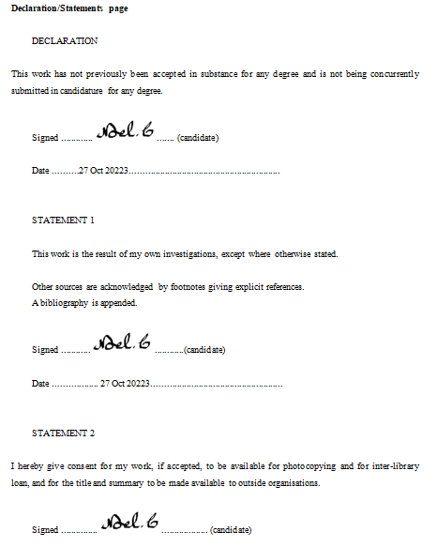
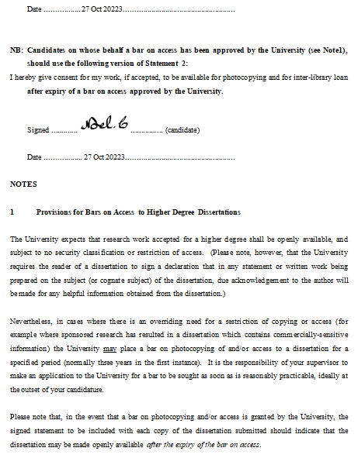
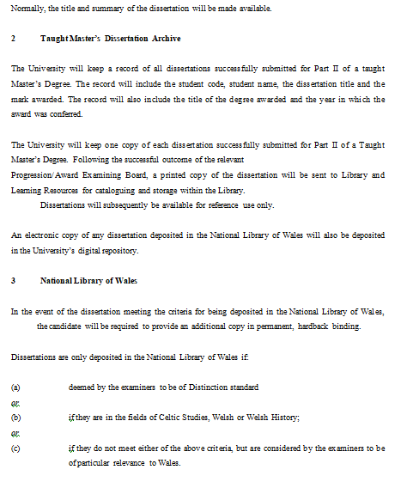

Acknowledgement

1. Introduction
With the wireless telecommunications and cellular telephony industries booming worldwide, mobile commerce (m-commerce) generates much interest. Mobile commerce refers to e-commerce activities using mobile devices like mobile phones and PADs. Mobile commerce will soon become a part of everyday life as new technologies develop, promising information anytime, anywhere (Kuo and Chen, 2006).

1.1 Research Background
The global outbreak of COVID-19 has caused a significant shift in consumer behavior and preferences (Zwanka and Buff, 2021), including in Hong Kong. As the world continues to navigate the pandemic, consumer choices about mobile network providers will be significantly impacted. This could be due to numerous factors, such as changes in awareness of digital connectivity, increased reliance on mobile devices, economic uncertainty and changes in customer behaviuor. Therefore, mobile network providers must take note of these changes and adjust their offerings accordingly to meet the needs of Hong Kong customers.

1.1.1 Increased Reliance on Mobile Devices
With more people working and studying from home and restrictions on social gatherings and travel during the COVID-19 pandemic (Ahmadi et al. 2022). It has become increasingly apparent that the residents of Hong Kong are becoming more reliant on their mobile devices to facilitate their daily communication, entertainment, online purchasing and other associated activities. Consequently, it is crucial to consider the reliability and quality of the network when selecting a mobile network provider. This consideration ensures that the individual's mobile experience remains uninterrupted and smooth, enabling them to continue their daily activities without limitations. Below are the categories of internet use.

Figure 1.1 Data for Internet Users 10+ Years Old in The Past 12 Months, Categorized by Internet Use
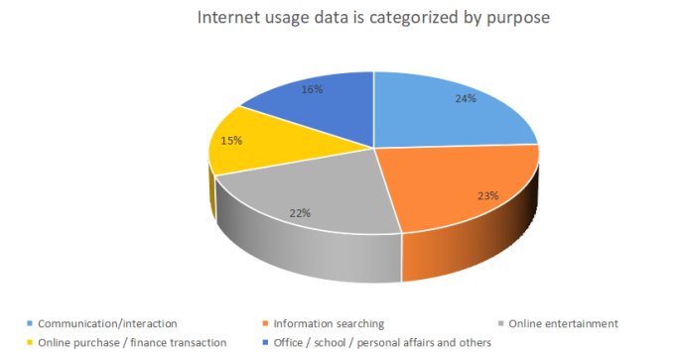
Source: Census and Statistics Department, 2021
1.1.2 Greater Awareness of Digital Connectivity
The pandemic has underscored the importance of digital connectivity in enabling remote work, learning and socialization (Nyberg, Shaw and Zhu, 2021). Hong Kong people were concerned about their health status, which was compounded by a lack of understanding of the full dangers of the pandemic and uncertainty about how long it would last (Scheinfeld et al. 2022). Hong Kong consumers may be more aware of the importance of having a reliable and fast mobile network connection and may be more willing to pay for higher-quality service.

1.1.3 Economic Uncertainty
The ongoing pandemic has brought about numerous financial difficulties for the residents of Hong Kong, including but not limited to unemployment, decreased income, and an overall sense of economic instability (Wong et al. 2021). These challenges have affected a significant population ratio, making implementing measures to relieve the situation crucial. Therefore, when individuals choose a mobile network provider, they may consider numerous factors. Among these criteria, pricing and promotions may be given higher priority due to their potential impact on the consumer's budget and overall satisfaction with the service.

1.1.4 Changes in Consumer Behaviour
The ongoing COVID-19 pandemic has significantly impacted consumer behaviour, with notable changes in shopping, entertainment and purchasing preferences. One such change is the surge in online shopping and streaming services (Valaskova, Durana and Adamko, 2021). In addition, as more people stay home to prevent the spread of the virus, they have turned to the internet to fulfil their shopping and entertainment needs (Miah et al. 2022). As a result, consumers living in Hong Kong may discover mobile network providers who provide additional services or benefits, including free data exceeding a certain speed of data usage, to be more attractive.

The outbreak of COVID-19 has significantly impacted the way consumers in Hong Kong approach their choices in the mobile network provider market. Considering the pandemic, network quality, price, and additional services have become consumers' top priorities when making informed decisions in the post-COVID-19 era.

1.2 Research Drivers
When individuals are in the process of selecting a mobile network service provider, there are numerous factors that they take into consideration. These factors may include but are not limited to the price of the service, the quality of network coverage, the availability of customer service, the brand reputation and the range of features offered by the provider. Therefore, it is essential to carefully evaluate these factors to make an informed decision that meets one's specific needs and preferences.

1.2.1 Network Quality
When selecting a mobile network provider, most individuals prioritize companies that offer expansive coverage and superior network quality. This is because they value uninterrupted usage of their mobile devices and wish to avoid experiencing dropped calls or other connectivity issues (Khan, 2010).

1.2.2 Pricing
When making purchasing decisions, consumers tend to prioritize pricing because they are keen on finding ways to maximize the value of their spending and ensure that they get the best deal possible for their money, whether online or offline (Gupta, Su and Walter, 2004). In addition, many consumers actively seek promotions, discounts, and other exceptional deals to reduce costs and save money. Overall, the ability to find good deals and make cost-effective purchases is a crucial concern for many consumers in today's market (Yildirim and Aydin, 2012).

1.2.3 Customer Service
Providing excellent customer service to mobile users is essential. However, ensuring fairness and equity for all users is also necessary. Achieving this balance will facilitate customer trust and loyalty and elevate the organization's reputation (Islam et al. 2021). Consumers expect their concerns to be addressed quickly and efficiently without causing inconvenience or trouble. It is essential to meet this expectation. This level of support can make all the difference in ensuring a positive overall experience with their service provider.

1.2.4. Brand Reputation
When selecting a mobile network provider, the company's reputation is one of the most critical factors. A network provider's reputation can be a key indicator of its reliability and trustworthiness, both crucial in ensuring a seamless and satisfactory mobile communication experience (Zhang and Ngwese, 2007). Therefore, it is strongly recommended that you conduct extensive research into the track record of the network provider, enabling you to make an informed decision and choose a company that values customer satisfaction. Furthermore, by assessing a mobile network provider's reputation entirely, you can rest assured that you are making an intelligent and careful investment in your mobile communication needs.

The COVID-19 pandemic may influence these factors, as consumers prioritize network quality and reliability as they rely more on their mobile services for work and communication (Salam et al. 2021). Economic concerns related to the pandemic may make pricing more important for consumers (Roggeveen and Sethuraman, 2020). However, further research would be needed to provide a more specific answer for Hong Kong customers.

1.3 Research Objective
In the aftermath of the COVID-19 pandemic, customers in Hong Kong will likely have a range of unique and individualized factors that influence their decision-making when selecting a mobile network provider. These factors could include price, network coverage, data speed, customer service quality, and other personalized preferences that reflect their needs and priorities. As such, mobile providers in Hong Kong will need to be attentive to these changing consumer demands and adapt their offerings accordingly to remain competitive and meet the evolving needs of their customer base.

Mobile networks have become indispensable to our everyday routines in this digital era (ABD et al. 2020). As consumers, we prioritize network quality when selecting a mobile service provider. Dependable coverage is a high priority for customers Mishram and Siddiqui, 2023), enabling them to stay connected and utilize mobile services seamlessly from any location in Hong Kong. This is especially vital for those relying on mobile devices for work, education and entertainment. The lack of network performance, such as congestion and high latency, is unacceptable and can cause significant disruptions to essential daily activities. Therefore, mobile service providers must ensure a strong network infrastructure to deliver reliable and consistent customer services.

Considering the ongoing pandemic and the economic uncertainty it has brought about, many customers will likely place a greater emphasis on affordability when selecting a mobile network provider. In addition, with numerous individuals facing job losses or reduced salaries, they may be more inclined to seek out providers that offer competitive pricing, promotions, and discounts to save money on the service (Toubes, Araújo and Fraiz, 2021). As such, mobile network providers may need to adjust their pricing strategies and promotional offerings to remain competitive in the current market.

Customer service plays a vital role in the retail industry of Hong Kong, primarily due to the high volume of complaints received. In this regard, mobile network providers that prioritize responsive and helpful customer support, user-friendly mobile apps, and transparent billing practices are highly preferred by customers. These businesses must establish an efficient customer service system that can promptly handle customer inquiries and complaints effectively, ensuring customer satisfaction and keeping the company's reputation (Dhruw and Sainy, 2023). In addition, mobile network providers that offer innovative solutions and value-added services can further enhance their customer experience and gain a competitive edge in the market (Chesire, 2015).

Overall, the objective of Hong Kong customers selecting a mobile network provider in the post-COVID-19 era will combine these factors, depending on their individual needs and preferences.

1.4 Research Question
Identifying the research question is a crucial phase in the research process since it helps narrow the research aim and objectives to specific areas on which the study will focus. This helps ensure that the research is targeted and focused, increasing the likelihood of achieving meaningful and useful results (Creswell, 2014). Having an unambiguous research question is crucial as it lays the foundation for formulating a well-defined research aim and objective that are closely interrelated. This is important because it helps researchers to stay focused, avoid ambiguity, and conduct their study with a specific purpose in mind (Martindale and Taylor, 2014).

When choosing a mobile network provider in Hong Kong after COVID-19, customers consider four main factors: (1) the network's coverage quality, (2) pricing plans that meet their needs, (3) the quality of customer service, and (4) the provider's reputation. These factors have been identified in previous studies and can influence a customer's purchasing decision. For more details, see Chapter 2's "Literature Review." Below are the four questions that need to be answered.
1. How important are network quality, pricing and promotion in Hong Kong customers' decision-making process when selecting a mobile network provider in the post-COVID-19 era?
2. What role does customer service play in Hong Kong customers' satisfaction with their mobile network provider, and how has the pandemic affected customer service expectations?
3. How has the COVID-19 pandemic affected mobile network provider reputation in the industry?
4. How do demographic factors such as age and occupation influence Hong Kong customers' preferences and behaviours when selecting a mobile network provider in the post-COVID-19 era?

In the current era that COVID-19 has heavily impacted, several research questions could be explored based on the objectives and focus of the study. To gather the necessary quantitative data, individuals from the public will be asked to complete a comprehensive questionnaire. The collected data will then be analyzed to identify any potential correlations or relationships between various variables and the overall purchasing intent of the participants.

1.5 Value of Research
The unprecedented COVID-19 pandemic has profoundly impacted people's lives, requiring them to drastically change their lifestyles, work arrangements, and social interactions (Alah et al. 2022). As a result, the process of selecting a mobile network provider in Hong Kong has also experienced a significant shift. In addition, the pandemic has increased reliance on digital communication and connectivity, with more individuals working remotely and online services becoming the primary source of entertainment, shopping, and socialization (Donthu and Gustafsson, 2020). Considering these developments, choosing a mobile network provider that can offer high-speed, reliable, and secure connectivity is essential, ensuring that customers can stay connected no matter where or what they are doing.

Through surveys among the public, we aim to investigate the factors that impact purchasing intentions. We aim to identify the essential determinants and consequences of customer intention and understand how customers have been treated considering the COVID-19 pandemic. By analyzing this data, we hope to provide valuable insights that can help businesses better cater to the needs and preferences of their customers, both in the short and long term.

According to a study, a significant connection exists between customers' preferences for mobile network providers and their purchase intentions, particularly considering the COVID-19 pandemic. Mobile network providers should consider this data when designing strategies to increase customer purchasing intention. In these uncertain times, customers have high expectations and seek providers to enhance their internal and external network stability and responsiveness. These findings are noteworthy for mobile network providers and should be considered in future decision-making processes.

Advice can then be provided to mobile network providers to improve their service quality, reputation, price management and network stability to increase customer purchase intention.

2. Literature Review
There are two primary components of a literature review. Firstly, it should provide a brief overview of the outcomes or views from previous research endeavours on a particular topic. Secondly, a literature review should decide regarding the precision and comprehensiveness of this information (Knopf, 2006).

2.1 Research Focus Areas: Explanation and Discussion of Variables
The COVID-19 pandemic has had a significant impact on both the health and economy of people across the globe. With the continuous spread of the virus, individuals and communities are increasingly focused on taking necessary protection and planning. From implementing safety measures to adapting business operations, everyone works together to navigate these exceptional times and prepare for what lies ahead (Khoo and Lantos, 2020).

Considering the numerous changes and challenges experienced by Hong Kong's business world over the past year, the government have had to implement various strategies to maintain business levels, such as subsidies, avoid bankruptcy, and prepare for post-epidemic growth (Vasiev, Denisov and Bocharnikov, 2020). The telecommunication industry's business volume heavily relies on citizens' purchasing intentions and other factors that require further verification. To this end, this study aims to identify the motivational factors that drive citizens' purchasing decisions and determine their relationship with purchase intention. This information will give businesses valuable insights to help them improve their strategies accordingly. Additionally, we will analyze how network quality, price, brand reputation, and customer service influence citizens' purchasing intentions to provide a more comprehensive understanding of the factors that drive consumer behaviuor in the mobile network industry.

Due to the pandemic, many countries restrict people's free movement. As a result, most individuals are hesitant to go out to shop, thus leading to an exponential increase in demand for network quality and traffic. The extended use of mobile phones is also on the rise, as businesses have implemented stay-at-home work policies to prevent the collective spread of COVID-19 among employees. As a result, streamers have seen a noticeable rise (Lemenager et al. 2021). Even in the post-pandemic era, with the flow of people still limited and most employees returning to the office (Babapour, Hultberg and Bozic, 2021), the demand for high-quality network providers still needs to be increased. As such, network providers must be adequately equipped to cater to this positive trend by ensuring the quality of their network, pricing, brand reputation, and customer service.

Establishing and nurturing long-term customer connections must be balanced in the current business landscape, characterized by cutthroat competition and constantly growing market dynamics. This is because the strength of suppliers and the level of consumer demand continue to soar, making it crucial for companies to maintain a customer base to ensure their success and survival. However, in addition to customer belief, other variables, such as the quality of products and services offered, also carry significant weight in any decision-making process (Giovanis, Tomaras and Zondiros, 2013). According to research, there are four key factors that businesses should focus on to create successful customer relationships: network quality, price, brand reputation and customer service. By prioritizing these factors, companies can maintain a competitive edge in the market.

2.1.1 Network Quality
In today's fast-paced world, mobile phones have become a crucial part of our daily lives, serving as a vital tool for work, entertainment, and communication. As a result, the quality of mobile networks has become an essential factor in the decision-making process for consumers when selecting a mobile network provider. Network quality plays a crucial role in determining the user's overall experience, and people tend to choose providers that offer faster connectivity, more reliable service, and broader coverage with security (Andrews, Ghosh and Muhamed, 2007). Therefore, mobile network providers must ensure that they deliver top-quality services to meet the ever-increasing demands of their customers. By doing so, they can retain their existing customers and attract new ones, eventually leading to a successful business.

Earlier to the outbreak of the COVID-19 pandemic, mobile networks were primarily used for personal communication and entertainment. However, with the shift towards remote work and online learning, there has been a significant increase in the usage of mobile network services (Feldmann et al. 2020). As a result, the reliability and quality of mobile networks have become critical factors for consumers when selecting a provider. The ability to maintain a stable connection, provide fast data transfer rates, and offer a seamless user experience has become essential in meeting the needs and expectations of users. These factors are necessary for consumers to switch to an alternative provider that can better cater to their needs and demands (Saha, Islam and Hoque, 2016).

Recent studies have revealed that individuals invest in mobile network services that provide faster download speeds, reliable connectivity, and broader coverage. The existence of a first-rate mobile network that affords an uninterrupted experience has the potential to significantly augment a person's capability to be productive, acquire knowledge, and enjoy entertainment. Consequently, customers are more likely to choose mobile network providers capable of ensuring such exceptional services which can provide a high network of the mobile service provider. (Kuo, Wu and Deng, 2009).

Mobile network providers must ensure that their services provide high-quality network experiences to their customers. This is because customers with positive experiences with mobile network quality are likelier to remain loyal and refer the services to others. Conversely, customers who encounter poor-quality mobile network experiences may switch to other providers due to frequent network problems, network instability, and other related issues, resulting in a loss of market share and revenue for the provider (Sathish et al. 2011). Therefore, it is crucial for mobile network providers to constantly improve their network services and ensure that their customers have the best possible experience. By doing so, they retain their existing customers and attract new ones.

Mobile network quality has recently become increasingly significant in consumer purchasing decisions, especially since the COVID-19 pandemic. Consumers seek good quality service. Therefore, mobile network providers must prioritize delivering high-quality networks that meet consumers' demands to keep existing customers and attract new ones.

2.1.2 Pricing
In today's world, mobile networks have become an integral part of our lives, helping us stay connected, informed, and productive. In the pre-COVID-19 era, the essential factor that drove potential mobile network consumers was the cost of the plans offered by different providers. People would compare prices between providers to find a cost-effective plan that met their specific needs or personalized requirements (Moon, Chadee and Tikoo, 2008). However, the outbreak of COVID-19 brought about a shift in customers' expectations. Due to COVID-19, people started relying more on mobile networks to stay connected with their loved ones, work remotely, and access essential services online. As a result, customers' priorities changed, and they were now looking for a more reliable mobile network service, even if it meant paying a premium. This change in consumer behaviour forced mobile network providers to adapt their pricing strategies accordingly. To meet the evolving needs of their customers, mobile network providers began offering more flexible and customizable plans that provided superior service and better aligned with their customers' changing needs.

In the current market, telecommunication providers have implemented various pricing adjustments to attract and retain customers. One of the most popular strategies has been to offer limited-time discounts or cashback deals to incentivize individuals to sign up for a new plan or renew an existing contract. This approach has proven effective in attracting new customers and retaining existing ones (HKCSL, 2023). These flexible payment options have positively impacted customers' purchase intention, as they are more likely to choose a provider that offers affordable plans and convenient payment options. In essence, pricing adjustments that offer customers greater flexibility and affordability are essential to building a loyal customer base in the highly competitive telecommunications industry.

Contract periods have also changed as a result of COVID-19. Many providers have started offering shorter contract periods. In contrast, others have removed long-term contracts with subscription fees, allowing customers to switch plans or providers more easily (Leowarin and Thanasuta, 2021). This change has given customers more flexibility and control over their mobile phone plans. With increased uncertainty and changes in lifestyle, having the option to switch plans quickly has become a more critical factor for customers.

It cannot be denied that value-added services have become increasingly essential today, especially after COVID-19. With the increased reliance on virtual communication for work and education, customers have come to expect more comprehensive data plans that cater to their needs. This includes free unlimited data allowances, video conferencing capabilities, and access to various entertainment services. Service providers have recognized this shift in customer behavior and have stepped up their game by offering more services to meet these demands. The impact of these value-added services on customer purchase intention is significant (Chang, 2017). Customers place a higher value on providers offering comprehensive services that cater to their needs. The availability of these services has become an essential factor in determining customer purchase intention.

The COVID-19 pandemic has significantly changed how mobile network providers operate, particularly in pricing strategies, contract periods, and value-added services. These adjustments have been made in response to customers' evolving needs during these challenging times. As a result, customers are now more likely to gravitate towards providers that offer affordable plans, flexible contract periods, and value-added services that meet their changing needs. By adapting to the current situation, mobile network providers can serve their customers better and maintain a competitive edge in the market.

2.1.3 Customer Service
In today's world, mobile networks have become an integral part of our lives, helping us stay connected, informed, and productive. In the pre-COVID-19 era, the essential factor that drove potential mobile network consumers was the cost of the plans offered by different providers. People would compare prices between providers to find a cost-effective plan that met their specific needs or personalized requirements (Moon, Chadee and Tikoo, 2008). However, the outbreak of COVID-19 brought about a shift in customers' expectations. Due to COVID-19, people started relying more on mobile networks to stay connected with their loved ones, work remotely, and access essential services online. As a result, customers' priorities changed, and they were now looking for a more reliable mobile network service, even if it meant paying a premium (Christensen, Johnson and Rigby, 2002). Foundations for growth: How to identify and build disruptive new businesses. MIT Sloan Management Review. This change in consumer behaviour forced mobile network providers to adapt their pricing strategies accordingly. To meet the evolving needs of their customers, mobile network providers began offering more flexible and customizable plans that provided superior service and better aligned with their customers' changing needs.

In the current market, telecommunication providers have implemented various pricing adjustments to attract and retain customers. One of the most popular strategies has been to offer limited-time discounts or cashback deals to incentivize individuals to sign up for a new plan or renew an existing contract. This approach has proven effective in attracting new customers and retaining existing ones (HKCSL, 2023). These flexible payment options have positively impacted customers' purchase intention, as they are more likely to choose a provider that offers affordable plans and convenient payment options. In essence, pricing adjustments that offer customers greater flexibility and affordability are essential to building a loyal customer base in the highly competitive telecommunications industry.

Contract periods have also changed as a result of COVID-19. Many providers have started offering shorter contract periods. In contrast, others have removed long-term contracts with subscription fees, allowing customers to switch plans or providers more easily (Leowarin and Thanasuta, 2021). This change has given customers more flexibility and control over their mobile phone plans. With increased uncertainty and changes in lifestyle, having the option to switch plans quickly has become a more critical factor for customers.

It cannot be denied that value-added services have become increasingly essential today, especially after COVID-19. With the increased reliance on virtual communication for work and education, customers have come to expect more comprehensive data plans that cater to their needs. This includes free unlimited data allowances, video conferencing capabilities, and access to various entertainment services. Service providers have recognized this shift in customer behavior and have stepped up their game by offering more services to meet these demands. The impact of these value-added services on customer purchase intention is significant (Chang, 2017). Customers place a higher value on providers offering comprehensive services that cater to their needs. The availability of these services has become an essential factor in determining customer purchase intention.

The COVID-19 pandemic has significantly changed how mobile network providers operate, particularly in pricing strategies, contract periods, and value-added services. These adjustments have been made in response to customers' evolving needs during these challenging times. As a result, customers are now more likely to gravitate towards providers that offer affordable plans, flexible contract periods, and customer value-added services that meet their changing needs. By adapting to the current situation, mobile network providers can serve their customers better and maintain a competitive edge in the market.

2.1.4 Brand Reputation
The role of mobile network providers in our daily lives cannot be overstated. They serve as the bridge that connects us to the broader world, enabling us to stay in touch with our loved ones and access vital information and services. However, the outbreak of the COVID-19 pandemic has had a significant effect on how we use these networks. With lockdowns and social distancing measures in place, we have had to rely more on mobile networks than ever before. This has not only placed stress on the network infrastructure of these providers but has also impacted their brand reputation, which in turn can affect consumer purchase intention to maintain their revenue per year (Wu, Yeh, and Hsiao, 2011). As such, mobile network providers must adapt to these changing circumstances and continue providing reliable networks and efficient service to their existing customers.

Before the beginning of the COVID-19 pandemic, the status of mobile network providers was mostly determined by parameters such as the quality of their service, network coverage, and pricing. Customers would generally switch providers based on whichever offered the most favourable deal or had the best network performance. However, with the advent of the pandemic, the importance of brand reputation took on a new dimension. Suddenly, mobile network providers were tasked with ensuring that individuals could effectively work, learn, and stay connected from the confines of their homes. This placed significant pressure on providers to deliver reliable and stable networks, and those who succeeded saw a substantial increase in their brand reputation. Customers feel more confident and secure when dealing with companies with a strong reputation for providing quality products or services. This can positively impact their purchasing decisions, as they are less likely to perceive any potential risks associated with doing business with a reputable brand (Martínez, Pérez and Del, 2014).

With the COVID-19 pandemic sweeping across the world, mobile network providers are facing increased scrutiny regarding their brand reputation. Consumers are now more discerning than ever and seek providers that can offer them the best possible service while demonstrating an unpretentious commitment to their customers' well-being. In response, providers are taking concrete steps to address the challenges posed by the pandemic, such as offering free or discounted data to help customers stay connected during social distancing and quarantine. By doing so, providers can improve their brand reputation and foster more excellent customer support. Someday, this can help them build stronger, more resilient businesses that weather future crises and challenges better. As a result, mobile network providers recognize the importance of prioritizing their customers' needs and being well-regarded during these uncertain times.

It is worth emphasizing the importance of brand reputation in influencing consumer purchase intention. Research has shown that consumers tend to gravitate toward providers with a solid reputation, even if the cost is slightly higher. This is primarily because a brand's reputation indicates trust and good quality, essential attributes in the mobile network industry (Agmeka, Wathoni and Santoso, 2019). It is significant that while pricing and network coverage remain essential factors in determining purchase intention, brand reputation plays an equally significant role. Therefore, businesses must prioritize maintaining a positive reputation to attract new customers and retain their current clientele. By doing so, businesses can remain competitive and continue to thrive.

After extensive analysis of the impact of the COVID-19 pandemic on the mobile network provider industry, it is evident that consumers have seen a significant change in how they view brand reputation. While factors such as quality of service, network coverage, and pricing have traditionally been the primary considerations, the pandemic has highlighted the importance of a provider's commitment to customer well-being. In other words, mobile network providers who prioritize the health and safety of their customers are now more likely to be considered favourably in the visions of the public. Moving forward, providers need to identify the critical role of a strong brand reputation in attracting and retaining customers (Abd-El-Salam, Shawky and El-Nahas, 2013). Mobile network providers can position themselves for success in a post-pandemic world by prioritizing customer well-being and building a dependable reputation.

2.1.5 Purchase Intention
Given the current global COVID-19 pandemic, various industries have experienced significant changes, and the telecommunication industry of mobile network providers is no exception. Thus, it is crucial to investigate deeper into the effects of this remarkable event on the telecommunication industry, particularly regarding network quality, pricing, customer service, and brand reputation. By meticulously examining these factors, we can make better-informed decisions about which providers to select and how to navigate the industry landscape during these challenging times. Ultimately, this research will provide us with a more comprehensive understanding of the current state of the mobile network provider industry and enable us to make more informed choices about our network provider options.

Previous to the outbreak of COVID-19, the quality of a mobile network was a significant consideration for consumers when selecting a service provider. Customers are expected to have access to fast and dependable network coverage at all times, regardless of location (Vijay and Krishnaveni, 2016). However, network quality has become even more crucial with the rapid shift towards remote work. Consumers require a network supporting bandwidth-intensive activities such as video conferencing, file sharing, and other work-related tasks. As a result, mobile network providers have had to prioritize expanding and enhancing their networks to meet the growing demand for reliable connectivity (Budnitzand and Tranos, 2022). While some companies have successfully met this challenge, others have needed help to keep pace. Ultimately, customers will choose the network provider that can deliver the highest service and support for their business needs.

When selecting a mobile network provider, the cost has always been an important consideration for consumers. Everyone wants to get the best value for their consumption, leading to intense competition in the industry. However, the COVID-19 pandemic has brought about a great deal of financial uncertainty and difficulty. As a result, customers are now more inclined to choose reasonably priced mobile plans that offer essential services. In this new environment, mobile network providers that can offer cost-effective plans without compromising quality will likely be chosen more frequently by customers; companies must be able to change and be creative. Being flexible is essential.

In light of the ongoing COVID-19 pandemic, the significance of customer service within the telecommunication industry has only increased. The current situation has boosted the importance of seamless connectivity as more and more people have shifted to remote work or work from home (Wong, Cheung and Chen, 2020). Any network disruption or downtime could significantly impact productivity, and as such, customers now expect quick and efficient solutions to any issues they may face. Mobile network providers that prioritize customer service and provide exceptional support to their clients will undoubtedly gain an advantage over their competitors in this highly competitive landscape.

Brand reputation is essential in the decision-making process when selecting a mobile network provider. Consumers want to partner with providers that they can trust and depend on. In the pre-COVID-19 era, a company's brand reputation was primarily established through impactful advertising and marketing campaigns. However, the pandemic has changed how brands are perceived, and companies that provide additional support to their customers have gained massive praise and recognition. Mobile network providers that have offered free data to frontline workers and extended payment deadlines for struggling customers have received high honours for their compassionate approach during these challenging times. Such acts of kindness and humanitarianism have helped these providers earn customers' trust and loyalty, enhancing their brand reputation.

To summarize, the COVID-19 outbreak has significantly impacted the telecommunication industry. With the sudden and widespread shift to remote work and online communication, there has been an overflow in demand for high-quality network services at affordable prices. As a result, consumers are now emphasizing essential factors such as network quality, pricing, customer service, and brand reputation toward purchase intention.

For instance, mobile network providers offering reliable and fast network speeds, competitive pricing plans, and excellent customer support are more likely to win over customers in this new landscape. Moreover, a strong brand reputation has become increasingly important as consumers are more cautious about selecting trustworthy and dependable providers.

Looking forward, it will be interesting to see how mobile network providers adapt to the changing needs of consumers in this post-COVID-19 era. As the situation continues to develop, providers that can stay ahead of the turn by offering innovative solutions and exceptional customer experiences will be well-positioned to succeed in the long run.

2.2 Formulation of Research Framework and Hypothesis
The research question leads to a hypothesis, which is then applied to determine the appropriate investigations or interventions to answer the question (Willis, 2023). This study aimed to assess the correlation between customers' purchase intention and various factors related to mobile network providers in the telecommunication industry. The study examined four key compelling customer decision-making features: network quality, pricing, customer service, and brand reputation. The study also aimed to test specific hypotheses about these features and their impact on customer purchase intention. Through this comprehensive analysis, the study seeks to provide valuable insights that can assist mobile network providers in understanding their customers' needs and preferences and improve their marketing strategies accordingly.
Figure 2.2 Research Framework
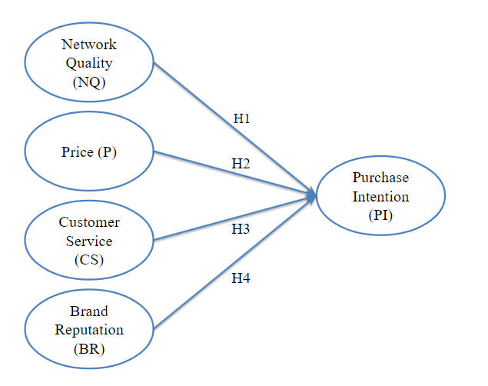
H1: A positive relationship exists between network quality and purchase intention for selecting a mobile network provider.
H2: A positive relationship exists between price and purchase intention for selecting a mobile network provider.
H3: A positive relationship exists between customer service and purchase intention for selecting a mobile network provider.
H4: A positive relationship exists between brand reputation and purchase intention for selecting a mobile network provider.

3. Research Methodology
Research is a methodical way of addressing a problem. It involves formulating a hypothesis, gathering facts or data, analyzing the information, and drawing conclusions. These conclusions can be in the form of solutions to the problem or contribute to theoretical ideas (Kothari, 2004).

3.1 Research Method
In academic study, there are two main methods of collecting and analyzing data: quantitative and qualitative. Quantitative research involves collecting numerical data, which can be analyzed mathematically. In contrast, qualitative research involves collecting non-numerical data, such as opinions and experiences, which can be analyzed through various techniques. These methods are meaningful and widely used in the academic community to gather and analyze data for research purposes.

Quantitative research is a powerful tool that can be utilized to address relational questions between variables in a given research study. It involves collecting and analyzing numerical data, allowing researchers to draw concrete conclusions and make informed decisions based on the results (Williams, 2007). By utilizing this approach, researchers can gain valuable insights into the relationships between different variables, facilitating a deeper understanding of the subject.

Quantitative researchers are focused on obtaining explanations and predictions that can be applied to various individuals and locations. The primary objective is to establish, confirm, or validate relationships and to develop generalizations that can contribute to the overall understanding of a particular theory (Leedy and Ormrod, 2001). Through quantitative research, researchers can gain accurate and reliable insights, which can be used to make decisions and recommendations.

Quantitative research begins with a problem statement and involves the formation of a hypothesis, a literature review, and a quantitative data analysis. According to Creswell, quantitative research utilizes specific inquiry strategies, such as experimental and survey methods like questionnaires. It involves collecting data via predetermined instruments for statistical data generation (Creswell et al., 2003). This highly structured and systematic approach enables researchers to establish transparent cause-and-effect relationships between variables and draw precise conclusions based on observed evidence. The findings from quantitative research can be predictive, explanatory, and confirming.

Qualitative research is a comprehensive approach that involves the discovery of particular phenomena. This type of research is often described as an unfolding model in a natural setting, enabling the researcher to develop a precise level of detail through their high involvement in the actual experiences. One essential identifier of qualitative research is the focus on the social phenomenon being investigated from the participant's viewpoint, providing a unique and often insightful perspective. Various research designs utilize qualitative research techniques to formulate the research approach, providing a deep and slight understanding of the subject matter (William, 2007).

Qualitative research is defined by its purposeful use in describing, explaining, and interpreting collected data. According to Leedy and Ormrod, this type of research needs to be more structured in its approach, as it focuses on formulating and building new theories. Qualitative research is beneficial when investigating complex or multifaceted phenomena, as it allows for a nuanced understanding of the subject matter (Leedy and Ormrod, 2001). In contrast to quantitative research, which relies on numerical data, qualitative research seeks to uncover a phenomenon's underlying meaning and context through close analysis of qualitative data. Overall, qualitative research is a valuable tool for generating rich and detailed insights into various topics and areas of inquiry.

According to Castellan, quantitative studies use predetermined concepts and theories to gather measurable data. Statistical analysis and hypothesis procedures are used to generalize findings from a sample to defined people. Typically, qualitative research involves collecting data through interviews, observations, and written documents. Researchers analyze data for specific themes and patterns to write a story and interpretation (Castellan, 2010). See Table 3.1 for quantitative and qualitative research components.
Table 3.1 Quantitative and Qualitative research components
Components of Research Approaches | Quantitative | Qualitative
Philosophical Assumptions | A researcher is independent of that which is researched | Multiple & subjective reality where the researcher interacts with that being researched
Method/Types of Research | Experimental, single subject and descriptive,  comparative, correlational, ex-post facto | Phenomenology, case study, cultural studies
Purpose/Goal of Research | Generalizability, explanation, prediction | Understanding, insight and interpretation
Questions or Hypothesis | The hypothesis is informed guess or prediction | Question is evolving, general and flexible
Those Being Researched | Randomly selected sample, proportionally representative of the population | Usually, a small number of non-representative cases
Data | Questionnaires, surveys, and tests in the form of numbers and statistics | Written documents from fieldwork, interviews, pictures, observations, objects, etc.
Data Analysis | Deductive process, statistical procedures | Inductive process: codes,  themes, patterns to theory
Source: Castellan, 2010
Currently, my primary area of research entails determining the most effective ways to employ quantitative and qualitative research methodologies to measure and describe the reports I am investigating. While I have made significant progress in this respect, I am facing a challenge in determining which method to implement first, as it appears to be a bit of a chicken-and-egg scenario. This part of the research has posed a significant burden and seeks viable solutions.

This research strategy applies the qualitative research method as an initial exploration to extract ideas covering the mobile network provider. I must comprehensively understand individuals' experiences, opinions, and perceptions regarding the mobile network provider by conducting in-depth interviews and focus groups. These insights can then be transformed into various variables, each of which can be used to segment different questions into a questionnaire that can be tested quantitatively.

Quantitative research involves systematically gathering and analyzing data to test a hypothesis, while qualitative research allows for an in-depth exploration of ideas and experiences (Wolstenholme, 1999). In the case of this study, the nature of the research relies on the quantitative approach, as it involves the application of well-established theories from the literature review and testing hypotheses in a numerical method. This allows for a more rigorous and objective analysis of the data collected. However, it is essential to note that both methods have strengths and limitations.

The foundation of this research is built on the collection of primary data, typically obtained through questionnaires to individuals within the participants' schoolmates, subordinates, friends and relatives. These questionnaires aim to obtain relevant information regarding the four key factors that impact purchase intention, which are this study's primary variables of interest. Given the sensitive nature of the data, participants must complete the questionnaire anonymously to ensure complete confidentiality and safeguard their privacy, so the participants do not need to fill in any personal information in the questionnaire. A briefing session will be introduced in the questionnaire to provide a more comprehensive and detailed understanding of the study's objectives. This session will facilitate greater participant clarity and understanding, resulting in a more potent and accurate data set.

Considering all available data sources, including secondary data, is essential when conducting research. Secondary data refers to information from previously conducted research, which is publicly available. This data type can be obtained from various sources, such as books, magazines, newspapers, journals, and published data. Chapter 2 of a research paper typically presents a comprehensive literature review incorporating relevant information and models acquired from secondary sources to establish the variables and hypotheses. By doing so, researchers can gain a deeper understanding of the research problem and formulate a research question that is both relevant and significant. Therefore, utilizing secondary data is crucial to conducting thorough and well-informed research.

Upon conducting the study, we meticulously checked that all items were adjusted accordingly to meet the necessary levels. I extracted only one factor from each scale we identified as key to the research: Network quality, Pricing, Customer service, and Brand reputation. We intended to use these variables to construct a comprehensive measure of purchase intention that would accurately capture all the dimensions involved. To achieve this goal, we implemented a variable-specific classification scheme that served as the basis for measuring the purchase intention of all participants. By doing so, I ensure that all aspects of purchase intention were captured correctly and accounted for in this study, which would provide a more accurate representation of the data and better insights into customer behaviour.

3.2 Research Framework
A research framework provides a fundamental outline of the concepts, abstractions, and interrelationships that form the foundation for investigating a particular phenomenon (Lester, 2005). It serves as a guiding structure that enables researchers to develop a systematic plan of action for their study. By providing a framework for conceptualizing and designing research studies, data can be better understood and common sense can be transcended, ultimately leading to more constructive outcomes (Lithner, 2008). Figure 3.1 showcases the research framework formulated to ensure the study's success. A comprehensive review of the literature on purchase intention was carried out as part of the preparation. Multiple sources, including journals, websites, and news, were scoured to gather relevant information. The aim was to develop a comprehensive understanding of purchase intention, enabling the study to be conducted efficiently.

Subsequently, a detailed questionnaire was developed, considering the information collected from various secondary sources. The questionnaire captured the participants' thoughts, perceptions, and attitudes towards purchase intention. The collected data was then put through a quantitative analysis process to solve the underlying patterns and trends. The objective was to understand better what factors influenced the participants' purchase intention.

The collected data was analyzed using advanced statistical tools (SPSS) and techniques to identify the statistically significant factors that affected purchase intention. The analysis indicated multiple factors positively correlated with purchase intention, including product quality, brand reputation, and pricing. The results provide actionable insights to help businesses improve their purchase intention.

Finally, based on the study's findings, recommendations were made to enhance the purchase intention. The recommendations were based on the identified factors that could improve purchase intention and were aimed at empowering businesses to make informed decisions. The study's ultimate goal was to comprehensively understand purchase intention and provide businesses with insights to improve mobile network providers' operations.
Figure 3.2: A Research Framework for Selecting Mobile Network Providers' Purchase Intention
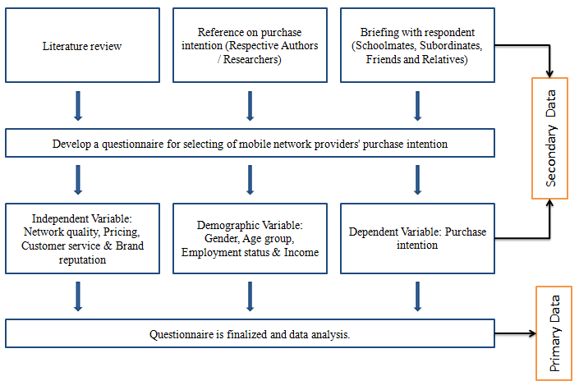
3.3 Research Hypotheses
Every study has a research hypothesis, a precise statement that predicts the outcome and nature of the results. The complexity of the hypothesis may vary, but it should be comprehensible to most readers. (Connelly, 2015). A hypothesis typically defines the specific connection between two or more variables. This connection can indicate a correlation between the variables or a cause-and-effect relationship. (Ross, 1998). Figure 3.2 is the hypothesis about the relationship between 4 Independent Variables and 1 dependent Variable for customers selecting mobile network providers' purchase intention as follows:
Figure 3.3: Research Framework
H1: A positive relationship exists between network quality and purchase intention for selecting a mobile network provider.
H2: A positive relationship exists between price and purchase intention for selecting a mobile network provider.
H3: A positive relationship exists between customer service and purchase intention for selecting a mobile network provider.
H4: A positive relationship exists between brand reputation and purchase intention for selecting a mobile network provider.

3.4 Research Design
To ensure organized and successful research, the design will clearly outline the data collection and analysis procedures.

3.4.1 Coding of Variables
Each variable is coded and grouped by nature.
Independent Variables (IV):
NQ - Network Quality
P - Pricing
CS - Customer Service
BR - Brand Reputation
Dependent Variables (DV):
Purchase Intention

The table below summarizes the coding and operationalization of 5 variables and their corresponding sources of scales.
Table 3.2: Coding of 5 variables and source of questionnaires
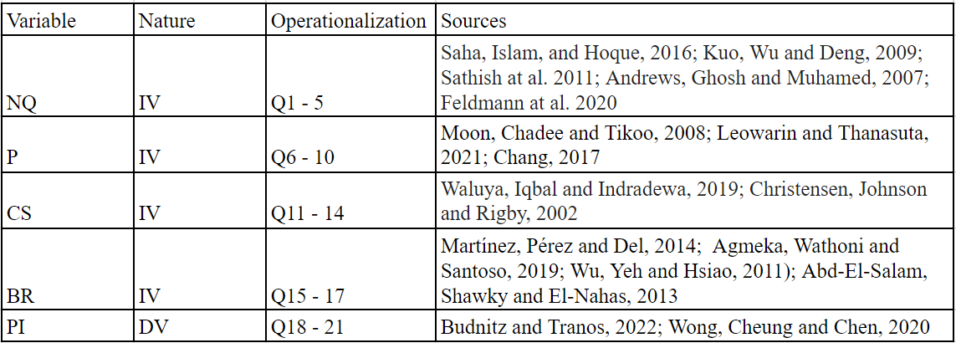
Source: Respective Authors / Researchers

3.4.2 Questionnaire Design
I have recently developed a comprehensive questionnaire tailored to assess an individual's preference towards selecting and purchase intention on a mobile network service provider. The questionnaire includes a series of meticulously composed statements specifically designed to elicit responses that reflect the purchase intention of the participants. To ensure optimal accuracy, participants must indicate their level of agreement or disagreement with each statement using a 7-point Likert scale. This scale is preferred over the traditional 5-point alternative as it provides a more nuanced and detailed insight into the participant's motivation for their response. Ultimately, this practical approach ensures that the questionnaire is both practical and highly appealing to the faculty of the participants' reason (Joshi et al. 2015).

To ensure consistency in the responses gathered, using a 7-point scale (ranging from strongly disagree to strongly agree) for participants to respond to a series of statements. The data collected was primarily quantitative and was obtained using a multi-item scale. The survey consisted of 25 questions, divided into two parts. The first part of the survey focused on gathering participant identification data, including information on gender, age group, employment status, and monthly income. The second part of the survey consisted of 21 questions and aimed to assess various aspects of network quality, pricing, customer service, brand reputation, and purchase intention. Overall, the survey was designed to gather comprehensive and detailed feedback from participants to better understand their experiences and perspectives on various relevant topics.

When performing research, it is advisable to prioritize secondary data collection. This is because it can save significant time and effort if relevant information is already accessible. To conduct a comprehensive literature review, one may use various online sources, such as academic journals, news articles, and reports. Yahoo and Google Scholar are widely recognized as reliable sources for accessing relevant journals and theories. By taking advantage of these resources, we can obtain a wealth of information to support our studies.

To ensure that my research is accurate, I have determined that collecting primary data through a survey on Google is the most effective approach. A questionnaire is necessary for this task as secondary data may need to provide more details. By utilizing this tool, we can understand customer demographics and behaviours in Hong Kong, which will be invaluable in informing our research and achieving our goals.

3.4.3 Target Population
This research aims to gather insights from Hong Kong citizens with a mobile device and a contract with a Hong Kong-based mobile network provider. The survey will be conducted via Google and contain individuals from both genders, over 16 years old, regardless of their employment status and monthly income.

3.4.4 Sample Method
When conducting surveys, there are two primary methods: random and non-random samplings. Random sampling is typically used in quantitative research, whereby each person in the population has an equal chance of being selected (Kelley et al. 2003). Random sampling demands much effort and resources, necessitating detailed planning and validation to guarantee complete unpredictability. Given these constraints, researchers may opt for non-random sampling, also known as convenience sampling. This method is less time-consuming and requires fewer resources to gather information.

In this study, I have adopted convenience sampling by conducting online surveys. The online survey involves forwarding the questionnaire to schoolmates, subordinates, friends and relatives through social networks. These sampling designs are non-random, and they eliminate the regression effect by surveying a broad range of customers, not just those who have a sense of loyalty or no loyalty towards different mobile network providers in Hong Kong.

3.4.5 Sample Size
According to the Journal on Determining the sample size authored by Morse (Morse, 2000), an equation exists for calculating the sample size. This equation can be used to ensure that the sample size is appropriate for the research being conducted.
Equation of Sample Size = (Z-score)² – StdDev*(1-StdDev) / (margin of error)²
As previously mentioned, it is crucial to note that the respondent's age should be over 16, regardless of gender. This critical information has been sourced from the Census and Statistics Department in Hong Kong, which currently estimates a population of roughly 6.6 million individuals, with a margin of error of approximately 8%.

Following the survey, a significant number of 150 questionnaires were gathered, indicating the willingness of the respondents to participate and share their valuable insights. While it is true that data collection can prove to be a challenging task, it is essential to acknowledge that every piece of information collected has significant value.

It is also important to note that there may be instances where the costs associated with data collection may outweigh the benefits of collecting the data (Lakens, 2022). Nonetheless, the data collected through this survey can provide valuable insights that can be utilized to make informed decisions at a personal and organizational level.

3.5 Data analysis Procedures
The research project begins with a thorough quantitative analysis of participant data through questionnaires. The data is analyzed using inferential and descriptive statistics through a well-regarded statistical program called Statistics Package for the Social Sciences (SPSS). In this study, the analytical functions of SPSS include reliability tests, specifically Cronbach's Alpha, and regression analysis, including simple and multiple regression.

The study's primary purpose is to determine whether independent variables, such as Network Quality, Pricing, Customer Service, and Brand Reputation, significantly impact the dependent variable of Purchase Intention. Therefore, multiple linear regression is conducted to measure the relationship between the two types of variables and the degree of the relationship, which could be either positive or negative e, for analyzing data to make predictions (Tranmer and Elliot, 2008). Since this study has four independent variables and one dependent variable, it is essential to test the four hypotheses to determine a positive impact between the two variables. The researcher aims to measure how these independent variables affect the dependent variable to draw conclusions that can be used to improve marketing strategies and increase customer satisfaction.

At the beginning of the questionnaire, participants are asked to provide basic information such as their gender, age group, current employment status, and monthly income. These variables determine the customer's purchase intention when selecting a mobile network provider. The collected data will then be analyzed using various descriptive functions. The outcome of these analyses will be presented in Chapter 4.

Conducting a reliability test is crucial in ensuring the integrity and accuracy of any data analysis. This test is specifically designed to check the consistency of the dataset, which is essential for drawing reliable conclusions. The reliability test examines the relationship between questions for each variable, typically represented by Cronbach's Alpha. This index measures the consistency between questions, with a higher index indicating greater consistency. By conducting a reliability test, analysts can have confidence in the accuracy and validity of their results, allowing them to draw more meaningful insights from the data.

An index of 0.7 or greater is considered appropriate and acceptable (Tavakol and Dennick, 2011). After analyzing the "SSPS Statistics" software, we have concluded that all five variables exhibit a Cronbach's Alpha value that surpasses 0.7. Additionally, it should be noted that the survey questions were meticulously designed to ensure that they are reliable and appropriate for the intended purpose.

3.6 Ethical Considerations
The conduct of this study was marked by careful attention to ethical considerations. The researcher ensures that participants are safe from unnecessary stress. This is the field of ethics (Hasan, 2021). Before involvement, everyone could provide informed consent. Participants were expressly informed that their participation was voluntary and that they had the right to withdraw from the study without incurring any negative consequences. To ensure complete confidentiality, participants were not required to provide identifying information, such as their name or email address. All data collected was stored securely and will be destroyed six months after the study. Google is open to receiving direct communication about any questions or concerns about this study's ethical conduct.

3.7 Pre-test
Before distributing the questionnaire, it is crucial to conduct a pre-test to evaluate the overall perception and reliability of the tool to prevent the failure result (Silk and Urban, 1978). This stage provides a valuable opportunity to identify areas that require improvement, such as determining whether the questionnaire is easily understandable for the participants. By doing this, we can ensure that the participants are comfortable and able to answer truthfully, ultimately resulting in a more seamless return of the questionnaire. This process is essential as it ensures that the data is accurate and dependable. Thus, conducting a pre-test is a necessary step that should be considered in order to ensure the validity and reliability of the data collected.

After thoroughly collecting all the essential information from the journal, I proceeded to the next step: establishing the dependent and independent variables. To ensure that the questions I created for each variable were relevant and reliable, I meticulously crafted them, considering the journal's supporting references for each question.

To further validate the accuracy and reliability of the questionnaire, I carried out a pilot test with a group of friends before distributing it to the participants. This pilot test helped the questionnaire to be as accurate and reliable as possible. Doing this ensured that the final questionnaire would deliver the best possible results, enabling me to make the most informed decisions based on the data collected.

3.8 Research Schedule
Following a structured process is crucial to ensure success when launching a research project. The first step is to carefully consider the research topic and determine the appropriate topic with the supervisor for the dissertation. This action will be completed in the first month of June. Once the topic has been identified, gathering all relevant information from reputable journals and sources is essential to ensure the research is based on solid foundations from June to October.

The next step is to draft a proposal that outlines the specific goals and objectives of the research project. This proposal should be clear and concise, outlining the research questions and methodology used.

Chapters one and two of the dissertation will focus on the introduction and literature review. The introduction should provide an overview of the research topic, while the literature review should analyze and evaluate existing research. After completing the literature review, it is time to design the questionnaire. The questionnaire should be carefully crafted to capture all the necessary information.

Before distributing the questionnaire to participants, it is advisable to conduct a pre-test to check for reliability, so it should be started in August. Once the questionnaire has been distributed and the data collected, it is time to begin drafting chapter three. This chapter should provide an analysis of the data collected, using relevant statistical tools such as SPSS to ensure accuracy.

In the last two months, chapter four and five should focus on discussing and interpreting the results, while Chapter six should provide a conclusion summarizing the findings and their implications. After completing the dissertation, submitting it to the supervisor for review and feedback is essential. Any necessary revisions should be made before the final submission of the dissertation. By following this structured process, you can ensure that your research project succeeds.

Finally, I have a Gantt Chart that outlines my research schedule. It helps me stay on track and achieve my goals efficiently.
Figure 3.8: Gantt Chart
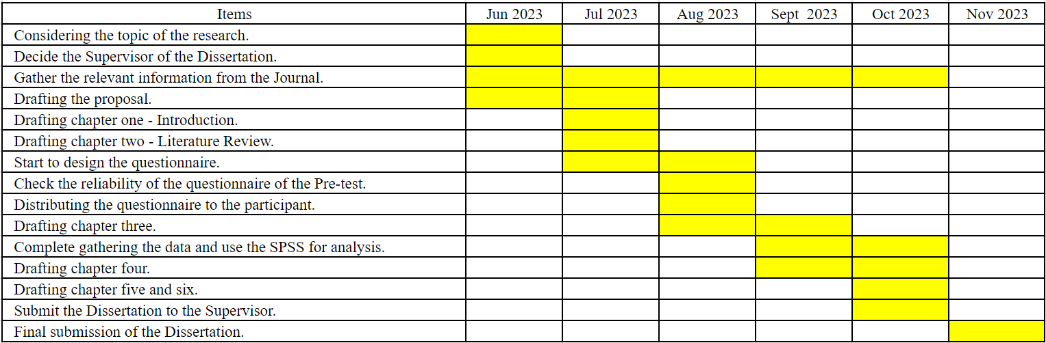

4 Data Description
In the following section, we will analyze the data from the questionnaire distributed among the participants. The data set that we have gathered is extensive and includes a wide range of information, such as an overview of the responses, the gender of the respondents, their age range, employment status, and monthly income. Furthermore, we have also recorded some astute observations concerning their purchase intention. However, before launching the analysis section, we must comprehensively understand the general data about the respondents. To achieve this, we will be utilizing a variety of tables and charts, which will assist us in accurately analyzing and comparing the data.

4.1 Overall Response Summary
A total of one hundred sixty-eight individuals participated in the survey, all of whom were based in Hong Kong and completed the questionnaire online. Fortunately, during the data inputting process, there were no instances of invalid data detected from the online surveys, and all required fields were filled out without any missing answers. This is likely because only fully completed questionnaires could be submitted, ensuring high data quality. As a result, the final number of valid samples amounted to 168.

It can be quite challenging to determine the precise response rate for an online survey, given that it takes work to track the number of people who click the survey hyperlink and read through the questions (Couper, 2000). However, it is worth noting that we collected 168 responses, which falls within the proposed sample size range as outlined in Chapter 3 (150 samples). Overall, this is pleased to report that the response rate and quality of the collected data are satisfactory.

It is imperative to take into account that the reason why 168 individuals are willing and able to respond and comprehend the provided inquiries is independent of their age. Nevertheless, it is equally crucial to acknowledge the probability of dropouts (Porter and Whitcomb, 2005) for online surveys, which necessitates the meticulous selection of a suitable website and the inclusion of messages before transmitting the survey hyperlink.
4.2 Data Description of Demography
This section will provide a comprehensive overview of the demographic data of all participants. This includes detailed profiles and characteristics of each individual's selection process when choosing a mobile network provider. Furthermore, the demographic data will be closely analyzed in convergence with the response pattern garnered from a survey.

4.2.1 Statistic Description on Age Range and Gender of Participant
Table 4.2(a): Statistic Description of Gender of Participant
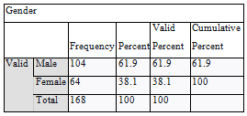
As per the data shown in Table 4.2(a), a total of 168 individuals took part in the survey. Of these, 104 were male participants, accounting for 61.9% of the overall respondents. In contrast, 64 were female participants, representing 38.1% of the total participants. Thus, it can be observed that the male participation rate was higher than that of female participants.

4.2.2 Statistic Description of Age Group of Participant
Table 4.2(b): Statistic Description of Age Group of Participant
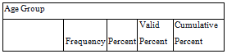
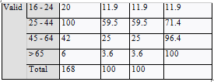
According to the data presented in Table 4.2(b), 168 individuals participated in the survey. The survey was divided into four age groups, the youngest being 16 to 24. This group accounted for 11.9% of the respondents, some students with little or no work experience. The largest group of participants fell within the 25 to 44 age range, with 100 individuals making up 59.5% of the total respondents. The second largest group was the 46 to 64 age range, which had 42 participants and accounted for 25% of the total respondents. The final age group comprised individuals over 65, with only 6 participants making up 3.6% of the total respondents. This group primarily consisted of retirees who had left the job market.

4.2.3 Statistic Description of the Employment Status of Participant
Table 4.2(c): Statistic Description of Employment Status of Participant
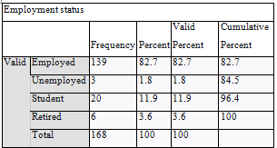
Based on the survey data in Table 4.2(c), 168 individuals participated. Most respondents, accounting for approximately 83%, were employed in the job market. Specifically, 139 participants (82.7%) fell into this category. The second largest group of respondents were students, accounting for 11.9% of the survey with 20 participants. It is worth noting that the remaining participants were either unemployed or retired. However, the number of individuals in these categories was significantly lower, with only 3 participants being unemployed (1.8%) and 6 participants being retired (3.6%).

4.2.4 Statistic Description of the Monthly Household Income of Participant
Table 4.2(d): Statistic Description of Monthly Household Income of Participant
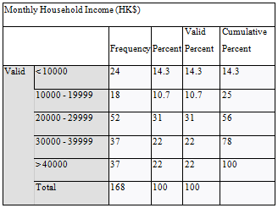
Based on the data presented in Table 4.2(d), the survey divided the participants into five categories according to their monthly income. Most respondents (31%) reported earning between 20K HKD to 29K HKD per month. This group had 52 respondents. The participants earned 30K HKD to 39K HKD and over 40K HKD, each with 37 respondents and accounted for 22% of the participants, a total of 44% for both categories. The category with the lowest number of respondents was the 10K HKD to 19K HKD group, which included only 18 participants and comprised 10.7% of the survey. Interestingly, the category with the most respondents among the lowest income groups was the less than 10K HKD group, with 24 participants accounting for 14.3% of the total participants.

5 Data Analysis
It is essential to remember that data analysis involves a multi-step process, which includes examining, categorizing, and tabulating or recombining evidence to meet the initial objectives of a study (Yin, 1989). According to Krueger and Casey (2000), revisiting a study's original intention is crucial at the start of the analysis, and a clear understanding of the study's purpose is essential for its success. While implementing this approach can be challenging, it is highly beneficial for managing data effectively. This method allows you to make sense of complex information, eliminate irrelevant data, and navigate intricate information paths safely (Rabiee, 2004). This section analyses the data collected from the questionnaire, and the questions were categorized into five variables: Network Quality, Pricing, Customer Service, Brand Reputation, and Purchase Intention. The analysis will include Reliability Tests, Correlation Analysis, and Regression Analysis, which will be interpreted.

5.1 Reliability Tests
According to the research conducted by Gliem and Gliem (2003), a single item set of questions may not be reliable enough to draw a meaningful decision. In contrast, a multiple item set of questions has the potential to achieve more excellent reliability. Therefore, this study constructed five different multiple item sets of questions to ensure that the results obtained are accurate and significant. It is essential to use reliable and valid measures to ensure the validity of research findings, and using a multiple item set of questions is one way to achieve this.

In order to ensure consistency among multiple questions that use the Likert Scaling method for each variable, it is common practice to measure the reliability using Cronbach's Alpha coefficient. This coefficient typically ranges from 0.7 to 0.95, considered an acceptable alpha level (Tavakol and Dennick, 2011).

V1: Network Quality
Table 5.1(a): Reliability Statistics of Variable Network Quality
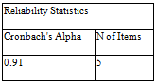
Based on the information presented in Table 5.1(a), there are a total of 5 items that are seeking opinions on Network Quality. It has been found that Cronbach's Alpha value is greater than 0.7, specifically at 0.910. The table indicates a high level of consistency and reliability for this set of items.

Table 5.1(b): Item-Total Statistics of Variable Network Quality
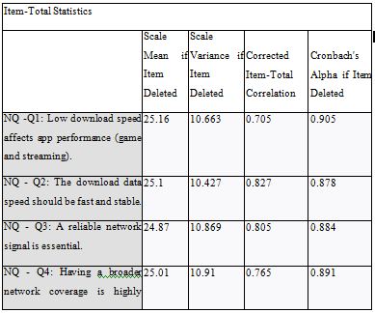
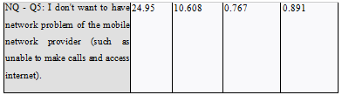
According to the data presented in Table 5.1(b), the current Cronbach's Alpha value of 0.91 is considered acceptable. This indicates that the internal consistency of the scale is solid and reliable. Furthermore, the correlation between the five items is expected to remain relatively high. These findings suggest that the scale is a valid and consistent measure of the construct being assessed.

V2: Pricing
Table 5.1(c): Reliability Statistics of Variable Pricing

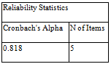

According to the data in Table 5.1(c), five distinct items are inquiring about pricing. The Cronbach's Alpha value has been calculated to be 0.818, indicating a high level of consistency and reliability for this particular group of items. This finding suggests that the set of items is dependable and provides a reliable measure of opinions regarding pricing.

Table 5.1(d): Item-Total Statistics of Variable Pricing
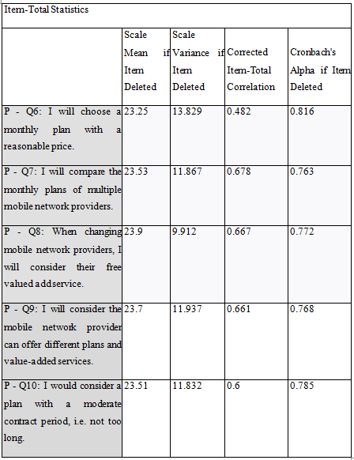
Table 5.1(d) presents the amended alphas for the first item, in case it is deleted, to determine the extent of improvement in the outcome. Nonetheless, the present Cronbach's Alpha of 0.818 is acceptable, and the correlation will remain almost the same even if the first item is deleted.
V3: Customer Service
Table 5.1(e): Reliability Statistics of Variable Customer Service
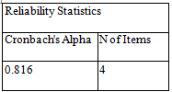

According to the data in Table 5.1(e), four separate items are inquiring about Table 5.1(e), containing data that displays four distinct customer service items. We can establish confidence in the accuracy of this information by reporting the Cronbach's Alpha value of 0.816, which indicates a high level of consistency and reliability among this group of items. Given this finding, the items in question offer a dependable measure of opinions related to customer service.

Table 5.1(f): Item-Total Statistics of Variable Customer Service
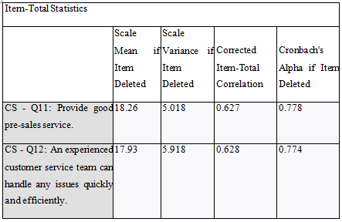
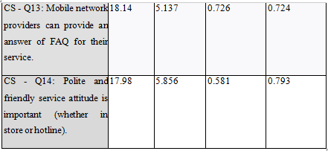
The statistical analysis presented in Table 5.1(f) reveals that the current Cronbach's Alpha value of 0.816 is deemed acceptable. This indicates that the internal consistency of the scale is robust and dependable. Moreover, the correlation among the four items is expected to remain stable. These findings strongly suggest that the scale is a reliable and consistent measure of the evaluated construct.

V4: Brand Reputation
Table 5.1(g): Reliability Statistics of Variable Brand Reputation
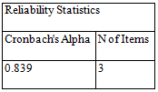
As per the details highlighted in Table 5.1(g), three items aim to gather feedback regarding the Brand Reputation. The analysis indicates that Cronbach's Alpha value is 0.839. This suggests high dependability and consistency for this particular set of items.

Table 5.1(h): Item-Total Statistics of Variable Brand Reputation
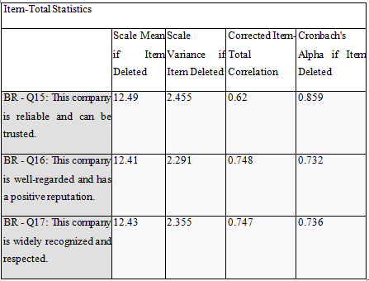
Based on Table 5.1(h), the current Cronbach's Alpha value of 0.839 is deemed satisfactory. This value signifies that the scale's internal consistency is solid and dependable. Additionally, the correlation between the three items is considered considerably acceptable. These observations indicate that the scale is a suitable and consistent meter of the construct under evaluation.
V5: Purchase Intention
Table 5.1(i): Reliability Statistics of Variable Purchase Intention
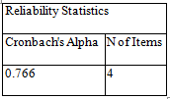
Based on the information presented in Table 5.1(i), four specific items are designed to collect feedback on the overall Purchase Intention Reputation. After analyzing the data, it was found that the Cronbach's Alpha value is 0.766. This indicates that the level of dependability and consistency for this particular set of items is considered acceptable.

Table 5.1(j): Item-Total Statistics of Variable Purchase Intention
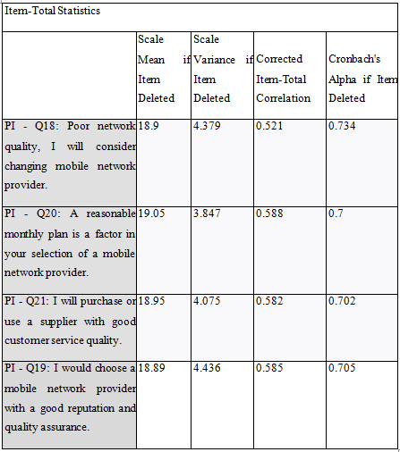
Table 5.1(j) shows that Cronbach's Alpha is currently at 0.766, which is a good value. This means that the scale is reliable and consistently measures what it should. The four items are also expected to have a consistent correlation. Overall, this suggests that the scale is reliable for measuring the construct being evaluated.

5.2 Correlation Analysis
Correlation is a valuable statistical tool that enables us to measure the strength of the association between two variables. It allows us to identify whether these variables are positively or negatively related or have no correlation. When changes in one variable impact the other variable, we can conclude that they are linked (Obilor and Amadi, 2018). During correlation analysis, the coefficient typically ranges between -1 and 1, indicating the degree of relationship strength (Zou, Tuncali and Silverman, 2003). The findings of this study show a correlation result, which is presented below.
Table 5.2(a) Correlations on Network Quality, Pricing, Customer Service, Brand Reputation and Purchase Intention.
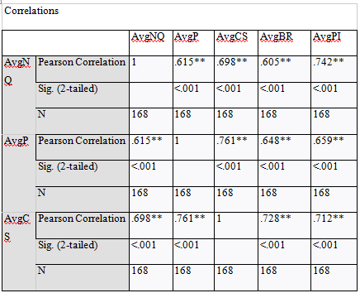
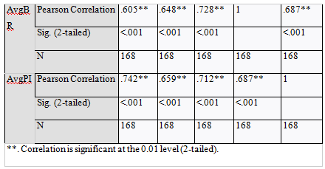
In Table 5.2(a), Pearson Correlation coefficients are presented for various factors, such as Network Quality, Pricing, Customer Service, Brand Reputation, and Purchase Intention. The correlation coefficient between Network Quality and Purchase Intention is 0.742 (r=0.742, p<0.05), indicating a strong and positive correlation between the two factors. Similarly, the correlation coefficient between Pricing and Purchase Intention is 0.659 (r=0.659, p<0.05), showing a strong and positive correlation. Furthermore, the coefficient between Customer Service and Purchase Intention is 0.712 (r=0.712, p<0.05), and the coefficient between Brand Reputation and Purchase Intention is 0.687 (r=0.687, p<0.05), both indicating a strong and positive correlation between these factors and Purchase Intention.

The significance value, commonly known as the p-value, is an essential indicator in statistical analysis. In this case, the p-values are 0.00, smaller than the accepted level of 0.01, indicating that the correlation between the variables is statistically significant. A p-value of 0.05 is also considered acceptable. The significance value helps ensure that the results observed are not likely to be the result of chance or coincidence.

5.3 Regression Analysis
When determining whether one variable can be used to predict another, we turn to regression as our primary statistical tool rather than correlation. We approach such inquiries through linear regressions, which can detect straight-line associations between predictor and response variables (Sweet and Grace, 1999). The study presents a single outcome of regression analysis, displayed below for your reference.

5.3.1 Network Quality, Pricing, Customer Service, Brand Reputation and Purchase Intention
Table 5.3(a) Regression Model Summary on Network Quality, Pricing, Customer Service, Brand Reputation and Purchase Intention
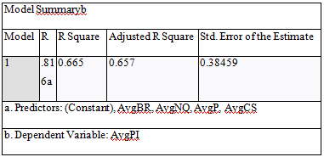

Table 5.3(a) is a comprehensive summary of the regression model, encompassing four independent variables: Network Quality, Pricing, Customer Service, and Brand Reputation. The dependent variable, in this case, is Purchase Intention. The correlation coefficient R is 0.816, indicating a positive and strong linear relationship between the variables. Furthermore, the R Square, which is 0.665, illustrates that 66.5% of the variations in Purchase Intention can be attributed to the four independent variables mentioned above.

Table 5.3(b) Regression Coefficients on Network Quality, Pricing, Customer Service, Brand Reputation and Purchase Intention
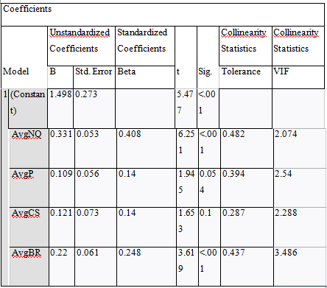
According to the data presented in Table 5.3(b), it can be observed that the significance values of the variables Network Quality and Brand Reputation are less than 0.05. This indicates that these independent variables are statistically significant and can be relied upon in the model. On the other hand, the significant values of the variables Pricing and Customer Service are greater than 0.05, which implies that these two variables are not statistically significant and cannot be considered reliable in the model.

The VIF, or Variance Inflation Factor, is a valuable tool for assessing multicollinearity, which refers to the high correlation between independent variables in a statistical model. VIF = 1 means no correlation, 1<VIF<5 means moderate correlation, 5<VIF<10 means highly correlated, and VIF ≥ 10 means weak regression coefficients due to multicollinearity (Shrestha, 2020). In the case of this particular model, the VIFs for Network Quality, Pricing, Customer Service, and Brand Reputation are 2.074, 2.54, 2.288, and 3.486, respectively. These values are larger than 1 but still within an acceptable range, indicating that multicollinearity is not a significant issue for this model.

Figure 5.3(a) Histogram
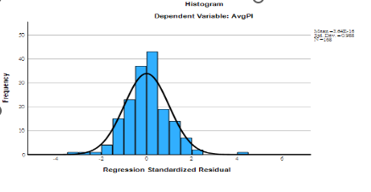
The histogram illustrated in Figure 5.3(a) shows the regression model's distribution of standardized residuals, which appear to follow a normal distribution.
Figure 5.3(b) Normal P-P Plot of Regression Standardized Residual
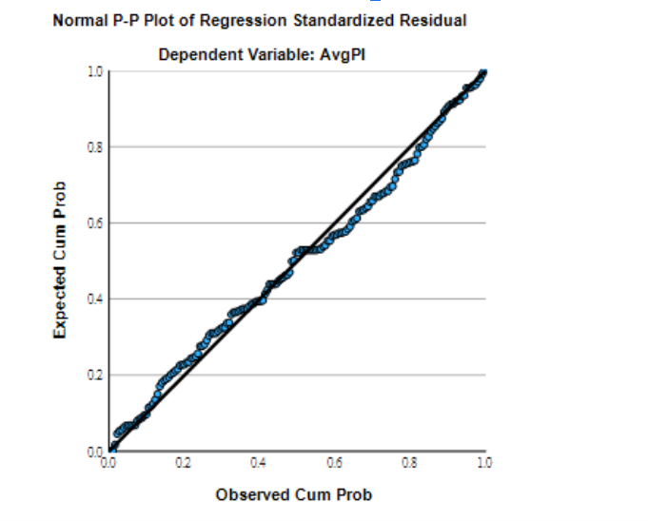
Per the findings presented in Figure 5.3(b), there is a notable and affirmative correlation between Network Quality, Pricing, Customer Service, Brand Reputation, and Purchase Intention.

Figure 5.3 (c) Scatterplot
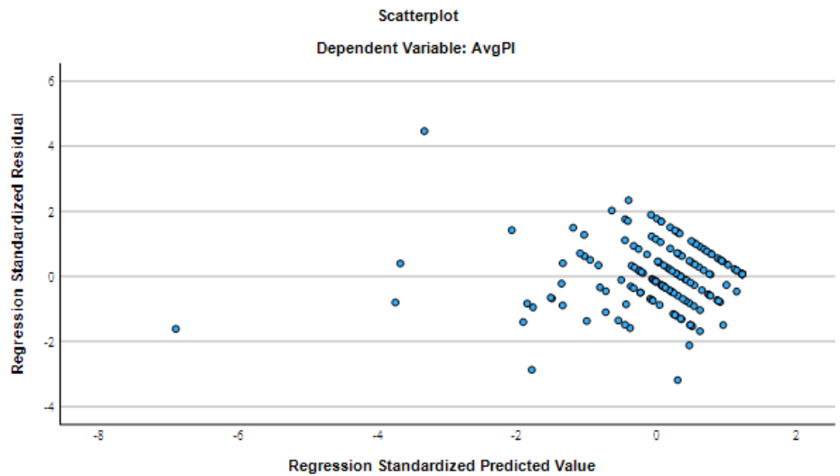
Based on Figure 5.3(c) of the scatterplot, it can be observed that the residual values are evenly and randomly distributed. This implies that the errors are independent and have no relationship with each other.

A Linear Regression Model equation has been derived from the analysis presented for the variables Network Quality (NQ), Pricing (P), Customer Service (CS), Brand Reputation (BR), and Purchase Intention (PI).
PI = 1.498 + 0.331 (NQ) - 0.109 (P) - 0.121 (CS) + 0.22 (BR)
The model predicts that a customer placing higher ratings on NQ and BR tends to put a higher rating on Purchase Intention but not for P and CS.

The results of the Hypothesis testing indicate that the predictor variables of Network Quality (NQ) and Brand Reputation (BR) have significant values smaller than 0.05 in Table 5.3(c). These findings lead to rejecting the null hypothesis and accepting H1 and H4, which suggest that NQ and BR have a positive relationship with Purchase Intention. However, the predictor variables for Pricing and Customer Service have sig. values of 0.054 and 0.1, respectively, indicating a negative relationship with Purchase Intention.

Table 5.3(c) Overall Result of Hypothesis Testing
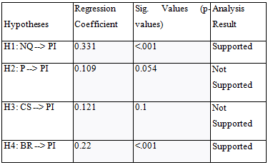
Hence, the decision-making process regarding the hypothesis is as follows:
Table 5.3(d) Overall Decision Makings on Hypothesis Testing
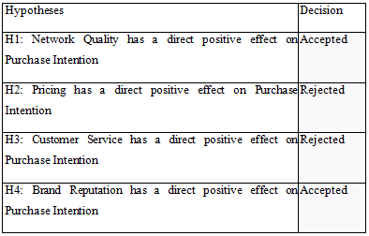
Upon reviewing the data, it is clear that in Table 5.3(d), the ultimate determination regarding hypotheses is that the only factors that significantly influence participants' acceptance are Network Quality and Brand Reputation. Conversely, Pricing and Customer Service do not significantly impact Purchase Intention. Participants do not prioritize these factors when selecting a mobile network provider.

6. Conclusion and Recommendations
6.1 Conclusion
The mobile network industry is highly competitive, and providers must find ways to differentiate themselves from their rivals. To accomplish this, they must employ various strategies and elements that make them stand out and create a memorable experience for consumers (Porter and Michael, 2001). Therefore, it is essential to research whether a consumer's decision to purchase is directly influenced by their selection of a mobile telecom provider. By gathering and analyzing this data, providers can better understand their target audience and customize their offerings to meet their needs and preferences, ultimately increasing their chances of becoming the preferred choice among customers.

After surveying 168 participants, it was found that the mobile network provider has fulfilled their customers' purchase intention requirements. This indicates that the product and service strategy's network quality and brand reputation are adequate. However, it is noteworthy that customers in the Hong Kong market do not consider price and customer service as the primary factors for choosing a mobile network provider. Therefore, other factors such as network quality and brand reputation play a more significant role in determining customers' choice of mobile network provider.

Based on a detailed analysis of literature reviews and research findings, it is evident that customers tend to consider changing their mobile network provider when their contract period is about to expire and they are dissatisfied with the service they receive. This highlights the importance of establishing a positive and credible brand reputation to attract and keep customers. In addition to this, the quality of the network and pricing strategy are also factors that customers consider when evaluating different service plans. It is worth noting that price alone is not the most significant consideration for customers, as they understand that better network quality often comes at a higher cost.

When a problem arises with a mobile network, the primary contact point for customers is usually customer service. The quality of customer service is a critical factor in shaping customers' intentions to make a purchase (Ali at al. 2021). However, it is worth noting that customer service efficiency does not always determine customers' decisions. Customers often feel frustrated and impatient when waiting to speak with a customer service representative for extended periods (Womack and Jones, 2015). Moreover, a lack of knowledge about the service restricts the ability to respond effectively to customer inquiries via the hotline and in-store. This lack of knowledge could lead to unsatisfactory service experiences for customers (Tzeng et al. 2021). As a result, although customer service is a crucial aspect affecting customers' purchase decisions, it is not necessarily the sole determinant.

The study's findings suggest that network quality and brand reputation significantly impact purchase intention, which supports the initial hypotheses. Both primary and secondary data collected reinforce this conclusion. However, the hypotheses on the impact of price and customer service on purchase intention produced insignificant results. Consequently, it can be inferred that network quality and brand reputation are crucial factors in consumer purchasing behaviour. At the same time, price and customer service may have less influence on purchase decisions.

6.2 Recommendations for Future Researchers
Prior studies on purchase intention for mobile network providers in Hong Kong have identified certain variables that require further attention. Suggestions have been made for future researchers to investigate additional factors that could enhance their understanding of purchase intention. These factors include customer experience, electronic word of mouth (eMOW), trust, and other relevant elements that could provide a more comprehensive understanding of the drivers of purchase intention. By incorporating these variables into their research, future researchers may obtain more convincing evidence and produce more accurate and robust results.

Researchers need to ensure that their literature review is comprehensive and contains credible citations. If the researchers meet this requirement in the literature review, they should spend more time conducting an in-depth review to acquire additional details and perspectives. By doing so, they can establish a more substantial base for their study, expand on previous knowledge, and establish a more robust theoretical framework.

Although online surveys are a convenient way to collect data, they can have limitations, such as missing data and incorrect responses caused by researchers' failure to provide detailed explanations (Lefever, Dal and Matthíasdóttir, 2007). Therefore, it is recommended to conduct face-to-face interviews as they allow for better clarification and understanding of questions (Irvine, 2011). A combination of online surveys and face-to-face interviews is advised to ensure a more comprehensive data collection process, address potential issues, and provide a more holistic perspective on purchase intention.

For future researchers aiming to improve the accuracy and consistency of their study, it is recommended that they strive for a larger sample size whenever possible (Ferguson, James and Madeley, 2002). An ideal sample size of 400 participants would consider the five variables being examined. A larger sample size would increase the representativeness of the study and provide a more extensive range of respondents with varying characteristics, thereby producing more robust evidence to support the research findings. This approach would enhance the practicality of the study and maintain confidence in the results.

The final objective of these suggestions is to enhance the inclusiveness, precision, and resilience of forthcoming surveys related to the intention to purchase mobile network providers in Hong Kong. By considering and executing these recommendations, researchers can push the boundaries of knowledge in this domain and offer significant perspectives for business professionals.

6.3 Managerial Implication
Maintaining and acquiring purchase intention is crucial for mobile network providers, and they must consider certain aspects based on research findings. The survey results indicate that customer service and pricing offered by providers play a minor role in increasing customers' purchase intention when they switch their mobile network provider. Therefore, it is recommended that providers focus on improving customer service and pricing to enhance purchase intention.

Companies are advised to provide extensive training programs for their customer service representatives to improve their customer service. These programs teach representatives how to effectively handle customer inquiries by equipping them with active listening, problem-solving, and empathy. Customer service representatives with these skills are better equipped to handle customer inquiries and increase overall customer satisfaction (Rane, Achari and Choudhary, 2023).

Many firms have integrated chatbots into their websites and apps to improve customer service and training programs. These chatbots are designed to assist customers at any time, even outside of regular business hours, ensuring they can get help whenever required. By providing immediate support, customers are more likely to receive quick responses to their inquiries, resulting in increased satisfaction and a greater chance of purchasing. Chatbots are an excellent complement to any customer service strategy and can significantly improve the overall customer experience.

Chatbots offer a notable advantage in their capacity to address customer inquiries promptly. Chatbots can handle multiple queries and respond immediately, unlike human agents who may be occupied or unavailable (Ta et al.2020). This shortens customer wait times and alleviates frustration, leading to an enhanced customer experience and a higher chance of a purchase.

Establishing a pricing strategy for telecom services, it is crucial to conduct comprehensive research and understand the pricing strategies utilized by competitors in the industry. This analysis will help determine a reasonable price range for competitive service plans that offer excellent value for money compared to other providers. Factors that should be considered when setting prices are plan features, data limits, call and SMS allowances, and any additional bonuses or benefits that customers can provide.

Competitive pricing in line with industry standards is crucial to attract cost-conscious customers and improve the likelihood of a purchase (Nagle and Muller, 2018). Nonetheless, it is equally important to showcase the exclusive features and benefits of the service plans, such as high-speed internet, unlimited data, discounted international calling rates, or customer rewards programs. By emphasizing the value of the service beyond its price, telecommunications providers can distinguish themselves from their rivals and appeal to a broader range of customers.

In addition to pricing and plan features, network quality and brand reputation are critical factors influencing customers' purchase decisions. To improve purchase intention, telecom providers should invest in upgrading and improving their network infrastructure to enhance network quality and reliability. This may involve upgrading equipment, increasing network capacity, or expanding coverage areas. By providing a consistently strong and reliable network, telecom providers can address one of customers' critical concerns and increase their confidence in choosing better services.

Finally, telecom providers should use effective marketing and communication strategies to increase brand visibility and awareness. This might include advertising campaigns, promotions for new products, SMS and chatbot messages, and social media presence. Content marketing can also be used to reach a wider audience and build a positive brand image (Zatonatska, Fareniuk and Shpyrko, 2023). By highlighting unique selling propositions such as quality of service, customer satisfaction, or innovative offerings, telecom providers can differentiate themselves from competitors and attract customers who value these features.

By following these recommendations, telecom providers can gain new customers, enhance existing customer relationships, and ultimately increase profitability for the company. It is essential to remember that customer service, price, network quality, and brand reputation are all interconnected factors that impact purchase intention. Therefore, it is crucial to balance these elements to ensure customers are satisfied and the company can achieve its goals.

6.4 Further study and the limitations of this research
It is crucial to investigate the long-term consequences of the pandemic on consumer choices, as current research mainly addresses its immediate effects. Further research could provide an in-depth understanding of the lasting impact of COVID-19, which may include alterations in customer purchase intention, preferences for particular mobile network features, and changes in pricing sensitivity.

Digital technologies have been widely adopted due to the COVID-19 pandemic (Shah et al. 2020). An interesting topic for future research could be how this increased awareness of digital connectivity has impacted the preferences of mobile network providers in Hong Kong among consumers. The study focused on determining the demand for faster internet speeds, reliable network coverage, and improved data plans to facilitate remote work, online education, and entertainment.

Although we conducted research, we encountered some limitations. The COVID-19 pandemic is ongoing, but it is gradually evolving and stabilizing. Due to the current situation, the existing research may need to capture changes in Hong Kong consumers' behaviour accurately. Recognizing that the results are time-sensitive and may only partially represent the current consumer environment is crucial.
As a result of time and resource constraints, researchers may have heavily relied on online surveys and secondary data sources, which could lead to biases and limitations in data collection. These factors could impact the accuracy and representativeness of the findings. In order to achieve a more comprehensive understanding of consumer choices, future research should explore alternative data collection methods, such as in-depth interviews or observational studies.

Due to the impact of the COVID-19 pandemic on consumer behaviour and preferences, it is necessary to conduct additional research to gain a more comprehensive understanding of the future of mobile network provider selection in Hong Kong. It is crucial to examine technological innovation's impact and address previous studies' shortcomings to develop effective strategies to meet customers' evolving needs during these challenging times.

Reference
- Abd-El-Salam, E. M., Shawky, A. Y., & El-Nahas, T. (2013). The impact of corporate image and reputation on service quality, customer satisfaction and customer loyalty: testing the mediating role. Case analysis in an international service company. The Business & Management Review, 3(2), 177-196.
- ABD RASHID, J. A. M. A. L. U. D. D. I. N., AZIZ, A. A., RAHMAN, A. A., SAAID, S. A., & AHMAD, Z. (2020). The influence of mobile phone addiction on academic performance among teenagers.
- Agmeka, F., Wathoni, R. N., & Santoso, A. S. (2019). The influence of discount framing towards brand reputation and brand image on purchase intention and actual behaviour in e-commerce. Procedia Computer Science, 161, 851-858.
- Ahmadi, F., Zandi, S., Cetrez, Ö. A., & Akhavan, S. (2022). Job satisfaction and challenges of working from home during the COVID-19 pandemic: A study in a Swedish academic setting. Work, 71(2), 357-370.
- Alah, M. A., Abdeen, S., Kehyayan, V., & Bougmiza, I. (2022). The impact of changes in work arrangements during COVID-19 pandemic on the lifestyle of Qatar's working population. Journal of occupational and environmental medicine, 64(2), e53.
- Ali, B. J., Akoi, S., Saleh, P. F., & Sardar, Z. (2021). Factors shaping customer satisfaction with residential flats: Evidence from Sulaymaniyah City. Jamal Ali, B., Akoi, S., Fadel
- Andrews, J. G., Ghosh, A., & Muhamed, R. (2007). Fundamentals of WiMAX: understanding broadband wireless networking. Pearson Education.
- Babapour Chafi, M., Hultberg, A., & Bozic Yams, N. (2021). Post-pandemic office work: Perceived challenges and opportunities for a sustainable work environment. Sustainability, 14(1), 294.
- Budnitz, H., & Tranos, E. (2022). Working from home and digital divides: resilience during the pandemic. Annals of the American Association of Geographers, 112(4), 893-913.
- Castellan, C. M. (2010). Quantitative and qualitative research: A view for clarity. International journal of education, 2(2), 1.
- Chang, A. Y. P. (2017). A study on the effects of sales promotion on consumer involvement and purchase intention in the tourism industry. Eurasia Journal of Mathematics, Science and Technology Education, 13(12), 8323-8330.
- Chesire, B. (2015). Relationship between porter’s competitive strategies and performance of value added services by mobile phone operators in Kenya (Doctoral dissertation, Egerton University).
- Christensen, C. M., Johnson, M. W., & Rigby, D. K. (2002). Foundations for growth: How to identify and build disruptive new businesses. MIT Sloan Management Review.
- Connelly, L. M. (2015). Research questions and hypotheses. Medsurg Nursing, 24(6), 435-436.
- Couper, M. P. (2000). Web surveys: A review of issues and approaches. The Public Opinion Quarterly, 64(4), 464-494.
- Creswell JW (2014) Educational Research: Planning, Conducting, and Evaluating Quantitative and Qualitative Research. Fifth edition. Pearson Education, Upper Saddle River NJ
- Creswell, J. W., Plano Clark, V. L., Gutmann, M. L., & Hanson, W. E. (2003). Advanced mixed methods research designs. Handbook of mixed methods in social and behavioral research, 209(240), 209-240.
- DHRUW, N., & SAINY, D. M. (2023). Customer Satisfaction Towards Telecommunication Service Provider: A Study on Bharti Airtel.
- Donthu, N., & Gustafsson, A. (2020). Effects of COVID-19 on business and research. Journal of business research, 117, 284-289.
- Feldmann, A., Gasser, O., Lichtblau, F., Pujol, E., Poese, I., Dietzel, C., ... & Smaragdakis, G. (2020, October). The lockdown effect: Implications of the COVID-19 pandemic on internet traffic. In Proceedings of the ACM internet measurement conference (pp. 1-18).
- Ferguson, E., James, D., & Madeley, L. (2002). Factors associated with success in medical school: systematic review of the literature. Bmj, 324(7343), 952-957.
- Giovanis, A., Tomaras, P., Zondiros, D. (2013), Suppliers Logistics Service Quality Performance and its Effect on Retailers’ Behavioral Intentions, The 2nd International Conference on Integrated Information, Social and Behavioral Sciences 73 (2013) 302 – 309
- Gliem, J. A., & Gliem, R. R. (2003). Calculating, interpreting, and reporting Cronbach’s alpha reliability coefficient for Likert-type scales. Midwest Research-to-Practice Conference in Adult, Continuing, and Community Education.
- Gupta, A., Su, B. C., & Walter, Z. (2004). An empirical study of consumer switching from traditional to electronic channels: A purchase-decision process perspective. International Journal of Electronic Commerce, 8(3), 131-161
- Hasan, N., Rana, R. U., Chowdhury, S., Dola, A. J., & Rony, M. K. K. (2021). Ethical considerations in research. Journal of Nursing Research, Patient Safety and Practise (JNRPSP) 2799-1210, 1(01), 1-4.
- Irvine, A. (2011). Duration, dominance and depth in telephone and face-to-face interviews: A comparative exploration. International Journal of Qualitative Methods, 10(3), 202-220.
- Islam, T., Islam, R., Pitafi, A. H., Xiaobei, L., Rehmani, M., Irfan, M., & Mubarak, M. S. (2021). The impact of corporate social responsibility on customer loyalty: The mediating role of corporate reputation, customer satisfaction, and trust. Sustainable Production and Consumption, 25, 123-135.
- Joshi, A., Kale, S., Chandel, S., & Pal, D. K. (2015). Likert scale: Explored and explained. British journal of applied science & technology, 7(4), 396-403.
- Kelley, K., Clark, B., Brown, V. and Sitzia, J. 2003, ‘Good practice in the conduct and reporting of survey research’. International Journal for Quality Health Care 2003, vol. 15, issue 3, pp. 261-266.
- Khan, M. A. (2010). An empirical assessment of service quality of cellular mobile telephone operators in Pakistan. Asian Social Science, 6(10), 164.
- Khoo, E. J., & Lantos, J. D. (2020). Lessons learned from the COVID‐19 pandemic. Acta Paediatrica (Oslo, Norway: 1992), 109(7), 1323.
- Knopf, J. W. (2006). Doing a literature review. PS: Political Science & Politics, 39(1), 127-132.
- Kothari, C. R. (2004). Research methodology. new Age.
- Krueger RA & Casey MA (2000) Focus Groups: A Practical Guide for Applied Research, 3rd ed. Thousand Oaks, CA: Sage Publications.
- Kuo, Y. F., & Chen, P. C. (2006). Selection of mobile value-added services for system operators using fuzzy synthetic evaluation. Expert Systems with Applications, 30(4), 612-620.
- Kuo, Y. F., Wu, C. M., & Deng, W. J. (2009). The relationships among service quality, perceived value, customer satisfaction, and post-purchase intention in mobile value-added services.
- Computers in human behavior, 25(4), 887-896.
- Lakens, D. (2022). Sample size justification. Collabra: Psychology, 8(1), 33267.
- Leedy, P. D., & Ormrod, J. E. (2005). Practical research (Vol. 108). Saddle River, NJ, USA: Pearson Custom.
- Lefever, S., Dal, M., & Matthíasdóttir, Á. (2007). Online data collection in academic research: advantages and limitations. British journal of educational technology, 38(4), 574-582.
- Lemenager, T., Neissner, M., Koopmann, A., Reinhard, I., Georgiadou, E., Müller, A., ... & Hillemacher, T. (2021). COVID-19 lockdown restrictions and online media consumption in Germany. International journal of environmental research and public health, 18(1), 14.
- Leowarin, T., & Thanasuta, K. (2021). Consumer Purchase Intention for Subscription Video-on-Demand Service in Thailand. Journal of Business Administration and Languages (JBAL), 9(1), 14-26.
- Lester, F. (2005). On the theoretical, conceptual, and philosophical foundations for research in mathematics education. Zentralblatt fuer Didaktik der Mathematik, 37(6), 457–467.
- Lithner, J. (2008). A research framework for creative and imitative reasoning. Educational Studies in mathematics, 67, 255-276
- Martindale S, Taylor R (2014) Alternative and complementary research approaches. In Taylor R (Ed) The Essentials of Nursing and Healthcare Research. Sage, Thousand Oaks CA.
- Martínez, P., Pérez, A., & Del Bosque, I. R. (2014). CSR influence on hotel brand image and loyalty. Academia Revista Latinoamericana de Administración.
- Miah, M. R., Hossain, A., Shikder, R., Saha, T., & Neger, M. (2022). Evaluating the impact of social media on online shopping behavior during COVID-19 pandemic: A Bangladeshi consumers’ perspectives. Heliyon, 8(9), e10600.
- MISHRA, A., & SIDDIQUI, D. I. N. (2023). An Empirical Study on Customer Satisfaction Related to Telecommunication Services (A Comparative Analysis of Airtel and Jio Services).
- Moon, J., Chadee, D., & Tikoo, S. (2008). Culture, product type, and price influences on consumer purchase intention to buy personalized products online. Journal of business research, 61(1), 31-39.
- Morse, J. M. (2000). Determining sample size. Qualitative health research, 10(1), 3-5.
- Nagle, T. T., & Muller, G. (2018). The strategy and tactics of pricing. Routledge.
- Nyberg, A. J., Shaw, J. D., & Zhu, J. (2021). The people still make the (remote work-) place: lessons from a pandemic. Journal of Management, 47(8), 1967-1976. (1968)
- Obilor, E. I., & Amadi, E. C. (2018). Test for significance of Pearson’s correlation coefficient. International Journal of Innovative Mathematics, Statistics & Energy Policies, 6(1), 11-23.
- Porter, M. E., & Michael; ilustraciones Gibbs. (2001). Strategy and the Internet.
- Porter, S. R., & Whitcomb, M. E. (2005). Non-response in student surveys: The role of demographics, engagement and personality. Research in higher education, 46, 127-152.
- Rabiee, F. (2004). Focus-group interview and data analysis. Proceedings of the nutrition society, 63(4), 655-660.
- Rane, N. L., Achari, A., & Choudhary, S. P. ENHANCING CUSTOMER LOYALTY THROUGH QUALITY OF SERVICE: EFFECTIVE STRATEGIES TO IMPROVE CUSTOMER SATISFACTION, EXPERIENCE, RELATIONSHIP, AND ENGAGEMENT.
- Roggeveen, A. L., & Sethuraman, R. (2020). How the COVID-19 pandemic may change the world of retailing. Journal of retailing, 96(2), 169.
- Ross, D. (1998). Hypotheses: How the research question is asked. Orthopaedic Nursing, 17, 3.
- Saha, N., Islam, M., & Hoque, A. (2016). Factors affecting customers’ satisfaction of mobile phone subscribers: an empirical study on mobile telecommunication Industry in Bangladesh. International Journal of Business and Management, 11(6), 252.
- Salam, M. A., Saha, T., Rahman, M. H., & Mutsuddi, P. (2021). Challenges to mobile banking adaptation in COVID-19 pandemic. Journal of Business and Management Sciences, 9(3), 101-113.
- Saleh, P., & Sardar, zhilwan.(2021). Factors Shaping Customer Satisfaction with Residential Flats: Evidence from Sulaymaniyah City. Black Sea Journal of Management and Marketing, 2(2), 1-12.
- Sathish, M., Kumar, K. S., Naveen, K. J., & Jeevanantham, V. (2011). A study on consumer switching behaviour in cellular service provider: A study with reference to Chennai. Far East Journal of Psychology and Business, 2(2), 71-81.
- Scheinfeld, E., Gangi, K., Nelson, E. C., & Sinardi, C. C. (2022). Please scream inside your heart: Compounded loss and coping during the COVID-19 pandemic. Health Communication, 37(10), 1316-1328.
- Shah, S. G. S., Nogueras, D., Van Woerden, H. C., & Kiparoglou, V. (2020). The COVID-19 pandemic: A pandemic of lockdown loneliness and the role of digital technology. Journal of medical Internet research, 22(11), e22287.
- Shrestha, N. (2020). Detecting multicollinearity in regression analysis. American Journal of Applied Mathematics and Statistics, 8(2), 39-42.
- Silk, A. J., & Urban, G. L. (1978). Pre-test-market evaluation of new packaged goods: A model and measurement methodology. Journal of marketing Research, 15(2), 171-191.
- Sweet, S. A., & Grace-Martin, K. (1999). Data analysis with SPSS (Vol. 1). Boston, MA, USA: Allyn & Bacon.
- Ta, V., Griffith, C., Boatfield, C., Wang, X., Civitello, M., Bader, H., ... & Loggarakis, A. (2020). User experiences of social support from companion chatbots in everyday contexts: thematic analysis. Journal of medical Internet research, 22(3), e16235.
- Tavakol, M., & Dennick, R. (2011). Making sense of Cronbach's alpha. International journal of medical education, 2, 53.
- Toubes, D. R., Araújo Vila, N., & Fraiz Brea, J. A. (2021). Changes in consumption patterns and tourist promotion after the COVID-19 pandemic. Journal of Theoretical and Applied Electronic Commerce Research, 16(5), 1332-1352.
- Tranmer, M., & Elliot, M. (2008). Multiple linear regression. The Cathie Marsh Centre for Census and Survey Research (CCSR), 5(5), 1-5.
- Tzeng, S. Y., Ertz, M., Jo, M. S., & Sarigöllü, E. (2021). Factors affecting customer satisfaction on online shopping holiday. Marketing Intelligence & Planning, 39(4), 516-532.
- Valaskova, K., Durana, P., & Adamko, P. (2021). Changes in consumers’ purchase patterns as a consequence of the COVID-19 pandemic. Mathematics, 9(15), 1788.
- Vasiev, M., Bi, K., Denisov, A., & Bocharnikov, V. (2020). How COVID-19 pandemics influences Chinese economic sustainability. Форсайт, 14(2 (eng)), 7-22.
- Vijay, P., & Krishnaveni, V. (2016). Customer Preferences towards the mobile network service provider-A study with the special reference to coimbatore City. International Journal of Management Research and Reviews, 6(10), 1386.
- Waluya, A. I., Iqbal, M. A., & Indradewa, R. (2019). How product quality, brand image, and customer satisfaction affect the purchase decisions of Indonesian automotive
- customers. International Journal of Services, Economics and Management, 10(2), 177-193.
- Williams, C. (2007). Research methods. Journal of Business & Economics Research (JBER), 5(3).
- Willis, L. D. (2023). Formulating the research question and framing the hypothesis. Respiratory Care.
- Wolstenholme, E. F. (1999). Qualitative vs quantitative modelling: the evolving balance. Journal of the Operational Research Society, 50, 422-428.
- Womack, J. P., & Jones, D. T. (2015). Lean solutions: how companies and customers can create value and wealth together. Simon and Schuster.
- Wong, A. H. K., Cheung, J. O., & Chen, Z. (2020). Promoting effectiveness of “working from home”: findings from Hong Kong working population under COVID-19. Asian Education and Development Studies, 10(2), 210-228.
- Wong, J. Y. H., Wai, A. K. C., Wang, M. P., Lee, J. J., Li, M., Kwok, J. Y. Y., ... & Choi, A. W. M. (2021). Impact of COVID-19 on child maltreatment: Income instability and parenting issues. International journal of environmental research and public health, 18(4), 1501.
- Wu, P. C., Yeh, G. Y. Y., & Hsiao, C. R. (2011). The effect of store image and service quality on brand image and purchase intention for private label brands. Australasian Marketing Journal, 19(1), 30-39.
- Yildirim, Y., & Aydin, O. (2012). Investigation of the effects of discount announcements on consumers’ purchase decisions: A case study in supermarket. Procedia-Social and Behavioral Sciences, 62, 1235-1244.
- Yin RK (1989) Case Study Research: Design and Methods, 2nd ed. London: Sage Publications.
- Zatonatska, T., Fareniuk, Y., & Shpyrko, V. (2023). Churn Rate Modeling for Telecommunication Operators Using Data Science Methods.
- Zou, K. H., Tuncali, K., & Silverman, S. G. (2003). Correlation and simple linear regression. Radiology, 227(3), 617-628.
- Zwanka, R. J., & Buff, C. (2021). COVID-19 generation: A conceptual framework of the consumer behavioral shifts to be caused by the COVID-19 pandemic. Journal of International Consumer Marketing, 33(1), 58-67.
- Zhang, M., & Ngwese, E. R. (2007). Brand reputation in international marketing case of Mobile telephone companies.

Websites
- Census and Statistics Department, 2021. Thematic Household Survey of Information Technology Usage and Penetration. Available at: https://www.censtatd.gov.hk/en/data/stat_report/product/C0000031/att/B11302732021XXXXB0100.pdf (Accessed: 7 Jul 2023)
- CSL, 2023. CSL official website. Available at: https://5g.hkcsl.com/5g/index.html (Access at: 1 Aug 2023)
- Apple, 2023. Apple official website of support service. Avaliable at : https://support.apple.com/zh-hk/my-support (Accessed: 1 Aug 2023)
- Census and Statistics Department, 2023. Population by Sex and Age Group. Available at: https://www.censtatd.gov.hk/en/web_table.html?id=110-01001 (Accessed: 5 Aug 2023)

Appendix
Questionnaire:


