Leadership and Management Skills for the Workplace
Student Name: IOANA CADERE
Student Number: 1909479
Module Code: BMSW5102
Module Title: Developing Relationships and Workplace Achievements
Lecturer’s Name: NANDISH PATEL
Assignment Title: Individual Presentation on "Training and Development needs for an HR officer"

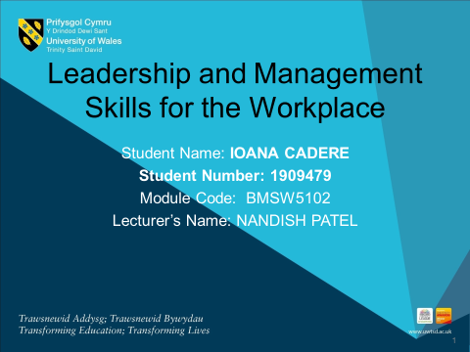
Table of Contents
1. Introduction 3
2. Company Context 4
3. Person’s role description 5
4. HR Officer’s current skill, knowledge and competency 6
5. HR officer’s career plan and training need 9
6. Scheduled review and performance assessment plan 14
7. Conclusion 15
Reference List 16

1. Introduction
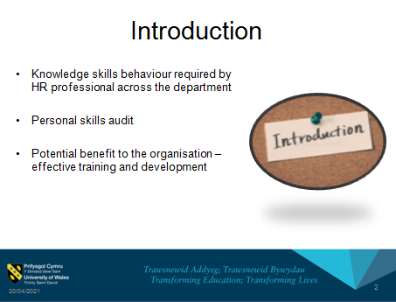
- Knowledge skills behaviour required by HR professional across the department
- Personal skills audit
- The potential benefit to the organisation – effective training and development
Speaker Note: The presentation includes the appropriate knowledge, skills, and behaviour required by the HR professional. Personal skills audit and potential benefits to the organisation to develop as an HR officer through effective training and development have been discussed. The required skills as an HR officer in Tails.com are going to be assessed and presented here.

2. Company Context
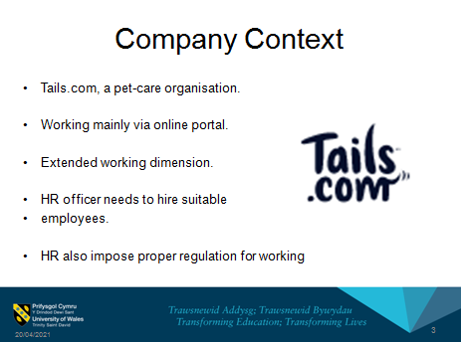
- Tails.com, a pet-care organisation.
- Working mainly via an online portal.
- Extended working dimension.
- HR officer needs to hire suitable employees.
- HR also impose proper regulation for working
Speaker Note: Tails.com is a small company in the UK working with only 170 employees country wide. The working field of this company is diversified as the company provides rare products and services. The company has aimed to provide customer-led service by making affordable products and services. In terms of HR officer, the company needs a person who can take care of all the employee's requirement and also deal with the customer's demand. As the company has been operating since 2013, it has a small set of the workforce. The main role of the HR officer would be to create a diversified range of working people whose skills, knowledge are suitable for the company. Hence, the HR officer has to plan the recruitment and selection drive, plan a proper training and development program and deploy laws and legislation of the country as well (Tails.com, 2021). The HR officer also has to deal with the employee relations issue in the company and solve any emerging problem. The company works in a hierarchical structure in management, so the HR officer has to meddle in all the layers of the structure and maintain proper synchronisation.

3. Person’s role description
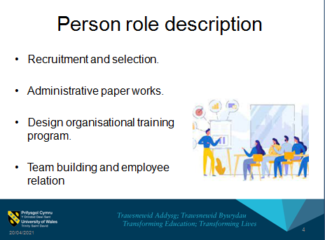
- Recruitment and selection.
- Administrative paper works.
- Design organisational training program.
- Team building and employee relation
Speaker Note: The role of the HR officer is crucial in Tails.com as the person not only has to promote the company but also process the recruitment and selection process. The HR officer is responsible for building a sustainable workforce in the company who can increase the company’s productivity. Being a domestic company, Tails.com has to follow all the legislations of the local and central government, hence, the HR officer needs to take care of those works also (Ismail et al., 2021). In order to develop an efficient workforce, the HR officer has to plan the training program and as Tails.com prefers in-house training program, the person has to design it in a cost-effective manner.

4. HR Officer’s current skill, knowledge and competency
a. Knowledge
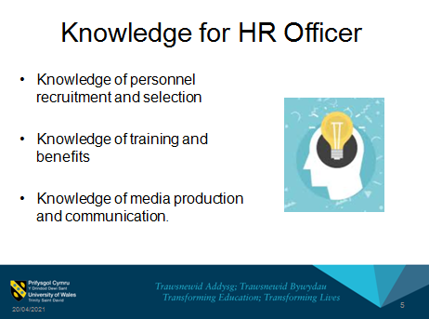
- Knowledge of personnel recruitment and selection
- Knowledge of training and benefits
- Knowledge of media production and communication.
Speaker Note: In Tails.com, the current knowledge of HR professionals is knowledge of principles and the process of personnel selection, training, compensation, or training and development. Apart from that, they have knowledge of negotiation, labour relations, media production, and communication along with knowledge of business and management principles, strategic planning, and safety or security (Romani, Holck, and Risberg, 2019).
b. Skills
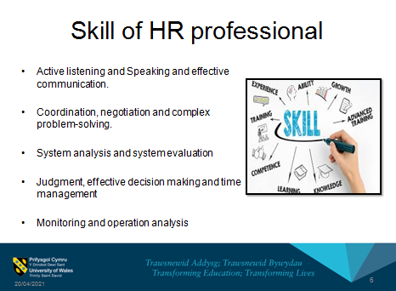
- Active listening and Speaking and effective communication.
- Coordination, negotiation, and complex problem-solving.
- System analysis and system evaluation
Speaker Note: The current skill by HR professions in Tails.com is active listening towards others, and speaking or communication to convey information effectively. Apart from they have skills such as coordination with others, good at problem-solving, effective decision making, and time management (Mamman et al., 2018). Moreover monitoring skills and operation analysis is also present in an HR professional in Tails.com.
c. Competencies
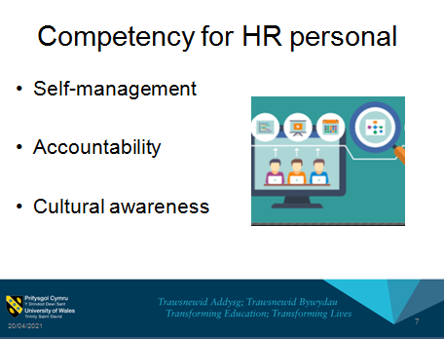
- Self-management
- Accountability
- Cultural awareness
Speaker Note: In Tails.com, the current competency that the HR officer has is self-management, which helps in business development and expansion; accountability, which infuses proper working practice in the company and cultural awareness which helps to build a multi-cultural diverse team in the company (Ismail et al., 2021).

5. HR officer’s career plan and training need
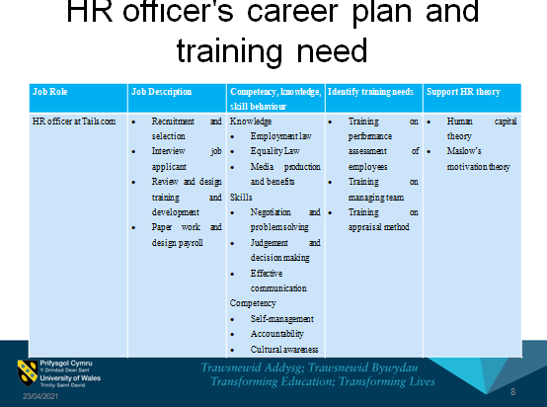
Speaker note: For the job of HR officer in Tails.Com, the job roles are to create a proper recruitment drive, do all the administrative paper works and review employees performance. Hence, the knowledge should be in different laws and legislations of the UK and media and production benefit awareness. The HR personnel must be efficient in negotiation, communication and take prompt and effective decision. The training program must cover all the aspect of performance management, appraisal and team management method. The HR officer must be aware of the Human capital theory where the employees are treated as the most important resource of the company. In order to have their proper efficiency, they should be motivated and Maslow’s motivational theory is proper framework for inducing motivation.

Training program
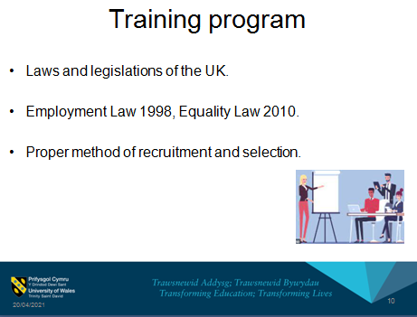
- Laws and legislations of the UK.
- Employment Law 1998, Equality Law 2010.
- The proper method of recruitment and selection.
Speaker Note: The HR officer also has to go through a detailed training and development program where he or she will learn about different employment and organizational laws of UK. This will help the HR officer to implement the legal practice. Even the HR officer has to get a proper idea about discrimination and Equality Law 2010 to serve equal opportunity (Romani, Holck and Risberg, 2019).
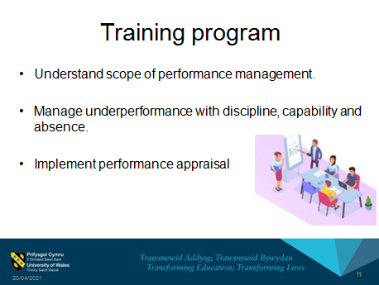
- Understand the scope of performance management.
- Manage underperformance with discipline, capability and absence.
- Implement performance appraisal
Speaker Note: Performance management means to monitor and evaluate employee's work. In the training program, the HR professional has to go through a whole course of performance management, which will help the underperformed employee to recover from the situation with proper precautions. Different types of performance will be assessed and rewarded by appraisal method (Franco‐Santos and Otley, 2018).
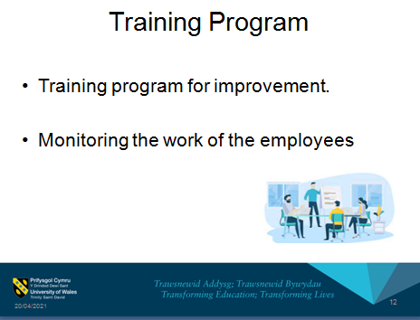
- Training program for improvement.
- Monitoring the work of the employees.
Speaker Note: The HR officer must undergo a training program for further development of knowledge. Even the supervisors or board members have to evaluate his or her work to assess the effectiveness of training program (DeNisi and Murphy, 2017).

6. Scheduled review and performance assessment plan
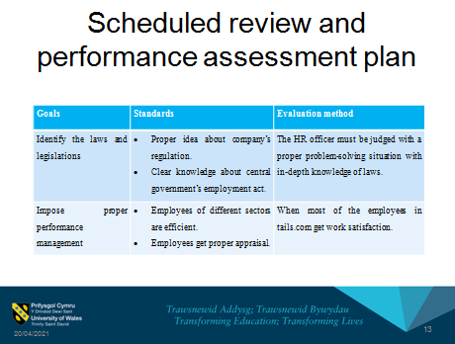
Goals | Standards | Evaluation method
Identify the laws and legislations | - The proper idea about company's regulation.  - Clear knowledge about central government’s employment act. | The HR officer must be judged with a proper problem-solving situation with in-depth knowledge of laws.
Impose proper performance management | - Employees of different sectors are efficient.  - Employees get a proper appraisal. | When most of the employees in tails.com get work satisfaction.
Table 1: Performance Assessment plan
(Source: Created by Author)
Speaker Note: With a proper review of the performance assessment plan after a certain period of time will help the HR officer to work on certain goals. Once, he or she get proper feedback from the assessment plan, will be easier to meet individual's goal as an HR officer and help the company to enjoy overall growth (Mamman et al., 2018).

7. Conclusion
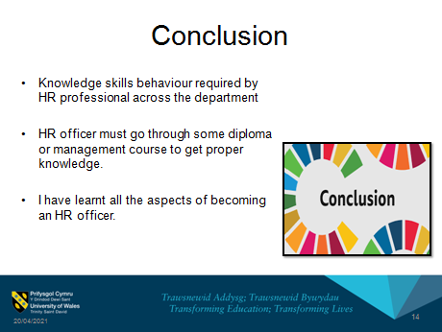
- Knowledge skills behaviour required by HR professional across the department
- HR officers must go through some diploma or management course to get proper knowledge.
- I have learned all the aspects of becoming an HR officer.
Speaker Note: In the presentation knowledge, skills, and behaviours of HR have been discussed along with personal skills identification. The HR officer of Tails.com must be provided with an official training and development program. Though there are skills, knowledge and competency currently a formal training program can help in having different dimensions of that particular role. From this assignment, I have learnt all the skills, knowledge required for being an HR officer. In future, I can develop those skills and establish myself as a renowned HR officer.

Reference List
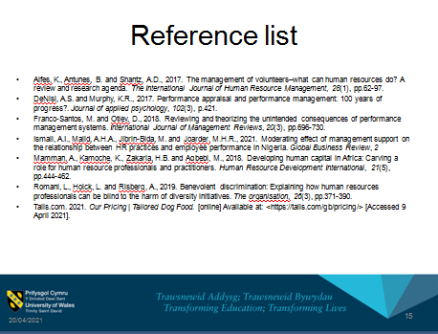
Alfes, K., Antunes, B. and Shantz, A.D., 2017. The management of volunteers–what can human resources do? A review and research agenda. The International Journal of Human Resource Management, 28(1), pp.62-97.
DeNisi, A.S. and Murphy, K.R., 2017. Performance appraisal and performance management: 100 years of progress?. Journal of applied psychology, 102(3), p.421.
Franco‐Santos, M. and Otley, D., 2018. Reviewing and theorizing the unintended consequences of performance management systems. International Journal of Management Reviews, 20(3), pp.696-730.
Ismail, A.I., Majid, A.H.A., Jibrin-Bida, M. and Joarder, M.H.R., 2021. Moderating effect of management support on the relationship between HR practices and employee performance in Nigeria. Global Business Review, 2
Mamman, A., Kamoche, K., Zakaria, H.B. and Agbebi, M., 2018. Developing human capital in Africa: Carving a role for human resource professionals and practitioners. Human Resource Development International, 21(5), pp.444-462.
Romani, L., Holck, L. and Risberg, A., 2019. Benevolent discrimination: Explaining how human resources professionals can be blind to the harm of diversity initiatives. The organisation, 26(3), pp.371-390.
Tails.com. 2021. Our Pricing | Tailored Dog Food. [online] Available at: <https://tails.com/gb/pricing/> [Accessed 9 April 2021].


