

University of Wales, Trinity St. David
BEng Ordnance, Munitions and Explosives

David
2222916

Project Penthus
Module Name: Group Work Based Project
Lecturer: Dave Holley

© UWTSD 2025. All rights reserved. No part of this publication may be reproduced without the written permission of the copyright owner.

Academic Integrity Declaration
I declare that:
- the thesis submitted has been written by me alone.
- the thesis submitted has not been previously submitted to this university or any other.
- that all content, including primary and/or secondary data, is true to the best of my knowledge.
- that all quotations and references have been duly acknowledged according to the requirements of academic research.
I understand that to knowingly submit work in violation of the above statement will be considered by examiners as academic misconduct.

Table of Contents
Academic Integrity Declaration i
List of Figures iii
Annex iv
1 – Introduction 1
2 – Design Project Management 1
2.1 – Management Tool 1
2.2 – Weekly Reviews 2
3 – My Role in the Team 2
4 – Presentation 3
4.1 – Hazard Identification and Analysis 3
4.2 – Risk Classification 4
4.3 – Storage 5
4.4 – Storage Mitigations 6
4.5 – Compatibility groups 7
4.6 – Transport 8
4.7 – Transport Mitigations 9
5 – Feedback from Presentation 10
5.1 – Team Feedback and Questions 10
5.2 – Individual Feedback and Questions 11
6 – Reflections 11
6.1 – Team 12
6.2 – Individual 12
6.3 – Answers to Presentation Questions 12
7 – Conclusion 13
8 – References 13
Annex 15

List of Figures
Figure 1 - Project management tool 2
Figure 2 - Risk classification matrix 4
Figure 3 - Pre-mitigated risk classification (Storage) 5
Figure 4 - Post-mitigated risk classification (Storage) 7
Figure 5 - Safety mechanisms 8
Figure 6 - Pre-mitigated risk classification (Transportation) 9
Figure 7 - Post-mitigated risk classification (Transportation) 10

Annex
Annex 1 - Slide 1 13
Annex 2 - Slide 2 13
Annex 3 - Slide 3 14
Annex 4 - Slide 4 14
Annex 5 - Slide 5 15
Annex 6 - Slide 6 15
Annex 7 - Slide 7 16
Annex 8 - Slide 8 16
Annex 9 - Slide 9 17
Annex 10 - Slide 10 17
Annex 11 - Slide 11 18

1 – Introduction
A requirement was identified to develop and manufacture a new explosive OME device which could destroy a hostile communication centre. The team were tasked with creating a system that can be deployed from at least 100m away and accurately destroy a target within the second floor of an office building. More detail on the initial requirements for the system can be seen in Annex 1 – Slide 1. This report will focus on the steps taken to ensure that the final explosive drone device is safe for transport, storage and operational use.
This project was undertaken by a group of 5 Ordnance, Munitions and Explosives students studying at the University of Wales Trinity Saint David (UWTSD). The group members were:
- David Tolhurst (Safety)
- Harry Grinstead (Safety)
- Rebecca Dingwall (Research and Development)
- Owen Miller (Manufacturing)
- John James (Disposal)

2 – Design Project Management

2.1 – Management Tool
Ensuring that the work being undertaken was manageable and trackable was an important step to make sure that the project deadlines were met. A decision was made to create a collaborative project management Microsoft excel sheet which could be accessed and edited by all project members. This would be used to assign work to individuals and capture a list of actions, a description of the task, date set, owner, date due and date completed. A red, amber, green status was also applied to each action depending on whether it was overdue, in progress or completed. An example of the project management tool can be seen below in figure 1.
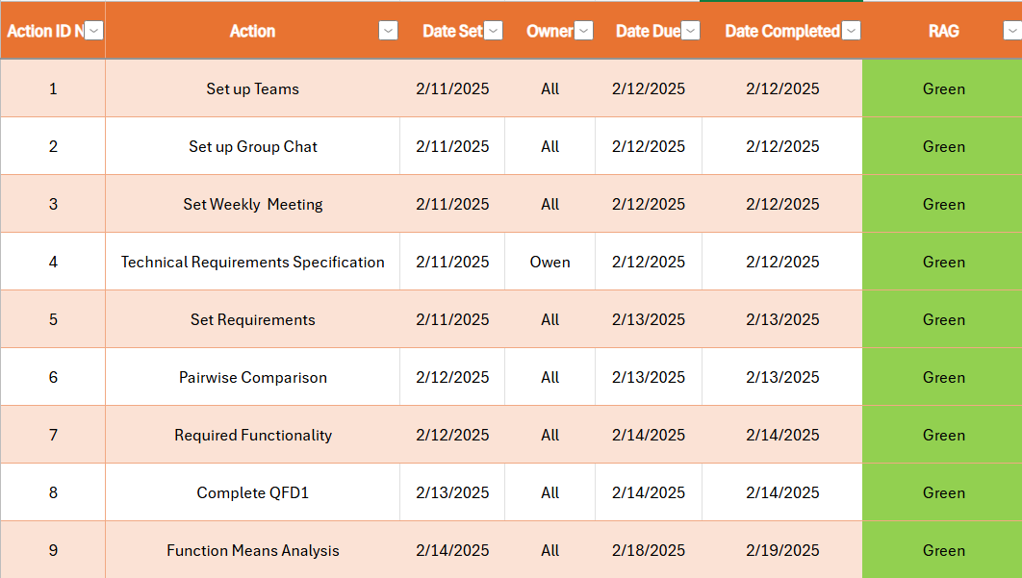
Figure 1 - Project management tool

2.2 – Weekly Reviews
Asides from the project management tool, the group decided that it would be beneficial to hold a weekly review to discuss the current state of the action list and allocate further work to the team to ensure that a steady stream of progress was being made. These sessions were also used as a platform for brainstorming ideas and answering any questions that arose during the project.

3 – My Role in the Team
As a member of the safety team within this project my role was to focus on making sure that the development, manufacturing, storage, transport and disposal of the OME device was carried out in a safe manner. This involved understanding the relevant legislation and regulations that are already being used for in service munitions within defence. Once this was done, a set of reliable processes were followed to help reduce the risk posed by the explosive device.

4 – Presentation
I opened the presentation and introduced the group members to the audience. Then I went onto deliver the project brief and requirement sets. This consisted of the key initial requirements and other requirements derived from stakeholder meetings.
The key initial requirements were:
- Neutralise comms centre with minimal structural or personnel damage
- Prefer disorientation over elimination of occupants
- Room: 10 × 8 × 4 m with 3 windows, 2 barred doors
- 6 operatives typically inside; standard block/plasterboard construction
Requirements derived from stakeholder meetings:
- Include fail-safes to prevent accidental initiation
- Support laser/GPS/inertial targeting for precision and obstacle avoidance
- Deliver repeatable effects
- Remain stable in storage and under environmental stress
- Be fully man-portable — no vehicle or crew required
From these requirements, an explosive charge was designed that would be carried by a Commercial off the Shelf Drone (COTS) using various systems engineering techniques and toolsets.

4.1 – Hazard Identification and Analysis
I started by following a Hazard Identification (HAZID) process which consisted of conversations between the main stakeholders and proposed operating personnel for the explosive device. The HAZID process involves coming up with as many potential hazards that could arise during the transport, storage and deployment of the device. This divergent way of thinking allows for quick a methodical brainstorm of ideas of what could go wrong and when. [1]
After successfully collating a list of hazards, I then went on to carry out a screening process which would discount any hazards which were not deemed to be credible or realistic enough to pose a threat to the device. This is a convergent thinking process that aims to reduce the overall workload for later in the Hazard Analysis (HAZAN) whilst retaining the hazards which do pose a credible threat. [2]

4.2 – Risk Classification
From this point I went on to assign a pre-mitigated risk classification for each hazard which made it through the screening process. This process involved using a risk classification matrix which was derived from Health and Safety Executive (HSE). The risk classification was assigned by identifying the severity and likelihood of each hazard so that a classification of low, low medium, medium, medium high or high using the risk classification matrix in figure 2 below. [1]
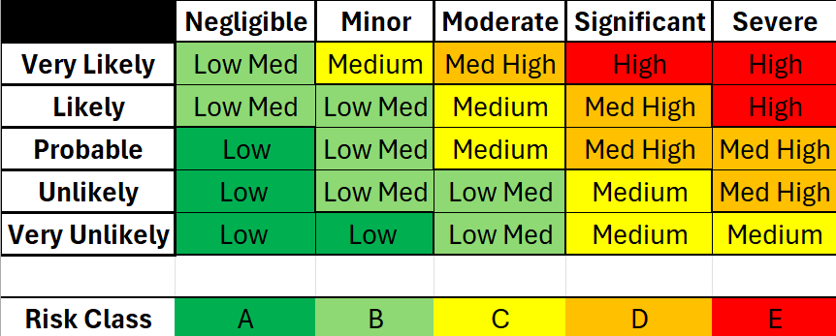
Figure 2 - Risk classification matrix
The severities used in the table are as follows:
- Severe – Multiple deaths or serious injuries
- Significant – Few deaths or serious injuries or life changing illnesses
- Moderate – Broken bones, short terms illnesses and burns
- Minor – Cuts, bruises, sprains and minor burns
- Negligible – Grazes and small cuts
The likelihoods used in this table are as follows:
- Very likely – Between x10¹ and x10²
- Likely – Between x10² and x10³
- Probable – Between x10³ and x10⁴
- Unlikely – Between x10⁴ and x10⁵
- Very unlikely – Between x10⁵ and x10⁶
The overall risk classification was created by multiplying the severity by the likelihood.

4.3 – Storage
Proper storage of the Plastic Explosive (PE8) based device is crucial as it prevents accidents, unauthorised accessed or the introduction of contraband to the explosive area which could cause an accidental detonation. During the HAZID and HAZAN stage, five main hazards were identified for storing the explosive device. They were:
- Fire
- Moisture ingress
- Drop/Impact
- Electromagnetic Radiation
- Unauthorised access
After following the above-mentioned risk classification process a pre-mitigated risk classification of Medium High (Unlikely & Severe) was assigned. This falls into the amber section of the risk classification matrix shown in figure 3 which is unacceptable.
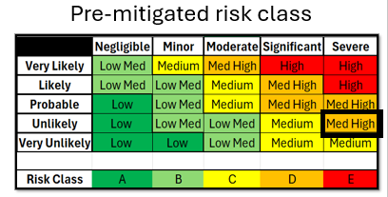
Figure 3 - Pre-mitigated risk classification (Storage)
To get the risk classification to move into a more suitable category, mitigations were put into place to reduce the overall risk from the hazards present.

4.4 – Storage Mitigations
The first mitigation put in place was to ensure that the explosive charge was stored in a secure, environmentally controlled, built for purpose building that could withstand the effects of a detonation. This building should include features such as reinforced concrete walls, traverses where necessary and blast proof doors. Firefighting capabilities such as extinguishers, smoke detectors and sprinklers should also be situated through the building.
Another set of mitigations to prevent unauthorised access is to ensure that there is 24/7 surveillance and security protocols including access control lists and alarms systems.
The container that holds the explosive charge should be designed so that it contains or limits the effect of accidental detonation. It should also be airtight and not susceptible to water ingress which could affect the chemical stability of the explosive. [3]
The environmental control system should keep the explosive device stored within a temperature range between 15-25 degrees Celsius to avoid extreme heating or cooling of which could also affect the chemical stability or cause the explosive material to prematurely deteriorate. [4] [5]
To ensure that our storage facilities are compliant with regulations and that our capabilities are not comprised then contraband signs should be displayed upon entrance and throughout the facility. These signs will contain a list of all the articles that are prohibited within the storage area.
A storage process flow diagram was also constructed to aid the understanding of how the explosive device will be received from the manufacturer and stored. It also highlights any areas of communication that would be suggested in the case of a fault being found upon inspection. See Annex 7 – Slide 7 for the annotated flow diagram.
Using the above-mentioned mitigations, the risk classification was reduced to Low Medium (Very unlikely & Moderate) which falls into the acceptable area. This can be seen in figure below.
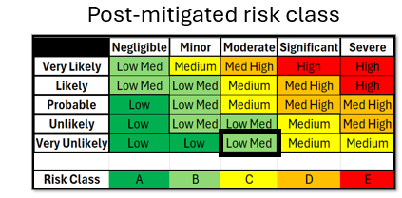
Figure 4 - Post-mitigated risk classification (Storage)

4.5 – Compatibility groups
After referring to the relevant documentation, the storage requirements regarding the compatibility groups for hazard divisions 1.1 explosives were identified. Since the final design that the group opted for consists of a primary explosive with at least two safety features it could be classified as a 1.1D explosive (See figure 5 for proposed safety mechanism design). This means that it is acceptable to store the explosive alongside other explosive articles such as pyrotechnics and propellant motors (in accordance with local building explosive licenses). [6]
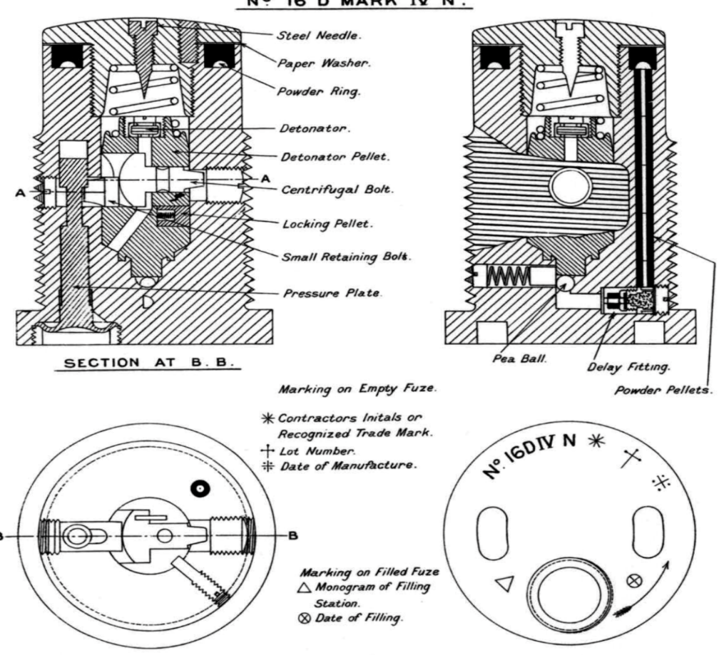
Figure 5 - Safety mechanisms

4.6 – Transport
The same HAZID and HAZAN process was repeated regarding transportation of the explosive. Three main hazards were identified, they were:
- Fire
- Drop/Impact
- Vibration
The same risk classification process was applied and a pre-mitigated risk classification of Medium High (Probable and Severe) was assigned. This falls into the amber section shown in figure 6 which is unacceptable.
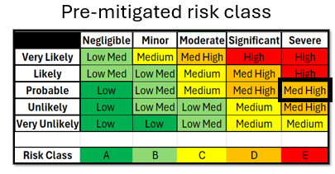
Figure 6 - Pre-mitigated risk classification (Transportation)

4.7 – Transport Mitigations
The first mitigation was to ensure that any lifting or lowering of the explosive is done using a safe method such as forklifting or on a pallet truck. These pieces of equipment would also be regularly inspected and maintained where necessary to reduce the chance of malfunction which could increase the likelihood of a drop and impact to the explosive. [7]
Another mitigation that would be recommended is to incorporate environmental controls into the transport. This would include have temperature and humidity regulated cells within lorries, trains and aeroplanes.
All road transportation should avoid congested areas to decrease the amount of danger posed to the public. A secondary route should always be available in case of road closures or accidents.
A transport process flow diagram was also constructed. This showed how the explosive would be safely taken from storage and loaded onto the delivery vehicle and the measures in place to deal with any faults found during routine inspections. See Annex 11 – Slide 11.
Using the mitigations mentioned above the overall risk classification was reduced to Low Medium (Unlikely & Moderate) which falls into the acceptable area shown in figure 7.
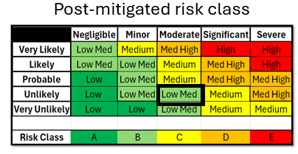
Figure 7 - Post-mitigated risk classification (Transportation)

5 – Feedback from Presentation

5.1 – Team Feedback and Questions
Strengths:
- Introduction to group members and what role they had was well presented and understood by the audience.
- The formatting of the presentation was mostly well received with positive remarks made about the contrast between text and backgrounds. All the images used throughout were of a good size and could be easily seen.
- Each section of the presentation managed to reference another group members section which highlighted that there was good collaboration within the project.
Areas for improvement:
- Some slides had white text on pale coloured background which may have been slightly more difficult to see. There were a few slides that deviated from the theme used for the rest of the presentation.
- There wasn’t a real conclusion to the presentation.
- Lack of a reference slide at the end of the presentation.
Questions:
- Did the group liaison with the drone manufacturer?
- How do you get clearance onto the drone?
- What do you do with drones that have returned from operations?

5.2 – Individual Feedback and Questions
Strengths:
- Good volume and pace of delivery.
- Some attempts made at interacting with the audience.
- Fairly open body language and confident delivery.
- The regulations that were required to be adhered to were understood.
Areas for improvement:
- Spoke to the screen for a large portion of the presentation which may come across as a lack of confidence and discomfort.
- Some hesitant moments in between sentences which can come across as under prepared.
Questions:
- Some additional requirements were derived, how were they gathered?
- Vibration requirements missing, were considerations made for road and air transport?
- What would be done with drone systems that returned from operations?
- Will flight hours be limited with regards to vibration of the system?

6 – Reflections
If the project was to be repeated the following corrections would be made based on the feedback received from the presentation audience.

6.1 – Team
- Each slide in the presentation would use the exact same colour schemes, text and formatting to give a more professional appearance.
- Pale colours on white background would be avoid and bolder contrasts would be used to aid visually.
- A sufficient conclusion page would be included at the end of the presentation to summarise all the key points which had been mentioned throughout.

6.2 – Individual
- I would focus on engaging with the audience more by holding eye contact and refrain from looking at the whiteboard too much to portray a better level of confidence and knowledge on the project.
- I would prepare some flash cards to help keep track of where I am and avoid hesitant moments in between sentences.

6.3 – Answers to Presentation Questions
Team:
The group did have discussions with the drone manufacturer about the capabilities of the drone system. The discussions covered topics such as maximum lifting weights, flight times and connectivity distances. These features were crucial for the system to functions as intended as the drone had to be capable of carrying the explosive charge without hinderance to flight. It also had to be able to stay connected to the operator’s deployment system and fly for long enough to execute the mission.
The clearance feature would utilise technology similar to car parking sensors which would alert the drone that it is flying to close to a surface or object and its flight path would be corrected accordingly. Only once the drone had reached the target area would this feature be disabled so that it could detonate upon impact or proximity.
With regards to return from operations, this would not be possible as the drone system was designed to be single used and used in groups to achieve the desired effect. The group may have not explained this very clearly and would be highlighted more clearly if the presentation was to be repeated.
Individual:
Extra requirements were gathered during the development of the storage and transport procedures. They were gathered by reading existing defence documentation and highlighted during the mitigation development stage. They were prioritised using a pairwise comparison tool so that resources could be prioritised.
Vibration requirements should have been developed to further ensure that the systems weren’t affected during transport or operational use. Considerations were made for road, train and air but many of the considerations were based on road transport in a 44-tonne articulated heavy goods vehicle (HGV).
In hindsight, the maximum suggested flight times and suggested maintenance periods should have been highlighted in the presentation for better understanding of the systems capabilities.

7 – Conclusion
In conclusion, using various safety identification and analysis techniques, an explosive drone system was presented that aimed to meet the original requirements described in the project brief and other stakeholder meetings that the group members attended. Using the feedback provided, corrections and possible future changes to the system have been noted and would be implemented if the task was to be repeated.

8 – References

[1] | Health and Safety Executive, “Managing risks and risk assessment at work,” [Online]. Available: https://www.hse.gov.uk/simple-health-safety/risk/steps-needed-to-manage-risk.htm. [Accessed 3 May 2025].
[2] | R. Meris, “Understanding the Ins and Outs of Process Hazard Analysis (PHA),” Safety Culture, [Online]. Available: https://safetyculture.com/topics/risk-assessment/process-hazard-analysis/. [Accessed 3 May 2025].
[3] | Occupational Safety and Health Administration, “1910.109 - Explosives and blasting agents.,” [Online]. Available: https://www.osha.gov/laws-regs/regulations/standardnumber/1910/1910.109. [Accessed 2 May 2025].
[4] | Defence Safety Authority, “Chapter 13 Section 5.3.1,” in STORAGE AND HANDLING OF EXPLOSIVES.
[5] | Defence Safety Authority, “Chapter 17 Annex A,” in TEMPERATURES FOR NORMAL STORAGE IN MAGAZINES AND STOREHOUSES.
[6] | “Explosive Blasting Type D,” HazMat Tool, [Online]. Available: https://www.hazmattool.com/info.php?b=UN0084&c=1.1D. [Accessed 3 May 2025].
[7] | Health and Safety Executive, Lifting Operations and Lifting Equipment Regulations, 1998.

Annex
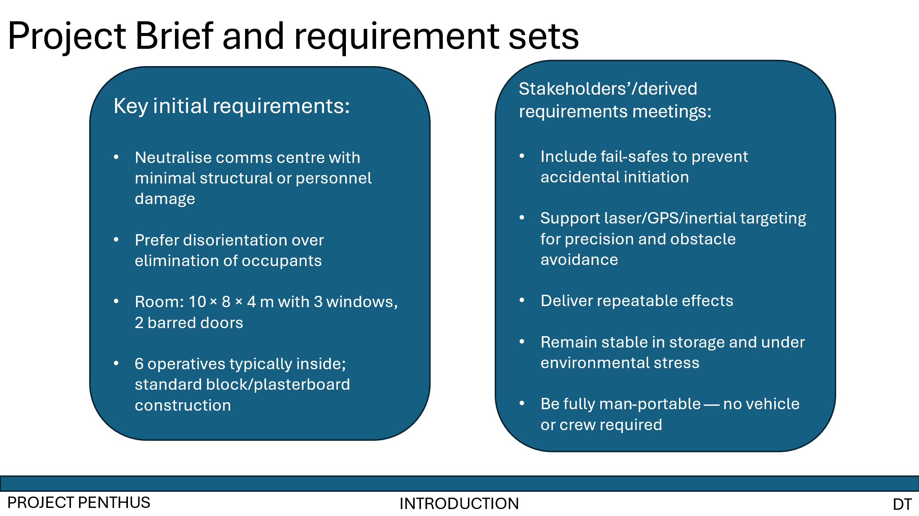
Annex 1 - Slide 1
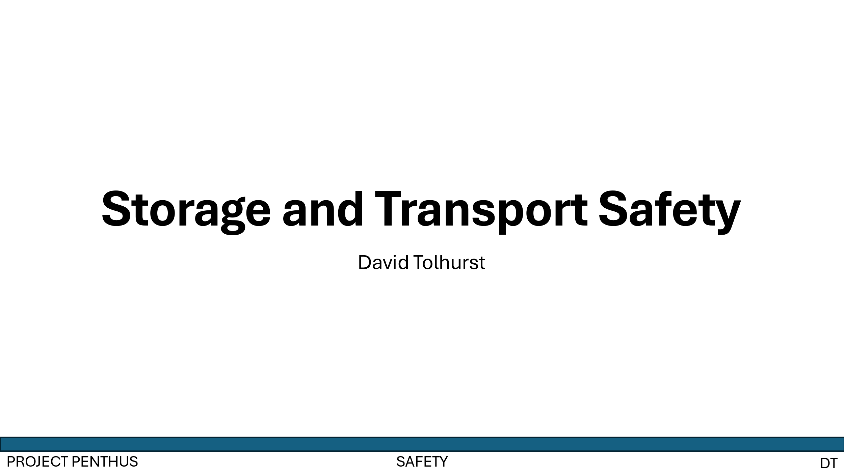
Annex 2 - Slide 2
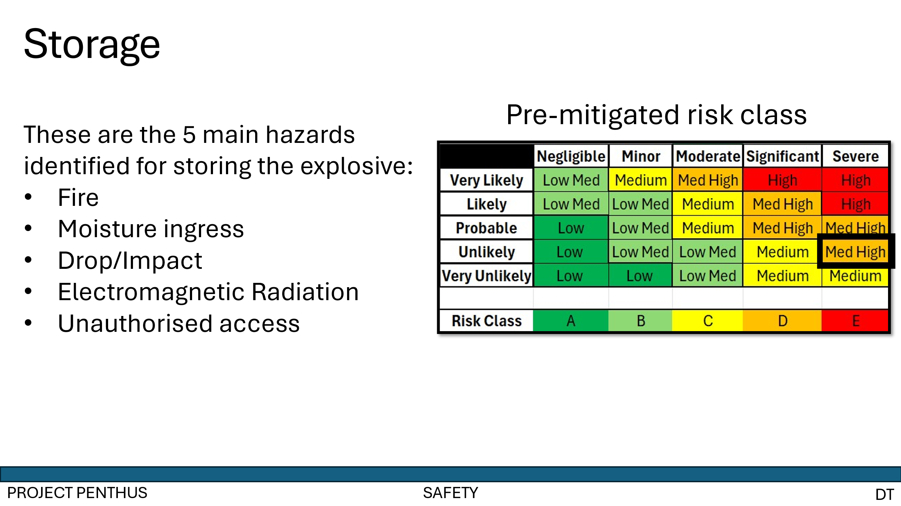
Annex 3 - Slide 3
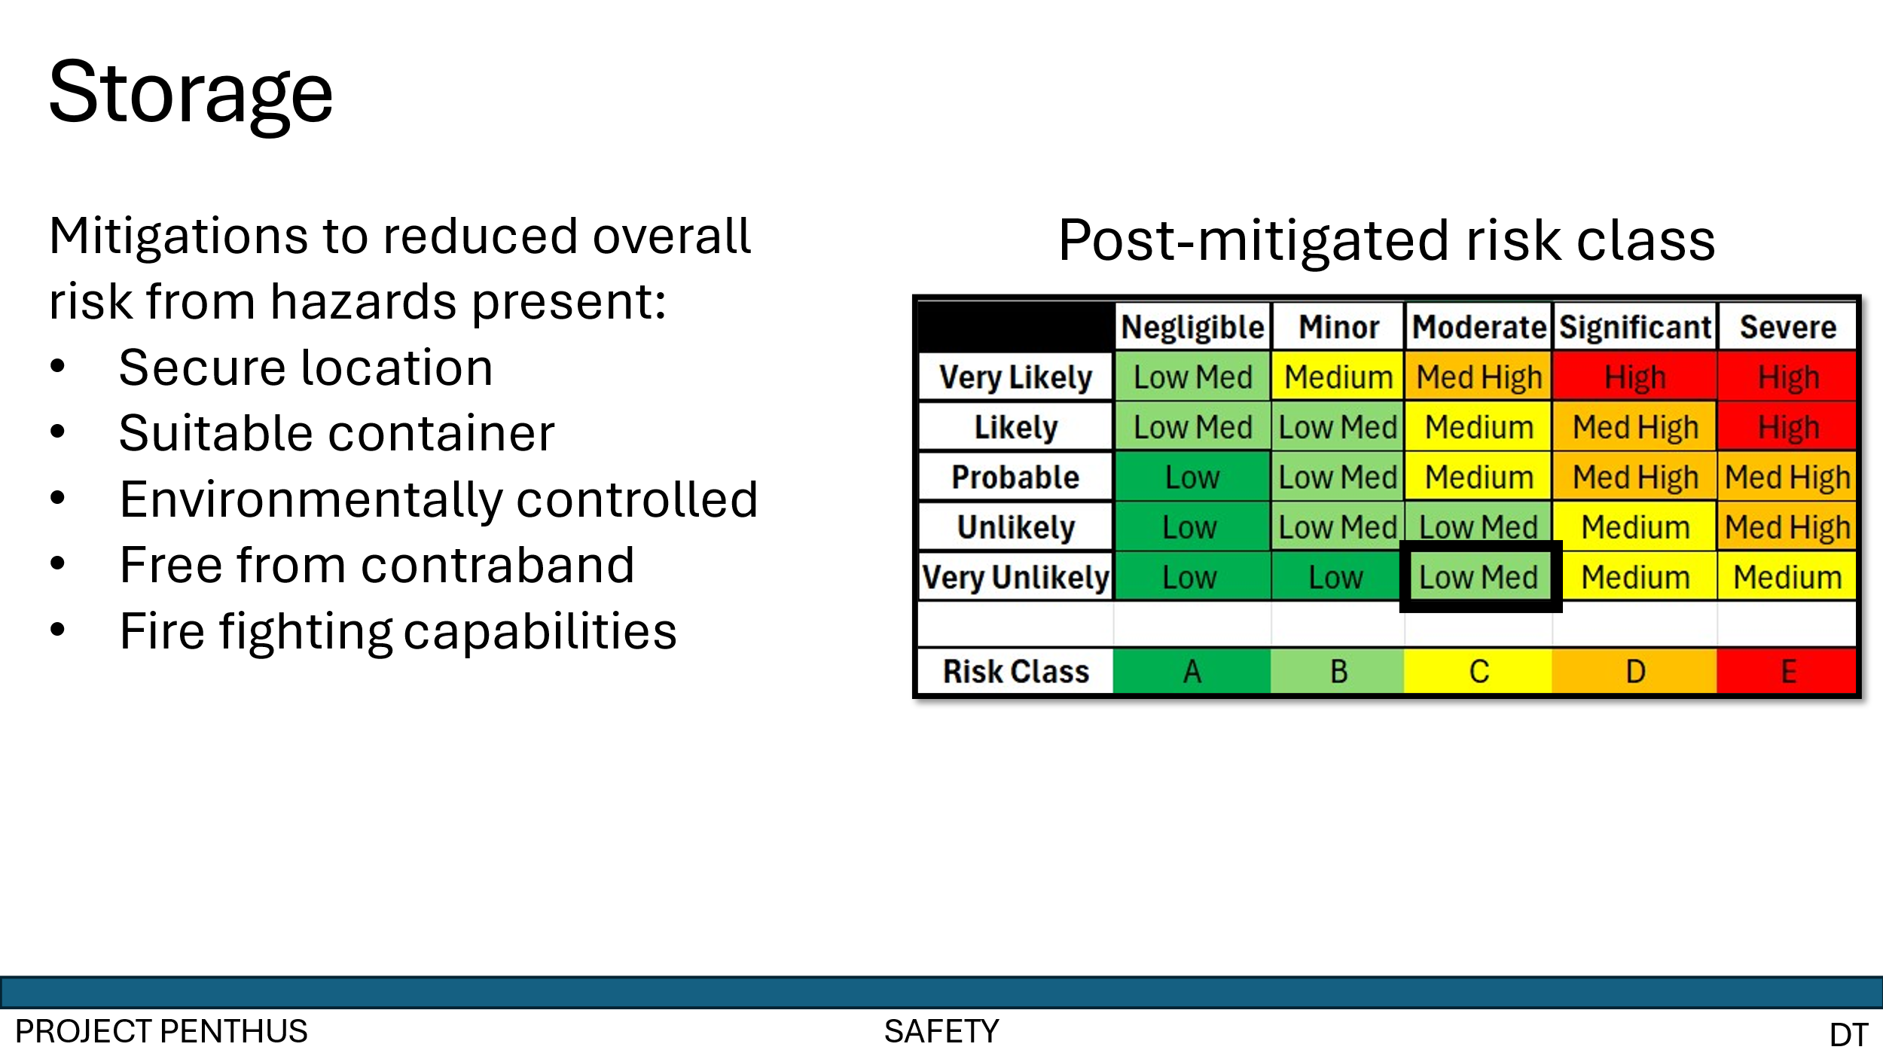
Annex 4 - Slide 4
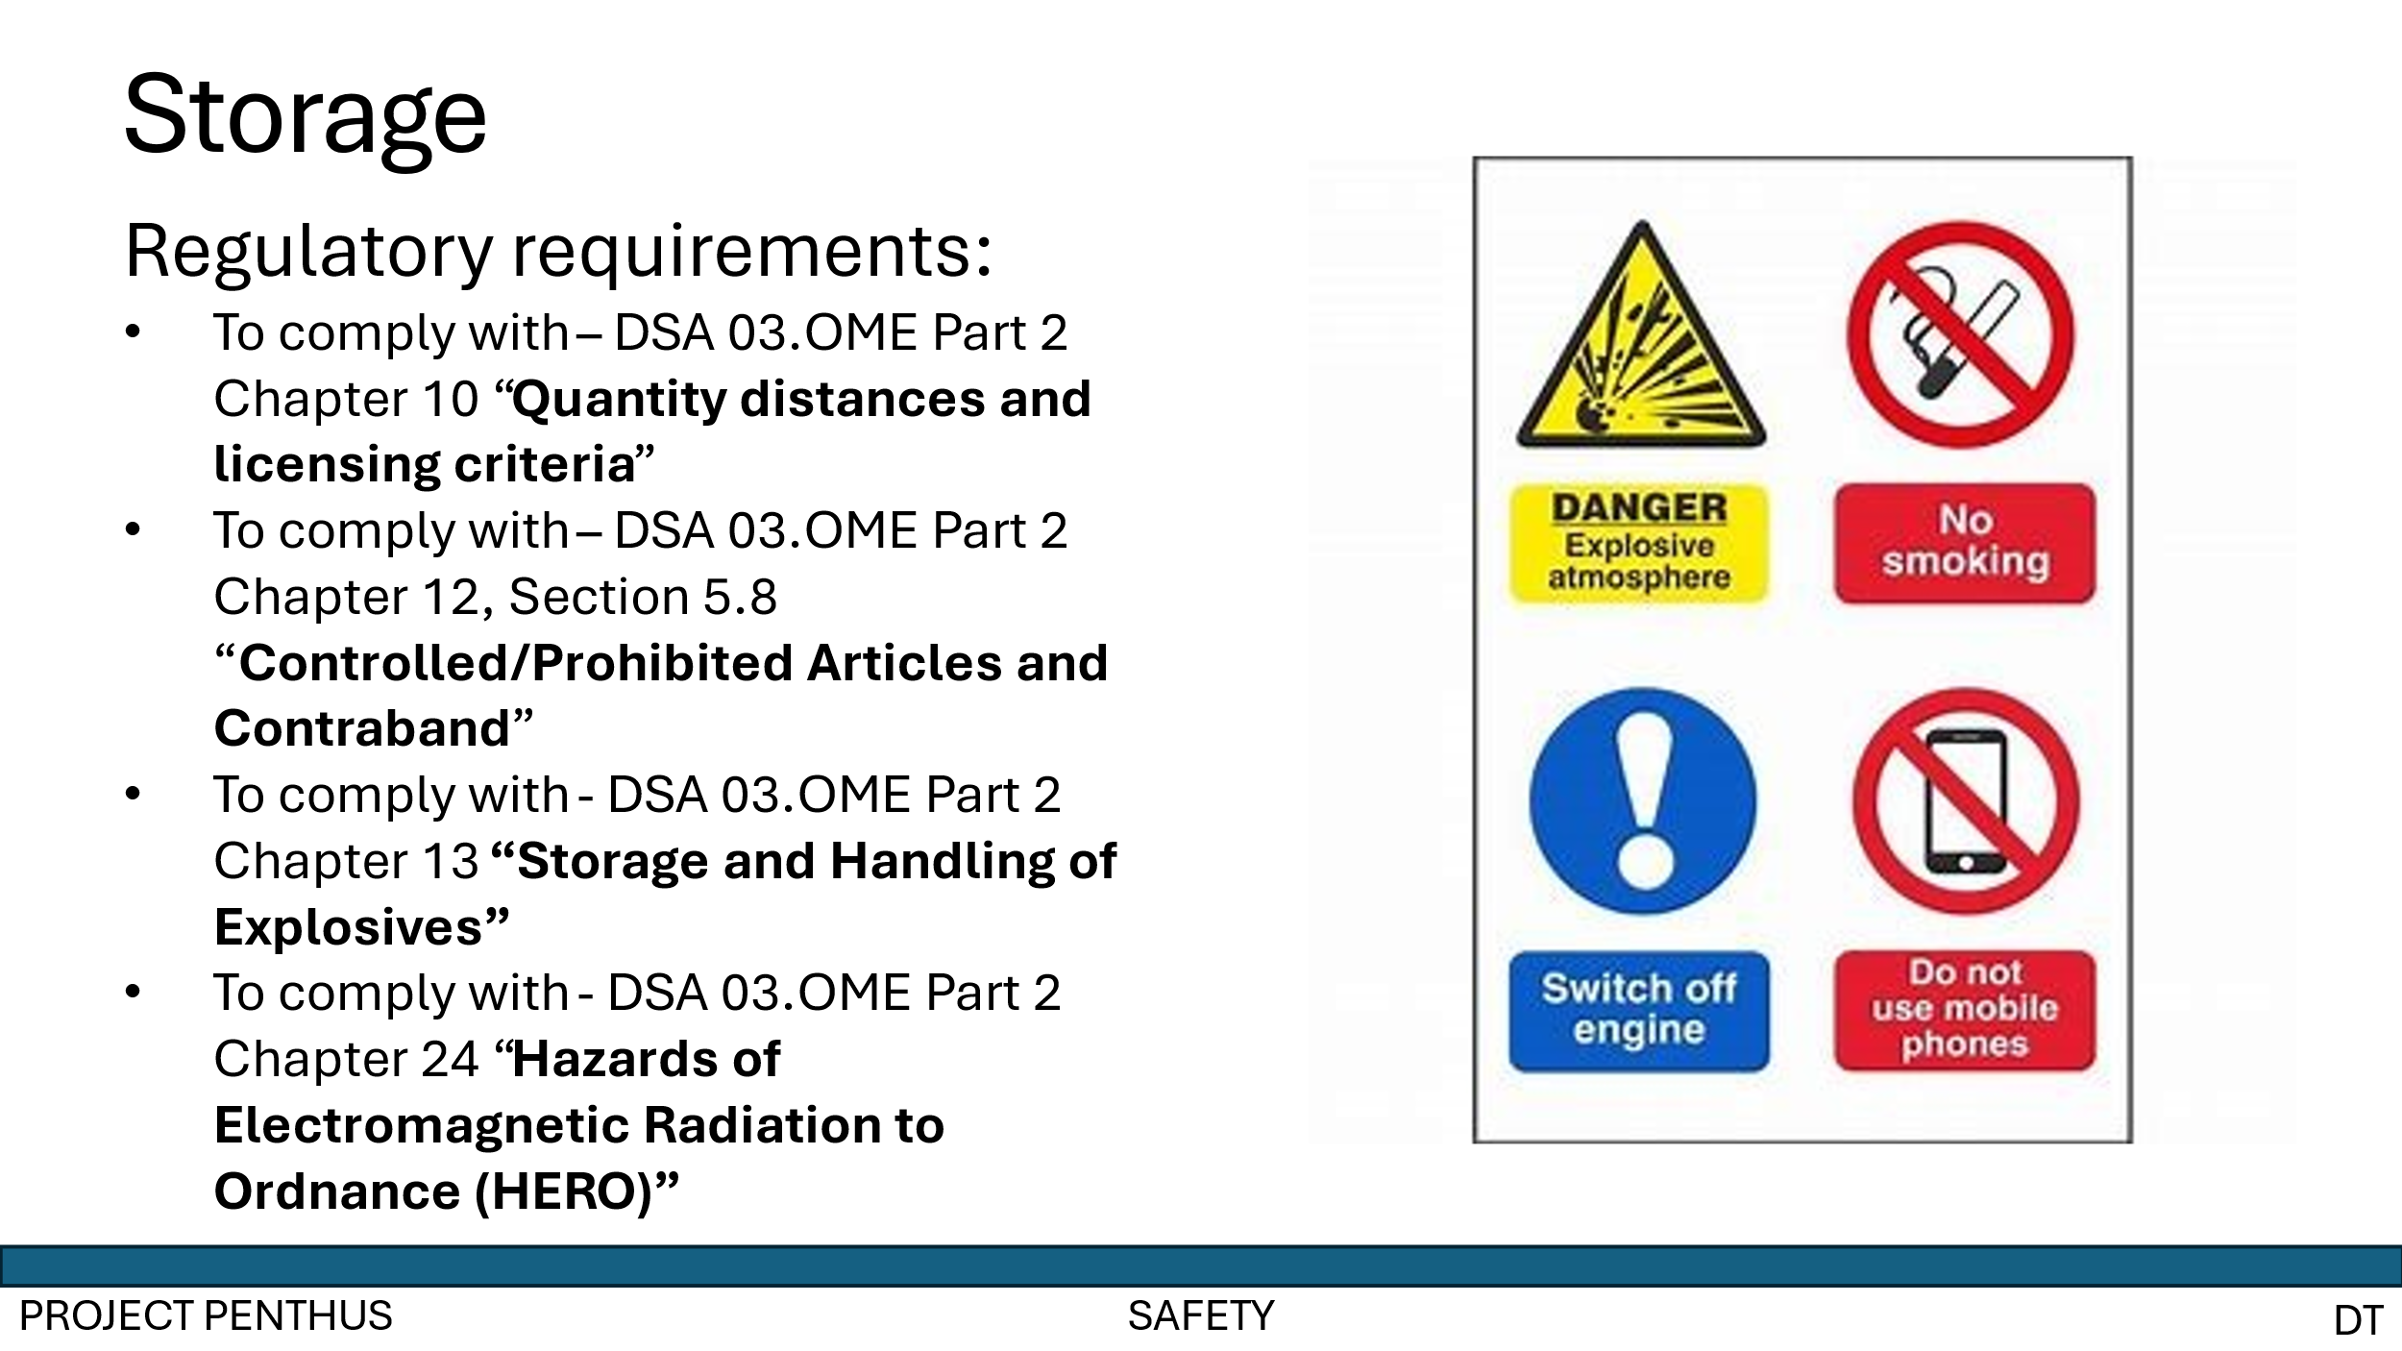
Annex 5 - Slide 5
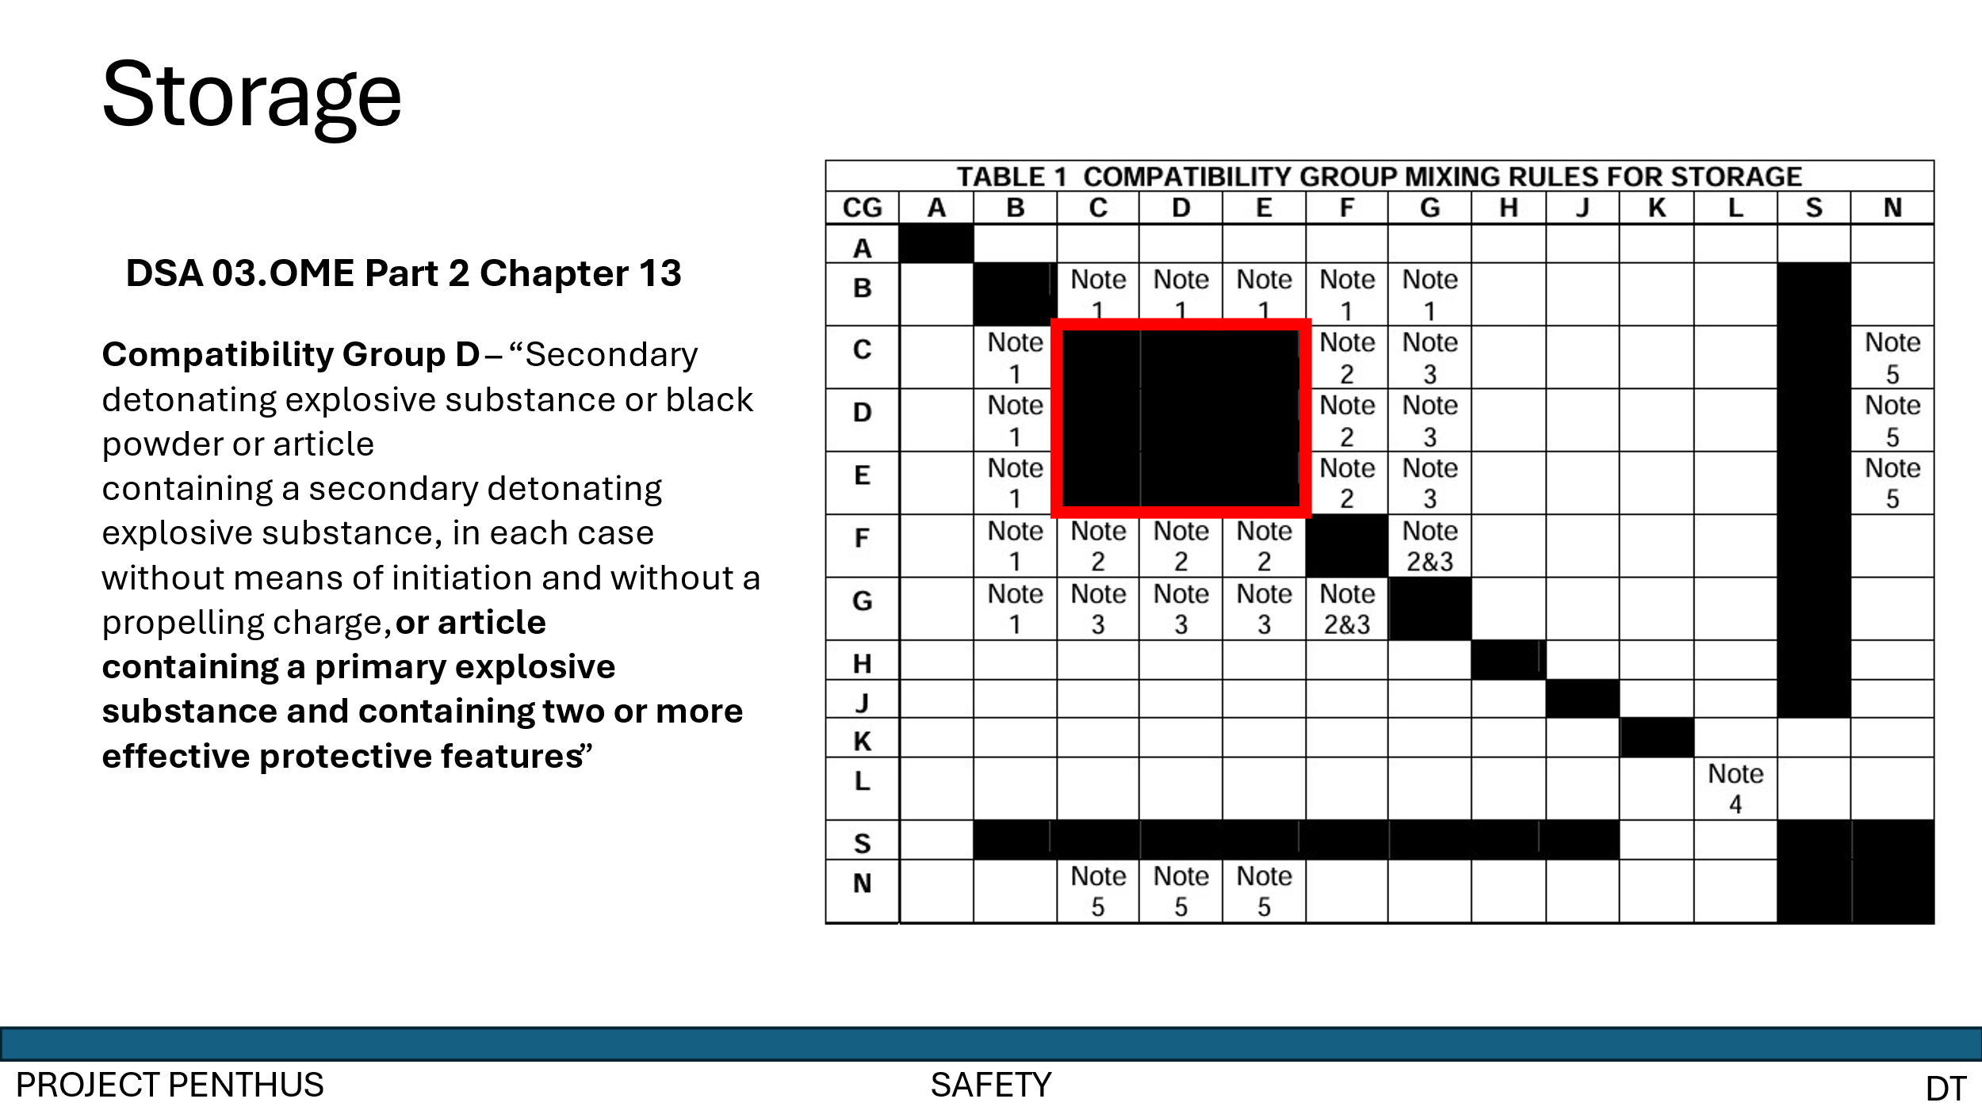
Annex 6 - Slide 6
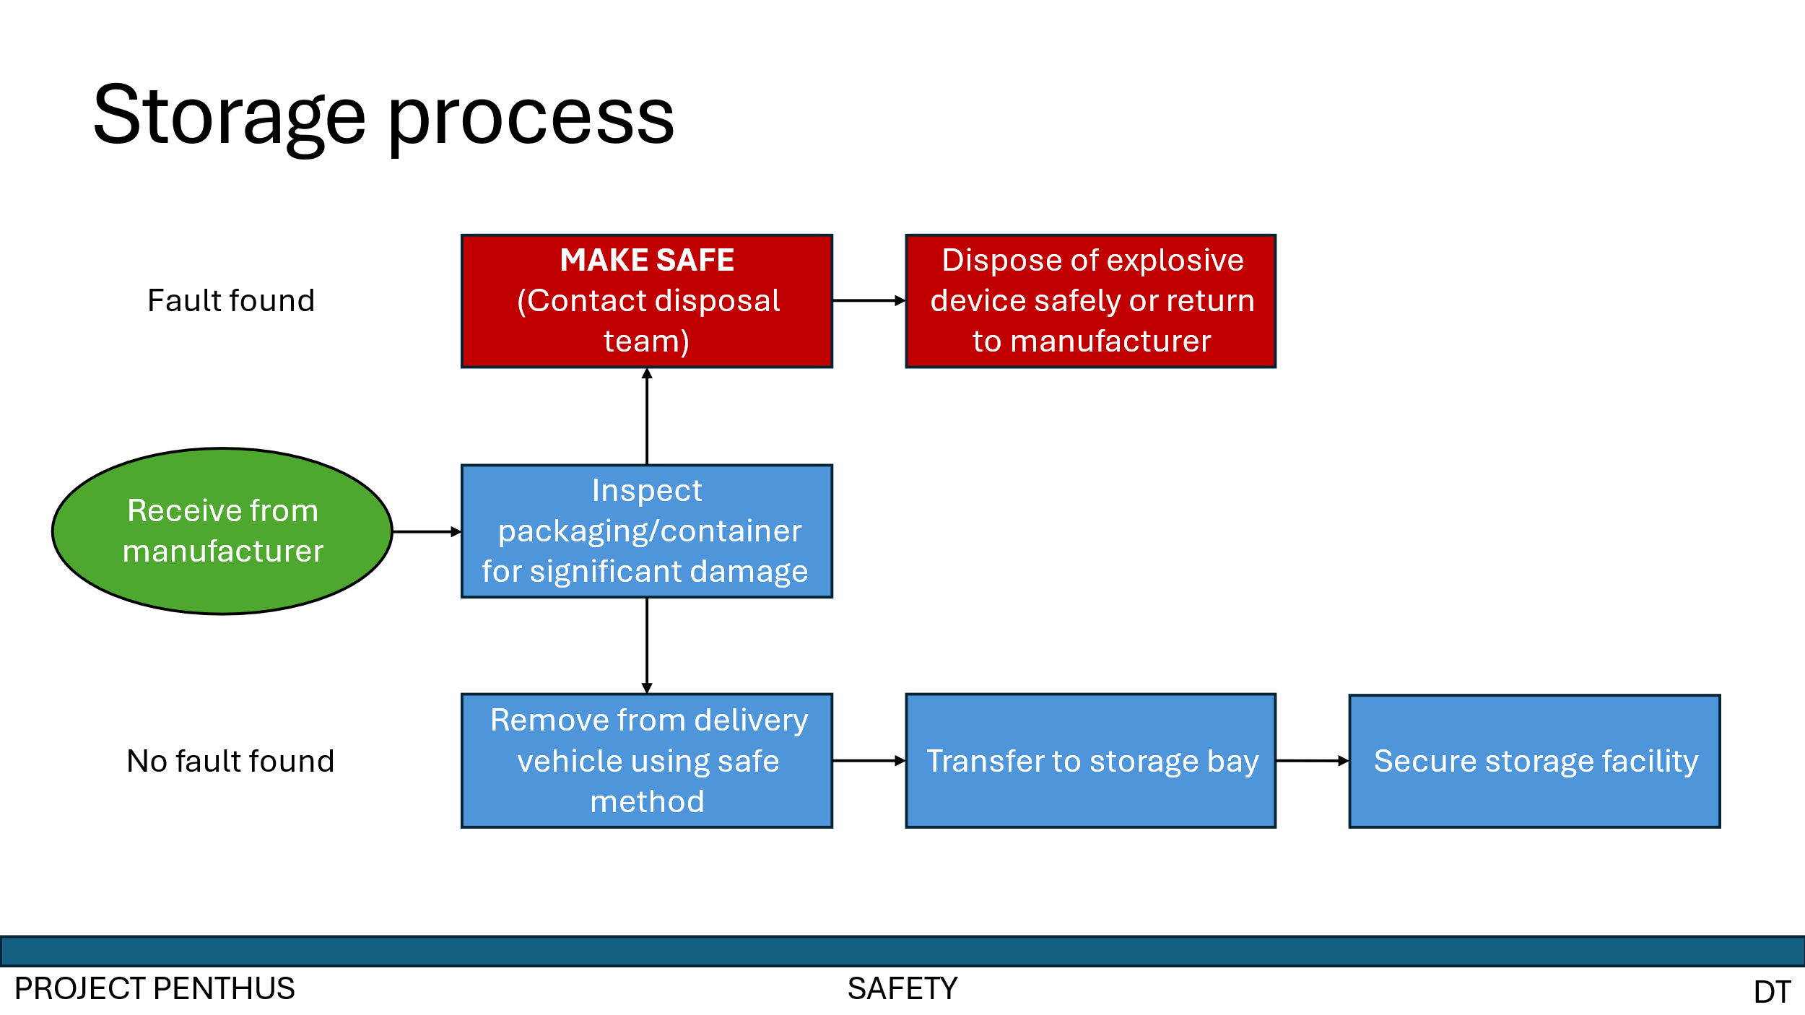
Annex 7 - Slide 7
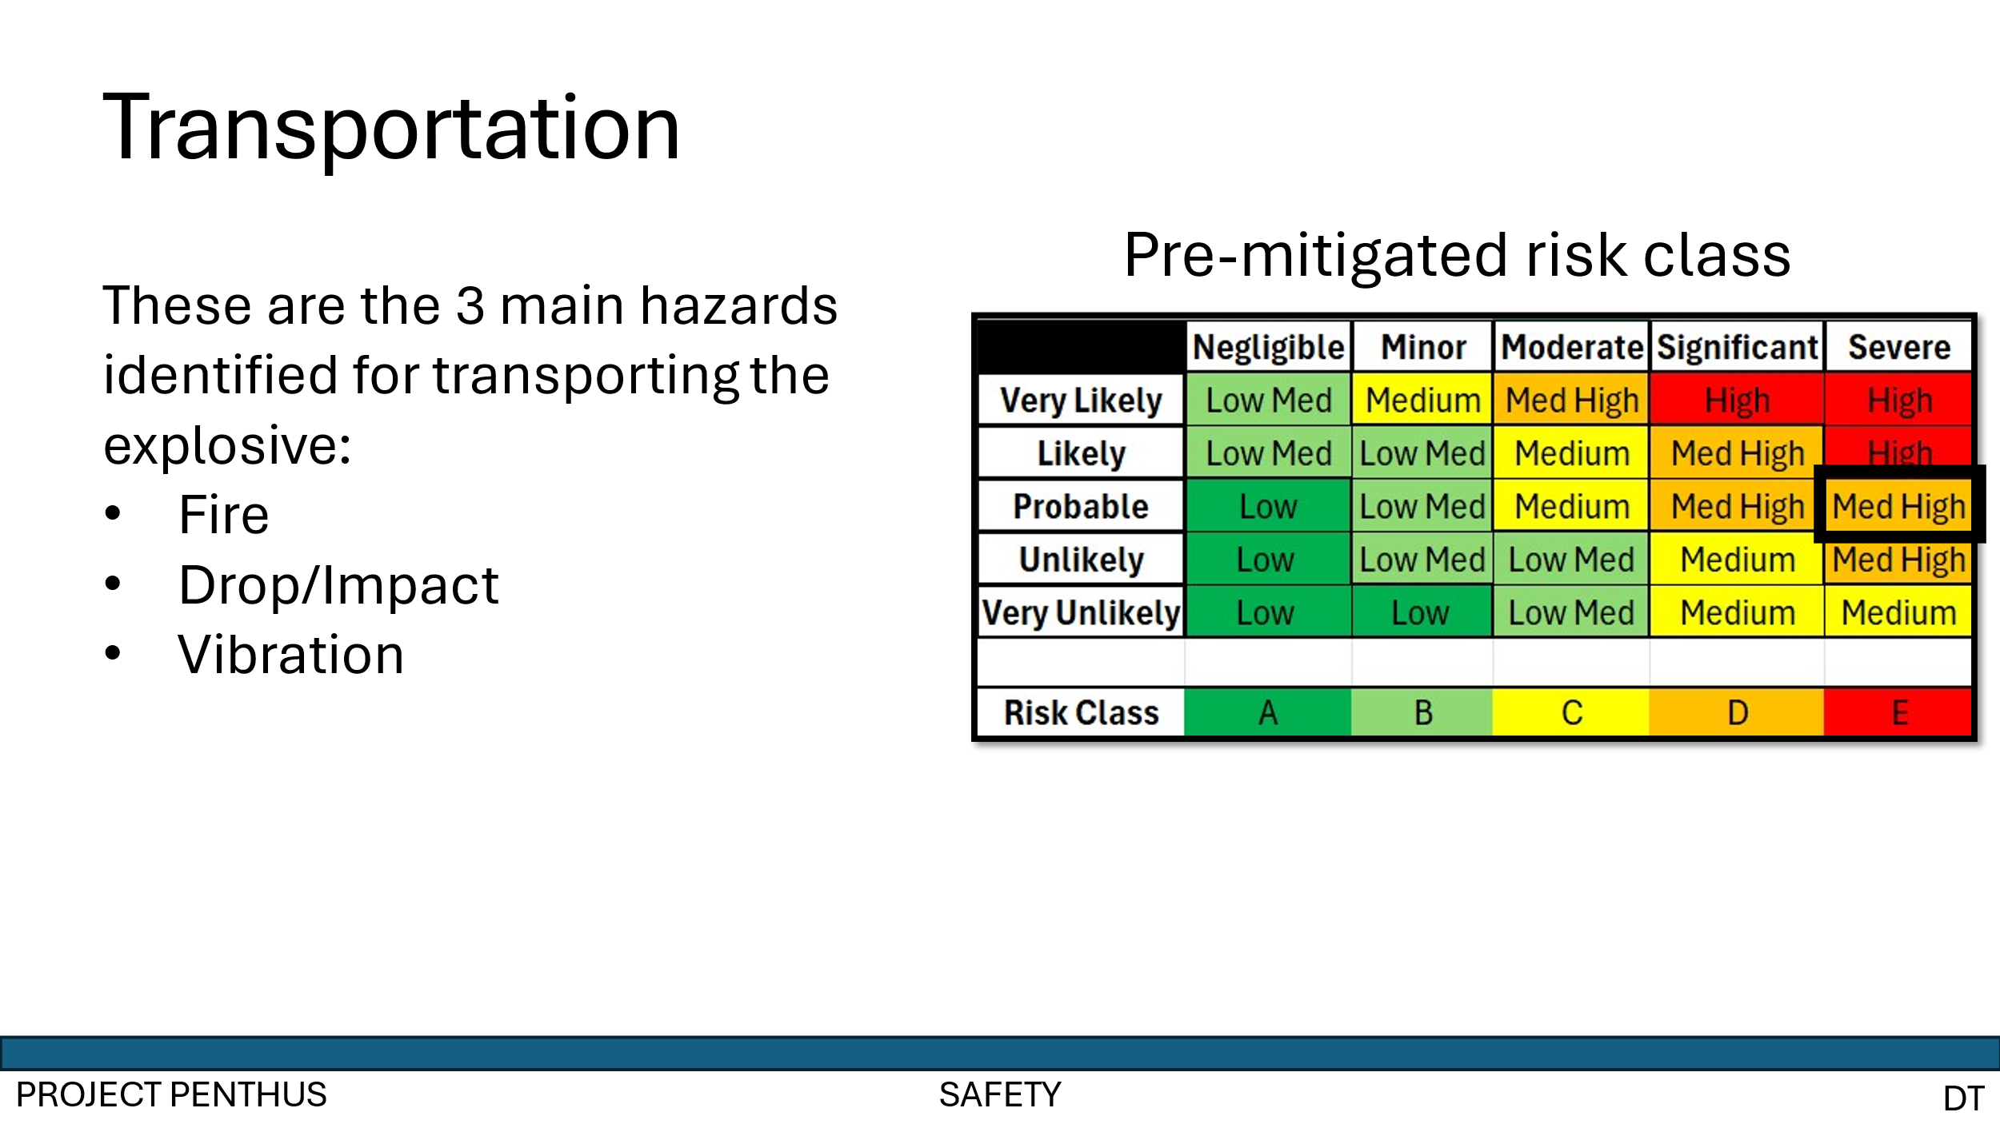
Annex 8 - Slide 8
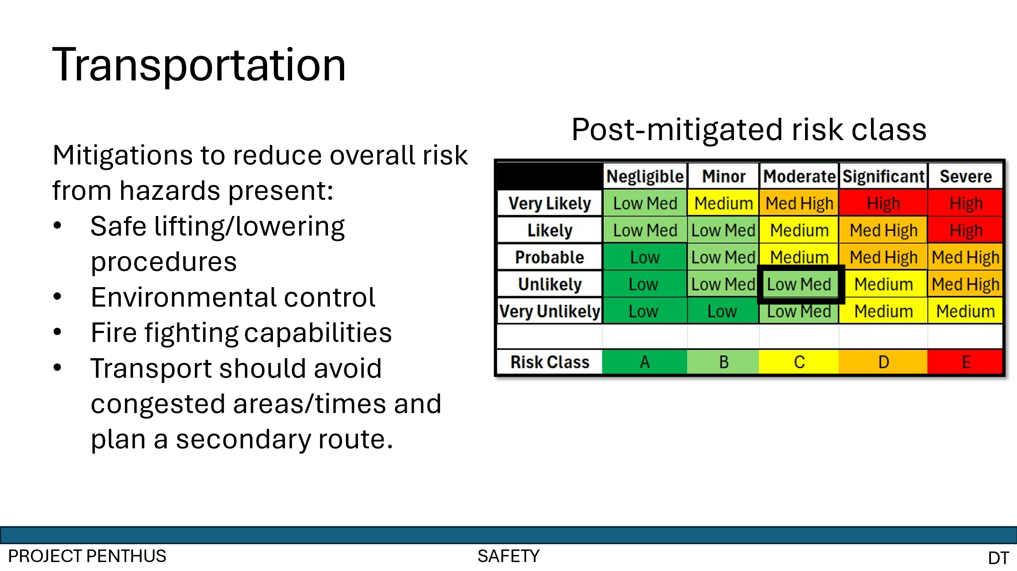
Annex 9 - Slide 9
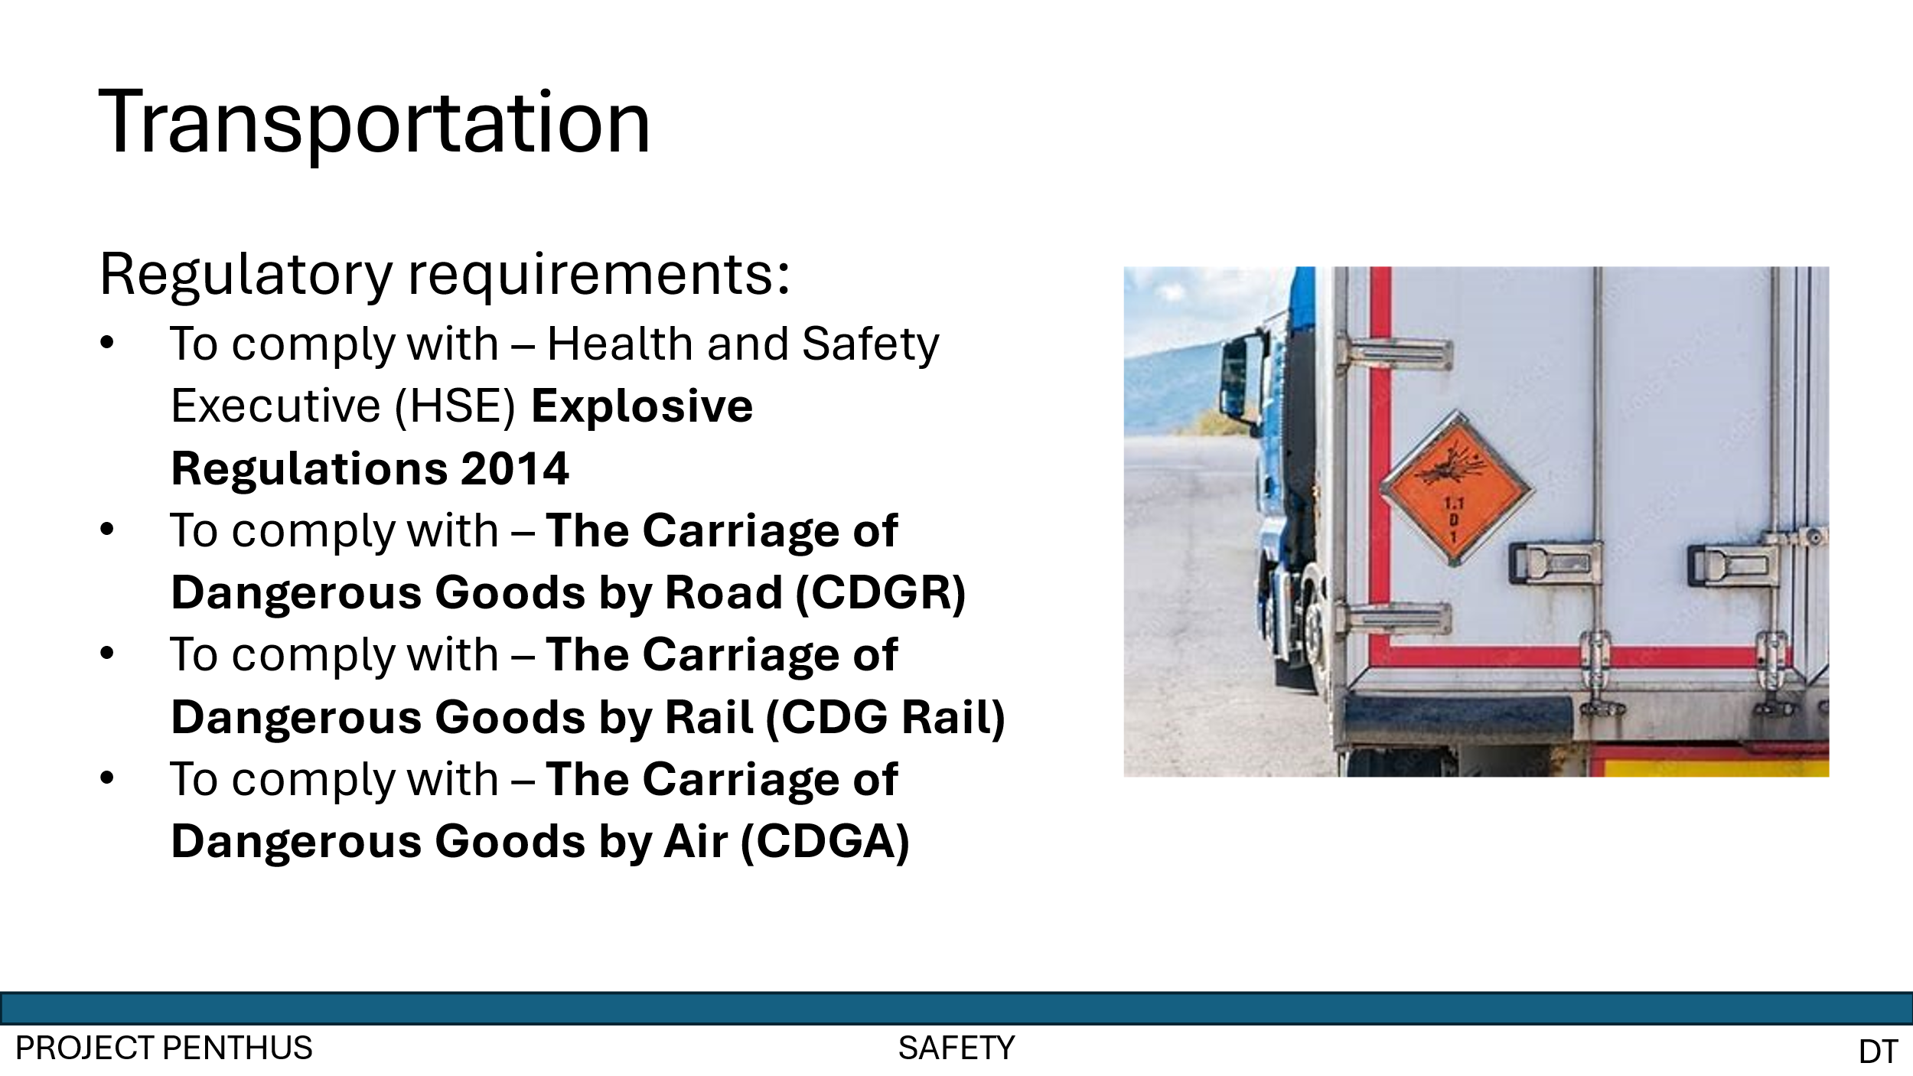
Annex 10 - Slide 10
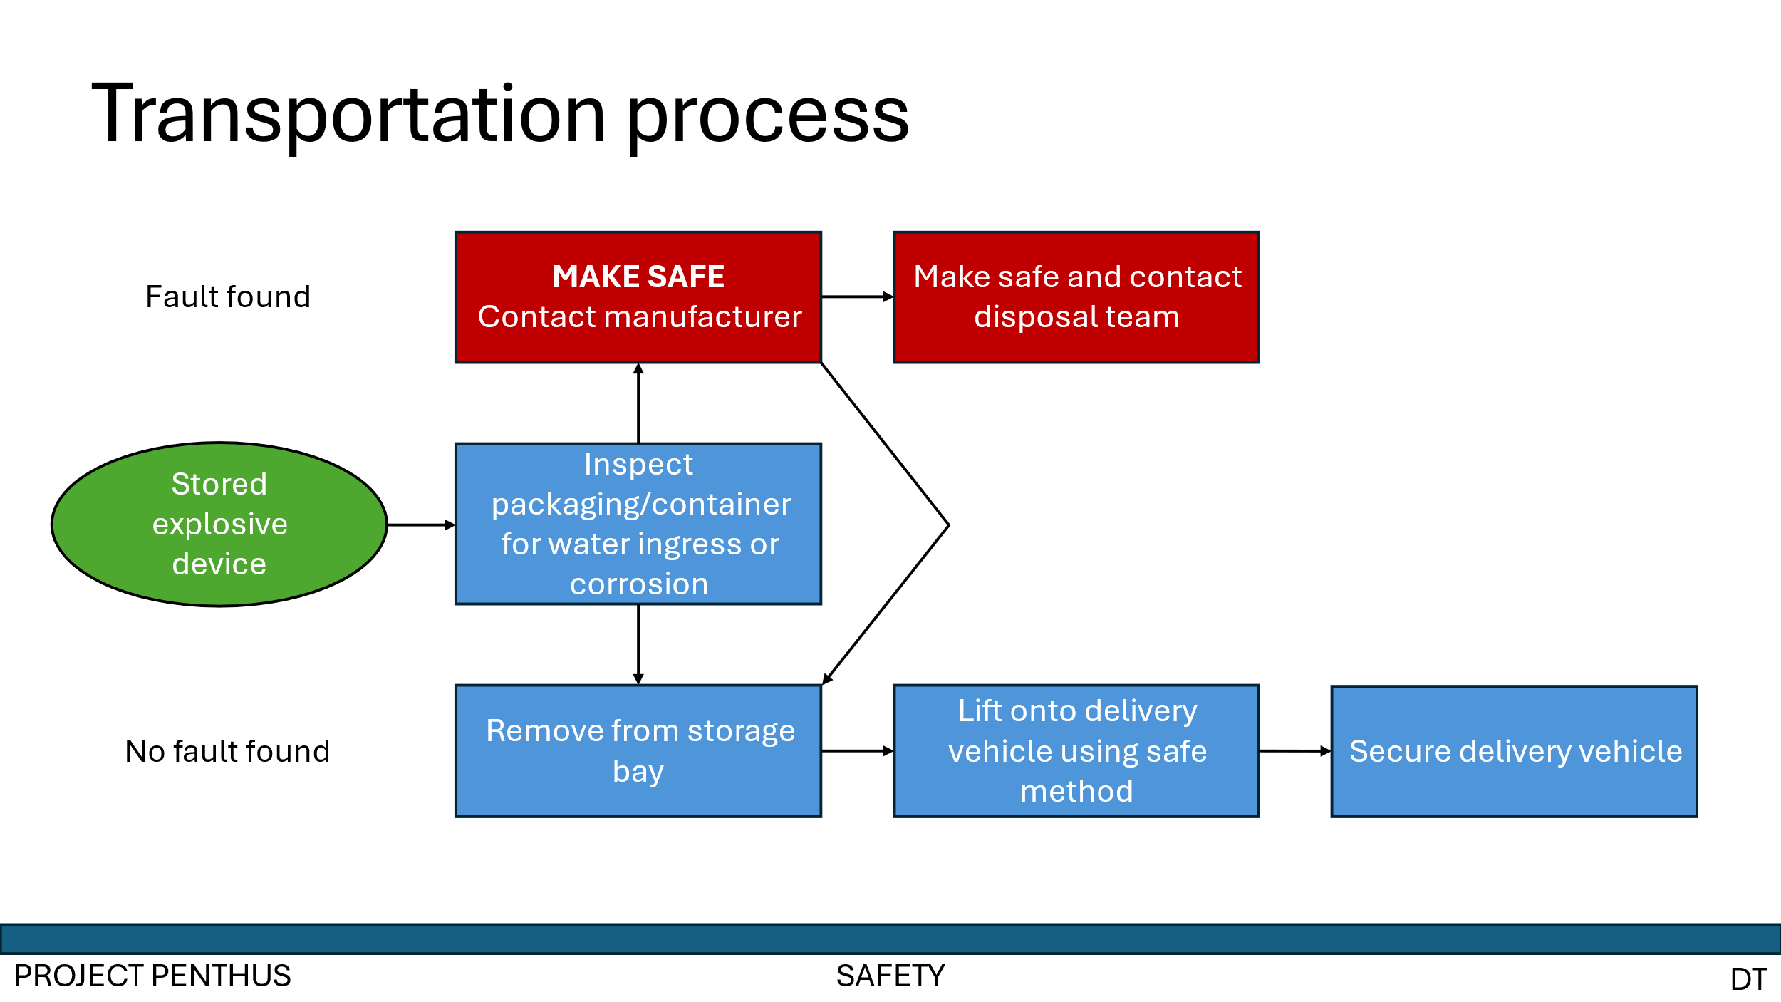
Annex 11 - Slide 11

