Hotel standards, reputation management and service culture

Student name: Rosario del Rocio Garcia Baez

Student ID: 2230623

Hospitality & Guest Services BMIH4003

Tutor leader: Charlotte Joyner

Date: June 12, 2023

Word count: 1643

Executive Summary
This report delves into three key areas of the hotel industry: hotel standards, reputation management, and service culture. It explores the purpose of brand consistency standards, highlighting their role in maintaining a strong and recognizable brand image. The report also examines the variation in standards among hotels and whether all hotels adhere to the same guidelines.

The report further addresses reputation management, providing insights into effective strategies for hotels to manage their reputation. It emphasizes the importance of guest reviews and their impact on a hotel's reputation, while also discussing the significance of managing negative reviews promptly and professionally.

In addition, the report explores service culture and its distinction from corporate culture. It emphasizes the importance of service culture in the hotel industry, highlighting its role in delivering exceptional customer service, fostering guest satisfaction, and creating a competitive advantage.

Lastly, the report offers recommendations for hotels in navigating market trends. It suggests staying updated, adapting to changing demands, embracing technology, enhancing online presence, prioritizing health, and safety, fostering guest engagement, and collaborating with local businesses. The report also acknowledges obstacles that businesses may face, including competition, economic factors, shifting consumer expectations, staffing challenges, and technology implementation hurdles.

By implementing the provided recommendations and addressing the identified obstacles, hotels can position themselves for success, enhance their reputation, and cultivate a strong service culture that drives guest satisfaction and loyalty.

Table of contain.

Introduction……………………………………………………………………………..4

Hotel Standards…………………………………………………………….................4
- What is the purpose of brand consistency standards?..............................4
- Do all hotels have the same standards?....................................................5

Reputation Management………………………………………………………………6
- How can hotels manage their reputation effectively?.................................7
- What is the importance of effective guest reviews management?.............10
- What is the impact of negative review?......................................................11

Service culture…………………………………………………………………………..11
- How does this differ from corporate culture?..............................................12
- Why is this important in the hotel industry?................................................12

Recommendations……………………………………………………………………...12

References……………………………………………………………………13, 14, 15, 16

Introduction
In the competitive world of hospitality, hotel standards, reputation management, and service culture play crucial roles in attracting and retaining guests. A hotel's success is not solely determined by its physical infrastructure or luxurious amenities but also by the intangible aspects that create a memorable and satisfying experience for its guests. This report aims to examine the crucial components of hotel standards, reputation management, and service culture within the hospitality industry.

Hotel standards
Hotel standards refer to the set of guidelines and practices that define the quality and consistency of services provided by a hotel. These standards encompass various aspects, such as cleanliness, comfort, safety, efficiency, and customer service. Establishing and maintaining high hotel standards is essential to meet and exceed guest expectations, thereby fostering positive reviews, customer loyalty, and increased revenue. (Torres, 2013).

- What is the purpose of brand consistency standards?

The purpose of brand consistency standards in the hotel industry is to establish and maintain a cohesive and recognizable brand identity across all touchpoints and interactions with customers. Brand consistency standards serve as a set of guidelines that ensure the brand's values, messaging, visual elements, and overall experience are consistently delivered to guests. (Rockcontent, 2020).

One of the key reasons for implementing brand consistency standards is to build brand recognition and recall. By presenting a consistent brand image, hotels can create a strong and memorable identity in the minds of customers. This consistency helps guests easily recognize the brand, distinguish it from competitors, and recall positive experiences they may have had in the past. Consistency also fosters trust and reliability, as guests come to expect a certain level of quality and service associated with the brand. (Linkedin, n.d).

Brand consistency standards also contribute to establishing a sense of professionalism and credibility. When all aspects of the hotel's communication, design, and service align with the brand's values and promises, it conveys a cohesive and well-managed operation. This consistency helps build trust among guests, as they perceive the hotel as reliable and dedicated to delivering a consistent experience.

Moreover, brand consistency standards help maintain customer loyalty. Guests who have had positive experiences with a hotel are more likely to return if they can rely on consistently excellent service, amenities, and overall experience. Consistency creates a sense of familiarity and comfort, encouraging guests to choose the brand for their future stays and recommend it to others. (Radley, 2023).

- Do all hotels have the same standards?

No, not all hotels have the same standards. Hotel standards can vary significantly depending on factors such as the hotel's star rating, target market, location, and brand positioning. Different hotels may have different standards in terms of amenities, service levels, cleanliness, safety protocols, and overall guest experience. (Ballina, 2016).

Here are a few examples to illustrate the variation in hotel standards:

The Ritz-Carlton: Known for its luxurious accommodations and exceptional service, The Ritz-Carlton brand sets high standards for its properties worldwide. Guests can expect elegant room designs, premium amenities, personalized service, fine dining options, and attention to detail in every aspect of their stay.
(The Ritz Carton, n.d).

Holiday Inn Express: As a brand that targets budget-conscious travellers, Holiday Inn Express maintains standards that cater to affordability without compromising on quality. Guests can expect clean and comfortable rooms, a complimentary breakfast buffet, efficient service, and amenities such as a fitness center and business center. (Holiday Inn, n.d).

W Hotels: W Hotels is a boutique luxury brand that focuses on offering a unique and vibrant guest experience. Standards for W Hotels often include stylish and contemporary room designs, trendy bars and restaurants, immersive social spaces, and a lively atmosphere that appeals to a younger, more design-conscious demographic. (W Hotels, n.d).

Marriott Hotels: As a prominent hotel chain, Marriott Hotels has established brand standards that prioritize consistency and quality across its properties. Guests can expect comfortable and well-appointed rooms, a range of amenities such as fitness centers and swimming pools, various dining options, and a reliable level of service that aligns with the Marriott brand. (Marriott Hotel, n.d).

Four Seasons: Known for its impeccable service and attention to detail, Four Seasons hotels uphold high standards across their global properties. Guests can anticipate luxurious accommodations, personalized service tailored to their preferences, exquisite dining experiences, extensive wellness facilities, and a commitment to providing a flawless guest experience. (Four Seasons, n.d).

These examples illustrate how different hotel brands have distinct standards and offerings to cater to various market segments and guest preferences. Each brand strives to differentiate itself through its unique positioning, service culture, and guest experience, providing a range of options for travellers with different needs and preferences.

Reputation Management
Reputation management refers to the practice of monitoring, influencing, and maintaining the perception and reputation of a business, organization, or individual. In the context of the hotel industry, reputation management involves actively managing and shaping the online reputation of a hotel by monitoring and responding to guest reviews, feedback, and mentions on various online platforms and social media channels. (Martin-Rios, 2018).
- How can hotels manage their reputation effectively?

Monitor Online Presence: Hotels should actively monitor online platforms, review websites, and social media channels to stay informed about guest reviews, feedback, and mentions. This includes using tools and software that can help track online mentions and set up alerts for new reviews or comments. (Moon, 2022).

Respond Promptly and Professionally: It is crucial for hotels to respond promptly to guest reviews and feedback, whether positive or negative. Timely responses demonstrate attentiveness and a commitment to guest satisfaction. Hotels should provide personalized and professional responses, addressing specific concerns and expressing appreciation for positive feedback. (Lo, 2019).

Here is an example of a review in which we can see a standard and non-personalized response about a similar problem in the two reviews and where nothing is offered to the customer.
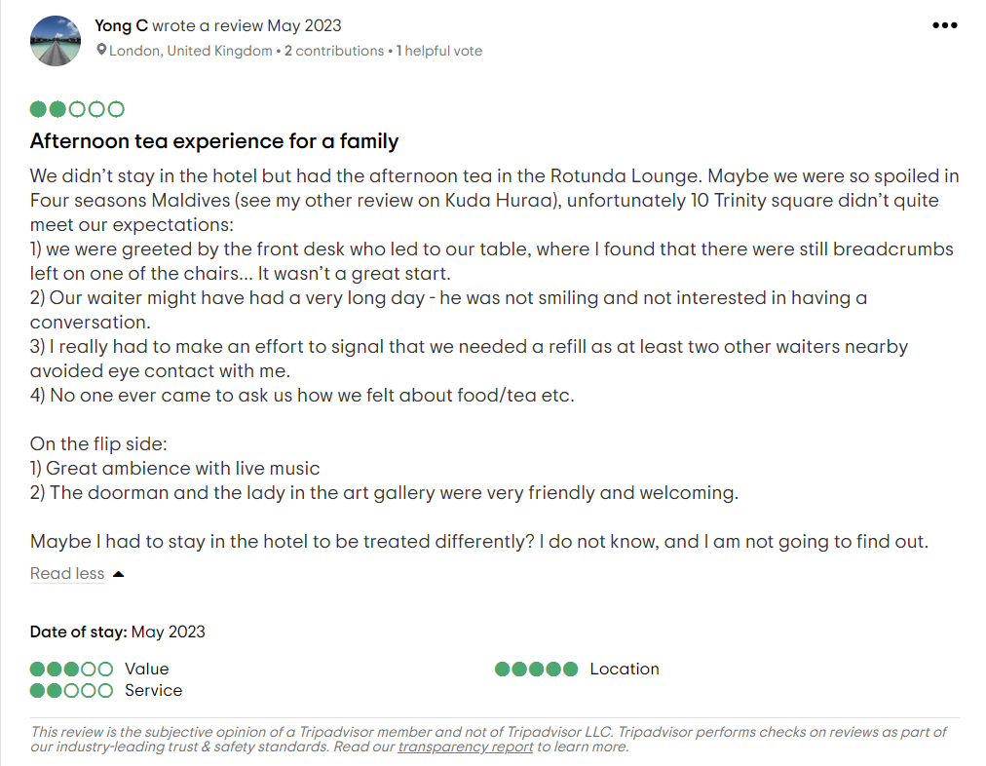
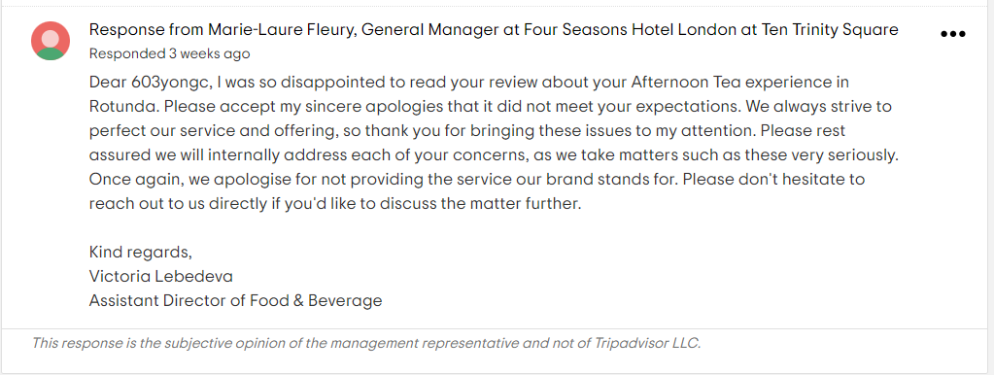

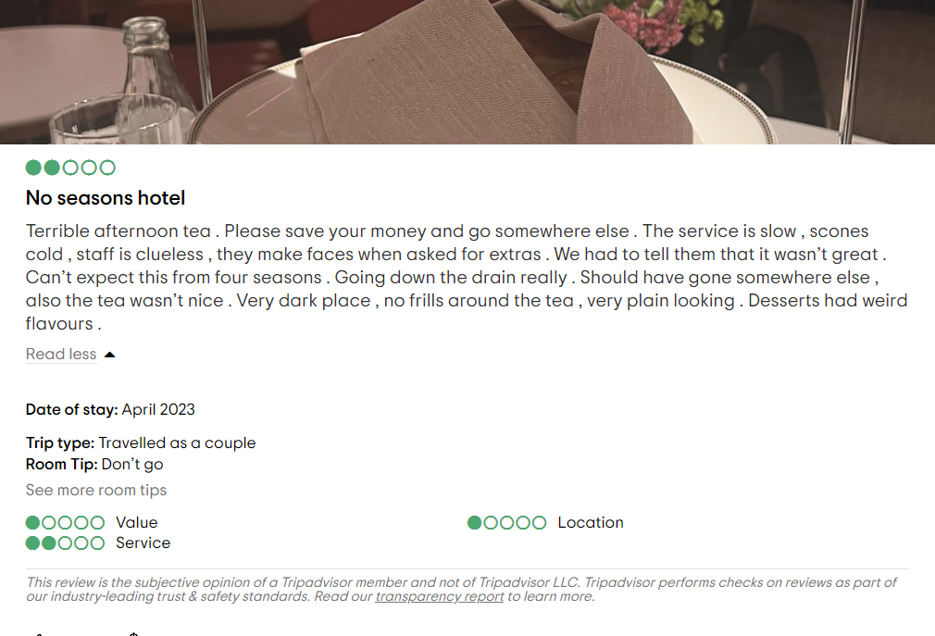
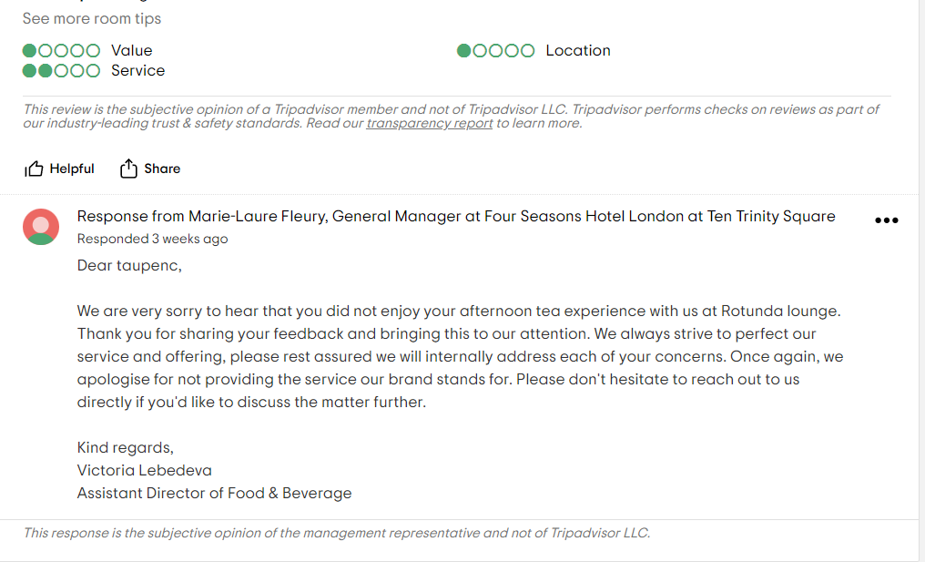
(TripAdvisor, n.d)

Train and Empower Staff: Hotel staff should be trained to handle guest interactions with care and professionalism. They should be empowered to address guest concerns and resolve issues in real-time, minimizing the likelihood of negative feedback. (Ford, 2020).

Take Action on Feedback: Hotels should view guest feedback as an opportunity for improvement. By taking constructive feedback seriously and implementing necessary changes, hotels can demonstrate their commitment to guest satisfaction. Regularly reviewing guest feedback and identifying common issues or trends can help hotels make informed decisions and enhance their services. (Mount, 2005).

Here is an example of a bad review taken on time and where a solution has been offered to the guest while he was still in the Hotel.
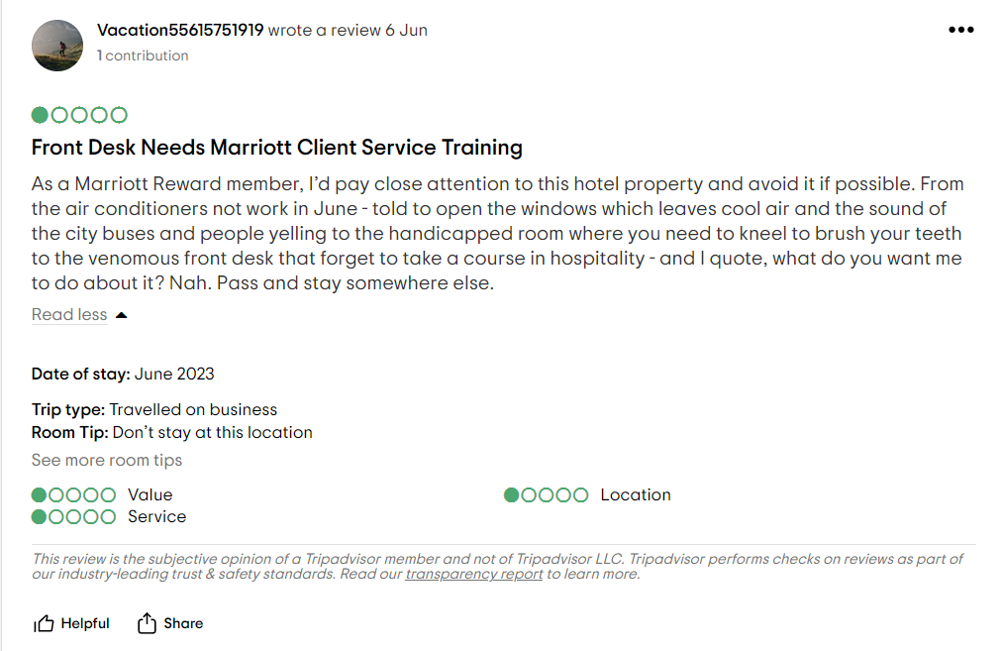

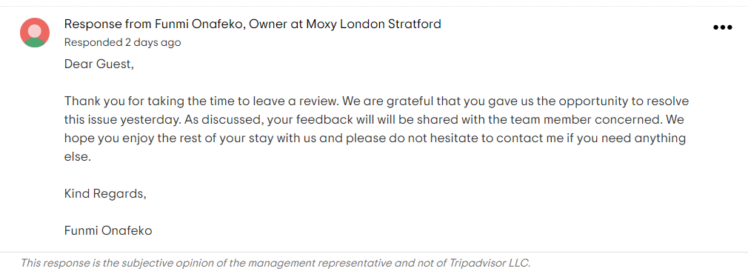
(TripAdvisor, n.d)

- What is the importance of effective guest reviews management?

This is vital for hotels as it impacts their reputation, influences booking decisions, and drives continuous improvement. Guest reviews serve as a trusted source of information for potential guests, helping them make informed decisions about where to stay. Positive reviews can attract new customers and build trust, while negative reviews can deter bookings. By actively managing guest reviews, hotels can shape their online reputation, address concerns, and showcase their commitment to guest satisfaction. Moreover, guest reviews provide valuable feedback that helps hotels identify areas for improvement, enhance services, and deliver exceptional experiences. Engaging with guest reviews demonstrates personalized service and fosters guest loyalty. By responding promptly and professionally, hotels can build a positive rapport with guests and turn them into brand advocates. (Nielsen, M. 2022).

- What is the impact of negative review?

Negative reviews can have a significant impact on a hotel's reputation and business. They can deter potential customers from booking, resulting in a loss of revenue. Negative reviews also damage the hotel's credibility and trustworthiness. Additionally, they highlight areas for improvement and may require immediate attention to rectify issues. Ignoring or mishandling negative reviews can further harm the hotel's reputation. Thus, it is crucial for hotels to address negative reviews promptly and effectively to mitigate their impact and demonstrate a commitment to guest satisfaction. (Book, 2016).

Service culture
Service culture refers to the values, attitudes, and behaviours within an organization that prioritize exceptional customer service. It encompasses the shared beliefs, norms, and practices that guide employees in consistently delivering outstanding service to customers. A strong service culture fosters a customer-centric mindset, empowers employees to exceed customer expectations, and ensures service excellence is embedded in all aspects of the organization's operations. (Lotardo, 2018).

- How does this differ from corporate culture?

While service culture and corporate culture are related, they have distinct focuses. Corporate culture encompasses the overall values, beliefs, and behaviours that shape the organization as a whole. It includes elements such as leadership styles, communication practices, and decision-making processes. Service culture, on the other hand, specifically emphasizes customer service and creating a customer-centric environment. It highlights the organization's dedication to delivering exceptional service, empowering employees to meet customer needs, and fostering a service-oriented mindset throughout the organization. (Tarver, 2023).

- Why is this important in the hotel industry?

Service culture is crucial in the hotel industry as it directly impacts guest satisfaction, loyalty, and the overall success of a hotel. In a highly competitive market, hotels that prioritize exceptional service create a distinct competitive advantage. A strong service culture enhances guest experiences, drives positive reviews and recommendations, and fosters guest loyalty. It also boosts employee morale and engagement, leading to higher productivity and better service delivery. Ultimately, a strong service culture contributes to the financial performance and long-term sustainability of a hotel. (Toister, 2022).

Recommendations
For hotels regarding market trends, it is recommended to stay updated, adapt to changing demands, embrace technology, enhance online presence, emphasize health and safety, enhance guest engagement, and collaborate with local businesses. Obstacles facing certain businesses include a competitive landscape, economic factors, changing consumer expectations, staffing challenges, and technology implementation hurdles. Overcoming these obstacles requires differentiation, strategic planning, adaptability, investment in employee training, and effective utilization of resources and partnerships.
References
- Ballina Ballina, F.J. de la and Valdés Peláez, L. (2016) ‘The effects of the combination of quality standards on company results in the hotel sector’, Universia business review, (52), pp. 198–221. Available at: https://doi.org/10.3232/UBR.2016.V13.N4.05.

- Book, L.A., Tanford, S. and Chen, Y.-S. (2016) ‘Understanding the Impact of Negative and Positive Traveler Reviews: Social Influence and Price Anchoring Effects’, Journal of travel research, 55(8), pp. 993–1007. Available at: https://doi.org/10.1177/0047287515606810.

- Ford, R.C. (Robert C., Sturman, M.C. and Sturman, M.C. (Michael C. (2020) Managing hospitality organizations : achieving excellence in the guest experience. Second edition. Thousand Oaks, California: SAGE Publications, Inc.

- Four Seasons (n.d) Discover Four Seasons. Available at: http://www.FourSeasons.com (Accessed 10 June 2023).

- Holiday Inn (n.d) Available at: https://www.holidayInn.com (Accessed 10 June 2023).

- Linkedin (n.d) The Role of Brand Standards in Service Consistency. Available at:https://www.linkedin.com/pulse/role-brand-standards-service-consistency (Accesed 09 June 2023).

- Lo, A.S. and Yao, S.S. (2019) ‘What makes hotel online reviews credible?: An investigation of the roles of reviewer expertise, review rating consistency and review valence’, International journal of contemporary hospitality management, 31(1), pp. 41–60. Available at: https://doi.org/10.1108/IJCHM-10-2017-0671.

- Lotardo, E. and Earle McLeod, L. (2018) Creating a Culture of Service. Carpenteria, CA: linkedin.com.

- Marriott Hotel (n.d) wonderful Hospitality. Always. Available at: https://marriott-hotels.marriott.com/ (Accessed 10 June 2023).

- Martin, C (2018) 4 Reputation Management Challenges Every Hotel Manager Faces. Available at: https://www.hospitalitynet.org/opinion/4088619.html
(Accessed 08 June 2023).

- Moon, H. et al. (2022) ‘Hotel privacy management and guest trust building: A relational signaling perspective’, International journal of hospitality management, 102, p. 103171–. Available at: https://doi.org/10.1016/j.ijhm.2022.103171.

- Mount, D.J. (2005) ‘General Manager Perceptions of Guest Satisfaction Measurement Systems in the Hotel Industry’, Journal of quality assurance in hospitality & tourism, 5(1), pp. 61–72. Available at: https://doi.org/10.1300/J162v05n01_05.

- Nielsen, M. and Zethsen, K.K. (2022) ‘“THE ROOM WAS QUITE SMALL BY AMERICAN STANDARDS” – ARE ONLINE HOTEL REVIEWS CULTURE-SPECIFIC?’, Tourism, culture & communication, 22(3), pp. 259–273. Available at: https://doi.org/10.3727/109830421X16345418234001.

- N. Torres, E. and Kline, S. (2013) ‘From customer satisfaction to customer delight: Creating a new standard of service for the hotel industry’, International journal of contemporary hospitality management, 25(5), pp. 642–659. Available at: https://doi.org/10.1108/IJCHM-Dec-2011-0228.

- Radley, M (2023) How to maintain brand standards in hospitality. Available at: https://trailapp.com/blog/brand-standards-in-hospitality (Accessed 08 June 2023).

- Rockcontent (2020) Brand consistency: what is it and how to build a strong brand.Available at: https://rockcontent.com/blog/brand-consistency/ (Accessed 09 June 2023)

- Tarver, E (2023) Corporate Culture Definition, Characteristics, and Importance.
Available at: https://www.investopedia.com/terms/c/corporate-culture.asp (Accessed 09 June 2023).

- Toister, J (2022) What are the advantages of having a service culture? Available at: https://www.toistersolutions.com/blog/what-are-the-advantages-of-having-a-service-culture (Accessed 09 June 2023).

- TripAdvisor (n.d) Four Season Hotel London at Ten Trinity Square. Available at: FOUR SEASONS HOTEL LONDON AT TEN TRINITY SQUARE - Updated 2023 (tripadvisor.co.uk) (Accessed 10 June 2023).

- TripAdvisor (n.d) Moxy Stratford. Available at: MOXY LONDON STRATFORD - Updated 2023 Reviews (Stratford City) (tripadvisor.co.uk) (Accessed 10 June 2023).

- The Ritz Carlton (n.d) Available at: https://www.ritzcarlton.com/ (Accessed 09 June 2023).

- W Hotels (n.d) W hotels Worldwide. Available at: https://w-hotels.marriott.com/ (Accessed 09 June 2023).

