Hotel Handbook for Intercultural Competence

Student name: Cristina Cornea
Student ID: 2117591
Lecturer: Rodrigo F. Aguilera
Module: Cultural Awareness

Executive Summary

As the hospitality business grows increasingly global, hotel workers must possess cultural intelligence and sensitivity to meet international guests' distinct requirements and expectations. This report is a hotel staff handbook that provides recommendations on preparing and managing international guest experiences. The report critically reviews the significance of cultural intelligence and sensitivity for hotel workers and focuses on the ramifications for Singaporean guests. The paper describes the various hotel departments and services that must change their service offering to fit their visitors' cultural norms and requirements. The study provides hotel workers with a "Dos and Don'ts" table as a briefing paper. The recommendations for personnel emphasize the necessity for cultural knowledge and training to provide good customer service to international visitors.

Cultural Intelligence and Sensitivity for Guest Experiences

Introduction

The hotel sector is growing more globally as more international guests travel for work or pleasure. This trend emphasizes the significance of cultural awareness and sensitivity for hotel staffs in ensuring guests feel comfortable and welcome during their stay (Ali et al., 2021). The paper focuses on visitors from Singapore, a nation renowned for its distinctive culture and traditions. This study aims to assist hotel workers in adapting their service delivery to the cultural norms and requirements of Singaporean clients.

Cultural Intelligence and Sensitivity for Hotel Personnel

Cultural intelligence is the capacity to comprehend, value, and work productively with people of various cultures (Ratasuk and Charoensukmongkol, 2020). Personnel with a high Cultural intelligence can communicate effectively with hotel guests, recognise their cultural differences, and adapt their services accordingly. Cultural intelligence is essential for hotel employees since it guarantees that clients feel comfortable and respected. According Paparoidamis, Tran and Leonidou (2019) it is necessary to employ cross-cultural theories and models to comprehend the cultural distinctions between Singaporean hotel clients and staff. One such model is Hofstede's theory of cultural dimensions, which describes five dimensions: individualism, long-term orientation, power distance, uncertainty aversion, and masculinity (Walw, 2023). Singapore has a high-power distance and uncertainty avoidance score, indicating that they have a hierarchical organisation, respect authority, and avoid ambiguity. Suryanarayanan et al. (2021), elaborate that they also have a low individualism score, indicating that they value group cohesion over individuality. Singaporean guests may have specific cultural implications that hotel staff should know to enhance their guest experience (Lam et al., 2021). First is indirect communication. Singaporeans may prefer indirect communication and avoid confrontation. Therefore, Khamsani, (2020) suggests that hotel staff should be polite and avoid direct negative feedback, which can be perceived as aggressive. Second, Singaporeans may prefer to maintain face, which means they dislike embarrassing themselves or others (Singapore Tourism Board, n.d.). Hotel staff should be sensitive to this and ensure they do not cause embarrassment to Singaporean guests. The third is the hierarchy. Singapore scores high in power distance, meaning they respect authority and have a hierarchical structure as stated by Suryanarayanan et al. (2021). Hotel staff should be aware of this and show respect to Singaporean guests, especially those in authority positions. The fourth one is dietary requirements. Singaporeans may have specific dietary requirements, such as avoiding pork and beef and preferring having tea or hot water with their meals. Ounsri, K. and Thawesaengskulthai, (2019) urge hotel staff to be aware of this and offer alternatives to pork and beef dishes and a variety of teas and hot water alongside coffee and other beverages.

Singapore Traditional Dish

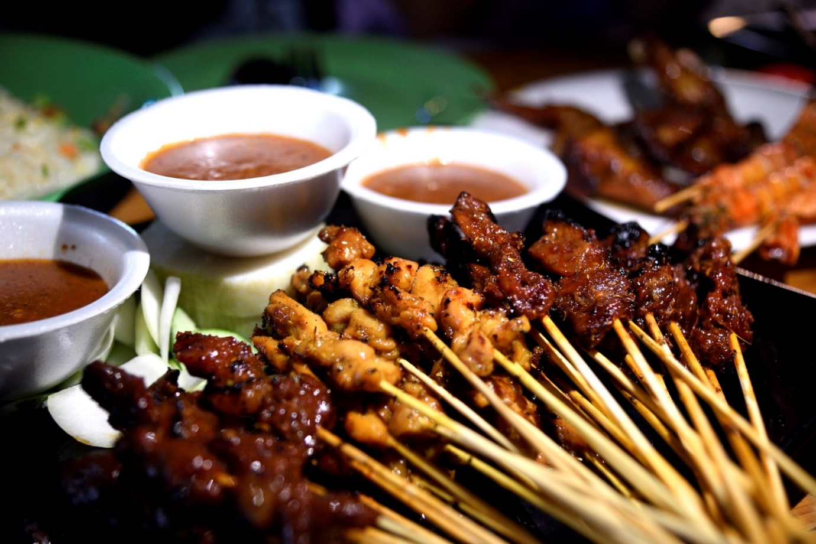

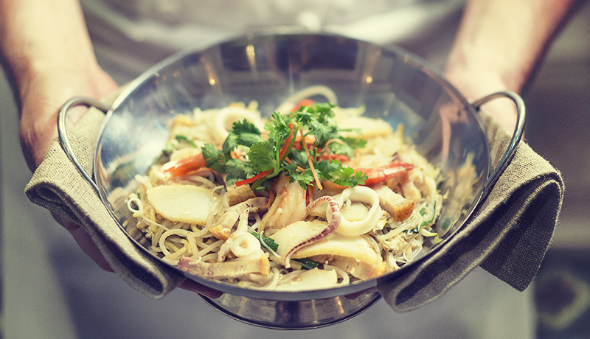

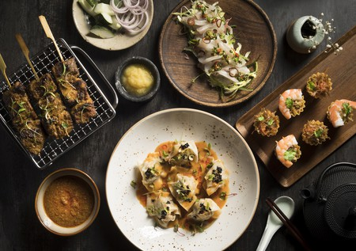
An image of food sample in Singapore hotel
Singaporeans also value punctuality and timekeeping, so hotel staff should ensure they are punctual for appointments and meetings. By being aware of these cultural implications, hotel staff can provide Singaporean guests with a more personalised and welcoming experience, making their stay more enjoyable and memorable.
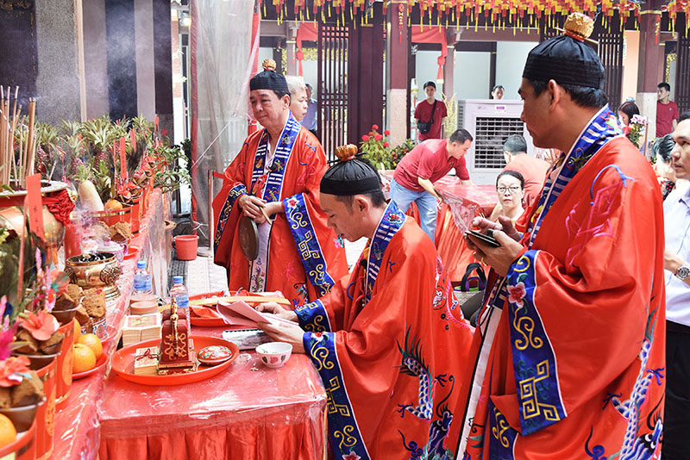
Singapore nationals enjoying their culture.

Implications for Hotel Departments/Functions
To satisfy Singaporean customers' distinct cultural norms and needs, hotel departments and services must modify their service offerings (Paparoidamis, Tran and Leonidou, 2019). The following are examples of how various departments and functions can accommodate Singaporean guests:
- Front Desk/ Reception
The front desk should be welcoming and warmly greet Singaporean guests. Afsar et al., (2020) states that they should also know the above cultural implications and adjust their communication style accordingly. Additionally, they should know Singaporean customs and etiquette to offer helpful recommendations to guests.
- Housekeeping
Housekeeping should respect guests' privacy and avoid entering the guest room without permission (Marneros, Papageorgiou and Efstathiades, 2020). They should also be attentive to guests' specific requirements, such as providing extra pillows or blankets or ensuring that rooms are stocked with green tea instead of coffee.
- Food and Beverage
The food and beverage team should be aware of Singaporean dietary requirements and preferences, such as halal or vegetarian food, and offer alternative dishes (Lam et al., 2021). They should also offer a variety of teas and hot water alongside coffee and other beverages and understand the importance of using the correct utensils for different dishes.
- Concierge
As Suryanarayanan et al. (2021) explain on hospitality, the concierge should be knowledgeable about Singaporean culture, customs, and etiquette and offer recommendations for activities and attractions that align with guests' interests. They should also be aware of the importance of punctuality for Singaporean guests.
- Spa and Wellness
The spa and wellness team should be sensitive to guests' preferences for modesty and provide appropriate clothing options (Klimkeit, Tang and Thirumaran, 2021). They should also be aware of the importance of non-verbal communication and use it to interpret guests' needs accurately.
- Sales and Marketing
The sales and marketing team should understand the Singaporean market and the specific requirements of Singaporean guests (Singapore Tourism Board, n.d.). They should create marketing materials highlighting the hotel's ability to accommodate Singaporean guests and promote their understanding of their culture and customs.

Do’s and Don'ts for Hotel Staff
Do’s
- Be welcoming and provide warm greetings;
- Be polite and avoid confrontations;
- Create a sense of belongingness;
- Show respect to guests, especially to those in position of authority;
- Offer alternatives to pork and beef dishes;
- Try to communicate with guests in their preferred language.
Don’ts
- Provide negative feedback directly;
- Disrespect authority figures;
- Offer pork or beef dishes without alternatives;
- Misinterpret guests’ non-verbal cues;
- Enter guests’ room without permission;
- Speak too quickly or use slang that may not be familiar to guests;
- Assume that all Singaporeans have the same preferences and requirements.

Summary
The Hotel Handbook for staff to manage guest service experiences for Singaporean visitors highlights the importance of cultural intelligence and sensitivity for hotel personnel. It overviews Singaporean culture, customs, and behaviour and highlights the implications for hotel departments/functions. The handbook also includes a "Do's and Don'ts” for hotel staff, as proposed by Ali et al. (2021) summarising how they can accommodate Singaporean guests' cultural norms and requirements. Finally, the handbook provides two recommendations for staff, including offering personalised experiences and providing cultural sensitivity training. Following these recommendations and guidelines, hotel staff can provide Singaporean guests with a more welcoming and memorable experience.

Recommendations
Two critical recommendations for hotel staff are to help them provide a better experience for Singaporean guests. First, they should provide cultural sensitivity training. Hotel staff should receive cultural sensitivity training to help them understand Singaporean guests' specific cultural norms and requirements. This training should cover communication style, customs, and etiquette and offer guidance on accommodating Singaporean guests' needs. Secondly, they should offer personalised experiences. Hotel staff should offer personalised experiences to Singaporean guests, such as providing Singaporean tea or snacks in the room or arranging for a tour guide who speaks their preferred language. By offering personalised experiences, staff can demonstrate their understanding of Singaporean culture and show guests they are valued and appreciated. By implementing these recommendations, hotel staff can improve the guest experience for Singaporean visitors and help create a positive and memorable stay at the hotel.

References

Afsar, B., Al-Ghazali, B.M., Cheema, S. and Javed, F., 2020. Cultural intelligence and innovative work behaviour: the role of work engagement and interpersonal trust. European Journal of Innovation Management, 24(4), pp.1082-1109. https://www.tandfonline.com/doi/abs/10.1080/15313220.2020.1745732
Ali, B.J., Gardi, B., Jabbar Othman, B., Ali Ahmed, S., Burhan Ismael, N., Abdalla Hamza, P., Mahmood Aziz, H., Sabir, B.Y., Sorguli, S. and Anwar, G., 2021. Hotel service quality: The impact of service quality on customer satisfaction in hospitality. Ali, BJ, Gardi, B., Othman, BJ, Ahmed, SA, Ismael, NB, Hamza, PA, Aziz, HM, Sabir, BY, Anwar, G. (2021). Hotel Service Quality: The Impact of Service Quality on Customer Satisfaction in Hospitality. International Journal of Engineering, Business and Management, 5(3), pp.14-28. https://papers.ssrn.com/sol3/papers.cfm?abstract_id=3851330
https://www.myskillsfuture.gov.sg/content/student/en/preu/world-of-work/industry-landscape/industry-detail.Hotel-and-Accommodation-Services-15631.html (Accessed: March 7, 2023).
Khamsani, M.S., 2020. Checking out: hoteliers’ preferences in managing language barriers within the Singapore hospitality industry. https://dr.ntu.edu.sg/handle/10356/138322
Klimkeit, D., Tang, C.M. and Thirumaran, K., 2021. Introduction: Service excellence in Asian tourism and hospitality. Service Excellence in Tourism and Hospitality: Insights from Asia, pp.1-7. https://link.springer.com/chapter/10.1007/978-3-030-57694-3_1
Lam, R., Cheung, C. and Lugosi, P., 2021. The impacts of cultural and emotional intelligence on hotel guest satisfaction: Asian and non-Asian perceptions of staff capabilities. Journal of China Tourism Research, 17(3), pp.455-477. https://www.tandfonline.com/doi/abs/10.1080/19388160.2020.1771500
Marneros, S., Papageorgiou, G. and Efstathiades, A., 2020. Identifying key success competencies for the hospitality industry: The perspectives of professionals. Journal of Teaching in Travel & Tourism, 20(4), pp.237-261. https://www.emerald.com/insight/content/doi/10.1108/EJIM-01-2020-0008/full/html?utm_campaign=Emerald_Strategy_PPV_November22_RoN
Ounsri, K. and Thawesaengskulthai, N., 2019, April. Hotel service quality factors among different cultures. In 2019 ieee 6th International Conference on Industrial Engineering and Applications (iciea) (pp. 306-312). IEEE https://ieeexplore.ieee.org/abstract/document/8715145/
Paparoidamis, N.G., Tran, H.T.T. and Leonidou, C.N., 2019. Building customer loyalty in intercultural service encounters: the role of service employees’ cultural intelligence. Journal of International Marketing, 27(2), pp.56-75. https://journals.sagepub.com/doi/pdf/10.1177/1069031X19837950
Ratasuk, A. and Charoensukmongkol, P., 2020. Does cultural intelligence promote cross-cultural teams' knowledge sharing and innovation in the restaurant business?. Asia-Pacific Journal of Business Administration, 12(2), pp.183-203. https://www.emerald.com/insight/content/doi/10.1108/APJBA-05-2019-0109/full/html
Singapore Tourism Board. (n.d.). Singapore Industry Landscape Detail. Home. Retrieved March 7, 2023, from https://www.myskillsfuture.gov.sg/content/student/en/preu/world-of-work/industry-landscape/industry-detail.Hotel-and-Accommodation-Services-15631.html.
Suryanarayanan, S., Srinivasan, S.R., Lin, W., Wang, L. and Sabharwal, J.K., 2021. Managing customer expectations: a study of two four-star hotels in Malaysia and Singapore. Service Excellence in Tourism and Hospitality: Insights from Asia, pp.41-53. https://link.springer.com/chapter/10.1007/978-3-030-57694-3_4
Walw, H. (2023) Hofstede's cultural dimensions theory, Corporate Finance Institute. Available at:https://corporatefinanceinstitute.com/resources/management/hofstedes-cultural-dimensions-theory/ Accessed: March 7, 2023).

