

Student name: Lourdes Cristina Fabre
Student ID: 2412080

Module name: Changemakers: Building your Personal Brand for Sustainable Employment
Module code: BMHP5015
Lecturer name: Caroline Salami

Contents
Introduction 3
Personal Employability Skills Required 4
Person Specification 4
Technical Requirements 5
Interpersonal Competencies 5
Evaluation of My Current Skills 6
SWOT Analysis 6
Direct Skills Comparison 7
Evidence for Transferable Strengths 8
STAR Example 9
Reflective Practice 9
Gibbs’ Reflective Cycle 9
Personal Brand and Professional Identity 11
Entry-Level Career Pathway 14
Resources Required 14
Conclusion 14
References 15

Introduction
The Surveillance and Audit Analyst role (Band 5, fixed-term 12 months, full-time) sits within the Infection Prevention and Control (IPC) Team at University College London Hospitals NHS Foundation Trust. The post involves collecting, analysing, interpreting and reporting data on bloodstream infections, surgical-site infections and clinical audits, converting surveillance intelligence into management information that drives evidence-based improvements in patient safety. The salary is £38,488 to £46,852 per annum; the advert closed on 9 August 2026 (NHS Jobs, 2026).
I selected this role because it supports my long-term ambition to become a Public Health Analyst. Infection prevention and surveillance particularly interest me because they operate at the intersection of data, clinical practice and patient safety, an environment where accurate analysis has direct consequences for health outcomes. I am in the final year of my BSc (Hons) in Health and Social Care at the University of Wales Trinity Saint David (conclusion September 2027) and hold a Certificate in Higher Education - Skills for the Workplace in Health and Social Care (2025). I bring transferable skills from nutrition practice, charity administration, journalism, lecturing, community engagement and press and media work.
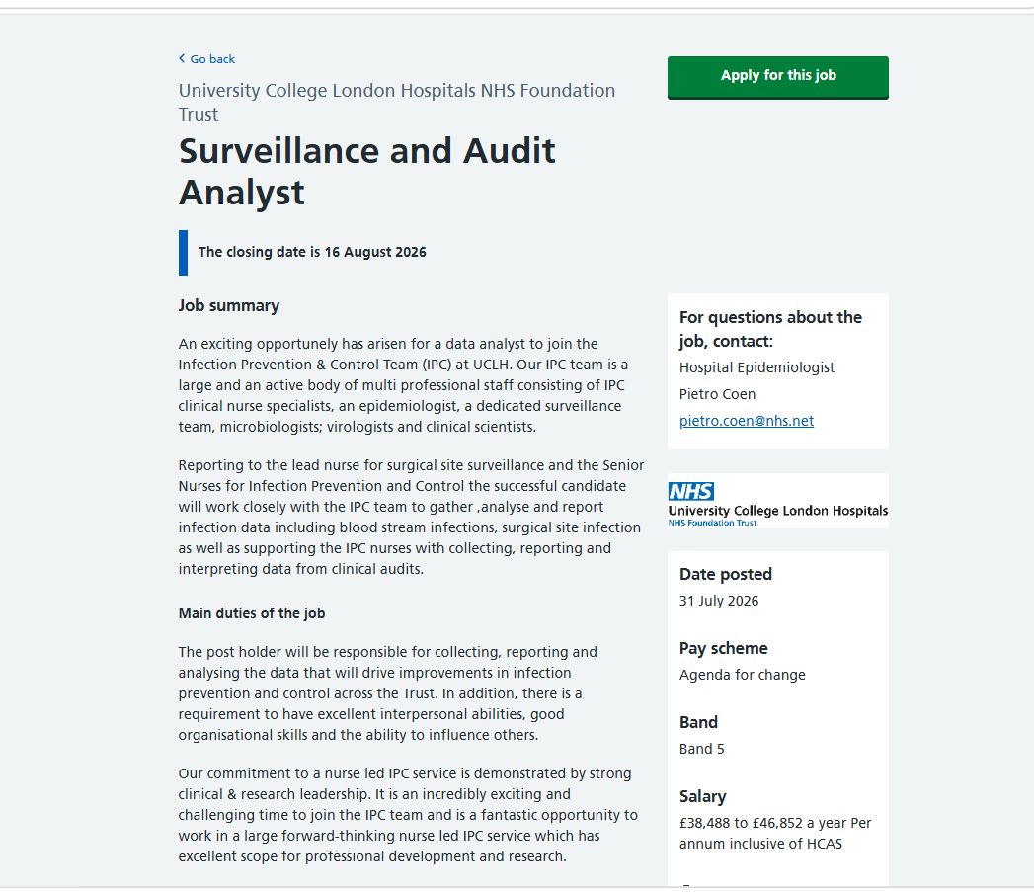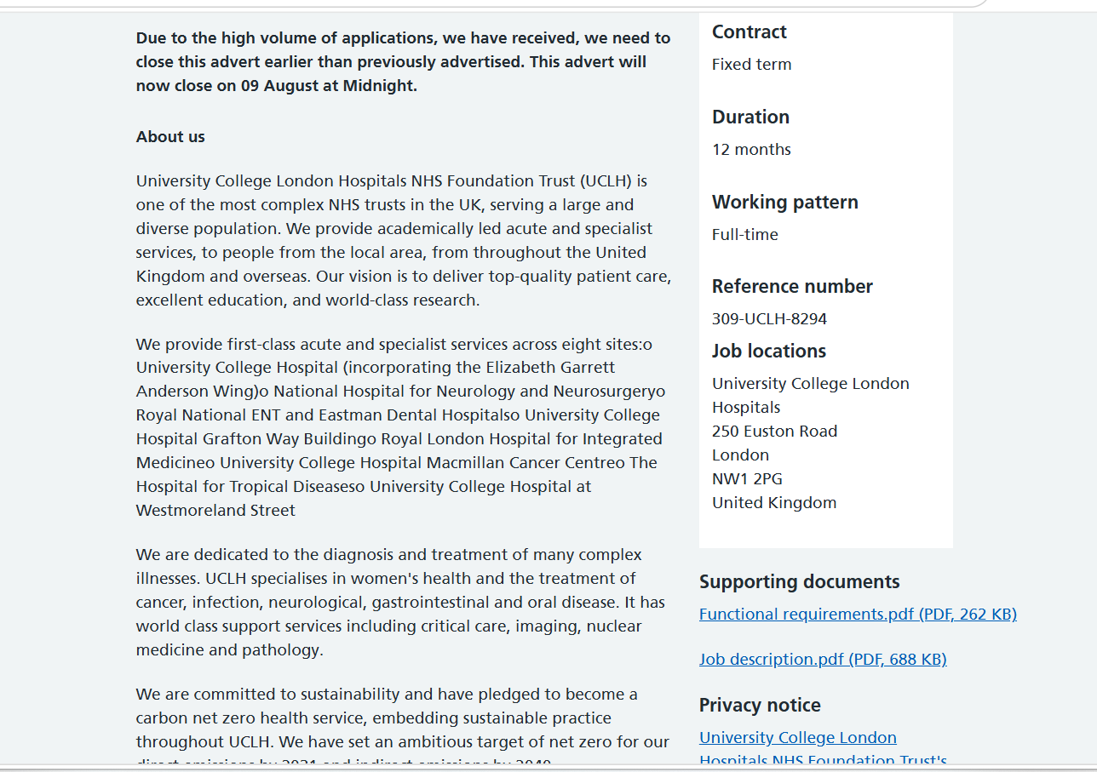
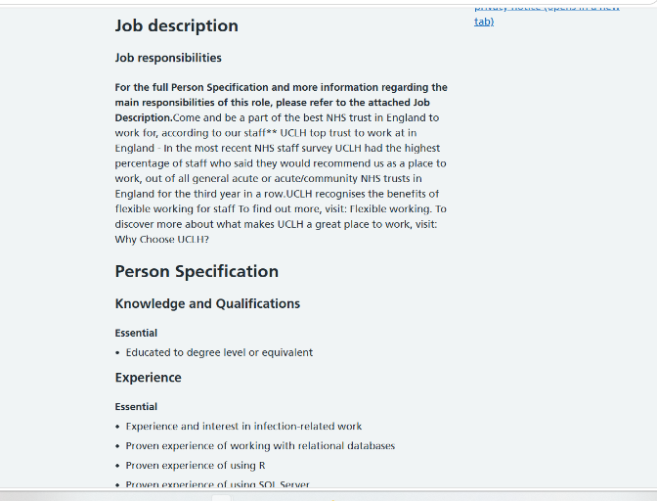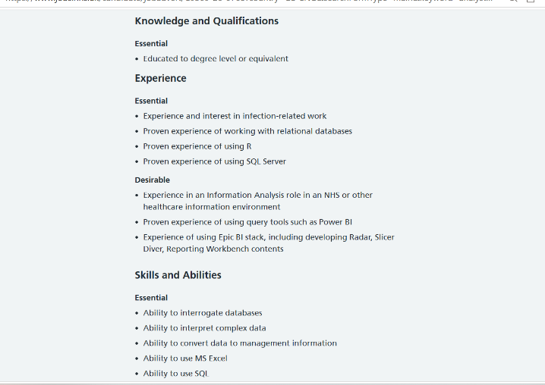
Figure 1: Surveillance and Audit Analyst vacancy at UCLH (NHS Jobs, 2026).

Personal Employability Skills Required

Person Specification
Table 1 presents the essential and desirable criteria from the person specification (NHS Jobs, 2026). The role demands both technical and interpersonal competencies.

Table 1: Person specification for Surveillance and Audit Analyst (Band 5), UCLH
Essential criteria | Desirable criteria
Degree-level education or equivalent qualification | NHS information-analysis experience
Experience and interest in infection-related work | Power BI and advanced Excel skills including Power Query
Proven experience with relational databases, R and SQL Server | Experience of using Python and the Epic BI stack
Ability to interrogate databases and interpret complex data | Understanding of data quality and validation methods
Proficiency in SQL and Excel for analysis and reporting | Experience submitting information to statutory bodies
Excellent interpersonal and communication skills
Data quality assurance, information governance and audit skills

Technical Requirements
The role demands proficiency in relational databases, SQL, R, and Power BI to collect, clean, analyse and visualise infection data. Data quality assurance is critical: incomplete or miscoded records can create false trends. For instance, an apparent rise in surgical-site infections may simply reflect better case detection rather than an outbreak. Analysts must therefore validate all data before interpretation, document limitations honestly, and apply rigorous audit skills and attention to detail throughout.

Interpersonal Competencies
The analyst works within a multidisciplinary team including specialist nurses, epidemiologists, microbiologists and clinical scientists. Findings must be communicated clearly to colleagues with varying levels of statistical knowledge, and the analyst must influence practice when data indicate a need for change. Teamwork is essential because infection data cannot be interpreted without clinical context: analysts identify patterns and limitations, while practitioner contribute specialist knowledge. This reflects UCLH's values of safety, kindness, teamwork and improving (UCLH, 2026). Organisation, resilience and accountability are also required. Kolb's Learning Cycle (1984) and the STAR model (Situation, Task, Action, Result) provide useful frameworks for developing and demonstrating these competencies.

Evaluation of My Current Skills

SWOT Analysis
Table 2 presents a SWOT analysis of my current position relative to the vacancy requirements.
Table 2: SWOT analysis
Strengths | Weaknesses
Communication and health education: nutrition practice, workshops, lecturing, journalism and editing | No evidenced experience of R, SQL Server or relational databases
Report writing, editing and presentation: ten years of journalism across national and international events | No experience of Power BI, Epic BI stack or advanced statistical methods
Confidential record-keeping and data accuracy: charity administration (2021–2024) and real-estate administration (2024–present) | No direct infection-surveillance, epidemiology or NHS information-systems experience
Organisation and stakeholder engagement: multi-agency coordination and managing competing priorities | Competing against established NHS analysts; BSc not yet completed
Bilingual communication (Portuguese native, English C2) and Microsoft Office proficiency | Technical portfolio still to be developed

Opportunities | Threats
Completing BSc (Hons) Health and Social Care (expected 2027); structured technical training via free platforms | Competition from experienced NHS analysts who meet all essential criteria
NHS work experience, volunteering and apprenticeship pathways (Level 4 Data Analyst apprenticeship) | Applying before demonstrating technical competencies, premature applications risk rejection
Public and open datasets (NHS Digital, UKHSA) for portfolio projects; mentoring from NHS analysts and university lecturers | Limited exposure to infection-prevention clinical settings

Direct Skills Comparison
Table 3 maps each key requirement against my current evidence, identifying gaps and the actions required.

Table 3: Skills comparison against vacancy requirements
Vacancy requirement | My current evidence | Development gap | Action required
Degree-level education | Final-year BSc (Hons) Health and Social Care, UWTS; CertHE - Skills for the Workplace (2025) | Degree not yet awarded | Complete BSc by December 2027
Relational databases and SQL Server | No formal experience | Cannot query or manage databases independently | Complete SQL and database courses; build three SQL exercises by December 2026
R programming | No prior experience | Cannot clean, analyse or visualise data using R | Complete introductory R courses; produce two reproducible analyses by December 2026
Infection-related work | Nutrition practice supporting clients with long-term conditions since 2022 | No direct infection-surveillance or epidemiology experience | Study epidemiology and surveillance; complete CPD by March 2027
Power BI and Epic BI | No experience | Cannot build or interpret dashboards | Complete Microsoft Learn Power BI path; build one dashboard by June 2027
Communication and influencing | Ten years of journalism and editing; university lecturing; nutrition consultations; press and media officer experience | Adapting clinical communication to data-sceptical audiences | Strengthen through supervised NHS experience and portfolio projects
Data quality and information governance | Three years of confidential record-keeping at The Bridge (2021–2024); two years at Harrys & Company (2024–present) | No formal IG training or data-quality assurance experience | Complete NHS Data Security Awareness training; apply data-quality principles in all portfolio projects

Evidence for Transferable Strengths
As a self-employed Nutrition Practitioner since 2022, I have assessed clients' health needs, developed evidence-based lifestyle plans and supported behaviour change. I designed and delivered an interactive nutrition workshop for women supported by The Bridge, a charity addressing health and social inequalities, which received excellent participant feedback. My ten years as a journalist and editor for a Brazilian daily newspaper, covering nationally and internationally significant events including the Olympic Games, involved investigating information, identifying inconsistencies and producing clear, audience-focused reports. University lecturing in Communication and experience as a Press and Media Officer further developed these skills. At The Bridge (2021–2024), I managed appointments, referrals, payments and service-user records; at Harrys & Company (2024–present), I coordinate tenancy administration and manage confidential information.

STAR Example
Nutrition workshop at The Bridge. I independently designed and delivered a nutrition workshop for women experiencing health inequalities. I adapted complex guidance into plain-language materials, encouraged participation and collected participant feedback. The session received excellent verbal feedback and was recognised by the charity's team as highly relevant and well delivered.
Situation: The Bridge identified a need for accessible health education among women experiencing health inequalities in Southwark community, London. Many participants had limited prior exposure to nutrition information tailored to their cultural and practical circumstances.
Task: I was responsible for independently designing and delivering a nutrition workshop that would be engaging, evidence-based and practically useful for participants with diverse health literacy levels.
Action: I researched the specific health concerns of the participant group, adapted complex nutritional guidance into plain-language materials, structured the session to include interactive discussion and question prompts, and encouraged participation throughout.
Result: Received verbal feedback for 90% of the participants who rated the session as very useful and reported increased confidence in making healthier food choices.
Reflection: This experience confirmed my ability to plan, communicate and engage diverse audiences. However, I learned that verbal feedback alone is insufficient evidence of impact. Next time, I would use structured pre- and post-session questionnaires and analyse the results in Excel to produce quantifiable evidence of learning outcomes.
This STAR example will be used in my CV, NHS supporting statements and interview preparation to provide concrete, structured evidence of my competencies.

Reflective Practice

Gibbs’ Reflective Cycle
Description: I designed and delivered a one-off nutrition workshop for women supported by The Bridge, a charity working with communities experiencing health inequalities. The session covered basic nutrition principles and behaviour-change strategies. I prepared plain-language materials, facilitated group discussion and answered participants' questions.
Feelings: I felt excited about sharing practical health knowledge and nervous about whether the content would be accessible and engaging. During the session, I was encouraged by participants' questions and willingness to share their own experiences. After the session, I felt positive about the interaction but uncertain about whether I had genuinely improved participants' understanding.
Evaluation: The positive aspects were the high level of participation, the relevance of the content to participants' daily lives, and the verbal feedback indicating that attendees found the information useful. The negative aspect was the absence of structured, measurable evaluation.
Analysis: Verbal feedback does not provide reliable evidence of impact. Without a baseline measure of participants' knowledge, I could not demonstrate whether the workshop improved understanding. This matters because health-education interventions should be evaluated against measurable.
Conclusion: I learned that good communication is necessary but not sufficient for demonstrating impact. I need to build evaluation into the design of any health-education activity from the outset, rather than adding it retrospectively. This insight connects directly to the Surveillance and Audit Analyst role.
Action plan: For my next health-education activity, I will design a short pre-session questionnaire, and a matching post-session questionnaire. I will enter the responses into Excel, calculate descriptive statistics and produce a brief evaluation report
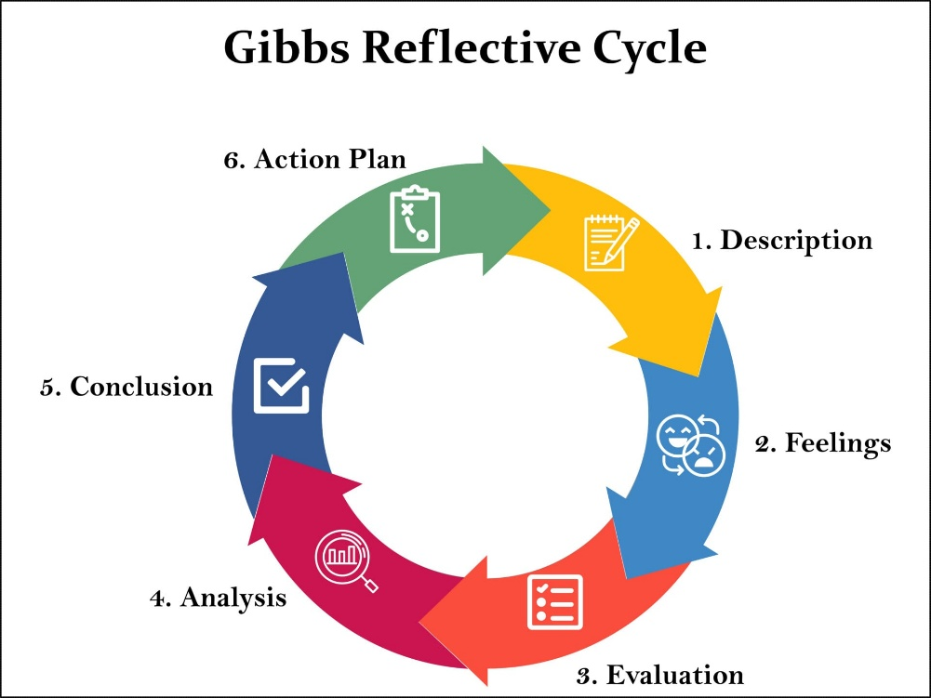
Figure 2: Gibbs' Reflective Cycle diagram (Guy-Evans, O., McLeod, S. (2025).
https://www.simplypsychology.org/wp-content/uploads/gibbs-reflective-cycle.jpg

Personal Brand and Professional Identity
My professional identity is based on evidence-based practice, equity, integrity, communication and continuous improvement, aligning with UCLH values (UCLH, 2026). My unique selling point combines health knowledge, community engagement, professional communication and developing health-data analysis skills. Experience as a nutrition practitioner, charity administrator, journalist and lecturer has strengthened my ability to communicate complex information with diverse audiences. Fluency in Portuguese and English supports engagement with London’s diverse communities. My portfolio will demonstrate developing skills in SQL, R, Excel and Power BI using public or anonymised data. My proposed LinkedIn headline accurately reflects my current stage: ‘Health and Social Care BSc Student | Developing Skills in R, SQL and Health Data Analysis | Aspiring Public Health Analyst’. Holland’s (1997) theory and the CareerEDGE model (Pool and Sewell, 2007) support my development across knowledge, experience, transferable skills and career planning.
Figure 3: Screenshot of my LinkedIn profile (Fabre, 2026).
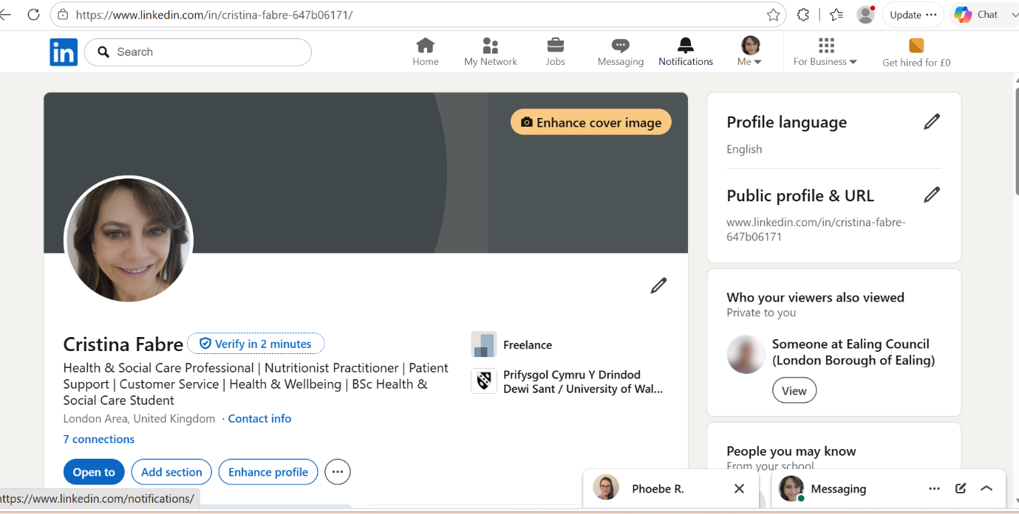Networking
I will engage with AnalystX, AphA, UKHSA publications, the NHS R Community, and university careers events to develop my NHS analytical network. I will seek mentoring from NHS analysts, UKHSA professionals, infection-prevention teams, data-quality officers and university lecturers. My targets are one webinar every two months, two professional contacts per quarter, and one university careers event per term. I will record all activities and learning in a CPD and networking log to monitor progress and support my transition into NHS analytical work.
Communication of Skills to Employers
I will restructure my CV around analytical projects, measurable achievements and transferable skills. NHS supporting statements will address every essential criterion with specific evidence and honest development plans. I will align LinkedIn with my analytical profile and portfolio. Interview preparation will use STAR examples from nutrition workshops, BSc studies, volunteering and supervised experience to demonstrate relevant skills, achievements and professional development.

Action Plan and Timeline
Table 4 presents a SMART action plan spanning 2026 to 2029, informed by Bandura's (1997) theory of self-efficacy, which proposes that confidence grows through successful performance, role models, encouragement and emotional management. Progress will be reviewed every three months using a red-amber-green rating system.
Table 4: SMART action plan with resources.
Timescale | SMART action | Evidence | Resources
Aug–Sep 2026 | Complete a skills audit and create a weekly learning schedule | Written audit and baseline self-assessment | University PDP template; careers adviser support
Sep–Dec 2026 | Complete introductory SQL (SQLZoo, W3Schools), relational database (Khan Academy) and R courses (DataCamp, Coursera) | Certificates; three SQL query exercises; two documented R analyses | SQLZoo, W3Schools, Khan Academy, DataCamp (free tier), Coursera (financial aid available)
Oct–Dec 2026 | Develop Excel skills: pivot tables, VLOOKUP/XLOOKUP, data validation, Power Query | Anonymised audit workbook demonstrating data cleaning and validation | Microsoft Office (university licence); Microsoft Learn Excel modules (free)
Jan–Mar 2027 | Study infection prevention, epidemiology, surveillance and information governance | CPD record and reflective summary; NHS Data Security Awareness certificate | UKHSA free e-learning; FutureLearn; NHS Digital IG training portal (free)
Jan–Apr 2027 | Analyse a public or simulated healthcare-associated infection dataset using SQL and R | Reproducible analysis with interpretation, data-quality commentary and limitations | NHS Digital open data; UKHSA reports; RStudio Cloud (free); university statistical support
Apr–Jun 2027 | Create a Power BI dashboard presenting infection or audit data for a non-technical audience | Published dashboard and written feedback from lecturer or analyst | Microsoft Power BI Desktop (free); Microsoft Learn learning path (free)
By Jun 2027 | Complete at least 40 hours of supervised health-data, audit or evaluation experience | Supervisor evidence; STAR reflection on contribution and learning | NHS Professionals bank; UCLH volunteering; university research project; charity evaluation
Throughout 2026–27 | Attend monthly webinar (AnalystX, AphA, HACA); make two professional contacts each quarter; meet a mentor every six weeks | CPD and networking log; meeting notes and documented actions | AnalystX (NHS England); AphA student membership; HACA conference; university careers service
By Dec 2027 | Complete BSc; submit six tailored applications for entry-level roles | Degree certificate; application tracker; revised CV and portfolio | University careers service; NHS Jobs alerts (Band 4–5); AnalystX jobs board
2028–29 | Progress towards an NHS analyst role; develop advanced Power BI, Excel and Python skills | Employment (subject to application); portfolio evidence of advanced competency | Employer CPD; NHS Elect training; advanced DataCamp/Coursera courses

Entry-Level Career Pathway
The Surveillance and Audit Analyst role is a medium-term goal. Initially, I will target Band 3–5 roles such as Data Quality Assistant to build relevant analytical and data-quality experience. Other routes include the NHS Level 4 Data Analyst Apprenticeship, and university research projects.

Resources Required
Most training will be free through R, SQL tutorials, Power BI, university Office 365, and NHS data-security resources. I will prioritise free options and seek financial aid for paid courses. University facilities, statistical support, careers services, AnalystX and AphA mentoring will complement self-directed learning.

Conclusion
The UCLH Surveillance and Audit Analyst role aligns strongly with my ambition to become a Public Health Analyst. My strongest current transferable skill is communication, evidenced through ten years of journalism and editing, university lecturing, health workshop delivery and client-facing nutrition practice. The foundation on which technical competence can be built. My three development priorities are technical analysis (R, SQL, relational databases), infection surveillance (epidemiology, NHS information systems), and NHS data experience (supervised health-data or audit work). The immediate next step is to complete a skills audit, establish a five-hour-per-week learning schedule and begin the introductory SQL and R courses identified in the action plan during September 2026.

References
Bandura, A. (1997) Self-Efficacy: The Exercise of Control. New York: W.H. Freeman.
Guy-Evans, O., McLeod, S. (2025) ‘Gibbs Reflective Cycle’. Available at: https://www.simplypsychology.org/wp-content/uploads/gibbs-reflective-cycle.jpg. (Accessed 13 August 2026).
Holland, J.L. (1997) Making Vocational Choices. 3rd edn. Odessa, FL: Psychological Assessment Resources.
Kolb, D.A. (1984) Experiential Learning: Experience as the Source of Learning and Development. Englewood Cliffs, NJ: Prentice-Hall.
NHS Jobs (2026) Surveillance and Audit Analyst: University College London Hospitals NHS Foundation Trust, reference 309-UCLH-8294. Available at: https://beta.jobs.nhs.uk/candidate/jobadvert/C9309-26-0768. (Accessed: 2 August 2026).
Pool, L.D. and Sewell, P. (2007) 'The key to employability: developing a practical model of graduate employability', Education + Training, 49(4).
University College London Hospitals NHS Foundation Trust (UCLH) (2026) Our motivation, purpose, values and strategy. Available at: https://www.uclh.nhs.uk/about-us/what-we-do/vision-values-and-objectives. (Accessed: 3 August 2026).

