June 2026 beatram Brown SSB 1
software solution for business
Computer skills

Student name: | Beatram Brown | Student Number: | 2438239
Programme: | CertHE Computing Skills  for Workplace
Module | Software Solutions for Business
Module code: | ACCA4026
Lecturer | Kwame Assa-Agei  Fahed Ahmed

UWTSD
Computing Skill for Workplace

Contents
Introduction 1
Task 1. e-Commerce Website builders/software solutions 1
1.1 Ionos 1
1.2 Google Site 1
Task 2. Mind-map of contemporary software applications 1
2.1 Describe mind mapping and explain the benefits of using mind mapping 1
2.2 Create a mind map of contemporary software applications 2
Task 3. Office Applications 2
3.1 Four office software solutions for business operations 2
Ms Word 2
Ms Excel 2
Ms PowerPoint 2
Ms Access 2
3.2 Test any two features 2
Mail Merge 2
IF Statement 3
Task 4. Communication and Collaboration applications 3
4.1 One contemporary Communication and one Online Collaboration 3
Gmail 3
Zoom 3
4.2 Test one feature of a freely available Communication (1) and one feature of a Collaboration (1) application 3
Gmail 3
Zoom 3
Conclusion 4
References 4

Introduction
This report explores a variety of contemporary software applications relevant to modern business operations, covering e-commerce platforms, information-organization techniques, office productivity software, and communication and collaboration tools. As businesses increasingly depend on digital platforms to engage customers, manage documentation, and coordinate teams, evaluating the practical advantages and drawbacks of these tools is essential for making sound technology decisions.
The report is organized into four main tasks. Task 1 assesses two e-commerce website-building solutions, IONOS and Google Sites, comparing their features, strengths, and limitations for businesses seeking to build an online presence. Task 2 introduces mind mapping as a method for visually structuring information, outlining its cognitive advantages before using it to map out the software applications discussed elsewhere in the report. Task 3 examines four widely used Microsoft Office applications, Word, Excel, PowerPoint, and Access, describing their function within business operations and demonstrating two practical features, Mail Merge and the IF Statement, in action. Task 4 turns to communication and collaboration technologies, analysing Gmail as a communication tool and Zoom as a collaboration tool, followed by a hands on demonstration of one feature from each.
Taken together, these tasks offer a comparative view of software commonly used in today's business environments, illustrating how each platform's design decisions lead to different trade-offs between cost, ease of use, functionality, and scalability.

Task 1. e-Commerce Website builders/software solutions


1.1 Ionos
is a German web hosting and cloud computing company, headquartered in Montabaur, Germany. it is an intuitive, web-based solution that allows users to build and scale an online store without requiring coding or web design which make it very easy to use. Ionos also have some brilliant features.
It has concrete legal implications Under GDPR, transferring EU citizens' data to US-based cloud providers has been a legal gray zone for years, since US law (like the CLOUD Act) can compel American companies to hand over data even if it's stored on servers physically located in Europe. Because IONOS is a European company headquartered in Germany, subject to German and EU law, it sidesteps that jurisdictional conflict entirely. This is precisely why it landed a contract with (Germany's federal IT agency) government bodies handling sensitive citizen data have strong incentives to avoid any exposure to foreign legal jurisdiction, even indirect. For private businesses, this matters most in regulated industries healthcare, finance, legal services where data residency requirements are often written directly into compliance frameworks. [1]
The hidden cost of using separate vendors isn't just the subscription fees it's the integration tax: different login systems, different support teams to call when something breaks, DNS records that need manual syncing between your domain registrar and your host, and billing reconciliation across multiple invoices. A small business owner without a dedicated IT team benefits disproportionately from consolidation, because troubleshooting "why isn't my email working" is much simpler when one company owns the domain, the DNS, the hosting, and the email server, versus when three different providers each blame the other.
This is a deliberate customer-acquisition strategy, and it's visible in the financials IONOS's average revenue per user (ARPU) declined recently even as total revenue grew, precisely because new customers are coming in at lower introductory price points. The bet is a classic land and expand model: get businesses in the door cheaply, then grow revenue per customer over time through upselling and cross-selling (moving a customer from basic hosting to a paid SSL certificate, then to cloud storage, then to a premium website builder tier, etc.). Their own reporting shows this cross-sell strategy is working, with combined customer growth and ARPU growth both compounding.
The practical upside is avoiding a migration event. Moving a live website or application to a new host is genuinely risky DNS propagation delays, downtime windows, broken configurations so businesses often "grow into" a limitation and just live with it rather than switch providers.
A 1988 founding date matters less for nostalgia and more because infrastructure businesses benefit enormously from accumulated operational knowledge data center redundancy planning, DDoS mitigation, backup architecture, and incident response processes all improve with decades of real-world failure scenarios encountered and fixed. This is different from software, where a newer competitor can leapfrog with a better UI hosting reliability is closer to a manufacturing process that gets refined through repetition.
This is where IONOS's current strategy is most aggressive. Management has stated they expect AI-related features to go from roughly 20% of incremental revenue in 2025 to 80% by 2028 meaning most of their new product development in the next few years will be AI-first. The "IONOS Momentum" AI phone receptionist is a good example of the target customer: a small business (say, a local service company) that has zero interest in configuring an AI system themselves but wants "answer my phone and book appointments" as a plug-and-play feature. That's a meaningfully different value proposition than, say, AWS Bedrock, which targets developers building custom AI applications.
A roughly 1% monthly churn rate compounds to about 11-12% annual churn solid for a subscription hosting business, where switching costs (fear of downtime, DNS reconfiguration hassle) naturally suppress churn somewhat regardless of satisfaction. Still, combined with strong new-customer growth (310,000 net adds in 2025) and rising ARPU, it suggests the retention isn't purely inertia customers are actively buying more from IONOS over time rather than just failing to leave.
The flip side of "does everything for SMBs" is that IONOS isn't chasing feature parity with AWS/Azure/GCP on advanced enterprise tooling things like sophisticated managed Kubernetes offerings, a global edge network, or a deep ML/AI platform ecosystem. If you're a large enterprise or a technically sophisticated engineering team, the hyperscale's likely still win on raw capability breadth. IONOS's advantage is squarely in being simpler, cheaper to start, and legally cleaner for the SMB and European-compliance-conscious segment not in being the most powerful cloud platform available.
1.2 Google Site
Google Sites is a free, structured web page that include creation tool as part of the Google Workspace suite. Even though it is not a dedicated, standalone e-commerce platform like Shopify, it can still function as a streamlined e-commerce website builder when paired with any other third-party integrations. The google site is best suitable for small businesses, creators, or hobbyists seeking a simple, It is of low-cost and would be best suitable for online storefront.[2]
This platform excels in every way with its user-friendliness, with featuring like intuitive drag-and-drop for editors that requires zero coding knowledge. New users can quickly design a professional-looking site with no real skill by using the pre-made templates that automatically optimize for desktop and mobile screens. Because it lives within the Google ecosystem, it integrates seamlessly with Google Drive, Forms, Docs, and YouTube, making asset management highly efficient and straight forward.
To enable e-commerce functionality, users must embed and enable external shopping widgets or payment buttons. Popular methods include inserting PayPal or Stripe payment buttons, and embedding an Ecwid shopping cart, or linking to a square checkout page. This will allow merchants to showcase their products, manage inventory, and securely process transactions.
Key Benefits:
- 100% Free: No hosting fees or platform subscription costs.
- Easy Setup: Extremely fast learning curve for beginners.
- Security: Hosted on Google’s secure, reliable infrastructure.

Main Limitations:
- No Native Cart: Requires third-party tools for checkout.
- Limited SEO: Basic search optimization tools compared to specialized builders.
- Basic Customisation: Fewer advanced design features and custom plugins.

Task 2. Mind-map of contemporary software applications

2.1 Describe mind mapping and explain the benefits of using mind mapping
Mind mapping is a visual technique for organizing information around a central idea. You start with a core concept in the middle of a page, then branch outward into related subtopics, and branch further from those into more specific details creating a radial, tree-like structure instead of a linear list or outline. Branches are often color coded, paired with keywords instead of full sentences, and sometimes accompanied by small images or icons to reinforce meaning.
Mind mapping is a visual note-taking method that mirrors how the brain processes ideas radiating outward from a core concept rather than marching down a page line by line. It's used for brainstorming, studying, planning projects, and taking notes in meetings or lectures.
Benefits of mind mapping:
- Mirrors how memory actual works. The brain stores information accordingly, not in strict lists so a radial map matches your natural thought patterns better than a linear outline. Your brain stores knowledge as a web of associations one concept triggers related ones, which trigger others, and so on. A linear list or outline forces that web into an artificial straight line. A mind map keeps the natural branching structure intact, so retrieving one idea makes it easier to retrieve the ideas connected to it, the same way remembering "beach" might bring "sunscreen," "waves," and "vacation" all at once.
- Boosts idea generation. Because there's no rigid order to follow, it's easier to jump between related thoughts and spot new connections you might miss in a bulleted list. Linear formats subtly pressure you to finish one point before moving to the next, which can choke off tangents that turn out to be valuable. With a mind map, you can leave a branch half-finished, jump to another one, and come back later nothing is "out of order." This lowers the mental friction of jumping around, which is exactly the friction that kills momentum during brainstorming.
- Improves recall. Colour, spatial position, and imagery all give your memory extra hooks to grab onto, which research on visual learning generally supports over plain text. This one has real backing from memory research: information encoded with multiple cues (spatial location, colour, image, and word) is easier to retrieve than information encoded as plain text alone a principle sometimes called dual coding. When you remember a mind map, you're not just recalling words; you're recalling where something was, what colour it was, and what it connected to, which gives you several independent paths back to the same memory.
- Shows a bigger picture immediately. You can see how subtopics relate to the main idea and to each other, which is harder to grasp when information is buried in paragraphs or nested bullets. Because everything radiates from one centre, you can visually gauge how "important" or "central" a topic is by its proximity to the core, and how developed an idea is by how many branches it has. That's information a bulleted list simply can't convey in a list, a minor detail and a major theme can look identical, just indented differently.
- Speeds up review. A well-made map condenses a lot of material into a single glanceable page, which is useful for studying or preparing for a presentation. A dense page of paragraphs takes real effort to re-read and re-absorb. A map, once built, can often be taken in with a glance your eye naturally follows the branches which makes it a strong format for last-minute review before an exam, a meeting, or a presentation.
- Encourages nonlinear thinking. It's well suited to brainstorming, since you can add branches wherever a thought occurs rather than committing to a sequence up front. Some of the best ideas emerge from unexpected connections between distant topics. Because a mind map has no fixed sequence, it's structurally suited to noticing that a sub branch on one side of the map actually relates to a sub branch on the other side a connection that's much harder to notice in a report or list, where far apart items are, well, far apart.
- Flexible across tasks. People use mind maps for notetaking, project planning, decision making, writing outlines, and problem solving the same structure and adapts to every different kind of thinking. The same radial structure works whether you're outlining a scrip, planning a wedding, studying for the bar exam, or mapping a company's chart. That smart and versatility come from the fact that a mind map isn't really a content format it's a relationship format. It doesn't care what the content is, only how the pieces relate to each other.

2.2 Create a mind map of contemporary software application
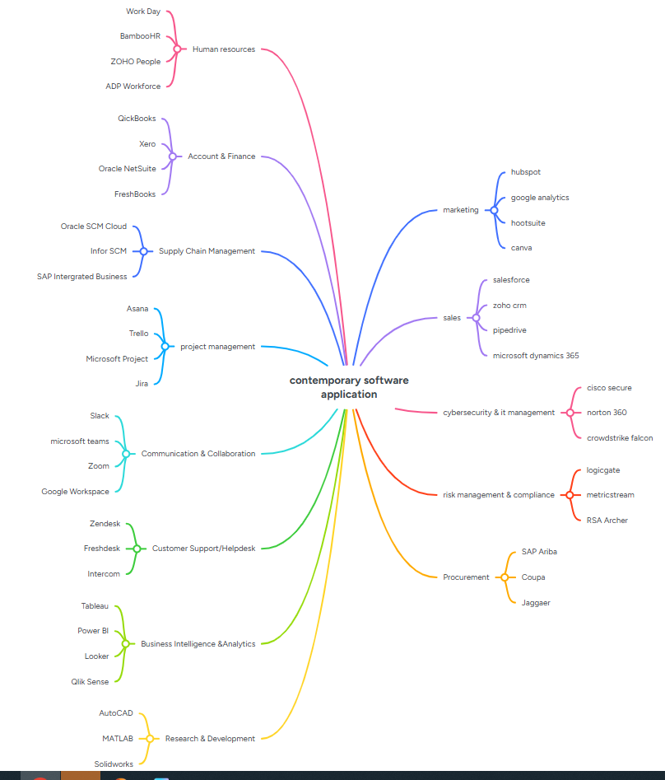

Task 3. Office Applications

3.1 Four office software solutions for business operations

Ms Word
Microsoft Word has several notable drawbacks. It isn't free full access requires a Microsoft 365 subscription or Office purchase, and costs accumulate over time compared to free alternatives like Google Docs. Its collaboration tools, while functional, feel less seamless than cloud-native competitors, often requiring Microsoft accounts and occasionally causing sync conflicts. Performance can suffer with lengthy or image heavy documents, and crashes or formatting corruption aren't uncommon. Compatibility is another weak spot files frequently lose formatting when opened in other programs, and even Word's own web, desktop, and mobile versions don't always behave identically. Many advanced capabilities styles, macros, mail merge carry a steep learning curve that most users never fully explore, and formatting in long documents can be fragile, breaking easily from a single misstep. Word also isn't well-suited to specialized needs academic writing with heavy citations fits tools like LaTeX better, technical documentation suits Markdown, and tabular data belongs in spreadsheets. Version tracking across many edits is clunky compared to Git-based systems. Offline editing works, but reconciling changes after reconnecting can create conflicts.[3] Finally, files tend to grow bloated with embedded media and tracked-changes history, making them cumbersome to share compared to lighter formats like PDF.

Ms Excel

Excel is the spreadsheet program in Microsoft's 365/Office lineup, designed to help users organize, compute, and present data ranging from everyday budgets to intricate financial models. Information is entered into a grid of rows and columns, where each cell can hold text, numeric values, dates, or formulas. The program supports calculations spanning simple operations like totals and averages to more sophisticated tools such as XLOOKUP, VLOOKUP, INDEX-MATCH, and various logical, statistical, and financial formulas. To help visualize data trends, it includes charts, graphs, sparklines, and conditional formatting options. PivotTables allow users to condense and cross analysed a large volumes of data without needing custom formulas. Additional data-handling features include sorting, filtering, validation rules, and Power Query for pulling in and cleaning external datasets. Users can automate repetitive workflows through macros, VBA scripting, or newer dynamic array and LAMBDA functions. On the collaboration side, Excel supports simultaneous editing, comments, and file version tracking via OneDrive or SharePoint integration. It's available across desktop, browser-based, and mobile versions. The standard file type is .xlsx (with .xls used in older releases), and while it's largely interoperable with programs like Google Sheets and LibreOffice Calc, complex macros or formulas don't always transfer perfectly between platforms.[4]

Ms PowerPoint
PowerPoint, Microsoft's presentation tool within the 365/Office suite, offers a user-friendly, drag-and-drop interface with templates and an AI-assisted "Designer" feature for quick, polished slides. It supports rich media images, video, audio, charts, and SmartArt along with animations and embedded content from Excel or Word. Collaboration features include real-time co-editing, comments, and version history through OneDrive or SharePoint, while Presenter View, rehearsal tools, and live captions aid delivery. Its .pptx format is broadly compatible with Google Slides, Keynote, and LibreOffice Impress, and it integrates smoothly with Teams and other Office apps.
However, limitations exist. Without design discipline, slides can become cluttered or overly text-heavy, contributing to disengaging presentations. It requires a paid subscription, and premium AI tools may sit behind higher pricing tiers. Large files with embedded media can slow performance, and formatting sometimes breaks when opened in other software or older versions. Real time collaboration lags Google Slides, and multiple offline editors can cause version conflicts. PowerPoint isn't ideal for text-heavy documentation or complex data dashboards, and advanced features like custom animations or master slide editing carry a notable learning curve that many users never fully master.

Ms Access
Microsoft Access is Microsoft's desktop database management system, part of the Office suite, used for storing, organizing, and querying structured data through tables, forms, queries, and reports.
Benefits: Access offers a relatively gentle entry point into database concepts, letting users without SQL expertise build functional databases using visual tools and wizards. It supports relational data modelling, letting tables link via defined relationships. Built-in forms and reports make data entry and presentation easy without separate design tools. It integrates well with other Office apps, especially Excel, for importing/exporting data. For small businesses or departments, it's a low-cost way to manage inventories, contacts, or records without needing a full database administrator or server infrastructure.
Limitations: Access struggles with scalability it's not built for large datasets or many simultaneous users, unlike SQL Server or My SQL. Performance degrades noticeably as file size grows, and it's prone to corruption with heavy concurrent use. It's Windows only, with no true web or mobile native version, limiting accessibility. Security features are weaker than enterprise-grade databases. It also requires a Microsoft 365 subscription or standalone purchase, and skills learned don't always transfer directly to more powerful, industry standard database systems, making long-term scaling a common pain point for growing organizations.

3.2 Test any two features

Mail Merge

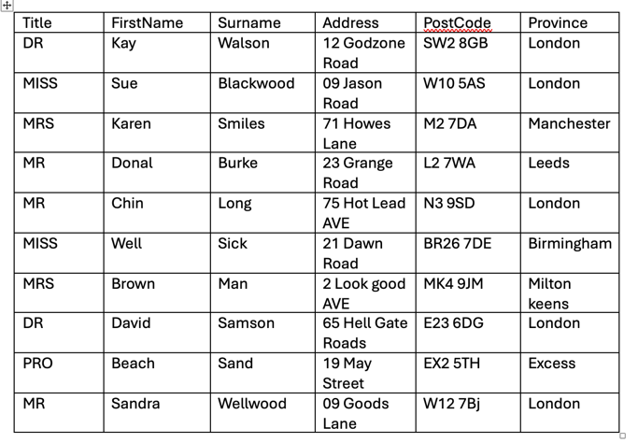



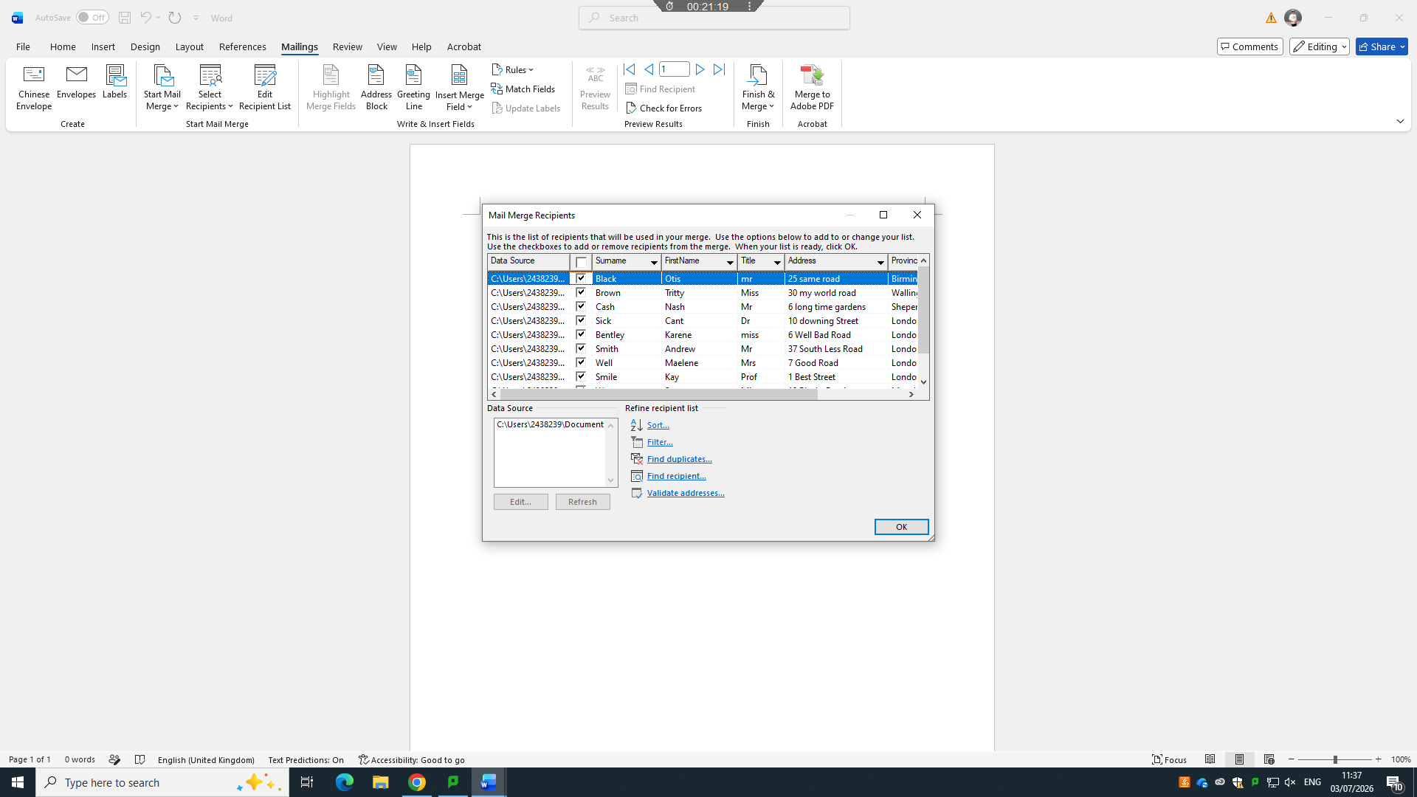



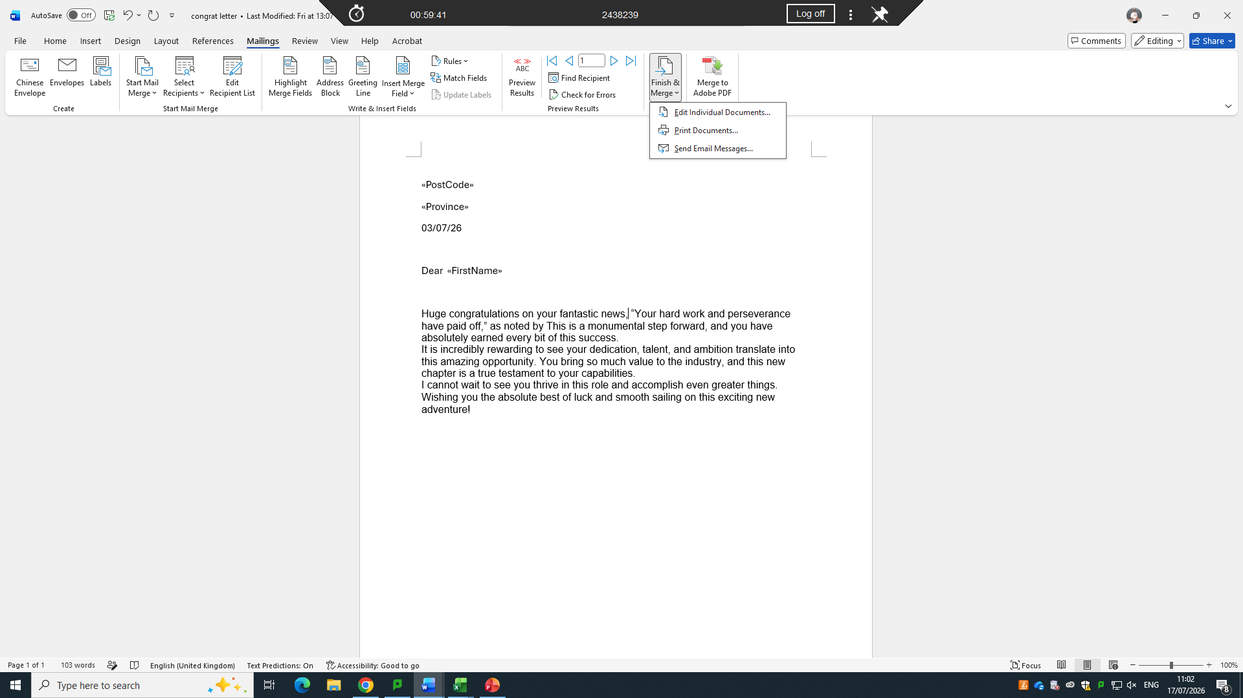


IF Statement


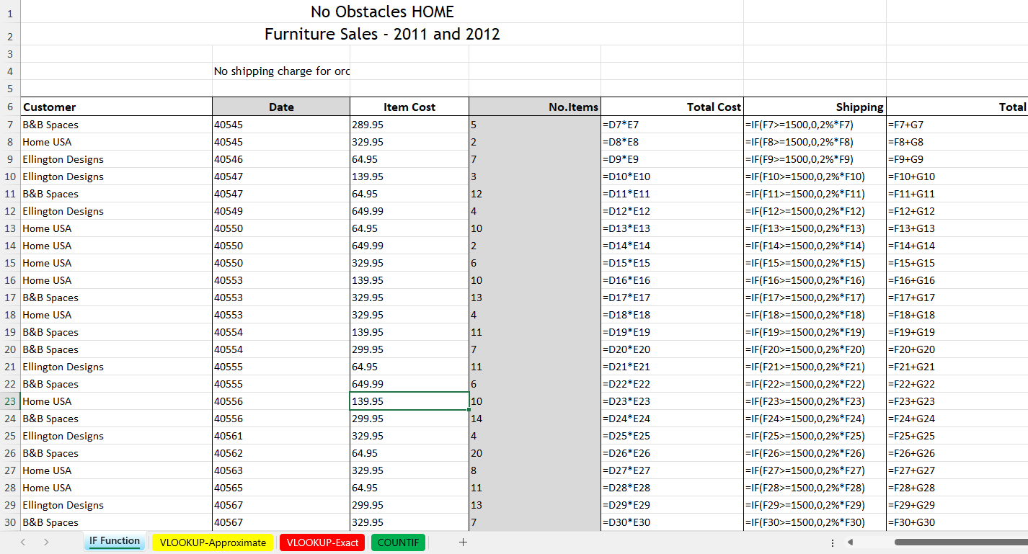

Task 4. Communication and Collaboration applications

4.1 One contemporary Communication and one Online Collaboration

Gmail
Since debuting in 2004, Google's Gmail has evolved from a limited, invite-only service into one of the most widely used email platforms on the planet, now serving well over a billion people worldwide. Much of its staying power comes from a mix of ample storage, sharp search capabilities, tight integration across Google's tools, and an interface that most users find genuinely easy to navigate though it isn't without its downsides.
Search is arguably Gmail's defining feature. Powered by the same technology behind Google's web search, it enables users to locate messages almost instantly by keyword, sender, date, or file type a major improvement over the sluggish search found in many older email systems. This effectively turns Gmail into a fully searchable archive, reducing the need for meticulous manual filing.
Rather than relying purely on traditional folders, Gmail uses a labelling system that lets a single message carry several tags at once say, both "Work" and "Urgent." Paired with automatic sorting into tabs like Primary, Social, Promotions, and Updates, this gives users a more adaptable way to manage large volumes of mail with minimal effort.
Storage is another strong point: 15GB comes free, shared across Gmail, Drive, and Photos, with reasonably priced upgrades available through Google One. Spam detection is also widely regarded as best-in-class, relying on machine-learning models trained across billions of accounts to keep unwanted match unusually high and accuracy.
Gmail's integration with the rest l out of Google's ecosystem is a major differentiator. Users can jump straight from an email into Calendar, Meet, Drive, or Docs scheduling meetings, joining calls, or opening shared files without leaving the thread. For organizations, Google Workspace builds on this further, turning Gmail into the centre of a broader collaborative suite complete with shared calendars and administrative controls.
Access is flexible as well Gmail runs smoothly across browsers, native apps, and third-party clients via IMAP/POP, syncing reliably no matter the device. Privacy remains Gmail's most persistent point of criticism. Although Google ended content-based ad scanning back in 2017, the service still exists within Google's larger data infrastructure, leaving privacy conscious users uneasy about consolidating so much personal communication under one company. This concern has fuelled alternatives like Proton Mail, which market themselves specifically on privacy grounds.
The automatic categorization that helps most users can occasionally backfire, misdirecting important messages into Promotions or Spam a frustration particularly common among freelancers and small businesses that depend on email for client leads.
While the free storage allotment is generous by historical standards, heavy use of Drive or Photos alongside Gmail can eat through it quickly, nudging users toward paid plans.
Offline access is also weaker than what dedicated desktop clients like Outlook offer, typically requiring extra setup through browser extensions to function without internet access.
Lastly, some power users find Gmail's simplicity limiting advanced filtering and complex organizational structures do exist, but they're less intuitive and flexible than what specialized email tools provide.
Gmail earned its dominant position by solving genuine pain points search, spam, and storage that plagued earlier webmail services, and its deep Workspace integration makes it compelling for individuals and businesses alike. Its two main weaknesses, privacy and occasional mis categorization, are tolerable for most but significant enough to keep alternative, privacy-first services relevant.

Zoom
Founded by Eric Yuan in 2011 and made public in 2013, Zoom Video Communications is a cloud based video conferencing service that rose to household name status during the COVID-19 pandemic. As remote work and virtual gatherings became the norm, its daily meeting participants surged from around 10 million to more than 300 million in a matter of months. Years on, Zoom remains a major force in video communication, though its role has evolved from pandemic-driven necessity to just one option among several competitors, including Microsoft Teams, Google Meet, and Cisco Webex.
Zoom earned its reputation through dependable performance stable connections and clear audio and video even on weaker networks, thanks to efficient compression that outpaced many competitors early on and still performs well today.[5] Joining a meeting is frictionless no account or software download needed, just a shared link that works across virtually any device. That simplicity was a key driver of its explosive growth when clunkier enterprise tools couldn't keep up.
The platform also scales well, handling everything from small one-on-one chats to massive webinars with thousands of participants, supported by built-in tools like breakout rooms and waiting rooms. Its feature set runs deep screen sharing, virtual backgrounds, live captioning, cloud and local recording, digital whiteboarding, and AI-driven additions like meeting summarization through Zoom AI Companion. Beyond meetings, Zoom has broadened its offerings with Zoom Phone for VoIP calling, Zoom Rooms for conference hardware integration, and Zoom Events signalling an ambition to be a full communications platform rather than a single-purpose tool. It also performs consistently across desktop, mobile, browser, and dedicated hardware.
Zoom's early days weren't without controversy. In 2020, it came under fire for security weaknesses, including so-called "Zoombombing" disruptions and overstated claims around end-to-end encryption. Despite meaningful security upgrades since then, that early reputational hit still shapes how some users and organizations view the platform.
The company also became closely tied to "Zoom fatigue," a broader phenomenon describing the mental exhaustion of extended video calls often linked to constant self-viewing, diminished non-verbal communication, and physical stillness during meetings. While not exclusive to Zoom, the brand became emblematic of the issue.[6]
Its free tier is another limiting factor, capping group calls at 40 minutes and nudging frequent users toward paid plans a more restrictive setup than some competitors offer for free. Competitive pressure is mounting too: Microsoft Teams benefits from being bundled into Microsoft 365, giving it a built-in edge Zoom must fight against as a standalone product, and Google Meet enjoys a similar advantage through Workspace integration. Meanwhile, as Zoom has added more features over time, some longtime users feel its once-streamlined interface has grown more cluttered.

4.2 Test one feature of a freely available Communication (1) and one feature of a Collaboration (1) application

Gmail
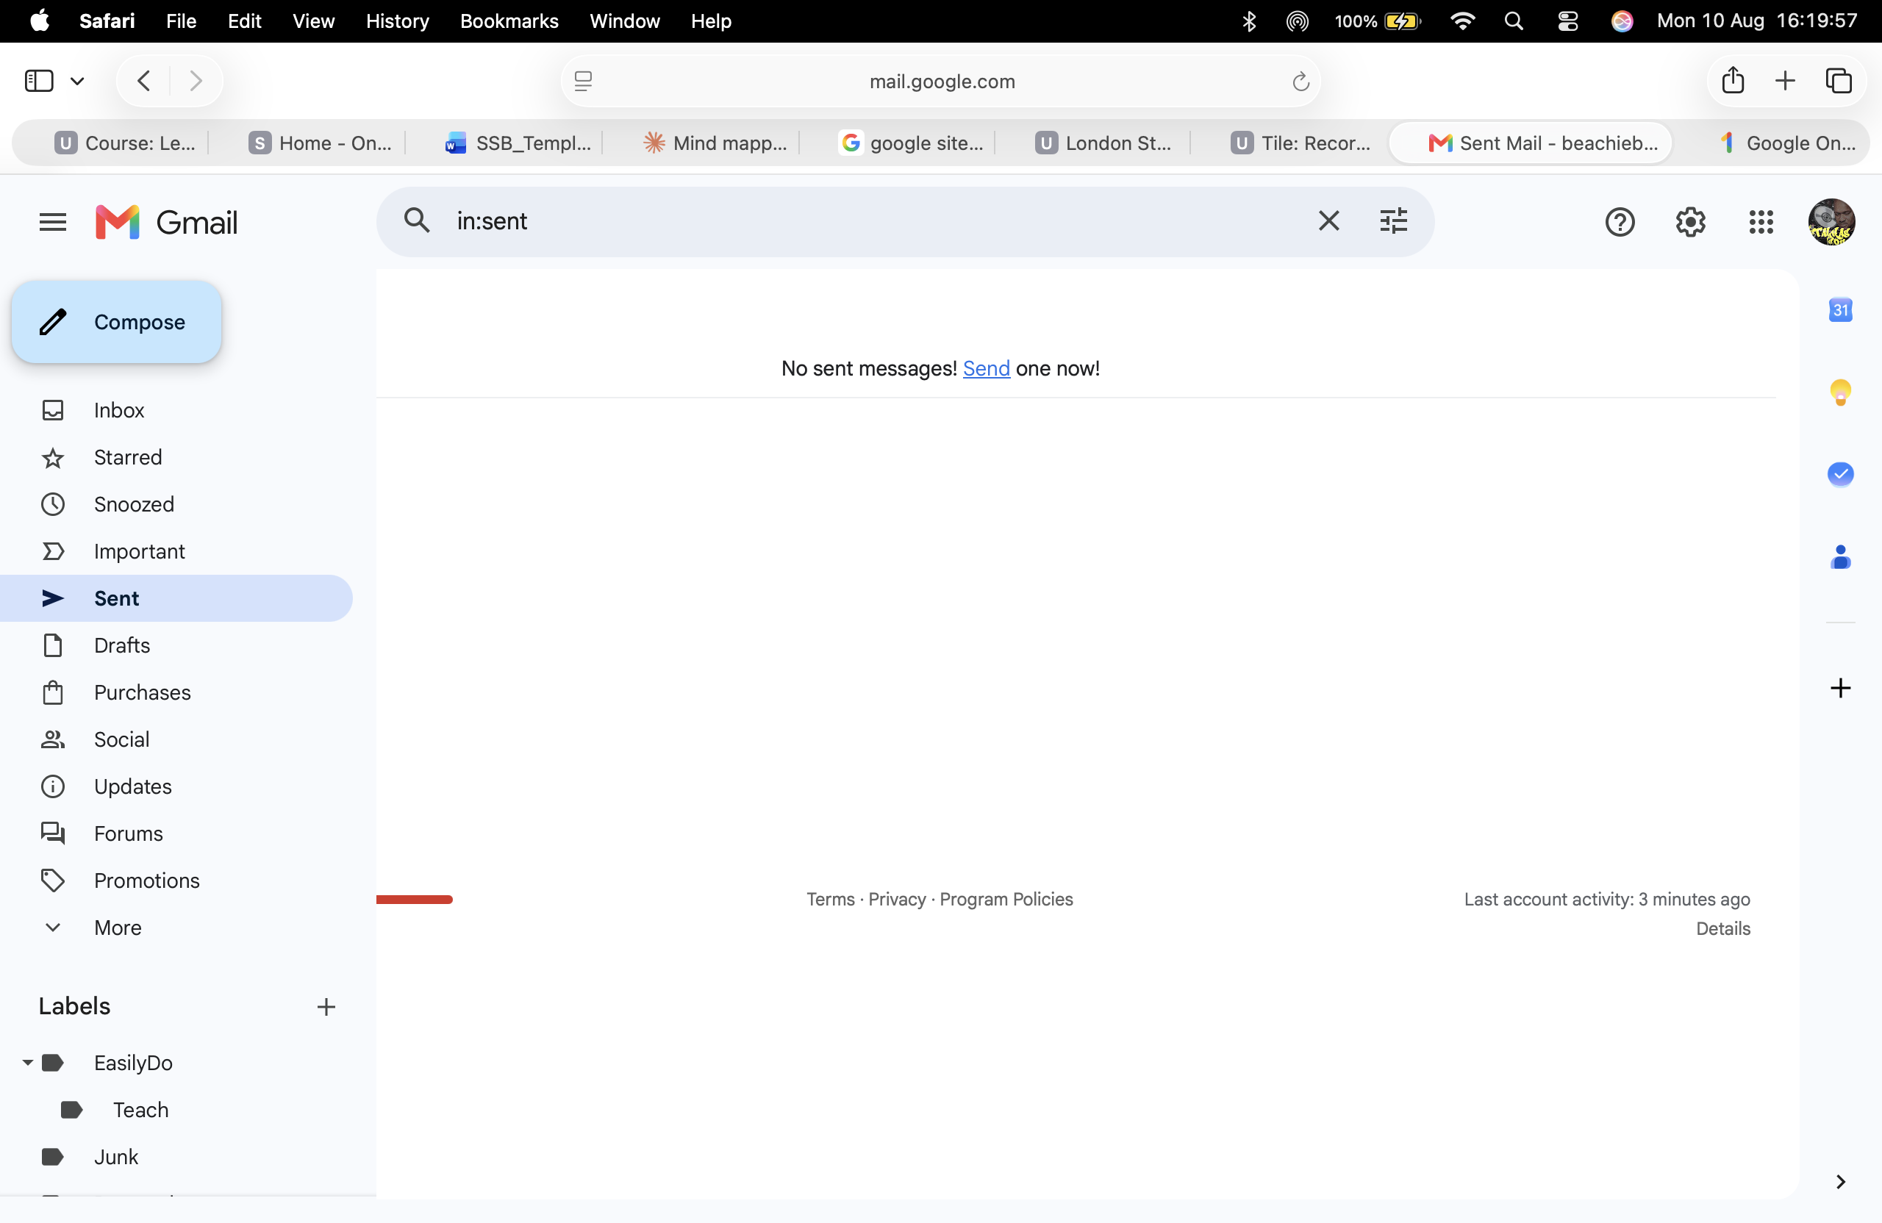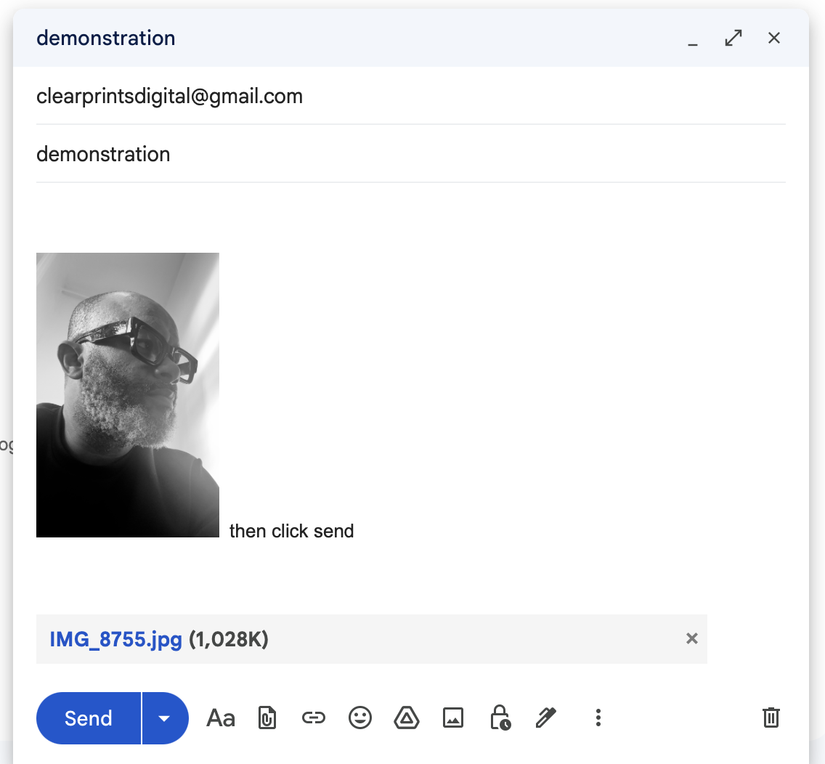
Log into Gmail click on compose then add your recipient and your subject and then add your body either text or images as you see above.

Zoom
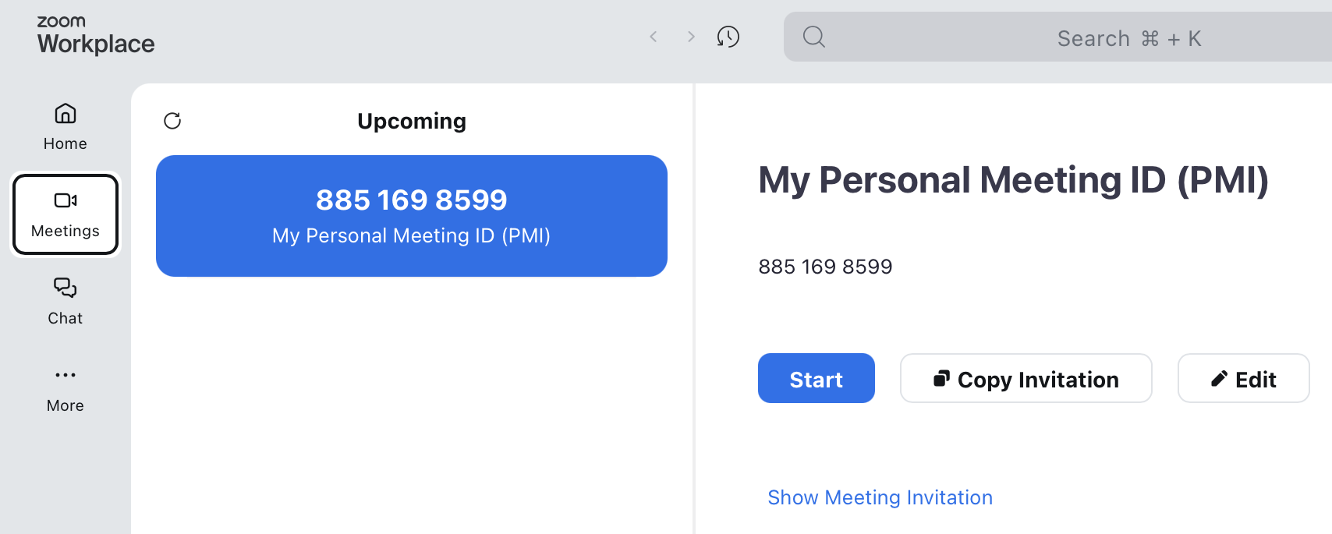 log into zoom then you can share your zoom meeting ID with your recipient


Conclusion
This report has examined a range of contemporary software applications that support key areas of modern business operations, from e-commerce and information organization to office productivity and team communication. Across the four tasks, a consistent theme emerged: no single tool offers the best combination of cost, usability, functionality, and scalability, and the right choice ultimately depends on a business's specific needs, size, and priorities.
In Task 1, comparing IONOS and Google Sites showed that e-commerce solutions involve a clear trade-off between built-in functionality and cost, with IONOS offering more robust, integrated features suited to growing businesses, and Google Sites providing a free, low-barrier entry point better suited to small-scale or hobbyist use. Task 2 demonstrated that mind mapping is a valuable tool not just for notetaking but for organizing complex information in a way that mirrors natural cognitive processes, making it useful for planning and presenting the software landscape covered in this report. Task 3's review of Word, Excel, PowerPoint, and Access highlighted that while each Microsoft Office application is powerful within its domain, all carry a subscription cost and a learning curve, and each is best suited to specific tasks rather than serving as a universal solution. Finally, Task 4's analysis of Gmail and Zoom showed how communication and collaboration tools have become central to business operations, each solving distinct problems, email management and video conferencing respectively, while facing their own limitations around privacy, cost, and feature complexity.
Overall, this report reinforces that selecting appropriate software requires weighing practical trade-offs rather than searching for a single "best" option. Businesses are best served by matching tool capabilities to their actual operational needs, budget constraints, and technical capacity, rather than defaulting to the most feature-rich or well-known platform available.

References
References
[1] N. S. Gaddapuri, Cloud Computing in Regulated Financial and Healthcare Systems (Architecture Patterns, Security, and Compliance Frameworks), Geh press, 2026.
[2] B. Sun, "Online Store," in Brand Intelligence: Navigating the Transformation in the AI and Web3 Era, Springer, 2026. pp. 155–191.
[3] L. F. A. da Silva, P. R. da Silva Amalfi Costa and C. Schepke, "Performance and Resilience Evaluation of a Hybrid Edge–Cloud IoT System Across Connected, Offline, and Reconnection Scenarios", in International Conference on Computational Science and Its Applications, pp. 651–668.
[4] J. Singh, M. N. Bano and M. S. Chaudhary,Applications of Computer Science: Practical Guide and Laboratory Manual for Learning Word Processing, Electronic Spreadsheets, and Presentation Tools, PV Mindspire Publishing, 2026.
[5] A. Sharma and D. Shrivastava,ICT and New Media Bridging Technology and Communication, CRC Press, 2026.
[6] K. Seyfi, Ö TONKAL and A. T. KARADENİZ, "BRAND BIAS AND POTENTIAL MANIPULATION IN GENERATIVE ARTIFICIAL INTELLIGENCE MODELS: A COMPARATIVE ANALYSIS OF TEXT-TO-IMAGE OUTPUTS,"

