3/4/2026
University of Wales Trinity Saint David
London campus
E-Portfolio Link: https://2524355.wixsite.com/my-site-4

Module Name: Learning In the Digital Era
Module Code: ACCA 4025

Student Name: Bakytbek Sydykov
Student ID: 2524355
Group: 1

Lecturer’s Name: Koushik Modak

LDE Assignment 1
E-Portfolio
Table of Contents
Introduction 2
Main Body 2
Task 1: Essential Academic and Employment Skills for the future career Path 2
Task 1 (a): Report on Essential Academic and Employment Skills 2
Task 1 (b): Evaluation of Task 1 (a) based on Similarity report 2
Task 2: Collaborative Mind Map and Individual Poster 2
Mind Map (Collaborative) 2
Poster (Individual) 2
Task 3: Virtual Collaboration and RefWorks 2
Report on Virtual Collaboration 2
Step-by-step process of using RefWorks with visuals 2
Task 4: E-Portfolio Creation and Evaluation 2
Task 4 (a): E-Portfolio Creation 2
Task 4 (b): Illustrative Review of E-Portfolio tool Selection 2
Conclusion 2
References 2
Task 1 References: 2
Task 3 References: 2

Introduction

Main Body

Task 1: Essential Academic and Employment Skills for the future career Path

Task 1 (a): Report on Essential Academic and Employment Skills

Useful skills worth learning in college improvement soft skills for every student or professional, why do we attend college and obtain a higher education?
We attend college because it’s important for our students to educate themselves in class and at home [1]

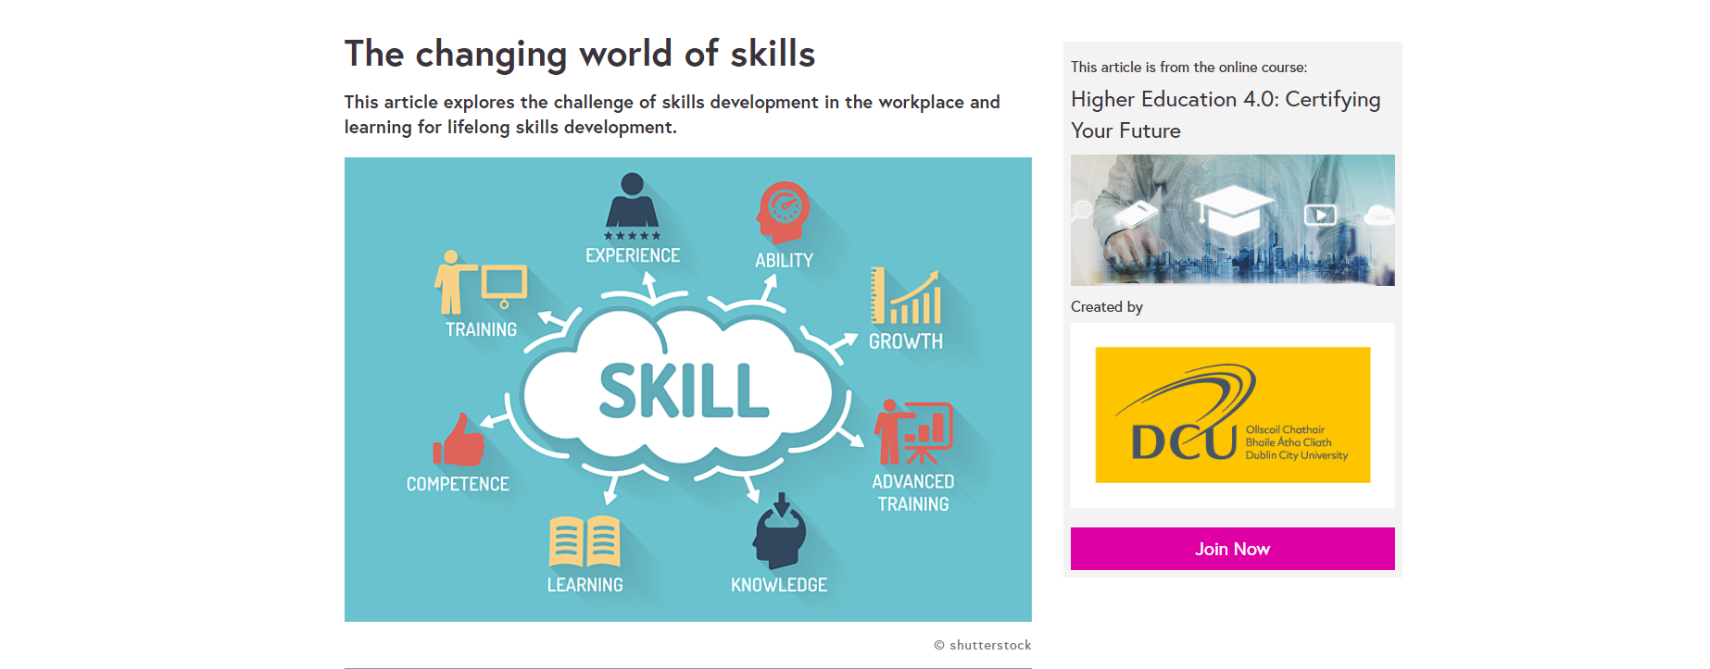

[2]
Professional skills classification generally, professional skills are divided into two types:
Hard skills. These are specific skills essential for professional development. They can be general: knowledge of language, ability to work with CRM systems, or business correspondence skills.
Soft skills. These are personal qualities that help an employee work in a team, oversee projects, or negotiate. The ability to meet deadlines and absorb new information is essential in any position.
Both give us full understanding about professional skills and their position in personal life. [3]
The most common mistakes when filling out skills are:
- Adding skills that are irrelevant to the job description (an economist writes about copywriting skills, while a designer writes about building financial models);
- Failure to specify the level of professional skill proficiency (for example, one introductory webinar about Yandex. Metrical doesn’t make you a pro);
- Vague wording (“confident PC user” instead of listing the programs you use). [4]
We can use different meaning about right description how we should write our CV.

References

[1] | 2026. [Online]. Available: “https://www.consultant.ru/edu/student/useful_advice/poleznie_navyki/,”.
[2] | Shuttterstock, “https://www.futurelearn.com/info/courses/higher-education-certifying-your-future/0/steps/210610,” 2015. [Online].
[3] | Y. 3. Team, “https://360.yandex.ru/blog/articles/kak-pisat-o-professionalnyh-navykah-v-rezyume-chtoby-zvali-na-sobesedovaniya,,” 2024. [Online].
[4] | i. c. choose, “https://icanchoose.ru/blog/kak-opisat-navyki-v-rezyume/,,” 24 January 2018. [Online].

Task 1 (b): Evaluation of Task 1 (a) based on Similarity report

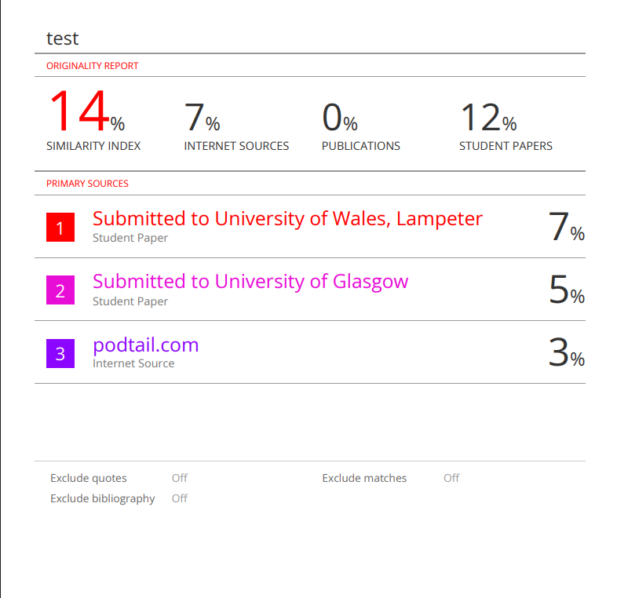

Task 1 (b): Evaluation based on Similarity Report
The similarity report for Task 1 shows a result of 14%, which is acceptable for academic work. This means that most of the report is original and written by me.
According to the report, 7% of the similarity comes from internet sources and 12% from student papers. This is mainly because I used some common academic phrases and information from sources. All the sources I used are included in the reference list.
There is no similarity with publications, which shows that I did not copy any professional or published materials. The matches in the report do not mean plagiarism, but show that I used sources correctly.
Overall, the similarity percentage is low and acceptable. This shows that I followed academic rules and used references properly in my work.

Final Conclusion
A similarity score of 14% indicates an acceptable level of originality. However, the assignment requires improvements in academic writing, paraphrasing, and referencing to fully meet university standards.

Task 2: Collaborative Mind Map and Individual Poster

Mind Map (Collaborative)
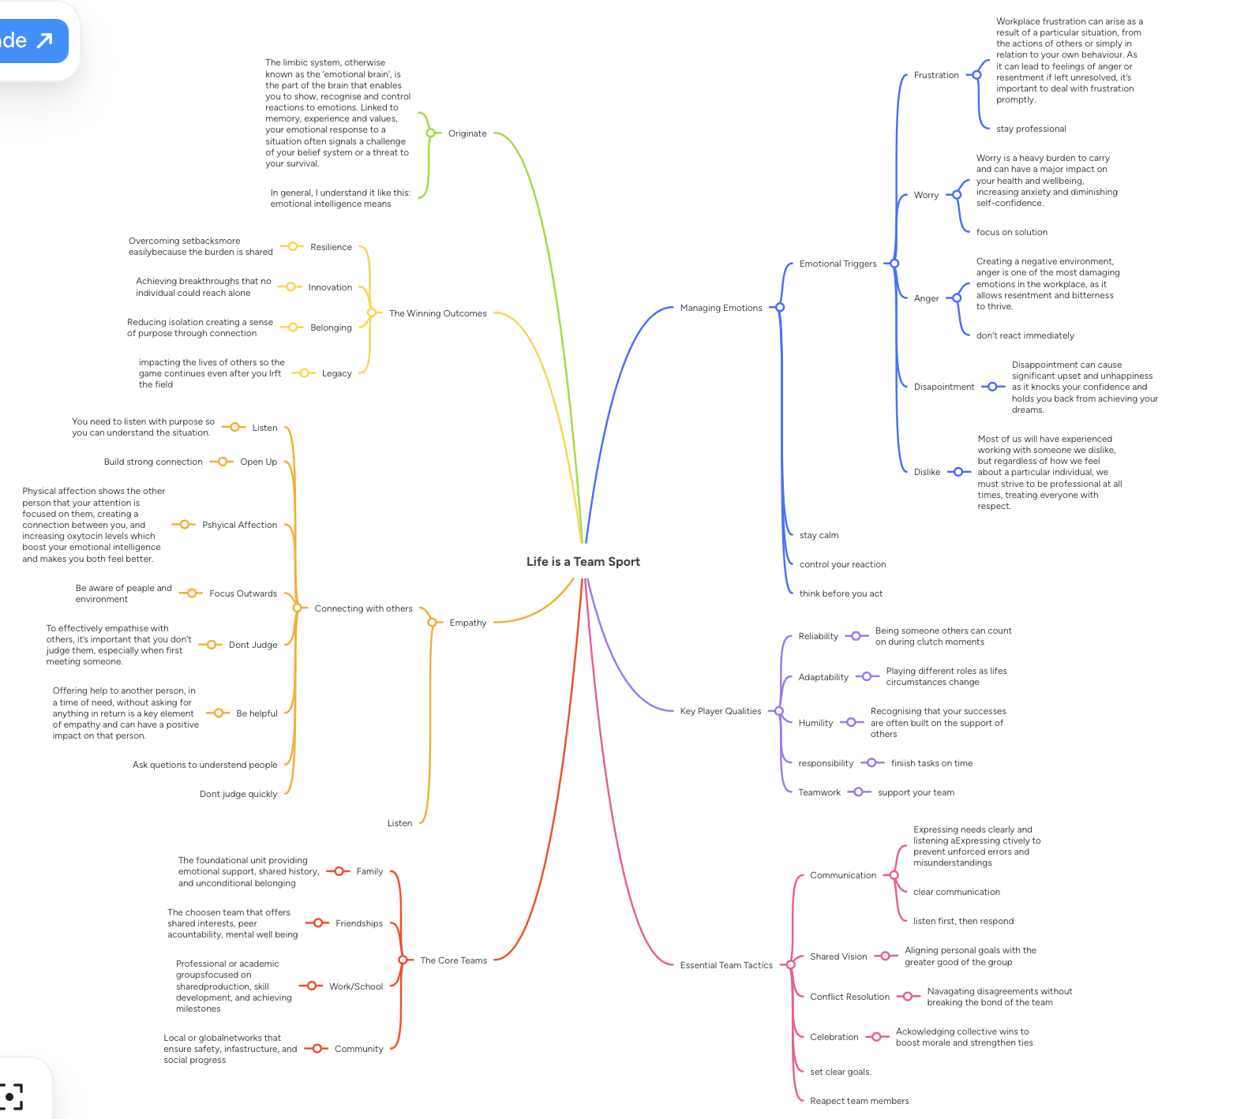
Link from MindMeister: https://mm.tt/map/3952545945?t=cSff7tionA

Poster (Individual)
Link from Canva: https://www.canva.com/design/DAHEG3anAz0/KM9c9CiHR13nAxDnU8lMGQ/edit?utm_content=DAHEG3anAz0&utm_campaign=designshare&utm_medium=link2&utm_source=sharebutton

Task 3: Virtual Collaboration and RefWorks

Report on Virtual Collaboration
Computing Skills for the Workplace
PART 1
VIRTUAL COLLABORATION

Introduction
Virtual collaboration is very important in modern life. It helps people work together online using digital tools. Today, students and workers use virtual collaboration to communicate, share ideas, and complete tasks. It is especially useful in education and business.

What is Virtual Collaboration

Virtual Collaboration means working together through the internet. People use tools such as Zoom, Microsoft Teams, and Google Docs. These tools allow users to talk, send messages, and share documents. Students can work on group projects even if they are in different places.
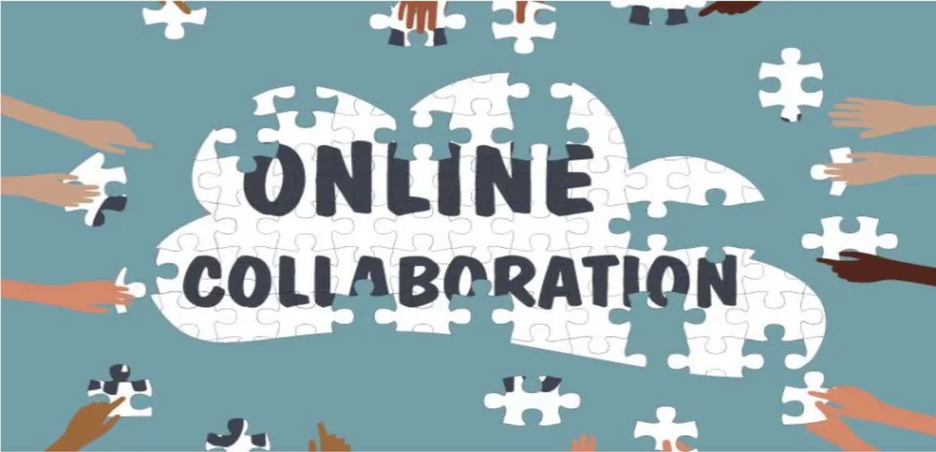

Figure 1: Online collaboration

3 Advantages and Disadvantages

Virtual Collaboration has many advantages. First, people can work from any location. Second, it saves time because there is no need to travel. Third, communication becomes faster and easier.
However, there are also some disadvantages. Internet problems can interrupt work. People may not always understand each other clearly. In addition, virtual communication is less personal than face-to-face interaction.

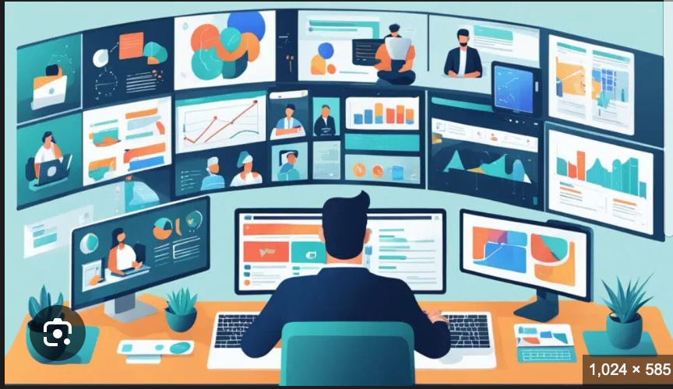

Figure 2: Virtual teamwork

4 Conclusion

In conclusion, virtual collaboration is a useful and important tool in modern society. It helps people work together effectively and makes communication easier. Despite some disadvantages, it is widely used in education and work.

Link from Google Docs:
https://docs.google.com/document/d/1fPhS5mlEG3O1Ytex85B9vfW7nl6uzOPnf7kG1InL97M/edit?usp=sharing
Step-by-step process of using RefWorks with visuals
- Create an account

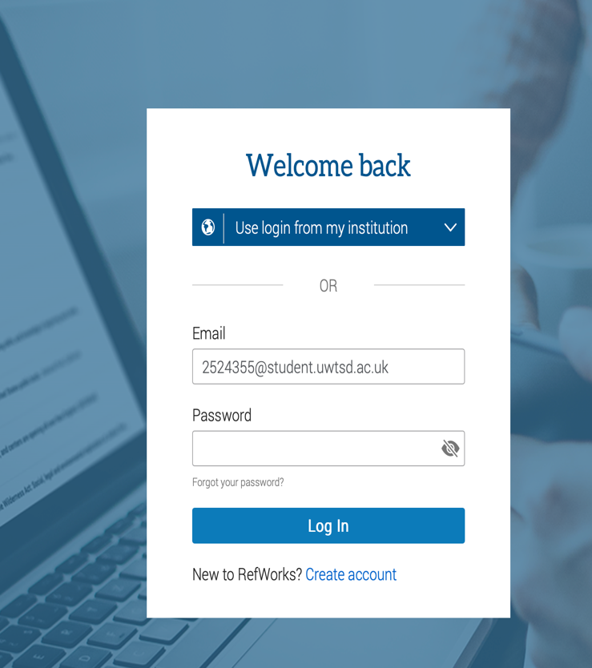

2. Add sources

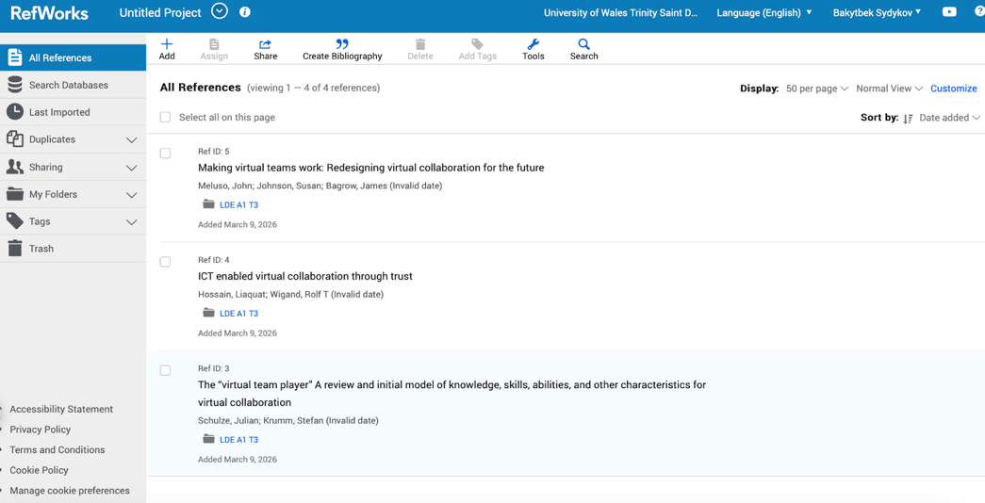

3. Organize sources

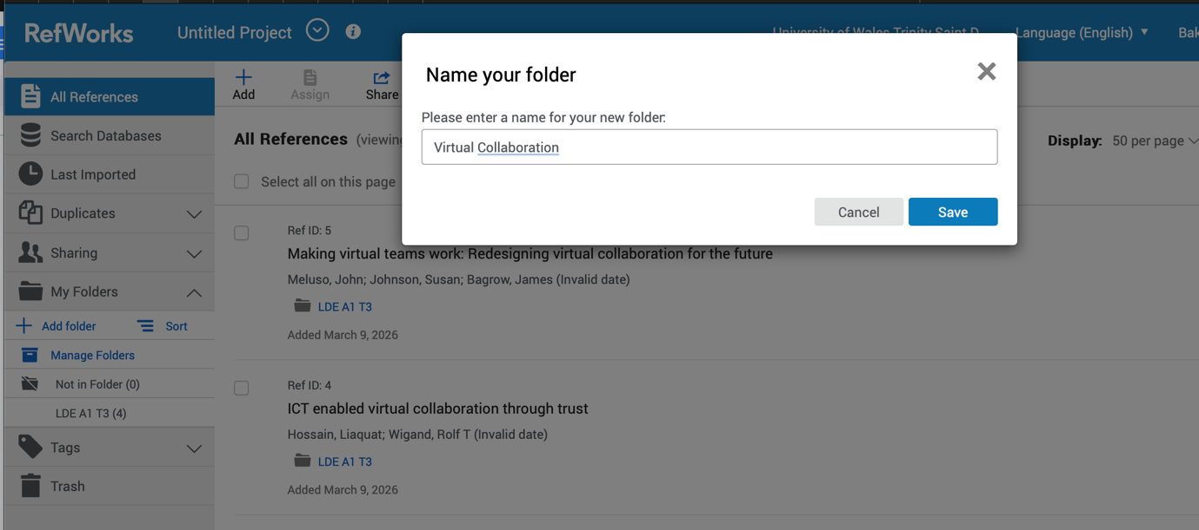

4. Resources finding

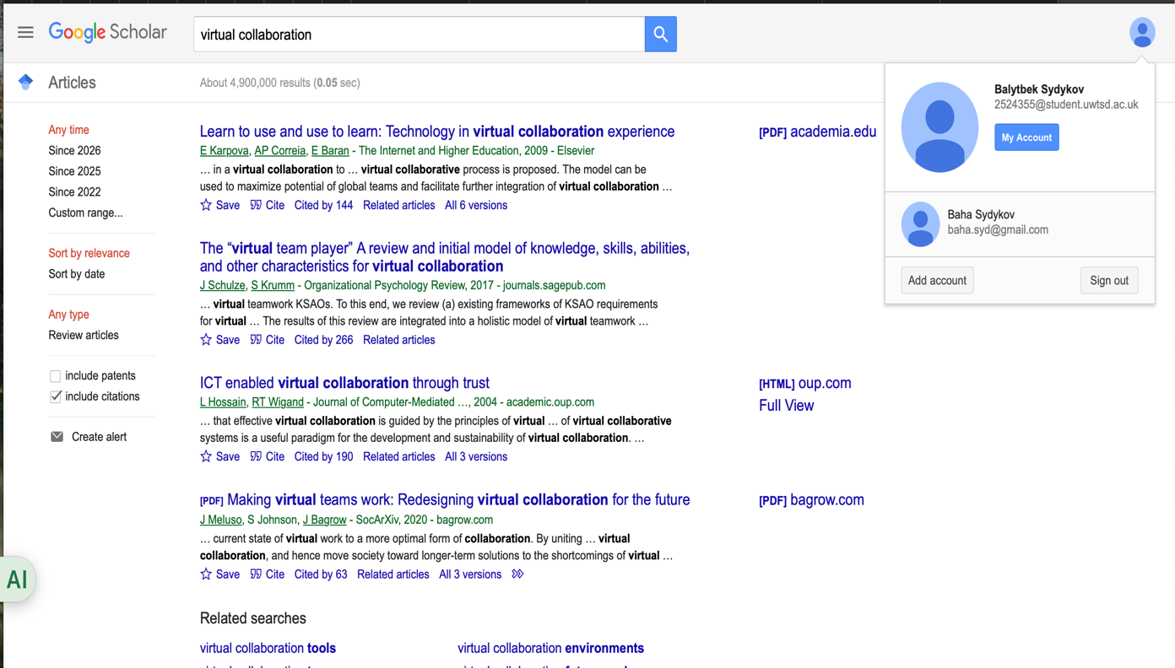

5. Create bibliography

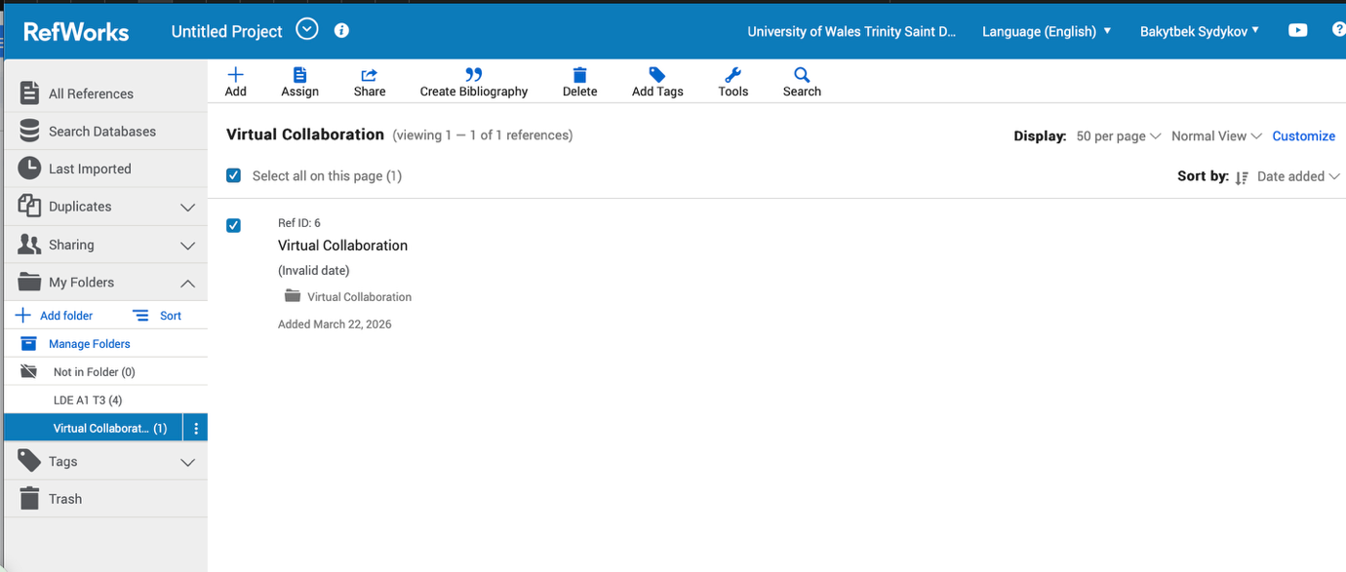
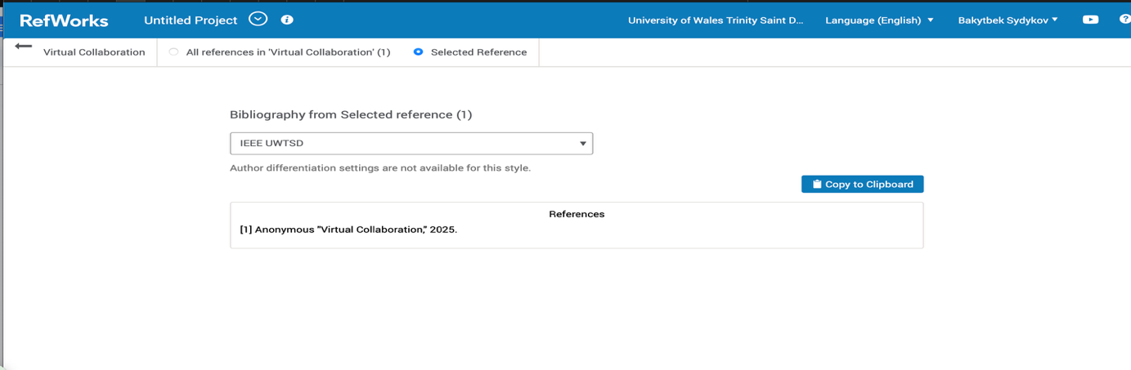

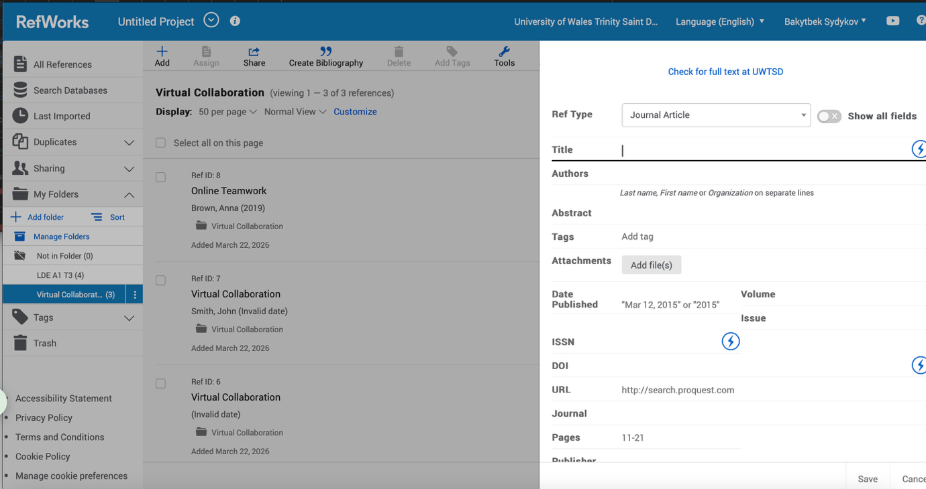

Task 4: E-Portfolio Creation and Evaluation

Task 4 (a): E-Portfolio Creation
In this task, I created my own e-portfolio using Wix. The main goal was to present my academic work in a clear and organised way. I added different sections such as Task 2, Task 3, and Reflection to show my progress.
Wix was easy to use because it provides ready templates and simple tools. I was able to add text, images, and links without technical skills. I also organised the pages so that users can easily navigate through my work.
This task helped me improve my digital skills and understand how to present information online in a professional way.
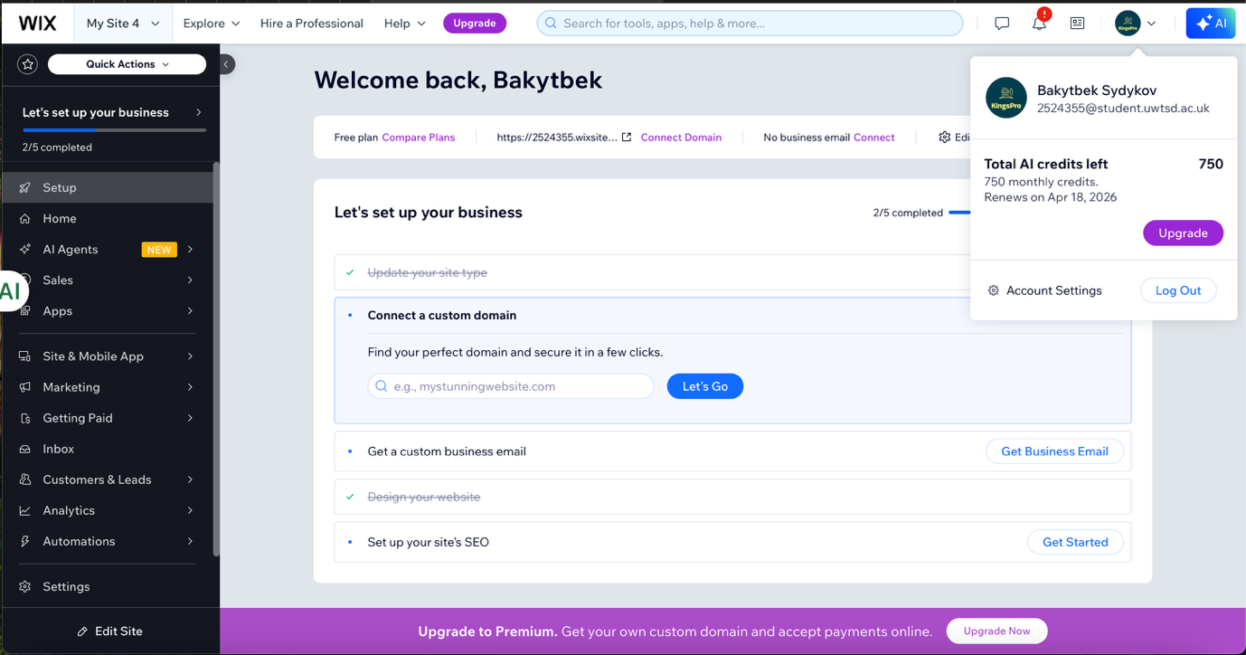

Task 4 (b): Illustrative Review of E-Portfolio tool Selection
In this task, Wix was selected as a tool for creating an e-portfolio. Wix is a website builder that allows users to create and manage websites without advanced technical knowledge.
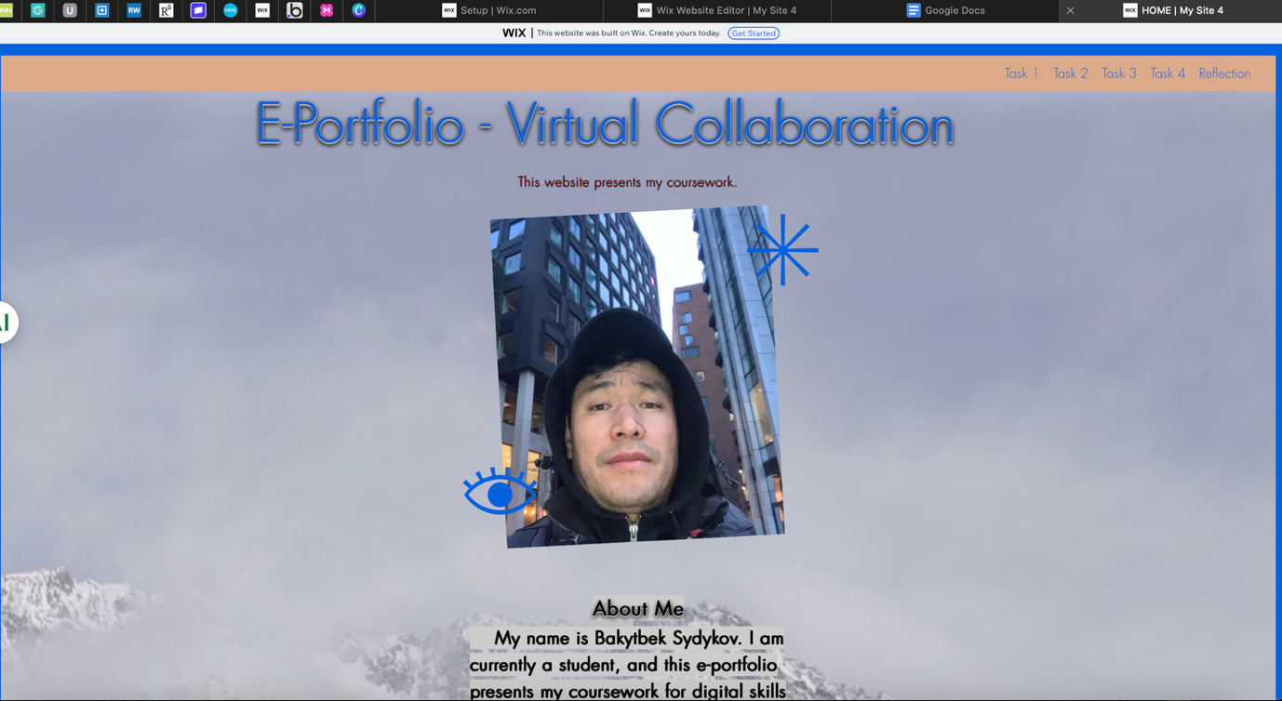
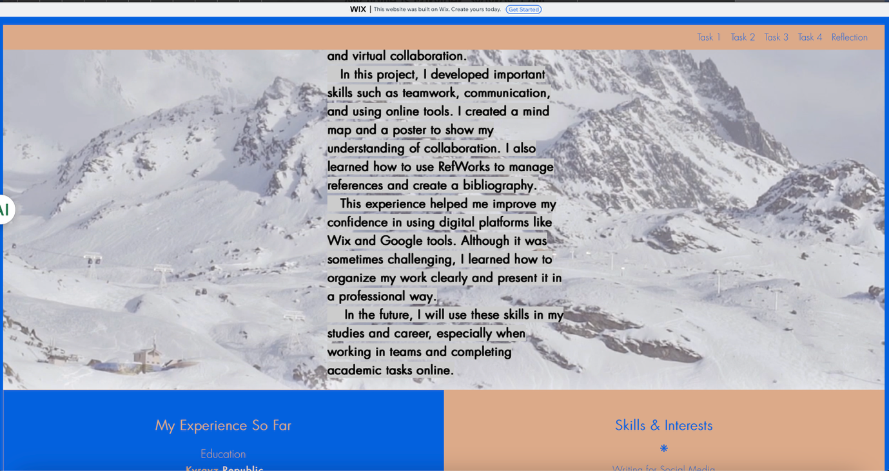
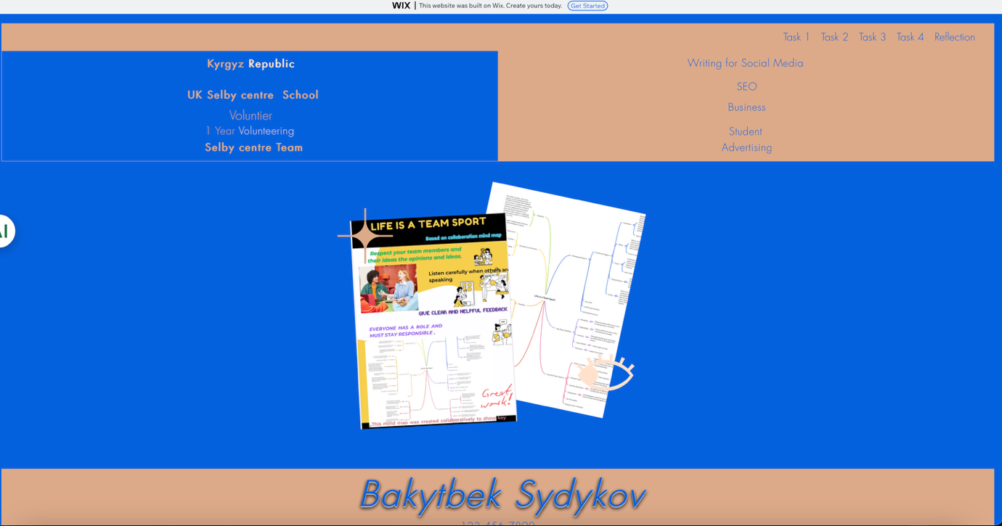
One of the main advantages of Wix is its user-friendly interface. It provides ready-made templates and design tools, which help users organise content clearly. This makes it suitable for students who need to present their academic work online.
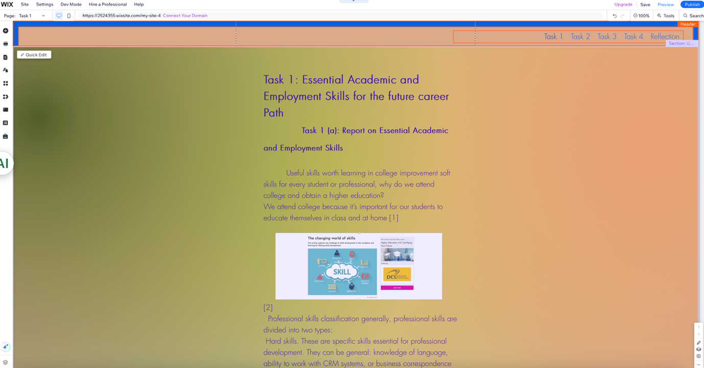

Another important feature is flexibility. Wix allows users to customise layouts, add multimedia content such as images and links, and create multiple pages. This supports clear structure and easy navigation within the e-portfolio.
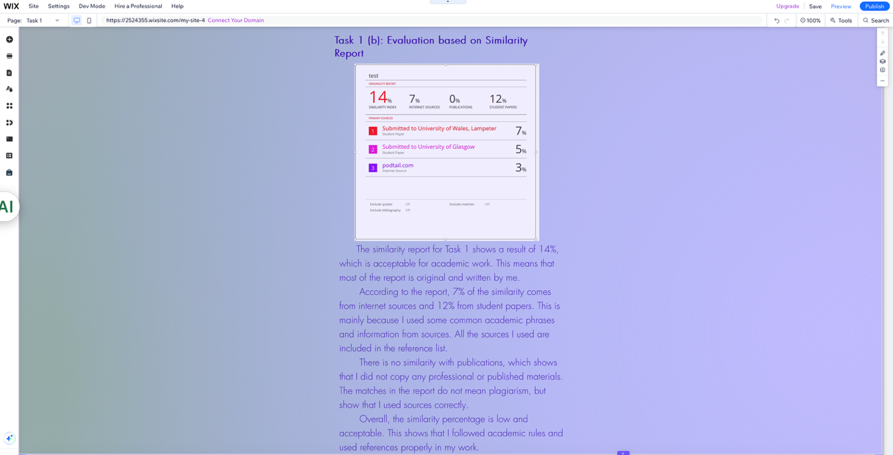

However, there are also some limitations. For example, some design options are restricted depending on the template, and adjusting layout elements can sometimes be time-consuming. In addition, users need to check how the website appears on different devices.
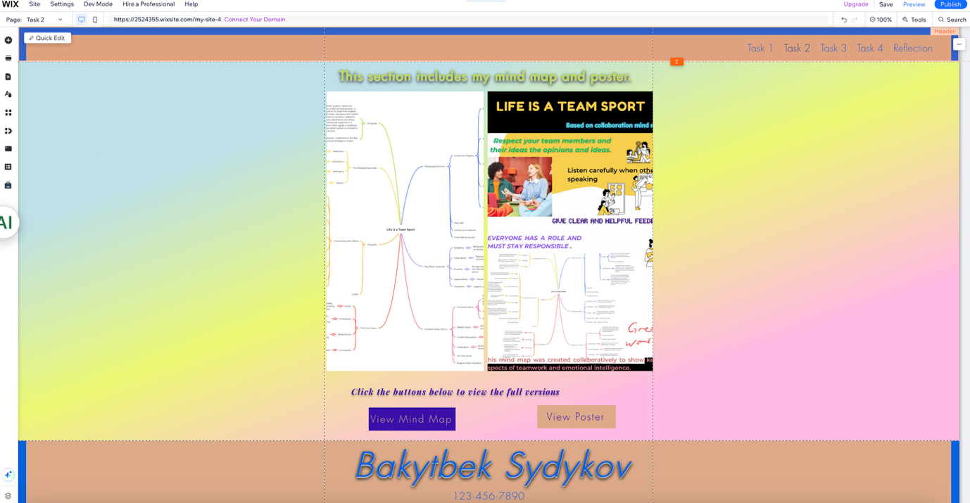

Overall, Wix is an effective tool for e-portfolio creation. It combines ease of use with useful design features, making it a suitable choice for presenting academic work.

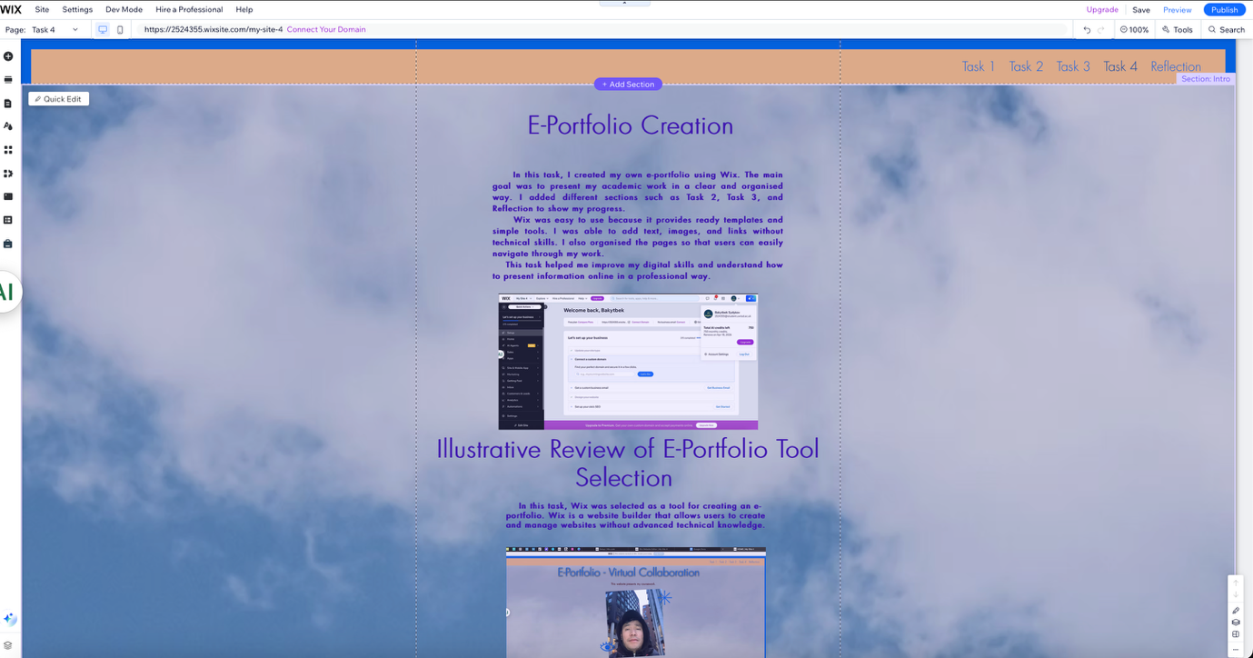

Conclusion
In conclusion, the development of the e-portfolio represents an effective way of presenting academic work in a structured and organised format. The use of a digital platform allows information to be displayed clearly and accessed easily by users.
The selection of Wix as a tool supports the creation of a functional and visually clear website. Its features, such as templates, page organisation, and multimedia integration, make it suitable for academic purposes. These elements contribute to improved navigation and a better user experience.
Furthermore, the e-portfolio demonstrates the ability to apply digital tools in an academic context. It highlights the importance of organisation, clarity, and structure when presenting information online.
Overall, the e-portfolio provides a professional way to showcase academic work and reflects the effective use of modern digital technologies.

References

Task 1 References:
[1] | 2026. [Online]. Available: “https://www.consultant.ru/edu/student/useful_advice/poleznie_navyki/,”.
[2] | Shuttterstock, “https://www.futurelearn.com/info/courses/higher-education-certifying-your-future/0/steps/210610,” 2015. [Online].
[3] | Y. 3. Team, “https://360.yandex.ru/blog/articles/kak-pisat-o-professionalnyh-navykah-v-rezyume-chtoby-zvali-na-sobesedovaniya,,” 2024. [Online].
[4] | i. c. choose, “https://icanchoose.ru/blog/kak-opisat-navyki-v-rezyume/,,” 24 January 2018. [Online].

Task 3 References:

[1] E. Taylor, "Remote Work Tools," 2022,
[2] A. Brown, "Online Teamwork," 2019,
[3] J. Smith, "Virtual Collaboration," 2020,
[4] Anonymous "Virtual Collaboration," 2025.

