

Innovation and Creativity

Taslima Begum

23/04/2021

—

Developing innovation and creativity for business advantage

—

Davina Evans

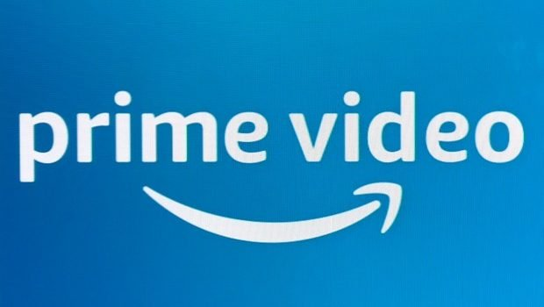

Executive summary
This report highlights the innovation process of prime video planning to do live streaming sessions for young children during the pandemic to help parents and care with homeschooling. The innovation process will be play and fun activities for children to watch which will be done by the prime video employees. Tools and technique models have been used to Annalise the process and the advantages and disadvantages the process will bring to the business. Prime have come up with this innovation process due to the pandemic and McKinsey’s research showed that many other online platforms have come up with innovation programs to enhance the business and increase profit.



Contents page
- introduction
- main findings
  - swot analysis
  - technology innovation matrix -Leadership
  - models of innovation
2.3.1- open and closed innovation
2.3.2- the innovation process
2.3.3- 4P’s to innovation
2.4 Kurt lewin’s force field analysis
2.4.1- barriers and risks
3.0 conclusion
4.0 recommendation
References

1.0 Introduction

This report was requested by the CEO of Amazon Prime Jeff Bezos. On the date of 23/04/2021 The CEO requested this report to see the outcome of an innovation and creativity idea of their digital platform prime video during the pandemic in order to see if this reaches to their audiences for younger children in order to keep them occupied by streaming a live sessions of play and activity. This research will be carried out by using various textbooks, journals, internet, and articles. This report will be researched and presented by one of the employees that work on the digital platform prime video. Prime video (1997-2021) is also known as amazon prime video. It is an American internet video on demand service that amazon developed and operated by amazon. Prime video offers television shows, films, films to rent or purchase. Prime video has a selection of amazon studios original content which has licensed acquisitions included in the amazon prime subscription. This is accessible in the UK, US, Germany, and many other territories. Prime video is also available through a video only membership which does not require the full prime subscription.

What is innovation?

According to Max (2014) innovation or practical creativity can be developed by improving the balance between you and your situation. The great innovators want more better and faster they take us forward. Which therefore innovation needs you to be dissatisfied with the way things are. Which you need to travel the limits in order to move forward. Innovators push them selves some fail some fall, but the attempt is made. It is about making new ideas useful.
However according to Larry (2013) innovation is reduced to a serious of brainstorming sessions where employers and employees say ‘hey there is no such things as a bad idea!’ using ideas out of the box and being creative in order to enhance the organisation or business.

What is creativity?

Mullins (2016) implies that creativity is a form of application of imaginative thought, which may lead to seeing thigs in a new way, and results in innovative solutions to a problem or the initiation of change.

The difference between the two is being innovated you are thinking practically realistically and by being creative you are imagining and idea outside the box which isn’t realistic. But the similarity is developing new ideas using both methods in order to enhance and create success for the business or organisation.

2.0 Main Findings

In the year 2020 the world has changed because of COVID -19, and the global pandemic started to impact on everyone’s personal life as well as professional life and business organisation. However, a survey was done by the Mckinseys & company (1996-2021) in June 2020, over 200 business organisation across variety of industries were taken over by the mckinseys company. Who discovered that 90% of respondents expected the impact of the pandemic to change the way they do business, with 75% agreeing that the pandemic is a new opportunity to create innovation and creativity in the business?

The business organisation amazon prime video took this opportunity in hand to try out an innovation opportunity in their organisation in order to create a business advantage.
Prime video is carrying out an innovation opportunity during the pandemic for the foundation phase children who are at home during this period. Prime video will be streaming live video sessions every morning 9.30 am to 10.30 am on different play and activities for children to watch learn and enjoy. Prime have not done live streaming before which therefore this is all new to the organisation. Prime will have employees doing research on this innovation opportunity to understand if this creativity idea will be a business advantage or not. The live streaming sessions will also be created by the amazon prime team. Prime video will need to think outside of the box for what to stream everyday for an hour and will this attract the attention of young children. However prime is streaming the 1st half hour free if you have no subscription and will have to subscribe to watch full live streaming. This research will be carried out by using the SWOT analysis to highlight the areas and the research from the swot findings, the opportunity then will be used to become more innovated to enhance the business.

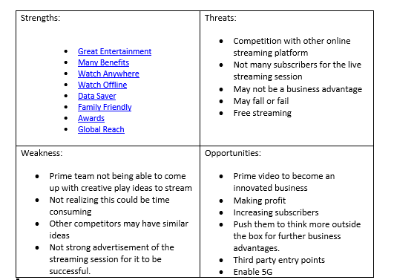
2.1 SWOT Analysis

According to mindtool (2020) SWOT analysis is a technique for assessing these four aspects of your business. STRENGTHS, WEAKNESSES, OPPORTUNITIES and THREATS. Using a SWOT analysis makes of what you got to your organisation best interest. Swot analysis can outline what is lacking and eliminating barriers that would have been unseen. This tool and technique distinguish the business from the competitors and so compete successfully in the market.

Looking at the SWOT analysis prime video has many opportunities to enhance this innovated process. Prime can have more subscribers as well as customers that are already subscribers will be using prime video more due to their children. This will increase their profits. Also being creative by hosting a live stream every morning with play and activities for children to learn and enjoy which will then lead them to further business advantages if this is a success they can do other live streaming sessions for children. Prime can also have the advantage of adding more screens such as watching on tv as well as phone tablets etc. all family members can watch at the same time different programmers. Prime can also think towards enabling 5g for better connection and HD streaming. Prime video also can have the recording option to be able to download the live streaming session later. Prime are already doing very well with their downloading.

According to Michael (2019) amazon prime video’s download grew 30% year over year in 2020, which has grown by 25% since 2019. Due to nationwide lockdown and WFH have pushed the demand for online streaming apps, which has benefitted amazon. This opportunity of the live streaming session will bring out a lot of benefits for prime video as they already has such a large number of subscribers the only threat to this opportunity is that they will have to watch their competitors who may have similar and better ideas. Prime can continue with he live streaming session when children return to school they can always change the timings to continue this innovation process.

2.2 Technology innovation

J.A.C (2001) initiates that Technological innovation creates opportunities for businesspersons to found new organisation and establish competitive situations as incumbents’ sources of advantage decay. Technological innovation also creates uncertainty and risk for incumbents because its outcomes can be easily imperfectly anticipated.
Prime video will be using an innovation matrix to explain their technological innovation program and how it fits in with this model and the pros and cons.
According to tools hero (2013-2021) the innovation matrix is to visualize the various aspect of the innovation. There are various innovation matrices which will fit in with prime video’s innovation program. In some cases, innovation can be misunderstood this is because it is viewed from the same perspective. Innovation however is a diverse activity, which occurs in many organisation such as laboratories, universities, and research centers. But also, in retail or coffee shop people are always thinking of ways to improve and develop new ideas for the business to take advantage. There are 4 types of innovation. Albert Einstein once said, “if I had 20 days to solve the problem, I would take 19 days to define it.” He means the most important part of the problem is defining the problem then solving it. The ability to define the problem is important strategy to choose the right innovation strategy. This is why prime video will need to use the model to identify the problems they will have in their innovation process in order to start the live streaming for younger children during the pandemic and how they can continue this live streaming once after schools open up again and will this be a good idea to carry on with the process in order to be innovated and creative to take a business advantage further. The innovation matrix will identify what is new to the organisation and what the organisation already has.

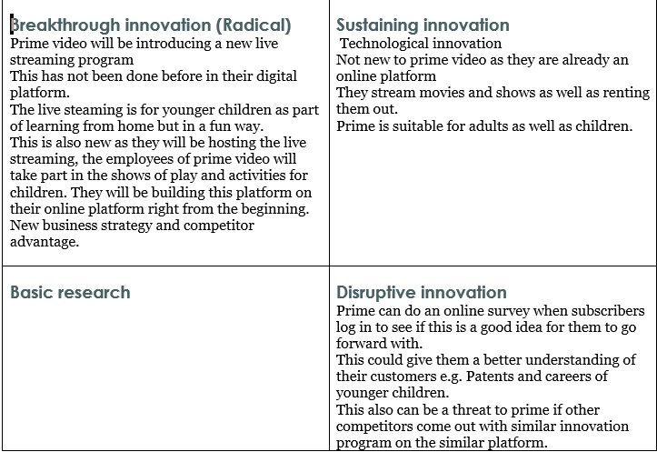

This innovation matrix model is considerably basic model just outlining what’s new and what they already have as a business. Its not pointing out the pros and cons of the innovation process. The only thing it points out is that it could be a threat as other similar online platforms can come up with same ideas.
It’s not an in-depth model which outlines barriers and how to solve them. The innovation matrix model is showing the organisation what they already know of and does not enhance the business in any way.

Leadership style:
The leaders in prime video have a very democratic style to this innovation process. They have let their employees take over the live streaming sessions with planning included, he will only get involved if he feels like has to do so. Before the employees run the live session they run through the whole concept each time before airing the show with the team leader and if its all set nicely in place they will get a thumbs up and if things need changing then they will have to do that before they start the show. This type of style is called democratic style of leadership.

Kendra. C (2020) implies that Democratic leadership style is known as a shared leadership it is a type of leadership style in which all team members take part in the decision-making process. This style can be applied to any organisation, from private business to schools and government. Every team member has been giving the opportunity to participate and exchange ideas freely. The democratic style particularly focuses on group equality and free flowing ideas. The leader is still there to offer guidance and control.
¹﻿

2.3 Model innovation

2.3.1- open and closed innovation

The difference between open and closed innovation is defined by the way in which innovation is created. A closed innovation is developed in a self-contained company environment, open innovation incorporates external knowledge into innovation management.

According to Daniel (2018) The closed innovation is only developed within clearly defined company boundaries. The company invest into large sums in internal research and development in order to establish the process. The companies use significant technological inventions that lead to innovative products and solutions. In order to have a successful closed innovation the company must follow certain factors into account. Closed innovation places an exceedingly high demand on employees, for example the company should always strive to the highly qualified employees.

This goes to show prime video is a closed innovation as the innovation program they are planning is within their company and internally. As the employees will be taking part in the live sessions planning and implementing the live shows for young children. This should be given to the employees who stand out with creative minds.

Whether a company prefers open or closed innovations as part of the innovation strategy this particular depends on three factors.

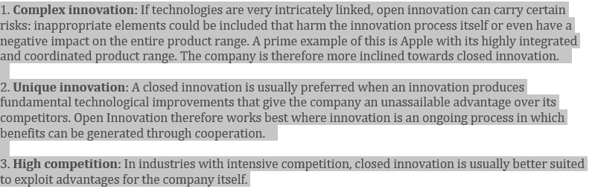

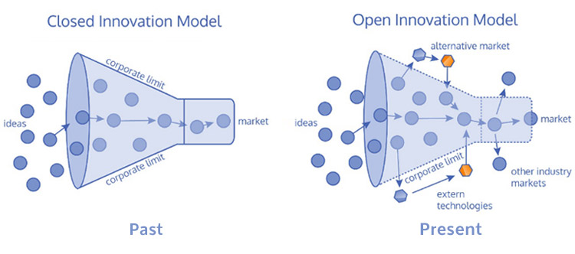
Looking at the three factors prime video fits in well with unique innovation and high competition this is because the innovation program they are planning does include technological improvements and gives the company an advantage to try something new to enhance their business advantage and also its an innovation program that will have competition with other similar online platforms.

In an article stated by sambit (no date) it states that Some organisations fall in the group category of closed model. The closed model includes hierarchical, formal, rational, bureaucratic, and mechanistic. Henry has pointed out that the closed model organisations have the following salient element:
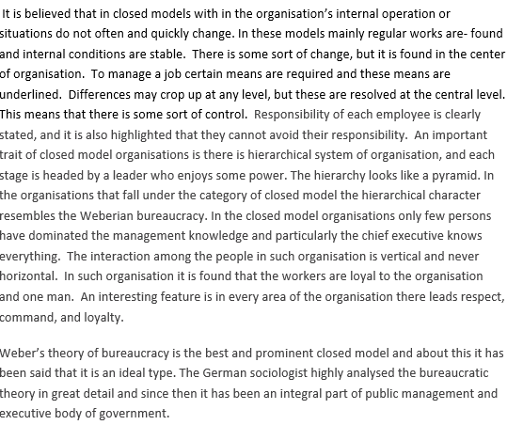
What the article is saying that closed model is within in the organisation and situations do not often change they stay the same throughout a period of time. Thinking outside the box is something the companies do not do. And employers follow management orders. And theorists have also different views on the closed model some positive some negative depending on each person’s perspective and how they see the model working. But this model fits in very well with prime video as it clearly shows that prime is heading toward a closed innovation as its within the organisation.

2.3.2- The innovation process

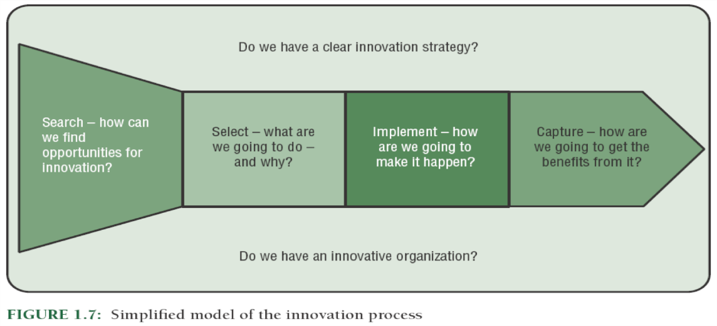According to lead innovation management (2021) The innovation process explains the path of converting new and/or existing knowledge into profitable solutions. Businesses that pursue a successful innovation process have something significant that puts them ahead of others - they have designed the path of an idea from invention, through development, to market entry.

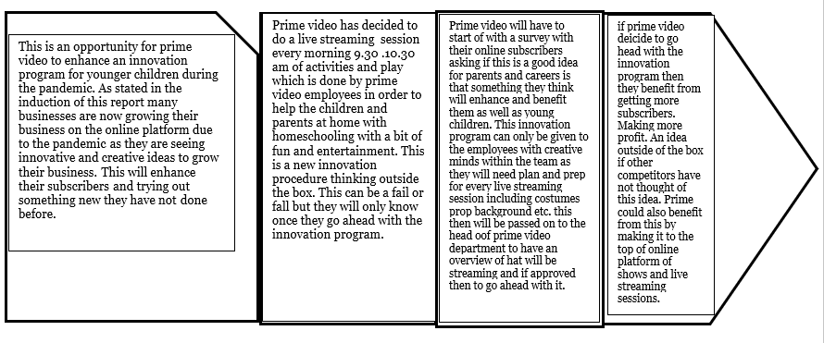

This model breaks down the process of each step that prime video will take in order to enhance their innovation process. Which therefore it is a greatly beneficial model to the business to use as it will bring out the thinking process from the company in how and why they will benefit from this innovation process.
However according to Sabina. J (2016) Innovation-Process-Models have become a more and more important issue of research. The main point of criticism on process-models is that innovation-processes are not inflexible, and segments do not run by force, but rather in recursive loops and with interruptions. Therefore, existing unidirectional innovation-process-models need to be modified.

2.3.3- 4P’s to innovation

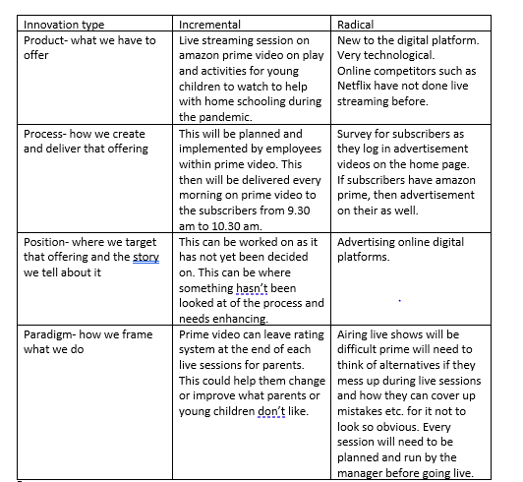
The innovation mix of the 4P’s is a model that was enhanced by john basset and joe Tidd (2013) this tool enables you to identify what can help you to discover what the innovation process can improve and bring to your business.

This table has given an insight of what prime have not highlighted. How they will target young children before they even start the streaming. Prime might have to pay other online platforms for them able to advertise few minutes of their video clips to catch children’s eyes for example YouTube. Or even children’s tv channels.

2.4 Assessment of the effectiveness

Creatley (2018-2021) initiate that the force field analysis is a change management model. It works as a problem-solving tool and decision-making tool during change planning. This tool is used to identify by visual mapping and the driving forces and restraining forces for and against the factors before ensuring successful implementation of the change plan. The force field analysis tool was developed in 1951 by the German American psychologist, Kurt lewin. Today this tool is even widely used in businesses decision making.
The basic idea behind this tool is that certain give situations stay the way it is because of counterbalancing forces, or because of the stability between the forces that drive the change and oppose change. So therefore, in order to promote change, whether the driving force should be strengthened or the resisting force should be weakened.
Force field analysis table:
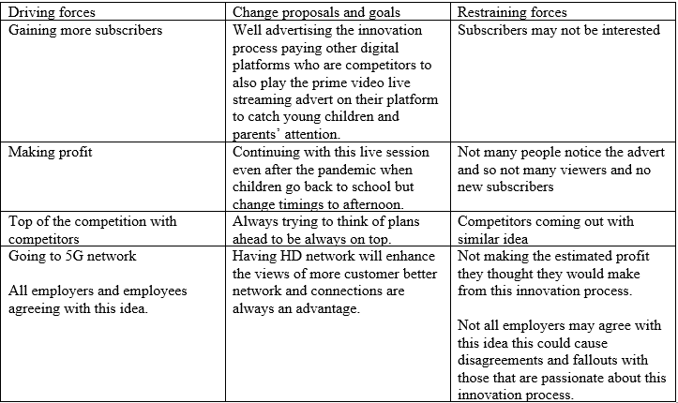

2.4.1- barriers and risks

This tool has been beneficial to see where prime video will need to think about realistically in order to go ahead with this innovation process and if they were to how this will benefit them. This tool has balanced out in both ways for prime video you either fail or fall without trying you will not know. So there fore in order to enhance this business advantage prime will need to take risks in order to see their success or failure. Here are advantages and disadvantages and the opinions from different professionals.
However according to Biznews (2020) they state a critical article on Kurt lewins force field analysis stating that In a force field analysis, it requires for all employers and employees to take on full participation to have an accurate information and opinion for an effective analysis. This can be criticized as all organization’s in a field analysis that doesn’t provide a realistic picture of two forces. The other criticism of the model is that teams and groups may not support each other decisions and may cause division within the team. One of the key things is that force field analysis is dependent on the experience and knowledge, skill level of the managers or team leader leading the group. There is also advantages for businesses doing a force field analysis when innovating a new process in the business.

According to James (2020) In a force field analysis the visual summary of various forces for and against that has been collected regarding a potential decision into a single graph. Its also helps identify any obstacles ahead so plan can be made to strengthen the forces supporting the decisions in order to reduce or avoid the forces preventing. The tool can be used as a visual aid and will help simplify communication among staff and break down barriers. The diagram can help staff identify the subject and all team members will have a clear concept of the reacted situations.

3.0 Conclusion
in conclusion to this report prime video have come up with an innovated process where they want to do live streaming session in the morning for young children during the pandemic. this idea was developed in the business due to the pandemic in order to gain more subscribers and thinking outside the box to enhance their business advantage in increasing profits. All the innovation models have shown advantages as well as disadvantages of the innovation process however this process can be doable, but prime won’t know if this is a success to their business unless they don’t start trying. So, this innovation process is either going to fall or pass.

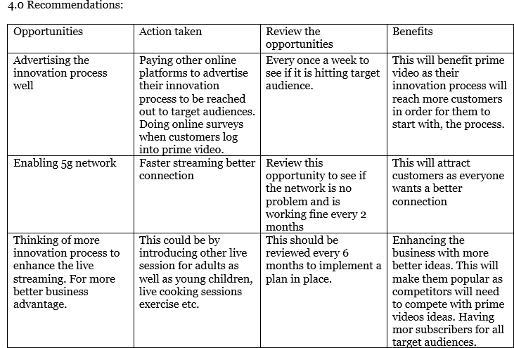

Reference list prime video

Prime video 1996-2021 Prime video available at: https://www.amazon.co.uk/gp/video/offers/ref=dvm_uk_sl_ambr_zzz_4xFkwg2wc_c80470622876386_s/258-5123310-7806830 accessed: 12/04/2021

McKeown. M (2014) The innovation Book persons education

Keeley. L (2013) Ten types of innovation 1st edition publisher: John Wiley & sons Canada

Mullins. J (2016) Management and organisational behavior Pearson education limited eleventh edition Great Britain

Mckinseys & Company 1996-2021 Global management and consulting Mckinseys & Company available at : https://www.mckinsey.com/ accessed: 13/04/2021

Mindtools 2020 SWOT Analysis how to develop strategy for success available at : https://www.mindtools.com/pages/article/newTMC_05.htm accessed: 13/04/2021

Michael. A 2019 ASO Teardown - A Lot of Opportunities for Amazon Prime Video available at : https://appfigures.com/resources/app-teardowns/amazon-prime-video accessed: 14/04/2021

J.A.C Baum 2001 international encyclopedia of the social & behavioural science technological processes available at : www.sciencedirect.com accessed: 15/04/2021

Toolshero 2013-2021 Innovation Matrix available at : toolshero.com accessed: 15/04/2021

Citatis.com 2017-2021 Albert Einstein available at : https://citatis.com/a4468/163bab/ accessed: 15/04/2021

Daniel. Z 2018 The innovation Blog available at : https://www.lead-innovation.com/english-blog/open-innovation-vs.-closed-innovation accessed: 18/04/2021

Lead innovation management 2021 The innovation process model available at : https://www.lead-innovation.com/en/innovation-process accessed: 19/04/2021

Sabina. J (2016) Automation, Communication and Cybernetics in Science and Engineering first edition springer international publishing Switzerland

Sambit (no date ) Models of Organisation: Closed and Open Models available at : https://www.yourarticlelibrary.com/organization/models-of-organisation-closed-and-open-models/63458 accessed: 19/04/2021

Joe Tidd (2020) Managing Innovation: Integrating Technological, Market and Organizational Change Paperback – 18 Dec. 2020 seventh edition Wiley publication

Creatley 2018-2021 The Ultimate Guide to Understanding the Force Field Analysis available at : https://creately.com/blog/business/force-field-analysis/ accessed: 19/04/2021

Biznews 2020 Disadvantages /Criticisms of Lewin Force Field Analyses available at : https://biznewske.com/kurt-lewin-force-field-analysis-model/#:~:text=%20Disadvantages%20%2FCriticisms%20of%20Lewin%20Force%20Field%20Analyses,the%20subjectivity%20of%20attributing%20scores%20to...%20More%20 accessed: 19/04/2021

James Freeman 2020 Advantages & Disadvantages of Force Field Analysis available at : https://www.edrawsoft.com/force-field-analysis-advantages-and-disadvantages.html accessed: 20/04/2021

Kendra. C 2020 Democratic style of leadership available at : https://www.verywellmind.com/what-is-democratic-leadership-2795315 accessed: 19/04/2021

