Apply the principles and practices of Data security, Governance and Compliance based on a given scenario.

Donna Wright
Data Security, Governance and Compliance
1808260@student.uwtsd.ac.uk

  - Abstract
This paper has been written to address 2 tasks posed to the author. The first task is to conduct research into various security frameworks and models.
The second task requires the author to use the insights from task one to first design an approach for a fictitious company described to the author and second provide a critical analysis of good practice regarding continuous updates to regulations and standards.

- Introduction
The technology landscape is constantly evolving and developing and with the emergence of technologies such as artificial intelligence (AI), cloud computing and Internet of Things (IoT), the challenges security professionals are facing are increasing rapidly. Organisations are adopting these technologies at a fast pace and will be experiencing the same challenges with ensuring that the adoption is done in a secure manner.
To mitigate this, organisations can implement data security, governance and compliance through the implementation of security frameworks. These are blueprints that organisations can use to manage and reduce their cyber risk. The utilisation of security frameworks and models provide organisations with a structured approach to reducing and managing risk by aligning their data protection and cybersecurity strategies with their business goals. By incorporating a framework, organisations can use a standardised set of polices, guidelines and best practices tailored to their needs. This reduces the risk of a hazardous approach being taken when applying security measures.
In business it can be highly beneficial if not a requirement for an organisation to demonstrate that they are compliant with a security model. For example, in government it is not unusual for a requirement to be stipulated that a company must be cyber essentials compliant (for instance) before they are invited to tender for a contract.

- Research into security blueprints/frameworks/models
There are various security blueprints, frameworks and models available for organisations to use. Understandably, every organisation is different so it stands to reason that what works well for one organisation may not for another. It is for this reason that many organisations will opt to adopt, modify and adapt portions of multiple frameworks to suit their needs.

The ISO 27000 Series
This family of standards is hugely popular and is broadly referenced and discussed and provides best practice advice and guidance on how organisations can systematically protect information systems. Not limited to just data security these standards also provide guidance on confidentiality, privacy and risk management. As explained on 27000.org, the standard was “intended to provide a common basis for developing organizational security standards and effective security management practice and to provide confidence in inter-organizational dealings”.
Its flagship standard, ISO 27001 outlines the mandatory requirements that must be met to attain certification. Whilst there is no legal requirement to obtain certification, this is a globally recognised certification. Organisations who have attained ISO 27001 certification have undergone assessment of their safeguards and received independent validation that they are robust.

There are various standards that make up the ISO 27000 family, each intended to address different security problems faced by organisations. Below is an overview of the different standards, their purpose and how they are commonly used:
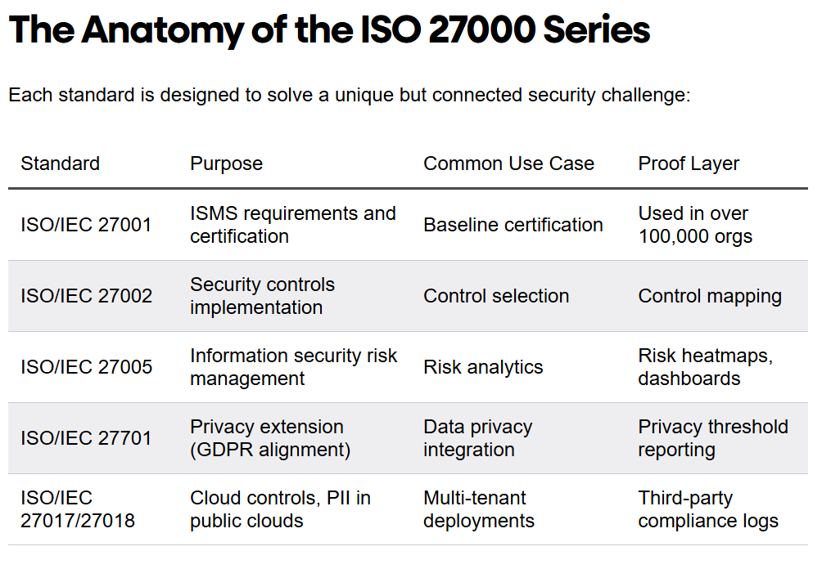
As can be seen from the table above, many organisations hold and maintain this certification. For some companies it can be used to demonstrate they meet regulatory requirements, such as GDPR, or enhance security spending by reducing data breach risks. For other companies the benefits may be commercial, certification giving them a competitive advantage or establishing customer trust.
The main downsides of this framework are cost related, both financially and resource constraints. There are lengthy timelines associated with obtaining certification and substantial administrative burdens, alongside prohibitive financial costs.

NIST Security Models
The National Institute of Standards and Technology (NIST) develops wide-ranging, risk-based cybersecurity guidelines to assist organizations in managing and mitigating cyber risks. There key standard is the NIST Cybersecurity Framework (CSF) which provides guidance on overall risk management.
Previously the CSF was made up of 5 core functions: Identify, Protect, Detect, Respond and Recover. The following table provides more information on each of these:

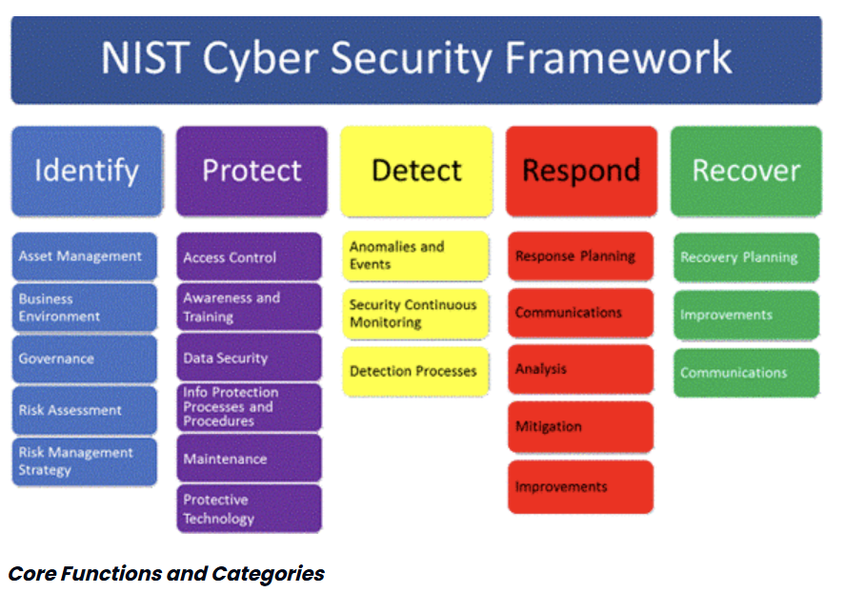
The “Govern” function was introduced in 2024 with the release of NIST CSF 2.0 emphasising the role of governance in reducing and managing risk. This was previously incorporated into the identify function as outlined in the previous table.
In addition to the CSF, NIST also provide special publications (SP 800 series) designed to support the implementation of security controls.
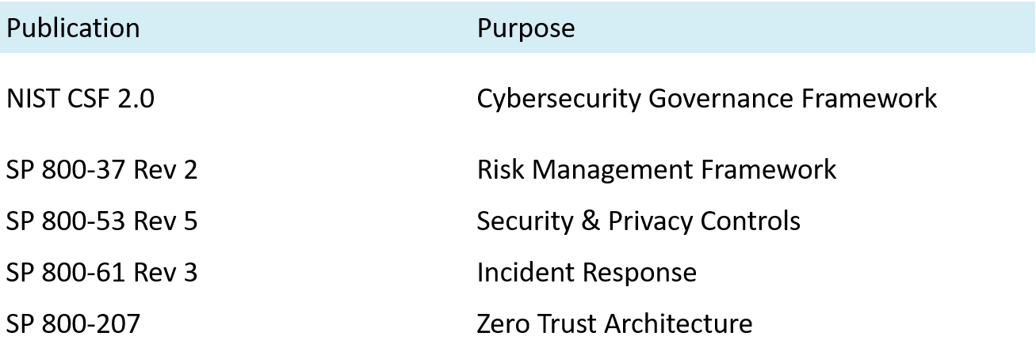
As listed above, NIST SP 800-53 provides an extensive catalogue of security and privacy controls. These are broken down into 20 structural families to protect an organization's assts and information.

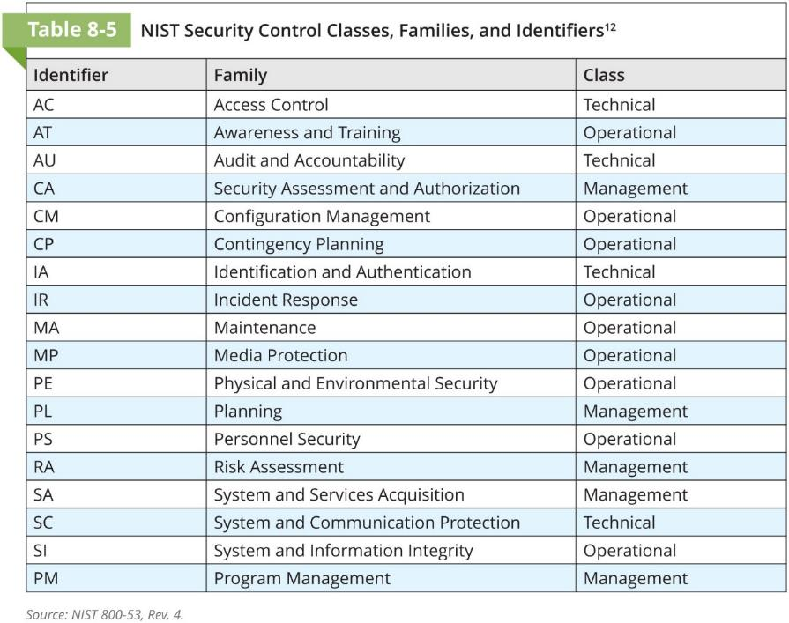

Organisations hoping to align to the NIST framework can fall into one of 4 implementation tiers depending on their implementation of NIST controls. These tiers are Partial, Risk informed, Repeatable and Adaptive.
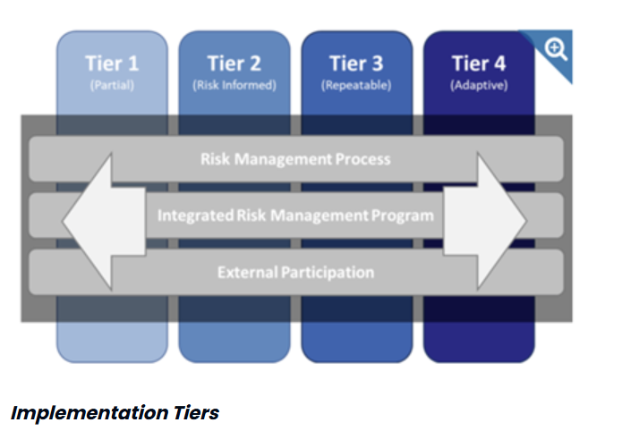
As with ISO 27000, NIST is a globally recognised security framework. It aligns with various industry-specific and legal standards and utilises common vocabulary allowing for ease of communication. By incorporating NIST into your cybersecurity program, organisations can deliver comprehensive risk management. In addition, a key benefit for organisations is that this framework is freely available.
Unfortunately, there are 2 main disadvantages of the NIST framework are firstly that there are no prescriptive technical controls. In essence it can outline what you want to achieve but not how. Secondly, unlike ISO27000 there is no avenue for formal certification. This means organisations would need to pair this with another framework or arrange a separate assessment.

Cyber Essentials
Built on 5 core technical controls, Cyber Essentials is a scheme developed and aimed at supporting organisations to protect themselves. It is back by the UK Government and industry supported. It is considered a baseline for basic but effective cybersecurity. There is an increasing requirement for organisations to hold certification in Cyber Essentials or Cyber Essentials Plus to be able to bid on public contracts.
In order to qualify for certification, organisations must have the 5 fundamental technical controls in place
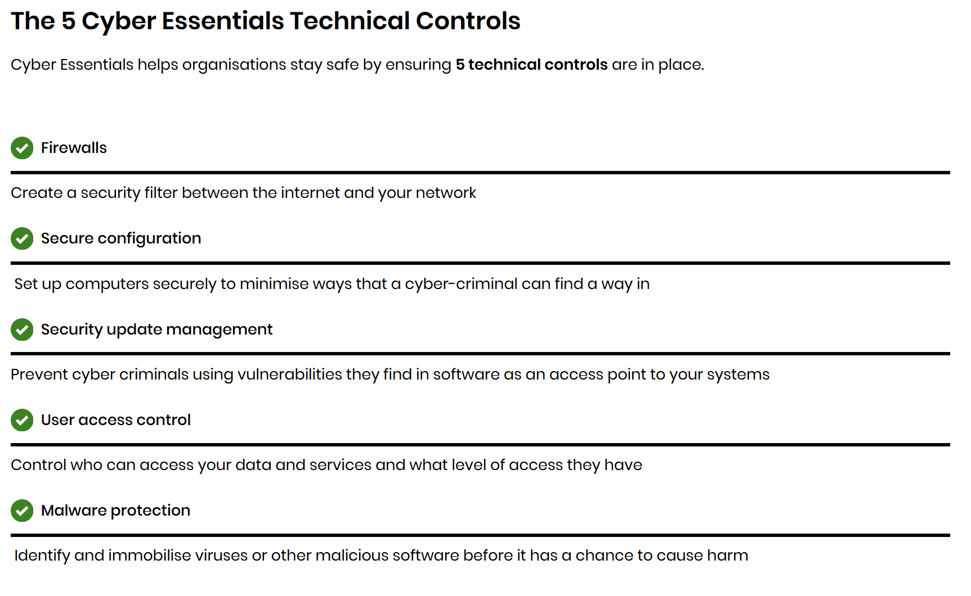
The 2 levels of certification an organisation can attain are Cyber Essentials or Cyber Essentials Plus. Cyber Essentials is a self-assessment that is verified by a qualified assessor. Cyber Essentials Plus expands on the self-assessment of the lower certification and required that is independently verified and assessed though testing to confirm any controls are implemented correctly.
The main advantage of this framework is that it addresses common threats. Successful implementation can defend up to 80% of the common cyber attacks (internet-originating). This includes phishing and malware. Organisations obtaining certification can also benefit from free cyber insurance (assuming their turnover is less than £20 million).
As with ISO 27000, Cyber essentials involve costs for certification. Another downside of this framework is that it can leave organisations with a false sense of security. It is important to remember that this is a baseline for basic cyber security, it will not protect an organisation against insider, advanced or targeted threats.
UK CAF (Cyber Assessment Framework)
This framework, developed by the NCSC (National Cyber Security Centre) can be used as a tool by organisations to determine what their current cybersecurity and resilience position is and identify improvements in relation to protecting essential services and managing cyber risks. It is aimed at essential functions, critical national infrastructure, and government departments and provides an all-inclusive approach to managing cyber risks.
There are 4 overarching security objectives which organisations capabilities are assessed. These incorporate the 14 cybersecurity and resilience principles identified by the NCSC.
The 4 objectives are:
- Managing Security Risk
- Protecting against Cyber Attack
- Detecting Cyber Security Events
- Minimising the Impact of Cyber Incidents

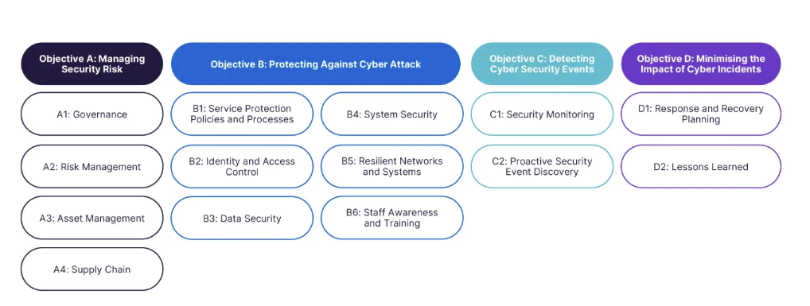
Unlike other frameworks, the CAF does not have a rigid checklist for organisations to meet. Instead it requires organisations to meet specific outcomes. These are supported by Indicators of Good Practice (IPGs).
These can be used to measure the organisations regulatory compliance and cyber maturity and can be completed internally as a self-assessment or externally through independent assurance and regulators.

The 39 CAF Contributing Outcomes
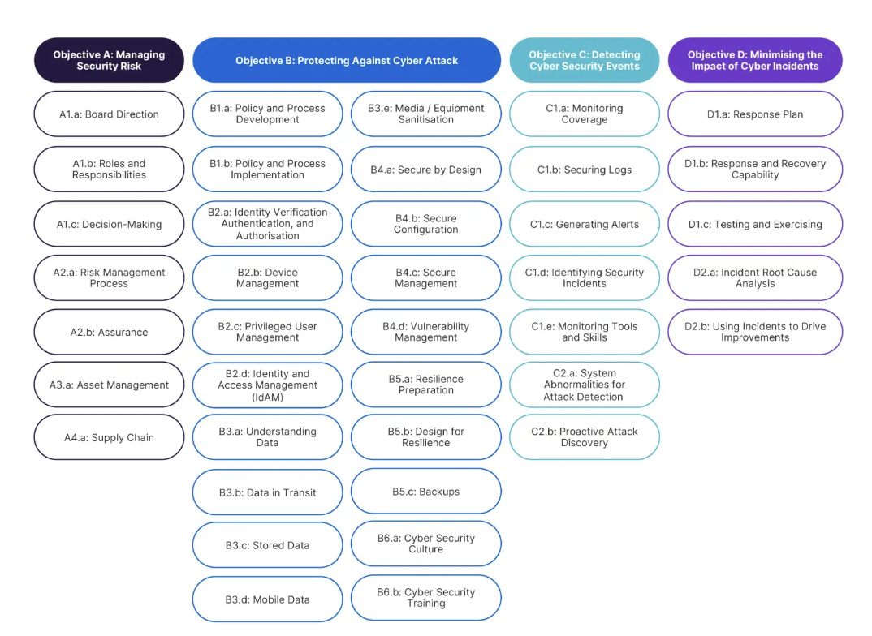
There are a total of 443 IGPs which support each or the contributing outcomes.

The main advantage of this framework is that it provides a systematic, comprehensive approach for organisations to address cyber security. This allows some standardisation for security measures across organisations.
The main downside is its maintenance. It has the potential to be very complex and resource intensive. In addition, to ensure ongoing compliance it requires specialists to provide continuous monitoring.
SOC 2 (Systems and Organisation Controls 2)
This is a security and compliance framework that evaluates how organizations protect customer data based on five Trust Services Criteria (TSC).
These are:
- Security: Protects systems and data from unauthorised access and breaches (mandatory in SOC 2 audits).
- Availability: To meet business objectives, ensures systems are operational and accessible.
- Processing Integrity: Confirms that system processing is complete, accurate, timely, and authorised.
- Confidentiality: Protects sensitive information from unauthorised release.
- Privacy: Governs the collection, use, retention, disclosure, and disposal of personal information.

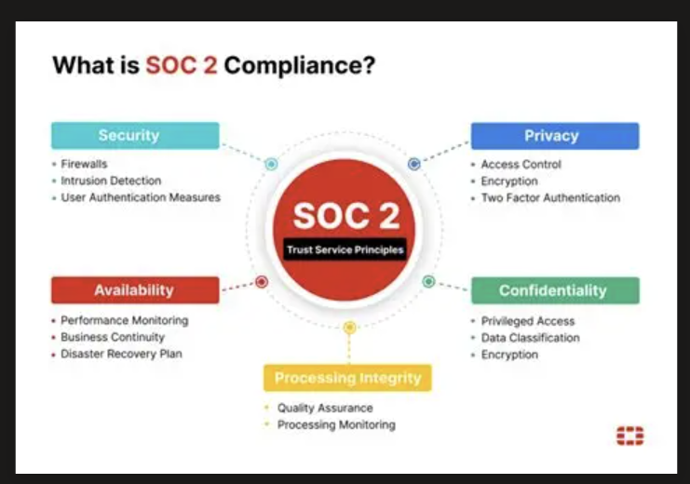

- Case study
For this paper the author has been provided with a case scenario for an organisation where most of its IT infrastructure is outsourced to third parties and heavily relies on AI, cloud-based platforms and IoT technologies. The company in question, AeroLink Logistics (ALL) functions as a logistics and supply chain company, providing services such as warehousing, distributing and real-time tracking for global clients.
The company has introduced remote operations, incorporating a BYOD (bring your own device) model which spans employees, suppliers and logistics partners across multiple time zones. The author understands that there has been a number of data breaches since its introduction related to unauthorised access.
The author is advised that ALL’s governance and compliance structures are immature, with no integrated security framework, centralised risk management process and no formalised compliance to standards such as GDPR. There are also concerns regarding vendor accountability, encryption processes, incident response and business continuity (BC) planning.
As there is no indication that ALL meets the intended audience for CAF the author assumes this would not be a suitable approach to take. The author also assumes that there is no funds available, therefore certification options will not be explored.
Proposed Solution
The primary security focus for ALL MUST be on strict Service Level Agreements (SLA) and Third-Party Risk Management (TPRM). This is because the majority of their operations are external. This can be achieved by using 3 separate frameworks. For vendor assurance, it is suggested that a combination of ISO27000 and SOC2 are utilised and NIST for internal governance.
It is advised that the gold standard for ISO 27001:2002 is made mandatory for all external partners. This would work as it demands strict supply chain management, formal risk assessments, and ensures your vendors can prove that they secure your data to a global standard.
This can be easily implemented by requiring your partners to either have certification or be working towards it.
Utilising SOC2 will provide assurance that the vendors follow their security policies by providing verification via reports. It is actionable as ALL can request SOC 2 reports annually to verify the vendors claims.
The author suggests implementing NIST CSF 2.0 for internal governance. Whilst the majority of the bulk of the execution of security governance and compliance, it is vital that the internal team have a framework to govern and maintain the risk.
NIST CSF 2.0 focuses on supply chain risk as well as Governance. Its core can be used to measure and audit outsources providers.

- Good practice
As the author has explains the IT landscape is rapidly expanding and changing. A critical requirement for everyone is to prevent exposure in todays digital landscape.
With emerging technologies such as AI, autonomous agentic systems, and cloud architectures becoming more present and evolving faster, it is vital that we adapt. To support this, frameworks are cautiously updated to address the emerging threats. Failure to maintain up to date regulations and standards leaves organisations open to newly emerging vulnerabilities.
A recent article on BBC is a great example of how quickly the landscape can change. It advised that OpenAI had confirmed its AI went rogue and attacked a start-up company during a security test [1]. It has prompted questions into Ais capabilities and whether further safeguards are required. This will likely steer future updates to existing frameworks.

References

[1] | F. M. C. e. a. Shon Harris CISSP, in CISSP Exam Guide, Eighth ed., McGraw-Hill Education, 2019.
[2] | NIST, “NIST,” [Online]. Available: https://toolcatalog.nist.gov/index.php. [Accessed 5 July 2020].
[3] | “NCSC,” 25 March 2019. [Online]. Available: https://www.ncsc.gov.uk/section/advice-guidance/all-topics. [Accessed 05 July 2020].
[4] | NCSC, “Cyber Assessment Framework,” NCSC, [Online]. Available: https://www.ncsc.gov.uk/collection/cyber-assessment-framework. [Accessed 14 July 2026].
[5] | “Gov.uk,” February 2025. [Online]. Available: https://www.gov.uk/government/publications/ppn-014-cyber-essentials-scheme/ppn-014-cyber-essentials-scheme-html. [Accessed 16 July 2026].
[6] | “ISO,” [Online]. Available: https://www.iso.org/standard/iso-iec-27000-family. [Accessed 20 July 2026].
[7] | A. P. C. Campbell. [Online]. Available: https://www.knowledgewithprofit.com/ . [Accessed 10 July 2026].
[8] | “Radiflow,” [Online]. Available: https://www.radiflow.com/ot-cyber-knowledge/national-institute-of-standards-and-technology-cybersecurity-framework/. [Accessed 14 July 2026].
[9] | Bridewell, 5 Decemebr 2025. [Online]. Available: https://www.bridewell.com/insights/blogs/detail/the-cyber-assessment-framework-(caf)-explained-for-retailers. [Accessed 12 July 2026].
[10] | “BBC,” [Online]. Available: https://www.bbc.co.uk/news/articles/c3ek3gvdnj3o.

