Name: Charnai Clarke
Student number: 2007510
Module: changemakers: creativity and value creation
Module code: BMHP5014_BIRM
Lecturer: Dr Azora Hurd
Assignment title: project outcomes written assignment

Contents Page Number

Introduction 3
Unit 1- how innovation changed the world 3
Unit 2- Storytelling 4
Unit 3- funding your idea 5
Unit 4- measuring success 6
My learning 7
Conclusion 8
Reference page 9

Introduction
During this assignment I will be able to show understanding of creativity and value. Having gained knowledge throughout this course and the online task, taking part in the online activities has allowed me to recognise and obtain knowledge upon those topics such as, innovation, making statements, creating values and many more. having did questionnaire after reading key information and watching videos helps to improve intellectual skills.
Throughout this assignment this reader will be able to expect useful information about the chosen topics from units one – four. Along with my overall experience from this module, having added additional l information and references to support material shown throughout this work. Having made links to the common goods within health and social care professions, where I see fit also showed how this would be useful within this field of work.
Unit 1 – How innovation changes the world
Innovation, this is the practical implementation of ideas that result in the introduction of new methods, devices, good and services. Innovation is important to the evolution of society as it has solved these kinds of social problems and enhanced society’s capacity to act. Benefits of innovations can be that they improve productivity and brand recognition and values as some inventions already exist but having been renewed helped increase the value, which impacts the world greatly.
Individual is the basic part of society. The interaction of individuals and develop relationships with each other, leads to a society. Innovation links to society, as it helps them to grow and plays a very important role in terms of economic growth (Kahn,2018). It helps problem solve, especially as the world's problems continue to evolve. Innovation helps individuals to stay on top, of constantly changing problems around the world. In addition to this innovation has changed the world at a high-speed as it has allowed everything to be more advance. This has been effective as innovations has touched on every aspect, including medicine, science, engineering, and social life, which is great for the health and social care as it has helped to increase life expectancy, allowing people to live longer or have more a fighting chance when sick.
Creativity means to be relating or involving the use of the imagination or original ideas to create something new or valuable, this can be intangible or real objects. Creating the future can be scary to think about but useful as planning ahead is always more effective (Stojcic,2018). Creating a future that does not always means having to invent something big but can be little things such as, saving money affectively, recycling and giving time.
The things listed previously are great examples of how affect it Is to plan. But how does this link to creativity and society? Well creativity allows people to view and unravel problems more freely, and with innovation, creativity also creates a healthy state of mind helping to keep stress levels down and has been proven to help ease the mind (Andereasen,2008).
Unit 2 – Storytelling
Stories are a connected series of events told through words, this could be written or spoken. Stories are told all the time and have been around for years, as before the internet this was how people communicated or shared experiences or events that had happened. but why do we tell them? Telling a story is a great creative outlet, this can also be because people love to listen and tell a story as they tend to be interesting, compelling, important, or funny (Fog,2005).
Spotting competences in stories this is to refers to false or misleading information which masquerades as legitimate news. often spread through fake people attempt to gain credibility, often emulate authentic news sources (Edson,2021). According to research, social media enables false claims to spread quickly – more quickly, in fact, than real news, people do this to make individuals show more interest into what they are saying or can do this to help promote ideas that have been created. Some people cause this bait fishing, this is to spread fake stories to draw in people.
Creating Competencies Make the competency definition behaviourally based. This ensures the competency can be verified and assessed through measurable behaviour. There are six steps that are followed to creating our own competency story which is.,
- Theme
- Scene execution
- Character
- Structure
- Concept
- Written voice
Following these steps are effective for creating our own competency, as These terms can be casually thrown about in the literary world (Spicer,2009). Offering writers in-depth instruction individuals can come away with a firm understanding of each element and how to master all six. This is important for writers of all levels.
Unit 3 –Funding your idea
Getting money provided by an organisation, bank, government, or individuals for a particular reason is called funding, this can be for anything from candles-buildings. There are many sources of funding out there as shown in the image below.
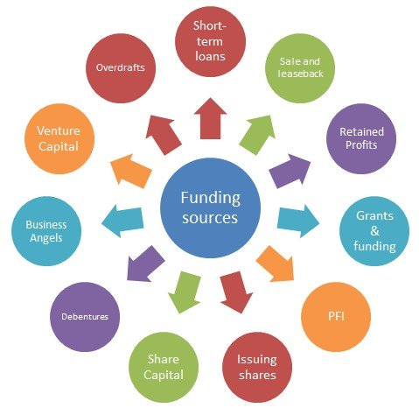

(Stakeholdermap,2008)
Creating a crowdfunding campaign is a donation-based crowdfunding: This type of crowdfunding is one of the most common. A crowdfunding campaign is people searching for and support a cause by donating to it without receiving anything in return (Basu,2009).
This type of campaign can be very easy to use or access as many sets these up themselves using apps or GoFundMe sites, this is great as sites like this already have individuals using them, meaning every time a new campaign is added, people can get alerted which means more chances of actual funding.
Understanding social enterprise is an organisation that applies commercial strategies to increase improvements in financial, social, and environmental well-being. Social enterprise is great to use as it focuses on various areas of business, this is the crucially important reason why social enterprise works. Profit is an excellent measure of growth and is solid this allows people to feel good about themselves knowing what they do is working and effective (Ridley-Duff,2012).
Social enterprise Creates positive impacts like, greater motivation, stronger relationships with people and enhances awareness for projects and brands, but with every advantage comes a disadvantage such as having to do regular research as rules and regulations change all the time. Overall, this is a fantastic way for improvement.
Unit 4 – Measuring success
Success is Accomplishment of an aim or purpose; this could be attainment of social status or wealth. Everyone oversees how they are seen and measure their life and goals. As we continue to set, work toward, and achieve those goals, stop occasionally, and ponder on what success means to people. There are many ways to measure success, for example discover values Highly motivated individuals often focus too much on execution without spending enough time to think about what to execute in the first place. Wellbeing enhance intrinsic motivation, decreases disciplinary problems, increases academic achievement, and leads to flourishing of individuals, communities, and nations (Buecker, 2018). Wellbeing links to success as when people feel good, they tend to do better.
The Pygmalion effect, or Rosenthal effect, is a psychological phenomenon in which high expectations lead to better performance in each area. The Pygmalion effect was discovered by Robert Rosenthal in his 1964 study. This is also known as the power of expectations (Rosenthal,2010).
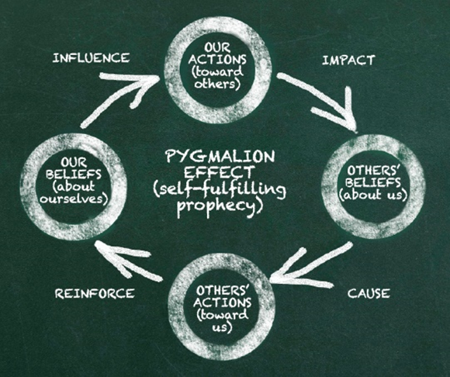
As shown in the picture. Pygmalion effects people daily as everyone goes through life with expectations of other people, that are constantly affecting people and their behaviour. Every decision we take, every move we make is influenced by others. If the expectation is positive, it can make us change our perspective, become stronger, smarter, or even faster. (Hurtado,2018)
Success and wellbeing enhance intrinsic motivation, decreases disciplinary problems, increases academic achievement, and leads to flourishing of individuals, communities, and nations (Buecker, 2018).
My learning
Changemakers: Creativity and value creation was the module been taught throughout this term, having learned numerous topics in the course from the e- learning material as listed throughout this assignment, was a great way to keep the mind refreshed. Learning values which is the regard that something is held to deserve the importance, worth or usefulness of something, this something that was learnt from the online modules and is important. Being able to recognise values is important because they impact ones attitude and behaviour, although many are not aware of this it is important to understand as everyone contributed to values and respect.
Another topic that stood out from the e learning material was creativity, as everyone has their own ways of learning, creativity makes it enjoyable as it allows people to add their own twist to education, is also opens the mind to wanting to reach beyond goals and engage in different activities. This was something I found more interested during the classes and throughout the teaching. But how does this link to health and social care? Well values in health and social care are very important, for example confidentiality having to keep secrets or private infromaion without disclosing any information. Breaking confidentiality can cause damage to people whose rights have been infringed, which can lead to upset and a lack of trust in the future. The creative side links to health and social care also as new ideas are always needed to help improve the wellbeing of everyone, which means having or gaining creativity will always be of use.
Conclusion
Throughout this assignment I was able to show my understanding pf the online topics that have been completed throughout the course, I was able to identify the topics in each section and how I gained knowledge, I found watching the videos during the activities had a better effect on me in terms of remembering the key information needed to complete the questions, although I found some of them hard to do, I tried my best to work at a pace that was easy for me and allowed me to work through them. Having did my own research outside of the module task to further my understanding also help dramatically as this allowed me to get a deeper insight.
Overall, I have learned that it is always good to learn and educated yourself no matter how small or important the work is, as we never know when we will need the information good or bad. Although some topics where less interesting than others they all had some form of information I would need to know to help success in the future during this field of work.

Reference page
Andreasen, N., (2008) The relationship between creativity and mood disorders., pp 251-255. Available at: https://www.ncbi.nlm.nih.gov/pmc/articles/PMC3181877/
Basu, A & J Wang (2009) ‘The role of branding in public health campaign’. Journal of communication management. pp. 13. Doi:10.1108/13632540910931409/full/html.
Buecker, S., Nuraydin, S., Simonsmeier, B., Schneider, M. & Luhmann, M. (2018). Subjective well-being and academic achievement: A meta-analysis. Journal of Research in Personality 74. Available at: https://edtechbooks.org/-PHzN
Edson, C. (2021) the Routledge companion to media disinformation and populism. United Kingdom: Taylor & Francis group.
Hurtado, C. (2018) The Pygmalion effect. Available at: https://medium.com/@cayehurtado/the-pygmalion-effect-28a65d2346eb
Kahn, KB,. (2018) understanding innovation., pp. 453-460. Available at: https://doi.org/10.1016/j.bushor.2018.01.011
Ridley-Duff, R, M Bull (2012), "Understanding Social Enterprise: Theory & Practice", Development and Learning in Organizations, Vol. 26 No. 6. https://doi.org/10.1108/dlo.2012.08126faa.002
Rosenthal, R. (2010) The Corsini Encyclopedia of Psychology: Pygmalion effect. Available at: https://doi.org/10.1002/9780470479216.corpsy0761
Spicer, C. (2009) ‘Building a competency model’. Available at: https://www.shrm.org/hr-today/news/hr-magazine/pages/0409spicer.aspx
Stake holder map., (2008) available at: https://www.stakeholdermap.com/project-management/project-funding-sources.jpg
Stojcic, N., Hashi, I. and Orlic, E. (2018), "Creativity, innovation effectiveness and productive efficiency in the UK", European Journal of Innovation Management, pp. 564-580. Available at: https://doi.org/10.1108/EJIM-11-2017-0166

