

The Art of Fear: Analysing the Game Design and Impact of Horror in Survival Horror Video Games

By
Alexander Jenkins
Supervisor: Adam Head
Project submitted as part of the requirements for the award of
BA (Hons) Computer Games Design

DECLARATION

I Alexander Jenkins declare that I am the sole author of this Project; that all references cited have been consulted; that I have conducted all work of which this is a record, and that the finished work lies within the prescribed word limits.

This work has not previously been accepted as part of any other degree submission.

Date: 23/04/2024

FORM OF CONSENT

I Alexander Jenkins hereby consent that my Project, submitted in candidature for the BA (Hons) Computer Games Design degree, if successful, may be made available for inter-library loan or photocopying (subject to the law of copyright), and that the title and abstract may be made available to outside organisations.

Date: 23/04/2024

Contents
The Art of Fear: Analysing the Techniques and Impact of Horror in Survival Horror Video Games 1
DECLARATION 2
FORM OF CONSENT 2
List of Media 4
Glossary of Terms 7
Introduction 8
Methodology 8
Defining a Survival Horror Video Game 9
Instalments That Defined the Survival Horror Video Game Genre and How 12
3D Monster Maze - 1981 12
Haunted House – 1982 12
Sweet Home – 1989 12
Alone in the Dark – 1992 13
Resident Evil – 1996 13
Silent Hill – 1999 14
Amnesia: The Dark Descent – 2010 14
7 Days to Die – 2013 14
Five Nights at Freddy’s – 2014 14
Dead by Daylight – 2016 15
Resident Evil 7: Biohazard (VR) – 2017 15
The Dark Pictures: Man of Medan – 2019 15
How is Horror Created in Video Games 16
Connection Between Horror Games and Horror Films 16
Jump scares 16
Lighting 17
Colour 18
Audio 19
Fight or Flight 20
Gameplay 21
Conclusion 22
Future Proposals 22
Summary 23
References 24

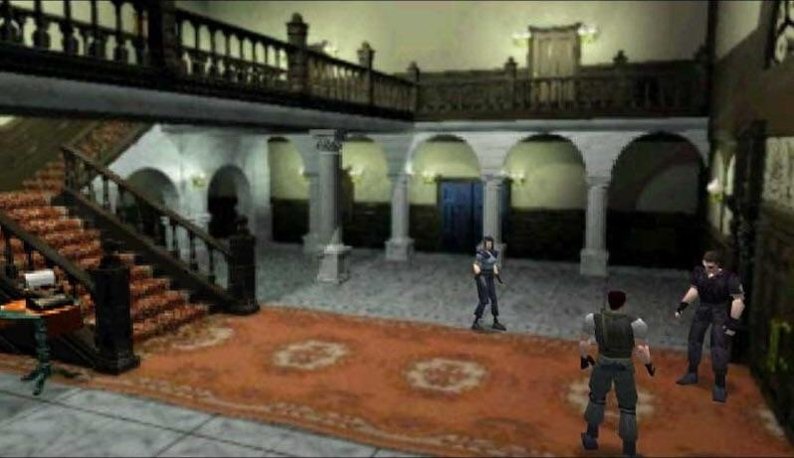
List of Media
[4]

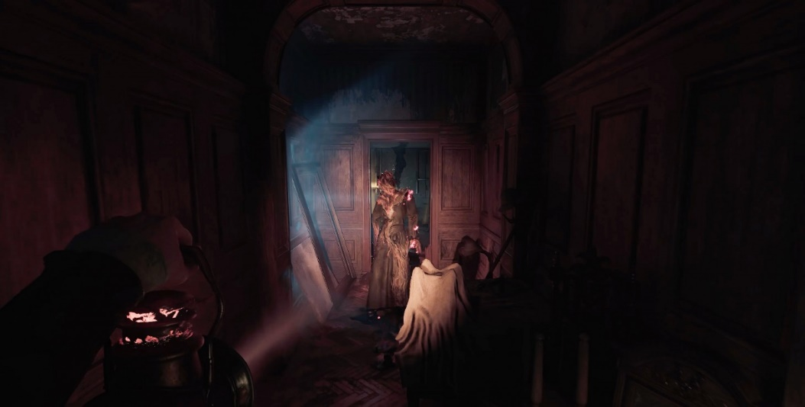

[8]

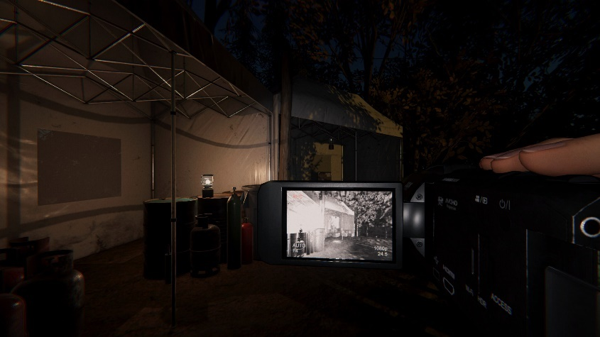

[9]

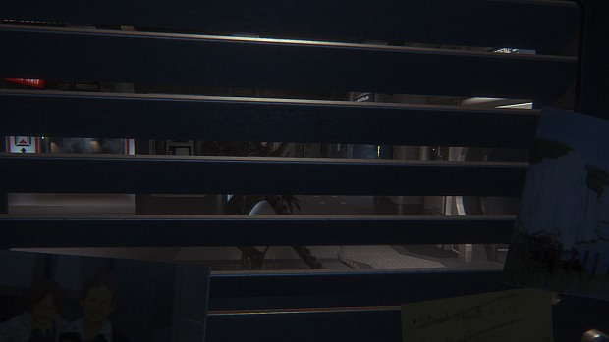

[10]

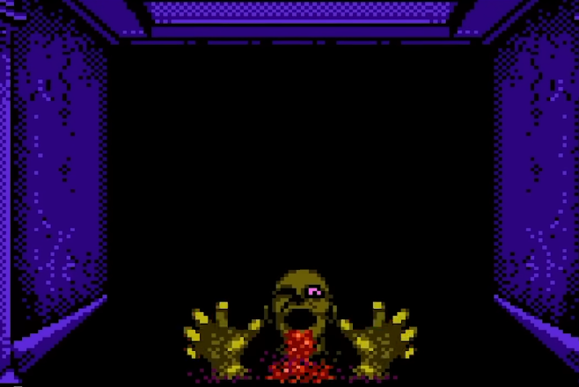
[20]

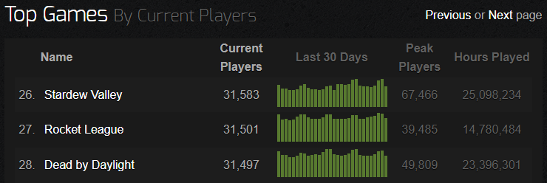

[43]

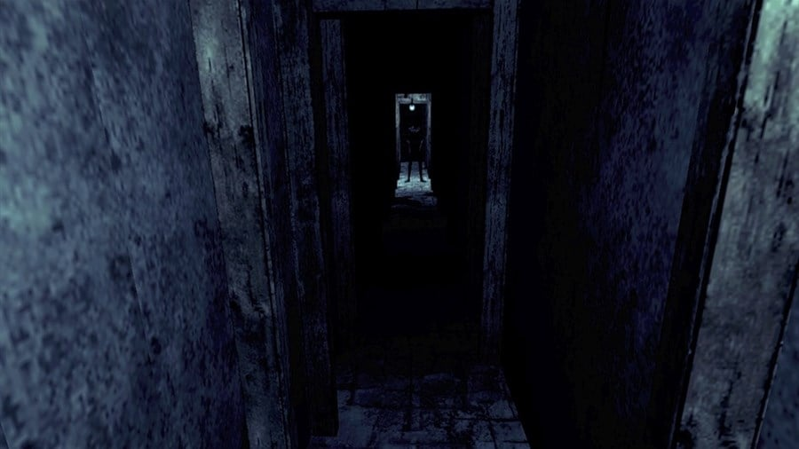

[79]

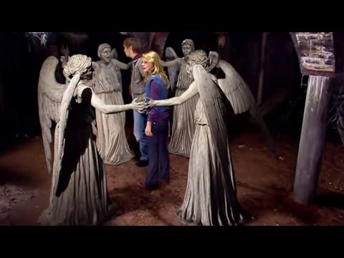

[82]

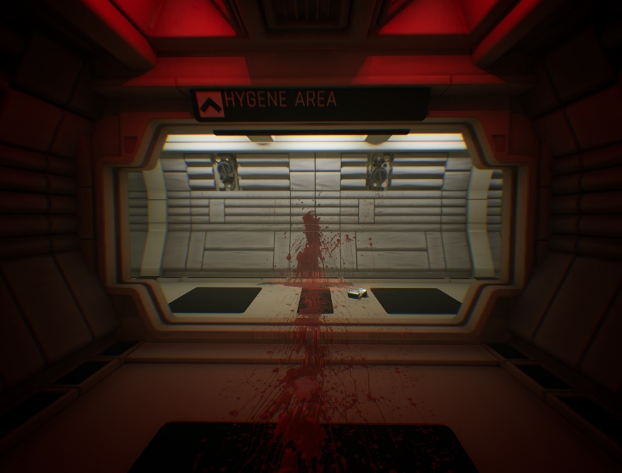

[10]

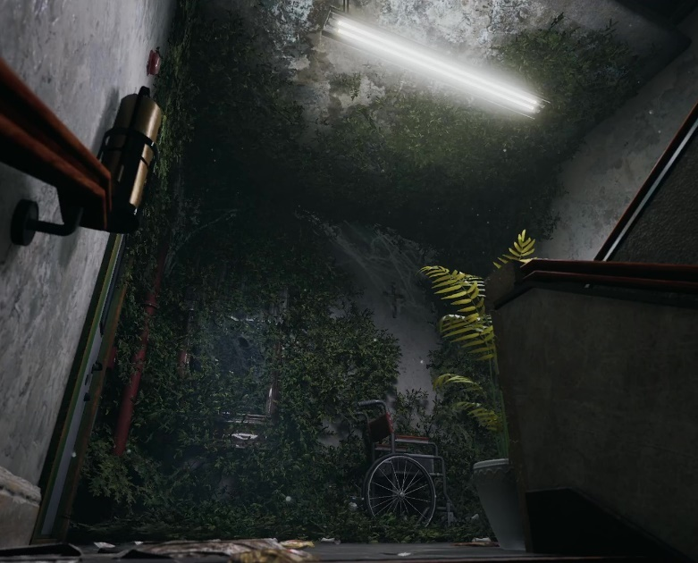

[87]

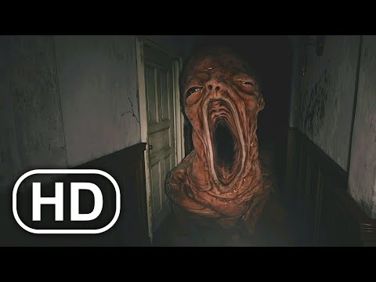

[112]

Glossary of Terms
Qualitative data – Subjective data
Quantitative data – Numeric data
Interpretivism – Use human subjective views
Positivism– Use facts and scientific/mathematical proof
VR (virtual reality) – A device that simulates a 3D environment by using headgear
Claustrophobia – Fear of confined spaces
Nyctophobia – Fear of the dark
Teraphobia – Fear of monsters
First person – from the perspective of the character
Third person - from behind, over the shoulder perspective of the character

Introduction
The aim for this project is to find out what makes a video game a survival horror game, as well as how and why do they scare people. This is split into 3 core objectives, the first one being what defines a survival horror game, researching and understanding the basic features that make up a survival horror game. The second objective is looking at how survival horror games innovated and changed over the years, analysing what gives them the survival horror title, including gameplay mechanics and fear factor. The last objective is delving into the fear and horror of the genre, to see how the fear is created.

Methodology
The method being used to collect data from sources will be qualitative data, this is because rather than numerical and measured data, determining what makes a video game a survival horror and fearful to play is opinion based and to do with the nature of human psychology, therefore research conducted will be opinion based on the thoughts of people who have experience in the relevant fields [108]. The research philosophy that will be studied for this project will interpretivism, as interpretivism deals with human behaviour and thoughts, just like qualitative data, oppose to positivism which looks for data of numbers and using quantitative research methods for researching [109]. Gathering the data needed will be done via methods that contain relevant qualitative data, which includes using the internet to access sources such as blogs, articles, and videos.

Defining a Survival Horror Video Game
Although it may seem simple what a survival horror video game is, there is some debate on what needs to be in a game for it to be classed as a survival horror. The definition of a survival horror game will differentiate from person to person. Although, there are many arguments that are commonly shared between people. The biggest debate comes from what makes a game a survival horror or an action horror, as these two genres are very similar to each other. Psychological horror may also come into the fray for this discussion, as it’s also one of the biggest horror game sub-genres. No single definition is correct, so multiple different opinions can be used to create a definition for this question.
The main defining factor for a survival horror game is to have a horror game where the player must survive, although it gets deeper than this, as the same can be said for action horror games. Using opinions from youtubers [[Mild Conviction]] [1] and Under The Mayo [2], both have similar views when it comes to defining a survivor horror. The main differentiating factor between action and survival horror is said to be in survival horror, you’re afraid of the threat and spend most of your time trying to avoid it, whereas with action horrors the player tends to be heavily weaponised, being able to tear through the threat, not needing to be cautious or hide. They both also put emphasis on decision making, where the player must actively think on the choices they make for survival, this can include using different ways to approach a scenario using resource management, as survival horrors typically have a more restrictive inventory capacity only giving finite resources to combat threat.
[4]

[[Mild conviction]] [4] and the Fandom wiki [3] note puzzle solving as being a factor too, although this isn’t a necessity as puzzle solving doesn’t correlate to surviving completely. They also state the Resident Evil [4] franchise as being the pioneer for the survival horror genre, coining the term with the release of their first game in 1996 with the first Resident Evil game.
Another popular horror genre are psychological horror games. According to Jesse on Digital Trends [8], psychological horrors play on what the player cannot see playing on the player’s psychological fear. A Quora user [6] shares their thoughts on how psychological horror compare to survival horror games. Saying in games such as Resident Evil [4] “you are forced to fight for your life” where psychological horror games “[are] meant to play with your mind, focus less on the survival aspect”.
The survival part has been defined, but what about the horror aspect? A comprehensive breakdown has been done by Thomas Evans [7] on “the fundamentals of designing a horror game”. Some key points mentioned throughout include one being level design, including claustrophobic environments such as “hallways and sharp corners”, this is to make the player feel like they have no place to hide. Another point made is how ambient sound should be used to keep the player on edge, “if they are lost in a forest, they should be able to hear the wind passing through the trees”.
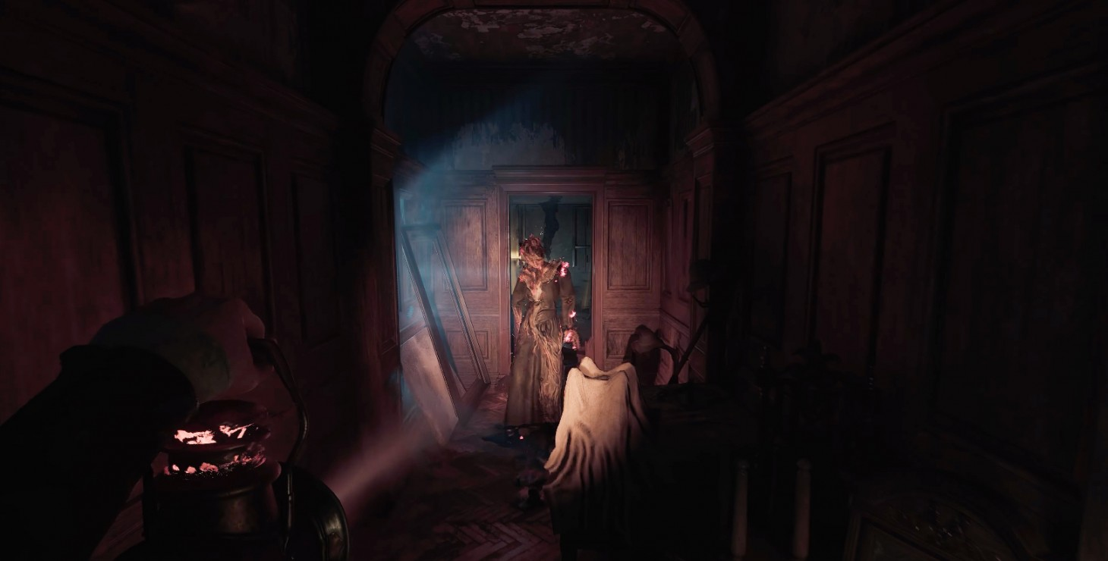
Horror games usually aim to be scare and creep the player, although there’s more to the horror genre than being just being scary. They are often seen with dark themes to create a darker atmosphere which sets the stage for the rest of the game.
[8]
Another game to look at which isn’t listed as a survival horror is Phasmophobia [9]. Phasmophobia is listed as being a psychological horror game, which it is. Although, it also has plenty of characteristics to fit into the survival horror genre. The objective of Phasmophobia is to deduct which ghost you’re dealing with while surviving the ghost, both puzzle and surviving is part of the core gameplay, as well as that you have a limited inventory space. Phasmophobia is a good example of a survival horror game.
[9]
Using various opinions from different sources, to define a survival horror the game must firstly fit into the horror genre, which would mean the game would most likely have a dark tone and put the player on the edge of their seat. For a game to be a survival horror, the player must be put into circumstances where one of the main gameplay mechanics revolves around them surviving [113] [114]. The difference between survival horror and action horror here is the way the player must survive. With survival horror, the player will have to think whether to engage with threats or not, resources should be scarce, and the player must use decision making on what measures they need to take to survive, which can include exploration. Whereas with action horror, there is far less emphasis on surviving and the game will be more action packed, focusing far more on combat by usually giving the player plentiful more resources and means of combat, leaving the player not having to worry about survival.
Stealth horror is usually a part of survival horror due to them often having a threat you can only avoid, this results in the player having to use stealth to evade them, this is a game mechanic used in the survival horror game Alien: Isolation [10] where the player is able to hide in lockers and under desks to avoid the alien threat.
[10]

Instalments That Defined the Survival Horror Video Game Genre and How
Since the origin of survival horror games, there have been a bountiful number of games in which have made their own impact on the survival horror genre. This will show how the genre has changed over the years in the way the games deliver their horror.

3D Monster Maze - 1981
One of the earliest signs of a survival horror video game is a game called 3D Monster Maze [11] developed by Malcom Evans in 1981. Even while being one of the earliest survival horror games, it has 2 factors that give it its survival horror title, which is narrative and the need to survive. It’s impossible to compare this game to survival horror games made now due to the heavy technological restraints they had in the 1980’s. The game has a basic plot to set the scene, narrative isn’t exclusive to survival horror games, although it’s become a big part of them. The second aspect is the game’s core gameplay is the player trying to survive as long as they can before being found by a Tyrannosaurus Rex. So not only is this one of the first survival horror video games, but it’s also the first to feature an enemy AI that the player must avoid, which is common to see in survival horror video games now. One extra thing to note is the maze in the game is procedurally generated, it’s possible that this format inspired other horror games that also do this such as Spooky’s Jump Scare Mansion [12] and SCP Containment Breach [13], which is what the youtuber Sagan Hawkes stated [14] [15].

Haunted House – 1982
The next notable game was made one year later and is called Haunted House [16], some sources claim this game to be the first survival horror entry, such as Nnamdi Ezekwe from CBR [17] and Media Wiki [18]. The aim of the game is for the player to find and collect pieces of a magic urn to bring back to the house entrance while avoiding enemies.
By looking at video footage of the game by Njenkin [19]. There are more survival horror elements present than in 3D Monster Maze. They both feature decision making as you need to decide which path to take to avoid the enemy, but Haunted House also features a life system, which are extremely common in video games today, although they are rarely seen in survival horror games. Haunted House has one of the factors that are commonly seen in survival horrors which is puzzle-solving, as the player needs to traverse up the floors within the house to find items to pick up and bring back to the starting point while avoiding the various enemies found within the house.

Sweet Home – 1989
Sweet Home [20] is a survival horror game where the player controls 5 different characters and must explore an old mansion in search of hidden treasures.
Sweet Home is considered by many articles to be the first true survival horror video game. It wields a plethora of survival horror attributes, one being the need for survival. There is more pressure for this in Sweet Home though, as if one character dies, they are dead permanently, this means the player must be extra careful and play with strategy in order to keep their characters alive. Marie Overman from Magic INC [21] goes in-depth on the history of Sweet Home and Resident Evil. She lists as problem solving as being part of the game, this is because there are puzzles featured, as well as fight battles which can be randomly encountered, so the player must always be prepared. An in-depth video was made by RagnarRox [22] on Sweet Home and its origins of survival horror. At one point it’s noted that Sweet Home has an extremely restrictive inventory, this has been discussed to be a trait of the survival horror genre, to not make the player feel overpowered. This also ties into problem solving as the player must decide what to bring and what to leave behind. They also state how the game contains imagery closely relating to jump scares, which could mean Sweet Home was the first game to incorporate this popular scare technique. Sweet Home offers exploration and secrets to be found, which is also a factor of survival horror video games.
As well as all this, Sweet Home has some disturbing graphics to go with the horror theme, mainly consisting of the enemy designs, which includes skeletons and corpses. This is to creep and disturb the player.
All of this makes it easy to see why Sweet Home is considered the true first survival horror video game.
One last bit of information to note is that Sweet Home was created by the same people that worked on Resident Evil, and in an in-depth article done by Ryan Lambie [23], it’s stated that the Resident Evil franchise was originally meant to be a direct sequel to Sweet Home. So, Sweet Home was the inspiration for arguably the biggest horror video game franchise.

Alone in the Dark – 1992
Alone in the Dark [24] is special as it was the first 3D survival horror video game. The main difference with this game compared to ones before is that now the game is fully 3D and using fixed camera angles. This inspired many survival horror games to come such as Resident Evil [4] and Silent Hill [25]. Many sources claim that fixed camera angles are part of what make a horror game a survival horror, on the survival horror wiki, it says “Games in the genre often have a metroidvania style of progression, and also make use of horror tropes common to cinema, such as fixed cameras” [3].
RagnarRox has another in-depth video, this time about Alone in the Dark. One quote from his video that shows how they feel about its impact on the horror genre whole is “without question one of the most important milestones for horror gaming” [26].
Alone in the dark is also the first survival horror game to have ambient background music playing, although this mainly consists of upbeat music, but with some giving off an aura of mystery. There are sound effects too to compliment this, which are more horror orientated, such as zombie groans and creaky floorboards [27].

Resident Evil – 1996
Resident Evil [4] is arguable the most influential and genre defining survival horror game out there and is considered as the golden era for the genre [28], being one of the most well-known and memorable survival horror instalments [29]. Capcom coined the term “Survival Horror” with the release of Resident Evil which truly started the rise of the survival horror genre. Resident Evil originally started off as a remake for Sweet Home, Capcom wanted to make a game similar to Sweet Home while taking advantage of the new graphical advances [23]. Like with Alone in the Dark, Resident Evil uses fixed camera angles, this allows the developers to only allow the player to see what they want them to see, possibly hiding monsters around the corner. Resident Evil was a massive success, selling over 2.7 million copies, this caused the survival horror genre to explode, causing more games of the genre to be made over the years [30].

Silent Hill – 1999
To many people such as MrHammers on YouTube, it’s stated that Silent Hill [25] is the peak of the golden era for survival horror games [31][32]. Silent Hill was one of the first horror video games to use elements of what are considered to be psychological horror games now, by having elements such as a disturbing atmosphere instead of encountering frightening enemies. Although, it still stays true to the survival horror elements featuring stealthy gameplay as well as needing to survive by using problem solving, an example being needing to turn off your flashlight to avoid detection [3]. It’s still considered to this day one of the scariest horror franchises to this date [33].

Amnesia: The Dark Descent – 2010
Amnesia: The Dark Descent [34] changed the game for the survival horror genre, as horror games were becoming more action orientated, Amnesia went back to the roots, featuring gameplay leaving the player weapon-less, as well as a unique sanity mechanic. This works by making the player more insane the longer they stand in the dark and look at the monsters. This creates terror as well as another problem you need to keep track of, not only being the monsters. The lower the players sanity gets, the more disturbing and dangerous the environment gets. The return to leaving the player powerless against monsters, along with the dark setting and eerie sounds, and importantly the innovative sanity mechanic, Amnesia: The Dark Descent changed the genre. [35] [36] [37].

7 Days to Die – 2013
7 Days to Die [45] is noteworthy as it was the first big base building game to feature horror and survival elements. The main survival features come from needing to manage your thirst and hunger, as well as what you carry, as the heavier items you hold the more cumbersome you become. This affecting how the player goes about playing the game, as it prompts the player to think carefully about how they go about surviving the enemies which are zombies. In a game review from B. North, it’s stated that “7 Days excels in going a step beyond typical survivor horror games in its realism”. This is due to the inventory weight restrictions, as well as falling onto surfaces can collapse under the pressure of your weight. Also, North states in the review that “The horde is the truly scary part of the [game]”. This is because after 7 in-game days, a massive horde of zombies will rush your base from all angles in the night. Being ambushed by the horde is terrifying, especially if you’re not prepared for it [46].

Five Nights at Freddy’s – 2014
The influence that Five Nights at Freddy’s [38] has had on the genre is monumental. Although it’s far different to all the games mentioned so far, being a 2D point and click survival horror. The game is so huge that there have been hundreds of fan-made games created inspired by Five Nights at Freddy’s [39]. Something that makes Five Nights at Freddy’s unique is the way it approaches the monsters, most survival horrors have you outmanoeuvring the enemies, whereas in Five Nights at Freddy’s, you are forced to stay still to survive, letting the player know there’s nowhere to run, and that the monsters are always approaching [40].

Dead by Daylight – 2016
Dead by Daylight [41] was one of the first multiplayer survival horror games to be released, and still to this day it’s one of the most popular horror multiplayer games, this is shown in the image to the left. As of March 2024, Dead by Daylight remains in the top 30 most played games on Steam [42] [43]. Dead by Daylight keeps the survival horror elements to its core gameplay elements, as the survivors must evade the killer by using stealth to repair all the generators. This is done with a player playing as the killer who is the one inflicting the fear into the survivors by hunting them down [44].

Resident Evil 7: Biohazard (VR) – 2017
Resident Evil 7: Biohazard [47] was the first AAA VR (virtual reality) survival horror video game, innovating by allowing players to experience horror in a whole new way. By looking at reviews from people, some were sceptical of how the game would be in VR, but after playing it, it gave one reviewer “confidence in the future of virtual reality” [49]. Having a company with a large number of resources create a VR horror game demonstrates how terrifying it is to be surrounded in the setting and atmosphere of the game. Another user by the name of PrinceOfHot shares his experience with playing the game in VR, saying “it has scared me more than any game I’ve played in my life”. They also showed the demo to their friend who even just frightened by seeing the characters in a physical space [49]. Seeing how successful Resident Evil 7 was in VR, it’s not surprise we started to see more survival horror video games being made, such as Blair Witch: VR Edition and Resident Evil Village’s VR mode [50] [51].

The Dark Pictures: Man of Medan – 2019
The Dark Pictures game series [52] are well known for being story rich survival horror video games that allow you to play co-op, where your choices matter and influence how the story goes. Multiple players have responded in a forum saying they found the game to have a “spooky” and “dark” atmosphere and setting [53]. Man of Medan uses some techniques pioneered in some of the first survival horror games, one being camera angles. This allows the game developers to only allow the player to see exactly what they want them to, being able to create claustrophobic angles as well as keeping monsters in the dark [54] [55]. Due to the fact your choices matter, it can make certain moments even more terrifying, as you’re trying to keep everyone alive, if you make one wrong move it can cost you a character [56].

How is Horror Created in Video Games

Connection Between Horror Games and Horror Films
Horror is a massive genre in both film and video games [57], both pieces of media aim to frighten and instil fear into their audiences. With this, the effects used in film and TV to create horror can also translate into survival horror video games. By looking at these effects, we can look at the effects being used in existing survival horror video games to see how well they work. All the themes and sub-genres can be shared, some more popular ones being Sci-Fi horror and Zombies. A blog by Eva Wierzbicki goes in-depth on the relationship between horror games and films. One point is how the immersion between the two is very different, and how with video games it’s far easier to get the player immersed [58]. This is because when watching TV or a film, it’s easy for the audience to hide and look away from the screen. With video games, the player needs to actively control the characters themselves to advance with the game, while also having to make all the decisions themselves, such as whether to look back when having to traverse a dark corridor [59]. A short article by Charles Zinn also shares some light on why we are more afraid playing a horror video game, they note that when you’re watching a horror movie, you are watching someone else being chased, but when you’re playing a horror game, you are the person getting chased, and it’s up to you to escape [60] [61] [62].

Jump scares
Jump scares are one of, if not the most prevalent tropes in the horror industry, starting all the way back in 1942 [63]. Since then, they have been commonly used throughout all different forms of media such as film and video games. Jump scares are commonly used to startle the player, giving them a rush, but the fear isn’t lasting, usually [59]. Jump scares work by usually having a sharp sudden loud song with a quick action happening on screen, such a creature jumping out. Jump scares are either built up over the span of usually a few seconds or are immediately thrown at you with no warning such as this moment in Resident Evil Village [64]. They are more effective if the player is already on edge, as the player being in a jumpy and tense mood will provoke a stronger startle, making the jump scare more efficient [65]. Jump scares can even instil fear without ever occurring, as sometimes just the prospect of a jump scare happening can create an immense amount of fear to the player [58] [63]. Two good examples of video games that do this is Slender: The Eight Pages [66] and Five Nights at Freddy’s. With Slender: The Eight Pages, you are being chased in the dark woods by the antagonist Slender Man. Immediately the game sets up the scene to have the player feeling tensed, having a restrictive light source in complete darkness. After you have collected the first page, a heartbeat sound begins to play, this happens once Slender Man starts chasing the player causing more tension. Slender Man will often chase the player from behind but can also teleport in-front of them around a corner, sneaking up on them. When the player makes eye contact with Slender Man, a piano key stroke happens to startle the player. The fact that Slender Man is pursuing the player and can appear at any time puts pressure on the player as they know the jump scare will happen at some point [67]. This is the same case for Five Nights at Freddy’s, as the player needs to avoid letting the animatronics get into the office, but if the player misses one, they can get in and will violently jump scare the player immediately once they have lowered their camera. This causes the player to constantly be on edge, as they know at any moment, they may be met with a jump scare and lose the game. Once the player runs out of power there is a jingle that plays with one of the animatronics present, which after it ends it goes completely black and silent, which then there’s a random amount of time in which the player gets jump scared and loses. Although, if the player is near the end, there’s a possibility they will reach the end of the night before getting jump scared, this creates a scenario where the player is anxiously waiting to see if they will finish the night before getting the jump scare [68] [69] [70].

Lighting
Underexposure is the most common technique used in horror media. This is simply done by reducing the brightness of the camera. This ties in with nyctophobia (fear of being in the dark), this fear is also more than just being afraid of the dark, but also fearing what you can’t see [71]. This is why underexposure is used is near all horror films and video games, to insinuate there may be horrors lurking in the dark. This being used in horror video games allows the developers to show the player exactly what they want them to see, commonly matched up with sounds such as someone running and boxes clashing, telling the player something unknown is hiding in the dark which cannot be seen [72] [73] [74]. Even without seeing any monsters or anything awry, the player can feel anxious and scared just by being in a dark atmosphere, not knowing what’s in the dark and when they will encounter any monsters [75].
Silhouettes are used to hide some of the physical appearance of what may be in-front of the player. This leaves some mystery for the player, as they’re left to wonder what the horror lurking in the dark looks like [76]. Silhouettes are also used to distort reality, creating shadows over the figure, the unnatural look the silhouette forms can make the entity appear more unknown and terrifying. This connects to the fear of what’s in the dark, which is why often horror game developers will put monster lurking in the dark [77] [78]. A good example of silhouettes being used to create horror is in the survival horror game Slender: The Arrival [79], in the homestead level, the player must go down into the cellar to retrieve fuel. While down there, the environment is dark with flickering lights. Alongside this, a figure hiding in the shadows can sometimes be spotted. With the dim lighting, a rough silhouette can be made out, revealing it appears to resemble a child. This segment makes great use of silhouettes as it leaves the player terrified and most of the features of the creature are left hidden hiding in the shadows.
Staying on-topic with the example used from Slender: The Arrival, also featured in the segment of the level are plenty of flickering lights. The effect caused by flickering lights relates back directly to nyctophobia and silhouette use. Flickering lights are usually dimmer as the light is dying, therefore causing the environment to be darker, this can be seen in the example above, the area is lit up by dying lights which periodically go out for a few seconds. The distortion effect created by silhouettes also apply to flickering lights, as the lights flick dimmer, object and surfaces will dimmer, becoming more disguised, as well as any features of anyone that may be nearby. There’s more to the effect of flickering lights than what is physically shown, as there are also mental effects to go along with it. Such as how the presence of a flickering light can symbolise how the environment around the player is decaying, as well as to tell the player that something is going wrong, to amp up their fear [80] [81].
Here is an example from the episode Blink from the television show Doctor Who [82]. The angels seen can only move once they’re not seen, to use this to their advantage one of the angels tampers with the light causing it to flicker on and off. This is an example of a unique way in which the flickering of the light is used to create horror. Although this is from a television show and not in a survival horror game, the same effect could be used within a survival horror game. With the player being surrounded by the angels and with the light dying, this would cause them a significant amount of fear knowing that if the light goes out, they are at risk of being caught by the angels.
One final indication that flickering lights often implies in media is the source of paranormal activity. In survival horror video games, more often ones featuring paranormal entities, flickering lights may be used to tell the player there may be something lurking around. An example of this is in the game Phasmophobia, a game where the player must deduct which room the ghost is hiding in. In this game, flickering lights are an indicator that the ghost is nearby and is interfering with the environment. But before the ghost starts an attack, all the lights around it will start to flicker, so, even when the ghost is simply interacting with the environment, to the player it could make them think the ghost is about to attack, tricking and fearing them.

Colour
Colour plays a crucial part on how a game feels, your typical survival horror game will use a darker, greyer colour palette, these can be categorised into a what is called a “muted colour palette”. This colour palette is popular among survival horror video games due to their “bleak and depressing atmosphere” [83]. A muted colour palette gives the atmosphere and environment a sense of bleakness and hopelessness, which adds to the emotions that the player will feel while traversing through the game, they’re not meant to feel happy [84] [85].
Aside from using muted and bleak colours, the colour red is iconic in horror media. This is because red is the colour of danger and blood, this emphasizes the fear that the player will feel when playing a survival horror video game, as seeing red may be used to tell them there is something wrong. An example is when the player sees a bloody trail, this tells them that something dangerous was there. In the image to the left shows a corridor in the game Alien: Isolation [10], which features a long blood trail, this would put the player more on edge due to the blood foreboding the danger that lies ahead. Also, in this image shows a red light, red lights imply that something has gone wrong, again, making the player feel more tense as they know the red lights may be foreboding that something bad is going to happen [84] [86].
Another colour prominent in horror, is the colour green, which can be used to represent decay and sickness. The colour green is thought as the colour of plants in nature, but when paired with the dark elements of horror, the green plants can be used to indicate death and decay.
This image from the upcoming horror game Whispers of West Grove [87], the colour green represents nature, but this shot doesn’t show blooming flowers or trees, but instead, dark green moss growing in the building walls as well as plants. So, instead of beauty, this shot is showing the player that this environment isn’t well kept and is decaying and dirty. Being in a dirty environment will make the player more uneasy [84] [86] [88].

Audio
Sound design is pinnacle for creating fear within a horror game, it helps build the atmosphere and mood on a game, which adds to the immersion which will make the player feel more on edge [89]. Sounds also need to be mixed together properly, and consistent in the way they sound, as if this isn’t done correctly, it will sound off to the player, and suddenly all immersion is broken. So, it’s extremely important that the audio is done well to convey a convincing piece of horror [90].
Ambience is commonly used in video games, it helps adds to the atmosphere and makes the environment feel more alive, this is the case with horror games also, but the ambience also serves to make the hairs on the players neck stand up. By creating a fitting ambience, you can make the player feel far more immersed within the environment of the game, making it feel more real by the sounds the player hears around them [91]. Looking at some examples, Phasmophobia has some basic ambience, which consists of black noise constantly playing while inside of the haunted area. It’s simple yet adds to the immersion and makes the playing more on edge, having this constant sound of noise. This also subconsciously tells the player that they are in danger, as the ghost can get to them and kill them in the building, unlike if they were to be safe and outside [92]. As well as the ambience, some maps such as Sunny Meadows have sound effects that randomly play thought the environment, such as footsteps in the distance as well as screams [9] [93] [94]. These add to the fear of the sound design, as it makes the place feel more haunted and sinister. Another example to look at is Slender: The Eight Pages, unlike with Phasmophobia, Slender: The Eight Pages builds on its atmosphere as the player progresses through the game, with each page collected, the ambience because more heavy and intense, this tells the player that the situation is getter more dangerous, as Slender Mans gets stronger which each page collected, the ambience does a brilliant job at reflecting this and making the player feel the pressure [66] [67]. One more example which does something different is the House Beneviento area in Resident Evil Village, which throughout it all features no ambience at all. Instead, all the sounds the player hears comes from sounds being made in the environment, such as your footsteps, doors creaking, a radio playing, etc. Having no ambience can also help boost the fear in the player, this allows the player to fully take in all the little sound effects, the area being quiet further boosts the eeriness and can make it easier for the game to get into the players head with no ambience for the player to focus on. Ambience is important, but, for situations like this, having no ambience can be just as effective if not more for creating for perfect horror setting [51] [95] [96]. Having ambience, then suddenly taking it away can also cause strain on the players mind, as they will be panicking wondering why the game has gone so silent, and all of a sudden, they have no ambience or sounds to distract them, left with just their thoughts as they must progress, this scares the player to making them think something bad is about to happen, due to the sudden change in tone [97] [98].
Sound effects are also needed to create an immersive and creepy environment, just as if you were to be walking in real life or opening a draw, these all make distinct sounds, these all also need to make sounds in a game for it to feel more real. Adding to the realism is vital, but sound effects can also add to the dread the player may feel, an obvious example is by having sound effects playing while the player is in a dimly lit area, this tells the player that they’re not alone and there is something else lurking around. Sound effects can also be played to directly scare the player to make them jump, like with jump scares, or maybe a vase smashes onto the floor behind them, creating a loud piercing sound. Having gruelling sound effects of a creature, and only hearing the sound, forces the player to use their imagination to fill in the blanks of what possible monstrosity is with them in the dark, letting the players imagination run wild with this leaves them to fear in the unknown [99]. Sound effects can also be used to disgust to play, as more disgusting sounds such as hearing bones snap, can make the player physically react, making them more anxious and disgusted, which in effect causes them to be more susceptible to all the other horror elements in the game [100].

Fight or Flight
The fight or flight response is triggered in the people when coming across something terrifying that puts fear into them, it can be by something mentally or physically horrifying. The effects of this are an increase of sweating, adrenaline, blood pressure, heart rate, and breathing rate, and they can last for up to 60 minutes after the cause depending on the severity [101] [102]. But what does this mean for people playing a horror game? Even being constantly afraid while playing will trigger the fight or flight response, but this can be heightened during certain parts such as when the player hears something or sees something lurking in the shadows. Another good example would be when getting jump scared, the loud noise combined with a monster being in your face quickly triggers your fight or flight response, which is people physically jump and their heart rate goes up. Their heart rate won’t go down straight away but instead will do so gradually over time. Audio can trigger this, whether it’s by sound effects playing in the environment, or a sudden shift in the ambience sound. An example would be when the player is traversing through a dark corridor, and suddenly the ambient music starts to build towards an apex, it leaves the player on the edge of their seat left apprehending on why the sound is suddenly building, making them believe something horrifying is about to happen. This would trigger the fight or flight situation from the player as they try to prepare themselves for what may be about to come [103] [104]. Horror games will take advantage of the psychology behind the fight or flight response, knowing that every piece of sound visual design is all working towards creating that perfect balance of fear in the player [105] [106] [107].

Gameplay
The gameplay is the core to every game, it is the most fundamental piece. This is also important for scaring the player, as even the way they must go about playing the game can have a massive effect on how they feel while doing so. A way to make the player afraid is by taking away their weapons and tools, by doing this, you are making them powerless and having no one of defending themselves, leaving only running as an option. A great example of this being done is in Resident Evil Village, during the entirety of the game leading up to House Beneviento, the player is for the most part always armed with their weapons and tools while progressing through the game. Once they arrive at House Beneviento, all their resources are gone, and they must traverse through the house completely vulnerable. The House Beneviento area of the game is well known for being the scariest part of the game, and the gameplay it promotes helps that. Near the end segment, the player is faced up against a disgusting creature in which you can only avoid by using stealth, while also needing to traverse to collect the fuse to escape. Right after the player places the fuse in the box, they must wait for the elevator to come back down. During this time the creature can be heard coming around the corner coming towards the player, this part is terrifying as the player is desperately wanting the elevator to come down before the creature gets to them, creating an intense confrontation [51] [110] [111] [112].

Conclusion
The results from the project show at the end of it all, it’s widely opinion based, from the definition of a survival horror game to what makes it terrifying. Even while finding a solid foundation for a definition, there will always differentiating opinions on what precisely needs to be in a game for it to be classed as survival horror. A rule of thumb is if the game features restrictive combat and resources, while have the active need to survive in a horrific setting, there’s a good chance it’s a survival horror video game. With creating horror, it’s been found that every little details goes towards building that immersive and gruelling experience. Each little sound effect is building the atmosphere and the environment of the game, making the player feel like as if they were there. Audio sets the tone of the game, as each ambience track needs to be chosen carefully to maximise the horror and atmosphere. The audio compliments the gameplay and graphics that the player sees, working together to create the perfect blend horror. Colour is considered when creating the aesthetic for a horror game, each one affecting how the player feels while traversing an area. Typically, muted colour palettes will be used as they are dark and bleaker. Phobias are taken advantage when trying to spook the player, the main one being Nyctophobia, as well as many horror titles will prey on claustrophobia and teraphobia.

Future Proposals
For future proposals, I would firstly use more methods for gathering data, I would conduct surveys online with questions relating to the project, such as finding what scares them in a horror game, as well as asking them what defines a survival horror game, to see how general people would go about answering it. I would also try to set up interviews with people who have experience working on survival horror titles, such as sound designers and environmental artists. This would provide valuable insight into how survival horror games are created and the techniques that they used to do so. I would conduct my own research and tests, by having people play different survival horror games, to see which parts scare them the most by their communication and heart rate. Finally, I’d go in-depth on more aspects relating to survival horror games, some examples being VR, different perspectives (first-person vs third), the psychology behind gore in video games and how it affects the player and are singleplayer horror games less scary due to not being alone (tests could be done for this also, getting people to play a survival horror game on their own then with multiple people).

Summary
To summarise, the elements that make up the gameplay for the survival horror genre may not be as obvious as it seems, and there’s more to it than just a scary survival game. There’s still some debate on what needs to be in a game for it to be classed as a survival horror, instead of a different dub-genre of horror. The main defining factor that almost all sources agreed on was that resources need to be scarce, opposed to being plentiful such as in action horror games. Some sources, but not all said puzzle solving needed to be featured. Lastly, decision making was also noted by many sources as being a feature of survival horror games. Then the horror elements were touched on to give a brief overview of how horror games scare the player, more focusing on the gameplay side.
The next part was about going through and listing genre-defining survival horror game titles, and with each one saying what made them special and how they made effected the genre. Doing this made it so what made them survival horror games could be analysed, relating to the gameplay and the horror aesthetic.
The final part to the project focussed purely on the horror, looking at how game developers scare the player with the tactics they use, which included the developers playing on the players fears, such as their fear of the dark and the unknown, as well using colours and sound to their advantage.

References
[1]〚Mild Conviction〛, “What is survival horror? – the genre’s history and defining characteristics,” YouTube, [Online]. Available: https://youtu.be/Op8sJT1V0_w?si=9k7_7OrRMAegkLHJ (accessed Jan. 3, 2024).
[2] Under The Mayo, “What makes a game ‘survival horror’? / Alisa Review,” YouTube, [Online]. Available: https://youtu.be/JRczA0juYVg?si=H6K2TrBi1JHUhiXg (accessed Jan. 3, 2024).
[3] Fandom, “Survival horror,” Survival Horror Wiki, [Online]. Available: https://survivalhorror.fandom.com/wiki/Survival_horror#Definition (accessed Jan. 5, 2024).
[4] Resident Evil. [Software], Capcom, 1996.
[5] J. Lennox, “Looking for the right scares? A guide to horror game subgenres,” Digital Trends, [Online]. Available: https://www.digitaltrends.com/gaming/horror-game-sub-genres/ (accessed Jan. 5, 2024).
[6] S. Brown, “What is the difference between survivor horror games and Psycological Horror Games?,” Quora, [Online]. Available: https://www.quora.com/What-is-the-difference-between-survivor-horror-games-and-psycological-horror-games#:~:text=While%20both%20subgenres%20aim%20to,and%20emotional%20aspects%20of%20fear. (accessed Jan. 5, 2024).
[7] T. Eaves, “The fundamentals of designing a horror game,” LinkedIn, [Online]. Available: https://www.linkedin.com/pulse/fundamentals-designing-horror-game-thomas-eaves (accessed Jan. 7, 2024).
[8] Layers of Fear (2023). [Software], Bloober Team, 2023.
[9] Phasmophobia. [Software], Kinetic Games, 2020.
[10] Alien: Isolation. [Software], Creative Assembly, 2014.
[11] 3D Monster Maze. [Software], Malcolm Evans, 1981.
[12] Spooky’s Jump Scare Mansion. [Software], Lag Studios, 2014.
[13] SCP – Containment Breach. [Software], Joonas Rikkonen, 2012.
[14] S. Hawkes, “Playing the first horror game,” YouTube, [Online]. Available: https://www.youtube.com/watch?v=XyQ8ymr5oZI&t=307s (accessed Feb. 2, 2024).
[15] C. to S. H. Wiki, “3D monster maze,” Survival Horror Wiki, [Online]. Available: https://survivalhorror.fandom.com/wiki/3D_Monster_Maze (accessed Feb. 2, 2024).
[16] Haunted House. [Software], James Andreasen, 1982.
[17] N. Ezekwe, “Atari has remade the original survival-horror game,” CBR, [Online]. Available: https://www.cbr.com/atari-haunted-house-remake/#:~:text=The%20new%20Haunted%20House%20pays,mansion%20full%20of%20colorful%20characters. (accessed Feb. 4, 2024).
[18] “Survival-horror,” Survival-Horror - FMMC0282, [Online]. Available: https://mediawiki.middlebury.edu/FMMC0282/Survival-Horror#1980s:_Foundational_Years (accessed Feb. 4, 2024).
[19] Njenkin, “Haunted house - on the atari 2600 - with commentary !!,” YouTube, [Online]. Available: https://www.youtube.com/watch?v=Q6m7twIkFyo (accessed Feb. 4, 2024).
[20] Sweet Home. [Software], Capcom, 1989.
[21] M. Overman, “Survival horror game history: From Sweet Home to Resident evil,” Magic, [Online]. Available: https://magicinc.org/survival-horror-game#:~:text=Sweet%20Home%3A%20The%20First%20Survival,most%20important%20survival%20horror%20aspects. (accessed Feb. 4, 2024).
[22] RagnarRox, “Sweet Home (1989) | origins of survival horror,” YouTube, [Online]. Available: https://www.youtube.com/watch?v=e2THjrOMT0Y (accessed Feb. 4, 2024).
[23] R. Lambie, “Resident evil: How sweet home inspired the series,” Den of Geek, [Online]. Available: https://www.denofgeek.com/movies/resident-evil-how-sweet-home-inspired-the-series-and-the-survival-horror-genre/ (accessed Feb. 5, 2024).
[24] Alone in the Dark. [Software], Infogrames, 1992.
[25] Silent Hill. [Software], Konami, 1999.
[26] RagnarRox, “Alone in the dark (1992) | origins of survival horror,” YouTube, [Online]. Available: https://www.youtube.com/watch?v=T3KBObD_LF8 (accessed Feb. 5, 2024).
[27] CommanderGrog, “Alone in the dark (1992) complete playthrough,” YouTube, [Online]. Available: https://www.youtube.com/watch?v=zsGaVrMr9N8 (accessed Feb. 12, 2024).
[28] M. Overman, “Survival horror game history: From Sweet Home to Resident evil,” Magic, [Online]. Available: https://magicinc.org/survival-horror-game (accessed Mar. 1, 2024).
[29] A. Reiner, “The top 25 horror games of All time,” Game Informer, [Online]. Available: https://www.gameinformer.com/b/features/archive/2015/10/31/the-top-25-horror-games-of-all-time.aspx (accessed Mar. 1, 2024).
[30] T. Fahs, “IGN presents the history of Survival Horror,” IGN, [Online]. Available: https://www.ign.com/articles/2009/10/30/ign-presents-the-history-of-survival-horror (accessed Mar. 1, 2024).
[31] MrHammers, “A brief history of survival horror video games,” YouTube, [Online]. Available: https://www.youtube.com/watch?v=-SYlaIH_IPc (accessed Mar. 5, 2024).
[32] J. Troughton, “From resident evil to dead space: The history of survival horror,” TheGamer, [Online]. Available: https://www.thegamer.com/survival-horror-history/ (accessed Mar. 5, 2024).
[33] T. Bowen, “10 games that defined the survival horror genre & where you can play them,” Game Rant, [Online]. Available: https://gamerant.com/influential-survival-horror-games-where-to-play/#silent-hill (accessed Mar. 5, 2024).
[34] Amnesia: The Dark Descent. [Software], Frictional Games, 2010.
[35] Hayleywilliams, “The legacy of amnesia: The dark descent,” Kotaku Australia, [Online]. Available: https://www.kotaku.com.au/2021/07/the-lasting-legacy-of-amnesia-the-dark-descent/ (accessed Mar. 08, 2024).
[36] “Sanity,” Amnesia Wiki, [Online]. Available: https://amnesia.fandom.com/wiki/Sanity (accessed Mar. 8, 2024).
[37] P. Andreu, “Why an 11-year-old game is still the scariest,” Medium, [Online]. Available: https://medium.com/permadead/why-an-11-year-old-game-is-still-the-scariest-2142efe6db48 (accessed Mar. 8, 2024).
[38] Five Nights at Freddy’s. [Software], Scott Cawthon, 2014.
[39] A. O’Connor, “A list of 1139 five nights at Freddy’s Fan Games,” Rock Paper Shotgun, [Online]. Available: https://www.rockpapershotgun.com/five-nights-at-freddys-fan-games#:~:text=Look%2C%20here%20are%20217%201139,Freddy%20Fazbear’s%20Pizza%20Massacre (accessed Mar. 8, 2024).
[40] C. Marshall, “Why Five Nights at Freddy’s was industry-changing,” OU Game Developers Association, [Online]. Available: https://sites.create.ou.edu/gamedev/2023/10/25/why-five-nights-at-freddys-was-industry-changing/#:~:text=What%20makes%20FNaF%20different%20from,your%20objective%20is%20*survive*. (accessed Mar. 8, 2024).
[41] Dead by Daylight. [Software], Behaviour Interactive, 2016.
[42] Steam. [Software], Valve Corporation, 2003.
[43] “Top games by current players,” Steam Charts - Tracking What’s Played, [Online]. Available: https://steamcharts.com/top (accessed Mar. 11, 2024).
[44] deadByBHVR, “The game: Gameplay, story and goals,” Dead by Daylight, [Online]. Available: https://deadbydaylight.com/game/ (accessed Mar. 11, 2024).
[45] 7 Days to Die. [Software], The Fun Pimps, 2013.
[46] B. North, “Game Review: 7 Days to Die,” Jan. 09, 2015. [Online]. Available: https://bennettnorth.com/2015/01/08/game-review-7-days-to-die/ (accessed Mar. 17, 2024).
[47] Resident Evil 7: Biohazard. [Software], Capcom, 2017.
[48] C. Rad, “Resident evil 7 proves VR is more than just a gimmick,” IGN, [Online]. Available: https://www.ign.com/articles/2017/01/26/resident-evil-7-proves-vr-is-more-than-just-a-gimmick (accessed Mar. 18, 2024).
[49] PrinceOfHot, “Too scary for its own good? - resident evil 7: Biohazard,” GameFAQs, [Online]. Available: https://gamefaqs.gamespot.com/boards/191629-resident-evil-7-biohazard/74909108 (accessed Mar. 25, 2024).
[50] Blair Witch: VR Edition. [Software], Bloober Team, 2021.
[51] Resident Evil Village. [Software], Capcom, 2021.
[52] The Dark Pictures: Man of Medan. [Software], Supermassive Games, 2019.
[53] “The Dark Pictures Anthology: Man of Medan for PlayStation 4 - GameFAQs,” GameFAQs, [Online]. Available: https://gamefaqs.gamespot.com/ps4/246133-the-dark-pictures-man-of-medan (accessed Mar. 25, 2024).
[54] C. Carter, “Review: The dark pictures: Man of Medan,” Destructoid, [Online]. Available: https://www.destructoid.com/reviews/review-the-dark-pictures-man-of-medan/ (accessed Mar. 30, 2024).
[55] MKIceAndFire, “Man of Medan gameplay walkthrough part 1 full game [1080p HD 60fps PC max settings] - no commentary,” YouTube, [Online]. Available: https://www.youtube.com/watch?v=wkftVVOTB3E (accessed Mar. 30, 2024).
[56] L. O’Brien, “The Dark Pictures: Man of medan review,” IGN, [Online]. Available: https://www.ign.com/articles/2019/08/29/the-dark-pictures-man-of-medan-review (accessed Mar. 30, 2024).
[57] C. Arkenberg, “Halloween horror: Feeding audiences’ appetites for cheap and Bloody Thrills,” Deloitte Insights, [Online]. Available: https://www2.deloitte.com/uk/en/insights/industry/technology/horror-movie-audience-statistics.html (accessed Apr. 2, 2024).
[58] E. Wierzbicki, “Virtually horrified: A comparison of the effects of horror in games versus film,” Game Developer, [Online]. Available: https://www.gamedeveloper.com/design/virtually-horrified-a-comparison-of-the-effects-of-horror-in-games-versus-film (accessed Apr. 2, 2024).
[59] A. Gramuglia, “Why Horror games are scarier than movies,” Why Horror Games Are Scarier Than Movies, [Online]. Available: https://vocal.media/gamers/why-horror-games-are-scarier-than-movies (accessed Apr. 2, 2024).
[60] C. Zinn, “Why horror games are Scarier than horror movies,” Medium, [Online]. Available: https://zinncharles.medium.com/why-horror-games-are-scarier-than-horror-movies-5fee4a5dbc0a (accessed Apr. 2, 2024).
[61] S. Editor, “Why Horror games are scarier than movies,” The Commonwealth Times, [Online]. Available: https://commonwealthtimes.org/2019/10/27/why-horror-games-are-scarier-than-movies/ (accessed Apr. 2, 2024).
[62] H. Alexandra, “The difference between horror movies and Horror games,” Kotaku, [Online]. Available: https://kotaku.com/the-difference-between-horror-movies-and-horror-games-1832123955 (accessed Apr. 2, 2024).
[63] S. Graves, “A brief history of the jump scare,” Collider, [Online]. Available: https://collider.com/jump-scare-history/ (accessed Apr. 2, 2024).
[64] Help Me Leon, “All jump scares and scary moments in resident evil 8: Village” YouTube, [Online]. Available: https://youtu.be/MAgukN7u5mA?si=lt4QDLJKrt12xmMm&t=417, 6:57 (accessed Apr. 6, 2024).
[65] M. Clasen, “The science that can help you tolerate the worst part of Horror movies,” Slate Magazine, [Online]. Available: https://slate.com/culture/2021/10/how-jump-scares-work-and-how-to-tolerate-them.html#:~:text=The%20jump%20scare%20does%20not,juice%20in%20their%20mental%20carburetor. (accessed Apr. 6, 2024).
[66] Slender: The Eight Pages. [Software], Parsec Productions, 2012.
[67] Gamer Max Channel, “Slender: The eight pages - walkthrough 8/8 pages gameplay,” YouTube, [Online]. Available: https://www.youtube.com/watch?v=9BMZ6pDiHC4 (accessed Apr. 6, 2024).
[68] The Game Archivist, “Five Nights at Freddy’s | full game walkthrough | no commentary,” YouTube, [Online]. Available: https://www.youtube.com/watch?v=jPzHagA1pls (accessed Apr. 6, 2024).
[69] EagleDoubleTT, “Every FNAF 1 jumpscare,” YouTube, [Online]. Available: https://www.youtube.com/watch?v=3Lv8x5mMD64 (accessed Apr. 8, 2024).
[70] gwn_mathé, “FNAF 1 Freddy Jumpscare,” YouTube, [Online]. Available: https://www.youtube.com/watch?v=NigLg8fQHF0 (accessed Apr. 8, 2024).
[71] A. Felton, “Nyctophobia: What it means, how it’s caused, and how it’s treated,” WebMD, 10-Nov-2022. [Online]. Available: https://www.webmd.com/anxiety-panic/what-is-nyctophobia. [Accessed: 12-Apr-2024]
[72] J. Bernard, “Techniques horror movies use to scare you,” Horror. [Online]. Available: https://vocal.media/horror/techniques-horror-movies-use-to-scare-you. [Accessed: 12-Apr-2024]
[73] E. G, “8 great horror film lighting examples,” Tutti.space, 18-Oct-2022. [Online]. Available: https://www.tutti.space/blog/8-great-horror-film-lighting-examples. [Accessed: 12-Apr-2024]
[74] D. Jones, “7 essential ingredients horror games have to build tension,” Game Developer, 09-Dec-2023. [Online]. Available: https://www.gamedeveloper.com/audio/7-essential-ingredients-horror-games-have-to-build-tension. [Accessed: 13-Apr-2024]
[75] J. King, “An Analysis of the Methods and Techniques Used to Create an Unsettling Atmosphere in Horror Games,” University of Abertay Dundee, 2015. [Online]. Available: https://static1.squarespace.com/static/54340376e4b0935ee578d933/t/55abd6cfe4b0ba36033940db/1437325007514/JamieKingDissertationPrint.pdf. [Accessed: 13-Apr-2024]
[76] M. Park, “The Aesthetics and Psychology Behind Horror Films,” Long Island University. [Online]. Available:‎https://digitalcommons.liu.edu/cgi/viewcontent.cgi?article=1030&context=post_honors_theses#:~:text=Our%20brains%20begin%20to%20imagine,darker%20places%20conceal%20horrific%20things.&text=Silhouettes%20hide%20some%20of%20the,with%20uplighting%20and%20prominent%20shadows. (accessed Apr. 13, 2024).
[77] Zeferinolights, “Spooky Lighting Techniques You Can Use in Your Horror Film,” Zeferino, 31-Oct-2016. [Online]. Available: https://zeferino.com/en/spooky-lighting-techniques-you-can-use-in-your-horror-film/. [Accessed: 13-Apr-2024]
[78] D. Winter, “5 ways horror films build suspense and tension (and how you can use them for content creation),” Lightworks, 14-Jul-2023. [Online]. Available: https://lwks.com/blog/5-ways-horror-films-build-suspense-and-tension-and-how-you-can-use-them-for-content-creation. [Accessed: 15-Apr-2024]
[79] Slender: The Arrival. [Software], Blue Isle Studios, 2013.
[80] “Why Are Flickering Lights Used In Horror Movies?,” HCI Lighting Ltd.. [Online]. Available: https://hcilighting.com/2023/10/30/why-are-flickering-lights-used-in-horror-movies/#:~:text=The%20Unknown%3A%20Flickering%20lights%20make,be%20hiding%20in%20the%20darkness. [Accessed: 15-Apr-2024]
[81]R/AskReddit, “What makes flickering lights scary?,” Reddit. [Online]. Available: https://www.reddit.com/r/AskReddit/comments/s26jko/what_makes_flickering_lights_scary/. [Accessed: 15-Apr-2024]
[82] Doctor Who, [Television Broadcast]. Cardiff, BBC, BBC One. 9 June 2007, [Online] Available: https://youtu.be/ByPrDPbdRhc?si=SXBCMNgvLFpr5SK4. (accessed Apr. 15, 2024).
[83] A. Felton, “Nyctophobia: What it means, how it’s caused, and how it’s treated,” WebMD, 10-Nov-2022. [Online]. Available: https://www.webmd.com/anxiety-panic/what-is-nyctophobia. [Accessed: 15-Apr-2024]
[84] T. bear, “Horror hideout: Creepy colors for spine-chilling gaming,” Medium, 15-Apr-2024. [Online]. Available: https://medium.com/@thebear_10293/horror-hideout-creepy-colors-for-spine-chilling-gaming-ce2b1574c81a. [Accessed: 16-Apr-2024]
[85] A. Blakemore, “The colour of fear: Exploring horror colour palettes in film posters,” LinkedIn, 25-Jul-2023. [Online]. Available: https://www.linkedin.com/pulse/colour-fear-exploring-horror-palettes-film-posters-adam-blakemore#:~:text=Horror%20is%2C%20understandably%2C%20a%20dark,that%20lurk%20in%20the%20blackness. [Accessed: 16-Apr-2024]
[86] “The Color Wheel of horror - creating mood with color lighting,” Fotodiox, 22-Oct-2021. [Online]. Available: https://fotodioxpro.com/blogs/news/the-horror-color-wheel-the-color-lighting-used-in-horror. [Accessed: 18-Apr-2024]
[87] Whispers of West Grove. [Software], Dylan Harder, 2024.
[88] DevDylan98, “How color influences your emotions,” GameDev.net, 12-Feb-2024. [Online]. Available: https://www.gamedev.net/blogs/entry/2277640-how-color-influences-your-emotions/. [Accessed: 18-Apr-2024]
[89] R. Mraz, “Analyzing the sound design of Horror Video Games - blog,” Splice, 09-May-2023. [Online]. Available: https://splice.com/blog/horror-video-games-sound-design/. [Accessed: 20-Apr-2024]
[90] N. Swanberg, “Creating sound and music in horror games.,” Game Developer, 05-Jan-2016. [Online]. Available: https://www.gamedeveloper.com/audio/creating-sound-and-music-in-horror-games-. [Accessed: 20-Apr-2024]
[91] T. Feldmann, “The vital role of music in horror games,” itch.io, 15-Feb-2024. [Online]. Available: https://itch.io/blog/682744/the-vital-role-of-music-in-horror-games. [Accessed: 20-Apr-2024]

[92] R. G. Ambience, “Phasmophobia ambience: Sunny meadows [1H] [4k],” YouTube, 02-Dec-2022. [Online]. Available: https://www.youtube.com/watch?v=BLh8vb3K_7s. [Accessed: 20-Apr-2024]
[93] ChickyTV, “Sunny meadows has the extra creepy sounds | phasmophobia #shorts,” YouTube, 06-Oct-2022. [Online]. Available: https://www.youtube.com/shorts/ZNaOAaEouOQ?app=desktop. [Accessed: 20-Apr-2024]
[94] ChickyTV, “The whispers of sunny meadows | phasmophobia #shorts,” YouTube, 01-Oct-2022. [Online]. Available: https://www.youtube.com/shorts/xHsSCGrBsTQ. [Accessed: 20-Apr-2024]
[95] PowerPyx, “Resident evil 8 village - house Beneviento Walkthrough (doll house puzzles),” YouTube, 06-May-2021. [Online]. Available: https://www.youtube.com/watch?v=zXyNcLrgbNU. [Accessed: 20-Apr-2024]
[96] R. Summers, “Unveiling The terrifying secrets of sound in horror games,” Rob Summers, 25-Jul-2023. [Online]. Available: https://robsummers.co.uk/unveiling-the-terrifying-secrets-of-sound-in-horror-games/. [Accessed: 21-Apr-2024]
[97] L. Blain, “Sounds scary: Why horror game music is the key to unlocking true fear,” NME, 28-Oct-2021. [Online]. Available: https://www.nme.com/features/sounds-scary-why-horror-game-music-is-the-key-to-unlocking-true-fear-3079713. [Accessed: 21-Apr-2024]
[98] Pekoeblaze, “How horror games use sound to scare the player,” PekoeBlaze, 20-Jan-2022. [Online]. Available: https://pekoeblaze.wordpress.com/2022/01/20/how-horror-games-use-sound-to-scare-the-player/. [Accessed: 21-Apr-2024]
[99] DevDylan98, “Understanding atmosphere in adventure horror games,” GameDev.net, 07-Nov-2022. [Online]. Available: https://www.gamedev.net/blogs/entry/2274390-understanding-atmosphere-in-adventure-horror-games/. [Accessed: 22-Apr-2024]
[100] M. Farokhmanesh, “What creepy video game sounds do to your brain,” Wired, 07-Feb-2023. [Online]. Available: https://www.wired.com/story/game-horror-sounds-psychology-dead-space-remake-scorn/. [Accessed: 22-Apr-2024]
[101] K. Cherry, “The fight-or-flight response prepares your body to take action,” Verywell Mind, 07-Nov-2022. [Online]. Available: https://www.verywellmind.com/what-is-the-fight-or-flight-response-2795194. [Accessed: 22-Apr-2024]
[102] “What happens during fight-or-flight response,” Cleveland Clinic, 08-Dec-2019. [Online]. Available: https://health.clevelandclinic.org/what-happens-to-your-body-during-the-fight-or-flight-response. [Accessed: 22-Apr-2024]
[103] J. Leamcharaskul, “What is horror game music and its effect on the player?,” Medium, 20-Nov-2017. [Online]. Available: https://medium.com/@JDWasabi/what-is-horror-game-music-and-its-effect-on-the-player-c3bfff3bc51d. [Accessed: 22-Apr-2024]
[104] Christina ♥’s Game Audio, “The Art of Fear: The Psychology of Sound Design in horror games,” Medium, 07-Mar-2024. [Online]. Available: https://medium.com/@GameAudio/the-art-of-fear-the-psychology-of-sound-design-in-horror-games-d85b9854c3b0#:~:text=The%20psychology%20behind%20sound%20design,after%20the%20game%20is%20over. [Accessed: 22-Apr-2024]
[105] A. Agnello, “Body of fear: How your body keeps you playing horror games,” IGN, 20-Sep-2019. [Online]. Available: https://www.ign.com/articles/2013/09/09/body-of-fear-how-your-body-keeps-you-playing-horror-games. [Accessed: 22-Apr-2024]
[106] “FIGHT OR FLIGHT: The Neuroscience of Survival Horror,” Game Developer, 12-Jun-2012. [Online]. Available: https://www.gamedeveloper.com/design/fight-or-flight-the-neuroscience-of-survival-horror. [Accessed: 22-Apr-2024]
[107] K. Phillips, “Indie horror games trigger my fight or flight in a way larger series’ just don’t,” TechRadar, 20-Oct-2023. [Online]. Available: https://www.techradar.com/gaming/indie-horror-games-trigger-my-fight-or-flight-in-a-way-larger-series-just-dont. [Accessed: 22-Apr-2024]
[108] The Fullstory Education Team, “Qualitative vs. quantitative data in research: The difference,” Fullstory, 06-Oct-2021. [Online]. Available: https://www.fullstory.com/blog/qualitative-vs-quantitative-data/#:~:text=Quantitative%20data%20is%20numbers%2Dbased,what%20happened%20behind%20certain%20behaviors. [Accessed: 23-Apr-2024]
[109] C. Nickerson, “Interpretivism Paradigm & Research Philosophy,” Simply Psychology, 13-Feb-2024. [Online]. Available: https://www.simplypsychology.org/interpretivism-paradigm.html. [Accessed: 23-Apr-2024]
[110] A. King, “Best of 2021: Why resident evil village’s scariest moment works,” GameSpot, 24-Dec-2021. [Online]. Available: https://www.gamespot.com/articles/why-resident-evil-villages-scariest-moment-works/1100-6499216/. [Accessed: 23-Apr-2024]
[111] S. Katsura, “Resident evil village’s scariest moments,” Game Rant, 18-May-2021. [Online]. Available: https://gamerant.com/resident-evil-village-scariest-moments/#:~:text=Picking%20up%20the%20flask%20in,flask%20in%20the%20doll%20workshop. [Accessed: 23-Apr-2024]
[112] GameClips, “Resident evil 8 village giant baby fetus monster boss fight 4K ultra HD,” YouTube, 06-May-2021. [Online]. Available: https://youtu.be/pjdG5CImm34?si=esrD9oha9O-eDKJF&t=503. [Accessed: 23-Apr-2024]
[113] G2A.COM, “What makes a good horror game?,” G2A News, 23-Oct-2023. [Online]. Available: https://www.g2a.com/news/features/what-makes-a-good-horror-game/#:~:text=Good%20horror%20video%20games%20must,horror%20with%20occasional%20jump%20scares. [Accessed: 23-Apr-2024]
[114] S. Horti, “How to make horror games actually scary,” Rock Paper Shotgun, 21-Jun-2018. [Online]. Available: https://www.rockpapershotgun.com/four-developers-of-scary-games-explain-how-to-make-scary-games-very-scary-indeed. [Accessed: 23-Apr-2024]

