

Evaluating Person Centred Care And Partnership Working In GP Surgeries: Ethical, Theoretical And Policy Perspective

Name: Abeer Al Qadhi
Student Number: 2410956
Course Name: Principles of Health and Social Care
Class Group: G2
Course Code: (BMHP5016_BIRM)
Lecturer Name: Farah Islam

Table of Contents
Abstract 3
Person Centred Care: Definition, Benefits and Limitations 4
Bronfenbrenner’s Ecological Theory And Its Application to Person-Centred Care 5
Ethical Fundamentals In Health And Social Care 5
Application Of Partnership Working In GP Surgeries 7
Policy And Legislation In Relation To PCC and PW 7
Recommendations For Future Development Of Person-Centred Care And Partnership Working 8
Conclusion 9
Reference List 10

Abstract
This report explores the significance of person-centred care (PCC) and partnership working (PW) in GP surgeries, emphasising their crucial roles in providing holistic, ethical, and effective care. PCC centres on recognising the patient as an individual, while PW facilitates coordinated support across various professions and services.
Bronfenbrenner’s Ecological Theory illustrates how care is influenced by broader social and organisational systems. Ethical principles, including autonomy, beneficence, non-maleficence, and justice, are examined in the context of real dilemmas faced by general practitioners. Additionally, pertinent UK policies, such as the Health and Care Act 2022 and the Care Act 2014, are assessed in relation to person-centred care (PCC) and partnership working (PW).
The report concludes with recommendations for strengthening primary care, which include longer consultations, promoting digital inclusion, implementing inter-professional training, and engaging in co-design.
Introduction
Person-centred care (PCC) and partnership working (PW) are widely recognised as essential components of contemporary health and social care delivery in the UK. Instead of viewing patients as passive recipients of care, PCC seeks to acknowledge individuals as active agents with their own rights, preferences, and personal values.
Partnership working enhances this approach by promoting coordinated practice among professionals, services, and service users, ultimately aiming to improve outcomes and reduce fragmentation (Glasby and Dickinson, 2014). GP surgeries are a pertinent setting for exploring these concepts, as they frequently serve as the first point of contact within the National Health Service (NHS).
This report assesses PCC and PW by examining their theoretical foundations, ethical foundations, practical applications, and policy perspectives. It employs Bronfenbrenner’s Ecological Theory to critically illustrate how PCC is influenced by social, organisational, and political systems, rather than solely by clinical skills or individual communication. Additionally, the report explores partnership working within GP practices and provides recommendations for future development in the UK.

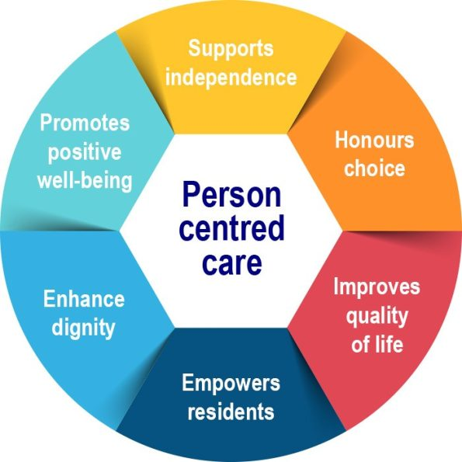
Person Centred Care: Definition, Benefits and Limitations

Person centred care (PCC) is an approach that respects the values, preferences, and needs of individuals, ensuring they are active partners in their care rather than passive recipients (Brooker, 2007). This approach shifts the clinical focus from What is the matter with the patient? to What matters to the patient? (Bhatt, Aljohani, and Forget, 2023). In GP surgeries, PCC entails more than just diagnosis and prescribing; it requires a comprehensive understanding of a patient’s social context, beliefs, communication needs, and long-term goals.
Evidence links patient-centred care (PCC) to higher patient satisfaction, stronger trust in clinicians, and improved treatment adherence (Barry and Edgman-Levitan, 2012). In primary care, PCC has been associated with reduced hospital admissions, enhanced self-management, and better outcomes for individuals with long-term conditions and multimorbidity. When patients feel heard and involved, they are more likely to engage in preventive measures and lifestyle changes, which aligns with NHS priorities.
However, several barriers hinder consistent implementation. Short appointment times, increased GP workload, and workforce shortages limit opportunities for personalised dialogue (BMA, 2025). Person-Centred Care also assumes that patients are confident, health-literate and capable of making informed decisions, which is not always true. Additionally, organisational resistance may arise in environments dominated by target-driven or biomedical cultures. In many GP surgeries, fragmented IT systems, digital exclusion, and limited access to multidisciplinary teams further undermine PCC.
Overall, PCC is widely supported in both policy and practice; however, its success in GP settings depends on adequate time, resources, training, and a cultural commitment to treating each individual as an informed partner in their own care.

Bronfenbrenner’s Ecological Theory And Its Application to Person-Centred Care
Bronfenbrenner’s Ecological Theory (1979) poses a robust support for person-centred care as it emphasises that individuals are influenced by interacting social systems rather than being seen as isolated clinical cases (Crawford, 2020). This perspective aligns with the fundamental goal of PCC: to treat patients as whole individuals, considering their values, relationships, and life experiences, rather than merely focusing on their medical conditions.
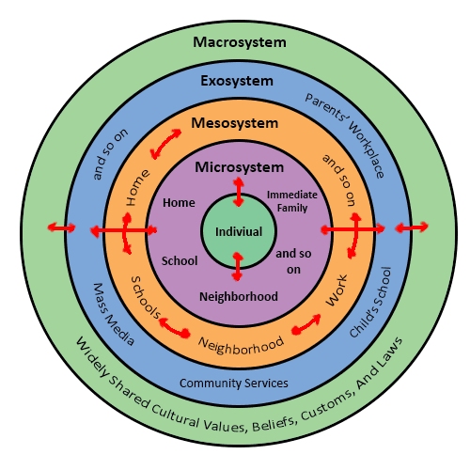
The theory is organised into five interacting layers. The microsystem encompasses the GP–patient interaction, where shared decision-making and trust are established. The mesosystem highlights the connections between various aspects of a patient's life, including collaboration among the GP, pharmacist, and family carer, thereby illustrating the concept of partnership working.
The exosystem encompasses indirect influences such as appointment systems, access to social care, and digital connectivity, all of which significantly impact the person-centredness of a GP practice. The macrosystem refers to broader structures, including NHS policy, cultural expectations, and legal frameworks, that shape concepts of dignity, choice, and equality. The chronosystem acknowledges that needs evolve over time, for instance, during ageing, the progression of illness, or life transitions.
The value of the theory lies in demonstrating that person-centred care requires more than just empathy; it relies on organisational support, effective teamwork and alignment of policies (Glasby and Dickinson, 2014). Its primary limitation is its practicality, as it necessitates system-level change rather than solely individual effort. Nevertheless, for GP surgeries dealing with complex, long-term conditions, it provides a realistic model for achieving fully person-centred care.

Ethical Fundamentals In Health And Social Care
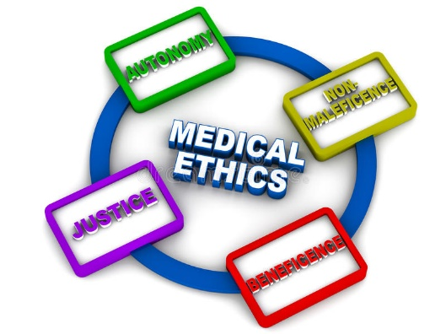
Ethical practice in health and social care is founded on four key principles: autonomy, beneficence, non-maleficence, and justice (Beauchamp and Childress, 2009). These principles underpin person-centred care, which emphasises patient choice and dignity, and partnership working, which shares responsibility among professionals to achieve fair and safe decisions.

Autonomy refers to respecting a patient’s right to make their own choices. For instance, in a GP surgery, a patient with diabetes may decide to refuse insulin. The GP faces the challenge of balancing this respect for the patient’s choice with the need for safety. By involving a diabetes nurse and the patient’s family, a collaborative plan can be developed.
Beneficence involves acting in a patient’s best interest. A GP might prescribe painkillers for arthritis, yet a social prescriber may recognise that loneliness is the underlying issue. By working together, both professionals can address the situation through medication review and community support, thereby broadening the definition of what constitutes the best interest of the patient.
Non-maleficence (avoiding harm) is challenged when a patient requests long-term sedatives. The GP may agree to prescribe them only for short-term use while arranging mental health support, thereby reducing potential harm through collaborative efforts.
Justice relates to fairness. When a patient requires an interpreter, they need additional time during their appointment. To ensure equal access, the practice reserves longer appointment slots for these patients.
These examples illustrate that ethical care in GP surgeries extends beyond individual morality; it relies on patient-centred care values and effective partnership systems.
Evaluation of Partnership Working in Health and Social Care
Partnership working (PW) involves organisations, professionals, service users, and communities collaborating to achieve common goals in health and social care (Petch, Cook and Miller, 2013). In the UK, PW has become a structural expectation, particularly with the introduction of Integrated Care Systems (ICS), which aim to dismantle traditional barriers between the NHS, local authorities and the voluntary sector (NHS England, 2021). The rationale behind partnership working is that complex health needs, especially for individuals with multimorbidity, cannot be effectively addressed by a single agency acting in isolation.
Benefits associated with PW include improved care coordination, reduced duplication of services, and smoother transitions for patients between hospital, GP, community, and home care settings. When GPs collaborate closely with social workers, pharmacists, physiotherapists, district nurses, and carers, patients benefit from fewer communication gaps and enhanced continuity of care. Additionally, PW facilitates earlier intervention and prevention through the pooling of knowledge and resources.
However, research highlights several challenges. Different organisations often have conflicting priorities, funding structures, or cultures, which can hinder practical collaboration (Pedro and Baylin, 2020). Information sharing poses a significant barrier, particularly when digital systems are incompatible or when data protection concerns restrict communication (Hassey, 2020). At the professional level, successful partnerships depend on mutual trust and clarity of roles; without these elements, collaboration may feel more tokenistic than meaningful. In GP settings, time constraints and staff shortages can make sustained joint working difficult, even when all parties support it in principle.
Overall, while partnership working offers clear value, it is not self-executing; it requires investment, leadership, and shared accountability.

Application Of Partnership Working In GP Surgeries
Partnership working in GP surgeries entails collaboration among GPs, nurses, pharmacists, social prescribers, mental health teams, and community services to provide coordinated care. This approach is particularly crucial for patients with long-term or complex needs who require support that spans multiple professions. For instance, a patient dealing with diabetes, depression, and mobility issues may receive a medical review from a GP, dietary advice from a practice nurse, medication support from a pharmacist, and referrals for local activities from a social prescriber.
This integrated approach minimises duplication, prevents unnecessary hospital admissions and promotes person-centred care. However, effective partnership working depends on shared records, clear communication, and time for joint planning,

Policy And Legislation In Relation To PCC and PW
Several key UK policies and laws influence the delivery of person-centred care and partnership working in GP surgeries. The Health and Care Act 2022 legally established Integrated Care Systems (ICS), which aim to enhance collaboration among the NHS, local authorities, and community services. This framework supports PW by promoting shared budgets and joint planning. However, many GP surgeries have reported that this integration often leads to increased workloads without sufficient staffing or digital support.
The Care Act 2014 imposes a duty on services to promote individual wellbeing and to involve people in decisions regarding their care. This establishes person-centred care as a legal requirement rather than an optional practice. In General Practice settings, this means that care plans must take into account social, emotional, and medical needs, rather than focusing solely on diagnosis.
The Health and Social Care Act 2012 enhanced patient choice and introduced the no decision about me, without me agenda. While it supported patient-centred care, it also fragmented services through competitive commissioning, which sometimes hindered partnership working by separating providers.
The Equality Act 2010 mandates that GP practices make reasonable adjustments for protected groups. This includes offering longer appointments for patients with learning disabilities and providing interpreters. Additionally, the Human Rights Act 1998 supports rights to dignity, respect, and autonomy, which play a crucial role in consent, safeguarding, and end-of-life decisions.
In practice, these policies encourage GP surgeries to adopt more personalised and collaborative care. However, their implementation heavily relies on available resources. When funding, staffing, or digital systems are lacking, the legal obligations remain, but the reality of personalised care and patient involvement becomes inconsistent.

Recommendations For Future Development Of Person-Centred Care And Partnership Working
While PCC and PW are integrated into policy, there are still several gaps in GP surgeries. These include limited consultation time, unequal access to digital resources, and inconsistent collaboration among professionals. If these structural barriers are not addressed, PCC may continue to be seen as an aspiration rather than standard practice.
A key recommendation is to implement protected longer consultations for patients with complex needs. Evidence indicates that multimorbidity necessitates extended consultation time to prevent repeat visits and unsafe decision-making (Tadeu et al., 2020). However, achieving this will depend on expanding the national workforce, which means that recruitment and retention policies must align with person-centred care goals.
Secondly, digital inclusion strategies should accompany the transition to online triage, remote monitoring, and shared care records. NHS England (2023) has established a national framework to reduce digital exclusion, but local GP practices need to collaborate with community organisations to provide access to devices and training. It is important to recognise that some patients will always need non-digital options; therefore, technology should supplement—not replace—face-to-face care.
Third, expand inter-professional training to enhance teamwork and minimise fragmented care. Research indicates that inadequate collaboration among professionals can lead to avoidable harm, emphasising the importance of shared learning across different roles (Choudhury et al., 2020).
Finally, embed co-design with patients and carers. Co-design enhances person-centred care by involving patients and professionals as equal partners in shaping services. Evidence indicates that it has improved areas such as discharge communication and breast care pathways (Fylan et al., 2021). While still evolving, it provides a practical approach to ensuring that GP services align with actual patient needs.
Overall, improvement relies on investment in staffing, digital equality, and a culture of partnership; policy statements alone are insufficient.

Conclusion
This report has demonstrated that person-centred care (PCC) and partnership working (PW) are vital for providing effective and ethical care in GP surgeries. PCC ensures that patients are treated as individuals with unique values and circumstances, while PW facilitates collaboration among services to address needs that go beyond medical treatment alone.
The analysis revealed that theory, ethics, policy, and practice all converge on a common goal: providing care that is holistic, collaborative, and centred around the individual rather than the system. However, obstacles such as limited time, workforce pressures, digital inequality, and fragmented communication continue to hinder progress. To enhance Person-Centred Care and partnership working in primary care, it will be essential to invest in shared records, meaningful patient involvement, and sustained cultural change. When these elements come together, GP surgeries can offer care that is both compassionate and effective.

Reference List
Barry, M.J. and Edgman-Levitan, S. (2012) ‘Shared Decision Making — The Pinnacle of Patient-Centered Care’, The New England journal of medicine, 366(9), pp. 780–781. Available at: https://doi.org/10.1056/NEJMp1109283.
Beauchamp, T.L. and Childress, J.F. (2009) Principles of biomedical ethics. 6th ed. Oxford University Press.
Bhatt, K., Aljohani, D. and Forget, P. (2023) 'Both patients and the public should be involved in setting the pain research agenda', BJA, 131(5) , pp. e166-e167. Available at: 10.1016/j.bja.2023.08.008
BMA (2025) Pressures in general practice data analysis. Available at: https://www.bma.org.uk/advice-and-support/nhs-delivery-and-workforce/pressures/pressures-in-general-practice-data-analysis (Accessed: 3 November 2025).
Brooker, D. (2007) Person-centred dementia care : making services better. Jessica Kingsley Publishers.
Care Act 2014, c. 23. Available at: https://www.legislation.gov.uk/ukpga/2014/23/section/1 (Accessed: 4 November 2025).
Choudhury, R.I. et al. (2020) ‘How interprofessional education could benefit the future of healthcare – medical students’ perspective’, BMC medical education, 20(1). Available at: https://doi.org/10.1186/s12909-020-02170-w.
Crawford, M. (2020) ‘Ecological Systems theory: Exploring the development of the theoretical framework as con-ceived by Bronfenbrenner’, J Pub Health Issue Pract, 4(2), pp.170.
Equality Act 2010, c.15. Available at: https://www.legislation.gov.uk/ukpga/2010/15/contents (Accessed: 3 November 2025).
Fylan, B. et al. (2021) ‘Using experience-based co-design with patients, carers and healthcare professionals to develop theory-based interventions for safer medicines use’, Research in social and administrative pharmacy, 17(12), pp. 2127–2135. Available at: https://doi.org/10.1016/j.sapharm.2021.06.004.
Glasby, J. and Dickinson, H. (2014) Partnership working in health and social care : what is integrated care and how can we deliver it? Second edition. Bristol: The Policy Press.
Hassey, A. (2020) Exploring the barriers to information sharing for direct care. Available at: https://www.gov.uk/government/news/exploring-the-barriers-to-information-sharing-for-direct-care#:~:text=The%20barriers%20to%20information%20sharing%20emerged%20as%20six%20themes:%20poor,and%20guidance;%20concerns%20about%20onward (Accessed:1 November 2025).
Health and Care Act 2022, c. 31. Available at: https://www.legislation.gov.uk/ukpga/2022/31/section/19 (Accessed: 1 November 2025).
Health and Social Care Act 2012, c.7. Available at: https://www.legislation.gov.uk/ukpga/2012/7/contents (Accessed: 2 November 2025).
Human Rights Act 1998, c.42. Available at: https://www.legislation.gov.uk/ukpga/1998/42/contents (Accessed: 3 November 2025).
NHS England (2021) Building strong integrated care systems everywhere. Available at: https://www.england.nhs.uk/wp-content/uploads/2021/06/B0664-ics-clinical-and-care-professional-leadership.pdf (Accessed: 5 November 2025).
NHS England (2023) Inclusive digital healthcare: a framework for NHS action on digital inclusion. Available at https://www.england.nhs.uk/long-read/inclusive-digital-healthcare-a-framework-for-nhs-action-on-digital-inclusion/ (Accessed: 6 November 2025).
Pedro, L. and Baylin, E. (2020) Creating partnerships for success. Available at: https://www.ncvo.org.uk/news-and-insights/news-index/creating-partnerships-success/challenges/#:~:text=their%20partnership%20makes.-,Culture%20change,each%20level%20of%20the%20structure. (Accessed: 3 November 2025).
Petch, A., Cook, A. and Miller, E. (2013) ‘Partnership working and outcomes: do health and social care partnerships deliver for users and carers?’, Health & social care in the community, 21(6), pp. 623–633. Available at: https://doi.org/10.1111/hsc.12050.
Tadeu, A.C.R. et al. (2020) ‘Multimorbidity and consultation time: a systematic review’, BMC family practice, 21(1). Available at: https://doi.org/10.1186/s12875-020-01219-5.

