

L4 – Fundamentals of Electrical and Electronic Systems
(OME Degree – Sem 3) ACDA4018
Circuit Design
Charlotte McCombe
Student Number: 2411524

Contents
Circuit description and operation 3
Proteus simulation schematic 4
Design Calculations 5
Simulation Timing Measurements 7
Frequency and time period 7
Capacitor Voltage 8
Diode Voltage 9
Output Voltage 10
Simulation Graphs 11
C1 voltage 11
Output Voltage 12
Details of 555 timer circuit on breadboard 13
555 timer pin functions 13
Connections of 555 timer on breadboard 13
Timing measurements taken from Breadboard 16
Graphs produced from breadboard simulation 17
Voltage graph of capacitor on breadboard (Data table in appendix A) 17
Voltage graph of output voltage of 555 timer (Data table in Appendix B) 18
Conclusion 19
Bibliography 19
Appendices 21

Circuit description and operation
The simulated circuit was a 555 timer to create alternate flashing a red and green Light emitting diodes (LED). The aim was for the LED’s to repeatedly illuminate then turn off one after the other. The circuit was simulated on the Proteus software and a breadboard.
The circuit consisted of a 555 timer, capacitors, resistors, a 9V voltage supply, a red diode and a green diode. The voltage supply of 9v provided a supply throughout the circuit.R1 and R2 opposed the voltage flow to the capacitor to allow it to charge gradually. C1 stored charge to the point that 2/3 of the Supply Voltage (Vcc ) was reached (6V) then released the charge. The output of the capacitor had a low output when discharging and high when charged. R3 and R4 controlled the brightness of the LED’s ensuring low current through the LED’s.

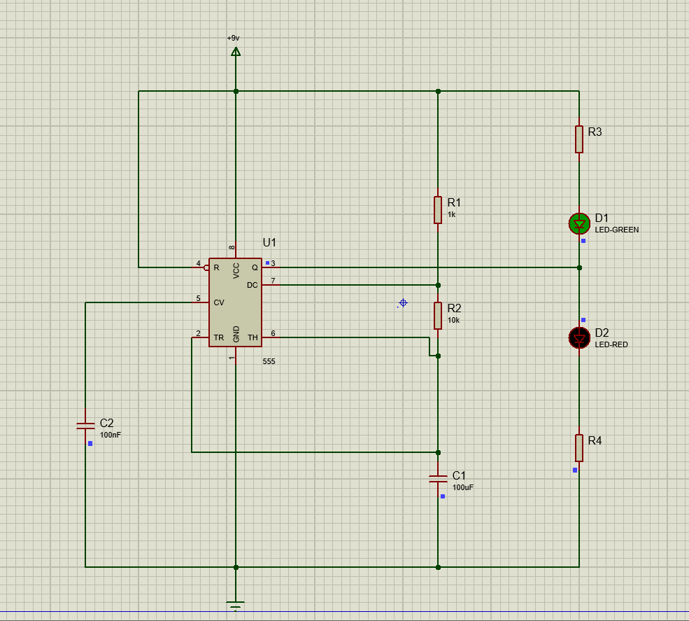
Figure 1 - Circuit schematic simulated on Proteus Software
The illumination of the diodes depended on the output voltage at pin 3. The transistors and flipflop within the timer controlled this. C1 charged through R1 and R2 to 2/3 of Vcc, then discharged through R2 and pin 7 until the value dropped below 1/3Vcc. This low voltage applied to the trigger pin 2 caused the output voltage (pin 3) to increase and determined the frequency [1].

Proteus simulation schematic
The circuit connected a 555 timer to a 9V Vcc. R1, R2 and C1 formed a series connection to control the charging and discharging of C1. C2 was connected to pin 5 and ground in parallel with the capacitors. R3 and D1 formed a series connection, as did D2 and R4. The output of the timer controlled with LED illumiated and for hot long. 1Kilo-ohm resistors were used in the simulation and breadboard for R3 and R4 due to supplied components and for comparison of results.
D1 illuminated when the output voltage was low.
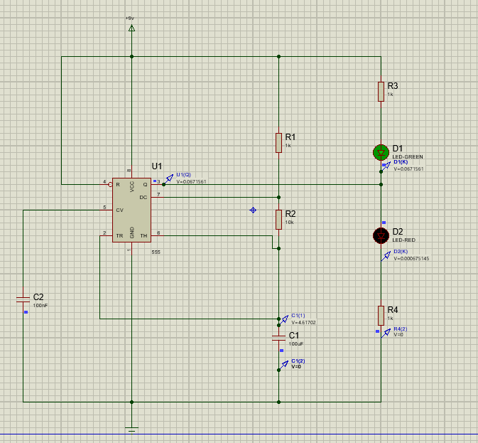
Figure 2- Green LED illuminated in 555 timer circuit

D2 illuminated when the output voltage was high
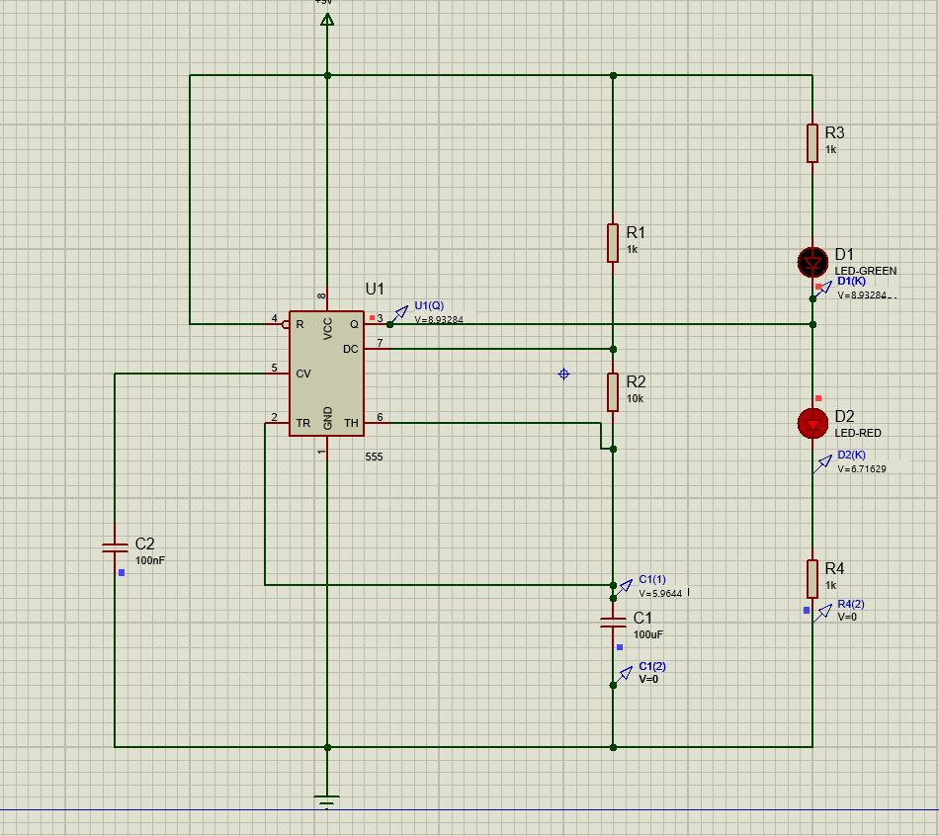
Figure 3 - Red LED illuminated in 555 timer circuit

Design Calculations

R3 and R4 had an unknown value and were calculated:
Forward voltage of red LED = 1.7-2.2, middle 1.95 [2]
Forward voltage of green LED = 2-3.3, middle 2.15 [2]
Current of LED’s = 20mA [3]
Using the supply voltages, forward voltages and forward currents the unknown values were calculated [4]
$$R3=\frac{(Vcc-Vf)}{ILED}$$
$$R3=\frac{9-2.15}{20 ×{10}^{-3}}=342.5Ω$$
$$R4=\frac{9-1.95}{20 ×{10}^{-3}}=352.5Ω$$

The high output (on) time and low output time (off) were calculated using the equations [5]:
$$T_{high}=0.693×(R1+R2)×C1$$
$$T_{high}=0.693×11000×100×{10}^{-6}$$
$$Thigh=0.7623$$
$$T_{low}=0.693×R2×C1$$
$$T_{low}=0.693×10000×100×{10}^{-6}$$
$$Tlow=0.693$$
$$Total T=1.4553(4dp)$$

An alternative calculation for astable circuit frequency [6]:
$$T=\frac{1}{f}$$
$$f=\frac{1.44}{\left(R1+2R2\right)C}$$
$$f=\frac{1.44}{(1000+20,000)×(100×{10}^{-6})}$$
$$f=0.6857 Hz (4dp)$$
$$T=\frac{1}{f}$$
$$T=\frac{1}{0.6857}$$
$$T=1.4583 (4dp)$$
The design calculation T was slightly shorter than the calculated T from the simulation.

Simulation Timing Measurements

Frequency and time period
The frequency of the LED’s were measured by counting how many cycles took place in 30s
The number of cycles was 18 doubled to give 36 in 60s.
$$f=\frac{number of cycles}{time(s)}$$
$$f=\frac{36}{60}=0.6Hz$$
$$Time period= \frac{1}{Frequency}$$
$$Time period=\frac{1}{0.6}$$
$$Time period=1.6667s$$
Compared to the time period of output voltage from proteus:
Using a period from peak to peak output voltage:
Time | Voltage
1.175191 | 8.93284
2.852848 | 8.93284

$$2.852848-1.175191=1.67766s$$
The time period was 1.678s which was greater than the calculated value. Using a longer measurement period could of made the results more accurate and similar.

Capacitor Voltage
The voltage through the capacitor initially decreased from 9V to 2.7V in 1.17s before then increasing to a maximum of 6.17V at 2.0s.
TIME | C1(1) | TIME | C1(1)
0 | 8.99991 | 1.181349 | 2.82538
4.36E-07 | 8.99991 | 1.192862 | 2.88967
0.00066 | 8.99401 | 1.204255 | 2.95263
0.01283 | 8.8858 | 1.215805 | 3.01579
0.028275 | 8.75037 | 1.227283 | 3.07791
0.043625 | 8.61783 | 1.238871 | 3.13997
0.059007 | 8.48703 | 1.250612 | 3.20218
0.074608 | 8.35641 | 1.262946 | 3.26683
0.091228 | 8.21948 | 1.276982 | 3.33952
0.106126 | 8.09866 | 1.288694 | 3.39946
0.119147 | 7.99451 | 1.304567 | 3.4797
0.13778 | 7.84783 | 1.329664 | 3.60422
0.151193 | 7.74392 | 1.349842 | 3.7023
0.169863 | 7.60157 | 1.381547 | 3.85282
0.198448 | 7.38871 | 1.441183 | 4.12451
0.249843 | 7.0209 | 1.560457 | 4.62596
0.352632 | 6.33921 | 1.799003 | 5.48171
0.55821 | 5.16635 | 2.037529 | 6.16995
0.969366 | 3.42038 | 2.043684 | 6.13238
1.175194 | 2.79073 | 2.058939 | 6.04027

Immediately the capacitor was in a discharged state and charged to greater than 2/3Vcc before discharging. These values were seen over each 2s period with values around 6V and 2.7V. The time to increase the voltage across the capacitor was longer than the time for the voltage to decrease.

Diode Voltage
The voltage across D1 switched from around 0.07V to a high voltage of around 8.9V approximately every 0.86s.
TIME | D1(K) | TIME | D1(K) |  | TIME | D2(K) | TIME | D2(K)
0 | 8.93284 | 1.175191 | 2.75475 |  | 0 | 6.71629 | 1.175191 | 0.013144
1.99E-08 | 7.15116 | 1.175191 | 6.31163 |  | 1.99E-08 | 4.94123 | 1.175191 | 0.593714
3.97E-08 | 5.3825 | 1.175191 | 8.93284 |  | 3.97E-08 | 3.18056 | 1.175191 | 4.10521
5.46E-08 | 4.05876 | 1.175287 | 8.93284 |  | 4.47E-08 | 2.74184 | 1.175191 | 6.71629
7.44E-08 | 2.29291 | 1.200507 | 8.93284 |  | 5.46E-08 | 1.86612 | 1.175287 | 6.71629
1.14E-07 | 0.067156 illuminated | 1.242743 | 8.93284 |  | 7.44E-08 | 0.208195 | 1.200507 | 6.71629 illuminated
8.25E-05 | 0.067156 | 1.29591 | 8.93284 |  | 1.14E-07 | 0.000675 | 1.242743 | 6.71629
0.024534 | 0.067156 | 2.037526 | 8.93284 |  | 8.25E-05 | 0.000675 | 1.29591 | 6.71629
0.066755 | 0.067156 | 2.037526 | 8.03515 |  | 0.024534 | 0.000675 | 2.037526 | 6.71629
0.119147 | 0.067156 | 2.037526 | 6.24525 |  | 0.066755 | 0.000675 | 2.037526 | 5.82183
1.175191 | 0.067156 | 2.037526 | 2.68837 |  | 0.119147 | 0.000675 | 2.037526 | 4.03912
1.175191 | 0.964853 | 2.037526 | 0.067156 |  | 1.175191 | 0.000675 | 2.037526 | 0.532218

When C1 voltage as at a minimum, D1 voltage was at a maximum.D2 reached a maximum of 6.7V whereas D1 reached 8.9V. The output voltage went low when 2/3 Vcc was reached therefore the current travelled to ground and discharged illuminating D1. When the voltage in the capacitor reached 1/3 Vcc the output was high and the current travelled from the power supply to D2 and illuminated D2 with 2/3Vcc.

Output Voltage
TIME | U1(Q) | TIME | U1(Q)
0 | 8.93284 | 2.037526 | 8.93284
1.99E-08 | 7.15116 | 2.037526 | 8.03515
3.97E-08 | 5.3825 | 2.037526 | 6.24525
5.46E-08 | 4.05876 | 2.037526 | 2.68837
7.44E-08 | 2.29291 | 2.037526 | 0.067156
1.14E-07 | 0.067156 | 2.037622 | 0.067156
8.25E-05 | 0.067156 | 2.062842 | 0.067156
0.024534 | 0.067156 | 2.105078 | 0.067156
0.066755 | 0.067156 | 2.158246 | 0.067156
0.119147 | 0.067156 | 2.852847 | 0.067156
1.175191 | 0.067156 | 2.852847 | 0.964853
1.175191 | 0.964853 | 2.852847 | 2.75475
1.175191 | 2.75475 | 2.852847 | 6.31163
1.175191 | 6.31163 | 2.852848 | 8.93284
1.175191 | 8.93284 | 2.852944 | 8.93284
1.175287 | 8.93284 | 2.878163 | 8.93284
1.200507 | 8.93284 | 2.9204 | 8.93284
1.242743 | 8.93284 | 2.973567 | 8.93284
1.29591 | 8.93284 | 3.715182 | 8.93284

The output voltage was initially Vcc but quickly dropped as C1 began to charge. As C1 charged, the output turned high and D2 illuminated. Shown at 1.175191s the output voltage was high which illuminated D2 with a voltage close to 2/3 of the Vcc at 6.7V. When the output voltage was low at 0.066755s D1 illuminated with a voltage of 0.067156.

Simulation Graphs

C1 voltage
The voltage from C1 was shown to have an initial value of 9V which immediately began dropping towards 1/3 Vcc before gradually rising to 2/3 Vcc. At 2/3Vcc the threshold pin 6 registered high which flipped the comparator and produced a low output voltage shown in figure 1. When the output was low the discharge pin was activated and he capacitor discharged. The trigger pin registered at low when the voltage in the capacitor was below 1/3 Vcc flipping the comparator at the trigger pin and enabled high output [7]. This was repeated over the 30s period shown on the graph.
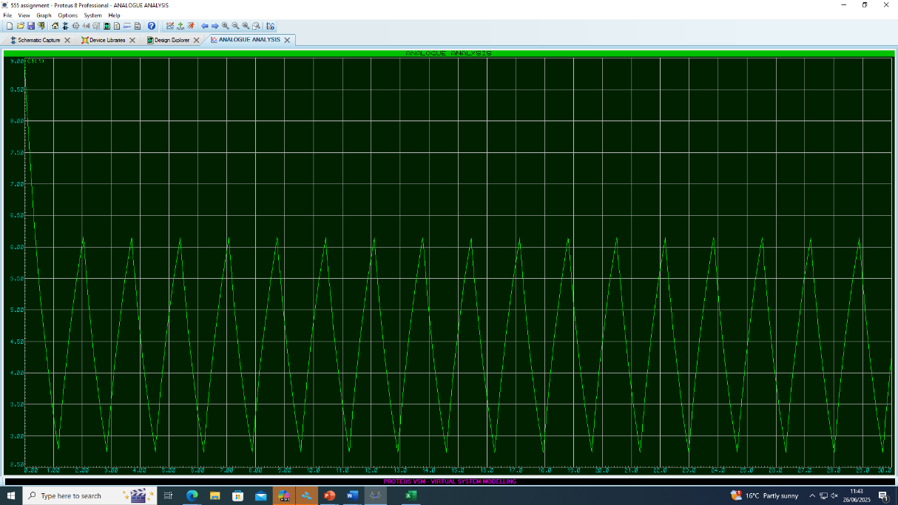
Figure 4 - Proteus simulation graph of C1 voltage over 30s

Output Voltage
The output voltage was measured using probe U1 in the simulation at pin 3 of the 555 timer. The voltage was initially 9V and dropped to almost 0V where the current remained constant for around 0.82s be. The voltage then increased to 9V and remained constant for 0.86s. This cycle repeated continuously with voltage drops and increase. The output voltage was high when discharge pin was low and high when threshold pin was low. These values add up to be close to the measured time period calculated for the proteus simulation of 1.6667s.
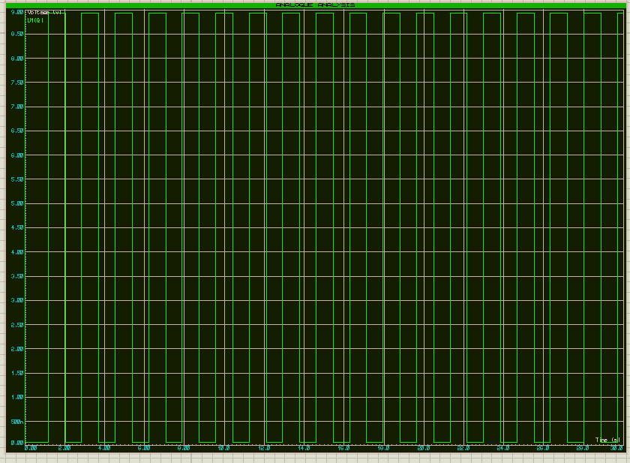
Figure 5 - Proteus simulation graph of output voltage over 30s

Details of 555 timer circuit on breadboard
A 555 timer is an integrated circuit that is used for several functions as it has various modes including monostable and astable. It is used for time related purposes due to its ability to create pulses. In the LED circuit the time acts in astable mode to produce a oscillating pulse between high and low [8] in order to turn the LED’s on and off. The timer consists of a potential divider chain of 3 resistors of the same value with reference voltages of 1/3 and 2/3 of the supply voltage, two comparators, a flip flop and a transistor [9].
The comparators in the circuit set the output low or high depending on the voltage input. The comparator connected to pin 2 compares the trigger input to a value of 1/3Vcc and the threshold pin 6 compares to 2/3Vcc. The flip-flop then outputted this signal and supplied voltage to the circuit.

555 timer pin functions
The 555 timer had 8 pins, each with a different function that allowed the circuit to function [10]:
Pin | Function
Pin 1 – Ground | Grounded the circuit
Pin 2 - Trigger | Set output high when capacitor voltage below 1/3Vcc
Pin 3 - Output | High or low output
Pin 4 - Reset | Resets circuit when pin low
Pin 5 – Control voltage | Controls threshold voltage of pin 6
Pin 6 - Threshold | Low output voltage when capacitor voltage over 2/3Vcc
Pin 7- Discharge | Capacitor discharge when output low, or disconnected when output high
Pin 8 – Vcc Supply | Connected to power supply

Connections of 555 timer on breadboard
The breadboard used the 555 timer connected across the centre divider and with the notch identifying the top of the timer and pin one on the left hand side. Pin one connected to ground in the left hand side power rail using a wire. Pin 2 connected C1 to ground to allow it to discharge and a wire connected to pin 6 to monitor the voltage and relay to the flip flop to control the output. Pin 3 connected D2 to ground and a wire connection to D1. R4 formed a series connection with D2 connecting from the negative leg to ground and R3 formed a series connection with D1 connecting to power supply. Pin 4 was the reset pin and connected to the power supply using a wire. Pin 5 connected C2 to ground and pin 6 connected to pin 2 using a wire to monitor the output. Pin 7 connected resistors R1 and R2 in series with C1. R1 connected to the power supply, R2 and C1. The capacitor discharged through R2 pin 7. Pin 8 connected to the power supply of 9V to power the circuit.

Figures 6 and 7 show the circuit on the breadboard with a 9V power supply connected to row 63.
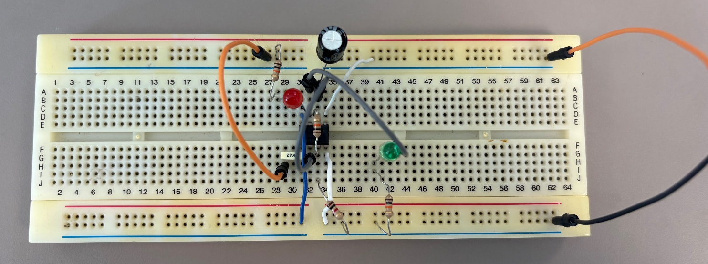
Figure 6 - 555 Timer circuit on breadboard
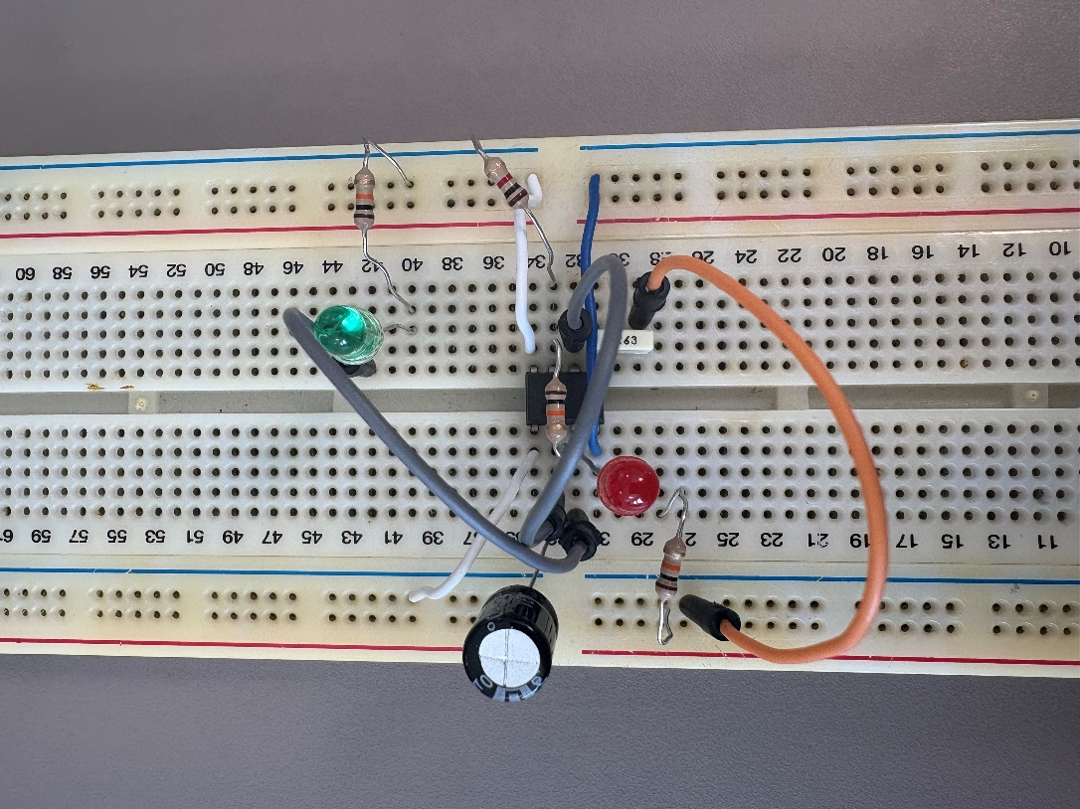
Figure 7- 555 Timer circuit on breadboard

Figure 8 shows pin 1, C1, R4 and C2 connected to ground.
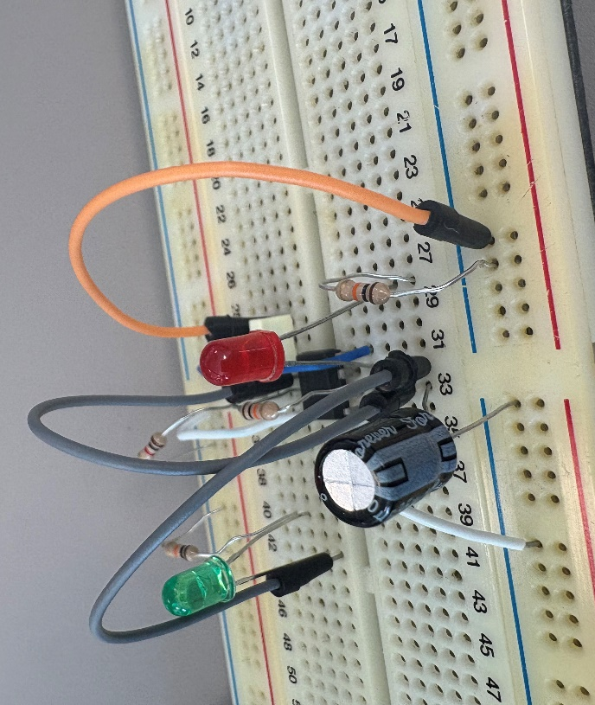
Figure 8- 555 Timer circuit on breadboard ground connections

Figure 9 shows pin 8, R1, pin 4 and R3 connected to the power supply.
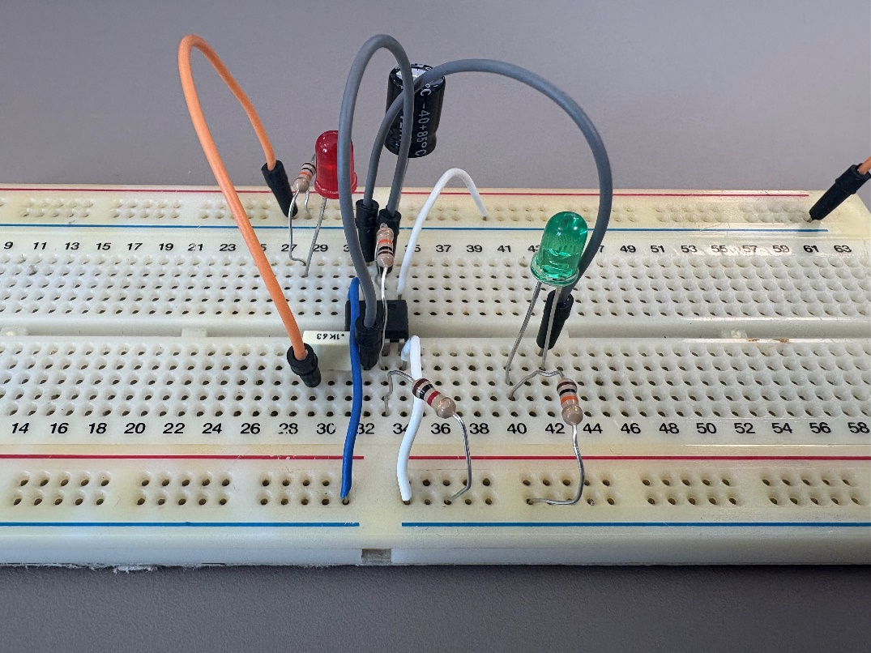
Figure 9- Connections to power supply from 555-timer circuit
The breadboard was tested by connecting the components above as described then supplying a 9V supply through the power pin using crocodile clip wires for the LED’s to illuminate. The LED’s were assured to be functioning by supplying a low voltage directly to the negative and positive leg of the component for them to illuminate. The wires and connections in the board were all pressed deep into the board to ensure proper connections.

Timing measurements taken from Breadboard
The frequency was calculated using the breadboard. This was measured by counting the number of cycles over a 30s time period using a video recording. A cycle was when the red light illuminated followed by the green light.
Cycles in 30s=22, 44 in 60s
$$f=\frac{number of cycles}{Time(s)}$$
$$f=\frac{44}{60}=0.73Hz$$
The time period was then calculated:
$$Time period= \frac{1}{Frequency}$$
$$Time period=\frac{1}{0.73}$$
$$Time Period=1.3699s$$
This value is very similar to the design calculation with a 0.09s difference. Counting the number of cycles over a greater length of time could have made the frequency and time period more accurate.

Graphs produced from breadboard simulation
The voltage output and C1 voltage were measured over a 30s period using a multimeter and a video recording to record results is 1 second intervals. The voltmeter was set to read up to 20V as the suitable voltage for the circuit to function was between 5 and 18 volts [11]. However as the voltage increased and decreased over milliseconds this was not very visible on the voltmeter and it was incapable of capturing the fluctuating voltage.

Voltage graph of capacitor on breadboard (Data table in appendix A)
To measure the voltage output of the capacitor a wire was placed in the breadboard at both ends of the capacitor, crocodile clips leads were connected to each wire and into the voltmeter. The graph showed the capacitor charging and discharging. It was expected for the capacitor to be at voltages close to 2/3 when charged and 1/3 when discharged. However, the graph shows the voltage going well above and below these values.
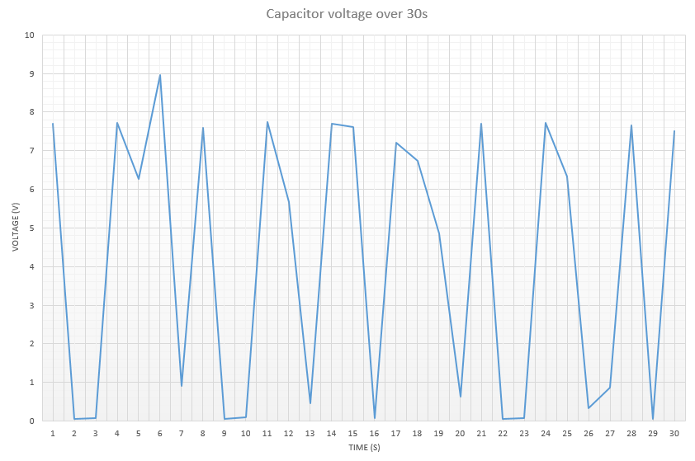
Figure 10 - C1 voltage over 30s on breadboard
Compared to the graphs produced on the simulation there was not as many occurrences of increasing and decreasing voltage. The maximum voltage is quite consistent at around 7.7V, which was higher than the simulated maximum of around 6.25V. The lowest voltage is also consistent and within the range 0.05V and 0.64V, lower than the simulated values. There are clear points where the voltage is increasing and decreasing over time however, these results do not capture every cycle. Within the simulation there was 17 peaks in higher voltage over the 30s period however the breadboard results only captured 10 with the gradients being much less steep than those of the proteus graph suggesting some results were not obtained. There are also clear areas such as between 16s and 20s where the voltage would have increased and decreased as the LED’s were alternatingly illuminated.

Voltage graph of output voltage of 555 timer (Data table in Appendix B)
To measure the voltage output a wire was placed in the breadboard at pin 3 and ground, crocodile clips leads were connected to each wire and into the voltmeter. Similarly to the capacitor the multimeter was unable to take readings at a fast pace. The output voltage showed both maxima close to supply voltage and minima close to 0, expected due to the charging and discharging of the capacitor.
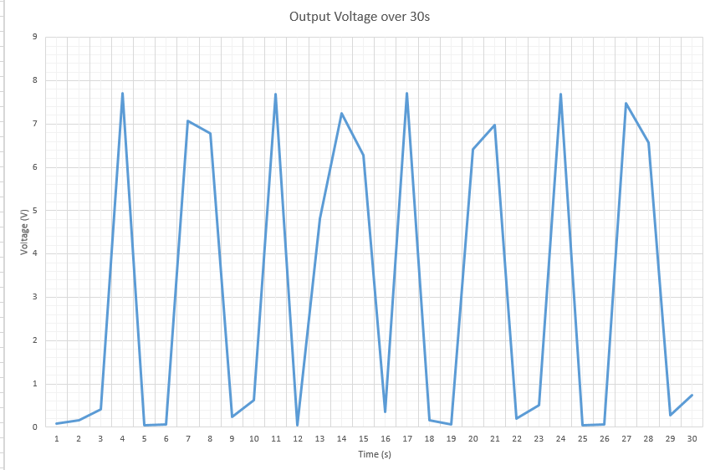
Figure 11 - Output voltage on breadboard over 30s
Compared to the simulated graph which had a periodic square wave shown in figure 5 , the breadboard graph is of similar shape but did not show a steady time period or areas of constant voltage. There are also 17 occurrences of maximum voltage on the simulation graph and only 8 occurrences on the breadboard graph, again highlighting missed occurrences. To improve this a different multimeter with a greater capability to measure the voltage over shorter periods could have been used or an oscillator to gain a larger data set and more square like waves.

Conclusion
In conclusion, the 555-timer circuit proved successful in creating alternating illuminated LED’s. There was variation in the time period through the design calculations, the simulation and the breadboard and but all proved successful in creating a functioning circuit. The 555 timer has many uses and the LED circuits could be used with greater number of LED’s or different time periods.

Bibliography

[1] | P. Kane, “How To Configure a 555 Timer IC,” Jameco Electronics, [Online]. Available: https://www.jameco.com/Jameco/workshop/TechTip/555-timer-tutorial.html#:~:text=In%20astable%20mode%2C%20capacitor%20C1,+%202*R2)%20*%20C1. [Accessed 10 July 2025].
[2] | Phidgets, “LED Guide,” Phidgets, 2023 June 26. [Online]. Available: https://www.phidgets.com/docs/LED_Guide?srsltid=AfmBOoqPAYGmzPFOyG0H5GQeSmBLWmPqJEJPXM6bpPr9KZPNvmBV51ZL. [Accessed 4 July 2025].
[3] | Soldered, “LED (Light-emitting diode) explained,” Soldered, 23 August 2024. [Online]. Available: https://soldered.com/learn/led-light-emitting-diode-explained/?srsltid=AfmBOorPqkWEJz0EmVCswHXG7pMZr4f1pi3wyPCt0npZfxd14YztYKDt. [Accessed 12 July 2025].
[4] | T. R. Kuphaldt, “555 Lab - Advanced Red LED Flasher,” All About Circuits, [Online]. Available: https://www.allaboutcircuits.com/textbook/experiments/chpt-8/cmos-555-long-duration-red-led-flasher/. [Accessed 14 July 2025].
[5] | C. K. Gamage, M. Sheshan, D. Senodh, J. U. Athapathhu and O. Gethmini, “Automatic Plant Irrigation System with NE555 Timer,” SLTC Research University, Sri Lanka, 2022.
[6] | E. Amagre, P. Okayim and A. Aloamaka, “Design and implementation of an astable multivibrator,” World Journal of Advanced Research and Reviews, vol. 22, no. 3, pp. 2015-2018, 2024.
[7] | A. Ghassaei, “555 Timer,” Autodesk Instructables, [Online]. Available: https://www.instructables.com/555-Timer/. [Accessed 9 July 2025].
[8] | J. Upadhyay, “555 Timer - 1. Introduction to 555 Timers,” CircuitBread, 06 April 2022. [Online]. Available: https://www.circuitbread.com/tutorials/555-timer-1-introduction-to-555-timers. [Accessed 15 July 2025].
[9] | F. everest, “The charachteristics and use of the 555 timer,” Electronics education, vol. 2000, no. 3, pp. 34-40, 2000.
[10] | Ø. N. Dahl, “555 Timer Tutorial: How It Works and Useful Example Circuits,” Build electronic circuits, 4 June 2021. [Online]. Available: https://www.build-electronic-circuits.com/555-timer/. [Accessed 1 July 2025].
[11] | EFY Bureau, “555 Timer IC Pinout, Circuit, Working, and Datasheet,” electronicsforu, 18 June 2024. [Online]. Available: https://www.electronicsforu.com/technology-trends/learn-electronics/555-timer-working-specifications. [Accessed 10 July 2025].
[12] | M. Abrar, “Design and Implementation of Astable Multivibrator using 555,” IOSR Journal of Electrical and Electronics Engineering, vol. 12, no. 1, pp. 22-29, 2017.

Appendices
Appendix A
Capacitor Voltage on Breadboard
Time (s) | Voltage (V) | Time (s) | Voltage (V)
1 | 7.69 | 16 | 0.07
2 | 0.05 | 17 | 7.21
3 | 0.08 | 18 | 6.73
4 | 7.73 | 19 | 4.86
5 | 6.27 | 20 | 0.64
6 | 8.96 | 21 | 7.69
7 | 0.91 | 22 | 0.05
8 | 7.6 | 23 | 0.08
9 | 0.06 | 24 | 7.71
10 | 0.1 | 25 | 6.33
11 | 7.75 | 26 | 0.34
12 | 5.68 | 27 | 0.87
13 | 0.47 | 28 | 7.66
14 | 7.7 | 29 | 0.06
15 | 7.62 | 30 | 7.5

Appendix B
Output Voltage on Breadboard
Time (s) | Voltage (V) | Time (s) | Voltage (V)
1 | 0.09 | 16 | 0.35
2 | 0.17 | 17 | 7.72
3 | 0.42 | 18 | 0.17
4 | 7.71 | 19 | 0.06
5 | 0.05 | 20 | 6.41
6 | 0.06 | 21 | 6.98
7 | 7.08 | 22 | 0.2
8 | 6.78 | 23 | 0.5
9 | 0.24 | 24 | 7.7
10 | 0.62 | 25 | 0.05
11 | 7.69 | 26 | 0.07
12 | 0.05 | 27 | 7.47
13 | 4.82 | 28 | 6.58
14 | 7.24 | 29 | 0.28
15 | 6.28 | 30 | 0.74

