Evolving Your Creative Craft – Assignment 1
By Joseph Lee - 2405184

Contents:
- Mind Map
- Mood Boards
- Designs
- Bibliography

Mind Map

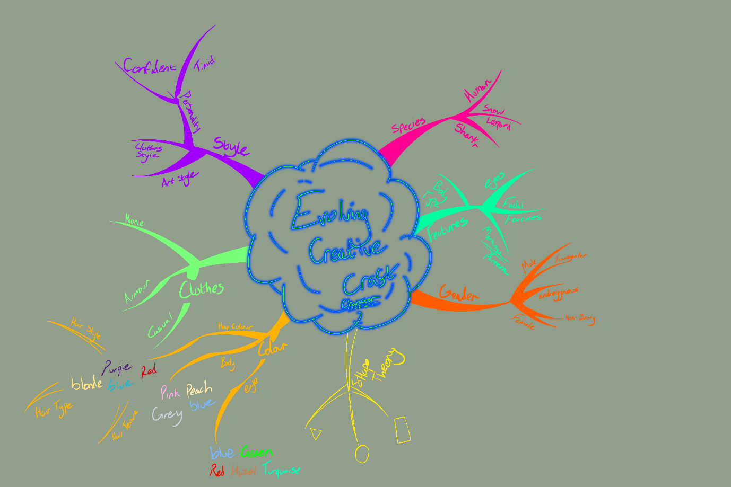
I created and used a mind map during the course of creating my designs to help me generate ideas, the mind map was done with the use of Tony Buzan’s mind mapping method, which uses the branching lines and differing colours [8], using this allowed me to create more unique ideas with my designs.

Mood Boards
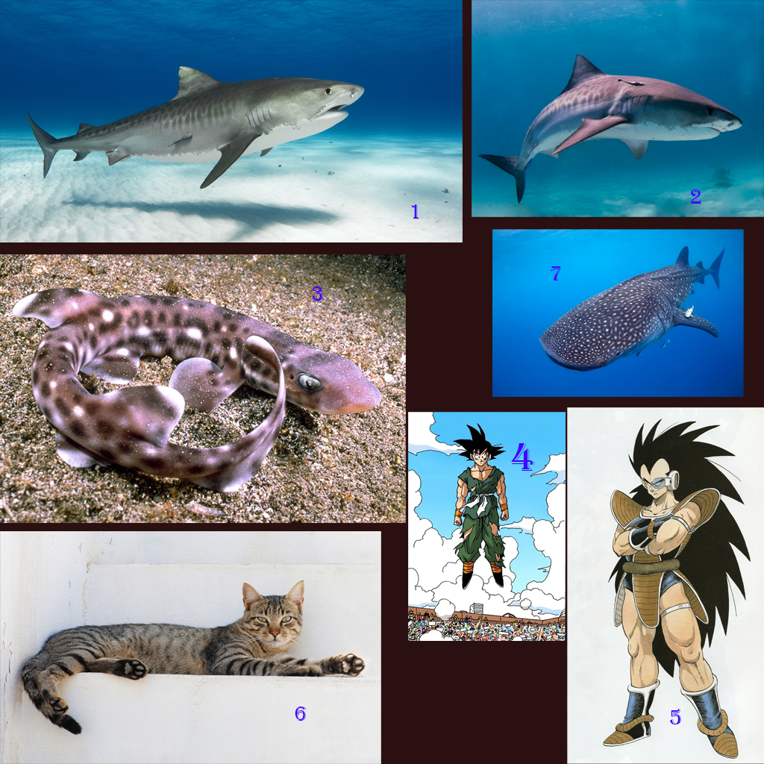
I used two mood boards for the designs, my first mood board was to find a good idea of what I wanted to make out of the design, furthermore, the mood board helped me to mix different things to create something unique. The second mood board I made was a mood board more focused on deciding and then refining which colours I wanted to use in the final design.

Designs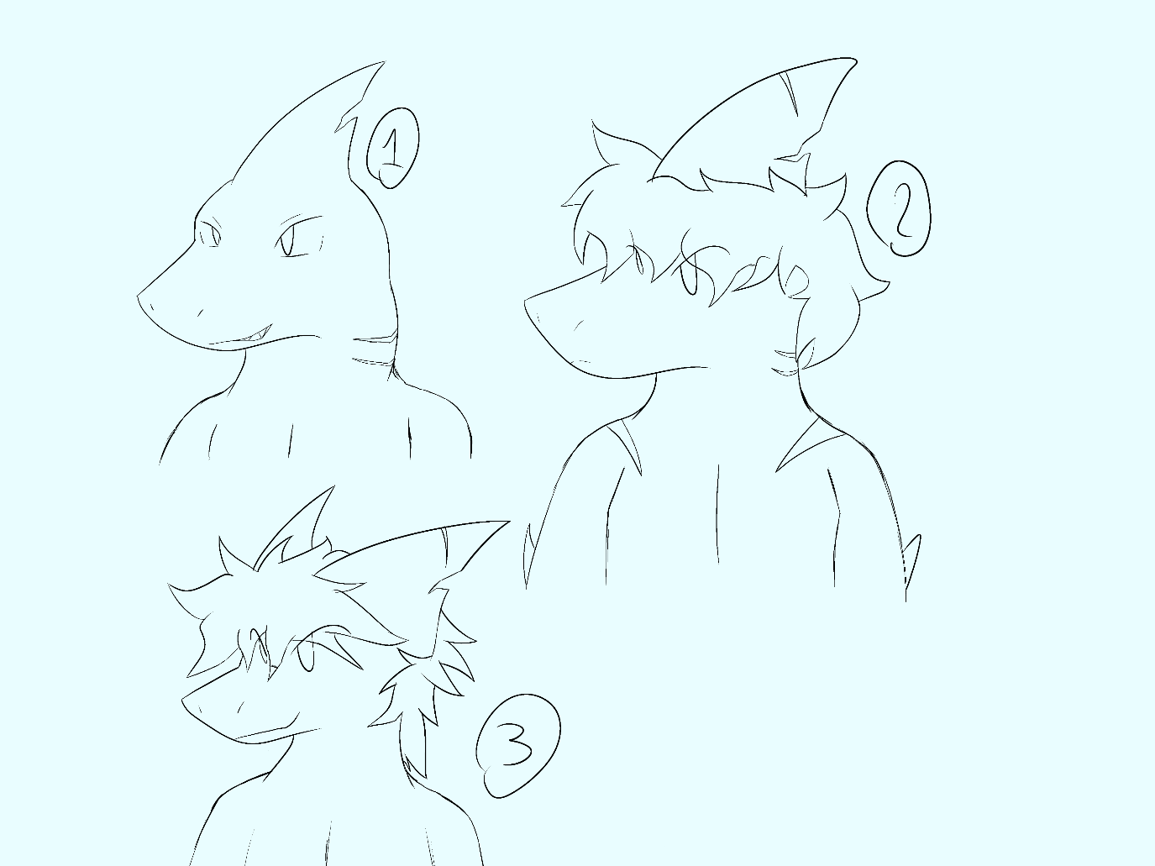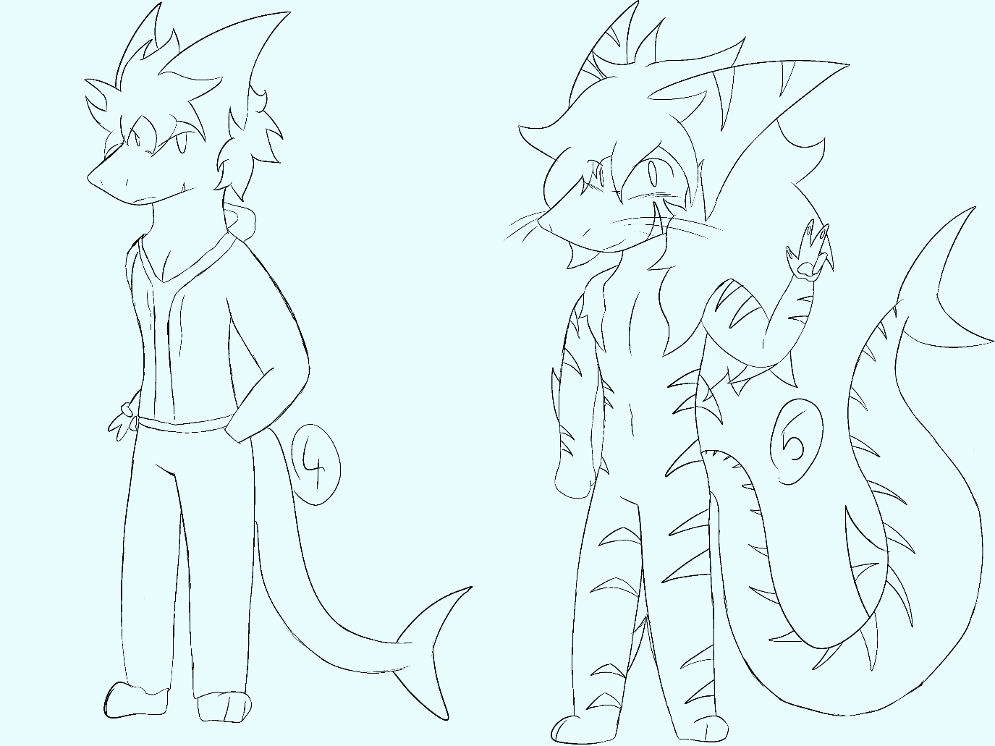
I created five designs using my Tony Buzan mind map and my two mood boards to come up with some ideas for the design I wanted to further work with. The designs I came up with aim to make a unique character. Each iteration of the design improves on making the character more unique, for example, many cases of shark characters stick with the single fin on their head, like the live-action version of “King Shark” from DC, by making little changes, the character becomes more unique.

Bibliography
[1] IFAW, “Shark facts and statistics,” IFAW, 2024. https://www.ifaw.org/ca-en/journal/shark-facts-statistics (accessed 5th January)
[2] Wikipedia Contributors, “Tiger shark,” Wikipedia, Mar. 03, 2019. https://en.wikipedia.org/wiki/Tiger_shark (accessed 5th January)
[3] Shark Foundation, “Shark Species: Coral catshark,” Hai.swiss, 2021. https://hai.swiss/en/database/search/species?spec=1060&desc=Coral%20catshark (accessed 8th January)
[4 + 5] Dragon Ball Z, Daisuke Nishio & Shigeyasu Yamauchi, Fuji Television & Toei Animation, 26th April 1989, available: https://en.wikipedia.org/wiki/Dragon_Ball_Z (Accessed 9th January)
[6] Wikipedia Contributors, “Cat,” Wikipedia, https://en.wikipedia.org/wiki/Cat, 19th march 2019, (accessed 7th January)
[7] Cancun Adventures, “13 Interesting Facts about Whale Sharks,” Cancun Adventures. https://www.cancun-adventure.com/en/blog/whale-shark-facts, (accessed 14th January)
[8] T. Buzan and D. O’brien, Mind map mastery : the complete guide to learning and using the most powerful thinking tool in the universe. London: Watkins, An Imprint Of Watkins Media Limited, 2018.

