A Resource Pack to Support Effective Classroom Management.

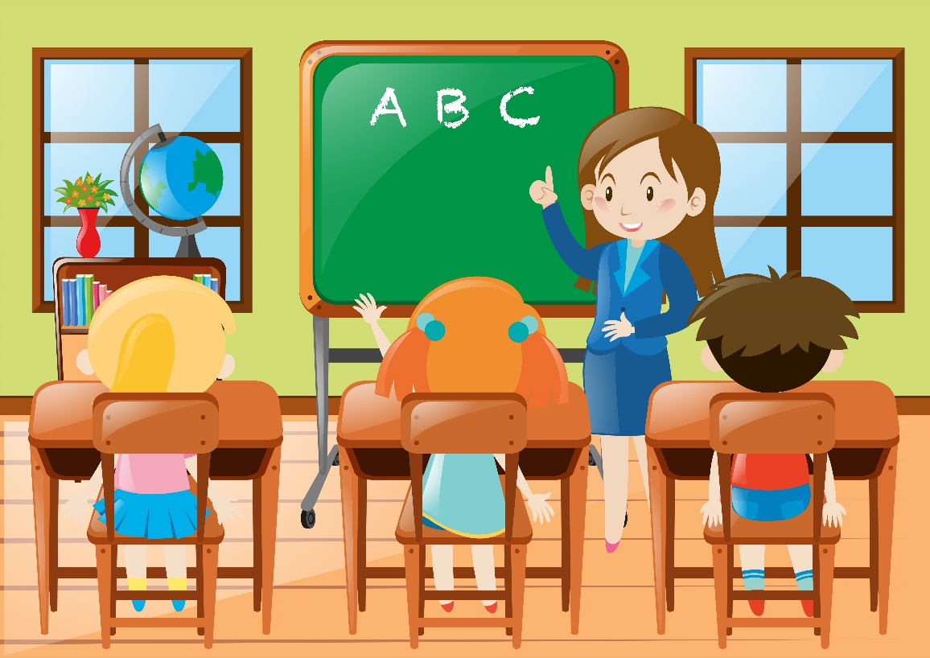
(Vecteezy, n,d)

The Resource
This resource pack is going to discuss the reasoning and logic behind the chosen teaching resource. It is going to show the learning, knowledge and how it helps with effective classroom management. It is also going to display how it promotes confidence building and forming those all- important skills needed in a classroom.
This resource pack is also going to discuss how it effectively contributes to classroom management and how it helps teachers and support staff. Finally, it is going to include a set of instructions as to how this resource should be used properly to make it effective.
Screening tools are used to identify those pupils that need the Speech and Language Therapy, they typically include a range of evidence-based, age-appropriate assessments that focus on the key areas of speech, language, and their communication development. It is better to have these assessments done whilst the child is still young to help with the early intervention and to get that child help quicker. Screening is often part of a developmental check process in the early years of a child’s life or at transition points in school, aiming for early identification and timely support (Family & Young Persons, 2025).
Speech therapy in schools may be delivered as a whole class, or used for an individual. Specialist therapy may consist of individual therapy sessions using evidence-based programs which are tailored to each child's communication profile. Using Ipads or laptops can be crucial when doing speech therapy as it also gets the child/ children to listen as well as using speech which means they are enhancing different skills. It is also a multifaceted service aimed at enabling children with speech, language, and communication challenges to help them overcome barriers to learning through evidence-based interventions tailored to their specific needs, teacher training, and whole-school communication strategies. Clearer articulation reduces avoidance of speaking up, encouraging active participation and fostering a positive learning environment. This work ultimately supports better academic achievement and social inclusion for affected children (Royal College of Speech and Language Therapists, 2023).
Within schools and education, speech therapy can be coordinated as part of a whole-trust approach where screening and referral systems are developed, reguakar testing on children is essential to know where they need to improve, staff are heavily trained and speech therapy sessions are integrated into school routines to help the child in knowing they can get help every day. Some schools even involve trained teaching assistants or support staff to deliver therapy under SLT guidance, which maximises the resource (National Autistic Society, n.d.).
Incorporating speech activities into daily routines whilst making them fun and engaging with games like eye-spy, clapping syllables (See Appendix A) role-plays, drawing, and storytelling. Using visual aids like flashcards (See Appendix B) or picture books to support their understanding. Consistent practice for a few minutes daily is key to their progression. Trying to get the family involved therapy based activities can create a supportive environment for that child (Geller, 2025). IT is important they understand the therapy goals we set their child and the progress they make. Family members staying informed about these things can provide encouragement effectively to their child. Family members can also receive guidance from teaching staff to help handle any emotional challenges and conflicts that arise whilst working with their child (Admin, 2024).

Rationale
It has been suggested that in order to create a positive learning environment, classroom management is essential to having that safe environment for children to thrive. Working within a primary school setting, it is vital to have a well-managed classroom and to make the expectations clear about how children should behave, if this is put into place at the beginning of the year it would hopefully set the children their boundaries. Once these rules are in place, you can work through behaviour problems by modelling and focusing on the children with good behaviour and using positive reinforcement as children thrive off being recognised and praised (Bradfield, 2025).
The reasoning behind this chosen resource pack is because speech therapy helps classroom management as it improves the learners communication skills which are of course an essential skill needed for learning and social interaction. When children have better communication skills it can reduce misunderstandings, frustration, and behavioural issues that can occur when children struggle to understand instructions and express themselves. Speech therapy also supports skills like attention, and organisation which promote better task completion and classroom behaviour. Additionally, speech therapy enhances many different skills, helping children interact appropriately with peers and teachers which then leads to improved behaviour and a more positive attitude towards their classroom and school work (Ccc-Slp (2022).
The aim of this resource is to help a child/ children with their speech so that they are able to learn effectively and have the same advantage as their peers. It is also to help enhance children’s learning, give them experiences and allow them to be independent and make those connections. This can be done within a small group or with a child on their own, it focusses on how children learn through speech and having that extra bit of help to help them get through their school work.
Resources, theories and classroom management have been used in schools from the beginning although it has been suggested they have come a long way since the early 1900s. There was the "Scientific Management" theory by Frederick Taylor (1911) which emphasised on efficiency, strict discipline and control, then there was the "Progressive Education" movement, led by John Dewey (1916), which shifted the focus towards children centered learning, emphasising the importance of the effective classrooms. Then along came B.F. Skinner's behaviourist theory (1953) which introduced the concept of operant conditioning, he suggested that student behaviour can be shaped through positive and negative reinforcement (Fiveable, 2025).
Speech therapy has been around in many different forms since at least the 18th century. It began with elocution and speech perfection which focused on public speaking in 18th-century England. Early practitioners worked with speech difficulties before the profession was officially recognised. Speech therapy as a formal profession has now been developing for around about a century, with roots stretching back roughly three centuries to early speech correction efforts and elocution coaching in the 1700s (Gorenberg, 2022).
A eminent theorist in the field of speech therapy is Noam Chomsky, who developed a theory of language acquisition. According to Chomsky, language is innate and biologically predetermined through a mechanism which he called ‘the Language Acquisition Device’ (LAD), which is hard-wired into the brain from birth. This theory posits that humans are naturally equipped for learning the languages and exposure to language activates this. Chomsky also emphasised that language is universal and unique to us as humans, and unlike other learned behaviours, it does not rely on the environmental reinforcement or teaching. Chomsky (1965) made an observation that there are deep structures and surface structures in every sentence, no matter what language you are using (Chomsky et al. (n.d.)
Evidence suggests that there are 9.5% of children in Wales as of January 2025 have additional learning needs. This number has decreased from previous years as the ALN system has been fully implemented and the identification criteria has been reviewed. The majority of these pupils (73.2%) have statutory Individual Development Plan (IDPs) in place under the new ALN system, which aims to provide tailored support to learners with ALN (GOV.WALES, 2025).
There is evidence linking speech therapy and related interventions to improved behaviour and those children being on task, particularly those children with speech, language, and communication needs.
Research shows that interventions like visual schedules, such as ‘now and next boards’ (See Appendix C), ‘Picture Exchange Communication System (PECS)’ (See Appendix D), combined with speech therapy techniques can reduce challenging behaviours in classroom settings.
There are many interventions that can help speech, one intervention combined play therapy and language facilitation showed that foundation phase children with developmental language disorders not only improved their communication skills but also showed decreasing challenging behaviours. This evidence suggests that speech therapy techniques that enhance language can also positively impact the child’s behaviour and help to engage and regulate them with in the classroom (Alharbi, 2024).
Speech therapy also addresses other related communication difficulties that are often accompanied, like memory loss, which can be things like understanding languages, word formation, and speech fluency (Geller, 2025b).

Instructions

- Go in white cupboard above the sink that says ‘be happy’ and get the green box out.
- Identify the children you need to work with.
- Create a quiet, distraction-free environment (usually on the table outside the classroom).
- Talk to the child in question and reflect on how they think the last session went and how confident they feel in their specific sounds now.
- Explain to the child what is going to happen in today’s session, whether that be Ipad, laptop or written work.
- Once chosen, (say Ipad for this session), get the Ipad out, log in to speech and language links (all the log in details are in the leopard print book on the table) and load up ‘speech therapy games’.
- Click on the Pupil’s name you are working with and all their sounds will load up.
- Choose a game either they wish to play or a game that focuses on a specific sound they are learning that week.
- Speak clearly and slowly, emphasising on the sounds the child finds difficult without pressuring them to repeat immediately time and time again.
- Model the correct pronunciation by repeating the child's attempts with the correct version gently and positively, giving that positive feedback (Child A likes to hear you say ‘’well done’’.
- Use simple, age-appropriate language and encourage the child to respond and imitate your speech.​
- Praise them once they have completed the first game.
- Move on to the second, third game etc until that session has finished.
- Ask them after every session how they feel that has gone and ask them can they repeat words back to me that has been said in the game to make sure they are also listening properly.
- Record on the evaluation sheet in the file how many words the pupil got right / what they didn’t pronounce correctly.
- Ask the child how they thought the session went and have a chat about how they are feeling in regards to their speech.
- Pack the files, books and sheets away.
- Log out of the Ipad (for safety and security reasons), switch it off, put it back in the box and the box back in the cupboard.

Images for reference


(Speech & Language)

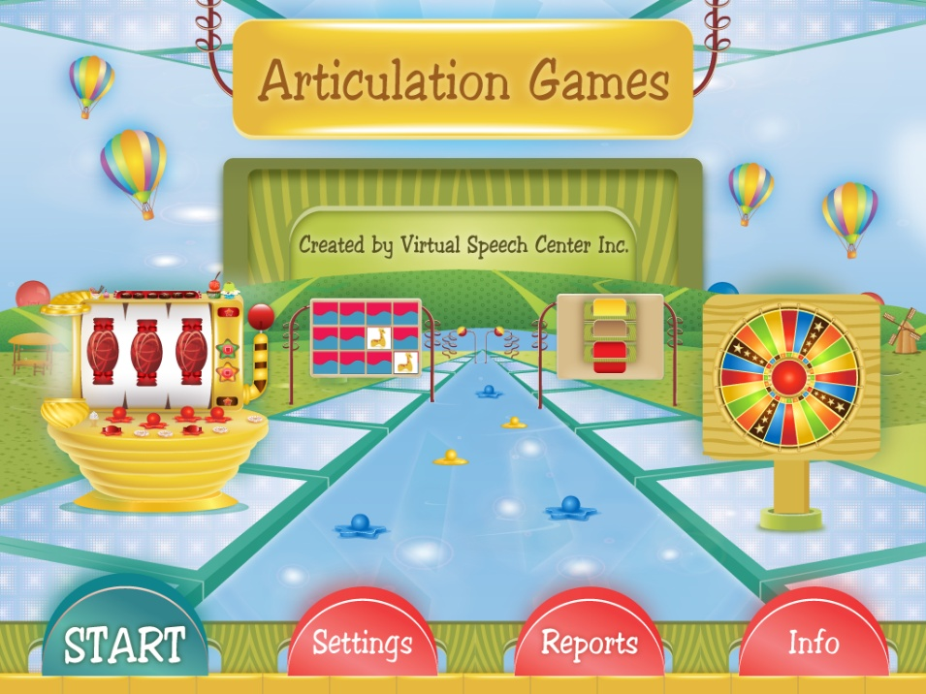
(Speech time fun)

Appendices

Appendix A –
Clapping syllables

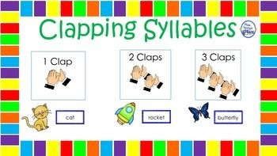
(Pinterest)

Appendix B -
Speech Therapy flash cards
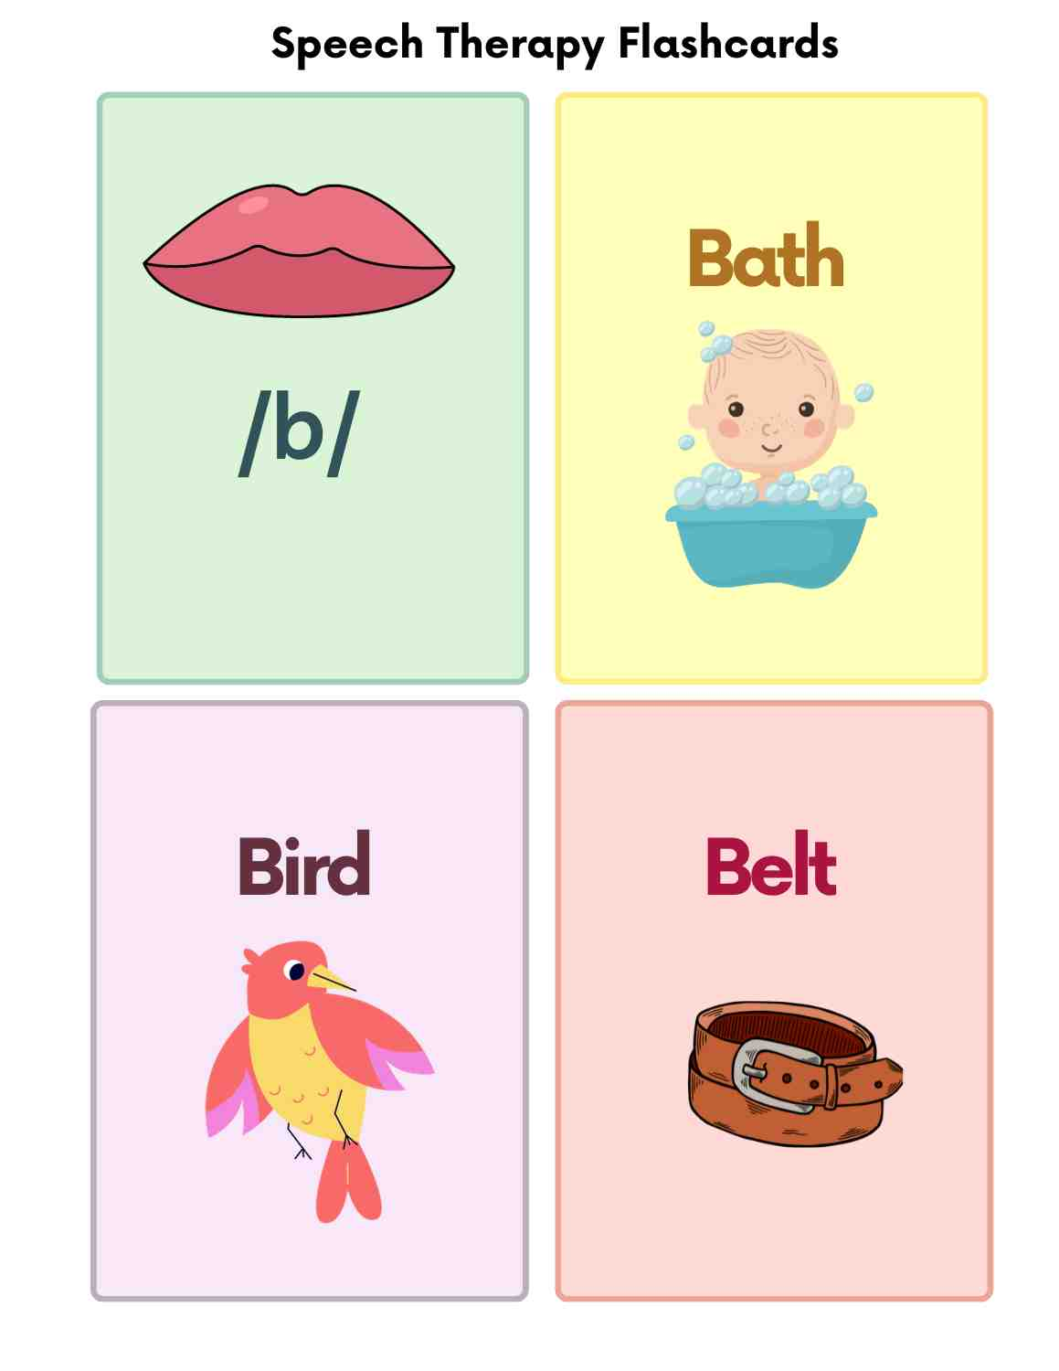
(Geevarcb, 2024)

Appendix C-
Now & Next visual board
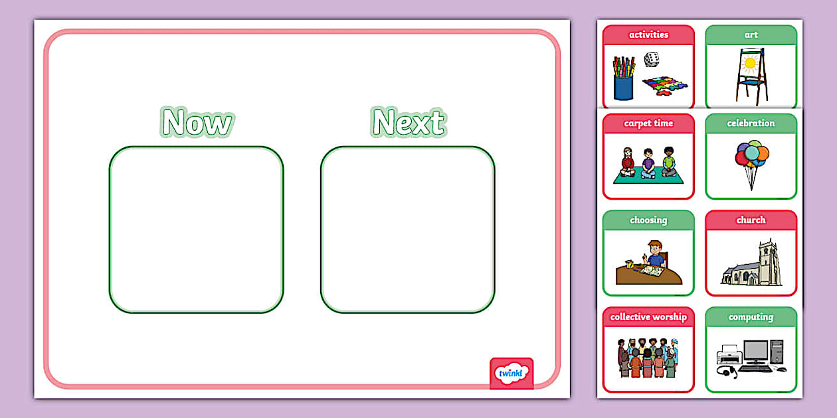
(Twinkl)

Appendix D-
Picture Exchange Communication System (PECS)
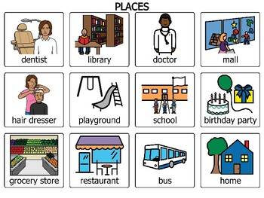
(PEC’S for school)

References:
Admin. (2024, August 15). The role of family and friends in at-home mental health treatment - Orchestrate Healthcare. Orchestrate Healthcare. https://www.orchestratehealth.com/the-role-of-family-and-friends-in-at-home-mental-health-treatment/ (Accessed 16.10.25)
Alharbi, N. H. (2024). The Effects of Interventions on Behavior Outcomes for Children with Speech and Language Delays: A Scoping Review. Creative Education, 15(07), 1297–1310. https://doi.org/10.4236/ce.2024.157078 (accessed 11.10.25)

Bradfield, S. (2025, August 4). Why classroom management is important for teachers | KAMI Blog. Kami. https://www.kamiapp.com/blog/classroom-management-importance/ (Accessed 10.10.25)

Ccc-Slp, E. V. M. (2022, January 13). How Speech Therapy can Help Academic Performance | TherapyWorks. TherapyWorks. https://therapyworks.com/blog/language-development/speech-strategies/how-speech-therapy-can-help-overall-academic-performance/ (Accessed 27.10.25)

Chomsky, N., Skinner, B. F., Piaget, J., & Vygotsky, L. (n.d.). Theories of language acquisition. In Theory: A Brief Overview of Language Development Theories. https://openlab.bmcc.cuny.edu/ece-110-172/wp-content/uploads/sites/1578/2021/05/Theories-of-Language-Acquisition.pdf (Accessed 24.10.25)

Fiveable. (2025, August 22). Historical perspectives on classroom management. Fiveable. https://fiveable.me/classroom-management/unit-1/historical-perspectives-classroom-management/study-guide/4x5GZBat6g2QBaiQ (Accessed 17.10.25)

Geevarcb. (2024, January 15). Free Speech Therapy Flashcards & Worksheets for Toddlers, Children’s and Adults - Printable PDF | AutisticHub. AutisticHub. https://www.autistichub.com/speech-therapy-flashcards-for-toddlers-childrens-and-adults/ (Accessed 29.10.25)

Geller, A. (2025, August 14). Speech therapy at home: 15 Useful tips & tricks for parents. Connected Speech Pathology. https://connectedspeechpathology.com/blog/speech-therapy-at-home-15-useful-tips-for-parents (Accessed 24.10.25)

Geller, A. (2025b, September 23). Speech therapy for memory loss: Effective Treatment Strategies. Connected Speech Pathology. https://connectedspeechpathology.com/blog/speech-therapy-for-memory-loss (Accessed 31.10.25)

Gorenberg, B. (2022, June 1). The history of speech therapy - the therapy place. The Therapy Place. https://www.therapyplacenj.com/the-history-of-speech-therapy/ (Accessed 30.10.25)

Introducing: Articulation games! - Speech Time Fun: Speech and language activities. (n.d.). https://speechtimefun.com/introducing-articulation-games/ (Accessed 24.10.25)

Link, S. a. L. (n.d.). Issue 28, pages 12-14: A Vision for DLD for the UK. Speech and Language Link. https://speechandlanguage.link/resources/issue-28-pages-12-14a-vision-for-developmental-language-disorder-dld-for-the-uk/ (Accessed 24.10.25)

National Autistic Society. (n.d.). Speech and language therapy in specialist schools. https://www.autism.org.uk/advice-and-guidance/professional-practice/speech-therapy (accessed 28.10.25)

PECs for School | TPT. (n.d.). https://www.teacherspayteachers.com/browse/parents?search=pecs%20for%20school (Accessed 25.10.25)

Pinterest, (n,d) Images. Syllable Clapping (Accessed 24.10.25)

Royal College of Speech and Language Therapists. (2023, December 1). Role of speech and language therapy in education | RCSLT. RCSLT. https://www.rcslt.org/speech-and-language-therapy/where-slts-work/education/ (Accessed 23.10.25)

Schools’ census results: January 2025 [HTML] | GOV.WALES. (2025, July 23). GOV.WALES. https://www.gov.wales/schools-census-results-january-2025-html (Accessed 18.10.25)

Screen and assess | Bradford Families and Young Persons. (2025, February 26). https://fyi.bradford.gov.uk/speech-and-language-content-for-early-years/screen-and-assess/ (Accessed 28.10.25)

TWINKL. Now and Next Cards and Board Resource Pack | Twinkl SEND (Accessed 29.10.25)

Vecteezy (n,d) Teacher teaching kindergarten students in class 369984 Vector Art at Vecteezy (Accessed 21.10.25)

