Advanced Physics of OME - ACDB5015
BEN LLOYD - 2219811

SHAPED CHARGE BEHAVIOUR IN MULTIPLE DIMENSIONS
- Abstract
An Assignment was posed to model Shaped Charge behaviour within ABAQUS; a software simulation programme developed by the French Aviation manufacturer, Dassault. Three Simulations were to be run: two to use two-dimensional (2d) modelling and one to use three-dimensional (3d) modelling. One of the 2d simulated Shaped Charges was a fictional design while the other 2d simulation was based on the Soviet RPG-7, the assumption being that an in-service Shaped Charge would perform more realistically than a fictional one. This design was subsequently used 3d in the simulation. The results of all three of these simulations have been collated and discussed.

Table Of Contents
- Abstract(Page 1)
- Introduction(Page 1)
- Underlying Concepts(Page 1 – Page 3)
- ABAQUS Modelling(Page 3 – Page 9)
- Simulation Conditions(Page 9 – Page 10)
- ABAQUS Simulation(Page 10 – Page 18)
- Simulation Results(Page 18 – Page 19)
- Discussion(Page 18 – Page 20)
- Conclusion(Page 20)
- References & Appendices(Page 21 – Page 27)

- Introduction

Shaped Charges are extremely common on the modern battlefield; the combination of being able to be scaled to any size, armour penetration relative to dimensions and well-understood technology guarantees their ubiquity. This flexibility enables them to be used in many different contexts; from High Explosive Anti-Tank (HEAT) rounds used in Tanks, man-portable systems such as the FGM-148 Javelin or even in air-launched systems such as the MBDA Brimstone.

- Underlying Concepts

Shaped Charges at their most basic have three components: a Casing (usually made of Steel), a conical Liner (usually made of Copper) and a High Explosive Filling. A typical Shaped Charge is shown below in Figure 1.
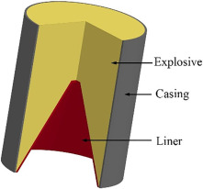
Figure 1 - Overview of a Shaped Charge [1]

Upon detonation of the High Explosive, the created explosive shockwave is concentrated onto the tip of the Liner, plastically inverting and deforming it into a hypervelocity “Jet” of Copper that moves at roughly 7 Kilometres per second. This concentration of force onto a single point is known as the Munroe Effect [2]. A basic representation of Jet formation achieved via the Munroe Effect is shown in Figure 2.

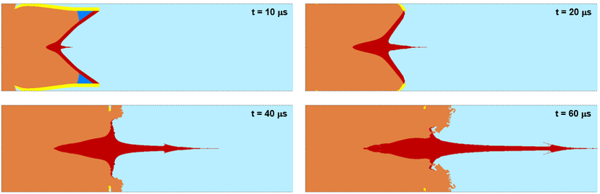
Figure 2 – Shaped Charge Jet formation [4]

During the Detonation process which occurs in the space of Microseconds, the Copper is under sufficient pressure that it behaves as a Liquid and can be considered as such by applying Potential Flow Dynamics, this is known as the Hydrodynamic Effect [3]. This effect also occurs within the target; as the Jet impacts it’s intended destination; the target material is subjected to sufficient pressure to also display this Liquid-like (Hydrodynamic) behaviour, allowing the Jet to pass through a previously Solid-behaving material and penetrate a large depth of armour relative to its size.

As previously stated, Shaped Charges are made of three constituent parts: the Case, the Liner and the High Explosive. However changing aspects of these parts can affect how effective the Shaped Charge will be in practice. A study performed in 1964 [5] shows that altering the Liner Material, the thickness of the Liner, the angle of the Liner and the Explosive can all modify the overall effectiveness of the Shaped Charge.

Modification of the Cone Angle correlates how deep a Jet may penetrate a material; as Cone Angle increases, penetration decreases, assuming a consistent Charge diameter. The opposite is also true, a narrow Cone Angle increases penetration but this decreases the space available within the Shaped Charge that may be used for Explosives. The study concludes that the ideal Cone Angle for maximum penetration to be achieved is 60 degrees.
Changing the material the Liner is made from also has an effect; the study notes that a Copper Liner provides the best penetration through Steel and the smallest entrance hole. For defeating Armour, this is ideal as Tanks and other vehicles have thick Armour plating that must first be penetrated in order to damage critical systems within. However an Aluminium liner creates the largest entrance hole and smallest penetration, this would be ideal for Structures as it would “crack open” a building and allow a secondary Charge into the created hole and destroy the target from the inside.
The Liner thickness has an effect on effectiveness too: Figure 7 of the study shows that the thickness of the Liner must be tailored to the overall Charge Diameter, the larger the charge, the thicker the Liner must be. For example, a 50mm Shaped Charge must use a 1.25mm thickness Liner for optimal penetration whereas a 100mm Shaped Charge would use a 2.5mm Liner.
Lastly, the study also indicated that choice of Explosives also affects penetration; a faster detonating Explosive predicably results in a greater Jet velocity and therefore the best penetration. From the provided table, it indicates that Composition B: a 50/50 mixture of RDX and TNT, offers the best detonation velocity and would be ideal Explosive Filling for a Shaped Charge. Naturally, the Case must be made of a sufficient thickness to “direct” explosive shockwaves correctly, otherwise the entire Shaped Charge would explode omnidirectionally and be useless as a Shaped Charge.
From these factors, we can conclude that to defeat Armour plating, the ideal Shaped Charge would be filled with Composition B, the Cone must be made from Copper and the Angle to be set at 60 degrees for maximum effectiveness.

- ABAQUS Modelling
2d First Simulation
As previously stated, the first of the 2d simulations was based on an entirely fictional design but was created without the prior knowledge obtained in [5], as such the behaviour is not ideal. The Design created is shown in Figure 3 below.

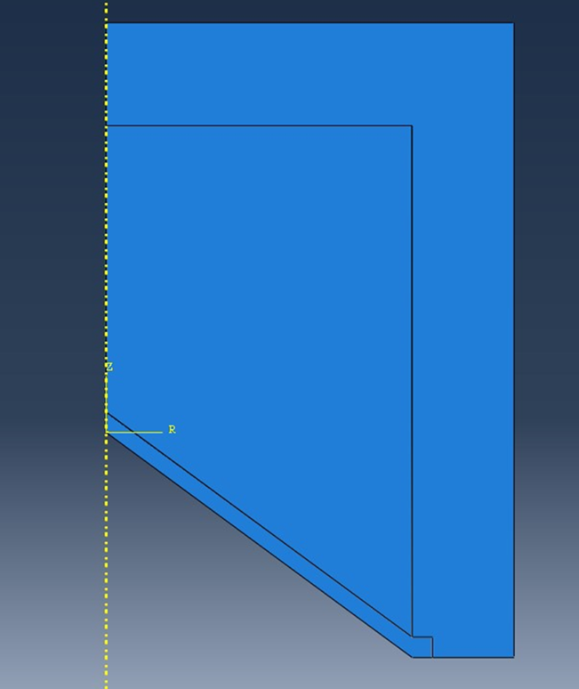
Figure 3 – 2d Shaped Charge, first iteration.

This initial design featured a 54 degree Cone Angle, a Charge Diameter of 200mm, a Casing thickness of 8mm and a Liner thickness of 2mm, this design was created without the knowledge obtained within [5] and was to serve as a “baseline” to see how ABAQUS would handle an explosive simulation task, even if the design was not ideal. For Meshing, a global Mesh of 0.004 was selected for the Casing, as the Casing required a less thorough analysis, a coarser mesh could be used to save computing power and speed up processing time. The opposite was true for the High Explosive and Liner, both had a centre-biased Mesh applied ranging from 0.005 to 0.00025, the mesh sizes were reduced at the point of deformation and would allow for a more detailed analysis at the cost of longer computing times. Figure 4 shows this Mesh.

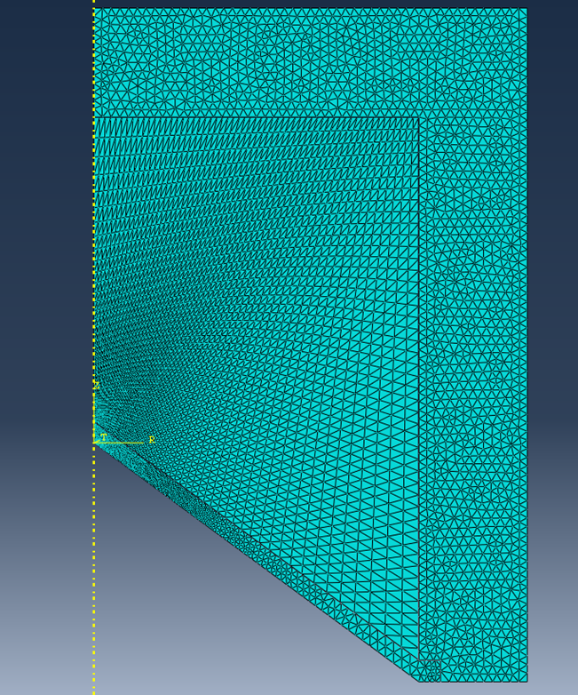
Figure 4 – 2d Shaped Charge, first iteration, Mes

2d Second Simulation
For the second iteration of the 2d simulation, a different approach was taken, a paper [6] was found that held a great amount of detail on the Soviet RPG-7, including a Warhead Schematic and Johnson-Cook material values. This approach was taken as the RPG is commonly used everywhere and is a well-understood Weapon.
For the Assembly within ABAQUS, this Schematic (shown in Figure 5) was translated into the software and served as a template for all simulations going forward, both 2d and 3d. The Casing thickness was not stated but from the difference between the inner and outer measurements of the Warhead (roughly 10mm), this was halved to 5mm to allow for some High Explosive to occupy the outermost corners as per the diagram. The Liner thickness was also not stated but was set at 1.75mm in line with the graph in [5] for a 70mm Shaped Charge. The cone angle was also set at 60 degrees as per the Schematic and the graph for an ideal Shaped Charge in [5].
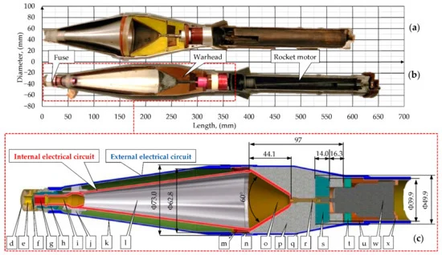
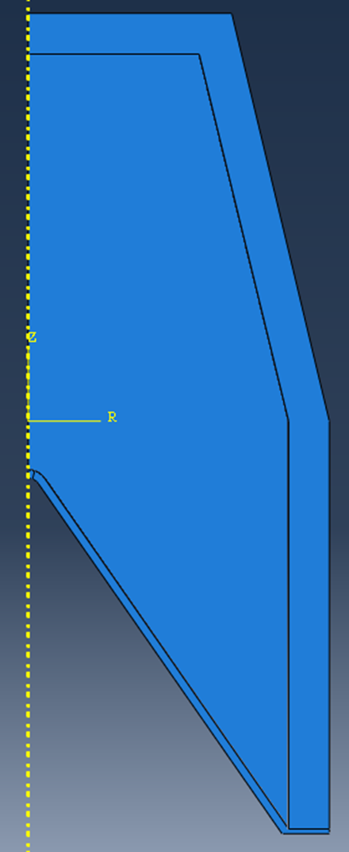
Figure 5 – RPG Warhead Schematic, obtained from [6]
Figure 6 – ABAQUS Model for RPG Warhead translated from Schematic

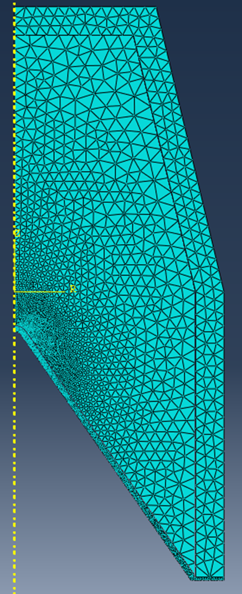
For Meshing, the same approach was taken from the first 2d simulation: a fine centre-biased Mesh for the Liner and High Explosive, with a coarser Mesh applied to the Casing. In this case, the Casing was set to 0.002, the High Explosive at 0.0025 to 0.005 with the Liner following similar behaviour, that was set to 0.0001 to 0.0005
Figure 7 -Meshing for the RPG Warhead in ABAQUS

3d Simulation
For the 3d Simulation, the exact same RPG-derived Assembly for the 2d was used, except extruded through 180 degrees and translated into 3d.

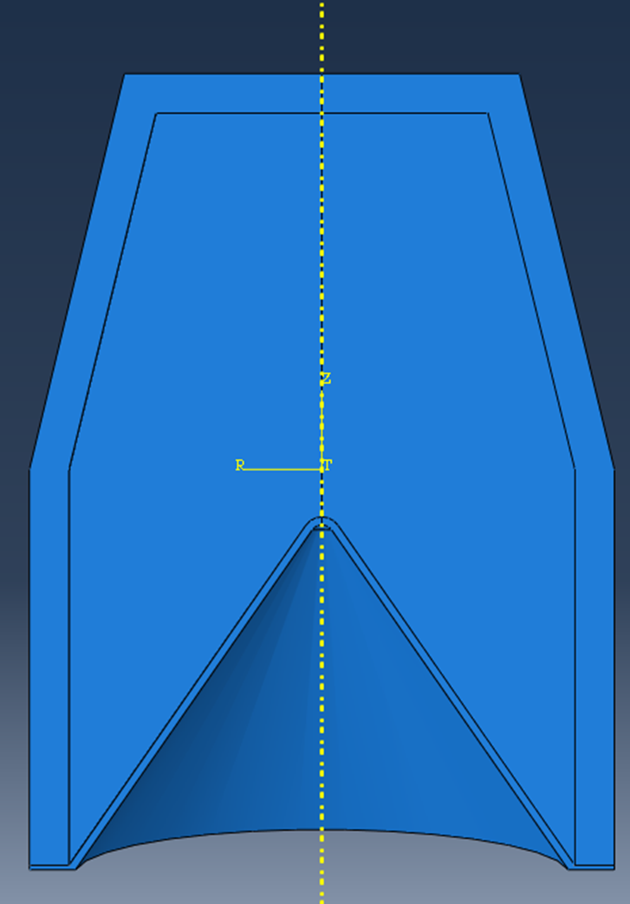
Figure 8 – 3d ABAQUS Model
Meshing the 3d component was done differently; the Casing still had a coarse mesh of 0.0035, the Explosive Filling was centre-biased meshed from 0.0025 to 0.0005, the Liner however was meshed at 0.0005 to 0.0025 but was accidentally biased away from the centre, it is unknown why but this method made the simulation run more reliably, further information is available in Paragraph viii.

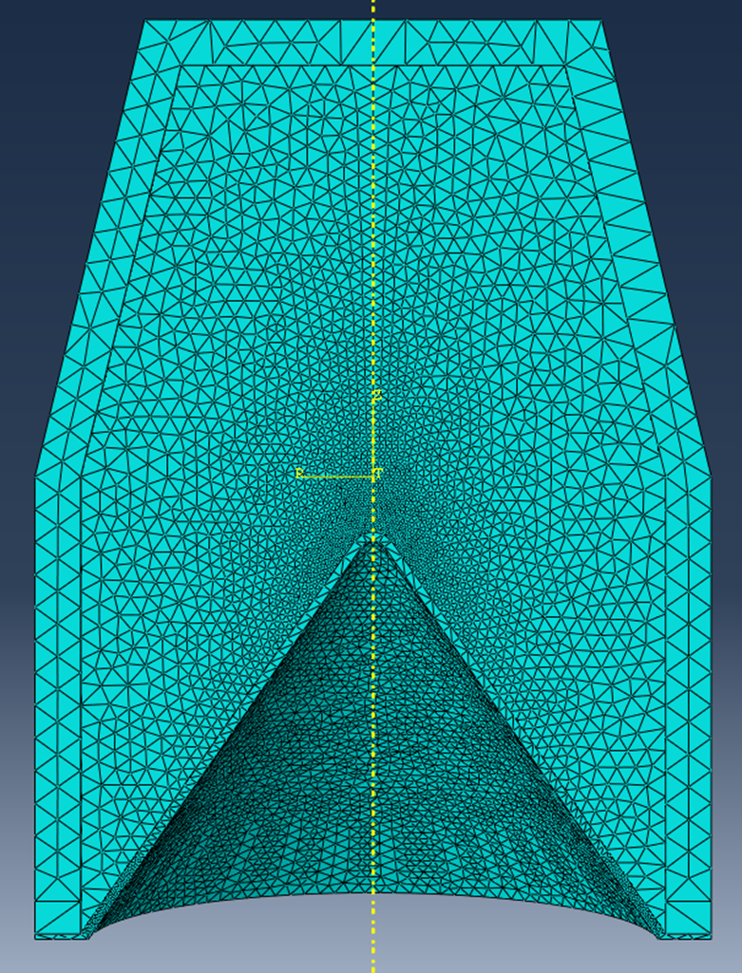
Figure 9 – Meshing of 3d simulation

- Simulation Conditions

For all versions of the simulation, the Detonation point remained the same, occurring at the centrepoint of where the High Explosive meets the Casing. On the RPG Schematic there is a component only identified as “S”, but this part could not be identified, even after searching through multiple RPG design documents. For the purposes of simulation, this has been ignored.

The Time Step required for all simulations is the same, it has been set at 1 Miillisecond. The logic being that the simulation will crash long before it comes to an end, which is what happened in all instances.

2d First Simulation

The first 2d simulation had Johnson Cook material values provided for the three materials involved in the simulation: Steel for the casing, Copper for the Liner and TNT for the High Explosive, they are attached below.

Steel
Density | Young’s Modulus | Poisson Ratio | A | B | C | N | M | Melting Temp | Transition Temp | ε
7850 | 21e10 | 0.3 | 553e6 | 6e9 | 0.013 | 0.234 | 1 | 1733 | 193 | 1
Copper
Density | Shear Modulus | C0 | A | B | C | N | M | Melting Temp | Transition Temp | ε | S | γ
7850 | 46e9 | 5240 | 1424e6 | 168e6 | 0.032 | 0.12 | 1 | 1356 | 293 | 1 | 1.4 | 19.7
TNT
Density | Wave Speed | A | B | Ω | R1 | R2 | Energy Density | Bulk Modulus | X | Y | Z | Delay
1601 | 8193 | 609e9 | 13e10 | 0.25 | 4.5 | 1.4 | 368e4 | 9e9 | 0 | 0.15 | 0 | 0

2d & 3d Second Simulation
A-IX-1
Density | Wave Speed | A | B | Ω | R1 | R2 | Energy Density | Bulk Modulus | X | Y | Z | Delay
1660 | 8258 | 887e9 | 238e8 | 0.45 | 5.18 | 1.6 | 368e4 | 9e9 | 0 | 0.045 | 0 | 0
The second 2d Simulation and 3d Simulations used the exact same values for both Copper and Steel, however the Explosives used was different. The analysis found within [6] indicated that the RPG uses a Soviet-designed explosive designated A-IX-1, the paper notes that it is largely RDX based and comes with differing values to that of TNT. Based off of the information in [5], we can see that that the Detonation wave speed is faster and should provide greater penetration than that of TNT.

- ABAQUS Simulation

2d First Simulation

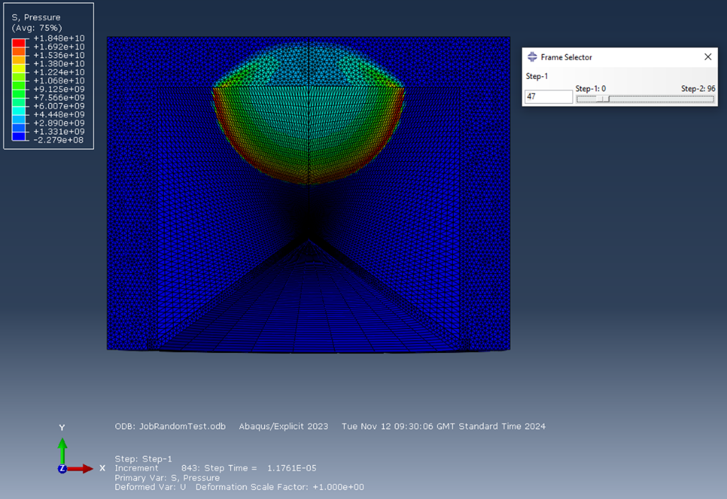
The first of the 2d simulations ran successfully, the Explosive detonated as to be expected and a clear blast wave was visible throughout the Shaped Charge. There was minimal deformation in the Casing and this is to be expected given it’s overall thickness.
Figure 10 – Blast Wave throughout the first 2d Shaped Charge
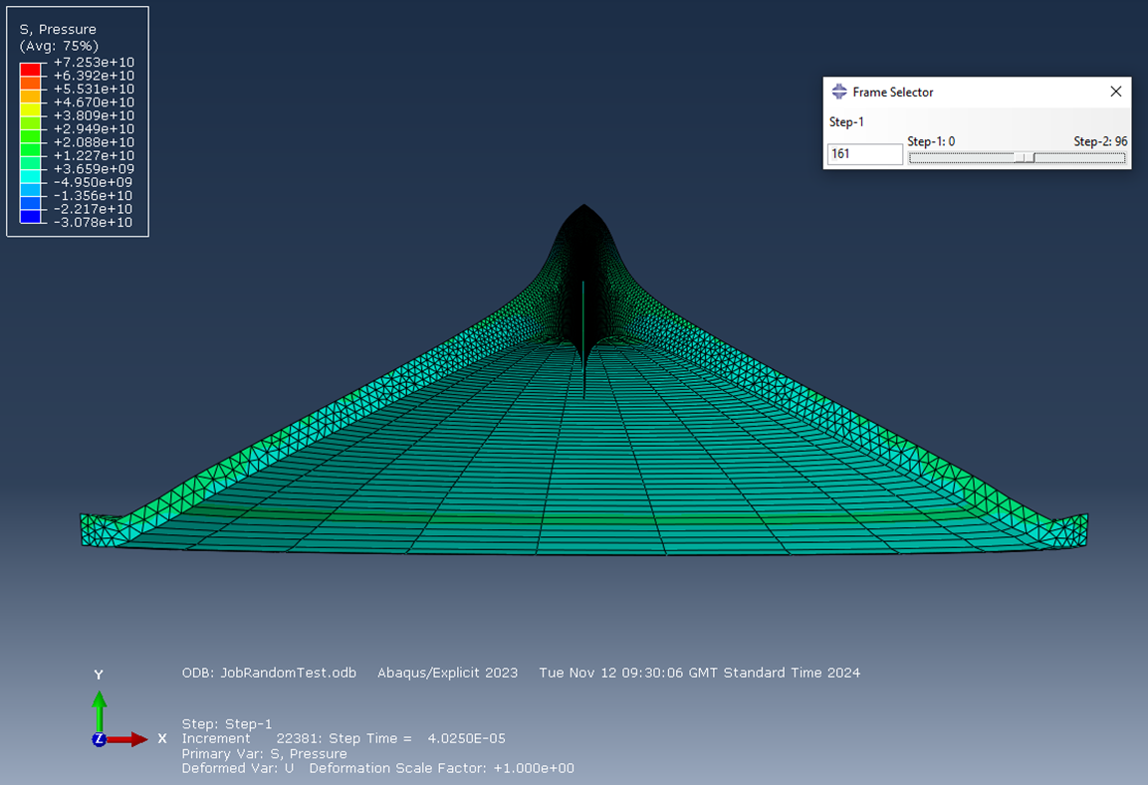
Figure 11 - Shaped Charge Jet formation progression, Liner Only

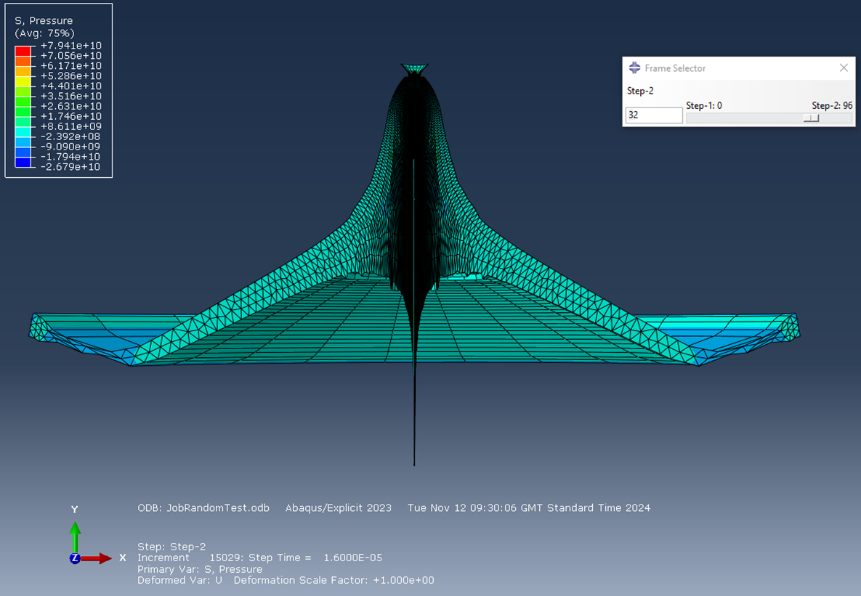
As the blast wave propagates, it can be seen that the charge is operating correctly and a clear jet of hypervelocity Copper can be observed. It is noteworthy that so much of the Copper goes “backwards” in all simulations, whilst some is to be expected as per the diagram in [4], it is strange that so much mass travels in this direction relative to the small amount of mass travelling in the correct direction. It is possible that if the simulation continued, the Jet would have fully formed and showed more “normal” behaviour but it had crashed long before that had a chance to happen.
Figure 12 - Shaped Charge Jet formation progression, Liner Only
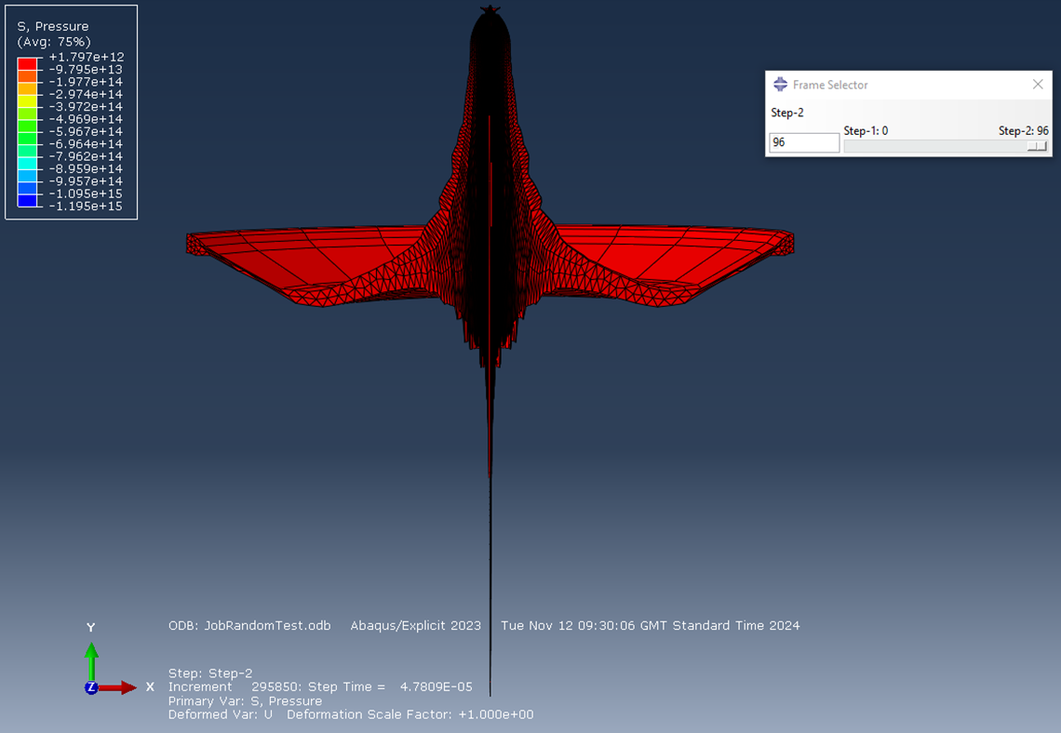
Figure 12 - Shaped Charge Jet formation progression, Liner Only

This simulation was 2d, however the results have been extruded and swept through 180 degrees, giving the illusion that it is 3d but it is not. Figure 12 clearly shows the beginnings of Jet formation however it is not complete, very few elements have travelled in the intended direction and if the software did not crash, it is entirely likely that a more “polished” Jet would be formed.

2d Second Simulation

As previously established, this simulation used the ABAQUS model for the RPG that were created earlier, it was expected that a semi-realistic Shaped Charge would perform better than an entirely fictional one and the results indicate that it does in some ways and does not in others. Figure 13 shows, as before, a clear blast wave travelling through the Explosive, the A-IX-1 performing very similarly to the TNT, as both are High Explosives, this is to be expected.

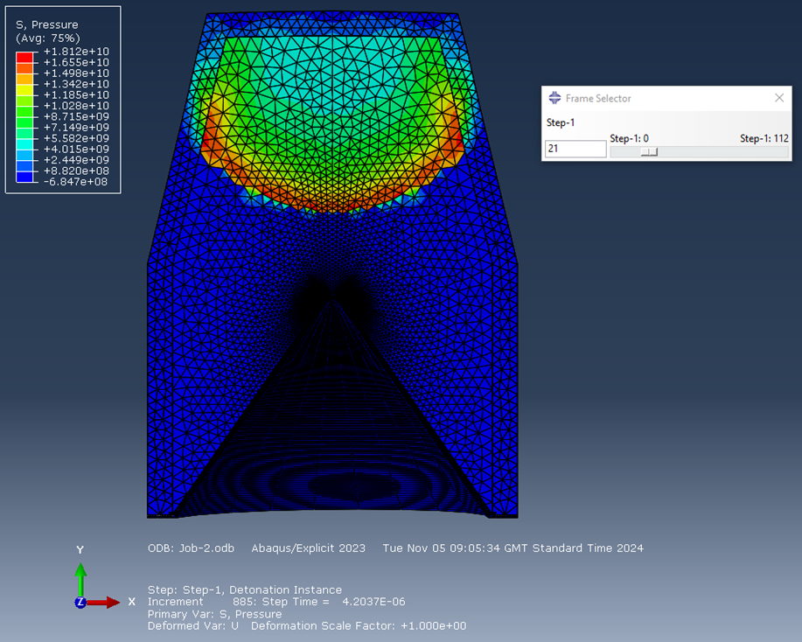
Figure 13 -RPG Warhead Blast Wave progression

It is worthy of note that unlike the previous test, there was significant deformation in the Casing, which is understandable given it is far thinner in this test than it was in the first iteration. It can easily be argued that in a realistic setting, this would result in a large amount of energy being wasted as Explosive energy is being used to bend the Casing rather than being used to form a Jet. If this test were run again, a thicker casing could be used to generate a greater Jet velocity and greater penetration. However, this deformation may be intentional, the RPG warhead was designed to operate in a mixed Armour-penetration and anti-Personnel setting [6], so Fragmentation of the Casing may be a case of “it’s not a bug, it’s a feature”.

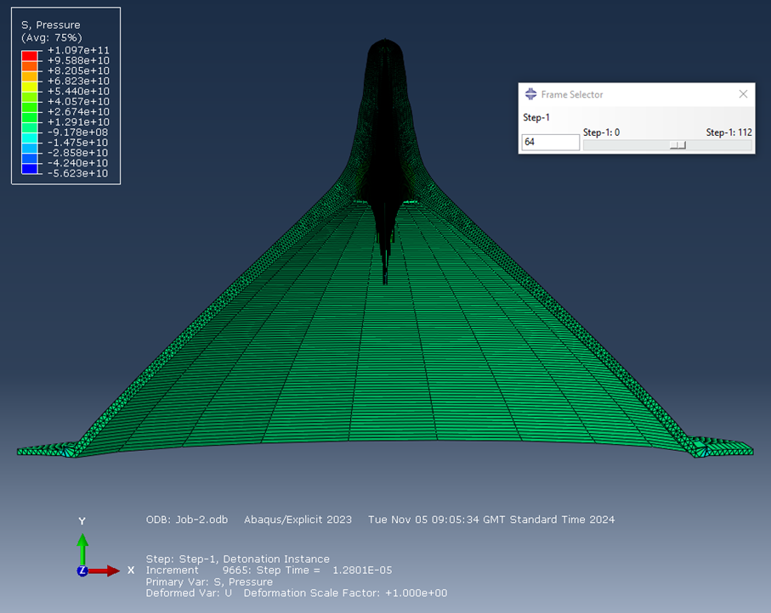
Figure 14 – RPG Shaped Charge Jet progression, Liner only

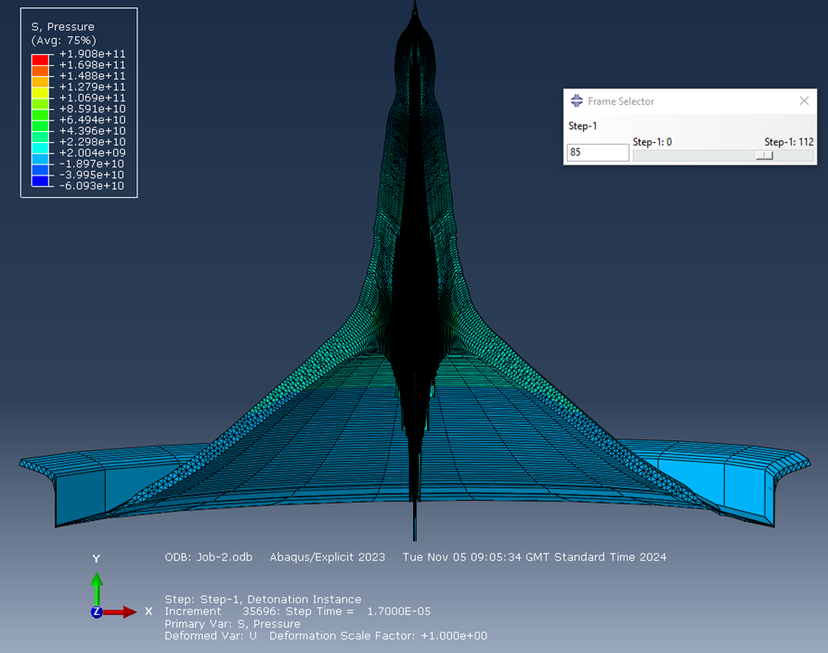
Figure 15 – RPG Shaped Charge Jet progression, Liner only

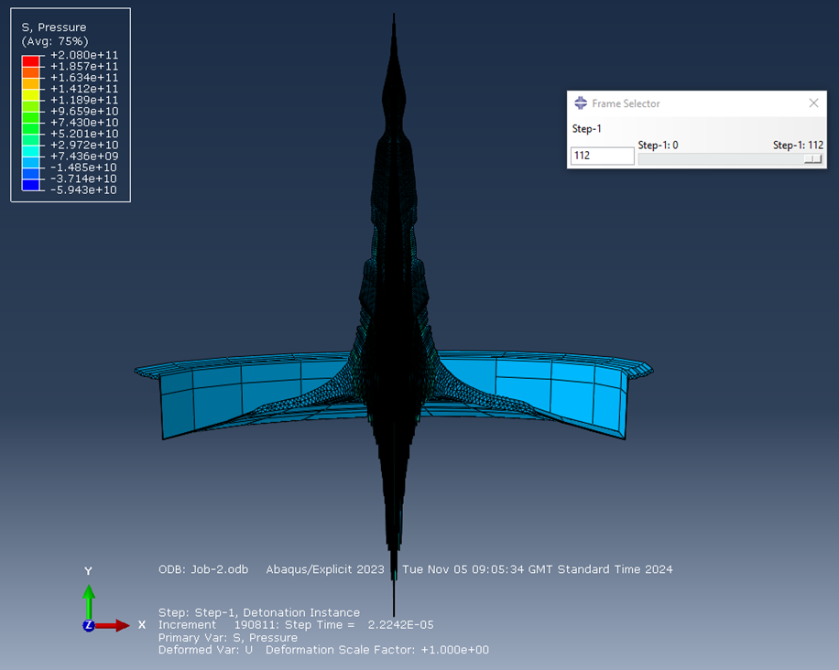
Figures 14 and 15 show the progression of Jet formation under Explosive force, unlike the previous test, this is showing a much “fuller” looking Jet; the increased elements and greater Jet mass would imply that this would be a more effective armour penetrator. Given that this is a realistic warhead, this is to be expected.
Figure 16 - RPG Shaped Charge Jet progression, Liner only

As before, these results are 2d but have been extruded to through 180 degrees to be similar to 3d results but are not “true” 3d. An unexpected behaviour is how the edges of the Liner have remained firmly attached to the Casing but the surrounding elements have “stretched” forwards, it was predicted that these would delaminate and become part of the Jet, as per the diagram in [4]. It is probable that this is a setting in the simulation that was hard-coded into the results, the software has been told that these have been permanently affixed to the Casing, and so they are.

Also unexpected is how even more material has travelled rearwards than before, this could be due to the tip of the Liner, it is curved unlike the previous attempt that was a fixed angle, the variable geometry could be causing the software to treat the Liner differently. It is also possible that if the simulation was able to run for longer, this “tail” would disappear and would be able to travel in the intended direction, but it crashed before this could happen and no amount of remeshing appeared to fix the issue.

3d Simulation

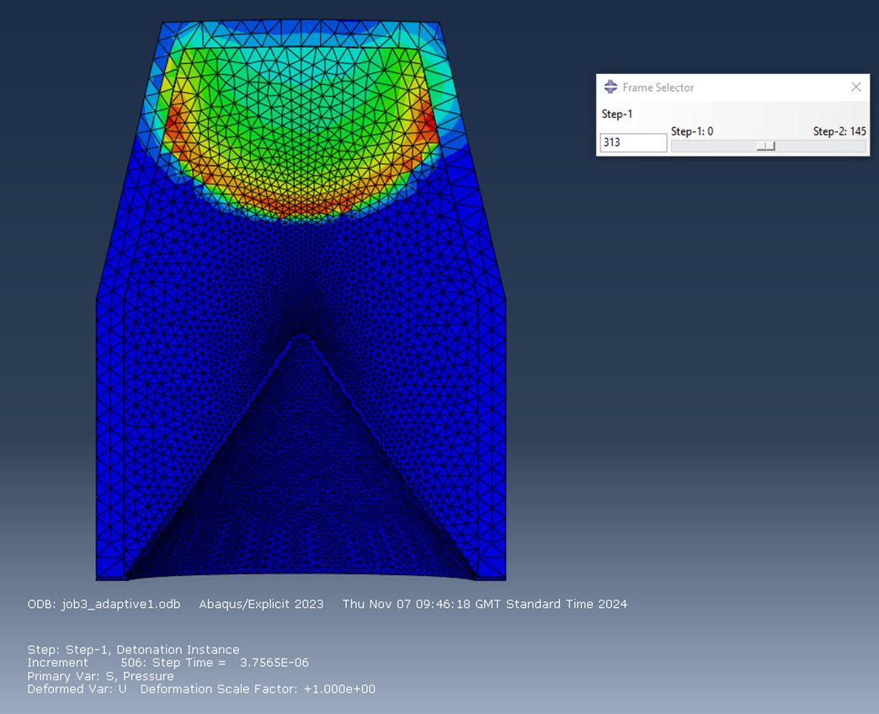
As before, the blast wave progresses through the Explosive, which is hardly surprising as the Mesh, material properties and dimensions are exactly identical to the previous test. The Casing deformation is also present here.
Figure 17 – 3d RPG Blast Wave Progression

As stated in Paragraph iv, the 3d simulation was run differently to the 2d versions. The liner was Mesh biased away from the centre, as shown in Figure 18. This was done entirely accidentally but was actually beneficial: a centre-biased Mesh crashed almost immediately and provided no usable data whereas the edge-biased version ran more reliably and provided something usable that could be analysed.

Software crashing has been mentioned previously; every time the simulation was run, it always ended with the same error message of Excessive Element Distortion, it is likely that elements are colliding with each other and compressing. The software probably does not know how to manage this material interaction and so ceases its calculations rather than continue.

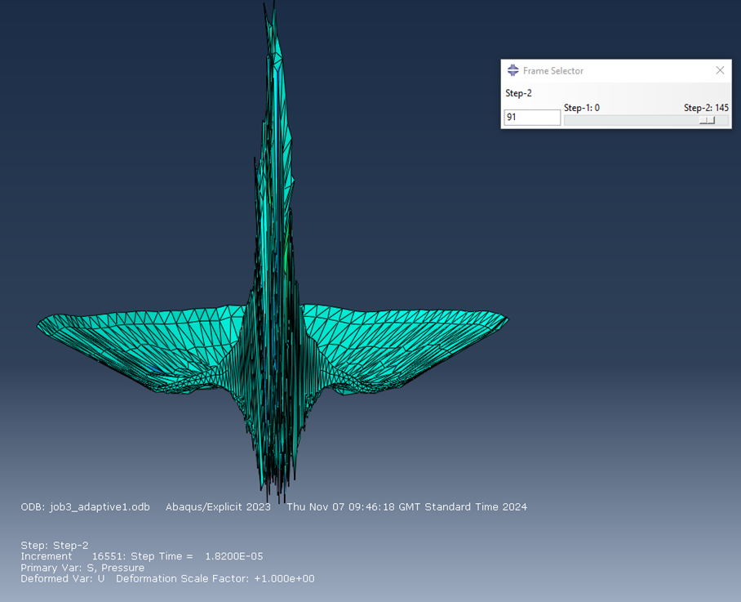
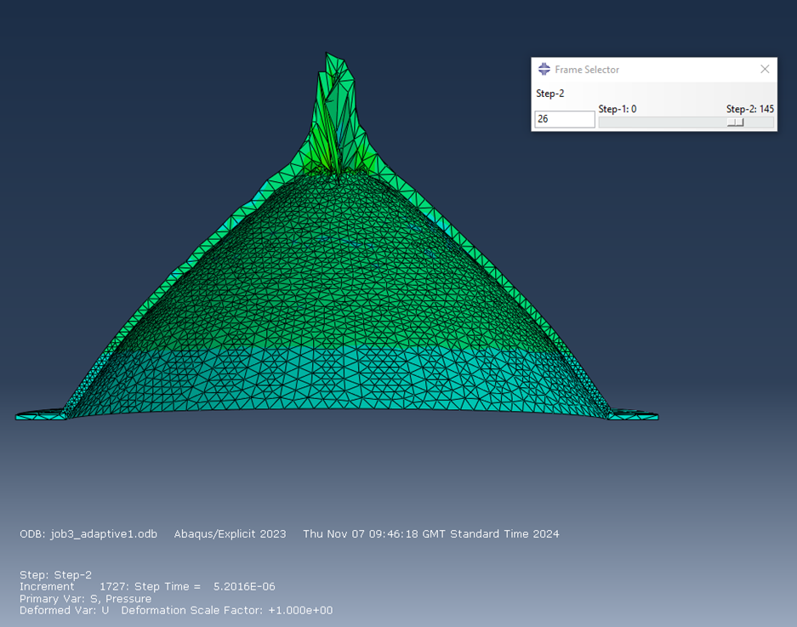
Figure 18 – 3d RPG Jet formation progression, Liner only
Figure 19 - 3d RPG Jet formation progression, Liner only
As the simulation progresses, the jet formation is noticeably different, whereas the 2d RPG simulation was relatively smooth, the 3d is jagged and rough. In real life, explosive products are not often perfect so it could be argued that this is a more realistic depiction of what a real Shaped Charge would look like.

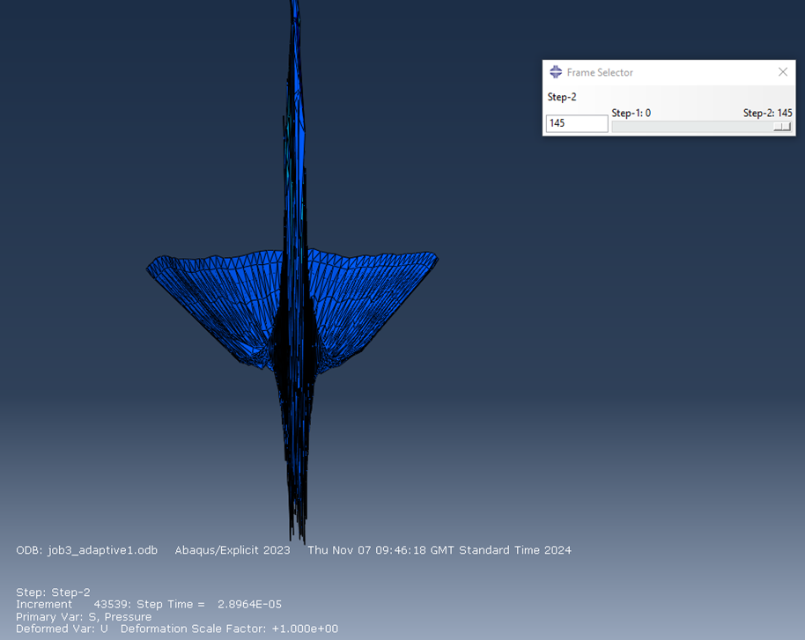
Figure 20 - 3d RPG Jet formation progression, Liner only

The 3d simulation reached this state before coming to a stop by crashing. Unlike the previous simulation, the edges have delaminated and if the simulation was allowed to continue, these “wings” would have likely joined the Jet and would have contributed to penetration.

The tip of the Jet is also completely different, all the other simulations have had sharp, consistent tips that concentrate force onto a single spot as dictated by the previously established Munroe Effect but this one is blunt and jagged and would likely be a relatively poor penetrator. However, the one consistent feature is the large amount of material that travels backwards, again for reasons that are not fully clear.

- Simulation Results
Now that all simulations are complete, the results can be discussed.

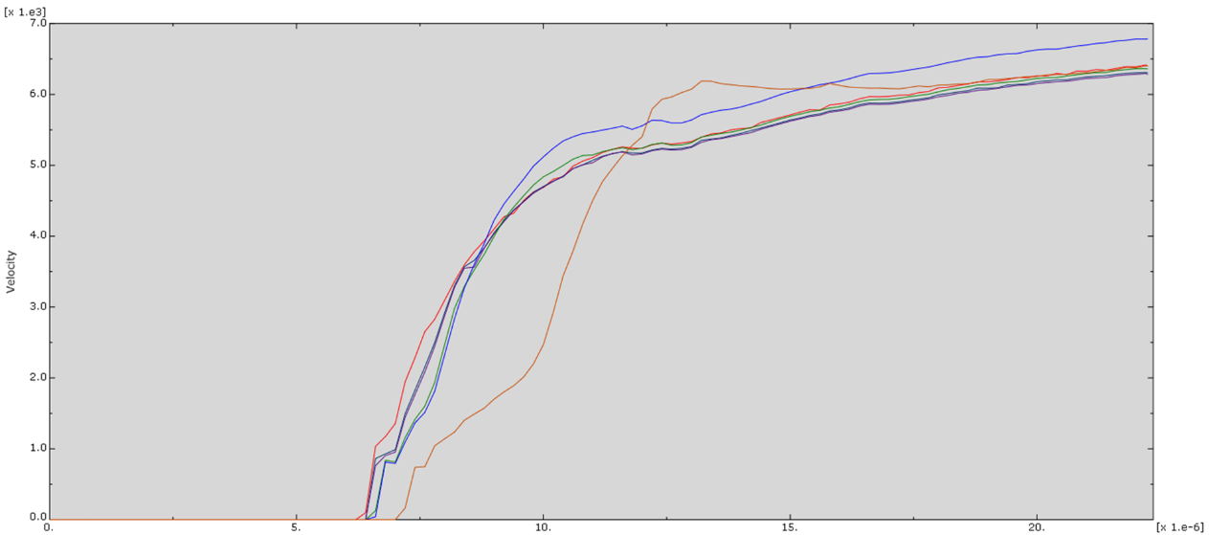
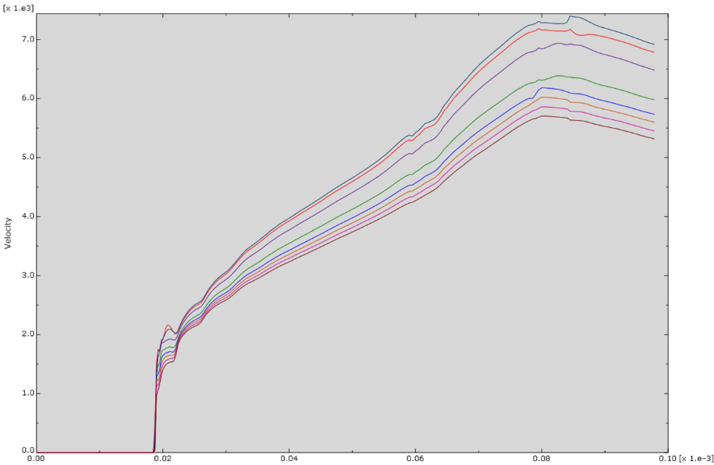
Figure 21 – Velocity Graph of 2d fictional Shaped Charge
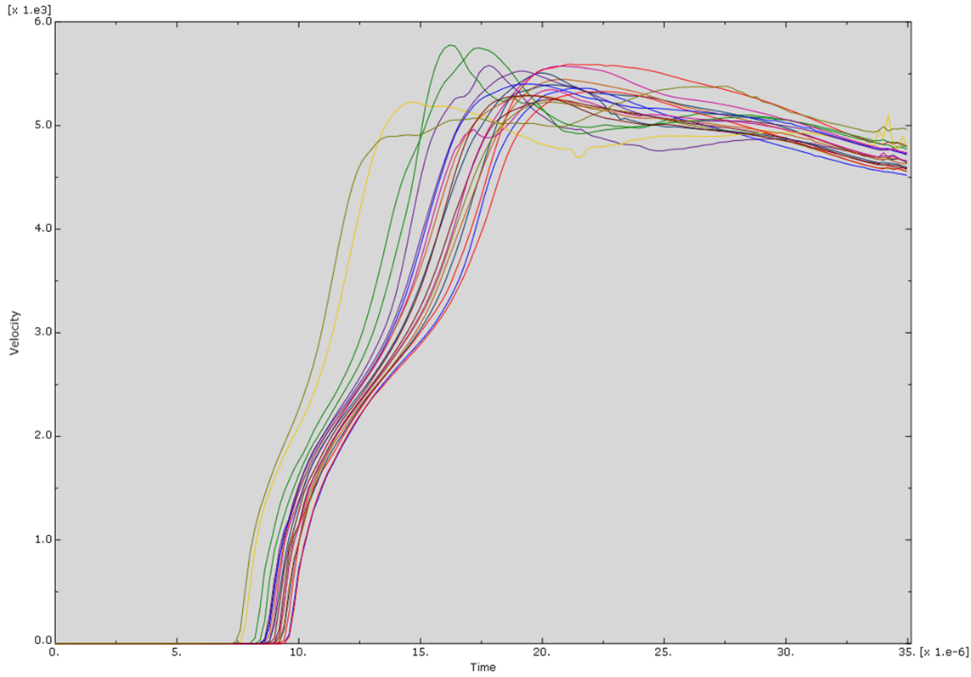
Figure 22 – Velocity Graph of 2d RPG Shaped Charge
Figure 23 – Velocity Graph of 3d RPG Shaped Charge
For all three graphs, they all show the same and correct behaviour consistent with Shaped Charges; they all feature a large initial “spike” of velocity as the Jet accelerates and slowly begins to slow down. This whole process happens within Microseconds and would explain the necessity of Stand-Off Distances, this allows the Jet and reach maximum velocity to form before reaching the target but not so far away that the Jet begins to slow down before impact. Essentially, it allows for the Shaped Charge to function far more efficiently.

- Discussion
From this process, many things were made clear about ABAQUS as a software package; in an attempt to solve the Excessive Distortion crashes, Adaptive Meshing was used. This is used to model the effects of wear and ablation and was intended to smooth the simulation and allow it to run more reliably, however this did not work and caused the simulations to run poorly by causing immediate crashes and was subsequently abandoned when it became clear that it was not helpful.
It was also discovered that a coarser mesh is sometimes better, a finer mesh sometimes caused crashes and was not a “catch all” solution to any reliability issues and if more time was available, further modifications to Meshing could have been made to find a more reliable size that provided results that ran more longer and provided a more complete Jet.

On the topic of meshing, the 3d edge-biased Meshing was more reliable than centre biased meshing, which often lead to crashes and was more harm than good in many cases. This links to the previous point where coarser is sometimes better. If more time was available, the other 2d simulations could have been Meshed this way and perhaps would have run more reliably and produced a more finished Jet.
There was also not enough time to model Liquid behaviour, this could have been useful, as in this mode; ABAQUS converts the Mesh to spherical elements and never crashes. As previously established, the Liner acts Hydrodynamically, these factors could have been the solution to reliability issues. If the 3d simulation was allowed to continue running in this format, it is entirely possible that the simulation would be able to produce a far more detailed impression of Jet formation.
Despite the 3d and 2d simulations being exactly the same on paper; the same Assemblies, dimensions and materials, both produced wildly different results. This could be a result of the increased realism involved in introducing a third dimension to the simulation, it could be argued that the 3d results are the most lifelike representation of how a real Shaped Charge works.

- Conclusion
Use of ABAQUS has been fraught with difficulty from the start; modelling, assigning materials and simulations were all carried out, only to produce a set of results that were not representative of a real Shaped Charge. This process could have been avoided if a physical testing of a prototype Shaped Charge was performed instead. However, this comes with downsides: cost of prototype manufacturing, time required to set up experiments and the Safety risk involved with working High Explosives are all large investments in resources.
By contrast, virtual Simulations can be used to prove underlying concepts and act as a “foundation” for further developmental work without having to rely on building multiple prototypes. Which keeps costs down, lowers Risk to personnel and allows for easier rectification of problems, as changing a model in ABAQUS is far simpler than building a new physical asset.
Therefore, a mix of virtual simulation and physical prototyping seems to be the most efficient form of developing new systems as the positives of either method may be combined and negatives be cancelled out.

- References & Appendices

[1] – T. Sołowski, International Journal of Refractory Metals and Hard Materials, Shaped Charges, 2018, https://www.sciencedirect.com/topics/materials-science/shaped-charge.
[2] – A.L. Yarin, Cambridge University, Shaped-charge (Munroe) Jets and Projectile Penetration, 13 July 2017, https://www.cambridge.org/core/books/abs/collision-phenomena-in-liquids-and-solids/shapedcharge-munroe-jets-and-projectile-penetration/09A254BC5AF213FC72C89E400960DBA0.
[3] – C.E Anderson, Southwest Research Institute, San Antonio, Texas, An examination of deviations from hydrodynamic penetration theory, 03 August 2008. https://www.sciencedirect.com/science/article/abs/pii/S0734743X08001267.
[4] – M.Kaya, 10th International Aerospace Conference, Ankara, Turkey, Determination of Shaped Charge Jet Characteristics Using a Neural Networks Model Based on Hydrocode Simulations, September 2019, https://www.researchgate.net/publication/337544828_Determination_of_Shaped_Charge_Jet_Characteristics_Using_a_Neural_Networks_Model_Based_on_Hydrocode_Simulations.
[5] – O.A. Klamar, Ammunition Engineering Directorate, Picatinny, New Jersey, Shaped Charge Scaling, March 1964, https://apps.dtic.mil/sti/tr/pdf/AD0600273.pdf.
[6] – Z. Pankowski & M Miszczak, Warsaw Institute of Technology, Experimental and Numerical Study on the PG-7VM Warhead Performance against High-Hardness Armor Steel, 02 June 2021, https://www.mdpi.com/1996-1944/14/11/3020.

Annex A - Steel Johnson Cook Values
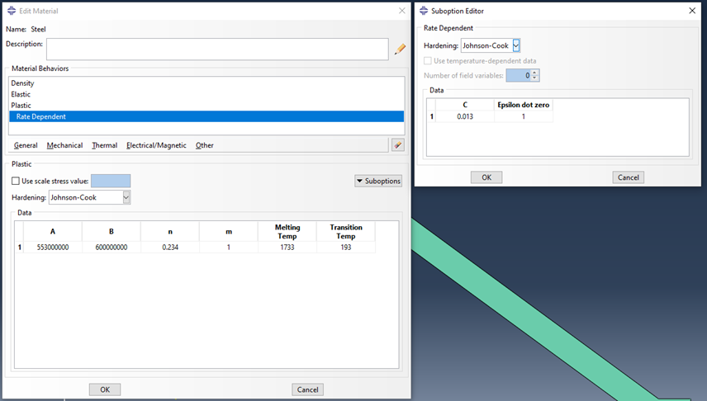
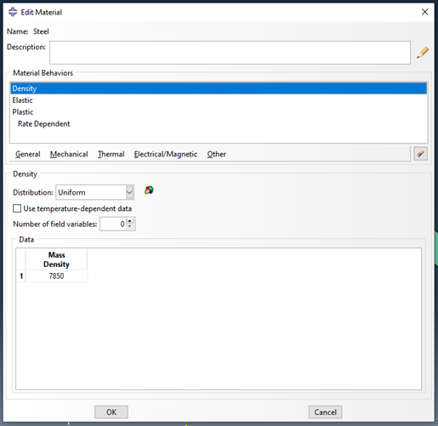

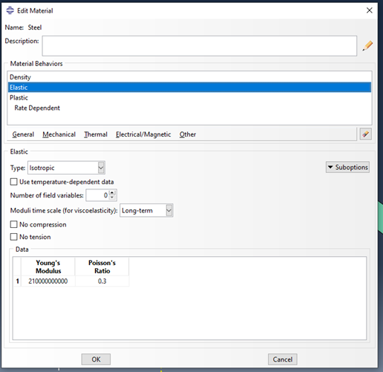
Annex B – Copper Johnson Cook Values
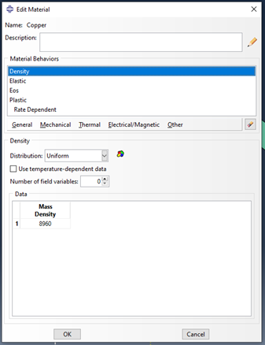

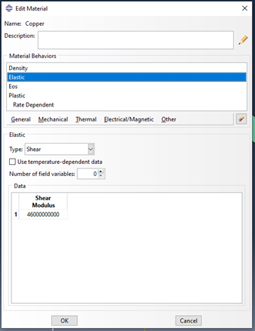

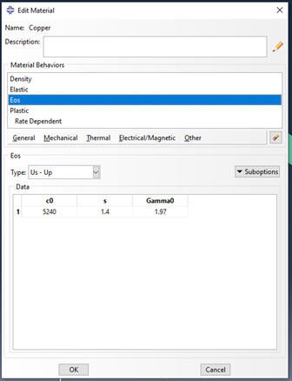
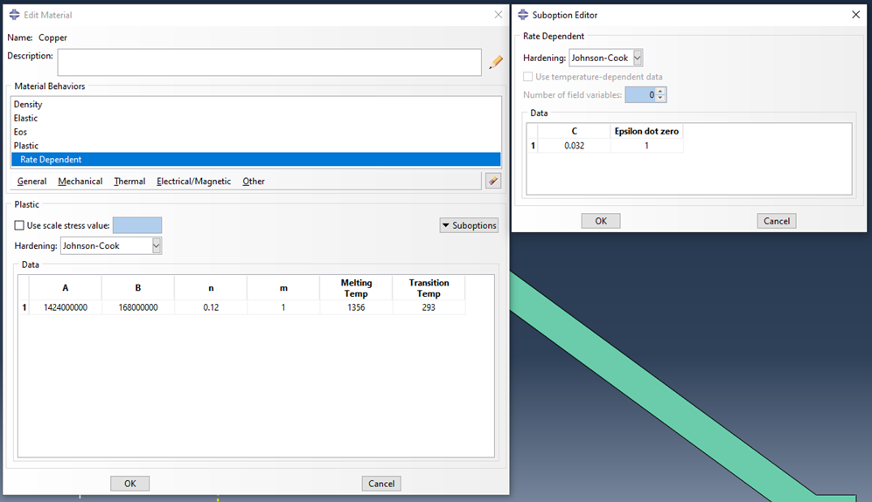

Annex c – TNT johnson Cook Values
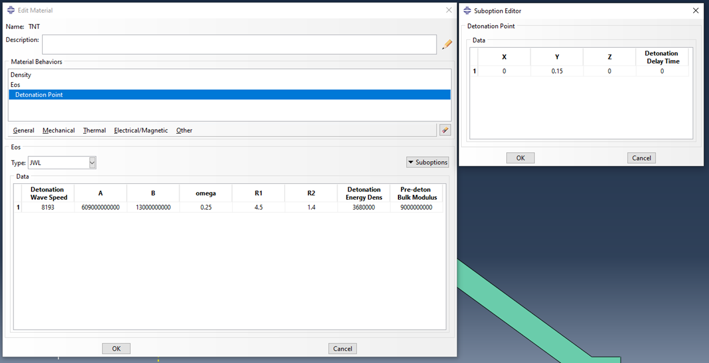

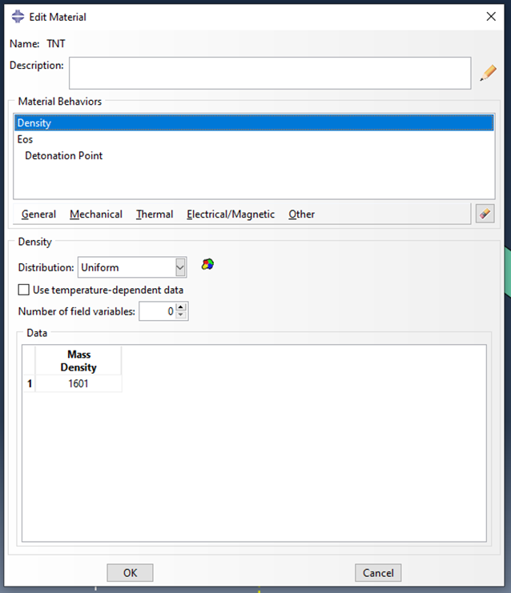

ANNEX D - A-IX-1 JOHNSON COOK VALUES


