Circular Economy
Alex Bell
Contents
- Executive summary
- Introduction
- What is the circular economy
- What is a linear economy
- The value hills
- brewing and the circular economy
- Bluestone brewery
- Challenges
- Conclusion
- References

Executive summary
This report gives insight into the circular economy and how it reduces waste and therefore helps the sustainability of the planet. The linear economy is having a harmful effect from all these years of mass waste in landfills from different businesses. Many products are not made to last, which creates a build-up of waste; however, with the circular economy, this can be reduced. An example of a circular economy to be discussed is Bluestone Brewery.It is a micro-brewery located in West Wales. It tries to reuse and recycle all of the by-products and packaging used during the brewing process. By doing this reduces waste and reduces their carbon footprint. It also helps their profit line. However, this micro-brewery has some challenges like all businesses.
Introduction
During this assignment, an investigation of the circular economy will be made. It will establish how all businesses should be thinking about becoming more circular. It will highlight the positive effects it can have on business growth and money-saving. IT will demonstrate the importance of the circular economy and how businesses can achieve this. Bluestone Brewery will be used as the example of a company that employs the circular economy. It will highlight how the brewery tries to be sustainable. It highlights how much thought has gone into this micro-brewery to make it more green and economical. A SWOT analysis of the brewery will be completed to provide their strengths, weaknesses, opportunities and threats. This analysis will also be used to determine what challenges Bluestone Brewery could face in the future.
What is the circular economy?
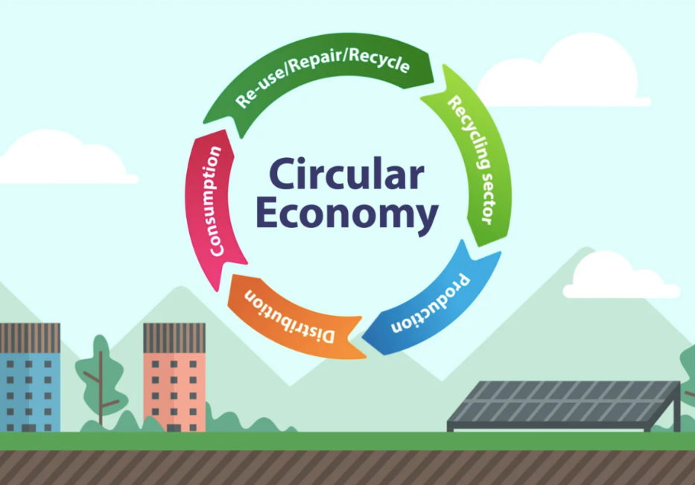
(Figure1 ( Bing images, 2021)
The circular economy is a production and consumption paradigm that encourages people to share, lease, reuse, repair, refurbish, and recycle existing materials and products for as long as feasible. The product's life cycle can be extended in this way (Guillot. J, 2022).
This means eliminating waste to the absolute minimum. When a product reaches the end of its useful life, its materials are reused as much as possible. These can be put to good use repeatedly, resulting in increased value (Guillot. J, 2022).The circular economy (CE) is a concept encouraged by the EU, and various national governments and enterprises around the world, including China, Japan, the United Kingdom, France, Canada, the Netherlands, Sweden, and Finland. According to a recent assessment by the European Commission, circular economy-style economic transitions might generate 600 billion euros in annual financial gains for the EU manufacturing sector (Kirchherr, J., Reike. D. &Hekkert, M,2017)
The circular economy is expected to generate yearly gains of 2.5 billion euros for Finland's national economy. The global economy would profit by $1 trillion each year. In 2008, China became the first country in the world to pass a circular economy law. The circular economy is advocated as a method of economic development compatible with long-term environmental and economic development. The modern economic system's present and traditional linear extract-produce-use-dump material and energy flow model is unsustainable. (Kirchherr, J., Reike. D. &Hekkert, M, 2017)
As one looks at the circular economy, one can see that it saves money, reduces waste in our communities, creates a green effect, and serves a purpose compared to the linear economy.
What is the linear economy?
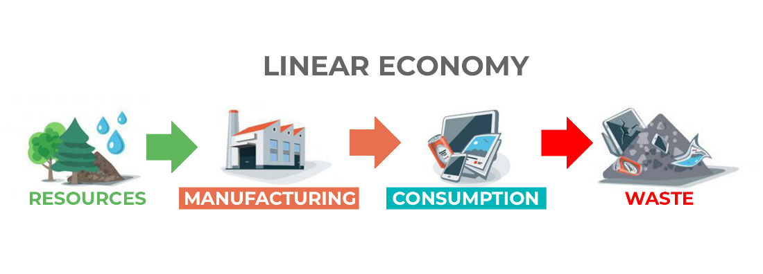
(Figure2, Bing images,2020)
The linear economy has an end goal of waste upon waste. This is what our economy does now, and how harmful it is for our society is why we must change and become more sustainable. The current economic system is based on the historically unequal distribution of wealth across geographic regions. The industrial nations have had an excess of material resources and energy since consumerism has been concentrated in the most developed areas (i.e., western cultures). Raw materials have been sourced progressively globally. The raw materials were inexpensive in this arrangement compared to the expense of human labour. As a result, producers have been encouraged to adopt business strategies that rely on substantial material consumption and cost-cutting (S. Furkan, 2017). The inevitable consequence of low-cost materials and high-cost labour is a widespread disregard for recycling, reusing, and placing a high value on waste. The regulatory accounting and scale rules were also supportive of this scheme, as they have not issued a protocol to charge producers for externalities; therefore, producers are less likely to examine the environmental consequences of their operations (Furkan,S.2017). The linear economy has a straight-line game, and if we continue to go in this direction, we will create permanent damage to our environment, which will not have a chance to be reversed.
The Value Hill

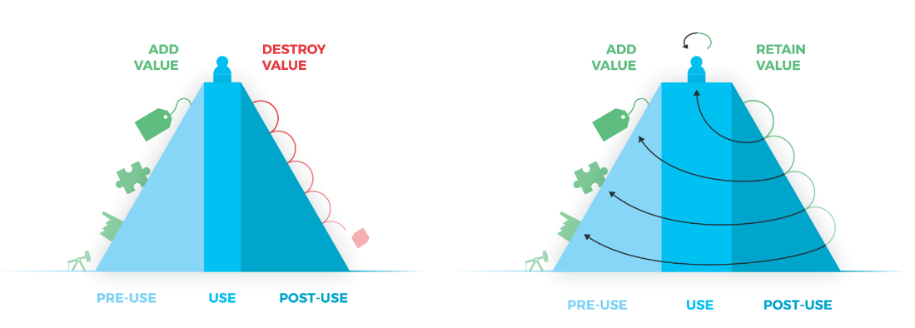
Figure 3 (Bing images,2021) shows the linear economy and circular economy in the Value Hill. This strategy gives a clear outline of how each economic method works.
The Value Hill suggests a classification based on a product's lifespan phases pre-, in-, and post-use. This enables organisations to determine their location on the Value Hill and identify potential circular initiatives as well as missing partners in their circular network (Achterberg, E., Hinfelaar, J., &Bocken, N. 2016).
Business models are typically sales-driven; therefore, profits are derived primarily from selling as many products as feasible. This offers an incentive for manufacturers to design items with a short life cycle in order to keep selling new ones. The value gained in the production process is swiftly destroyed when outdated products end up in landfills or are incinerated. In the Value Hill above, the entire lifespan is depicted. As a product is produced (the left side uphill slope), value is added, and as the product reaches the top of the hill, the product's value is at its peak. However, after a relatively short lifecycle, the product's value is swiftly depleted, and value rapidly declines (Achterberg, E., Hinfelaar, J., &Bocken, N. 2016).
Additional or new business models that have yet to be established can readily be added to the Value Hill framework. It classifies circular business models based on their position in the value chain and their business activities. As a result, it provides entrepreneurs with an easy-to-use tool for positioning themselves and exploring gaps and possibilities in their circular value network. (Achterberg, E., Hinfelaar, J., &Bocken, N. 2016).
Businesses should be seeking new strategies to become more sustainable and reduce business costs. These businesses still provide great products for their consumers. Breweries have taken on board the circular economy by creating a sustainable cycle that reduces waste and protects the environment.
Brewing and the circular economy
Breweries can accumulate a lot of mass waste. There is a lot to think about to reduce their carbon footprint, but by doing so, they will reduce emissions by a massive percentage; many businesses struggle as there is no initial government guidance to follow when they want to incorporate the circular economy.
The main brewery wastes created and packaging materials used, as well as their range of composition and yields were identified by examining the beer brewing process. It would be necessary to replace one-way containers with lighter, reusable, or recycled ones in order to reduce the contribution of packaging material to the carbon footprint of beer. Even when the contribution of the beer consumption phase was considered, no conclusive option for a less environmentally friendly beer packaging format could be found. (Cimini, A. &Moresi, M., 2021)
Food and agriculture have been given specific emphasis under the foundation's three circular economy concepts. Each of the following sections has been expanded upon in one of their most recent publications, Filling in the blanks. Climate change and the circular economy (Lemaire, A.,2020).
The first premise focuses on reducing food waste, which can be accomplished by better matching supply to changing demand. Digitalisation and policy efforts that support it help to speed up the process. This modification has the potential to contribute to a 50% decrease in edible food waste by 2030, as well as a 1.4 tonne CO2e reduction in annual emissions across the food value chain (Lemaire, A.,2020).
The second principle's goal is to see this as feedstock for other sections of the economy, rather than waste. Products may be made, natural fertiliser can be used, and even anaerobic digestion can be employed to recover energy. In 2050, by-products and green waste composting might produce 0.3 billion tonnes of CO2e each year (Lemaire, A.,2020).
The third premise is about renewing natural systems, and it represents the best chance to make the food system a significant player in climate change solutions. Carbon sequestration, improved water retention, and the use of fewer synthetic fertilisers could all be benefits of regenerative agriculture. The annual CO2e emissions from managed grazing1 and regenerative cropland2 are expected to be 1.4 billion and 2.5 billion tonnes, respectively (Lemaire, A., 2020).
For the brewing industry, there are many options for them to reduce their carbon footprint and contribute to the circular economy by becoming more sustainable, At Bluestone Brewery, nothing goes to waste, and everything has a second or third purpose (Lemaire, A., 2020).
Bluestone Brewery
Bluestone Brewing is a family-owned and operated brewery located in rural North Pembrokeshire, Wales. Simon and Amy, a father and daughter partnership, founded the company in 2013. The Brewery has grown from strength to strength in our first four years, and it's been incredible to see their dream come true. They now have four great taste stars throughout our entire range, as well as honours from the Society of Independent Brewers. (Welsh country, 2021)
They have a selection of 12 different beers that change with the seasons. They supply pubs, restaurants, and shops throughout Wales, as well as wholesale to the rest of the United Kingdom. On the farm, they have their own music arena where they host amazing live music nights throughout the summer (Welsh Country, 2021).
The water they utilise to make their Rock-Solid Ales is a Bluestone exclusive. The water comes from the Preseli Mountains' core and is collected in a well on their property at the foot of the slopes. This spring water is so pure and clear that it goes straight from the well into our beers without being filtered or treated with chemicals. They think that because beer is 98 per cent water, the distinctive quality of Bluestone water provides their beer with a distinct, pure, and substantial flavour that you won't find anywhere else! In addition, they take pleasure in being an environmentally conscious company, with solar panels, a reed bed filtration system, and a heat exchange system in place. Any leftover hops and grain are fed to the farm's cattle (Welsh Country 2021).
Like many small businesses, Bluestone Brewing Co is continuously seeking methods to lessen its carbon footprint. The Brewery has earned multiple honours for its efforts in sustainable production throughout the years, and they are still working to achieve a carbon-neutral firm. Their efforts have ranged from reed bed filtration systems for wastewater, tree planting, 100 per cent renewable electricity sourcing, compost toilets, and building with salvaged materials, but perhaps the most ambitious project to date is their collaboration with Swansea University to capture CO2 naturally produced by yeast in the brewing process and turn it into valuable biomass. If the project is successful, it is hoped that the approach can be replicated by other small-scale CO2 producers. (Welsh country, 2021)
Bluestone Brewery is a unique mini brewery located in west Wales. Everything has been thought and planned to become greener. There is no waste as far as this Brewery goes. They provide excellent products to its consumers from it, with a family-run atmosphere and the summer festival feel. Nothing is lost but more is gained.
Challenges
Bluestone brewery has many strengths, weaknesses, opportunities and threats like most businesses, the main characteristics of this are:
Strengths  - Very sustainable, no waste  - Good communication with consumers, suppliers, and community  - Locally made beer in different flavours  - Local consumers | Weakness  - Due to the use of electronic vehicles, it is difficult to distribute products further out.  - Lack of use of advertisement and social media use
Opportunities  - To find other economical ways to distribute products further, to gain a more extensive customer base.  - Target the use of social media to widen the knowledge of the business  - Advertise their products to gain a more extensive customer base | Threats  - Change in brewing policies  - Economy changes  - Pandemic  - Change in government policies

As we can see from the swot analysis of a microbrewery like Bluestone, there are many advantages and disadvantages they face. Still, they have a great number of strengths, especially being sustainable, reducing waste in all ways possible, even using electric cars to deliver their products to reduce emissions. Still, the unfortunate thing is that these electronic vehicles cannot make the large journeys the organisation needs to distribute their products.
There are several opportunities, but the main ones are for them to be able to distribute their products further for more recognition of their hard work, use social media for advertising their events to draw attention to the business and attract more customers. The threat that can affect a microbrewery like Bluestone is economic changes that can reduce their intake. Pandemics can force closure which we have seen during the covid 19 pandemic, which reduces intake, and a change in governing policies will also impact a business-like bluestone brewery.
There are many challenges the organisation may face, but their main ones are the distribution of their products because of the location of the venue, and the vehicle transportation minimises the number of miles out they can deliver to, and their use of social media platforms keeps them hidden from a wider population as they could become an attraction for many people from many places this will widen their community.

Conclusion
To conclude, the circular economy is becoming more recognised in business in recent years. The change is becoming more apparent due to the effect mass waste is having on our planet with global warming and more catastrophise happening with bush fires and ice being melted away in different parts of the world. Business has a responsibility to reduce their waste and start protecting our planet. Bluestone Brewery has done just that with their no waste policy everything is used or recycled or used as a replacement for something else, everything is locally used and distributed to reduce any harmful waste.

References

J. Guillot , 2022. (online) Europarl.Europa.eu. Available at: <https://www.europarl.europa.eu/pdfs/news/expert/2015/12/story/20151201STO05603/20151201STO05603_en.pdf> (Accessed 4 March 2022).
Kirchherr, J., Reike, D. &Hekkert, M., (2017). Conceptualising the circular economy: An analysis of 114 definitions. Resources, conservation and recycling, 127, 221-232.
S, Furkan. (2017). Linear Economy Versus Circular Economy: A Comparative and Analyzer Study for Optimisation of Economy for Sustainability. Visegrad Journal on Bioeconomy and Sustainable Development. 6. 10.1515/vjbsd-2017-0005.
Achterberg, E., Hinfelaar, J., &Bocken, N. (2016, September). MASTER CIRCULAR BUSINESS WITH THE VALUE HILL. Circular economy.Europa.Eu. Retrieved March 3, 2022, from https://circulareconomy.europa.eu/platform/sites/default/files/master_circular_business_with_the_value_hill.pdf
Cimini, A. &Moresi, M., (2021). Circular economy in the brewing chain. Italian Journal of Food Science, 33(3), 47-69.
Lemaire, A., (2020). " Circular economy: Best practices and future perspectives for the beer brewing industry. Louvain School of Management. Université catholique de Louvain, 2020.
Welsh country, 2021 Bluestone Brewing - Welsh Country
Bing images, 2021 https://thecsrarena.com/wp-content/uploads/2021/04/ce8.png
Bing images, 2020 https://th.bing.com/th/id/R.32e3695033fcfad5ec5585c85e6fa262?rik=ZACdB0sEyOZIAw&riu=http%3a%2f%2fzerowasteyukon.ca%2fwp-content%2fuploads%2f2019%2f06%2flinear-economy-graphic.png&ehk=cJWo7mgIAGYT%2bXTnDRjLOyv0bPlh8s2ZxN1mqf8PSto%3d&risl=&pid=ImgRaw&r=0
Bing images, https://assets.website-files.com/5d26d80e8836af2d12ed1269/5dbc3e36788895a9fcd82f4c_linear-circular-hills-e1474545163614.png

