Operating Systems
Module Name: COMPUTER ARCHITECTURE AND OPERATING SYSTEMS
Module Code: ACCA4022
Student Name: CHOSTAN ISSE MUKETE
Student ID: 2528998
Lecturer Name: Dr MD SHANTANU ISLAM
Submission date: JULY 17 2026

Click or tap here to enter text.
Contents
Introduction 4
Key functions of general Operating Systems 4
Task Management: 5
Application/Program Management: 5
File/Directory Management: 6
Device Management: 7
Security Management: 8
Use of Windows OS CLI commands 10
Example 1: 10
Example 2: 10
Example 3: 11
Example 4: 11
Example 5: 12
Example 6: 13
Example 7: 13
Example 8: 13
Example 9: 14
Example 10: 14
Use of Linux OS CLI commands 15
Example 1: 15
Example 2: 16
Example 3: 16
Example 4: 17
Example 5: 17
Example 6: 18
Example 7: 18
Example 8: 19
Example 9: 19
Example 10: 20
Use of Windows OS scripts 21
Example 1: 21
Example 2: 22
Use of Linux OS scripts 24
Example 1: 24
Example 2: 25
Conclusion 27
References 28
Appendices 29

Introduction
This coursework provides an overview of essential concepts related to operating systems and computer management. It explains the purpose and functions of operating systems, including how they manage hardware, software, files, and system resources. The report also examines key areas such as application management, file and directory management, and the general functions that support efficient computer operation. Each section aims to build a clear understanding of how operating systems work and why they are important in modern computing environments. Overall, this report offers a structured foundation for further study in computer systems.

Key functions of general Operating Systems
Introduction to Operating Systems
Operating systems (OS) have existed since the 1950s [1], evolving from simple batch processors to modern, user-friendly platforms like Windows, macOS, Linux, Android, and iOS. An OS is essential because it manages hardware, runs applications, and provides an interface for users. Key functions include process management, memory management, file handling, security, and device control.
These functions are:
Process management: controls how programs run and share CPU time.
Memory management: allocates RAM to applications efficiently.
File management organizes data into directories and controls access.
Device management: handles communication with hardware like printers and drives. Security management: protects data through permissions and authentication. Together, these functions ensure stability, performance, and user safety.

Task Management:
Windows provides built-in tools for task management that help users monitor system performance, close unresponsive programs, and organise running applications. The main tool, Task Manager, shows detailed information about how the computer’s resources are being used. In the screenshot example, the system is using around 70% of its memory, and four main applications are open: Microsoft Edge, Microsoft PowerPoint, Microsoft Word, and Task Manager itself. It also shows that 116 background processes are running, along with several Windows system processes. This information helps users understand what is affecting performance and decide whether to end tasks or free up resources this as shown of the figure below [2].
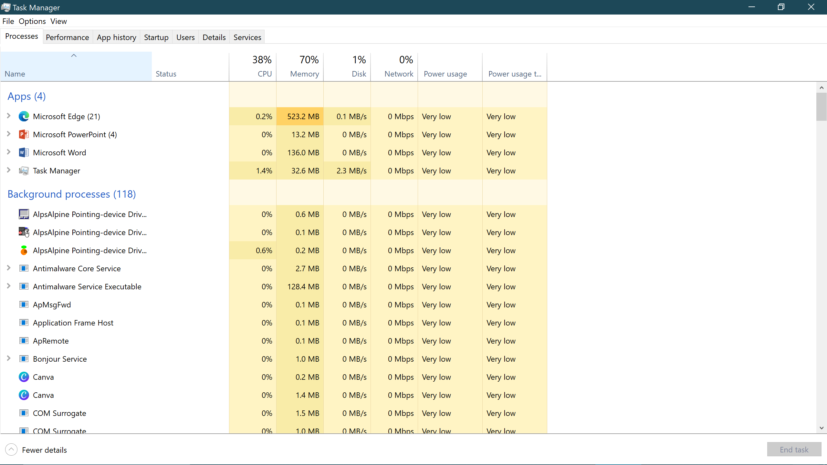
Figure 1: task management.

Application/Program Management:
Application and program management in Windows involves the processes used to install, update, organize, monitor, and remove software on a computer system. Windows provides several built-in tools to support this, including Settings → Apps, Control Panel, Task Manager, and the Microsoft Store. These tools allow users to manage storage, control startup applications, monitor performance, and uninstall unwanted programs to improve system efficiency.
For advanced management, Windows also supports PowerShell and Group Policy, which enables administrators to automate software deployment and enforce security policies across multiple devices. Effective application management helps maintain system stability, enhances security, and ensures that users have access to the tools they need [3]. 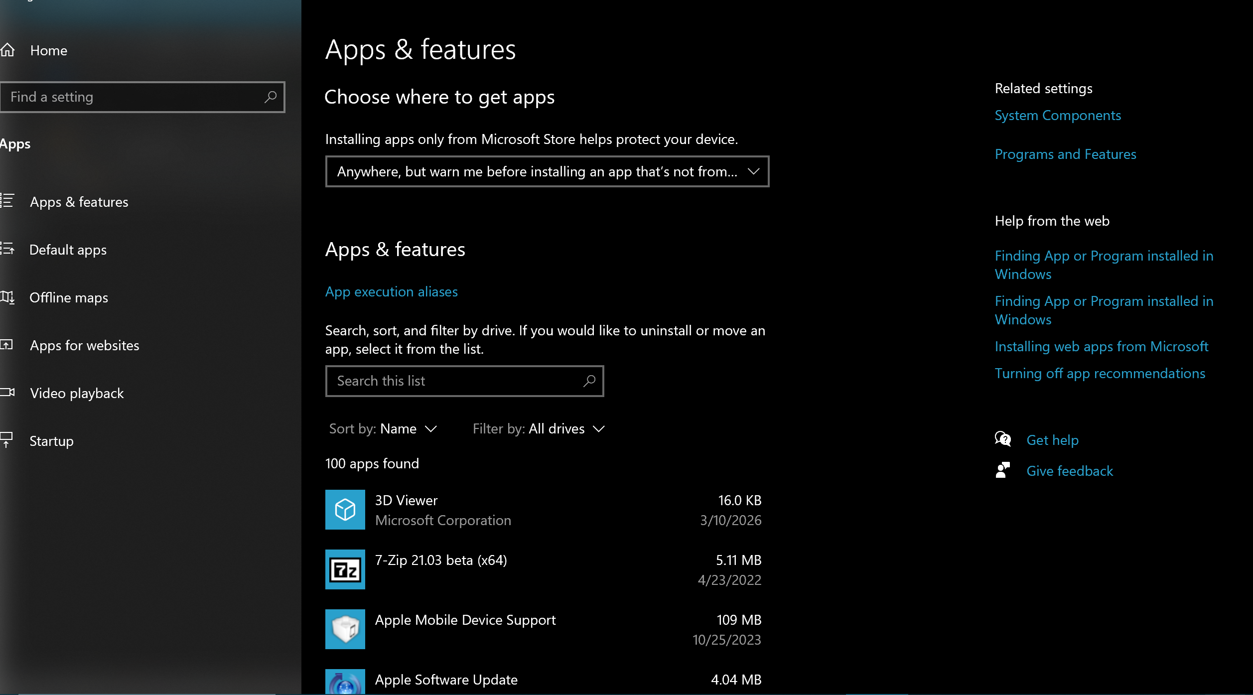
Figure 2: program management.

File/Directory Management:
File and directory management in Windows refers to the methods used to create, organize, access, modify, and maintain files and folders within the operating system. Windows provides several built-in tools for this purpose, including File Explorer, which allows users to navigate storage devices, copy or move files, rename items, and manage folder structures. Users can also adjust file properties, sort items by type or date, and use the search function to quickly locate documents.
Advanced management features include Command Prompt and PowerShell, which allow users to automate tasks such as bulk file renaming, directory creation, and permission management. Effective file and directory management improves productivity, ensures data organization, and supports system efficiency [4].
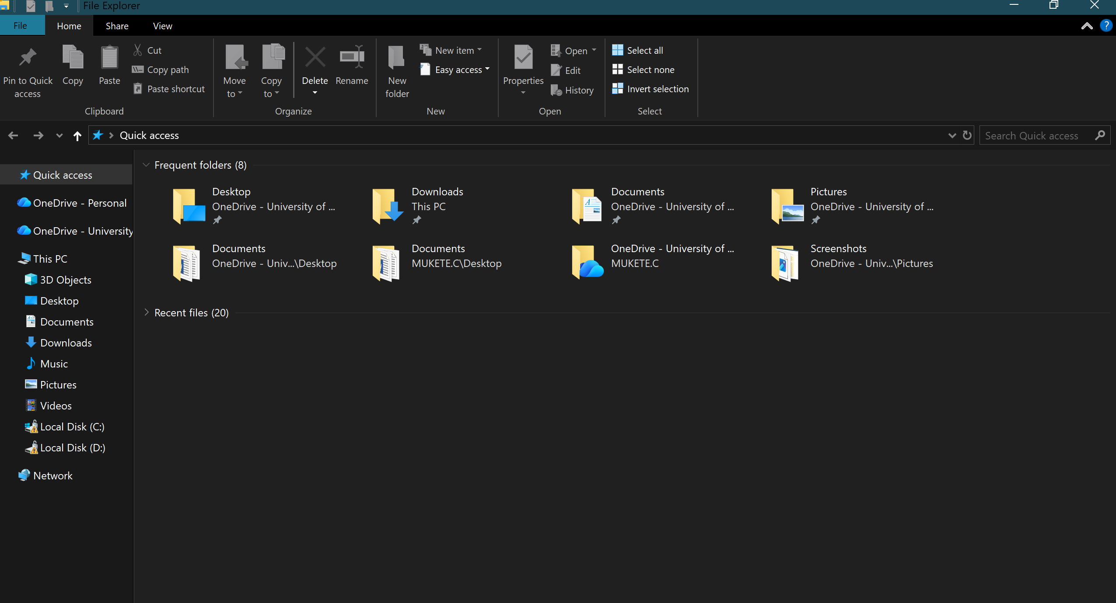
Figure 3: File management.

Device Management:
Device management in Windows is the process of organising and controlling the hardware and drivers that make a computer function properly. One of the main tools for this is Device Manager, which lets users view every component inside the system—such as processors, display adapters, sound devices, and storage controllers. Through this tool, users can install drivers, check for hardware errors, and remove or disable faulty devices [5].
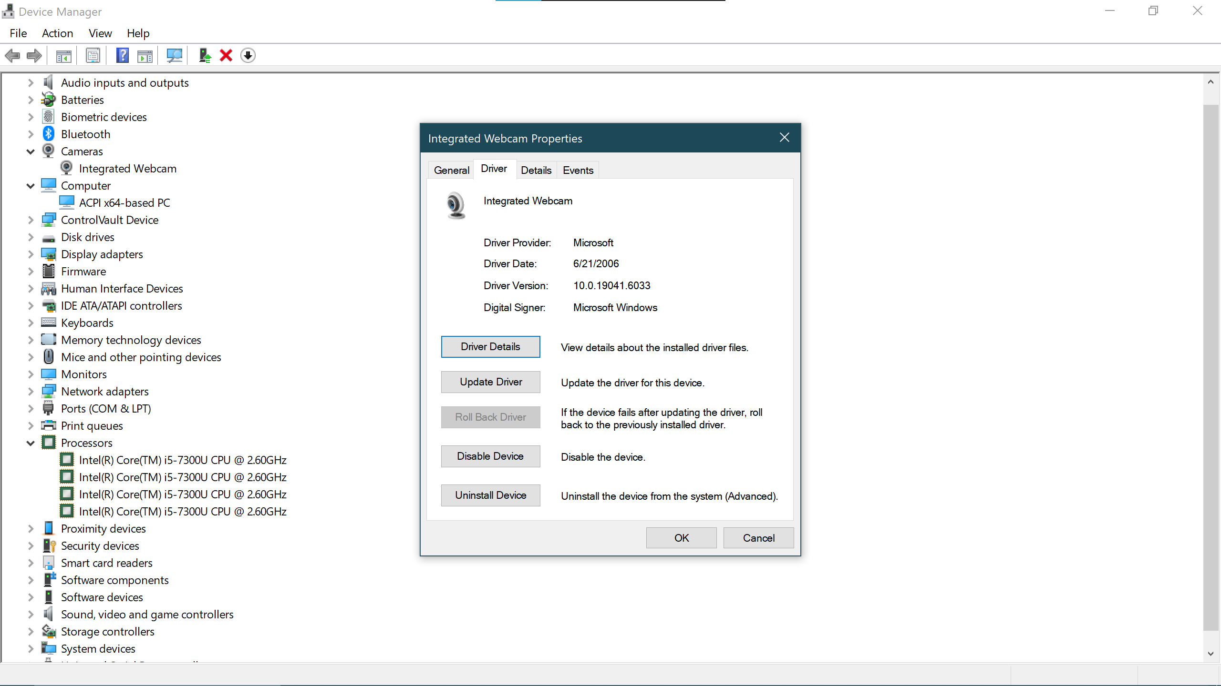
Figure 4: Device Management.

Security Management:
Security management in Windows focuses on keeping the operating system safe from threats such as viruses, malware, and unauthorised access. Windows provides several built-in tools, including Windows Defender Antivirus, which scans files and monitors activity to block harmful software. The Windows Firewall controls incoming and outgoing network traffic to prevent attacks. Windows also uses security policies to manage passwords, permissions, and user access. Features like BitLocker drive encryption protect stored data, especially on lost or stolen devices. Together, these tools help maintain privacy, system integrity, and overall device safety all these are shown in the figure below [6].
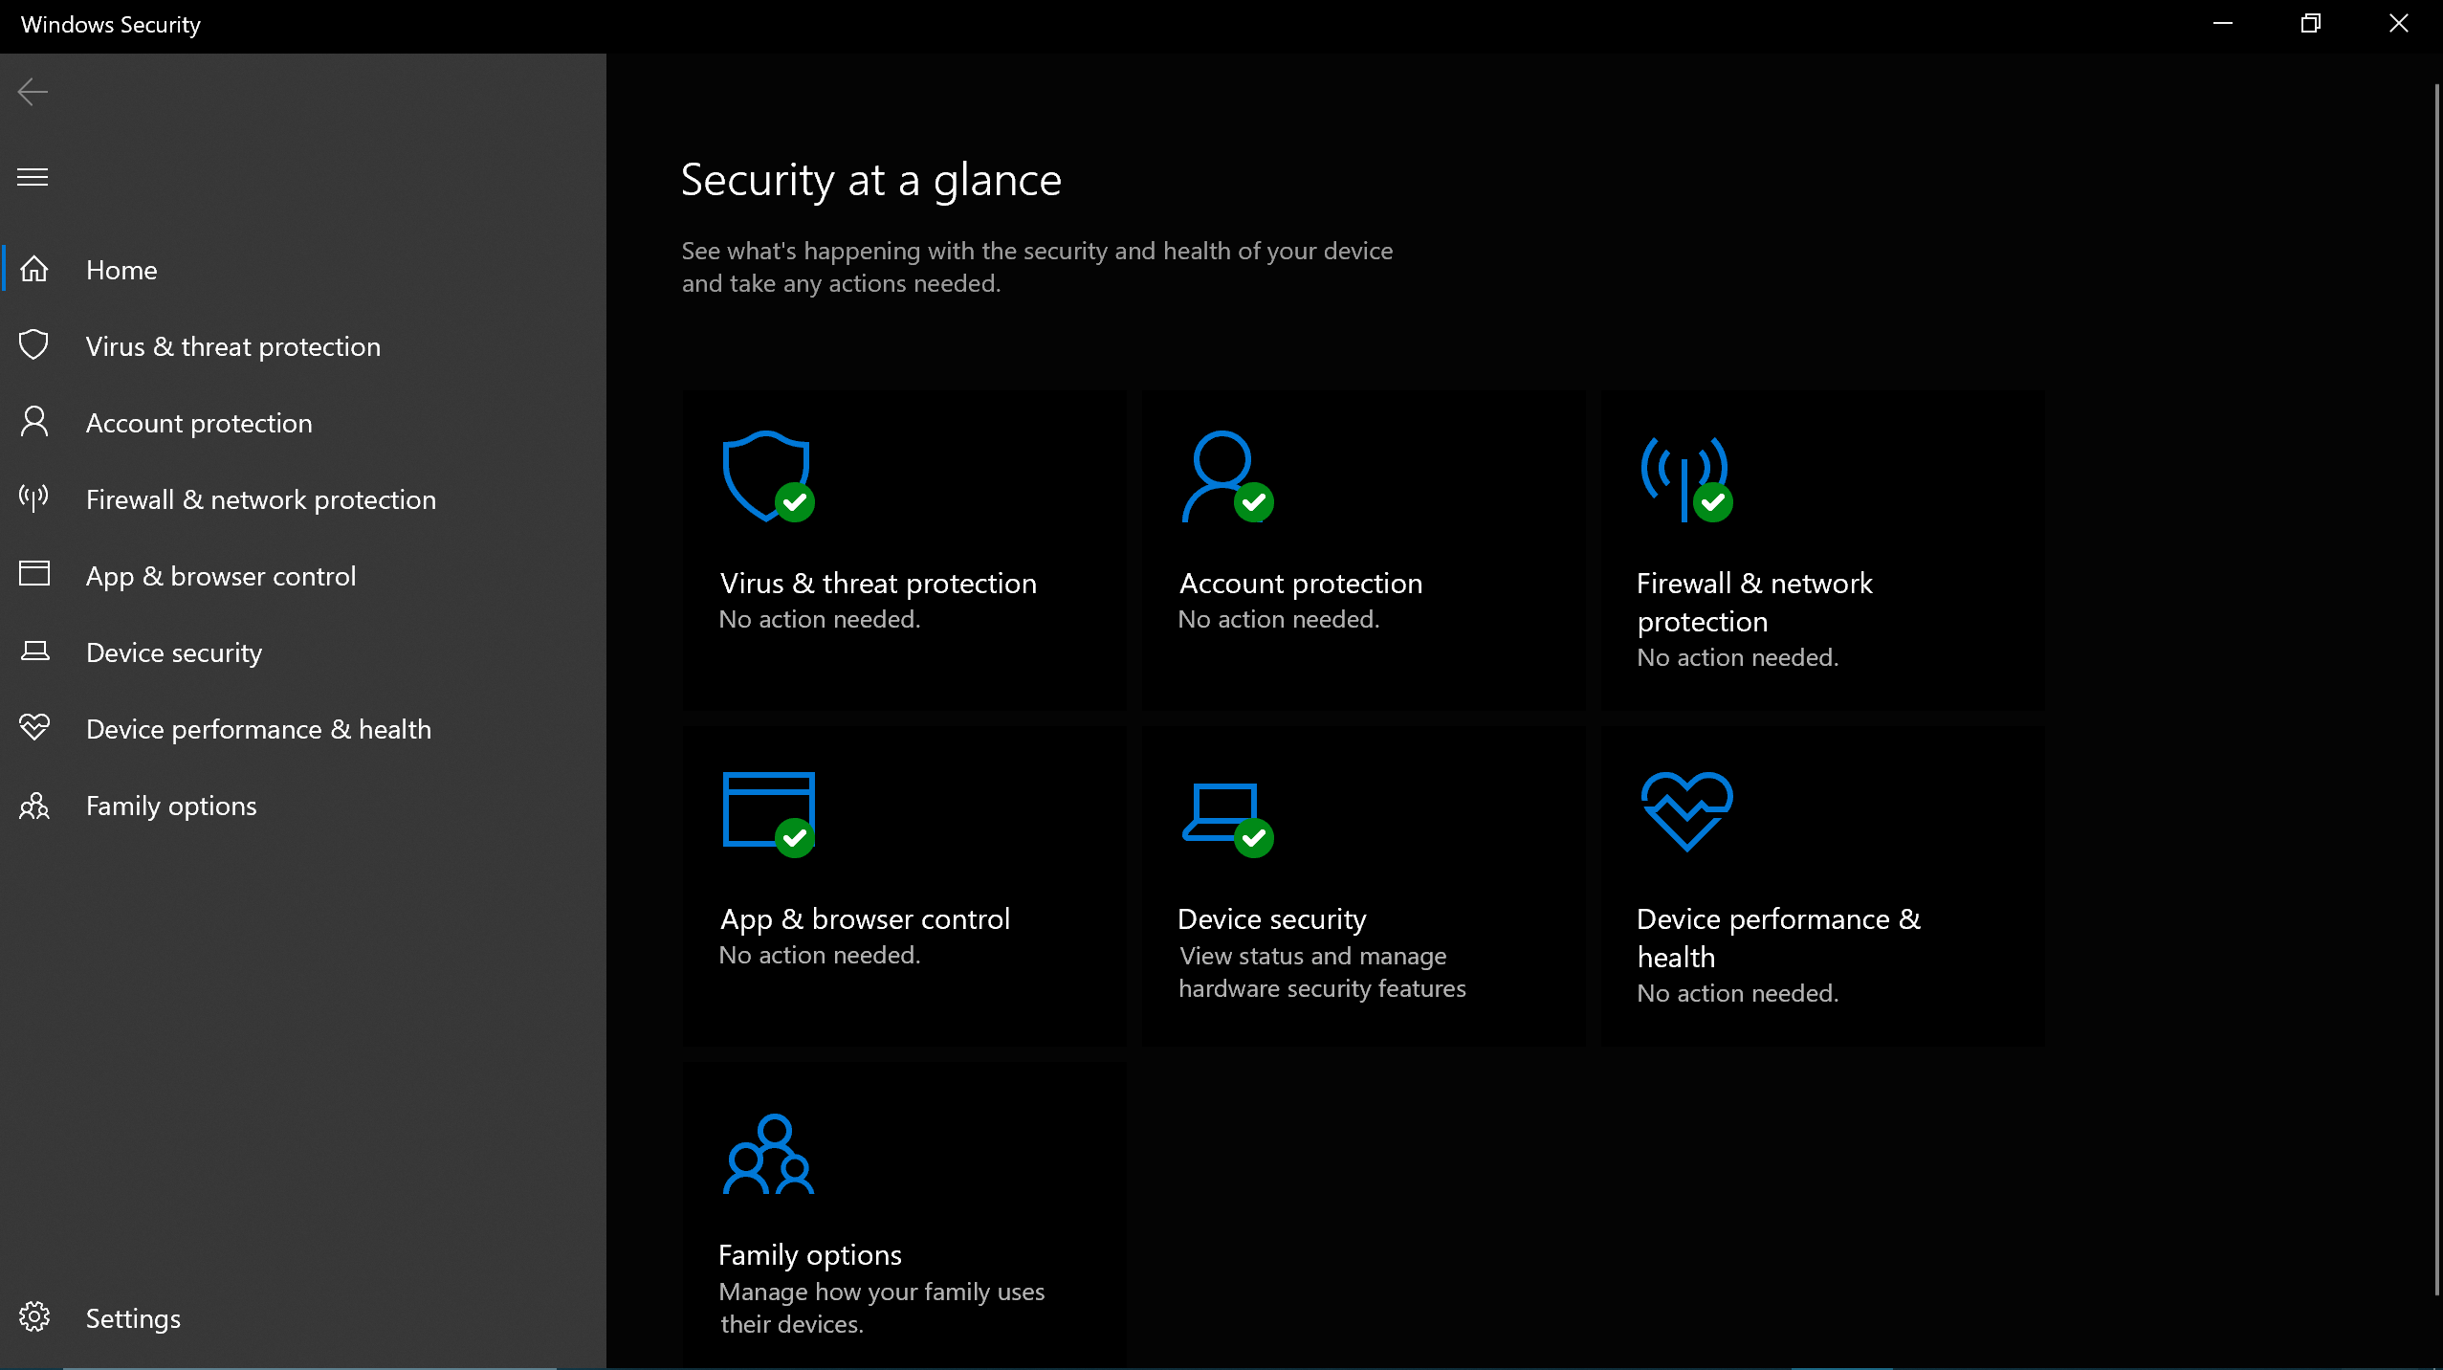
Figure 5: Security Management.

Use of Windows OS CLI commands
CLI means command line interface Windows CLI commands provide fast system control through tools like Command Prompt and PowerShell. They support file management, networking, automation, and troubleshooting, making administration efficient for users and IT teams. These functions enhance flexibility and precision in Windows environments.

Example 1:
According to the figure below, it shows that the dir command lists all files and folders in the current directory. The output shows names, sizes, and dates, helping users understand what items exist in that location.
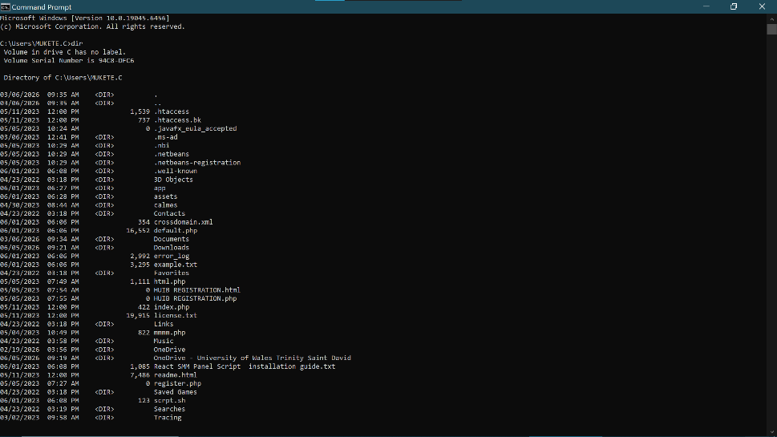
Figure 6: dir.

Example 2:
Going back to the previous location and how to change the location in command prompt. First cd failed and oath was not found and the second time it worked and prompt to show new location.
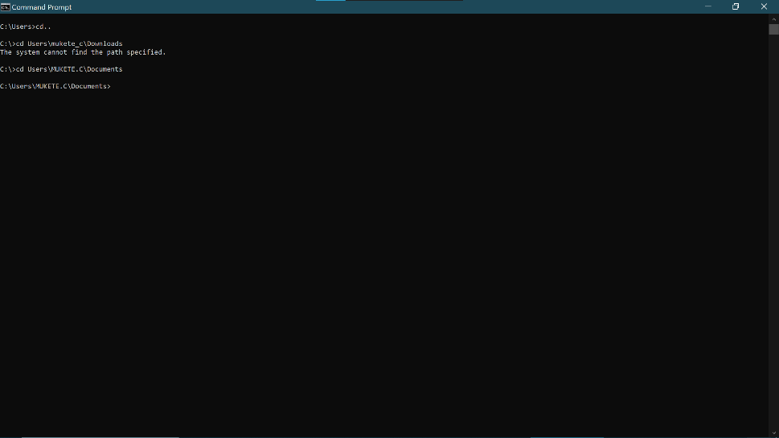
Figure 7: cd.

Example 3:
Figure 8 shows mkdir command making a directory and creating a new folder creating a new folder name test3. Output shows creating new folder named test3.
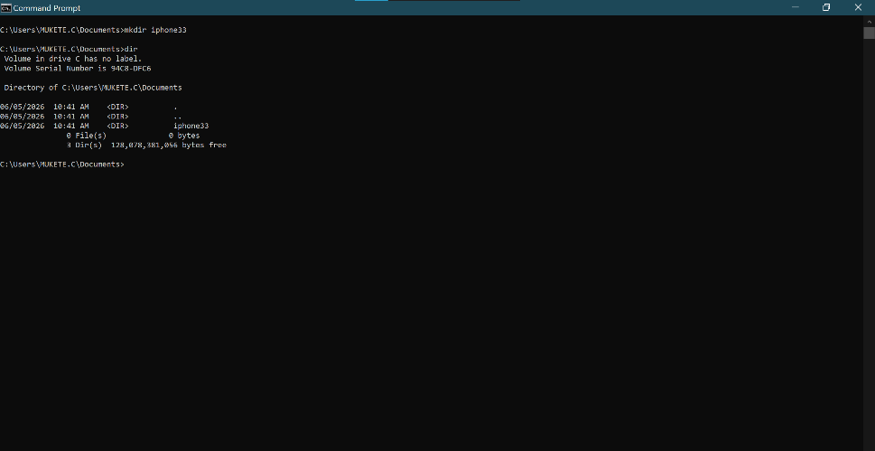
Figure 8: mkdir.

Example 4:
rmdir removes an empty directory. Example: rmdir folder deletes folder permanently. Successful execution shows no output; errors appear only if the directory contains files or doesn’t exist.

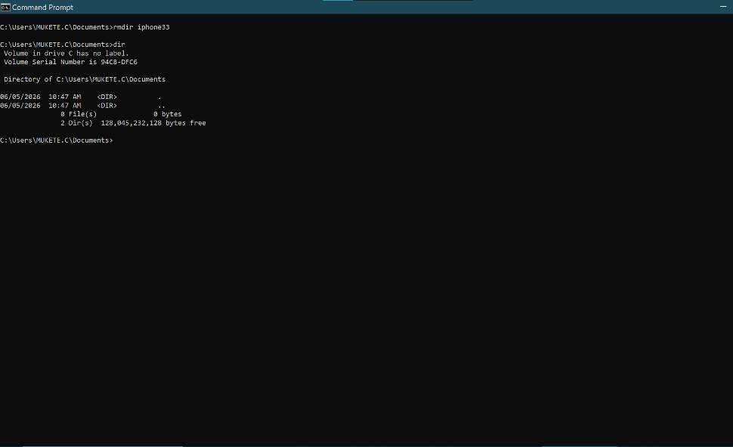
Figure 9: rmdir.

Example 5:
As shown on figure10 below, rename changes a file’s name.
Example as in my screenshot below I rename a file name which was spelled wrongly then it was corrected by updating the filename this can happen while keeping its contents unchanged.
Output shows nothing if successful; errors appear only when the command fails.

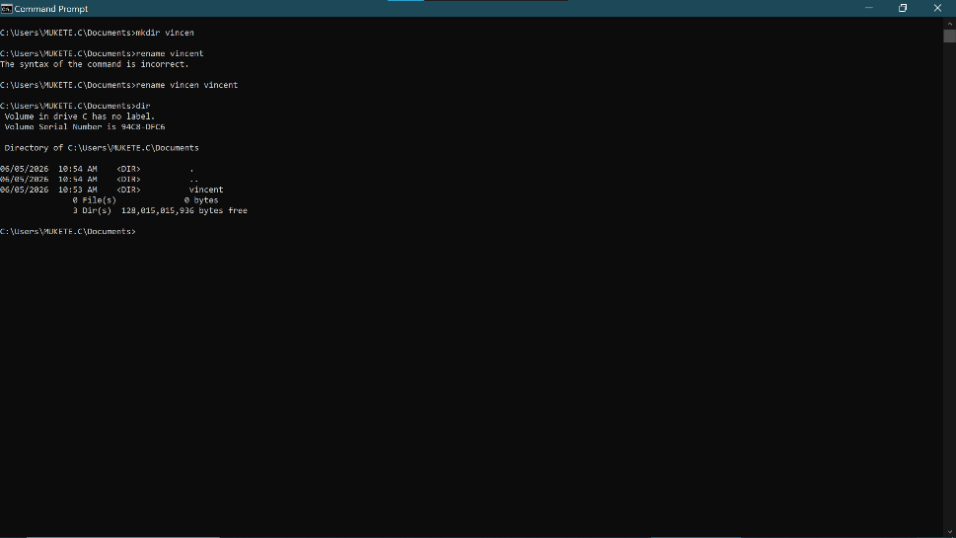
Figure 10: rename.

Example 6:
Ipconfig shows adapter detains most are media connected only WLAN is active with ipv4, subnet mask and default gateway.
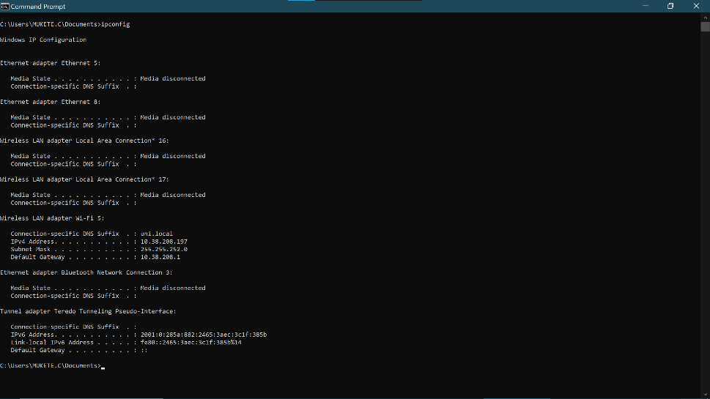
Figure 11: ipconfig.

Example 7:
Ping tests network connectivity by sending packets to a host example is www.googlelcom.
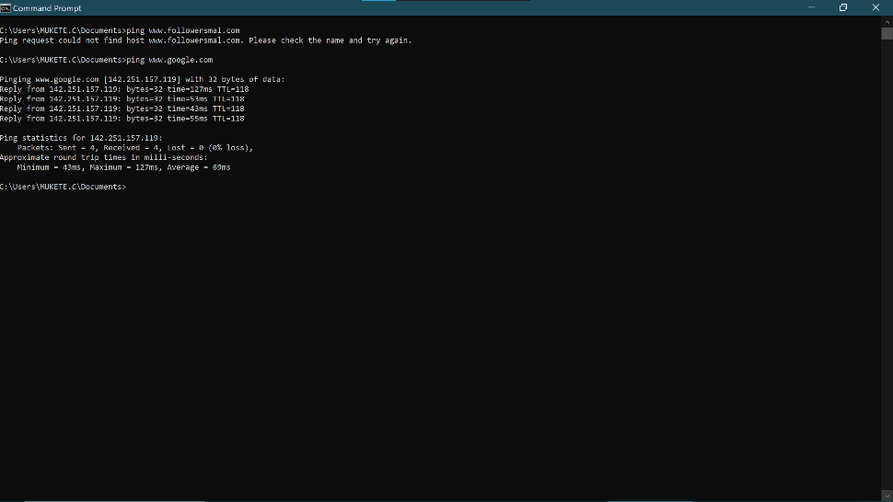
Figure 12: ping.

Example 8:
Netstat displays active network connections ports with outputs shown on the screenshot.
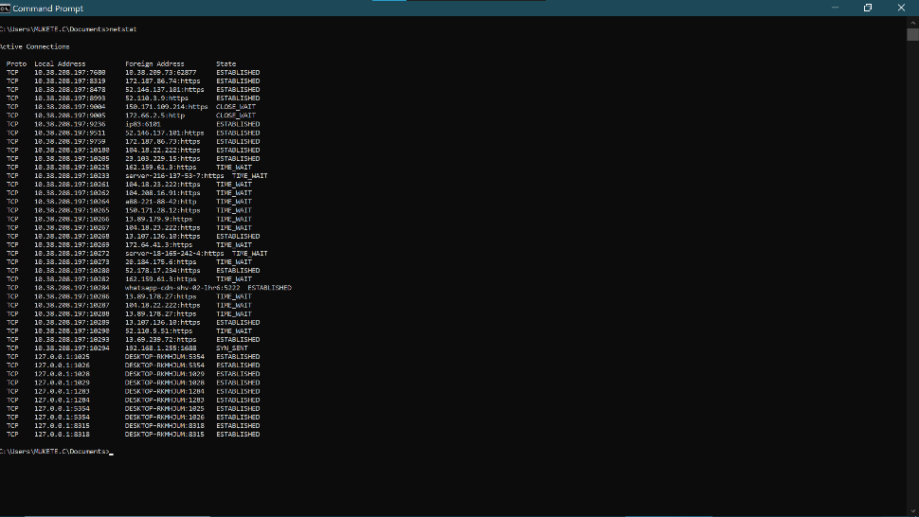
Figure 13: netstate.

Example 9:
The command is systeminfo. It displays detailed window system data like OS version, host name, memory, Bios, processors, and network info for the diagnostic.
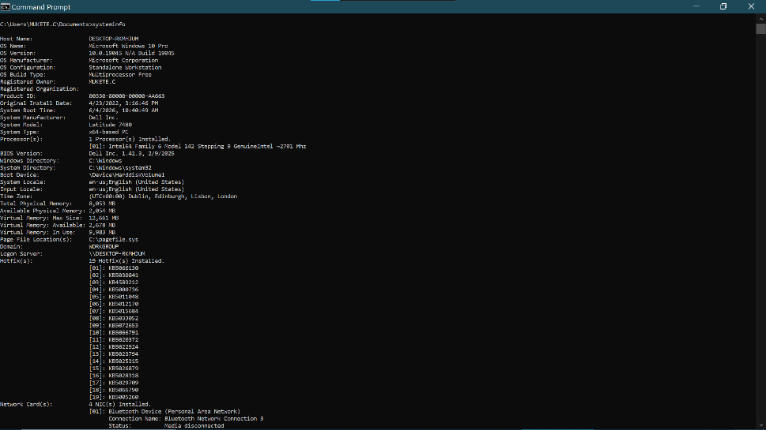
Figure 14: syteminfo.

Example 10:
The command is tasklist. It lists all running window processes and memory usage for system monitoring or troubleshooting.
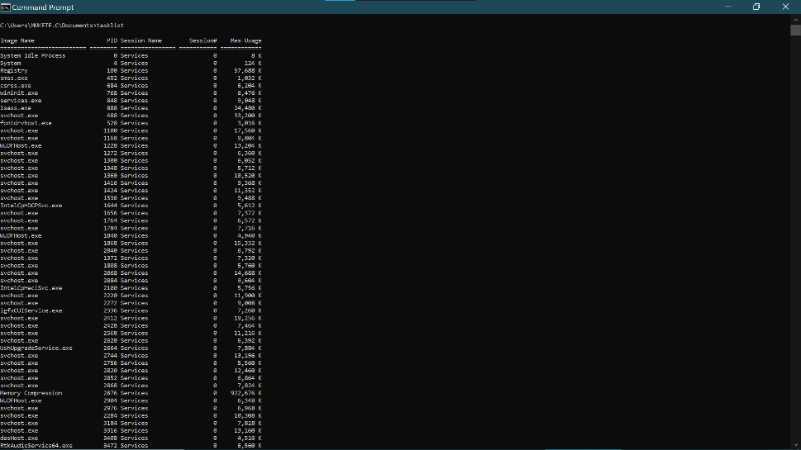
Figure 15: tasklist

Use of Linux OS CLI commands
Linux CLI provides text-based control for file management, system monitoring, and automation using commands like ls, grep, and ssh. It is essential for servers, scripting and Devops tasks due to speed and remote access efficiency [7] [8].

Example 1:
The su command switches use su to become root, then su sysadmin to switch back, showing prompt changes from $ to # and back. Which indicate the admin which is the superior account and other user.
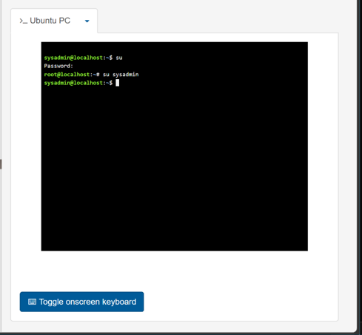
Figure 16: su

Example 2:
Ls lists visible files/folders. Ls-a shows all files including hidden ones starting with ls-l gives details long format permissions, owner, size, and names.
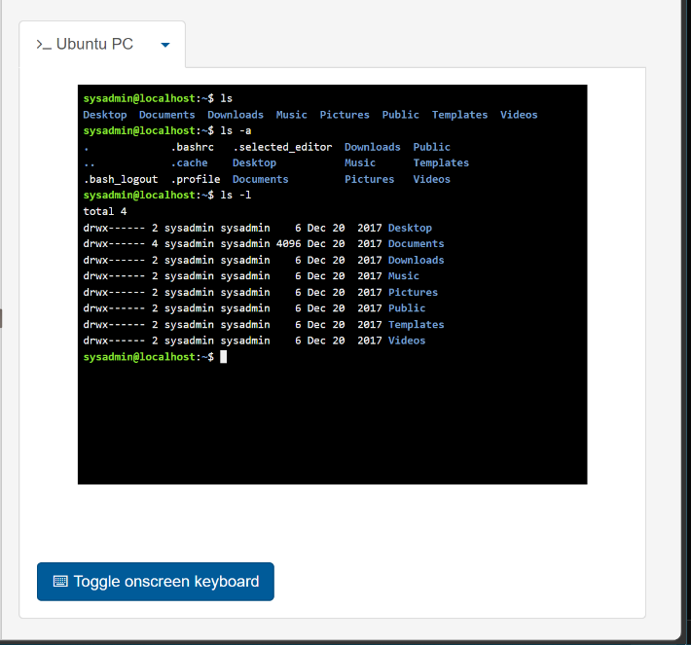
Figure 17: ls -l

Example 3:
cd Desktop Shows current location or directory command. It moves the terminals into the desktop folder. The output shows the prompt changed to desktop$, confirming the current location is now Desktop.
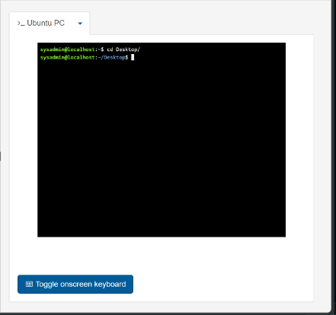
Figure 18: cd Desktop

Example 4:
Pwd present working directory it displays the full path of your current fold. The output /home/sysadmin/Desktop shows the terminalis located inside the Desktop directory.
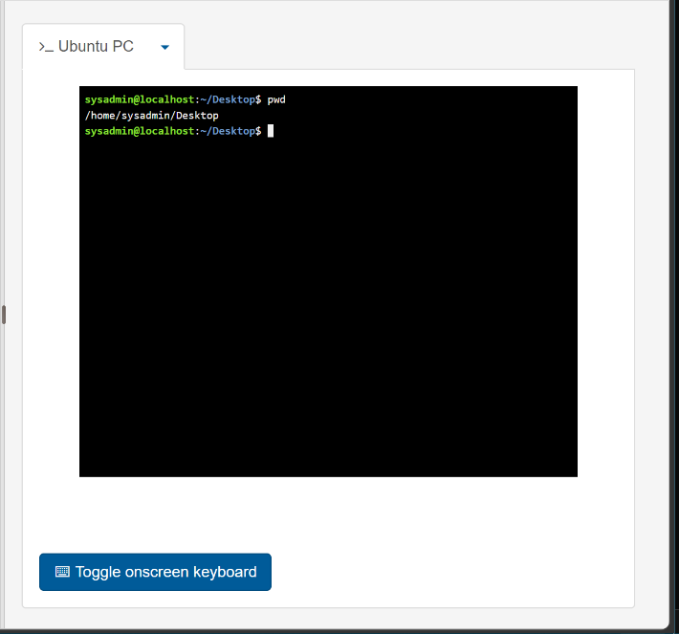
Figure 19: pwd

Example 5:
The user first enters mkdir without a directory name, producing a missing operand error. They then create a folder named new using mkdir new. The ls command confirms its creation.
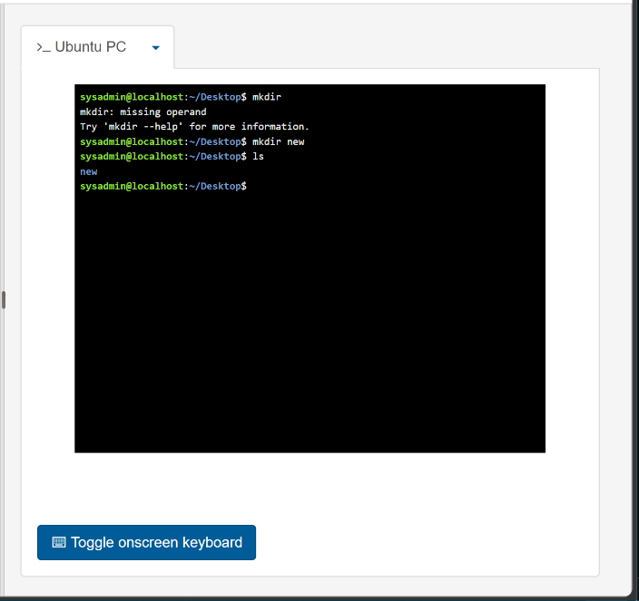
Figure 20: Description mkdir

Example 6:
rmdir new Delete empty folder or directory named new.
No message appears, just return to the prompt
Which means the empty folder was deleted successfully.
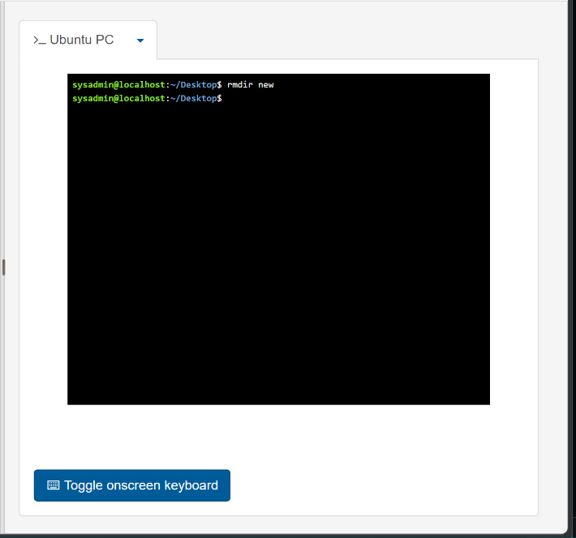
Figure 21: rmdir

Example 7:
Touch new.txt creates an empty file named new.txt in Linux. Ls list directory content output confirms new.txt now exist on the desktop.
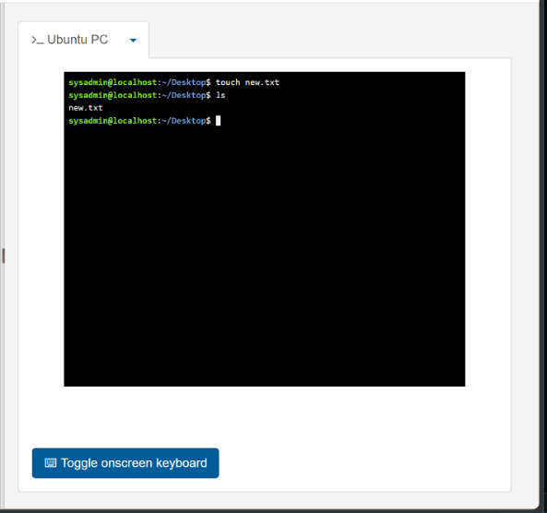
Figure 22: touch

Example 8:
Echo writes while cat reads the echo chostan > new.txt command writes the text "chostan" into the file new.txt. The cat new.txt command reads and displays the file's contents, showing "chostan".
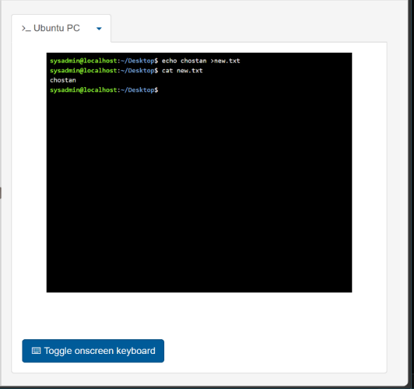
Figure 23: echo and cat

Example 9:
The command ifconfig displays network interface details on linux. Shows eth0 with IP:192.168.12, MAC, status UP, and lo loopback 127.0.0.1 confirming active internet/network configuration.
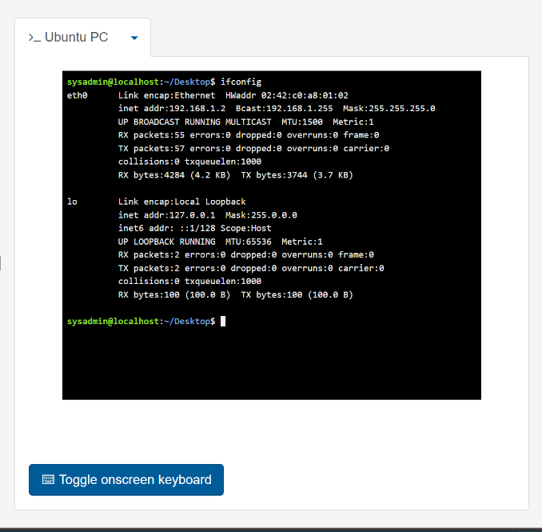
Figure 24: ifconfig

Example 10:
The command whoami shows current user sysadmin.date displays system date and time. The output sysadmin then Fri Jun 12 09:53:46 UTC 2026, confirming user identity and system time.
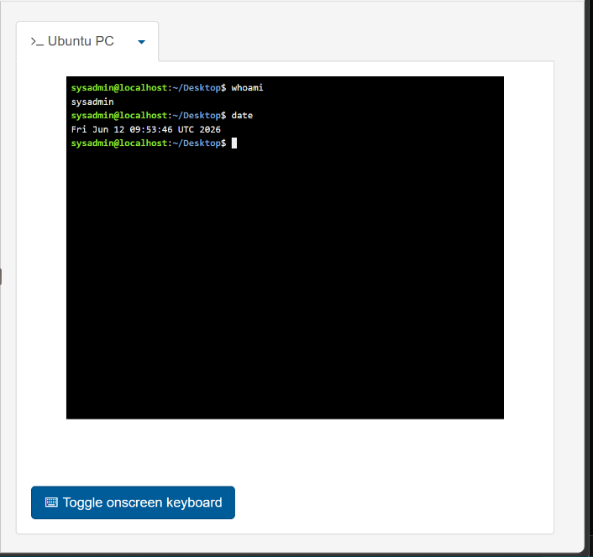
Figure 25: whoami and date

Use of Windows OS scripts
Batch scripting in Windows uses cmd.exe to run sequences of commands for automation. It enables tasks such as file management, backups, software execution, and system configuration. Scripts support variables, loops, and conditionals, making them useful for repetitive administrative work. Although PowerShell is more advanced, batch files remain valuable for quick, lightweight automation [9] [10].

Example 1:
This batch script is a simple command-line program that performs addition using user-provided input. It begins with @echo off, which hides command execution details so only the program’s messages appear. The line set /p number1= displays a prompt asking the user to enter the first number, storing the response in the variable number1. The next line repeats the process for number2. The command set /a total= number1 + number2 performs an arithmetic calculation, adding the two stored values and saving the result in total. Batch scripts require /a to indicate that the expression should be evaluated mathematically rather than treated as text. The script then prints the result using echo, producing a message such as “The sum of two number is 15” depending on the inputs. Finally, pause keeps the window open, allowing the user to read the output before the program closes.
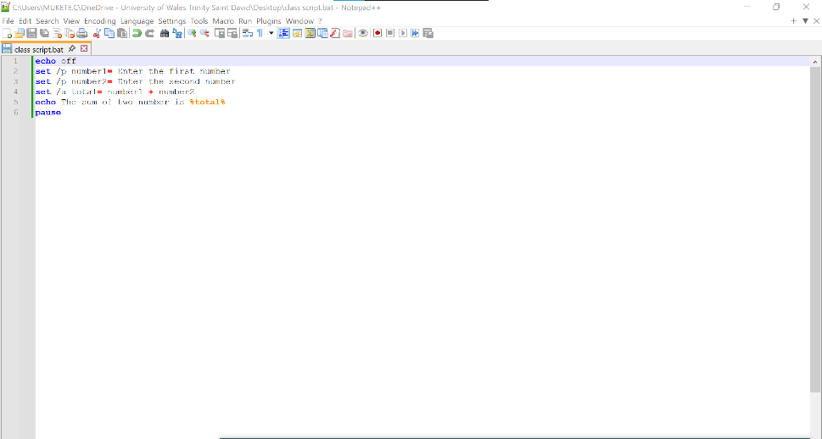
Figure 26: script to add two numbers
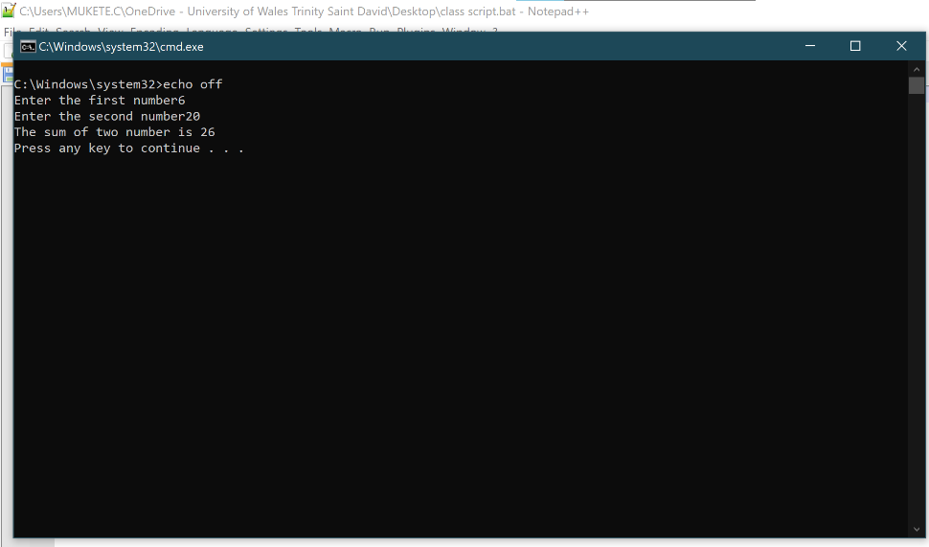
Figure 27: results

Example 2:
This is a Windows batch script that uses an IF...ELSE statement to check a user's age. The command @echo off hides the execution of commands, making the output cleaner. The line set /p age=Enter your age prompts the user to type their age and store the input in the variable age. The if %age% GEQ 18 (statement checks whether the entered age is greater than or equal to 18 (GEQ means "greater than or equal"). If the condition is true, the script displays the message "you can vote". If the condition is false, the else block runs and displays "sorry you cannot vote". Finally, the pause command keeps the Command Prompt window open until the user presses a key, allowing them to read the result before the program closes. The output therefore depends on the age entered by the user, demonstrating conditional decision-making in a batch file.

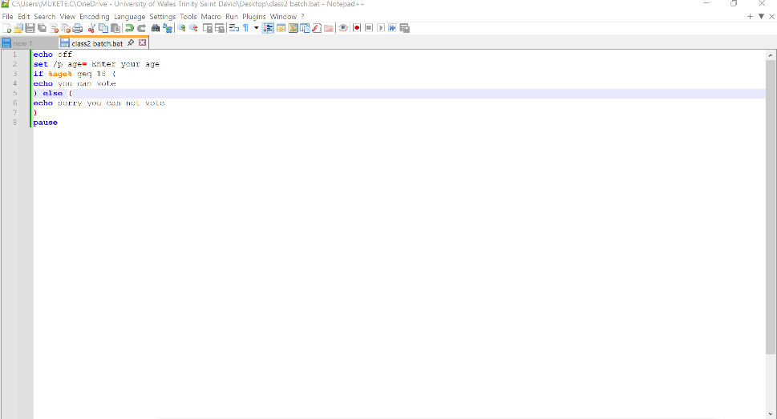
Figure 28: Description
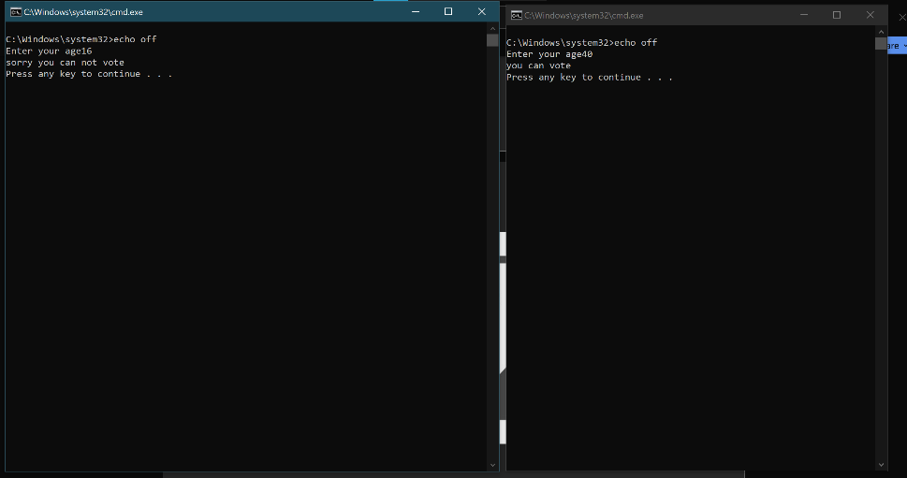
Figure 29: results

Use of Linux OS scripts
BASH (Bourne Again Shell) scripting is a way of automating tasks in Linux using shell commands. It is widely used for system administration, file management, backups, software installation, monitoring system performance, and automating repetitive tasks. BASH scripts improve efficiency, reduce manual work, and minimize the risk of human error [11].

Example 1:
The Bash script is a simple city bus ticket booking system that runs on a Linux operating system. It starts by displaying the title "CITY BUS " and asks the user to enter their name and destination using the read command. The script sets the bus fare to 50 using the variable fare=50 and then prompts the user to enter the amount of money they wish to pay. An if statement checks whether the amount entered (pay) is greater than or equal to the bus fare. If the payment is sufficient, the script confirms the ticket, displays the passenger's name and destination, calculates the change using extra=$((pay-fare)), and prints a thank-you message wishing the passenger a safe trip. If the payment is less than the fare, the else statement displays "Not enough money!". In the output, the passenger John travels to London, pays 60, receives 10 as change, and the ticket is successfully confirmed.
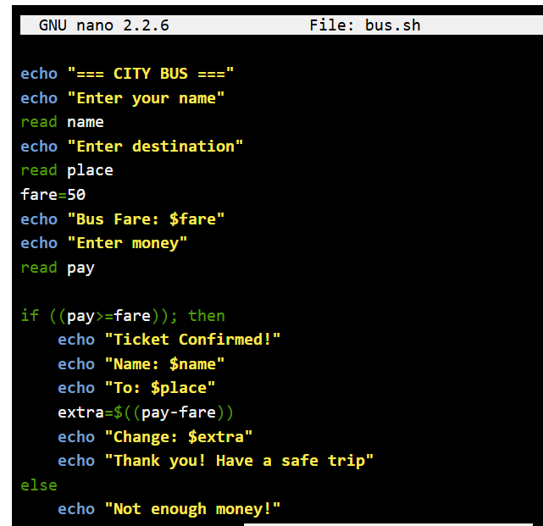
Figure 30: bus booking system.
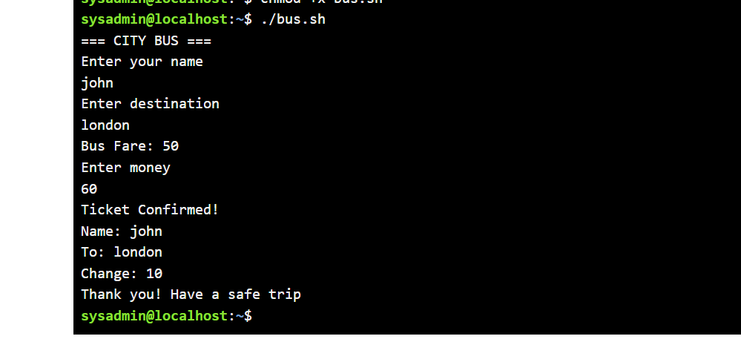
Figure 31: results.

Example 2:
The Python script is a simple taxi booking system that runs on a Linux (Ubuntu) operating system. It begins by displaying a welcome message, WELCOME TO QUICK TAXI BOOKING, to greet the customer. The program then asks the user to enter their name, current location, and drop-off location using the input () function. After collecting these details, it displays a list of available taxis (Taxi A, Taxi B, and Taxi C) and asks the customer to choose one by entering 1, 2, or 3. The program is intended to use an if-elif-else statement to assign the selected taxi and confirm the booking.
In the output, the user successfully enters their booking details, but the program stops with a NameError. This happens because the script contains the misspelled function inupt() instead of input() when requesting the taxi choice. Correcting the spelling to input() will allow the taxi booking system to continue and display the booking confirmation successfully.

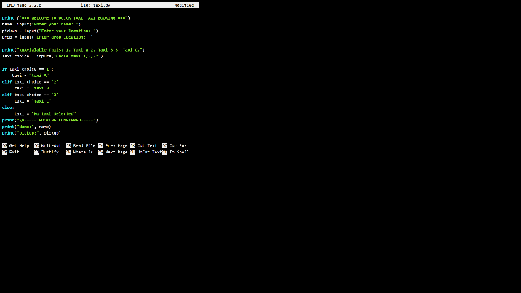
Figure 32: taxi booking system.
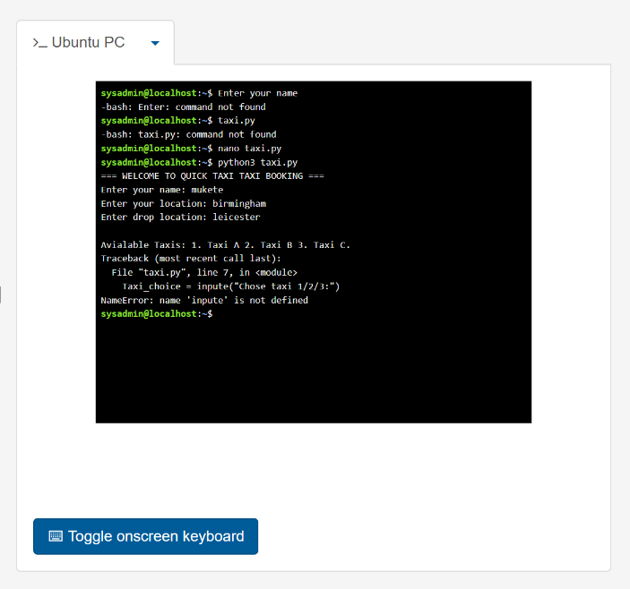
Figure 33: results.

Conclusion
In conclusion, the coursework demonstrates a clear understanding of operating systems, including their core functions, command-line usage, and scripting in both Windows and Linux. By exploring tasks, device, file, and security management alongside practical CLI and scripting examples, the report shows how OS tools support system control, automation, and efficient administration.

References

[1] | P. B. Hansen, Operating system principles, Prentice-Hall, Inc., 1973.
[2] | P. a. A. L. Pedreiras, Task management for soft real-time applications based on general purpose operating systems, INTECH Open Access Publisher, 2007.
[3] | H. a. C. E. a. B. C. S. a. L. J. W. Song, Web based application program management framework in multi-device environments for personal cloud computing, Springer, 2011.
[4] | F. Hafeez, “Role of File System in Operating System,” International Journal of Computer Science and Innovation, vol. 2016, pp. 117--127, 2016.
[5] | A. a. C.-M. C. a. S. A. P. a. V. X. a. N. R. a. S. D. Mavromatis, “A software-defined IoT device management framework for edge and cloud computing,” pp. 1718--1735, 2019.
[6] | D. B. Parker, Computer security managemen, Reston Publishing Company Reston, VA, 1981.
[7] | R. Blum, Linux command line and shell scripting bible, John Wiley \& Sons, 2008.
[8] | W. Shotts, The Linux command line: a complete introduction, 2026.
[9] | T. Hill, Windows Script Host, Sams Publishing, 1999.
[10] | W. A. S. L. B. Book, Windows Admin Scripting Little Black Book, Paraglyph Press, 2004.
[11] | R. Blum, Linux command line and shell scripting bible, John Wiley \& Sons, 2008.
[12] | A. a. C.-M. C. a. S. A. P. a. V. X. a. N. R. a. S. D. Mavromatis, “A software-defined IoT device management framework for edge and cloud computing,” pp. 1718--1735, 2019.

Appendices
Online Course name: Linux Unhatched.

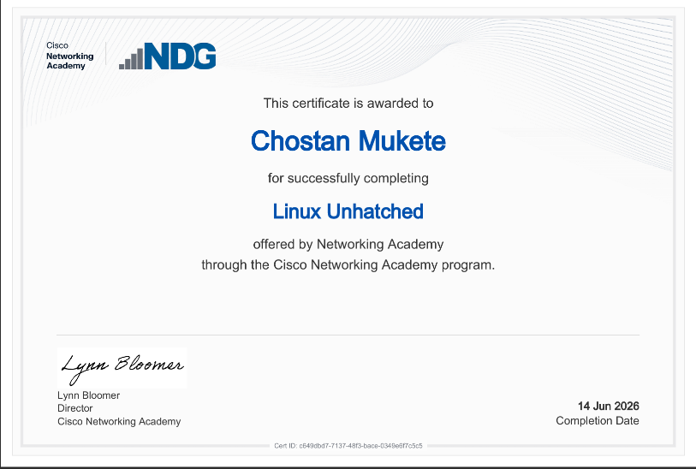
Figure 34: Certificate of completion.

