

Module Name: Learning in the Digital Era (ACCA4025)
Assignment Title: Assignment 1: E-Portfolio
Student Name: Tayyab Ahmed
Student Number: 2528542
Course Title: CertHE Computing Skill for Workplace

Portfolio Link
https://sites.google.com/view/e-portfolio-tayyab-ahmed/home

Table of Contents
Task 1: 2
Part 1a: Essential Skills for Study and Employment in Computing 2
Part 1b: Turnitin Similarity Reflection 2
Task 2: 3
Part 2a: Group Mind-Map: Important Reflections of Effective Teamwork 3
Part 2b: Academic Poster: Life is a Team sport 3
Task 3 3
Part 3a: Unit 3 Topic Summary: E-Portfolios as Virtual Collaboration Tools 3
Part 3b: Use of RefWorks 4
Task 4: e- Portfolio Creation and Review 5
References 7

Task 1:

Part 1a: Essential Skills for Study and Employment in Computing
At the fast-paced stage of Computing, it is undoubtedly crucial to be able to combine both technical and transferable skills to continue being successful in school and be employable in the long-term. Employers are actively recruiting IT graduates with diverse skills in solving problems, clear communications, and flexibility to solve complexities that may arise in Industry 4.0 [1]. In recent research, it was pointed out that whereas digital literacy and mastering the essential tool-handling skills, i.e., programming, database administration, cloud architecture, and basic network security are fundamental minimums to be future-ready, teamwork and social skills are the real distinguishing factors in the modern and globalised workplace [2]. The acquisition of these various, high-demand competencies throughout my CertHE Computing course will be directly relevant to my broader career path. Once I have mastered stringent technical concepts coupled with a teamwork, I shall be successful in bridging critical communication gap between technical engineering and business strategy. This will enable me to comfortably convey elaborate online solutions to non-technical stakeholders which is an important leadership attribute in the IT consulting, systems analysis, and secure software development domains. Moreover, the skill to use developing technologies such as generative AI in a responsible manner will help to improve my performance both academically and professionally as long as the results are verified critically and supported with quality literature offered by fellow scientists [3]. Everything depends on a balance between technical skills of high competence and analytical and interpersonal skills that contribute to overall preparedness to the challenges and unpredictability of the global and constantly changing technological industry.

Part 1b: Turnitin Similarity Reflection
After entering my Task 1 summary into the Turnitin similarity checker, I was assigned a similarity score of about 12%. This shows that most of my work is original, and small matches probably occur due to similarity in academic wording and properly written IEEE references. To enhance this in subsequent submissions I would paraphrase sources in a more extensive way as opposed to strictly replicating the sentence structure of an author, and I would make sure that all the citations are clearly differentiated between my analysis and that of the author. Following the Generic Assessment Criteria (GAC) as a rubric, my self-assessment on the basis of the generic assessment criteria would be about 65% a Very Good grade because I have used a credible and up-to-date body of peer-reviewed literature, including a 2025 publication [1] and a 2026 study [2], used IEEE referencing accordingly, and provided a well-structured analytical summary. The inclusion of additional critical depth and wider involvement with the meta-analytic evidence of Lei et al. [4] would bring the work to the Excellent band.

Task 2:

Part 2a: Group Mind-Map: Important Reflections of Effective Teamwork
This mind-map was created in group cooperation with my team during lecture-tutorial lesson and drawn up with the help of a free online mind-mapping tool Mind Meister. Co-ordination was done remotely through Microsoft Teams. Hegarty and Thompson [7] point out that in instances where teachers actively engage students in the development of digital artefacts such as e-portfolios and collaborative assessment tools, student engagement is much greater, and that is exactly what has guided our team in approaching this collaborative mind-mapping exercise.

Part 2b: Academic Poster: Life is a Team sport
The academic poster was developed on its own and was based on the Academic Poster Guidelines that can be accessed in Moodle, such as font size prescriptions, two-column structure, and requirement to make citations. It points out important ideas of Unit 2 Topic 4 and explains why it is important in academic and professional achievement in Computer Science. According to Felea and Stanca [8], structured e-learning systems that are meant to facilitate peer engagement and content creation promoted collaborative skills in students - which directly helped in supporting the teamwork skills that were discussed in the poster. The entire A4 print-ready academic poster can be seen in separate poster.png file.

Task 3

Part 3a: Unit 3 Topic Summary: E-Portfolios as Virtual Collaboration Tools
Digital learning has played a major role in virtual collaboration with the use of e-portfolio platforms which facilitate interaction, reflection and evaluation of work between a student and educator without regard to geographical or institutional boundaries. The adoption of remote learning in the COVID-19 pandemic increased the use of such tools by the institution and revealed their strengths and weaknesses as tools of virtual collaboration [10]. E-portfolios are effective virtual collaboration tools since they provide a continuous, mutual, shared online environment where students can post their work, asynchronous feedback from tutors, and professional growth over time. Totter and Wyss [3] see both the potential and the pitfalls of e-portfolios in the learning context and note that although they promote structured self-reflection and enable a meaningful tutor-student conversation, the issues of technical accessibility and learner motivation need to be addressed to make the most of their collaboration potential.
The ability of the portfolio to integrate virtual practise with real-world competency acquisition has been confirmed in the fields of healthcare and professional education. Franco et al. [9] illustrate based on the case of Portuguese-speaking medical students that portfolios that serve in teaching communicative skills and professionalism generate organised possibilities of students to cogitate on real interactions a type of mediated virtual co-operation between lived experience and academic feedback. This reflective aspect applies to computing students, who must record their technical education experience and share it in a professional way with their future employers on platforms like GitHub or their personal portfolio websites. Abuzaid, Elshami and Noorajan [10] also attest to the endurance of e-portfolio as a virtual collaboration tool by showing that clinical practise e-portfolios in radiology education did not deteriorate in terms of assessment quality and student engagement during the COVID-19 outbreak, despite the complete impossibility of face-to-face contact. This fact is a solid argument in their application across various fields such as computing, where remote project management and distributed work are becoming characteristic professional procedures.
Felea and Stanca [8] continue to say that with careful design, e-learning software environments can serve as an active supporter of collaborative learning all of the essential elements of successful virtual collaboration. To the computing students, the mastery of such digital platforms directly emulates professional processes in the Agile software development and open-source contribution areas [1].

Part 3b: Use of RefWorks

To handle references to this assignment, I relied on the cloud-based reference management tool, RefWorks, which is made available to me by the UWTSD library portal. I identified each of the sources through Google Scholar and the UWTSD library database and then imported them into RefWorks with the help of the Import option and chose the IEEE citation style. I the next ran the Write-N-Cite automatic numbered in-text citation came in as I was typing my conclusion and automatically created my final reference list by clicking the Create Bibliography feature and opting to use the IEEE format. It largely minimised the amount of hand formatting mistakes and allowed the use of a uniform citation style across the board proving the usefulness of automatic reference tools in Level 4 academic writing.

Task 4: e- Portfolio Creation and Review
Platform Used & Rationale
In this e-portfolio, I open to create the site with the help of Google sites as it offers a user-friendly structure, clean design, and easy integration with cloud applications; instead of actually writing a code to create my own site. This holds true based on educational research; Garcia [1] showed that the development of digital portfolios as authentic project-based learning assessment can enable students to acquire the necessary professional presentation skills and digital competencies. This justifies the application of a contemporary site builder to a CertHE Computing student who aims to showcase the practical digital curation and design skills.
Zainuddin et al. [2] also endorse this method as they conclude that e-portfolios can be associated with a powerful improvement in reflection, professional identity, and digital preparedness, which is achieved successfully by structuring the content in such a platform as Google Sites. Although Totter and Wyss [3] admit that e-portfolios used in educational institutions pose design and technical issues, working with such digital mediums is an excellent learning experience. Most importantly, the Google Sites platform is easy to access without any form of authentication or restricted access level, which means that tutors can readily view the portfolio posted there without any accessibility requirements or any limitation on access. Lastly, Huang, Yang, and Chang [5] discovered that learners who are satisfied with their e-portfolio experience are more motivated to learn as well as more internet self-efficacious. With the help of such a useful and easy-to-use tool as Google Sites, I could dedicate all my efforts to the creation of the high-quality content and reflection practise and create significant results in my experience academic activity.

Screenshots of Each E-Portfolio Page
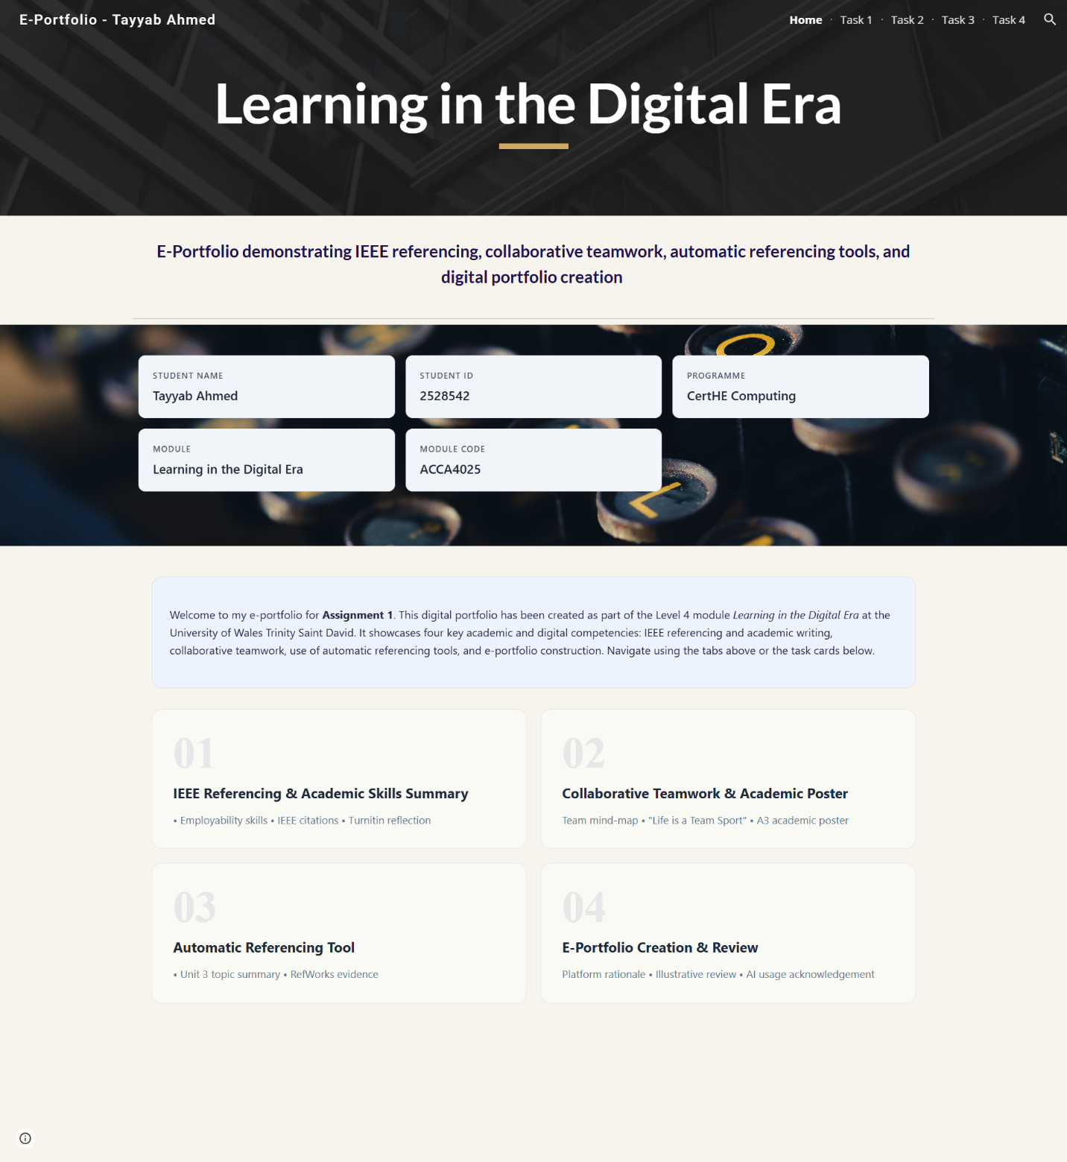
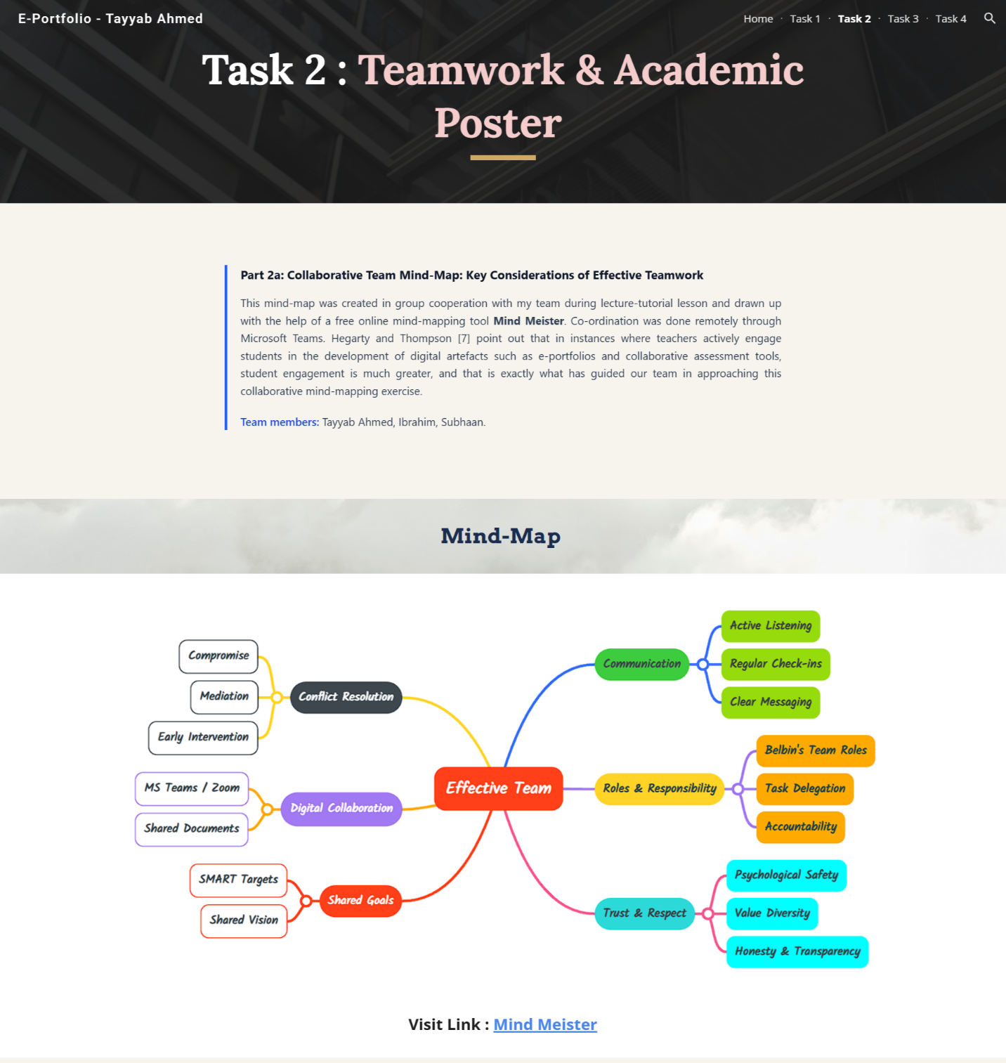
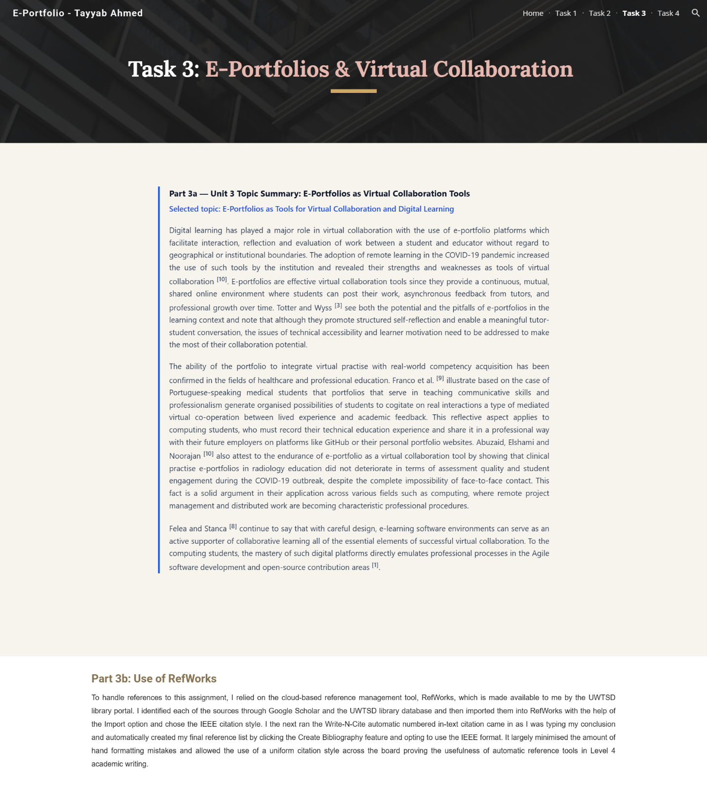
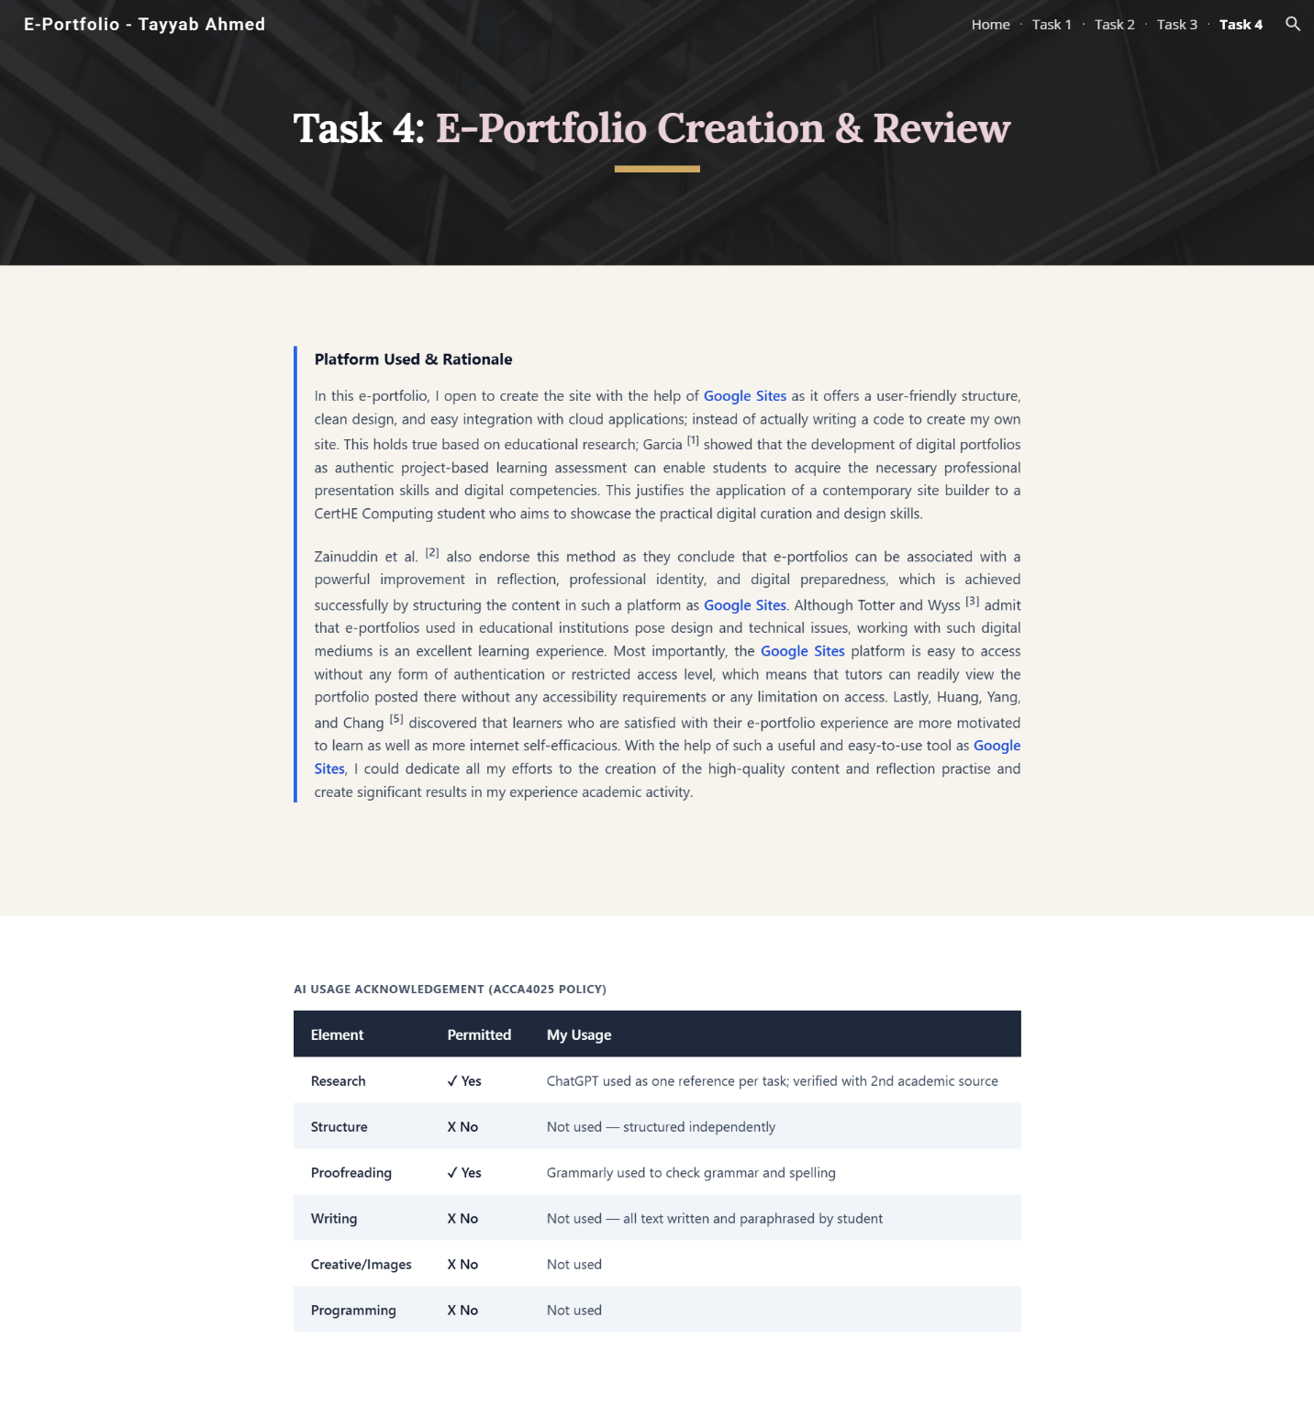

Portfolio Link
https://sites.google.com/view/e-portfolio-tayyab-ahmed/home

References
[1] M. B. Garcia, "Self-Coded Digital Portfolios as an Authentic Project-Based Learning Assessment in Computing Education: Evidence from a Web Design and Development Course," vol. 15, no. 9, 2025, doi: 10.3390/educsci15091150.
[2] Z. Zainuddin, M. Churiyah, W. P. Rahayu, H. Pratikto and S. H. Halili, "E-portfolios as authentic assessment in pre-service teacher education: enhancing reflection, professional identity, and digital preparedness," 2026, doi: 10.1007/s10639-025-13869-y. Available at: https://doi.org/10.1007/s10639-025-13869-y.
[3] A. Totter and C. Wyss, "Opportunities and challenges of e-portfolios in teacher education," vol. 11, no. 1, pp.69–75, 2019,
[4] H. Lei, Y. Cui and W. Zhou, "Relationships between student engagement and academic achievement: A meta-analysis," vol. 46, no. 3, pp.517–528, 2018,
[5] J. J. Huang, S. J. Yang and M. C. Chang, "The effect of ePortfolio satisfaction on students' learning motivation and internet self-efficacy," vol. 4, no. 1, 2011,
[6] T. Honicke and J. Broadbent, "The influence of academic self-efficacy on academic performance: A systematic review," vol. 17, pp.63–84, 2016,
[7] B. Hegarty and M. Thompson, "A teacher's influence on student engagement: Using smartphones for creating vocational assessment ePortfolios," vol. 18, 2019,
[8] R. Franco, C. A. G. Franco, M. A. De Carvalho Filho, M. Severo and M. A. Ferreira, "Use of portfolios in teaching communication skills and professionalism for portuguese-speaking medical students," vol. 11, 2020,
[9] M. M. Abuzaid, W. Elshami and Z. Noorajan, "The impact of clinical practice E-portfolio in radiology education during COVID-19 outbreak," vol. 13, no. 06, 2021,

