Postgraduate/Distance Learning
Assignment coversheet & feedback form

THIS SHEET MUST BE THE FIRST PAGE OF THE ASSIGNMENT YOU ARE SUBMITTING (DO NOT SEND AS A SEPARATE FILE)

For completion by the student:
Student Name: Hedy Mowinckel

Student University Email: 2015812@student.uwtsd.ac.uk
Module code: HPCA7015  Module title: Foundations in Cultural Astronomy and Astrology | Student ID number: 2015812 |  |  | Educational support needs:  No
Assignment title: Essay based on a Sky Journal

Assignment due date: 4th December, 2020
This assignment is for the 1st module of the degree
I confirm that this is my original work and that I have adhered to the University policy on plagiarism.
Signed ……………………………………………………………
Email submission:if you are submitting this form via email, please tick this box  □ ✔
(as a substitute for your signature) to confirm that you agree to the above declaration.
Assignment Mark
1st Marker’s Provisional mark
2nd Marker’s/Moderator’s provisional mark
External Examiner’s mark (if relevant)
Final Mark

NB. All marks are provisional until confirmed by the Final Examination Board.

For completion by Marker 1 :
Comments:

Marker’s signature: |  |  | Date:
For completion by Marker 2/Moderator:

Comments:

Marker’s Signature: |  | Date:
External Examiner’s comments (if relevant)

External Examiner’s Signature: |  | Date:

Essay based on a sky journal

“Be clearly aware of the stars and infinity on high. Then life seems almost enchanted after all.”
Gogh, Vincent van, and Ronald de Leeuw, The Letters of Vincent Van Gogh. London: Penguin Books, 1997, p.392.

This essay considers the relationship of the night sky to my urban landscape of the London borough of Hackney. I observed the moon and the night sky in the evenings preceding the Full Moon penumbral Lunar Eclipse on November 30th 2020, and during the evenings immediately following the eclipse until December 2nd 2020. While conducting my sky gazing fieldwork, I focussed on the moon and cloud coverage, as well as how this exercise altered my perception of the passage of time. This essay will analyse the significance of my findings in relation to Vincent Van Gogh’s prescription to “be clearly aware of the stars and infinity on high (…) so that “life seems almost enchanted after all.” It is worth commenting on Van Gogh’s choice of words, which implies that through observing the sky, life on earth is imbued with magic. I will analyse my experience in relation to the concept of enchantment, as an effect with a magical quality. It’s important to note that Van Gogh writes that ‘life’ itself seems enchanted, rather than he himself falling enchanted, this detail is relevant as while observing the night sky, the moon itself and the phenomena seemed enchanted if observed in isolation, however when viewed within the context of my specific urban landscape, I felt a strong sense of disenchantment with life on earth.

Although it is unclear exactly at what point in his life Van Gogh wrote the words “be clearly aware of the stars and infinity on high. Then life seems almost enchanted after all,” we know that he left Paris for Arles in February of 1888. According to Stanley David Gedzelman, Van Gogh left Paris due to the dreary weather, and travelled to the south of France where he painted “the blazing suns, and the incandescent skies”. We are told that his earlier works painted in Holland and France, were painted to accurately reflect the dull, grey appearance of the northern European sky. Gedzelman is adamant that although Van Gogh’s depiction of what he saw is not photographic or documentary in style, “whatever he did paint was derived almost directly from what he had seen.” Therefore if we consider the sweeping vistas of his landscape paintings from 1889 in the south of France, (Fig.1 and Fig.2) we can see that there was a dynamic interplay between the sky and the natural landscape surrounding him. Whether exaggerated or not, the vast emptiness of the fields that stretched in front of him (see figure 1) and the curvaceous dance of the cypress leaves (see figure 1) have a vibrant quality. When compared with my own photos taken during my sky gazing in Hackney, London, (see figures 3 and 4), it is no surprise that Van Gogh found something magical or fantastical through the night sky. In ‘A wheatfield with Cypresses,’ (figure 2) the empty field that stretches before him appears to invite the clouds to tumble down towards the earth. By contrast, my own experience was that of trying to connect with the sky and be swept away with the swiftly dancing clouds, only to notice the flickering of the screen through my neighbour’s window as they watched mundane reality television. Therefore when viewing the night sky in relation to my specific landscape of east London with its terraced housing and light pollution, it was difficult for it to cast an enchanting light on life. If anything, the juxtaposition of the extraordinary natural sky above and my limited, brick-fenced garden only made me feel more disenchanted with life on earth. The fact that Van Gogh left the confines of Paris, which we are told by Gedzelman was primarily due to the dreary weather, is evidence enough to show that context, and landscape greatly affects whether life is able to seem enchanted. During my time connecting with the sky, my uninspiring urban landscape was the biggest obstacle in my attempt to see life through an enchanted lens as Van Gogh’s statement suggests.

During my observation of the sky, I was surprised by the speed at which the cloud formations moved across the sky and in front of the moon. They danced around the moon’s body and then in front of it becoming an extension of the moon itself against a dark backdrop. (see figure 4) Not only did this experience alter my perception of the passage of time, but it also made human time-keeping systems in daily life seem futile and out of sync with the natural rhythm of the sky above. However, the disillusionment I felt indirectly accentuated the magical quality of the sky by comparison. If we consider Van Gogh’s context when painting the sky both at night and during the day, at the end of the 19th century, he did not have the confines of an omnipresent clock on his mobile phone or laptop mapping the minutes while he painted.The presence of phones, clocks and the structure of daily working life in 2020 is a primary obstacle to the effect of enchantment. The very act of observing the sky at the same time each day and the regularity of the process prevented an effect of enchantment from taking over, as the structure of the exercise kept me firmly in the disenchanted state of urban working life. Roy Willis and Patrick Curry when writing of disenchantment reference Max Weber’s view that the central pillar of a disenchanted society is that there must be “no mysterious incalculable forces that come into play.” Therefore it is difficult to view the sky through the enchanted lens Van Gogh speaks of when using an iphone as a main accessory throughout my obsesrvation. My regularly timed intervals of interaction with the sky each day prevented a sense of wonder and magic from seeping through. It would have been better to clear my schedule entirely for three days and sketch the moon instead of using a phone. I know from previous experience that the sky is itself a natural wonder, but the disenchantment that has permeated present day living in London is too strong a barrier to cross.

Timekeeping itself was one of the main obstacles in allowing enchantment to have effect. I came across several articles about Van Gogh’s piece “Evening landscape at Moonrise” from 1889 (see figure 5) that detail the ‘detective work’ of Professor Olson from Southwest Texas State University who pinned down the timing of the painting through tracking the cycles of time. The professor and his team are referred to in the publication Science News as “astronomical detectives” who carried out an extensive quest to decipher exactly at what time and on what day Van Gogh painted the moon in “Evening Landscape at Moonrise,” of 1889 (see figure 5). They narrowed down the timing of the painting to “9.08 pm local mean time on July 13, 1889.” A Guardian Newspaper article of the same subject adds the word “precisely” to their headline and proudly states that the detectives figured out when the masterpiece was created “to the minute”. It is this sort of rational fixation on pinning down the heavenly bodies in Van Gogh’s work that shows why it was harder for me to feel like life seemed enchanted while gazing at the sky. The trappings of the 21st century do not leave much space for enchantment to bloom. Both my mobile phone as well as my neighbour’s television reminded me exactly what time of day it was, firmly rooting me in the present minute. If the central tenet of disenchantment is Max Weber’s idea that “there are no mysterious incalculable forces that come into play,” then the act of observing the sky within a timed, scheduled context falls into the disenchanted category, as it allows no room for mystery. Professor Olson’s pursuits are a threat to the promise of enchantment that could otherwise be found in Van Gogh’s artwork depicting the sky.

Much of Van Gogh’s artwork depicting the sky in the south of France was carried out while he was staying in confinement in Saint-Remy de Provence after a mental breakdown. His fixed location to one room would mean that much of this art was painted either outdoors, or from the same vantage point of his bedroom window. He did not have the confines of modern working life such as a set bedtime in order to get the proper amount of sleep or professional interaction with others, so his time was relatively free and unlimited. This is crucial as it allowed Van Gogh to interact with the sky in a way that was not available to me in my urban setting while adhering to a midweek schedule. Therefore his promise of ‘life seeming enchanted’ did not come true for me, and instead I felt somewhat infantile and powerless, my experience so limited by my surroundings. Indeed, teachers Kathy Cabe Trundle and Sally Hobson note that for many children the process of gathering data about the sky can be “frustrating” at best. Cabe Trundle and Hobson note that their young pupils aged between 7 and 9 often “become upset when cloud cover blocks their view of the sky” and that “large obstacles like trees or buildings also interfere.” In my case it wasn’t so much the terraced housing that acted as obstacles but also the lack of my neighbour’s taste in television.

During the time I observed the moon on the 1st December, the clouds moved across the sky in different ways, pushing from North-East to South-West either completely engulfing the moon, and later swathes of cloud coverage looping underneath it only. (see figures 3 and 4) At some moments I was unable to accurately detect whether the clouds covered the moon itself, or simply wrapped closely around it, as the light of the moon eclipsed out any clear delineation of where the clouds began and where they ended. (see figure 3 from 20.35) This dance of the clouds was the only aspect of my sky observation I found enchanting and delightfully mysterious. However the speed of their movements had the effect of making mortal life seem particularly slow, if not static. Ultimately I found the experience of observing the sky both humbling and disempowering. While observing the sky, my concept of time was altered, my perception of my own urban landscape became defined as one of complete disenchantment, and my sense of impotence as a human being was amplified. Having observed the sky and the “infinity on high” which Van Gogh references, I can say that a great deal of the enchantment he speaks of, is a result of the willingness of the participant, which is in turn affected by the context of the viewer. Any lucid human being with their feet firmly rooted in the polluted streets of Clapton would be a fool to allow themselves to be enchanted, only to be even further disenchanted upon sunrise when the stars and the moon have abandoned the viewer and they’re left with the city.

Figure 1. Van Gogh, Vincent. Landscape at Saint-Remy (Enclosed Field with Peasant) 1889, Oil on Canvas, Indianapolis Museum of Art at Newfields.

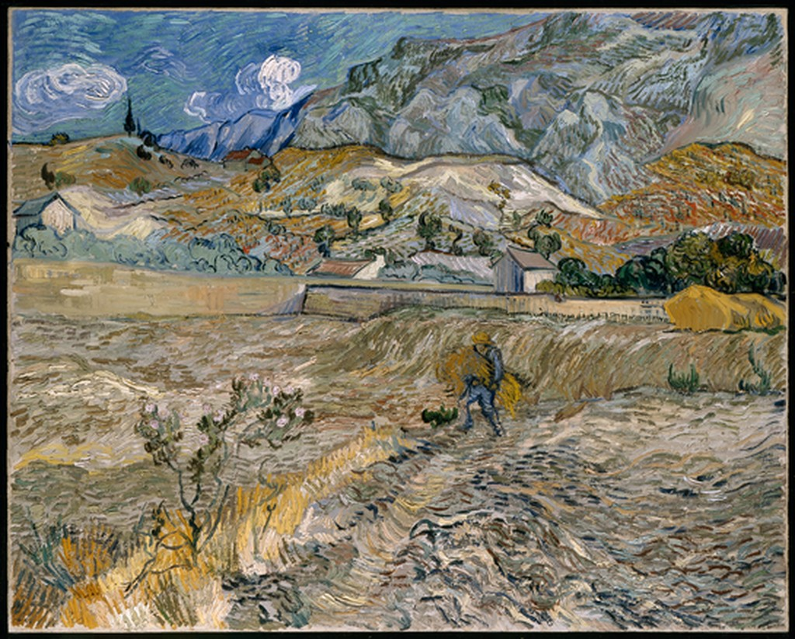

Figure 2. Vincent Van Gogh, A Wheatfield, with Cypresses. 1889. The National Gallery, London.

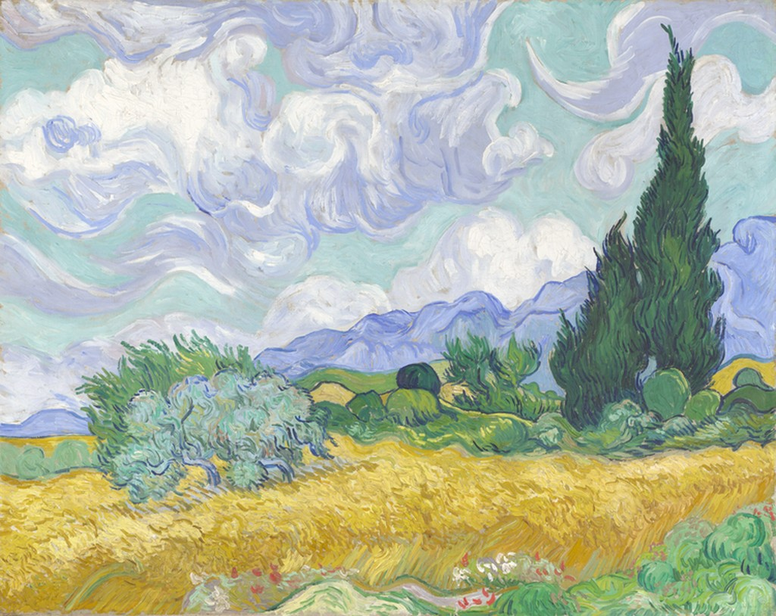

Figure 3.
Photograph of the moon as seen from my garden in London, E5 on 1st December at 20:16 pm.

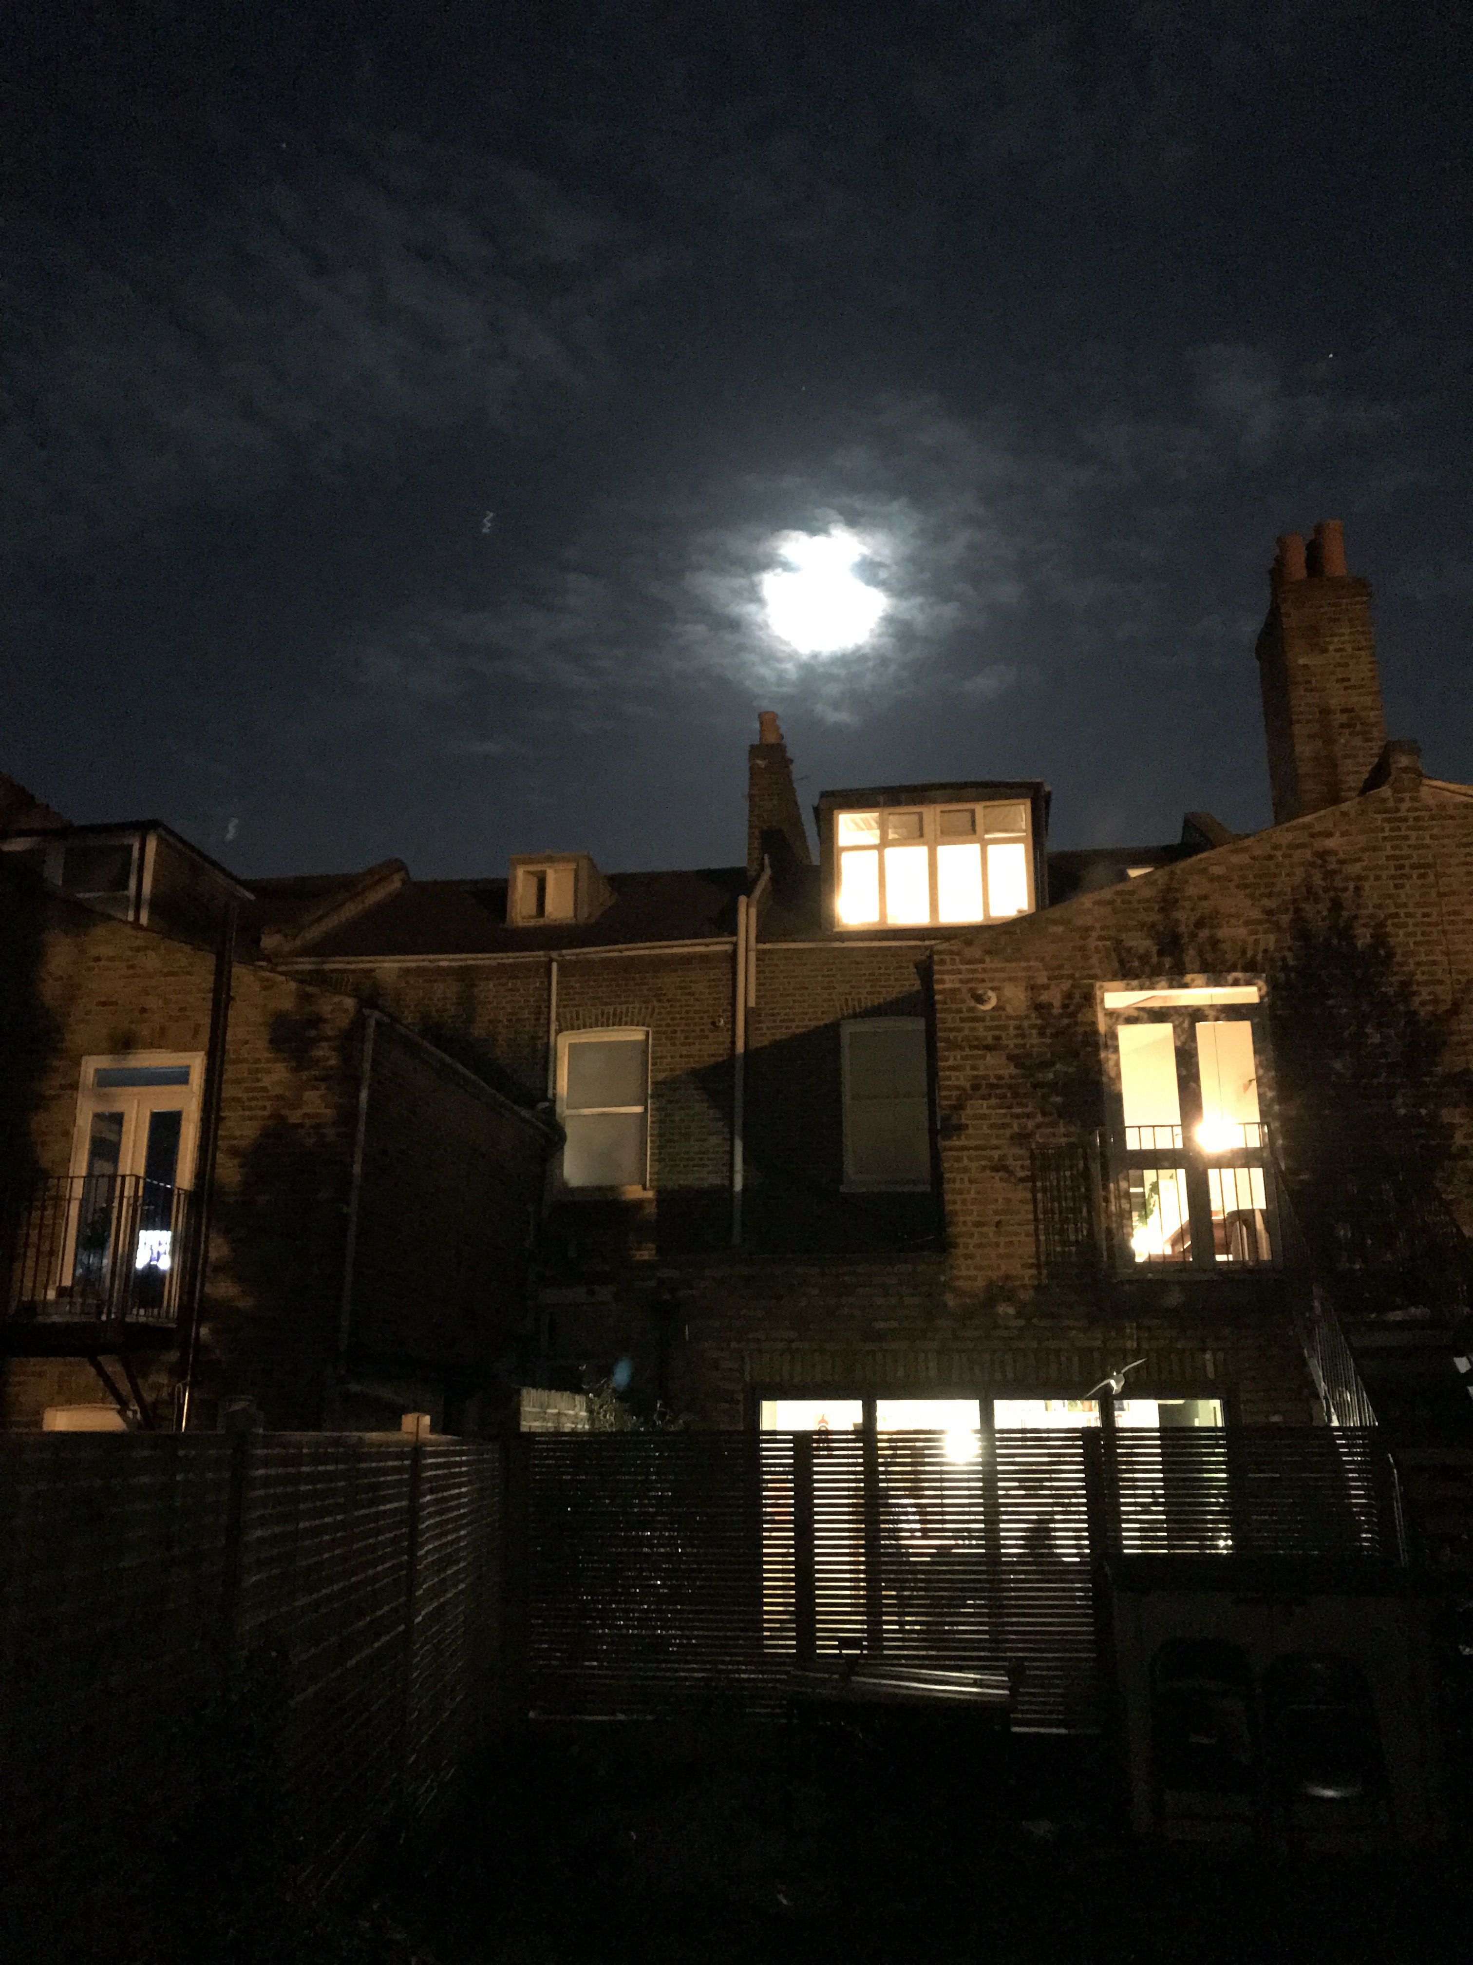

Figure 4. Picture of the moon as seen from my garden in London, E5 on 1st December 2020 at 8:35pm

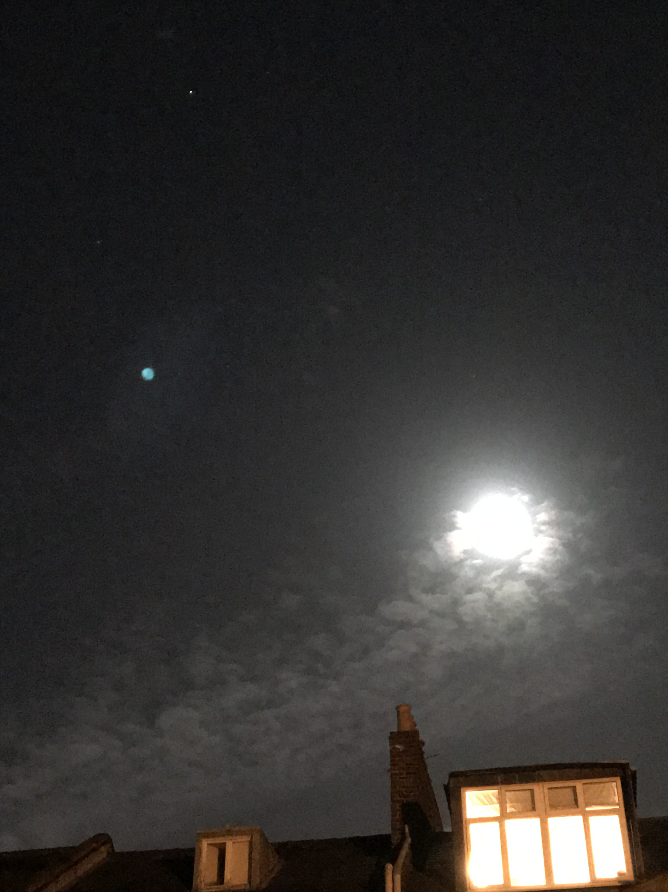

Figure 5. Vincent Van Gogh, Evening landscape at Moonrise, 1889, Oil on canvas, Kroller Muller Museum, Otterlo.

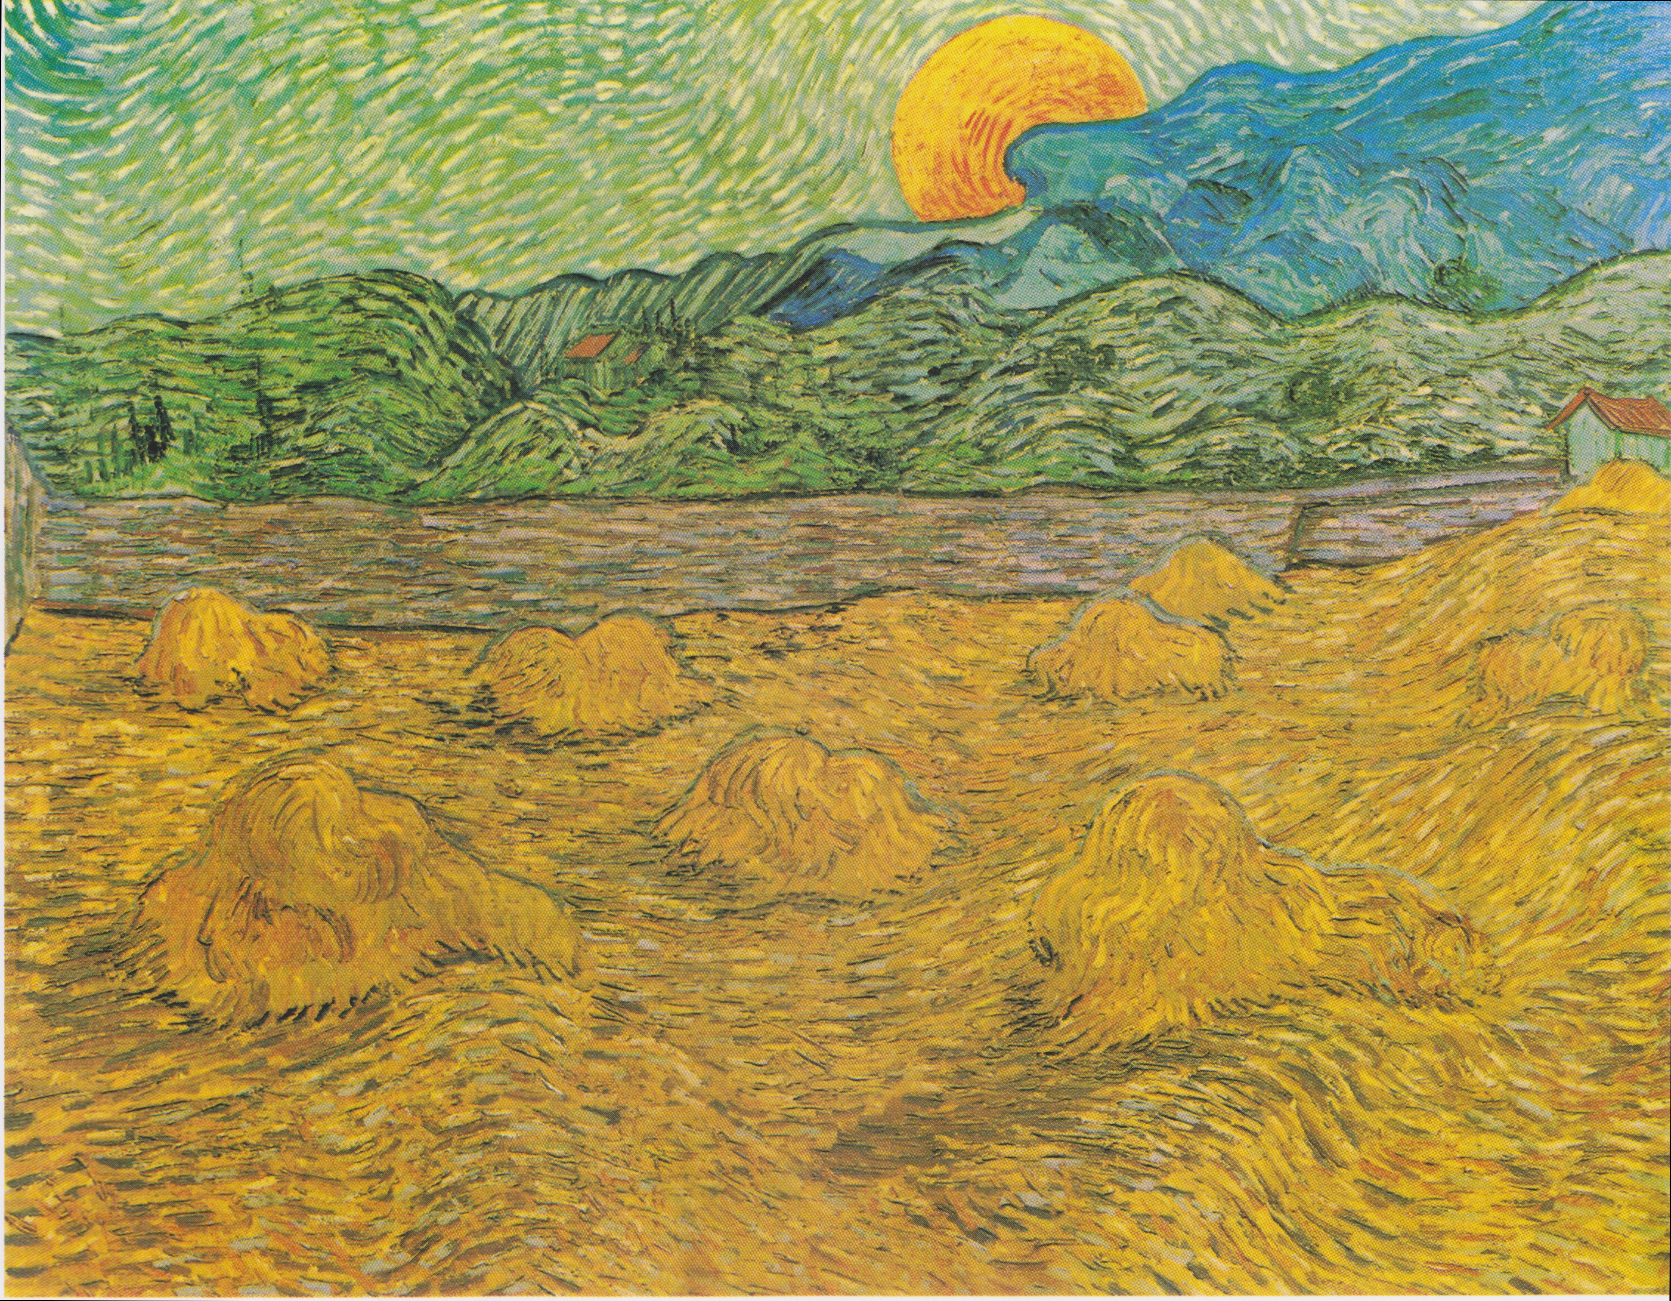

Bibliography:

Cabe Trundle, Kathy and Hobson, Sally. ‘To the Moon and Back.’ Science and Children, Vol. 49, No.4, Instructional Technology (December 2011), pp.51-55. National Science Teachers Association.

Cowen, Ron, ‘Timing a Moonrise’ Science News Vol.164, No. 1 (Jul 5, 2003), p.6

Gedzelman, Stanley David, ‘The Meteorological Odyssey of Vincent van Gogh’ Leonardo, 1990 Vol.23, No. 1 (1990) pp.107 -116.

Radford, Tim, ‘Moonrise, as seen by Van Gogh at 9.08pm precisely’ The Guardian Newspaper, 12th July 2003.

Taylor, Joshua, C, ‘Vincent Van Gogh’ Bulletin of the Detroit Institute of Arts, Winter 1962 – 1963, Vol 42, No.2. pp.34-35.

Willis, Roy and Curry, Patrick. Astrology, Science and Culture. Pulling Down the Moon. (Berg publishers, 2004), pp. 77-93

Websites:

The Online Cambridge Dictionary, ‘Meaning of enchanted in English,’ Cambridge Dictionary, https://dictionary.cambridge.org/dictionary/english/enchanted (accessed December 2nd, 2020.)

The Online Merriam Webster Dictionary ‘Definition of enchanted.’
https://www.merriam-webster.com/dictionary/enchanted (accessed December 2nd, 2020)

Vincent Van Gogh and Ronald de Leeuw. The Letters of Vincent Van Gogh. London: Penguin Books, 1997, p. 392
The Online Cambridge Dictionary, ‘Meaning of enchanted in English,’ Cambridge Dictionary, (accessed December 2nd, 2020.)
The Online Merriam Webster Dictionary ‘Definition of enchanted.’ (accessed December 2nd, 2020.)
Stanley David Gedzelman, ‘The Meteorological Odyssey of Vincent van Gogh’ Leonardo, 1990 Vol.23, No. 1 (1990) pp.107 -116.
Gedzelman, ‘The Meteorological Odyssey of Vincent van Gogh’ pp.107-116
Gedzelman ‘The Meteorological Odyssey of Vincent van Gogh’ pp.107-116
Gedzelman ‘The Meteorological Odyssey of Vincent van Gogh’ pp.107-116
Willis, Curry, Astrology, Science and Culture. pp. 77-93
Cowen, Ron, ‘Timing a Moonrise’ Science News Vol.164, No. 1 (Jul 5, 2003), p.6
Cowen, ‘Timing a Moonrise’ p.6
Radford, Tim, Moonrise, as seen by Van Gogh at 9.08pm precisely. The Guardian Newspaper July, 2003.
Radford, Tim. The Guardian Newspaper. July, 2003
Willis, Curry, Astrology, Science and Culture. pp. 77-93
Cabe Trundle, Kathy and Hobson, Sally. ‘To the Moon and Back.’ Science and Children, Vol. 49, No.4, Instructional Technology (December 2011), pp.51-55.
Cabe Trundle, Kathy and Hobson, ‘ To the Moon and Back.’ pp.51-55.

