

Birmingham Campus

STUDENT NAME: PADAM BAHADUR SHAHI
STUDENT NUMBER: 1711132
PROGRAMME: BA (Hons) MANAGEMENT AND LEADERSHIP SKILLS FOR THE WORKPLACE
MODULE: BMSW5104 - PROJECT PLANNING AND MANAGEMENT IN WORKPLACE
GROUP: 2
LECTURER: OLUBUKOLA ADEGBITE / PAUL RANSON

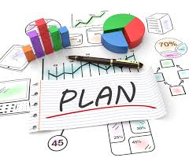

Table of Contents
Introduction: 3
Vintners Antiques Overview: 4
Vintners Project Structure: 4
Project Risk Assessment: 6
How to reduce the risk? 7
Project Management tools and techniques: 8
The MoSCow Chevron- Tool 9
The Iron Triangle - Tool: 9
The Delphi Technique: 10
Roberts Method: 11
Gantt Chart: 11
Communication of project plans with stakeholders: 12
Managing project with the future recommendations & Self-development Plan: 12
My personal development Plan: 13
Conclusion: 13
References: 14

Introduction:

In this management report, you will find how management and planning is important to complete a Vintners Business relocation project; how to estimate project and how we monitor our project. In this report, you will find a project called Vintners Antiques, who are Vintners Antiques, where are they and what they are trying to do? Risks associated with this project, management tools and techniques used to complete this project and how the project plans will be communicated with the stakeholders. At the end you will find my personal reflection on how I will be managing future projects and self-development plan to improve my own performance.
In the first week of our lesson, we were taught about project. We did spend sometime to built LEGO village to get some practical experience in a small project, how it is to go through project practically. From this practical experience, we learnt many things like what can go wrong. There was a lack of communication; there was some personality clashes and so on. We also learnt how can we complete a project in a better way. We also had the brief idea what project is? A project is a piece of work, which has a start date, an end date and goals. “A project is a temporary management environment created to produce a specified deliverable which, when used, leads to benefits which outweigh the investment made in its development and operation” (Roberts, 2011).

“Project management is the application of knowledge, skills, tools, and techniques to project work to achieve project requirements” (Heagney, 2016).
There are five phases of project management, which can help to simplify them into a series of logical and manageable steps. They are project initiation, planning, execution, monitoring and control and closure.

“A successful project management is all about structure, control, sufficient attention to detail and continuously driving action” (Newton, 2016).

We are given a project (Vintners Antiques), here is the approach taken to develop the project and highlight the techniques used to minimise any issues that arise.

Vintners Antiques Overview:

The Vintners family have run an antique shop for years. They are the third generation of people to do this. Grandfather bought the shop over 30 years ago. The business comprises of two properties, a retail outlet located in Shirley High Street and a warehouse in Sparkhill which is used for storage. Its family run business. The warehouse is only lock up place; there is no office space, no electricity, no telephone and no Internet. Doreen Vintner is an accountant, runs a tight business, and obeys all the rules. Danis Vintner searches for the antiques. Has a passion for old stuff. Suha Madani handles the customer services. Everyone likes her. Just returned from a year away. Omar King is general all-rounder. Has worked in the shop since he was a boy. He knows where everything is. Danis and Doreen would like their business to be improved like The Salvage Hunters, they would like to organize the warehouse same way that Salvage Hunters operates.

Vintners Project Structure:

Project is to organise the warehouse for Vintner Antiques and give them a platform where it can be a successful business like the Salvage Hunters. The warehouse is a shell with four walls. To complete this project, project management team did oversee all the work from plumbing, security, internet, office equipment, electricity, fixtures and fitting, designing the website etc. We also worked out the steering group, described our roles in the project. We estimated time and cost for the project by using the user stories, Microsoft planner and Gantt chart.
“ In a project it’s very important to know rough estimates of the work, cost, time and other requirements of the project” (Maund, 2018). It is very crucial that member of the project management team understand their roles and responsibilities. For that reason it is very important to form a Project Steering Group, included Sponsor, Financial expert, user expert, and specialist and project manager. It makes things easier to complete a project.

Danis Vinter (Project Sponsor)
Dennis is the Managing Director of Vintners Antiques and makes the major decisions; he is the main person of Project Steering group responsible for giving instructions and directions. He is also responsible for keeping the project progress operations in line with the project proposition. He is the highest-ranking person on the project. His main responsibilities are to make sure the overall project is achieving the organisational objectives, goals and budget targets.
Project Sponsor is the person who makes the decision on a project. Project sponsor is the person with the overall accountability for the project. Project sponsor is primarily concerned with ensuring that the project delivers the agreed business benefits. “Project Sponsor is an executive from the Project Board with accountability for the project’s success and responsibility for appointing project team members” (Breese, R., Couch, O. and Turner, D., 2020).

When we create a steering group, we must include members from these three areas, Commercial, Specialist and User. We have created following project steering group for Vintners Antiques project:

Doreen Vintner (Finance Manager)
Doreen Vintner is the equal shareholder in the Vintners Antiques. She is the finance manager and responsible for all financial aspects of the business, she will be the person in charge of the expenses and cost issues relating to the project and she covers a commercial role on the steering group.

Omar King (Specialist)
Omar King is very long time employee of Vintners Antiques; he has been with the Vintners Antique for a very long time and is the expert craftsman. He is responsible for all repairs and is familiar with every piece of antiques in the business. He is expert and repairer and has a lot of knowledge antiques. He is one of the important person in the project steering group, he is responsible for layout of the different sections of the warehouse and layout of current and future antique pieces.

Suha Madani (Customer Relations-User)
Suha Madani deals with the customers, she is responsible for all aspects of customer relationship tasks. She has a very good understanding and knowledge of customer expectation and needs. She input in the project and on the steering group will provide customer user viewpoint perspective.

Project Risk Assessment:

Project risk is defined as “an uncertain event or condition that, if it occurs, has a positive or negative effect on one or more project objectives such as scope, schedule, cost, or quality” (Muriana, C. and Vizini, G. 2017).

There are some risks to complete the project, they are:

Poorly managing project: one of the biggest risk projects not to be success is poorly managed project i.e. incorrect project initiation, wrong estimation of budget and time etc. It is very important that to manage the project properly from the very beginning.

Change of requirements: Today’s market is very competitive; clients may sometimes change their vision of how their product should look like. It is very difficult to be deal with the change of requirements. It’s one of the very important things we need to consider.

Not communicating properly to steering group member: There is a big chance of failing if we don’t communicate to the team; message has to be clear and transparent so that everyone understands their roles and responsibilities.

Personality clashes: This can be issue if there are personality clashes between members of team. We have seen this during our LEGO village practice in classroom exercise. If they don’t follow project sponsors direction, then it is more likely project to be failed or not completed on time.

Some technical problems: Budget cut or low budget can be most challenging risks as it forces into a situation where you need to satisfy client’s requirements while being low on resources.

Unavoidable Risks: These risks can’t be controlled or estimated, example: technologies being discontinued and changes I government policy.

During our practical project, we did face some of the above issues. Example, personality clashes between our group member, communication issues, and some technical issues like we did the planner and Gantt Chart in one of the members laptop and had to do Skype call from another member’s laptop; so we couldn’t show our planner and Gannt Chart to our clients.

According to Berkeley, Humphreys and Thomas (1991)
We shouldn’t ignore the project risk.
We shouldn’t deal any project with in a completely random way.
We should find any project risks in the earliest project phases.

How to reduce the risk?

There are few methods, which can reduce the risk of a project failure. There are
Microsoft Planner
The Iron Triangle
The Chevron

During our project we mainly used The Chevron. The chevron approach tries to work out the must be done compared to what would be nice to have.

According to Heagney, J. and Lewis, J. (2016)
The Chevron approach helps to reduce the risk of project failure, in this approach helps to find out that which work must be done compare to what would be nice to have. There are three sections in The Chevron, first one is Must- in this section all the stories or task must be included and done. Second one is Wants- in this section all the stories or task that we want to be included or to be done in project. Third one is Nice- In this section tasks that would be nice to have but not necessity, if there is lack of budget than we can postponed these tasks.

In our project work we have used the Chevron method and prioritised our work. For example, Electricity, Internet, office equipment, etc. to must do list, please find below the example:
Must:
Office equipment’s, Electricity, Website, Delivery van, Phone, computer, internet, heating and plumbing, fire alarms, security alarms, waste management and painting and decorating.
Want:
Company Mobiles, Pest Control, Forklifts and kitchen.
Wish:
Vending Machines, Canteen, Smoking area.

Project Management tools and techniques:

In the class we learnt, to complete a project successfully using following method, tools and techniques:

User Stories - Method
User story is a way to find out what people need for their project and it is a term describes features of an undertaking or project as seen from the point of views of users. The key considerations are who, why, what and how?

A technique that project manager converse with the stakeholder’s slow brains is called user stories. “User story is not any descriptive line of statements or any case study. It means some important functionality or feature to be extracted from the user requirements which can be used for measuring size of product” (JADHAV, S.K., SHAGA, V. and THORAT, S. D., 2017).

The MoSCow Chevron- Tool
The Chevron was a very useful tool for identifying and prioritising tasks within the project and allowed us to understand the significance of individual elements. This tool make us to prioritise tasks, very important (Must have), Needed (should have), Desirable (Could have) and Luxurious (Won’t have) elements in their allocated categories.

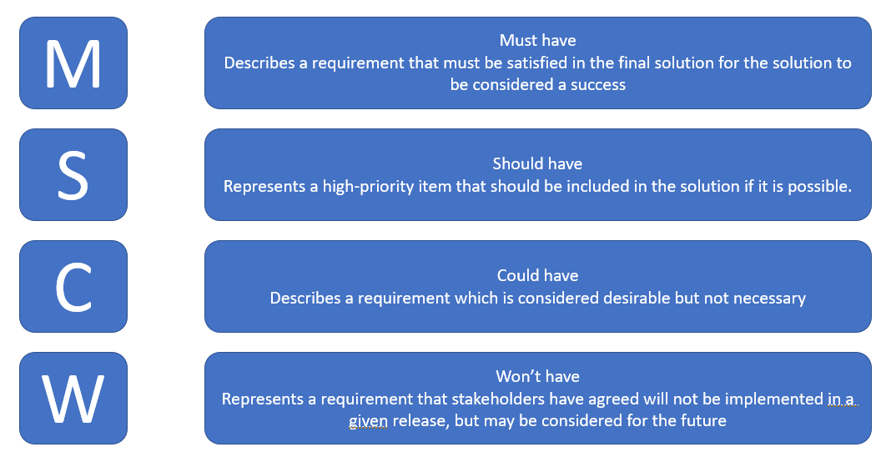

The Iron Triangle - Tool:
The iron triangle is called project management triangle also. Iron triangle won’t solve the problem, but it will give you good ideas of choices we have. Three corners of iron triangle are Time or Schedule, secondly cost/budget/resources and third corner is quality or functionality. Iron triangle is also known as triangle of balance.

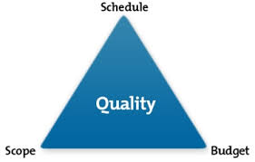

“The iron triangle is a representation of the most basic criteria by which project success is measured, namely, Whether the project is delivered by the due date, within budget, and to some agreed level of quality, performance or scope” (Pollack, J., Helm, J. and Adler, D., 2018).

If you want to change one of the corners, we can’t because Iron triangle is rigid. If you change for example time, you want to deliver project earlier, it affects the cost. It’s going to cost us more. If we change one of the corners, we have to change at least one another corner. These three corners constraint one another.

The Delphi Technique:
The Delphi Technique is based on an idea developed by the ancient Greeks but became popular in the 1950s and the cold war. A man called Dalton proved this in a experiment and called it the wisdom of the crowd. Dalton proved that a collective opinion of a group of people can often better than that of an individual expert. Using the Delphi technique, we can be more accuracy into our estimates. “The Delphi Technique is a method for structuring a group communication process, allowing a group of individuals to address a complex problem collectively” (Flostrand, 2017).

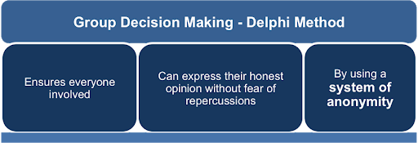

Roberts Method:
Roberts method is a very simple tool used to determine the time required for specific tasks, based on the tasks complexity and size.

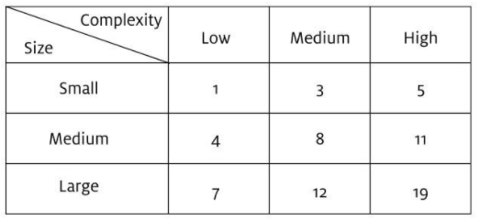

Gantt Chart:
A man called Henry Gantt in 1910 developed Gantt charts. Gantt chart is an instinctive way of managing a project. “The Gantt chart is one of the most used planning and controlling tools in projects today” (Geraldi, J. and Lechter, T., 2012).
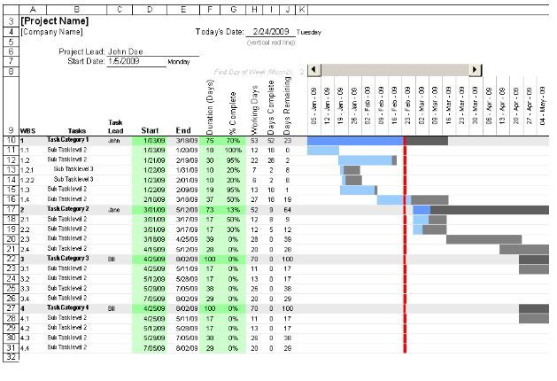

Communication of project plans with stakeholders:

Communication with stakeholders on a project is very important to achieving a successful outcome. “Stakeholder is anyone who has vested interest in the outcome of a project” (Heagney, 2016).
PM must plan and execute stakeholder communication in a focused and flexible process. Followings are the ways to effectively communicate with stakeholders:

- Meeting with Stakeholders
- Send out a newsletter
- Online meetings
- Project summery report
- Conference calls

Managing project with the future recommendations & Self-development Plan:

During classroom workshop and practical experience on Vintners Antique project, I have learnt about project and how to complete the project successfully. What I have learnt? Before starting any project, It is very important that you know all the important point of a project. Get your project started on the right foot by having check of all the details and lay the groundwork for the project success. It is also important to be decisive, trust others, lead by example and know your team well. Following are the important points, I will consider and apply in my future projects. They are:
- What is project deadline?
- What are the roles and responsibilities of various team members?
- What factors would prevent the project from being successful?
- What would be the preferred mode of communication between the team and clients?

My personal development Plan:

- Set and prioritise the goals.
- Set the deadline.
- Recognise Strengths, opportunities, weakness and threats.
- Work on weakness and threats.
- Develop skills to increase knowledge
- Review progress
- Learn new things

Conclusion:

It was a wonderful and learning experience for me while studying Project Management module. This learning experience took me through various phases of project and gave me real insight how a project can be completed successfully; how we start the project, how we set up the steering group, risk of the projects, project management tools and techniques, how we communicate to stakeholders, and complete the project. I learnt a lot from classroom exercise, how people behave? How people plan? Personality clashes, communication issues, and how we face unexpected challenges. Overall, I learnt what’s the best way to manage a project.

References:
- Berkley, D. Humphreys, P.C., Thomas, R. D. (1991) Project risk action management, Construction Management & Economics. Vol (9) pp 3-17.

- Breese, R., Couch, O., Turner, D. (2020) The Project sponsor role and benefits realisation: More than just doing the day job, International Journal of Project Management, Vol 38 (1), pp. 17-26.

- Flostrand, A. (2017). Finding the future: Crowdsourcing versus the Delphi technique, Science Direct, Business Horizons, Vol 60 (2), pp 229-236.

- Geraldi, J. and Lechter, T., (2012). Gantt chart revisited. International journal of Managing Projects in Business, Vol 5(4), pp. 578-594.

- Heagney, J. (2016) Fundamentals of Project Management Fifth Ed. New York: American Management Association.

- Heagney, J. and Lewis, J. (2016). Fundamentals of project management. New York: Amacon.

- Jadhav, S.K., Shaga, V. and Thorat, S.D., (2017) User Storied for Proposed Web application using Agile Approach, International Journal of Advanced Research in Computer Science, Vol. (8) Iss. 9,

- Maund, A., (2018). BA in leadership and Management, Skills for the workplace Student Year book, SAGE: London.

- Muriana, C. and Vizzini, G. (2017). International Journal of Project Management, Project risk Management: A deterministic quantitative technique for assessment and mitigation. Vol (35), pp 320-340.

- Newton, R. (2016) Project Management Step by Step. 2nd Ed. Essex Pearson Education.

- Pollack, J., Helm, J. and Adler, D., (2018). What is the Iron Triangle, and how has it changed? International journal of managing projects in business, 11(2), pp. 527-547.

- Roberts, P. (2011). Effective project management. London, U.K. : Kogan Page.

