Evaluate how carbon footprint methodologies can help us assess the impact of COVID 19 on our environmental targets and how it can facilitate the formulation and implementation of a Covid-19 green recovery plan in the UK.

Introduction

According to Public health England (PHE), the World Health Organisation (WHO) was informed on 31st of December 2019 of a cluster of cases of pneumonia of unknown cause in Wuhan City, Hubei Province, China (Public health England, 2020). It was named COVID-19 - a strain of coronavirus which affects your lungs and airways. The virus swept across the globe, national lockdowns were put into place to keep the public safe. As of the 18th of November, there has been more than 1.3 million fatalities across the globe and this number is growing (WHO, 2020). Due to the urgency of the matter drastic efforts are being made to keep the public safe and scientists all around the world endeavour to develop a vaccine as quickly as possible.

Nonetheless, the pandemic saw changes in the environment, such as a reduction in Greenhouse gas (GHG) emissions. This decrease caught the attention of many people and has been a highly researched topic in 2020. Such as Rugani and Caro’s research into the Impact of COVID-19 outbreak measures of lockdown on the Italian Carbon footprint (Rugani and Caro, 2020). Investigations into air quality has been published such as Nakada and Urban work in Brazil (Nakada and Urban, 2020) and in studies in China too (Li et al., 2020) both saw significant decrease in air pollutants.

Leaders and governments are looking at a “Green Recovery” plan to recover from the pandemic to benefit the economy and also to benefit the environment (OECD, 2020). In June 2019, Theresa May announced that the UK is set to bring all GHG emissions to net zero by 2050 and a green recovery plan could be a crucial step to achieve this goal (GOV.UK, 2019). According to the Institute for Government - Net zero refers to reaching a balance between the volume of GHG emissions produced and the amount which is removed from the atmosphere (Institute for Government, 2020).

The UK is signed into the Paris Agreement; one of the aims is to reduce GHS emissions by at least 40% by 2030 (European Commission, 2013). Carbon foot-printing (CFP) is a tool to measure the total GHG emissions caused by individuals, organisations, events, products and services. The footprint measures GHG emissions. CFP is an essential tool to be used in achieving the target in GHG emission reduction. It is a widely recognised tool and is used by individuals and also large-scale business’ and organisations (Carbon Trust, 2017). This essay will discuss the use of CFP and the application of this in the UK in further detail later on.

Discussion.

CFP’s provide a numerical value which is easier to work with. For example - using it to create goals/targets, compare to other countries, use data sets for research and monitor progress. The total CFP of the UK comprises of three greenhouse gasses: carbon dioxide (CO₂₎, methane (CH₄) and nitrous oxide (N₂0) (Department for Environment, Food and Rural Affairs, 2020).

According to the UK’s carbon footprint report published by DEFRA, CFP refers to the emissions which are associated with the consumption spending, meaning that it covers emissions associated with the consumption of goods and services by households in the UK (Including emissions related to the supply chain of goods and services). It also considers the use of burning fuels for energy and private transport (Department for Environment, Food and Rural Affairs, 2020).

In the UK there are two additional measures to estimate the UK’s emissions. Firstly; the measures of emissions based on a “residential” basis relate to the emissions caused by UK residents as well as UK business’ in the UK, even if they are situated abroad. This figure excludes emissions in the UK which are caused by overseas residents and businesses. The final measure is based on UK “territorial” GHG emissions. Territorial measures only include emissions which occur from inside the UK’s borders, meaning that emissions from UK business’ and residents which occur abroad are excluded (Department for Environment, Food and Rural Affairs, 2020). These different measures should be viewed as complementary ways of accounting for carbon emissions within the UK (Department for Business, Energy & Industrial Strategy, 2020), having a combination of all three gives a deeper understanding of the UK’s GHG emissions.

The findings report states that the statistics relating to CFP are classed as experimental statistics due to the uncertainties in the estimation of GHG emissions. There is on-going refinement and debate on the carbon footprint methodologies as there is no standard method accepted globally (Fang, 2020, p.12). The UK’s carbon footprint is provided by the University of Leeds, previously carried out by the Stockholm Environment Institute, using a multi-region input-output (MRIO) model which - “links the flows of goods and services describes in monetary terms, with the emissions generated in the process of production” (Department for Business, Energy & Industrial Strategy, 2020, p.7).

As there is no standard calculation for the CFP we do not know for certain how accurately governments are setting goals and how precisely we are achieving them. As stated in the findings report, there was uncertainty in the estimates that showed a standard error total in any one year lies within the range of 3.3 - 5.5 per cent (Department for Environment, Food and Rural Affairs, 2020). The UK also relies on downstream supply chains to convey correct information in order to calculate the countries carbon footprint, these emissions are referred to as emissions that are “embedded” in imports and these aren’t as easily measured.

However, the reason we have environmental targets are primarily to do with CFPs. From CFPs, countries have been able to identify what areas are having the most impact in terms of GHGs and so allows governments to focus their attention to areas which cause the most issues – adapting policies to improve the environment. It is then a quantifiable and comparable method to understand what we have and can achieve for example the work of Rugani and Caro in Italy. They were able to assess what impact COVID-19 had on the environment by comparing 2020 to previous years CFP and found a 20% lower than past CFPs (Rugani and Caro, 2020, p.1) CFPs are also a versatile methodology which is accessible for both academia and to the public which allows for individuals to do their part and contribute to international efforts.

COVID impacted the environment in several of ways; although positive impacts have occurred from these situations it is important to keep in mind that there were/are severe social implications, economic consequences and fatalities which COVID-19 has caused. The impact that COVID-19 has had on the environment has clearly shown that with drastic change it is possible to reduce GHG emissions, in 2020 global emissions are expected to have fallen by 5-10% (Committee on Climate Change, 2020). However, this is a temporary reduction.

Nevertheless, it still showed it can be done. This discussion aims to consider how CFP can aid in facilitating a Green Recovery, otherwise known in the UK as - “The Ten Point Plan for a Green Industrial Revolution” (Department for Business, Energy & Industrial Strategy, 2020).

Stated in the UK emissions progress report: “Important new parts of the policy framework have been introduced since the target was set a year ago. Most have not yet delivered, however, so must progress in the coming year. Their work should be integrated with the wider COVID-19 recovery strategy.” - (Committee on Climate Change, 2020). Progress has been slow but COVID-19 has provided the UK with a unique opportunity to build back better to reach the net-zero target and has quickly responded with a green recovery ten-point plan to aid and accelerate our progress.

The ten-point-plan outlines how the country plans to build back better from the impact of COVID-19. The report states that there will be hundreds of thousands of new jobs will be created in green sector with over £5 billion support from the government (Department for Business, Energy & Industrial Strategy, Prime Minister’s Office, 2020). See appendix for ten-point plan. The main aim towards net-zero is to reduce our GHG emissions, which CFP does look at. However, decarbonising is not the only target on the ten-point plan agenda.

Point 1 | Advancing Offshore Wind. CFP methodology assists.
Point 2 | Driving the growth of Low Carbon Hydrogen. CFP methodology assists.
Point 3 | Delivering New and Advanced Nuclear Power. CFP methodology assists, it is low
Point 4 | Delivering New and Advanced Nuclear Power. CFP methodology assists, it is low carbon but Nuclear is controversial.
Point 5 | Green Public Transport, Cycling and Walking. CFP methodology assists
Point 6 | Jet Zero and Green Ships. CFP methodology assists.
Point 7 | Greener Buildings. CFP methodology assists.
Point 8 | Investing in Carbon Capture, Usage and storage. CFP methodology assists. Controversial again. Not dealing with the Carbon just putting it out of sight out of mind.
Point 9 | Protecting our Natural Environment. Not facilitated by the CFP methodology. “The natural environment is one of the most important and effective solutions we have for capturing and sequestering carbon long-term.”
Point 10 | Green Finance and Innovation.
Figure 1- The Ten Point Plan for a Green Industrial Revolution. (Department for Business, Energy & Industrial Strategy, 2020)
Point 9 on the agenda is “Protecting our natural environment” - decarbonising is protecting the natural environment however, CFP methodologies do not consider factors such as biodiversity. Although, factors such as biodiversity will be included in environmental impact assessment which is a standard procedure when constructing/planning for something which may have an environmental impact. For example, point 1- Advancing Offshore Wind, the UK plans to quadruple offshore wind capacity by 2030 – how will this affect the marine environment? There are both short term and long-term issues which affect the marine environment from the construction stage from completion as shown in figures 1 & 2 in the appendix for example.

Consideration for the wider environment is paramount and CFP does not look at the whole picture. For example, renewable and clean energy is required for de-carbonising and reaching the 2030 target. However, we must question where is this going to come from? It may be clean energy but was biodiversity considered? For example, the case study of the Kielder reservoir situated in the River North Tyne. Hydroelectric power is harnessed from this reservoir which is considered a clean and renewable source of energy. This water transfer scheme affected the availability of a suitable habitat for young Atlantic salmon (Salmo salar) when it was first built and (Soulsby et al., 2001) and dried up spawning grounds for these fish, causing disruption to wildlife.

Another approach which is commonly used is the Ecological Footprint (EFP) created by Mathis Wackernagel and William Rees in the early 1990’s. An EFP calculates how much pressure we put on natural resources, the human demand on nature. It is measured in terms of land required in global hectares which is needed for humans. The EFP tracks the use of six categories of productive surface areas: cropland, grazing land, fishing grounds, built-up land, forest area, and carbon demand on land (Global Footprint Network, n.d.). The EFP is then compared to a city, state or nation’s biocapacity. Biocapacity represents the productivity of an area’s ecological assets, the ability of a particular area to renew what humans demand. If a population’s EFP exceeds the region’s biocapacity, then that region runs an ecological deficit. CFP is accounted for in EFP, illustrated in figure 1 in the text.

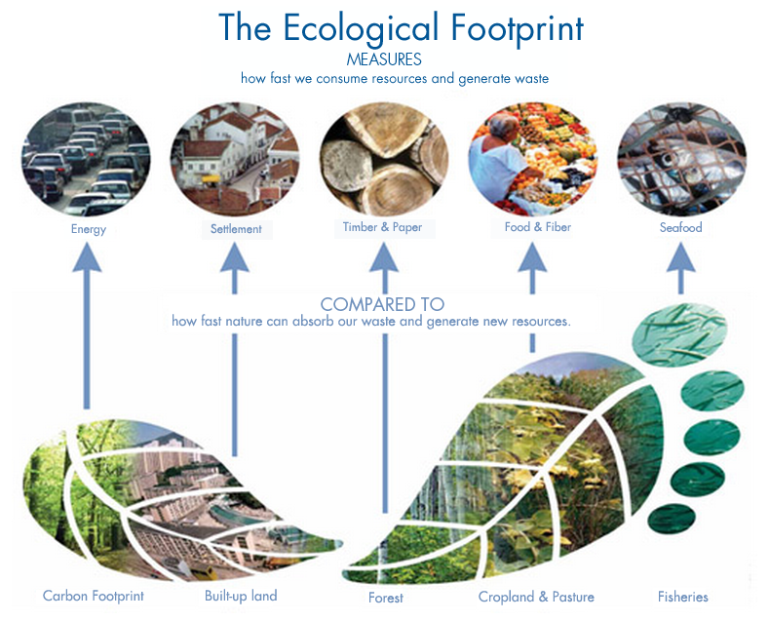
Figure 2- The Ecological Footprint. (Global Footprint Network, n.d.)

Curry and Maguire’s research demonstrated that there is a valuable role for EFP and CFP in policy making by producing an evidence-based proposal which set out the actions needed to attain the changes set by ecological and carbon footprints in Northern Ireland. Policies were evaluated using the Resources and Energy Analysis Programme (REAP) and results showed that current sustainable policies would not have been achieved in either of the footprints (Curry and Maguire, 2011, p.917 ). The use of footprint analysis has lead to regional policy making to be evaluated and methodologies to be developed further.

Conclusion

The perspective which we are looking from with the green recovery is heavily dependent on cutting down on GHG emissions and developing economically which is of course key in the UK’s mission towards net zero and recovering from COVID-19. However, this perspective is forgetting that natures resources are essential to human well-being, only looking at nature from an economic point of view disconnects us from the matter at hand. We depend upon nature; obvious this may be, but easily forgotten (Wakernagel and Rees, 1998, p.7). Similarly, when we only look at an issue which only harms human health (for example air pollution) there is no doubt that this is an issue, however the emphasis purely on human health leads to a narrow ecological understanding and disconnection.

Unfortunately, there is no one answer to the problem that is climate change and so there is not one single tool to use. CFP’s are a crucial tool in the facilitation of a green recovery but it is not the only tool and GHG’s are not the only factor to consider within the ten-point plan. A combination of different footprint tools such as the ecological footprint could provide different perspectives and be more efficient for some parts of the green recovery and future policy making.

Referencing.

- C, Soulsby., C.N, Gibbins., M.J. Jeffries and R, Acornley. (2001) ‘Developing ecologically acceptable river flow regimes: a case study of Kielder reservoir and the Kielder water transfer systems’ Fisheries Management and Ecology, 8(6), pp.463. Available at: https://web.a.ebscohost.com/ehost/pdfviewer/pdfviewer?vid=4&sid=6a0ef97b-a293-4e96-9c6c-f3792340dfef%40sessionmgr4008 (Accessed: 17 November 2020).
- Committee on Climate Change. (2020) Reducing UK emissions Progress report to parliament. Available at: https://www.theccc.org.uk/publication/reducing-uk-emissions-2020-progress-report-to-parliament/ (Accessed: 24 November 2020).
- Department for Business, Energy & Industrial Strategy, and Prime Minister’s Office, 10 Downing Street. (2020) The Ten Point Plan for a Green Industrial Revolution. Available at: https://www.gov.uk/government/publications/the-ten-point-plan-for-a-green-industrial-revolution (Accessed: 23 November 2020).
- Department for Business, Energy & Industrial Strategy. (2020) 2018 UK greenhouse gas emissions, Final Figures. Available at: https://assets.publishing.service.gov.uk/government/uploads/system/uploads/attachment_data/file/862887/2018_Final_greenhouse_gas_emissions_statistical_release.pdf (Accessed: 23 November 2020).
- Department for Business, Energy & Industrial Strategy. (2019) UK becomes first major economy to pass net zero emissions law. Available at: https://www.gov.uk/government/news/uk-becomes-first-major-economy-to-pass-net-zero-emissions-law. (Accessed: 23 November 2020).
- Department for Environment, Food and Rural Affairs. (2020) UK’s Carbon footprint 1997 - 2017. Available at: https://assets.publishing.service.gov.uk/government/uploads/system/uploads/attachment_data/file/918325/Consumption_emissions_March_20_fullycompatible.pdf (Accessed: 23 November 2020).
- European Centre for Disease Prevention and Control. (2020) COVID-19 situation update worldwide as of 20 November 2020. Available at: https://www.ecdc.europa.eu/en/geographical-distribution-2019-ncov-cases (Accessed: 23 November 2020).
- European Commission. (2013) A 2030 framework for climate and energy policy. Available at: https://eur-lex.europa.eu/legal-content/EN/TXT/PDF/?uri=CELEX:52013DC0169&from=EN (Accessed: 27 November 2020).
- Global Footprint Network. (n.d.) Ecological Footprint. Available at: https://www.footprintnetwork.org/our-work/ecological-footprint/?_ga=2.94102237.1101622414.1606405788-1388334272.1606405788 (Accessed: 26 November 2020).
- GOV.UK. (2019) PM Theresa May: we will end UK contribution to climate change by 2050. Available at: https://www.gov.uk/government/news/pm-theresa-may-we-will-end-uk-contribution-to-climate-change-by-2050#:~:text=and%20emissions%20trading-,PM%20Theresa%20May%3A%20we%20will%20end%20UK,to%20climate%20change%20by%202050&text=Legislation%20laid%20today%20puts%20the,zero%20emissions%20target%20in%20law.&text=The%20Prime%20Minister%20has%20today,to%20climate%20change%20by%202050 (Accessed: 27 November 2020).
- Institute for Government (2020) UK net zero target. Available at: https://www.instituteforgovernment.org.uk/explainers/net-zero-target (Accessed: 23 November 2020).
- IUCN (2010) Greening Blue Energy: Identifying and managing the biodiversity risks and opportunities of offshore renewable energy. Available at: https://books.google.co.uk/books?hl=en&lr=&id=p0EctSt4l6gC&oi=fnd&pg=PR7&dq=offshore+wind+impact+on+biodiversity&ots=Zj38gCVhx2&sig=Xm2yOiP0FN-Lrblym-vqwLHch68#v=onepage&q&f=false (Accessed: 27 November 2020).
- Fang, K. (2020) Environmental Footprints: Assessing Anthropogenic Effects. Switzerland: springer nature.
- Nakada, L.Y.K., Urban, R.C. (2020) 'COVID-19 pandemic: Impacts on the air quality during the partial lockdown in Sao Paulo state, Brazil’ Science of the Total Environment, 730(139087), pp. 1-5. Science Direct. Available at: https://www.sciencedirect.com/science/article/pii/S0048969720326048?via%3Dihub (Accessed: 23 November 2020).
- Public Health England (2020) COVID-19: epidemiology, virology and clinical features. Available at : https://www.gov.uk/government/publications/wuhan-novel-coronavirus-background-information/wuhan-novel-coronavirus-epidemiology-virology-and-clinical-features#:~:text=On%2031%20December%202019%2C,Hubei%20Province%2C%20China. (Accessed: 23 November 2020).
- Rugani, B. and Caro, D. (2020)’“Impact of COVID-19 outbreak measures of lockdown on the Italian Carbon footprint’ Science of Total Environment, 737 (139806), pp. 1-2. Science Direct. Available at: https://www.sciencedirect.com/science/article/pii/S004896972033326X?via%3Dihub (Accessed: 23 November 2020).
- Wackernagel, M. and Rees, W. (1998) Our Ecological Footprint. Canada: New Society Publishers.
- OECD. (2020) Focus on green recovery. Available at: http://www.oecd.org/coronavirus/en/themes/green-recovery (Accessed: 3 December 2020).
- Carbon Trust. (2017) Carbon footprinting. Available at: https://www.carbontrust.com/resources/carbon-footprinting-guide (Accessed 3 December 2020).
- Curry, R. and Maguire, C. (2011) ‘The use of Ecological and Carbon Footprint Analysis in regional policy making: application and insights using the REAP model’, Local Environment, 16, pp. 917. Available at: https://web.b.ebscohost.com/ehost/pdfviewer/pdfviewer?vid=2&sid=11f8abdc-bca7-4174-b10a-1f50a0958a1f%40pdc-v-sessmgr01 (Accessed 3 December 2020).

Appendix.

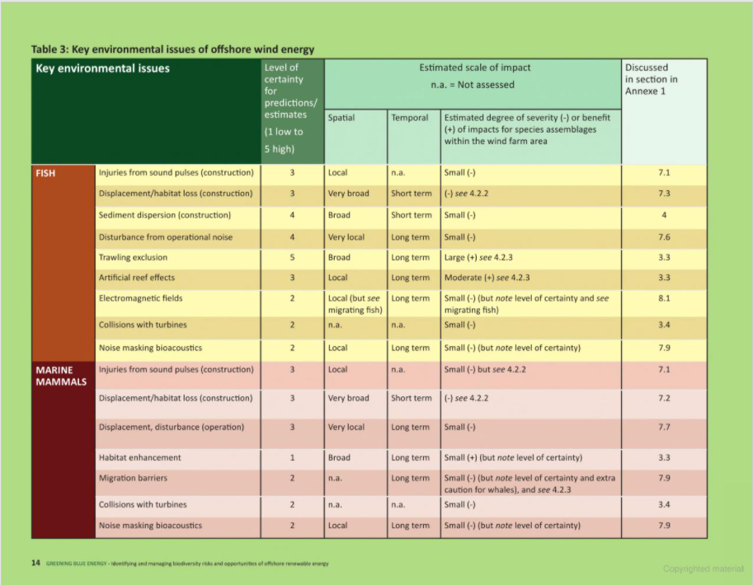
Figure 3 - Impacts of offshore wind farms on the marine environment (IUCN , 2010).
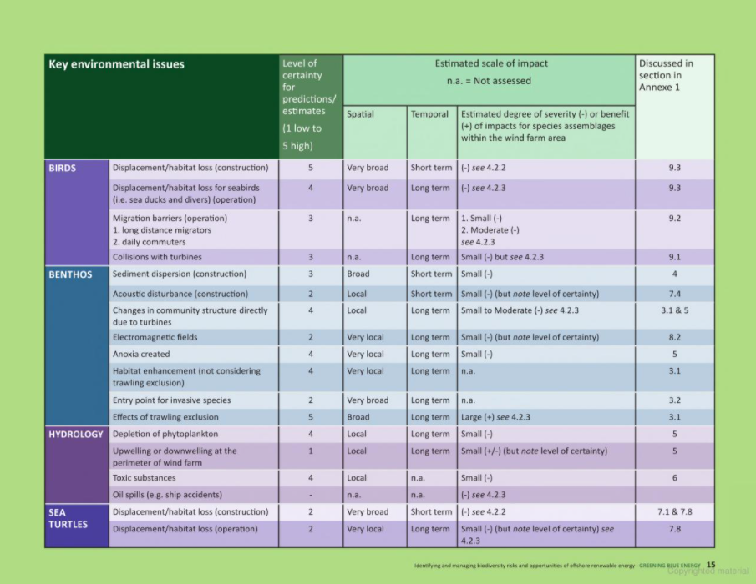

Figure 4 - Figure 3 - Impacts of offshore wind farms on the marine environment (IUCN , 2010).

