Corina Cernat (2019920)

Corina Cernat (2019920)

Questionnaire and website analysis

Contents
Introduction 1
Questionnaire design & analysis 2
Website design 5
Conclusion 9
References 10

Website login details
Email address: 2019920cc@gmail.com
Password: Doris03@

Introduction

The purpose of this report is to analyze the findings from the primary market research I have conducted to help me create a business plan for an artisanal gelato shop in Cardiff.
The research tool I have used is a questionnaire as this is one of the most widely and cost-effective ways to gather data from a large group (Brace, 2018).
The data gathered has been examined and the information has then been used to mainly identify my target market and to create an SEO strategy for a website that will be the main marketing tool for my business.

Questionnaire design & analysis

The market research conducted is an essential step in identifying my target demographics and developing my products and business plan (Sarstedt & Mooi, 2014). The ice cream and frozen desserts market in UK is continuously growing, in 2020 alone had a growth of 20.7% compared to the previous year (Trenda, 2021).
I have submitted below an analysis of some of the most important questions.

- What is your age and gender?

Among the interviewed people, we can see an equal distribution between men and women, with 33% of them being aged between 35-44, followed by 28% aged between 25-34, followed by those between 45-54 years old and 18-24. This information will be used in the marketing strategy for targeting both man and women who will be aged between 18-54 years old.
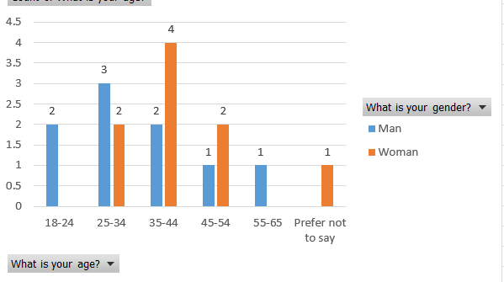

- Where do you live?
The location of the potential customers is very important for marketing purposes and since 78% of the respondents said they live in Cardiff, I know I will mainly need to target men and women from this city, but also from Newport, and other close locations. These locations will also be added on the website and used as keywords for SEO purposes.

- What do you like about your favorite brand of ice-cream?

For this question the respondents were asked to write what they like of their chosen brand and 47% said it is the taste, followed by 29% who chose flavor. These answers will be used for the SEO strategy when creating the website, as keywords, but also in the description of the products.

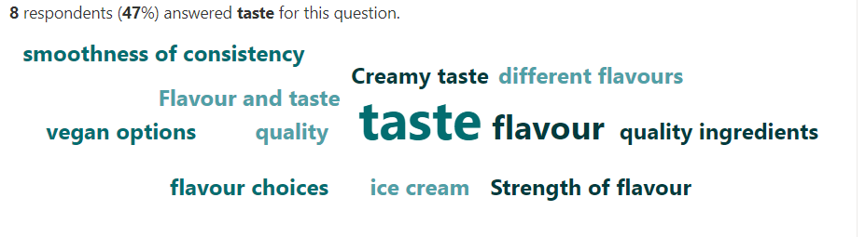
- Please rate the following factors in terms of importance, when deciding to buy from a gelato shop.

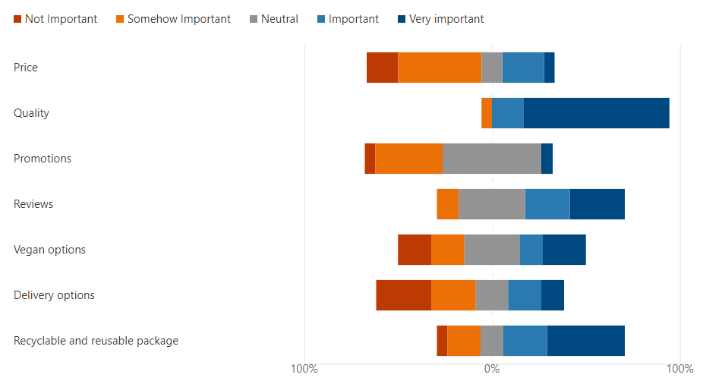
This question has been used to determine what is the most important for potential customers when deciding to buy from a gelato shop and among the very important factors are quality, chosen by 77% of them, followed by recyclable and reusable package, chosen by 41%, reviews by 29% and vegan options chosen by 24%.
These insights prove that the customers will not pay too much attention on the price if the quality is great and are also more likely to buy from a business that is environmentally friendly and offers vegan options. These factors will be considered when creating the website, there will also be a section dedicated to reviews, vegan products will be visible and tagged and there will be mentions about the source and quality of the ingredients used.

- What else would you expect to buy from a gelato shop?
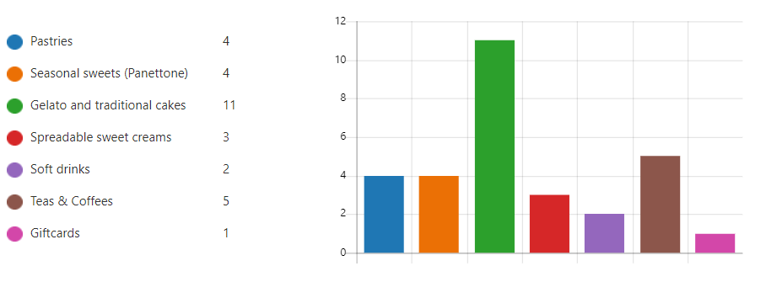
Both in the physical and online shop, I will be looking to see other products and the interviewees have been asked to say what else they would be willing to buy apart from gelato and 61% said they would buy traditional and gelato cakes, 27% would also buy teas and coffees, and 22% would also buy pastries and other seasonal sweets.
On the website I will be having categories added for each of these products and will also be used as keywords for the SEO strategy.

- What is your favorite ice cream flavor?
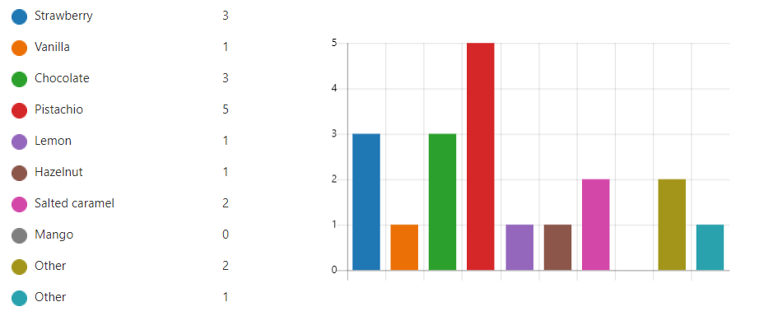
When it comes to the preferred ice cream flavor, the majority chose pistachio, followed by chocolate, strawberry, salted caramel, and others. Considering the results, this information has been used to create the logo of my business, it consists of a cone with a pistachio gelato on a background of pastel green. I have used the cone as this has been another choice of the respondents when it came to how they preferred to have their ice cream served.
Another critical question was how often my potential customers consume ice cream, and although 50% of them eat it only during the season, 31% buy it monthly and 13% consume it weekly. The fact that more people consume this dessert outside the summer months is a result of increased temperatures throughout the year and a growth of disposable income (IbisWorld, 2021). To make the gelato more appealing to the consumers who only buy this dessert seasonally, I will mention on the website that gelato is stored at a temperature higher with 10-15 degrees than regular ice cream, which makes it perfect to enjoy even when weather is colder (Konstantas, et al., 2019).

Website design

The website design plays an important role for the success of a business as it is demonstrated that web interactivity can turn into favorable attitudes and positive behavioral intentions (Yang & Shen, 2017).
To increase the reach of my online page, I have created an SEO strategy using some of the findings from my questionnaire that is meant to position my web page at the top of the search engine results (Saura, et al., 2020).
The fonts used play an important role as well and I have decided to include a selection of Sans Serif ones, as research shows that users read these faster and more accurate than Serif fonts (Dogusoy, et al., 2016)..
Throughout the pages I built, I have used a triadic color scheme, with a yellow green that is dominant, and a pale pink and blue that complement, colors that target both women and men. This scheme is vibrant and enthusiastic (Malpas, 2020) and this is how I want the website visitors to feel when they view my online shop. The background has been left white in most of the places to bring clarity, express minimalism, and style, and emphasize the other design parts like text and pictures used (Kuo, et al., 2021)

Home page
At the top of the page, I have banner with a selection of gelato cones, mainly to reflect the answers provided by the respondents to their preferred way of serving ice cream and flavors.
I have continued with a short description of products offered, keeping in mind the ones that my potential customers said they would also buy from a gelato shop. I have then included pictures to reflect some of those and a Menu button that would lead to a page where they would be able to see the full selection.
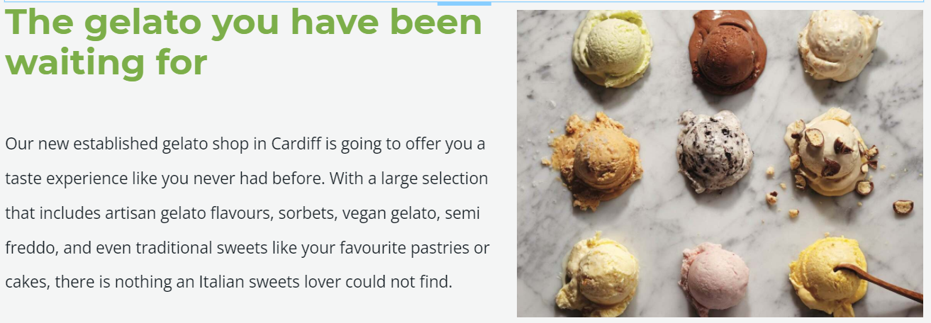
I have also included keywords for this page naming all the gelato flavors identified in my market research, also added all the descriptions that my respondents have written when they were asked what they like about their preferred ice cream brand- words like taste, quality ingredients, flavor. As a page description, I have written a brief overview of my new business and its location.
About
At the top of the page, I included a short paragraph to explain why I have started this business and next to it I attached the logo. I have decided to create this based on the findings from my research, where the respondents said they prefer to consume ice cream from a cone and favorite flavor is pistachio. My intention is for them to associate the logo and its colors to my brand. Green is one of the colors preferred by both men and women and the shades used by me are associated with vitality, growth, and positive feelings like calmness (Kumar, 2017) .
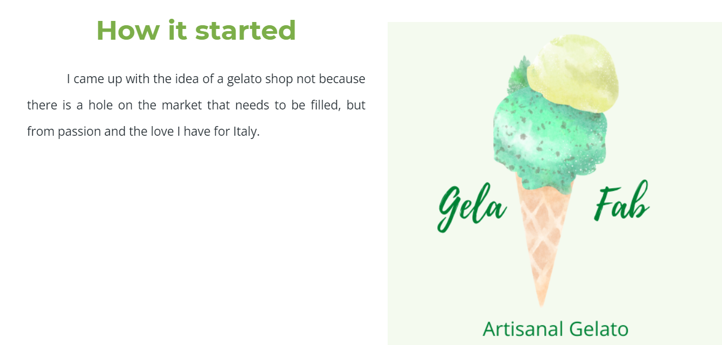
In the middle of the page, I have included my mission statement and business aims. I wanted to highlight the fact that I will be using high quality ingredients, as this is the deciding factor of my potential customers when it comes to the buying process. Another important aspect that resulted from the questionnaire is that for consumers it is very important the use of recyclable and reusable package, so I have added this in my business aim.
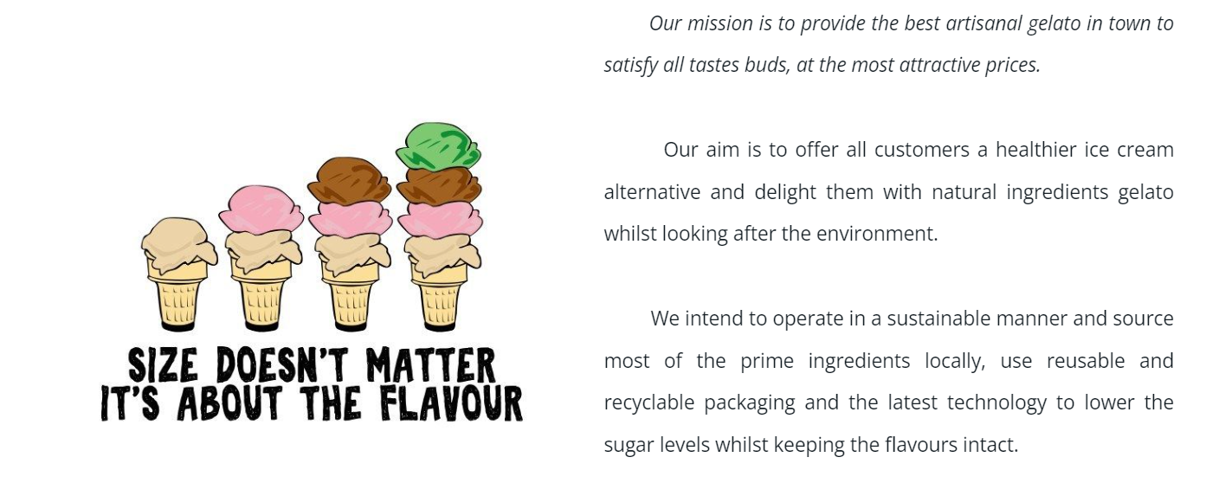
In terms of SEO, I have included a page permalink, description, as well as key words such as: about us, Italy, gelato shop, mission, aims, gelato quote, artisanal gelato, artisan sweets.

Contact us
For this last page I kept a simple approach, including a contact form, a map that shows my shop location and at the bottom I have included social media links, together with email address and telephone number.
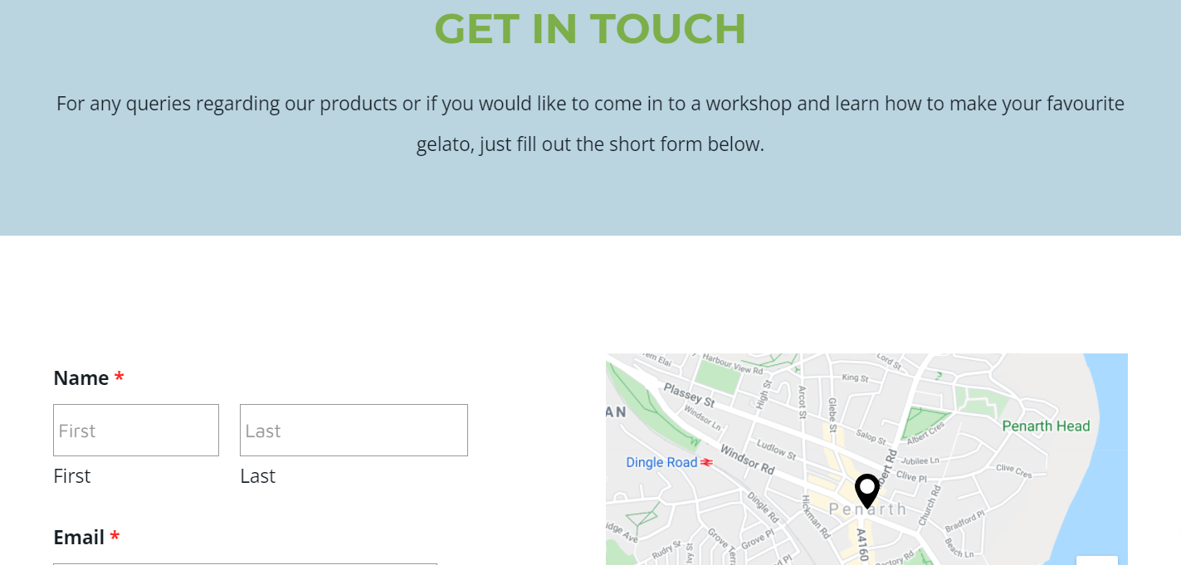
The SEO keywords include the locations from my potential customers identified in the questionnaire, along with contact form, social media, email, telephone number.
The inclusion of social media icons will help with gaining more trust, increase number of followers and the reach of my content (Townsend, et al., 2019).

Conclusion
After conducting the analysis of my primary research, I have concluded that my main target demographic will be men and women from Cardiff and surroundings, aged 18-54.
The marketing and SEO strategy for my website will be looking to target this segment, with keywords and images reflecting the favorite gelato flavors, locations, and products they are willing to buy from my shop.
The website has a clean and simple format, with a color scheme meant to target both men and women and fonts that are modern, easy to read and perfect for digital screens.

References

- Brace, I., 2018. Questionnaire Design: How to Plan, Structure and Write Survey Material for Effective Market Research. 3rd ed. s.l.:Kogan Page Publishers.
- Dogusoy, B., Cicke, F. & Cagiltay, K., 2016. How Serif and Sans Serif Typefaces Influence Reading on Screen: An Eye Tracking Study. s.l., Springer.
- IbisWorld, 2021. Ice Cream Production in the UK - Market Research Report. [Online]
Available at: https://www.ibisworld.com/united-kingdom/market-research-reports/ice-cream-production-industry/
[Accessed 29 November 2021].
- Konstantas, A., Stamford, L. & Azapagic, A., 2019. Environmental impacts of ice cream. Journal of Cleaner Production, Volume 209, pp. 259-272.
- Kumar, S., 2017. ThePsychologyofColourInfluencesConsumers’Buying Behaviour –A Diagnostic Study. Ushus-Journal of Business Management, 16(4), pp. 1-13.
- Kuo, L., Chang, T. & Lai, C.-C., 2021. Visual effect and color matching of dynamic image webpage design. Color Research and Application, 46(6), pp. 1321-1331.
- Malpas, P., 2020. Colour Theory. In: Capturing Colour. London: Routledge, pp. 1-20.
- Sarstedt, M. & Mooi, E., 2014. Introduction to Market Research. In: A Concise Guide to Market Research. Berlin: Springer, pp. 1-9.
- Saura, J. R., Reyes-Menendez, A. & VAn Nostrand, C., 2020. Does SEO Matter for Startups? Identifying Insights from UGC Twitter Communities. Informatics (Basel), 7(47), p. 47.
- Townsend, C., Neal, D. & Morgan, C., 2019. The impact of the mere presence of social media share icons on product. Journal of Business Research, Volume 100, pp. 245-254.
- Trenda, E., 2021. Value growth of the ice cream and frozen desserts in the United Kingdom in 2020 compared to the previous year, by product. [Online]
Available at: https://www.statista.com/statistics/536829/ice-cream-market-value-growth-in-the-united-kingdom-uk/
[Accessed 30 November 2021].
- Yang, F. & Shen, F., 2017. Effects of Web Interactivity: A Meta-Analysis. Communication Reseaerch, 45(5), pp. 635-658.

