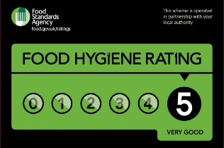



Welcome to our heart-warming restaurant. We are very pleased to have you as our customer. Please enjoy the scenery while the waitress will be on you table shortly.

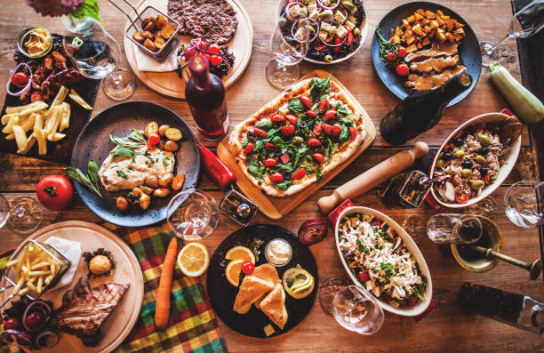
Dishes
1.Slow-cooked spaghetti Bolognese (550g) – 39.99 £
-A British classic with lots of steak, bacon, garlic, tomato sauce with small bits, beef and spaghetti.
Recommended with: "Trattmann" Pinot Noir Riserva Alto Adige DOC 2018
Contains: Wheat and Milk
2.Seafood and chicken paella(700g)-42.99£
-A perfect blend of seafood with fish, chicken, chorizo, rice, onions, different types of peppers, olive oil and calamari.
Recommended with: Trimbach 'Cuvée Frédéric Émile' Riesling 2004, Alsace
Contains: Fish and may contain Crustaceans
3.Chinese chicken salad (500g)- 20.99 £
-A salad composed of shredded cabbage, chicken, onions, tortilla strips, peanuts and seed mix with a special dressing made of garlic, ginger, oil mix and soy sauce.
Contains: Wheat and peanuts
4.Spring carbonara (600g) – 31.99 £
-A popular choice of pasta in a variety of ingredients such as egg, parmesan cheese, pork, beans, olive oil and ground pepper.
Contains: Wheat, egg and cheese

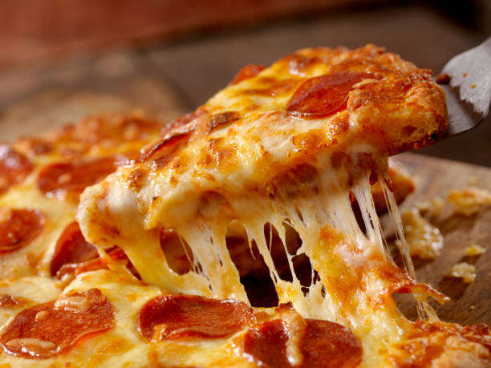
Pizza
1. Margherita^{(V)} (350g) – 18.99 £
- An Italian classic with a hefty toping of mozzarella, tomato sauce and a drizzle of olive oil.
Contains: Wheat, Egg and Milk
2. Quattro Formaggi^{(V)} (350g) – 19.99 £
-A perfect blend of multiple types of cheese, a notch of oregano and tomato sauce.
Contains: Wheat, Egg and Milk
3.Quattro Stagioni (370g) – 21.49 £
-Made with tomato sauce, mozzarella, mushrooms, and olives. ham and pepperoni is also there to scale the balance
Contains: Wheat, Egg and Milk
4.Tuna (380g) 22.49 £
-With a nice scenery of the Swansea coast landscape it surely gets your appetite and this pizza might be the choice for you. Made of tuna, onions, tomato sauce and tuna.
Recommended with:David Duband Gevrey Chambertin 2018, Burgundy, France
Contains: Wheat, Egg and Milk
5.Broccoli BBQ Pizza^{(Ve)} (420g) 22.99 £
-With a misleading name, this is one for the Vegan. Made out of broccoli as main ingredient base, crispy cauliflower, onion and garlic sauce.
Legend
V- Vegetarian
Ve- Vegan

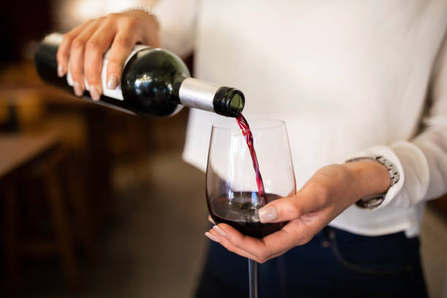
Wines^{(Ve)}

Red Wine
-David Duband Gevrey Chambertin 2018, Burgundy-79.00 £
-"Trattmann" Pinot Noir Riserva Alto Adige DOC 2018- 69.00 £
White wine
-Trimbach 'Cuvée Frédéric Émile' Riesling
2004, Alsace- 119.00 £
-"Biollicine" Grecanico IGP Bio 2020- 39.00 £
Sparkling wine
-"Arzanà" Prosecco Cartizze Superiore DOCG – 44.99 £
-"Dubl+" Metodo Classico 2016- 56.99 £
- "Grande Cuvée Alma" Bellavista Non Dosato Franciacorta DOCG – 84.99 £

Champagne^{(Ve)}
-Taittinger brut prestige rosé NV, - 250.00 £
- Laurent-Perrier la cuvée champagne – 280.00 £

Deserts^{(v)}
Chocolate brownies (150g) – 20.99
Contains: Wheat and peanuts
Red velvet cupcake (150g)- 21.99
Contains: Wheat and cheese
Welsh Cakes/Picau ar y Maen (200g)- 18.99
Contains: Wheat and milk

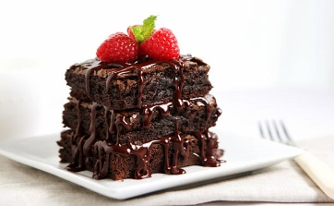

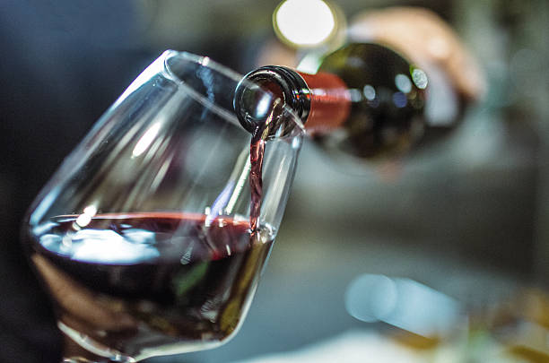
Drinks^{(Ve)}

Coca Cola- 300 ml – 4.99 £
Coca Cola Zero- 300ml – 4.99 £
Fanta- 300 ml – 4.99 £
Mountain Dew – 300ml – 4.99 £
Water- 500 ml – FREE
Jamaican Lime Water- 500ml 4.99 £
Pina Colada -500g – 12.99 £
Fuzzless Navel- 350ml -8.99 £
Afterglow- 400ml- 9.99 £

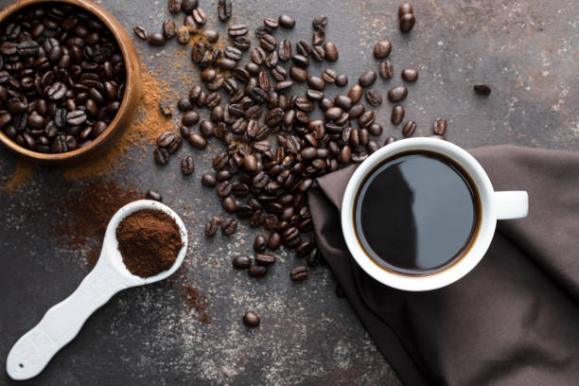

Caffe^{(V)}
Espresso – 250ml – 7.99 £
Caffe-Latte 250ml- 7.99 £
Normal Coffee 250ml – 4.99 £
Frappe- 250 ml –7.99 £

Special Orders
For any special orders in regards with commercial food delivery companies please use our intended website at: www.trinityhotelrestaurant.co.uk
For any further inquires at the restaurant please seek forward to the manager. You can also contact by using the phone number or e-mail address.
Contact Number: 0754 982 164
E-mail address: trinity.hotel@gmail.com

References

Welsh Food – 18 Best Traditional Dishes as Recommended by a Local [ONLINE]
Available at: https://nomadparadise.com/welsh-food/ [Accessed 23th of February 2022]
The Week - Five-star food: ten main course recipes created by chefs from luxury hotels [ONLINE]
Available at: https://www.theweek.co.uk/food-drink/106770/five-star-food-ten-main-course-recipes-chefs-luxury-hotels [Accessed 23th of February 2022]
Pezzo D’Italia – Top 10 Italian Pizzas [ONLINE] Available at: https://pezzoditalia.co.uk/blog-and-recepies-detail/Top-10-Italian-Pizzas [Accessed 23th of February 2022]
[Images acquired from] Gettyimages [ONLINE] Available at: https://www.gettyimages.com/ [Accessed 23th of February 2022]
[Wines acquired from] Svinando [ONLINE] Available at: https://www.svinando.co.uk/sparkling-wines# [Accessed 23th of February 2022]

