BMHP 5014

BSC HEALTH AND SOCIAL CARE

CHANGEMAKERS

CREATIVITY

AND

VALUE CREATION

COMPONENT 2
ASSIGNMENT REPORT

2224032
NADIA KHAN

CONTENTS PAGE

Page 1 : Front Cover

Page 2 : Contents Page

Page 3 : The Medi Time Watch INTRODUCTION

Page 4 : Key facts about Dementia

Page 5 : The Market

Page 6 : Products available on the market

Page 7 : The need and importance of medication

Page 8 : Realistic Timeline for innovation and how the innovation could be created

Page 9 : How can technology be used in the creation and dissemination

Page 10 : Advertising the Medi watch and the possible negative effects

Page 11 : Elevators Pitch

Page 12 : Elevators Pitch continued

Page 13 : Elevators Pitch continued

Page 14: References

Page 15: References

THE MEDI TIME WATCH
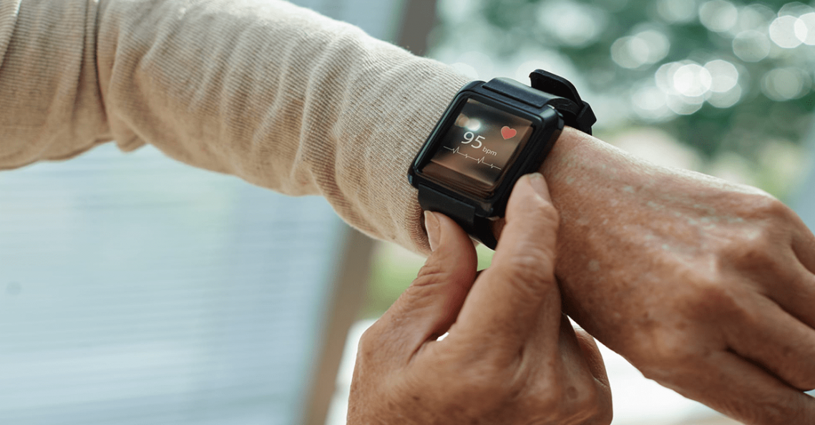 Image from www.caring.com

INTRODUCTION

The phrase 'Prevention is better than Cure' is often attributed to the Dutch philosopher Desiderius Erasmus (1466 - 1536). It is now a fundamental principle of modern health care and inherent within health and social care strategies across the UK.

In this report I will be discussing my innovative product called ‘Medi time’ which is a medication watch, specifically aimed for patients suffering from Alzheimer's Disease and Dementia.

The main goal of the product is to improve the NHS health service by delivering safe and effective care as well as promoting patient independence for those suffering from dementia.

KEY FACTS

- Alzheimer's disease is the most common disease that causes dementia. Frontotemporal degeneration, Lewy body disease, vascular disease can all cause symptoms of dementia.
- Currently more than 55 million people have dementia worldwide, over 60% of whom live in low-and middle-income countries. Every year, there are nearly 10 million new cases.
- Dementia results from a variety of diseases and injuries that affect the brain. Alzheimer disease is the most common form of dementia and may contribute to 60–70% of cases.
- Dementia is currently the seventh leading cause of death and one of the major causes of disability and dependency among older people globally.
- In 2019, dementia cost economies globally US$ 1.3 trillion, approximately 50% of these costs are attributable to care provided by informal carers (e.g. family members and close friends), who provide on average 5 hours of care and supervision per day.
- Women are disproportionately affected by dementia, both directly and indirectly. Women experience higher disability-adjusted life years and mortality due to dementia, but also provide 70% of care hours for people living with dementia. www.dimentiauk.org

THE MARKET

In recent years, the integration of technology into healthcare has transformed patient care, particularly in how medications are managed. One innovative concept is the development of a medication watch, a device designed to monitor medication intake, remind users to take their medicines and even alert healthcare providers and family members when doses are missed.

The question arises is there a gap in the UK market for such a device within our national health service?

The NHS has increasingly recognised the importance of medication adherence, as no adherence can lead to serious health complications and increased healthcare costs.
Statistics show that approximately 30% - 50% of patients do not take their medications as prescribed, which highlights a critical need for solutions that can bridge the gap, WHO (2016).
A medication watch could serve as an effective tool to encourage patients to follow their treatment plans and improve their overall health.

Moreover, the ageing population in the UK presents a significant opportunity for a medication watch. As people age, they often require multiple medications to manage chronic conditions, making it challenging to keep track of dosages and schedules,
Wearable devices could simplify this process by providing timely reminders and facilitating communication with health care providers. It could also serve the growing demographic of tech savvy young people, who are increasingly aware of their health and technology’s role in it.

However, challenges must be addressed before such a product can be successfully integrated into the NHS. While there is a clear demand for increased medication adherences, the success of a medication watch hinges on various factors, including design technology integration and cost. The challenge also includes addressing varying levels of technological proficiency across the population, particularly among older adults who may be less inclined to adapt to new devices. Therefore, a successful product would need to incorporate user friendly designs and possibly educational components to ensure wider acceptance.

In conclusion, there does appear to be a gap in the UK market for a medication watch within the NHS. The potential for introducing a medication watch in the UK is significant. Health challenges related to medication adherence present opportunities for innovative solutions that leverage technology.

As the NHS continues evolving, the recognition of digital health tools is essential. A medication watch could fill this gap in the market, supporting patients, improving health outcomes, and alleviating some of the pressure on the NHS. By adhering to patient centred design principles and considering the technological needs of the population, stakeholders can pursue the development of such transformative solutions in health management.
https://www.kingsfund.org.uk/insight-and-analysis/data-and-charts/nhs-budget-nutshell#:~:text=The%20vast%20majority,Spending%20Review%20process.

DIGITAL HEALTH WATCHES AVAILABLE TO PURCHASE ON THE MARKET

Image 1
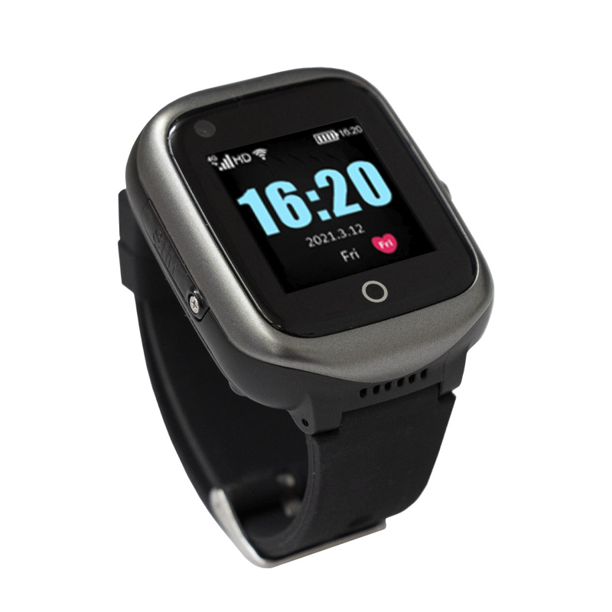

https://www.healthandcare.co.uk/user/products/large/medpage-gps-location-tracker-watch-phone-with-fall-detection-hm-1.jpg

Currently on the market there is available the Pivotell 8 alarm watch with large display and vibrating audio alarms. It is perfect for reminders for medication. This watch is available to purchase on the company's website. In my opinion I think it's a great product to have and is very effective in its uses. Wearable tech currently dominated by smart watches is a multi billion dollar industry with a sharp focus on health tracking.

Image 2
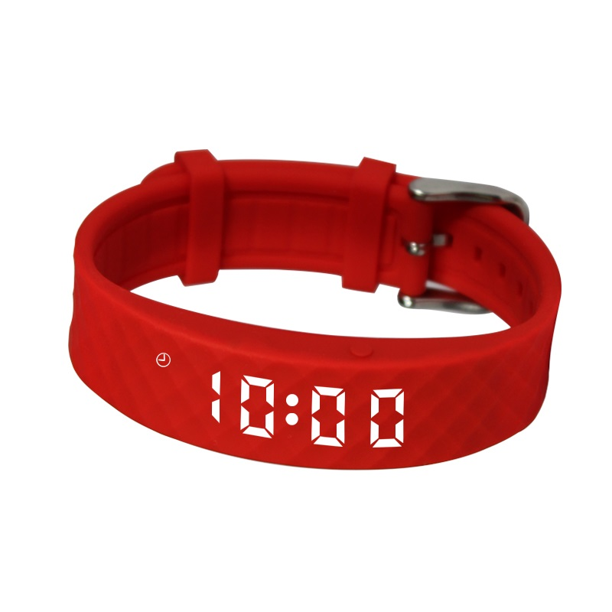https://www.healthandcare.co.uk/user/products/large/pivotell-vibratime-red.jpg

WHY IS MEDICATION SO IMPORTANT FOR DEMENTIA PATIENTS AND THE NEED FOR A MEDICATION WATCH

The benefits of such a device within the healthcare system are numerous and impactful, particularly for patients, caregivers and healthcare providers.

Medications are the most common medical intervention. They are an important part of medical care for older people.

Without medications, many older people would function less well or die at an earlier age, Cochrane Database systems rev. May (2020).

FINANCING THE MEDI WATCH

The vast majority of public NHS funding comes from general taxation and National Insurance contributions.The level of NHS funding in a given year is set by the central government through the Spending Review process.
The funding would need to be requested from the stakeholders in the NHS when considering the financial cost of the product, areas of production and implementation.

WHAT IS A REALISTIC TIMELINE FOR DESIGNING THE MEDI WATCH

The realistic timeline for designing the watch could be between 12 months to 1 year depending on the design and creativity.

HOW THIS INNOVATION COULD BE CREATED

Many wearables, including smartwatches, incorporate GPS technology for navigation.
When considering a medication watch, appropriate computerized design will need to be considered such as time, doses and names of medication. All which can be created in the production stages.

This involves a combination of traditional craftsmanship and cutting-edge technology. Metal components such as gears, springs, and cases are often created through a process called CNC machining, while delicate dials, buttons and indices may be meticulously crafted by skilled artisans.

The Medi Watchwill have GPS tracking functions to provide caregivers or family members with peace of mind, knowing they can keep track of an older adult's location and medication intake.
This feature is especially beneficial for Alzheimer patients if they have concerns about wandering or getting lost because of cognitive impairments like dementia.
The medi watch could include a vast number of features all designed in the production stages of the product. As a result it can provide essential benefits to patients, caregivers and Health and Social Care providers.

https://www.healthandcare.co.uk/user/products/large/medpage-gps-location-tracker-watch-phone-with-fall-detection-hm-1.jpg

WHO CAN BENEFIT FROM THIS INNOVATION

Most people with Alzheimer’s can show symptoms starting from the ages of 60 and above. However young onset dementia is any form of dementia that can occur in people between the ages of 14 to 65 years and can also be beneficial for this age range too. Younger onset dementia is the same as dementia in an older person. But the disease can affect your life in different ways.
There are a lot of health benefits. It empowers patients to get involved in their health care. It allows them to understand lifestyle choices and promotes independence.
For the caregiver it allows regular monitoring of the patient's medication intake as well as providing the patient with the independence to take their medication, depending on the severity of the health condition.
Medication is vital when considering overall healthcare and so with a device like The Medication watch, it can promote a positive outcome for both the caregiver and the patient.
An example of how a similar health condition has benefited from a health watch is in the following document.
https://www.england.nhs.uk/2022/04/parkinsons-patients-benefit-from-revolutionary-watch-on-the-nhs-to-manage-care-at-home/#:~:text=The%20 cutting%2d Edge,who%20have%20a Parkinson%E2%80%99s.

OTHER FACTORS AND BENEFITS A MEDICATION WATCH CAN PROMOTE

- Fall detection features.
- Heart health monitoring.
- Activity tracking.
- Medication reminders.
- Emergency SOS.
- Health apps.
- Communication.
- Noise alerts.
livingmadeeasy.org.uk

HOW CAN TECHNOLOGY BE USED IN THE CREATION OR DISSEMINATION

Modern smartwatches increasingly focus on health and fitness features, including heart rate monitoring, sleep tracking, and workout guidance.
ActLight's Dynamic PhotoDetector (DPD) technology plays a crucial role in enhancing health tracking capabilities by providing accurate and reliable biometric sensing.

Throughout the 1990s, wearable computers devices had increasingly complex data storage capabilities and battery lives. Some of the first smartwatches were based on Microsoft's Smart Personal Objects Technology. Fossil and Suunto introduced the first watches in (1984).

The smartwatch receives data from the smartphone, such as incoming calls and notifications, and displays it on the watch's screen. Some smartwatches can also work independently of a smartphone, using a cellular connection or WiFi to connect to the internet and perform functions such as receiving and sending messages.

To be marketed legitimately and safely, smartwatches must obtain the CE marking and respect them European standards defined by Directive 2014/30/EU on Electromagnetic Compatibility, by Directive 2014/35/EU (Low Voltage Directive), by regulation 2002/95/EC (RoHS Directive) and by Directive 2014/53/EU (RED) on radio, Doe, J & Rowell, A.(2019). Medication management through technology. Journal of Health technology, 15(2), 123-134.

ADVERTISING THE MEDI WATCH

The dissemination of the product could be promoted through various advertising methods such as TV adverts, NHS websites, Health and fitness magazines. Posters and Leaflet distribution, face to face trials and displays could be an effective way to create awareness of the Medi Watch.

NEGATIVE EFFECTS OF WEARABLE HEALTH TECHNOLOGY

- Not always reliable as device can breakdown
- Unreliable information due to technical faults
- Time consuming when repairs are needed
- Ineffective communication (if there are language barriers)
- Can be a hassle to some users as smartwatches require daily charging
- Small screens can be an issue if a patient has visual impairment production and implementation stages of the watch. The communication of data could be enhanced by a tracking app that could be used by patients doctors, caregivers and family
Smith, A.(2021). Wearable technology in dementia: A safety net for the elderly. International Journal on Aging, 34(2), 112-120.

ELEVATOR PITCH

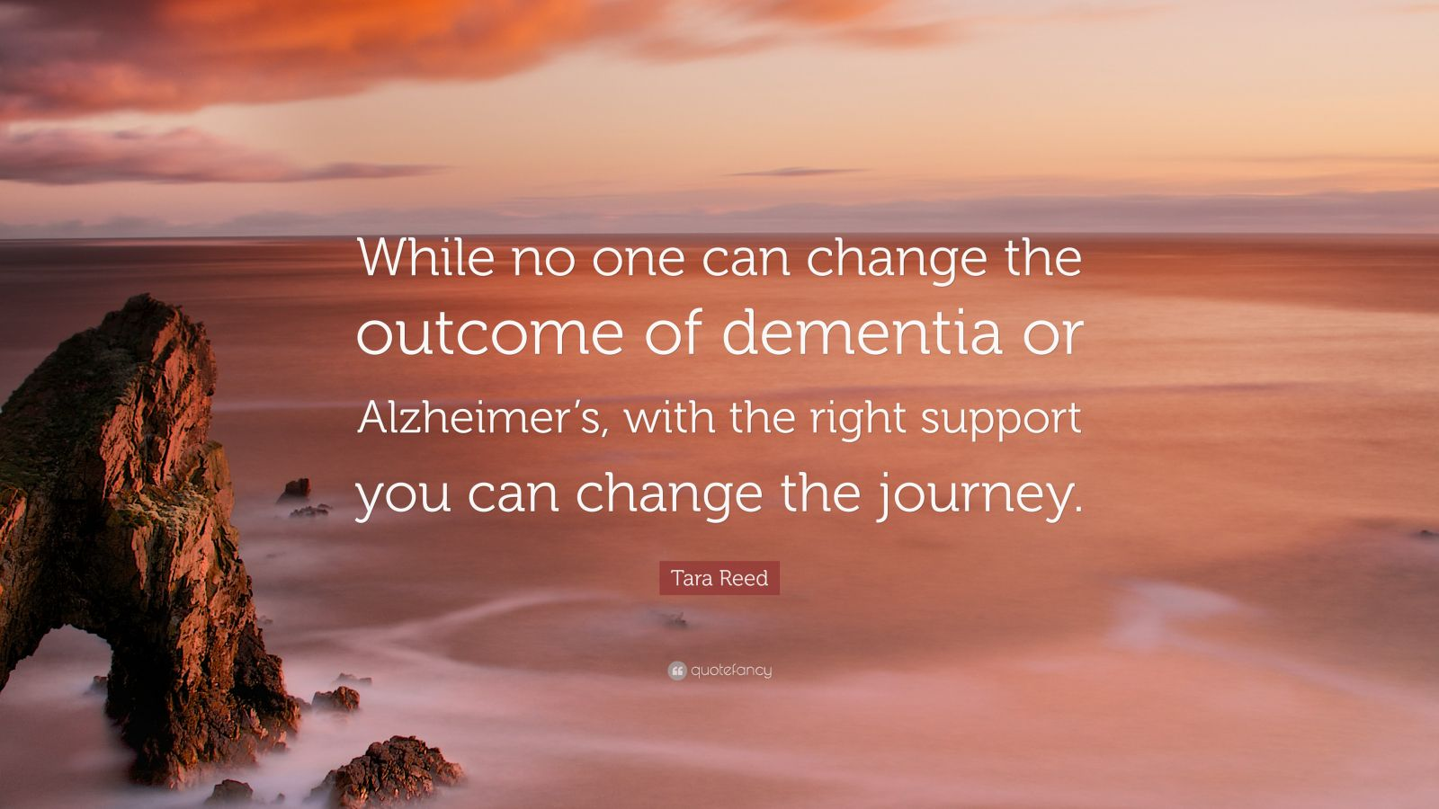Image captured from www.brainyquotes.com

The Medi Watch is positioned as a groundbreaking device that caters to a range of health monitoring needs.
Its unique selling point lies in its dual functionality which combines the features of a smart watch with advanced medical capabilities. Unlike conventional smart watches that primarily focus on fitness tracking and personalised notifications, the medi watch distinguishes itself with medical grade sensors that provides real time health data and insights.
This functionality makes it especially valuable in individuals who are health conscious or have pre existing medical conditions requiring constant monitoring.

One of the stand out features of the medi watch is its ability to monitor vital signs such as heart rate, blood pressure, and blood oxygen levels continuously throughout the day. This offers users the chance to detect abnormalities earlier on, which can be crucial in addressing potential health issues before they become critical.

By employing advanced algorithms, the Medi watch not only tracks these metrics but also analyses trends over time allowing users to understand their health better and make informed decisions.
The watch can also integrate seamlessly with mobile devices allowing users to receive notifications, access health data remotely, and share information with healthcare professionals and social care providers.

In addition to these functional features, The Medi Watch will intend to boast a stylish and ergonomic design, which means users do not need to sacrifice aesthetics for functionality.
Together, these elements will work synergistically to establish the Medi Watch as a compelling choice in the health tracking market.

This wearable device will offer multiple benefits that can greatly enhance the experience of dementia patients within the healthcare system, addressing both their specific needs and those of the caregivers.
By providing reminders, tracking medication usage, and facilitating communication with health care providers, medication watches become essential tools in the management of dementia.

These watches will help mitigate the risks associated with missed doses. When medications are taken correctly, it can lead to better control of dementia symptoms and potentially slow the progression of the disease, thereby greatly enhancing the quality of life for these individuals.
These features can significantly alleviate the anxiety experienced by family members who may worry about the well being of their loved ones.

The data logging capabilities of medication watches will also provide another layer of benefit. Many of these devices will be able to store information about when medications were taken, allowing healthcare providers to review this data during consultations.
This aspect of the medication watch will facilitate more informed discussions about a patient's actual medication adherence. With this data, clinicians will be able to access weather adjustments about a patient's treatment plan, enabling healthcare providers to tailor.

Furthermore, The Medi Watch will intend to incorporate additional features, such as alerts for refill reminders, side effects tracking, or even emergency contacts.
These functions help ensure comprehensive patient management. For example, alerts that can notify caregivers when medication refills are due, can prevent lapses in treatment and potential exacerbation of symptoms.
Similarly, tracking side effects will allow for timely reports to be produced to healthcare providers, enabling early intervention that can enhance patient comfort and stability.

In conclusion, the benefits of a medication watch for dementia patients extend well beyond mere reminders.
The Medi Watch will provide a pivotal role in enhancing medication adherence, empowering caregivers, and facilitating better communication with health care providers.
But not only reminding patients to take their medications but also offering a host of supportive features, medication watches represent a significant advancement in dementia care, which in today's market and economy is most relative for the future of the healthcare system.
As technology continues to evolve, integrating these devices into everyday practice will be crucial in enhancing the quality of life for individuals with dementia and their families, ensuring that they receive the care and attention they deserve.
The health secretary Wes Streeting has talked about a proposal to give wearables to millions of NHS patients in England, enabling them to track and monitor health symptoms. Therefore The Medi Watch will fit perfectly in the market and especially within the NHS.

REFERENCES

Alzheimer’s Disease International. (2020)

Doe, J & Rowell, A.(2019). Medication management through technology.
Journal of Health technology, 15(2), 123-134.

Jones, M. (2021). The impact of reminder systems on medication adherence.
Health Psychology Review, 10(3), 254-267.

Smith, R. (2020). Innovations in personal health monitoring. Technology in Medicine, 22(1),45-56.

Smith, A.(2021). Wearable technology in dementia: A safety net for the elderly. International Journal on Aging, 34(2), 112-120.

Cochrane Database Systems rev. May (2020).

Global action plan on the public health response to dementia (2017-2025).

Dementia wellbeing in the COVID-19 pandemic June (2021).

URL

https://www.england.nhs.uk/2022/04/parkinsons-patients-benefit-from-revolutionary-watch-on-the-nhs-to-manage-care-at-home/#:~:text=The%20 cutting%2d Edge,who%20have%20a Parkinson%E2%80%99s.

https://www.kingsfund.org.uk/insight-and-analysis/data-and-charts/nhs-budget-nutshell#:~:text=The%20vast%20majority,Spending%20Review%20process.

https://www.nhs.uk Challenge on Dementia (2020)

https://www.healthandcare.co.uk/user/products/large/medpage-gps-location-tracker-watch-phone-with-fall-detection-hm-1.jpg

https://www.healthandcare.co.uk/user/products/large/pivotell-vibratime-red.jpg

https://www.dimentiauk.org

s://livingmadeeasy.org.ukhttp

