
Skills for the Workplace
Module Assignment Submission
Student Name: | Gareth Thomas
Student Number: | 2011839
Module No: | BMSK4006
Module Title: | Part 2 Reflection

Statement of Confirmation of Authenticity
By the act of making this submission, the student declares that this is the work of the student named above. The work has not, in whole or in part, been knowingly presented elsewhere for assessment, or where assessment has been built on a previous assessment, this has been identified. Where materials have been used from other sources it has been properly acknowledged. If this statement is untrue, the student acknowledges that an assessment offence has been committed.
Attention is drawn to the plagiarism and unfair practice policies of both the University and of ILM.

Table of Contents
Introduction 3
What is Reflective Observation? 4
The importance of reflection. 4
Models of reflection 4
Kolb 4
Gibbs Reflective Cycle. 6
Description. 7
Feelings 7
Evaluation 8
Analysis. 9
Conclusion. 9
Action Plan. 9
Summary. 10
Appendix 1. 11
Schön's theory 11
Appendix 2. 12
The Boud Reflection Model 12
Appendix 3 13
Atkins and Murphy Model of Reflection. 13
References 14

Introduction

During the second part of this assignment for BMSK 4006, the task was to write a reflection on our experience of the first part of the assignment which was to create a business plan.
In order to do this, there are numerous frameworks that can be utilised that will highlight learning through effective reflection.
There are academics who have studied the processes of reflection, and
from this they have created a reflective learning framework and below are some examples.
The reflective practitioner: how professionals think in action. New York: Basic Books. (Schön, 1983) (appendix1) Schön's theory is that there are two types of reflection, one during and one after an activity or event.

The Boud Reflection Model (Boud D, et al (1985) is a reflective learning model by David Boud, Rosemary Keogh and David Walker (1985), which focuses on learning by reflecting on one's practice. ... (appendix 2).

Experiential learning: experience as the source of learning and development.: Kolb, (1984). This theory works on two levels: a four-stage cycle of learning and four separate learning styles.
Atkins and Murphy Atkins, and Murphy, (1993) (appendix3) The model was created with the intent to study an individual’s experience in order to identify points for improvement, also referred to as reflective practice. (As described by Zeeman, A. (2020).

Learning by Doing: A Guide to Teaching and Learning Methods. Oxford: Oxford Further Education Unit Gibbs, G. (1988).

Although the models vary slightly, after research I have found that I personally prefer Gibbs Reflective Cycle. Gibbs (1988) version. Which I will be discussing along with: Kolb, (1984).
The model chosen for this assignment will Gibbs, and through this I will be sharing all feelings and emotions that I experienced whilst navigating the assignment, and from this I will be able to create a swot citation creating the business plan and my failings and successes will be highlighted with a S.W.O.T analysis in order to build on my strengths and turn my weaknesses into strengths or at least opportunities, and eliminate the threats, or at least minimise them, now that I am aware of them.

What is Reflective Observation?

According to Briz-Pounce et al (2016) reflective observation is: -
1. The stage of learning where a person observes others or makes observations about their own experience.
2. A learning ability or mode that requires reflecting or observing on immediate experiences grasped by concrete experience (CE).

The importance of reflection.

Reflection is a process, and it occurs in all aspects of our professional and daily life, and on a regular basis, whether we realise it or not.
An example of this would be.
“In a professional context, ‘reflection’ often means critically assessing the ways in which we can improve upon a certain task or performance, how we cope with certain situations or even, how we interact with people we meet.”
Webb, L. (2018).

Models of reflection

Kolb
Models of reflective practice can be used as a basis for the structure of a reflective essay; an example of this is Kolb’s Learning Cycle (1984).

Effective learning is seen when a person progresses through a cycle of four stages: of (1) having a concrete experience, (2) observation of and reflection on that experience which leads to, (3) the formation of abstract concepts (analysis) and generalizations (conclusions) which are then, (4) used to test hypothesis in future situations, resulting in new experience (McLeod (2013)
Kolb states that by reflecting on an experience this will enable the person(s) to form ideas about that experience, and to be able to take the learning from one experience, and use lessons learned through reflection to assist in other future projects.

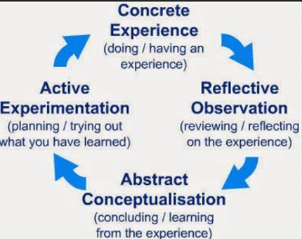

Gibbs Reflective Cycle.
Another formula and the one I will be using is Gibbs Reflective Cycle (1988).
Which states that in this model of reflection there are six stages six stages to take into account.
1. exploring an experience: 2. description, 3. Feelings.4. Evaluation. 5. Analysis. 6. Conclusion and an Action plan.

Gibbs states” That by reflecting on your learning experience, it allows you to better your performance as it is happening, as well as improving it for the future.” Proudfoot, T. (2019).
The reflection of our own experience will assist us greatly in the future endeavours. He says that it is hard to learn just by experience, and that in order to learn and really understand, that reflection is a necessity.

Using the ‘Reflective Cycle,’ you can take away key concepts from the experience, as well as recognising what went well and what could be improved upon for next time.

Gibb reflective cycle.
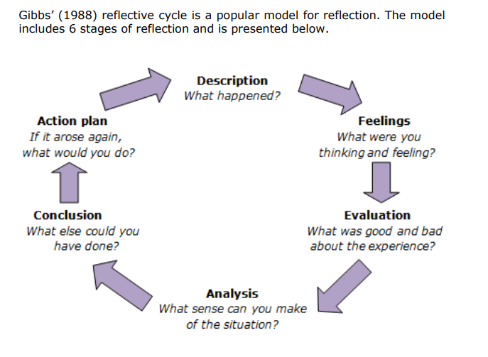

Description.
Firstly, we were asked as a class to create a business plan, and we had free reign to decide upon what type of business we were to create.
I was quite confident as I already had a business proposition in mind.
But apprehensive at the same time. I knew I had a lot of research to compile.

Feelings
As I read articles and researched about how to create an effective business plan and how it should be completed, I realised how much I was unprepared and how much I had underestimated the whole task ahead of me. It was at this point my confidence evaporated and it started to turn into self-doubt, which fear and trepidation.
I had major concerns as to if I could complete the task ahead of me, but with advice and guidance from the tutor, who advised myself and all the others in the class, that if we broke down the plan into a more manageable size chunks, and to take it one step at a time, it would not be so daunting, I took onboard this advice, and as I started to complete individual segments. And as the segments grew the business plan started to take shape.
Although it was by far the most daunting assignment yet, after completing it, I felt relieved and quite happy with my effort, but also thought I could improve on some of the content,
As after submitting the assignment, I read it again and realised there was more information that I needed to include, an example is my starting capitol, although I inserted a monetary figure in graphs and tabular form,
I neglected to disclose as to where the start-up capital had come from, i.e., inheritance, savings or loan.

Evaluation.
The evaluation stage is very interesting as it makes us look introspectively at ourselves and at what we have done and question or even second guess our work.
Although I know I made a lot of mistakes, I am content with the way that I created the business plan.
Some of the negatives were that the research needed to build a plan even though there were plenty of articles I felt as if I was just keeping my head above water at some stages but on other parts felt that I was competent to complete the task to a satisfactory standard.
A few examples of where I had issues was when it came to other financial streams, as although there are some, I found it difficult to quantify how much money they would generate as they were reliant on others.
An example of where I felt confident were the financial projections for which I used an excel spreadsheet, and I also used a graph for demonstration purposes, another area where I felt quietly confident was the use of a S.W.O.T analysis (Schooley, 2019) and also using a S.M.A.R.T. objective (Doran 1981) as these are things we have learned during the course, and it was nice to put new found knowledge into practice using them helped me in the building of the business plan.
As I have reread the assignment, I have picked up on things I could have done differently. But overall, I think it was a big assignment, and I feel I managed to complete it to a satisfactory standard obviously with room for improvement, I think I could have done better. As I now have a better understanding of what content is expected and knowing what I missed out from including in the business plan.

Analysis.
As I have now completed my first business plan, I have now learned how to structure it and make it more presentable, along with all the content it requires to make it an effective business plan.
So, in the future, whenever I ever need to create a business plan, I will do a lot more in-depth research into the statistics and data, as that will create a platform on which to build a more effective business plan and spend more time and effort in getting the content that is required to enable this process.
An example of this would be more field research this will highlight the target market.

Conclusion.
There is a conclusion that can be drawn from the assignment, and the main conclusion that I have drawn is that the next time I am tasked to create a business plan I will take things apart and dissect them into their component parts of the plan and work on each component one at a time, I will also strive to complete the task to a standard.
By breaking it down into its component parts it will make the task easier and not as in this case look at the plan as a whole and let it overwhelm me.

Action Plan.

If in the future I am ever in a position where I need to create a business plan, I will firstly use a template which breaks down the plan into its component parts, or more manageable pieces.
The next step will be to organise all the completed component parts and take any relevant information and complete the business plan by showing all data and any information relevant to that part of the plan, each component will be dealt with one element at a time.
This will work in the same way as a jigsaw, as when I complete the parts and assemble them it will show the whole picture and once, I have completed all of the business plans component parts, I will arrange all the components into the template and the person looking at the business plan will see the plan as a completed article.
I feel I needed to carry out more field research, in order to achieve better data, this in turn shows a true reflection of what I am trying to portray to a possible backer. And more importantly my target market, as they will be my potential customers/revenue.

Summary.
Whilst conducting the reflection on my business plan and my self-appraisal, I realised that although my reflective analysis is good practice, and it highlights the things I thought I did well, along with highlighting the errors I thought I made. This is only my opinion; I feel I need critique from peers to help my reflection as it will give it a broader base from which to truly reflect.
I feel that this is only a one-sided reflection and I feel for it to be a complete learning experience, I feel I need independent critique from a peer or tutor in order for it to be a complete learning experience.
With this said I will be awaiting the results of the assignment, and feedback from my tutor, as I feel this will be a model to base my reflection upon.
Once received I will study the tutors’ comments, and hopefully they won’t be far off my own self appraisal, and from this I feel I will gain a greater understanding, and this will give me a broader knowledge of the subject matter. As reflected in the reflective framework Gibbs (1988) I used which is a cyclical model.

Appendix 1.

Schön's theory
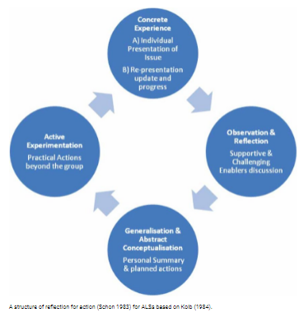

Appendix 2.

The Boud Reflection Model
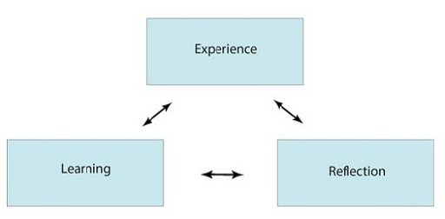

Appendix 3

Atkins and Murphy Model of Reflection.

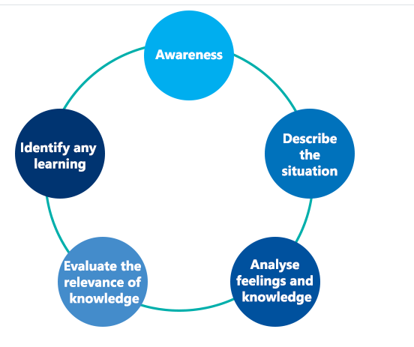

References
All Answers. November 2018. Atkins and Murphy Model of Reflection | NursingAnswers.net. [online]. Available from: https://nursinganswers.net/reflective-guides/atkins-and-murphy.php?vref=1 [Accessed 17 July 2021].
Boud, D., Keogh, R. and Walker, D. (1985). Reflection, turning experience into learning. London: Kogan Page; New York.
Briz-Ponce, L., Juan Antonio Juanes-Mendez and JoséF. (2016). Handbook of research on mobile devices and applications in higher education settings. Hershey, Pa: Information Science Reference.
Doran, G.T. (1981). There’s a S.M.A.R.T. way to write managements’ goals and objectives. pp.35–36.
Gibbs, G. (1988). Learning by Doing: A Guide to Teaching and Learning Methods. Oxford: Oxford Further Education Unit
https://study.com/academy/lesson/abstract-conceptualization-definition-examples.html
Kolb, D.A. (1984). Experiential learning: experience as the source of learning and development. Englewood Cliffs, NJ: Prentice Hall.
Mcleod, S. (2017). Kolb’s Learning Styles and Experiential Learning Cycle. [online] Simplypsychology.org. Available at: https://www.simplypsychology.org/learning-kolb.html [Accessed 6 Jul. 2021].
Proudfoot, T. (2019). Gibbs’ Reflective Cycle and Leaning - Learning Performance. [online] Learning Performance. Available at: https://learningperformance.com/gibbs-reflective-cycle-and-learning/.
SchönD.A. (1983). The reflective practitioner: how professionals think in action. New York: Basic Books.
Schooley, S. (2019). SWOT Analysis: What It Is and When to Use It. [online] Business News Daily. Available at: https://www.businessnewsdaily.com/4245-swot-analysis.html [Accessed 19 Jul. 2021].
Webb, L. (2018). Why “Reflection” Encourages a Better Learning Experience. [online] Learning Pool. Available at: https://learningpool.com/why-reflection-encourages-a-better-learning-experience/ [Accessed 11 Jul. 2021].
Zeeman, A. (2020). Atkins and Murphy model of reflection? Theory & examples. [online] toolshero. Available at: https://www.toolshero.com/personal-development/atkins-murphy-model-of-reflection/ [Accessed 17 Jul. 2021].

