Student Name: Jacqui Fowler Student Number: 1703065
Course: BA Architectural Arts: Glass
Tutor's name: Julia Lockheart Date: May 2018 Words: 1198
A Woman’s Place

During this centenary of Votes for Women in the UK we remember the early feminists (Walters, 2005) who went to extreme measures to challenge political convention. Notably, in parts of the world, women are still not allowed to vote, or drive, or even look a man in the eye. Here in the UK, postmodern freedoms (Lyotard, 2001) require constant challenge to the ingrained gender specific expectations where “boys will be boys”, “nice girls don’t do that”, and “a woman’s place is in the home” (Belotti, 1975).

In this so called ‘post-modern era’ (Sim, 2005) where metanarratives are challenged (Browning, 2000) and artists give themselves license to shock the world, it is apparent that there are geographical boundaries to the freedoms that accompany postmodernism. Tsai (2016:56) reports that in other parts of the world freedom of expression for artists is very different to that which we take for granted in the UK.

The theme of this exhibition is political activism by feminist artists. It highlights five brave female artists who have spoken out against their respective governments. They have broken with the stereotypical behaviours expected of women in their locality and suffered the judicial consequences.
ARTISTS

The first artist is suffragette, Olive Wharry (figure 1), who went to Holloway Women’s Prison for 18 months for arson in 1918, where she was force fed whilst on hunger strike to protest the conditions in the prison (Crawford, 1999:707). This exhibition will display her art (figure 2) and her scrapbook recording her time in prison (figure 3).
Figure 1: Olive Wharry
Figure 2: Painting by Olive Wharry of a bombed church near Exeter
Figure 3: Olive Wharry’s scrapbook of her time in prison

The second artist is Zehra Dogan from Diyarbakır, Turkey (figure 4). She is a Kurdish artist, award winning journalist and editor of JinHa, a feminist Kurdish news agency, with staff consisting entirely of women. Dirik (2016) reports “JinHa's workers exposed the State's crimes from a gendered perspective. Now JinHa is banned and several members are in jail”.

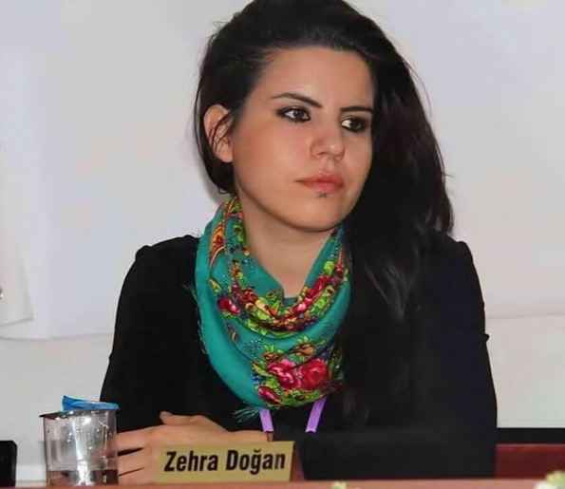
Figure 4 Zehra Dogan
In March 2016, Zehra was sentenced to nearly three years in prison for circulating images of her own painting depicting the destruction caused by Turkish forces in Nusaybin, a city in the Kurdish region of south-eastern Turkey. Prosecutors used the image - based on a widely circulated state news photograph - to allege her connection to the Kurdistan Workers' Party, which the government considers a terrorist organization (Art and AsiaPacific, 2017:36). See figures 5 and 6.

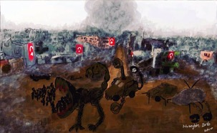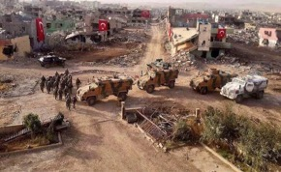
Figure 5: Painting of bombed city Nusaybin Figure 6: Original photo, taken by Turkish authorities
The third artist is Atena Farghadani (figure 7), an Iranian artist and activist, who has recently served time in prison for mocking members of the Iranian government over their vote to control contraception methods (figure 8). Atena was sentenced to over 12 years in Tehran’s Evin Prison. Her crimes included “insulting members of parliament through paintings” and “spreading propaganda against the system”, according to Amnesty International (2016).
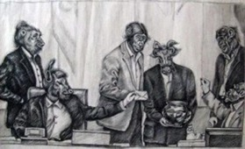
Figure 7: Atena Farghadani Figure 8: a drawing of human figures with animal heads
Atena was further charged with indecency after she shook hands with her lawyer (Tsai, 2016:57). In an interview on a podcast produced for Amnesty International (Action for Individuals, 2016) Atena reported "The prosecutor said if I were ‘a good girl’ I would not shake hands with a man". Later in the interview Atena expresses her intentions "I won’t stop what I’m doing at all, even though I think I may get sent back to prison. I don’t intend to stop protesting or making political art".

The final two artists are Nadezhda Tolokonnikova and Maria Alyokhina, lead singers in the feminist punk rock band Pussy Riot (figure 9). They were arrested in 2014, after an impromptu performance of an anti-Putin song in Moscow's Cathedral of Christ the Saviour and were sentenced to two years in prison for hooliganism (Elder, 2012).

Figure 9: A photograph of the offending Pussy Riot performance in Christ the Saviour Cathedral in Moscow.
Rutland (2014:575) proves the point regarding how women are expected to behave when he asks:
Will the persecution of Pussy Riot go down in history as one of the classic trials that have punctuated Russian history … or is it just a flash in the pan, an artifact of media fascination with attractive young women behaving badly?

Rutland (2014:577) also suggests that Putin benefitted from the publicity Pussy Riot brought because of the poor public reactions to their demonstrations. He says:
There remains prejudice against Pussy Riot among the Russian people as they are perceived as women who do not behave as women should”.

Figure 10: A poster used by followers to protest the harsh treatment of members of the Pussy Riot band

Photographs and images of this feminist punk rock band (figures 9 and 10) are included in the exhibition as well as their music played throughout the venue.

EXHIBITION VENUE

With Relph’s concept of a “spirit of a place” in mind (2007:17-25), this exhibition is to be held at the gallery in the new Women’s Centre to be built on the site of the recently closed Holloway Prison. The Women’s Centre (figure 11) is yet to receive planning permission but is proposed to be amongst the luxury flats that the land is destined for.

In an attempt to remember the social history and often traumatic stories generated from Holloway Prison there is a group of local women campaigning to preserve the public space that was the Visitors’ Centre.
The Centre was originally built with public money on public land now sold off by the Council to private developers. The proposed Women’s Centre will help to bring local women’s services and social spaces into the 21st Century (Holloway Prison Stories, 2018).
Figure 11: Artists Impression of proposed Women’s Centre: Copyright: Niki Gibbs, Blue Sunflower Enterprises Ltd

Figure 12: Artists impression of the gallery space in the proposed Women’s Centre. Copyright: Niki Gibbs, Blue Sunflower Enterprises Ltd

The plans for the new Women’s Centre include the “double coding” (Jencks, 1991) of this aspirational building design; it has been imagined in the shape of the Venus symbol that represents woman (figure 11). Proposed aspects would, “enhance social comfortability, whereby individuals will feel more comfortable and will be more likely to interact socially” (De Certeau, 1988:177) and will include a basement swimming pool, café, art gallery and roof garden (figure 12).

CONCLUSION

Pajnik (2015:60-72) writes that the feminist struggle is not over. These female artists represent feminists all over the world who are still suffering the judicial consequences of trying to chip away at the patriarchal status quo. In this context, art is being used as a beacon to highlight the injustice and create discussion.

Holloway Prison has been used in the past as the ultimate threat to prevent women behaving badly. This is why this space has been chosen to host the exhibition. It’s a metaphorical link between the past and the present. It represents how far the feminist struggle has come and how far there is still to go. The exhibition I have curated, A Woman’s Place, provides a safe space to allow the campaign to continue.

BIBLIOGRAPHY

Amnesty International (2016) ‘Atena Farghadani Released Early After Being Imprisoned for Her Art in Iran’. Action for Individuals [Online]. Available at:
https://www.amnesty.org.uk/iran-atena-farghadani-released-free-imprisoned-art-political-cartoons#.VWz8-PnF-Sq (Accessed: 26 March 2018).

Anon (2017) ‘Controversy: Without Notice’. Art and AsiaPacific, 103:36 [Online]. Available at: https://search-proquest-com.ezproxy.uwtsd.ac.uk/docview/1891259120?accountid=130472&rfr_id=info%3Axri%2Fsid%3Aprimo (Accessed: 6 May 2018).

Belotti, G. (1975) Little Girls: Social Conditioning and its Effects on the Stereotyped Role of Women During Infancy. London: Writers and Readers Publishing Cooperative.

Browning, G. (2000) Lyotard and the End of Grand Narratives. Cardiff: University of Wales Press.

Certeau, M.de. (1988) The Practice of Everyday Life. Berkeley, California and London: University of California Press.

Crawford, E. (1999) The Women's Suffrage Movement: A Reference Guide, 1866–1928. London: Routledge.

Dirik, D, (2016) ‘Erdogan’s War on Women’. Open Democracy [Online]. Available at: https://www.opendemocracy.net/5050/dilar-dirik/erdogan-s-war-on-women (Accessed: 6 May 2018).

Elder, M. (2012) ‘Russian Punk Band Pussy Riot Branded as “Sinners” by Orthodox Church’. World News, The Guardian [Online]. Available at: https://www.theguardian.com/world/2012/mar/12/russian-band-pussy-riot-sinners (Accessed: 26 March 2018).

Cain, C. (2018) ‘Women’s Building’. Holloway Prison Stories [Online]. Available at: http://www.hollowayprisonstories.com/womens-building (Accessed: 26 March 2018).
Jencks, C. (1991) The Language of Postmodern Architecture. 6th. ed., London: Academy Editions.

Lyotard, J.F. (2001) The Postmodern Condition: A Report on Knowledge. Manchester: Manchester University Press.

Pajnik, M. (2015) ‘Feminism and Critical Political Economy of Communication’. Journal for the Critique of Science, for Imagination and New Anthropology, 43(259):60–72, Beletrina [Online]. Available at: https://doaj.org/article/4b91f40f0813436ebbc791d595f2bee5 (Accessed: 6 May 2018).

Relph, E. (2007) ‘Spirit of Place and Sense of Place in Virtual Realities’. Research in Philosophy and Technology, 10(3):17-25, Techné [Online]. Available at: https://doi.org/10.5840/techne20071039 (Accessed: 6 May 2018).

Rutland, P. (2014) ‘The Pussy Riot Affair: Gender and National Identity in Putin's Russia’. Nationalities Papers, 42(4):575-582, Routledge [Online]. Available at: http://librarycatalogue.uwtsd.ac.uk/primo_library/libweb/action/basket.do?fn=display&doc=TN_hus_96920427&vid=44WHELF_UWTSD_VU1 (Accessed: 6 May 2018).

Sim, S. (2005) The Routledge Companion to Postmodernism, Second Edition. London and New York: Routledge.

Tsai, S. (2016) ‘Extreme Sensitivity’. Art and AsiaPacific, 11:56–57, Almanac [Online]. Available at: https://search-proquest-com.ezproxy.uwtsd.ac.uk/docview/1755874338?accountid=130472&rfr_id=info%3Axri%2Fsid%3Aprimo (Accessed: 6 May 2018)

Walters, M. (2005) Feminism: A Very Short Introduction, Oxford: Oxford University Press Inc.

ILLUSTRATIONS

Figure 1: Digital photograph of Olive Wharry whilst incarcerated in Holloway Prison, Circa 1918.
Figure 2: Digital photograph of a watercolour painting by Olive Wharry of St Sidwell’s Church near Exeter, bombed in the first world war. Copyright 2013 Royal Albert Memorial Museum and Art Gallery, Exeter City Council.
Figure 3: Digital photograph of the Scrapbook produced by Olive Wharry whilst incarcerated in Holloway Prison collated in 1918-19, currently owned by the British Library.
Figure 4: Digital photograph of Zehra Dogan, courtesy of the Voice Project [Online]. Available at: http://voiceproject.org/takeaction/free-zehra-dogan (Accessed: 6 May 2018).
Figure 5: Digital photograph of painting by Zehra Dogan of bomb site in Nusaybin. Zehra has changed the military parade into scorpions and minibeasts [Online]. Available at: http://artpil.com/zehra-dogan (Accessed: 6 May 2018).
Figure 6: Digital photograph of the bomb site in Nusaybin taken by State officials [Online]. Available at: http://artpil.com/zehra-dogan (Accessed: 6 May 2018).
Figure 7: Digital photograph of Atena Farghadani, courtesy of Amnesty International [Online]. Available at: https://www.amnesty.org.uk/podcast-in-their-own-words-atena-farghadani-imprisoned-art-iran-nazanin-boniadi (Accessed: 6 May 2018).

Figure 8: Digital photograph of a cartoon by Atena Farghadani showing members of the Iranian parliament as goats and monkeys as they vote to restrict contraception and ban certain birth-control methods, courtesy of Cartoonists Rights Network International [Online]. Available at: https://cartoonistsrights.org/artist-activist-atena-farghadani-gets-12-year-prison-term-in-iran (Accessed: 6 May 2018).
Figure 9: Digital photograph of the Pussy Riot performance in Christ the Saviour Cathedral in Moscow courtesy of Pussy Riot [Online]. Available at: http://cornellsun.com/2015/10/15/meisel-lies-about-bad-jokes-and-triggers (Accessed: 6 May 2018).
Figure 10: Digital photograph of the ‘Icon Pussy Riot’ used by followers to protest the harsh treatment of members of the Pussy Riot band [Online]. Available at: http://www.thes1n.com/?p=2043 (Accessed: 6 May 2018).
Figure 11: Artists Impression of the proposed Women’s Centre to be built on the site of the Visitor’s Centre at the former Holloway Prison: Copyright: Niki Gibbs, Blue Sunflower Enterprises Ltd [Online]. Available at: http://www.hollowayprisonstories.com/womens-building (Accessed: 6 May 2018).
Figure 12: Artists Impression of the ground floor of the proposed Women’s Centre, including art gallery, to be built on the site of the Visitor’s Centre at the former Holloway Prison: Copyright: Niki Gibbs, Blue Sunflower Enterprises Ltd [Online]. Available at: http://www.hollowayprisonstories.com/womens-building (Accessed: 6 May 2018).

APPENDIX



