DS 1 Template

My Screenshots/Photos
- Please add 4–6 screenshots or photos of your digital life.
- You can use your phone or laptop.
- For each screenshot, write one or two sentences explaining what it shows.

Screenshot/Photo 1
[Insert Photo/Screenshot below]
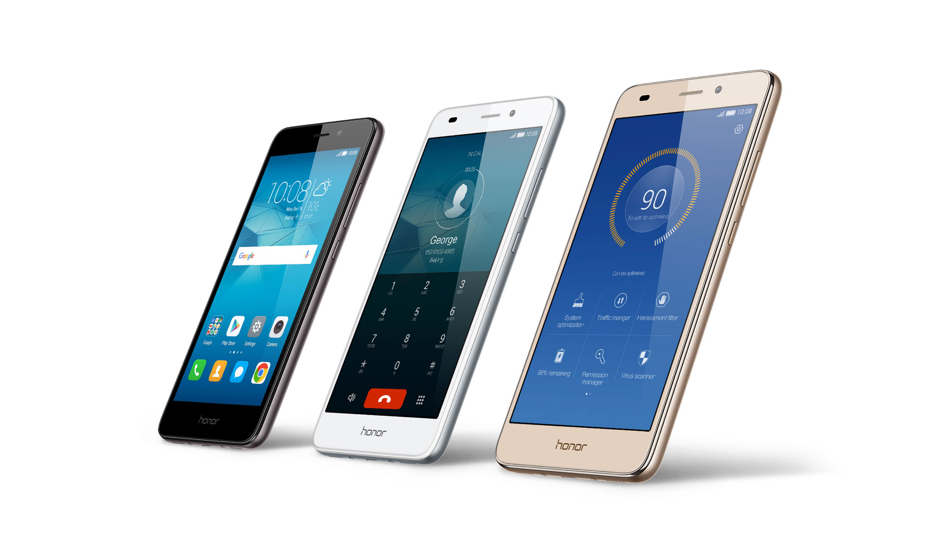
Smart phone help with my daily activities, receiving phone calls, receiving text message, able to log in into my banking app and also means of communication

Screenshot/Photo 2
laptop is the fastest way to reduce daily stress and to use organize school work assignment

Screenshot/Photo 3
[Insert Photo/Screenshot below]

1. Mental Well-being: It help to meet with family and friend all over the world .
2. Physical Mobility & Travel
Seeing this icon heavily your photo apps, maps, or calendar apps highlights your relationship with the physical world.

Screenshot/Photo 4
[Insert Photo/Screenshot below]
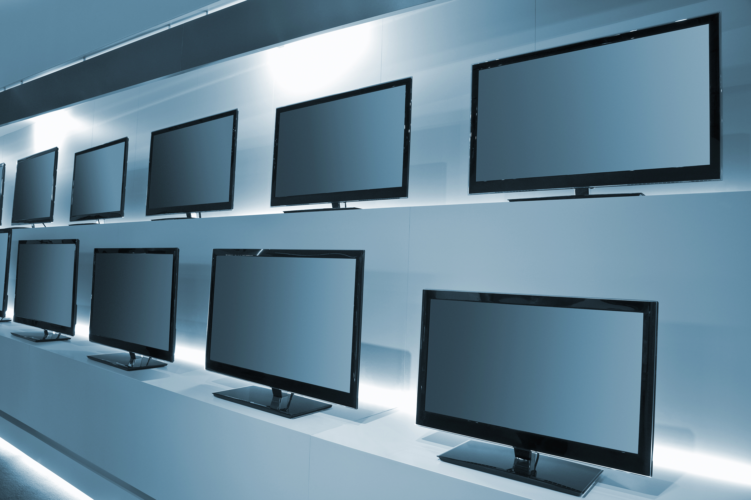
Smart TV shows a digital entertainment tastes, real-time news and seeing what is happening all over the world

Screenshot/Photo 5
[Insert Photo/Screenshot below]
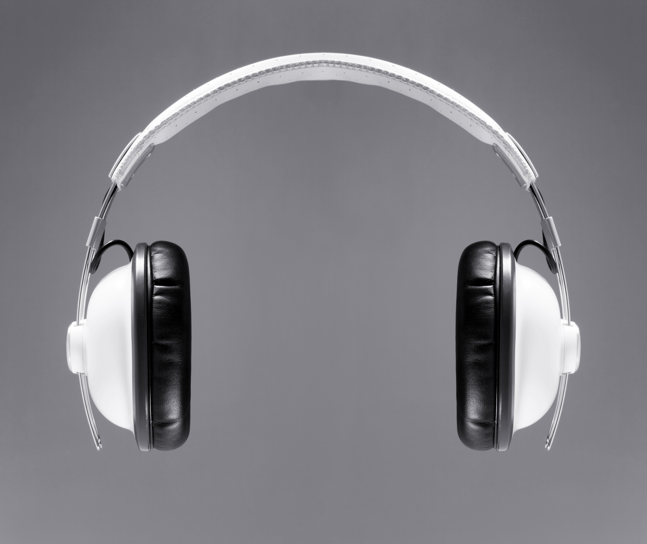
Headphone to listening to music from my laptop and phone

Screenshot/Photo 6
[Insert Photo/Screenshot below]

I use washing machine to washing my clothes, it make life more easy for me

My Short Reflection
- Write 5–8 simple sentences about your digital life.
- You can use the sentence starters below if helpful.
I spend a lot of time on my computer answering questions and helping others learn. This makes me feel happy and productive because I enjoy being useful. I use digital tools to look up interesting facts and organize new information. I think my digital life is exciting because there is always something new to discover. In the future, I hope to learn how to understand people even better and help in my everyday life.

Sentence starters
- I use digital tools to … Complete school assignments and research topics. Connect with friends, family, and colleagues through social media. Manage my daily schedule, emails, and personal finances.
- I feel confident when I … Office apps like Microsoft Word, Excel, and PowerPoint (or Google Docs/Sheets). Communication platforms like WhatsApp and Zoom. Creative or organization tools like Canva and Google Drive
- I want to improve … My data analysis skills. My understanding of digital security and online safety best practices. My ability to create professional digital content and presentations.
- I often use these tools: … Office apps like Microsoft Word, Excel, and PowerPoint (or Google Docs/Sheets). Communication platforms like WhatsApp and Zoom. Creative or organization tools like Canva, Notion, and Google Drive
- I sometimes feel nervous about … Office apps like Microsoft Word, Excel, and PowerPoint (or Google Docs/Sheets). Communication platforms like WhatsApp, Slack, and Zoom. Creative or organization tools like Canva Notion, and Google Drive
- I hope this module will help me … Bridge the gap between being a casual user and a proficient, secure digital professional. Specifically, I hope to gain the confidence to analysed data efficiently, design high-quality presentations without second-guessing myself, and navigate the internet safely and securely
- Digital skills are important for me because … They are essential for almost every modern workplace and career path. They help me stay connected, organized, and independent in a digital world
You can write more if you want.

Submission Checklist
Before you submit, please check:
​​​ ☒ I added 4–6 screenshots
☒ I wrote short sentences for each screenshot
☒ I wrote my short reflection
☒ My work is my own
☒ My file opens correctly
​​☒ My file opens correctly

