

The Investigation, Implementation and Mitigation of Recent Cyber Exploits
By Daniel Carlson

Supervisor: Dr Nitheesh Murugan Kaliyamurthy

Project submitted as part of the requirements for the award of BSc Computer Networks and Cybersecurity
September 2022

Declaration Form and Form of Consent

DECLARATION

I, Daniel Carlson declare that I am the sole author of this Project; that all references cited have been consulted; that I have conducted all work of which this is a record, and that the finished work lies within the prescribed word limits.

This work has not previously been accepted as part of any other degree submission.

Date: 24/04/2023

FORM OF CONSENT

I Daniel Carlson hereby consent that my Project, submitted in candidature for the B.Sc. (Hons) Computing Computer Networks and Cybersecurity degree, if successful, may be made available for inter-library loan or photocopying (subject to the law of copyright), and that the title and abstract may be made available to outside organisations.

Date: 24/04/2023

Abstract
Given how omnipresent technology is in our society today, understanding how to use it securely is crucial. The majority of earlier research papers and publications focused on addressing specific cyber-security concerns rather than examining the complete problem and the most difficult areas that need to be addressed. The spectrum of possible exploitation vectors is expanding as a result of the continual development of technology, with a focus on specific exploits, particularly social engineering.
The continuous development of technology is resulting in an expansion of the variety of possible exploitation vectors, which is principally marked by a focus on certain exploits, most notably social engineering. As a direct consequence of this, so too must our knowledge. Recently, there has been an increase in the frequency of exploits of all types; nonetheless, further preventative measures are required.
This project will delve into the various methods used by cyber criminals to exploit vulnerable systems and networks covering numerous exploits with each individual exploit being researched and demonstrated covering both real-time scenarios and a physical implementation with the final aim of providing a better understanding of how these exploits affect individuals and in what ways they are implemented onto target systems by using simulated networks and providing relevant mitigation strategies to the covered forms of exploitation.
Overall, this project aims to provide an all-encompassing analysis of the realm of cyber exploitation and its effects on both persons and organizations, emphasizing the most recent forms of cyber exploitation. In an increasingly interconnected world, it will also give people and organizations actionable guidance on how to safeguard themselves against the possibility of falling victim to these forms of exploitation.

Table of Contents
Declaration Form and Form of Consent 2
Abstract 3
Table of Contents 4
Table of Figures 6
Table of Tables 7
1. Introduction 8
1.1 Aim 10
1.2 Objectives 10
1.3 Structure of The Project 11
2. Research and Review of Literature 13
2.1 Introduction 13
2.2 Cyber-Exploitation and Espionage 14
2.3 Types of Cyber-Exploits/Cyber Attacks 16
2.4 Social Engineering 17
2.5 Phishing Exploitation 19
2.6 Ransomware 22
2.7 Summary of the Literature Review 25
2.8 – Researched Tools for Implementation 25
2.9 Conclusion 27
3. Research Methodology 28
3.1 Research Overview 28
3.1.1 – Research Process 29
3.1.2 – Research Philosophy 29
3.1.3 Research Methodologies 30
3.1.4 Data Collection 30
3.1.5 Research Design and Methodology Outline 32
3.1.6 Research Deliverables 33
3.1.7 Gantt Chart 33
3.1.8 Contingency Plan 34
3.2 Conclusion 34
4. Design and Implementation 35
4.1 Overview of the Implementation 35
4.2 Blueprint of the Implementation 35
4.3 Social Engineering Implementation 37
4.3.1 Plan of this Implementation 37
4.3.2 Implementation 38
4.4 Phishing Implementation 42
4.4.1 Plan of the Implementation 42
4.4.2 Real-time Examples 43
4.4.3 Physical Implementation 45
4.5 Ransomware Implementation 50
4.5.1 Plan of this Implementation 50
4.5.2 Real-Time Scenarios/Examples 51
4.5.3 Physical Implementation 53
4.6 Conclusion 58
5. Mitigation Strategies 59
5.1 Overview 59
5.2 Social Engineering Mitigations 59
5.3 Phishing Mitigation Strategies 60
5.4 Ransomware Mitigation Strategies 61
6. Evaluation 62
7. Conclusion and Recommendations 63
7.1 Summary of the Project 63
7.2 Conclusion 64
7.3 Recommendations for Further Research 65
8. Reflection 66
8.1 Technical Reflection 66
8.2 Personal Reflection 67
Reference List 68

Table of Figures
Figure 1- Life cycle of cyber-espionage and intelligence activities. Adapted from Fig 1, [12] 15
Figure 2 - Layered IIoT architecture and possible attacks. Adapted from Fig 1, [8] 16
Figure 3 - The conceptual evolution of social engineering in cybersecurity - Adapted from Fig 1, [18] 18
Figure 4 - General phishing attack process – Adapted from Fig 1, [21] 21
Figure 5 - Evolution of Ransomware - Adapted from Fig 7, [27] 23
Figure 6 - Email from Ngrok detailing banned account reasons. 26
Figure 7 - Adapted from [Fig 1, 33] 28
Figure 8 - Research Methodology Flowchart 32
Figure 10 - Gantt Chart of Project 33
Figure 11 - Full Implementation Blueprint 36
Figure 12 - Social Engineering Implementation 37
Figure 13 – A Screenshot of First Contact with First Scammer (“Today” refers to events on 12/10/2022) 38
Figure 14 - A Screenshot of Conversation with First Scammer (“Today” refers to events on 12/10/2022) 39
Figure 15 - A screenshot of First contact with Second Scammer (“Today” refers to events on 12/10/2022) 39
Figure 16 - A screenshot of the Final Conversation with the Second Scammer (“Today” refers to events on 12/10/2022) 40
Figure 17 - A Screenshot of Full Report on Scammers 41
Figure 18 - Phishing Implementation 42
Figure 19 - Spear Phishing Email - Finance Assistance Department 43
Figure 20 - Spear-Phishing Email - Cloud Storage 44
Figure 21 - Spear-Phishing Email - Delivery 44
Figure 22 - Exploit Setup Page within Kali Linux 45
Figure 23 - Zphisher Service and Port Selection 46
Figure 24 - Zphisher Generated URL's 46
Figure 25 - Created phishing email with Masked Link 47
Figure 26 - Masking Email Link 47
Figure 27 - First phishing email received without error. 47
Figure 28 - Second Email Received with Masked Link 48
Figure 29 - Fake Generated URL Login Page for Instagram 48
Figure 30 - Harvested Credentials and Information from URL 49
Figure 31 - Ransomware Implementation Plan 50
Figure 32 - Server Encrypted with Ransomware - Message of Ransom 51
Figure 33 - Encrypted Text within Server 52
Figure 34 - Detected Ransomware Script being deleted. 53
Figure 35 – Microsoft Support Response to Malware Installation 53
Figure 36 - Ran Sim Start Page on Windows 10 VM 54
Figure 37 - Initial Scan Beginning with Ransomware Scripts being detected. 55
Figure 38 - Detection of Ransomware Scripts by Windows Defender 56
Figure 39 - Detection of Vulnerable and Non-Vulnerable Ransomware 56
Figure 40 - Results of Completed Ransomware Injection/Implementation 57

Table of Tables
Table 1 - An overview of cyber threats and countermeasures. Adapted from Tab 1, [8] 11
Table 2 - Research philosophies and data collection methods 25
Table 3 - Research Methods Used within the Project 27

1. Introduction
The strategy, significance, and comprehension of cyber-defence and its results are increasingly becoming paramount in today's technological age because of the continued expansion and transformation of our digital and cyber civilisation and the endless possibilities for possible future outcomes. With the constant development and creation of new technology and digital devices, the continuous development within the cyber-terrorism side of our cyber-civilisation is becoming an increasing problem. With proper understanding and comprehension of the developments, we can avoid/mitigate these problems, otherwise known as Cyber-Exploits.
The scope of cyber-terrorism is consistently expanding and is boundless; It’s critical to know the defining characteristics of the cyber domain to comprehend the dynamics of contemporary cyber assaults completely. Since there are no physical borders or limitations in the cyber world, covert and complex cyberattacks may be launched at incredible speeds from great distances. Without a powerful physical army on the ground, such attacks may be effortlessly carried out by someone or several individuals sitting safely in their homes using computer systems. [1] This is becoming a massive and extensive threat that we must address for us to be able to progress within the evolving cyber domain.
Recent years have seen a rise in digitisation, and worldwide expansion has enabled practically everybody to benefit from the global phenomenon of innovation. This significantly aided the relationship between individuals and modern human technological achievements, including using modern technology to commit crimes and encourage crime worldwide. [2] Depending only on the benefits of the use of technology and communication tools. Naturally, these new types of criminal activity demanded innovative approaches to law and defence of our national security systems.
With the imposing threat of Cyber-Terrorism, the review and innovation of new counteracting technologies have become a significant focus to many governments and industries globally; this threat has caused numerous controversial discussions and reviews to find and create the most suitable course of action moving forward. With the numerous different sectors within the IoT/Cyberspace, the comprehensive analysis and investigations into the main problems that need addressing create many issues and inquiries.
As R. Das [3] noted “due to the increasing use of IoT applications, security vulnerabilities arise. When IoT applications are used in critical infrastructures, serious cyber-security problems arise.”
An example of a devastating cyber-terrorism attack that occurred in 2020 was a cyber-attack that successfully gained access to the control systems of one of Israel’s most significant water infrastructures, which caused severe repercussions and luckily was caught before possible harmful and life-threatening chemicals were added to the nation’s water supply. [3] There have been countless other central cyber-exploits/reaches ranging from simple data breaches through Social Engineering, such as the most recent Uber Breach [4] and numerous major violations associated with the current Healthcare shortage due to the Covid-19 pandemic.
This has led to numerous vulnerabilities being discovered within all sectors, from transport to healthcare. [5] These vulnerabilities are now giving so-called hackers opportunities to capitalise on the new technology integration to exploit previously outdated systems to extort companies using methods such as ransomware and phishing, and social engineering to cause identity theft and data breaches within security systems.
This report frames this complicated issue to illustrate the attack vectors and vulnerabilities. The discussion of how these vulnerabilities arise from a multidisciplinary perspective is set against the potential impact of security vulnerabilities. The study encompasses the theoretical and practical view of the entire environment of implementation of devices concerning cybersecurity risks rather than a purely technological approach, with a detailed investigation and analysis of a significant amount of information methods of cyber-attacks and what effect these had on our cyber-civilisation. Finally, this paper will demonstrate an in-depth and detailed implementation of a few specific cyber-exploits and what impact these have on people but also discuss how these can be mitigated in real-time and possible future improvements to ensure future security within the Cybersecurity sector.

1.1 Aim
The aim of this project is to investigate the recent cyber-exploits on simulated networks to provide a better understanding by implementing these threats and propose relevant mitigating strategies to counteract/reduce the chances of falling victim to these exploits.

1.2 Objectives
• To critically evaluate information available about cyber-exploits.
- Investigate the available literature around the current state of cyber-space.
- Analyse and evaluate recent cyber-attacks.
- Research tools that can be used for implementation of the cyber-exploits.
• Based on Evaluation of the Literature Review:
- Using the proven methodologies, select the most appropriate methodology strategy for this project.
- Based on the selected methodology, Select relevant exploits for Demonstration.
- For the chosen exploits, Select the required tools for implementation.
• Using the selected information, demonstrate the implementation of these exploits.
- Apply researched tools on specifically chosen exploits within a simulated network to provide a demonstration.
- Collect demonstration results for suggestion of Mitigation Strategies.
• Based on the outcomes of the implementations:
- Collect all researched information and implementation results to decide and suggest the most appropriate mitigation strategies.
- Suggest future improvements to enhance security.

1.3 Structure of The Project
This project will be structured into several chapters, covering different aspects of the overall project. The first area will give a basic overview, and in-depth introduction to the project’s purpose and what it aims to cover by the end of the project, numerous literature and credible articles will be used to show both a theoretical and physical problem analysis and implementations based on the overall project.
The second area of the project will cover a detailed performance of all covered and researched cyber-exploits to show real-life examples of how the researched exploits are used in a real-time environment. The implementations will be demonstrated using simulated environments within Virtual Machines.
The final area of the project will cover the overall analysis of all findings discovered and implemented during the project, give different mitigation strategies and improvements for future work within the report, and provide a conclusion/completion of the entire project.
Chapter One will give a detailed overview of the project, covering the initial aspects and setting aims and objectives. As stated, the first chapter will provide a thorough introduction to the project; it will also set the project's relevant Aim and goals, ensuring the research project's success after completion.
Chapter Two concentrates on the research and literature review relevant to the project’s aim. The chapter will be structured into numerous sections covering all study aspects, such as subcategories, to provide a detailed analysis of more specific areas. Finally, a conclusion will be given at the end of the chapter to provide an overall analysis and offer a brief ending to the research of the literature section.
Chapter Three focuses on the research and creation of research methodology and data collection. With data collection, relevant resources will be created to collect and provide the information needed for future analysis. The chapter will contain research into applicable research methods and data collection methods and give a designed resource that will ultimately be used for data collection within the report. Finally, an analysis and conclusion of the collected data and research will be given to close the chapter.

Chapter Four will exhibit the design and implementation phase of the project; the chapter will provide details design and implementation of the research problem. This chapter will cover all design phases and research that will lead to the full implementation of the project and demonstrations of the relevant cyber-exploits in a simulated environment. Following the successful implementation and demonstration, an evaluation and conclusion will be made to evaluate all the possibilities of improvements/advantages of the implementation.
Chapter Five focuses on the mitigation strategies presented after the fundamental research and implementation to give great suggestions and improvements after the complete study and analysis. The mitigation strategies and methods will cover all areas and angles that can be covered to provide the best possible mitigation methods that are relevant and successful in reducing/counteracting the targeted exploits.
Chapter Six will focus on the evaluation of the completed project with reference to the objectives achieved and what could be done differently.
Chapter Seven puts everything covered within this report into one place, providing a summary, conclusion, and recommendations for future work for the comprehensive report.
Chapter Eight will provide a full review and evaluation of the overall project, including timings and progress throughout the project, with a critical analysis of my performance.

2. Research and Review of Literature

2.1 Introduction
This section contains an overview of the literature on the risks in our cyber-domain systems and works linked to them. The primary security threats are outlined, along with potential defences. We explore their efficacy in producing breaches and their impact in particular, and we bring up interesting issues that need more research and study.
Within the cyber domain, being a hacker has many meanings, from being a defensive hacker to being a black-hat hacker who aims to exploit and cause server damage to systems and organisations. When a possible attacker has the dominant position, a cyber strike is often undetectable, unpredictable, catastrophic, transnational, and a total game changer, making it an excellent toolkit for both large and small-scale players. In cyberspace, many entities operate, from supporting forces to neutral forces and competitors. The numerous possible attack vectors continuously increase by the day without so much of a response from the defence side until a new attack vector is used. Cyber exploitation is a technique that interferes with and compromises an information system's functionality by exploiting its known or discovered weaknesses. The deterioration and destruction of organisational productivity and protection from consistently carrying out well-defined activities and duties is just one of the main consequences of cyber exploitation.
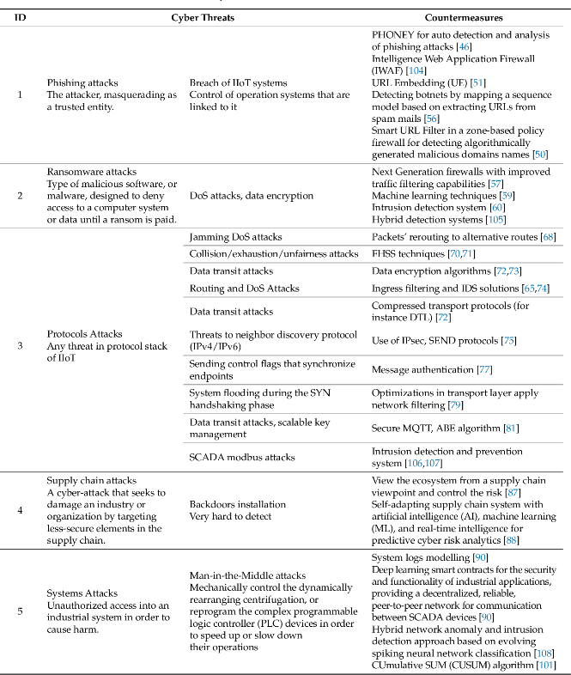
With constant uptake in the use of technology, the increasing need for understanding and knowledge of proper digital and cybersecurity is now becoming essential. There are four general categories and classifications of threats as stated in [6] range based on severity and the possible effect that could happen because of them. They are categorised as direct, indirect, veiled, and conditional threats which are generic threat margins but can be used to define all types of threats ranging from physical to digital/cyber threats and exploits. With the constant threat of exploitation, we must first understand and review previous mistakes. Then, we can discover and implement fixes and mitigations to the researched problems from analysing those last breaches. With the table below found in [7], we can see an example of possible investigation and analysis of cyber-threats in real-life systems and what countermeasures were used:
Table 1 - An overview of cyber threats and countermeasures. Adapted from Tab 1, [8]
The number of exploits that occur every day is unimaginable. Still, only some successfully do severe harm or gain access to systems because new countermeasures are constantly being developed. As a result, exploits are becoming more sophisticated to avoid and bypass the mitigation techniques that have been put in place. Digital risks are a constant pressing concern relating to and preserving information resources. Most frequently, prospective outcomes of digital strikes are sensitive knowledge. They can lead to the theft of sensitive and vital data, such as medical information. They could impede computer and phone operations and deactivate systems, delivering information that is tough to access. The idea that digital risks may alter how we conduct our lives is not overstated in the least.[8]

2.2 Cyber-Exploitation and Espionage
Cyber Exploitation, or Cyber Espionage, is a massive area within the cyber domain; it covers anything from hardware exploitation to cyber espionage and data exploits. Although no specific definition exists for cyber exploitation and espionage, a few quotes represent the overall area. As said by H. Lin, “Cyber espionage, also known as “cyber exploitation, can be understood as “the use of actions and operations—perhaps over an extended period—to obtain information that would otherwise be kept confidential and is resident on or transiting through an adversary’s computer systems or networks.”[9].
Attackers have become increasingly adept in constantly invading companies' networks and maintaining covert monitoring as cyber exploitation becomes more sophisticated. As technology advances with new safeguards designed to stop illegal activity, cybercriminals are also integrating mechanisms and developing ways to bypass these safeguards. From this, a key point to understand, as stated in [10] is that “When a system is identified to be vulnerable through multiple exploratory efforts, this becomes an easy pass into the network.”
As I. Kara notes:
Cyber-espionage and intelligence are the activity of infiltrating computers and other devices to collect or destroy information through hacking or other techniques without the knowledge and consent of the target. Therefore, cyber-espionage and intelligence activities can affect critical areas of countries such as military, energy, health, and political areas. [11]
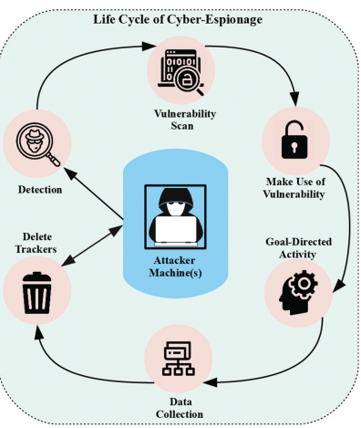
To mitigate and lessen the likelihood of any organisational data being destroyed, thorough analysis and data security are crucial, given the endless possibility of exposure to any exploit or vulnerability. As a result, cyber espionage is being brought to light, and pertinent analysis and statistics are being developed to show all possible methods by which a "hacker" enters the system through cyberattacks. A perfect example and demonstration of the mindset and techniques used by hackers when attempting to exploit a system are illustrated in [11]
Figure 1- Life cycle of cyber-espionage and intelligence activities. Adapted from Fig 1, [12]

With constantly discovering new approaches and methods, the diagram above clearly shows that all attack methods follow the same structure. Based on the sensitive data sought, the entity carrying out this action, and the environment in which it takes place, cyber espionage can take many forms. The only thing that changes is either the method used to exploit a system or the approach to each step may differ. Because of several factors, including the fact that massive quantities of confidential data are stored in the cyber domain, this makes a resource-rich haven for cyber infiltrators to target, and the ease with which they can access this data thanks to cyberspace's immediate numerous forms of espionage has increased exponentially since the development of the internet. [12].

2.3 Types of Cyber-Exploits/Cyber Attacks
Cyber-Exploits and attacks can take many different forms, from physical intrusions and assaults to using toolkits to take advantage of a vulnerability that has been identified; the potential and breadth of many attack vectors are expanding daily. The range of assaults that may be utilised depends on the targeted area/layer and the many IoT layers that must be considered while focusing on a particular spot. The Industrial Internet of Things (IIoT) is one of several subfields that make up the Internet of Things (IoT). Within the IIoT framework, an excellent example of the layers, what they entail and what possible attack vectors could be used is seen in [7]
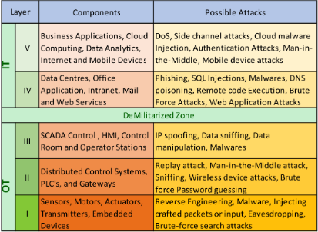
With so many layers of IoT systems, the ones demonstrated above are only some of the most basic attacks and possible vectors out of thousands available now. The main issues and exploits used in real-time and are the most common based on previous and recent confirmed cyber attacks are Social Engineering, Ransomware and Phishing; these have been chosen as these have shown up the most often within the recent vulnerability exploits and data breaches. The most recent attack based on Social Engineering was the Marriot Data Breach [13] which confirmed that a total of 20GB of member data, including credit card information and confidential documents, were leaked via Social Engineering. Also, other known attacks were during the recent COVID-19 pandemic, where SE became a massive problem due to hackers using the opportunity of vaccine appointments to gain personal medical information from patients.
Figure 2 - Layered IIoT architecture and possible attacks. Adapted from Fig 1, [8]

As investigated and explained by S. Venkatesha:
The public health emergency brought on by the COVID-19 pandemic, the fear, anxiety, and uncertainty present in the general public, and the desire for information on the pandemic present the ideal opportunity for exploitation by cybercriminals deploying SEAs. When news about the pandemic made headlines in the early months of 2020, SEAs with the over-arching theme of the pandemic shot up in frequency. [14]
Due to this problem, Social Engineering became and is still a major attack vector used to exploit vulnerable individuals. But there is also the major issue of susceptibility to ransomware within organisations; this became a major problem due to the emergence of the information/vulnerabilities obtained by hackers in a previous attack which allowed other collectives of hackers to install ransomware within an organisational system. The main recent attack in this manner was on the company Nvidia which is a significant company in creating processors and computer components which run everything. This attack saw substantial parts of its business shut down for two days and over 1TB of confidential data stolen. [15]
The efficiency of our mitigation techniques and these exploits’ impact on our systems must be further examined in light of these vulnerabilities. The three most common cyberattacks will be discussed in more detail in the following phase of the review, which also aims to increase your comprehension of the problem's size and what needs to be done.

2.4 Social Engineering
Operations using social engineering have posed a significant security risk to the internet. Nevertheless, there remains a lot we need to understand concerning how and why social engineering techniques work. Social Engineering awareness and understanding are now crucial to cybersecurity and data protection. We must investigate and analyse further. Still, we must first understand what social engineering entails. As stated by W. Zuoguang:
In the context of computer and cyber security, social engineering describes a type of attack in which the attacker exploit human vulnerabilities by means such as influence, persuasion, deception, manipulation and inducing, so as to get classified information, hack computer system and network, obtain unauthorised access to restricted areas, or breach the security goals [16]

If appropriately used, we see that this method of social engineering is a massively practical way for a hacker to gain unauthorised access to a system by using the human error method. Social engineering has become a popular attack method among hackers since the late 1960s and early 1970s. In contrast to conventional vulnerability exploits, social engineering attacks focus on subjugating human attack vectors to get around or get past security hurdles without dealing with network security or intrusion detection and prevention software by deep programming. Furthermore, there isn't a computer system that isn't dependent on or includes human elements.
These human factors may either be heavily exploited as security flaws by skilled attackers or are intrinsically vulnerable. As the technological evolution of our cyber domain continues to grow, so do the numerous different methods of social engineering, from the use of well-known social platforms such as Twitter, Discord or Facebook, to simple emails that can give hackers access to personal and critical info that they can use to either cause harm in an organisation or to exploit the targeted victims further. Within the course of the evolution of the Social Engineering attack vector, the diagram demonstrated in [17] gives an excellent simplified conceptual analysis of the progression and development of the SE attack vector:
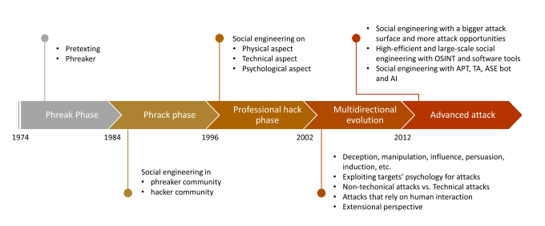
Figure 3 - The conceptual evolution of social engineering in cybersecurity - Adapted from Fig 1, [18]
The figure demonstrated is separated into five sections with their periods also stated to show the development of Social Engineering since it first was discovered/became aware of in 1974. This scale offers a relative evolutionary scale that we can follow within the development of SE. The SE attack vector’s growth has allowed more exploitation through open-source information gathering, or OSINT.

Open-Source Intelligence (OSINT) historically referred to a particular intelligence source. Generally speaking, intelligence sources generate original data that can be analysed further over the six stages of the intelligence cycle to yield insights. Open-source intelligence is information derived from publicly accessible sources that are gathered, utilised, and distributed promptly to the target demographic to answer a particular purpose or need. [18] The development of huge data systems and database mining technologies has made it possible to use open-source intelligence (OSINT) to create a plausible social engineering attack. Hackers may use publicly accessible information you post online on any website and datasheet to piece together your location, true identity and any other personal information they could get their hands on.
Due to the use and availability of OSINT, A properly planned and executed SE assault may be successful even among users who self-identify as conscious of the social engineering techniques utilised, many alone individuals with little to no security knowledge [19]. It is easy to obtain some background knowledge from social media or the Internet to research certain persons and create a targeted hack. However, this is only one approach towards the SE attack vector. The number of ways to exploit a person is growing daily without any indication of slowing down due to the ongoing expansion of modern cyberspace, which now creates more and more opportunities for successful social engineering attacks to become successful. The phishing exploit is a massive part of the social engineering attack vector that needs to be considered and investigated in more detail.

2.5 Phishing Exploitation
Due to how many online users fall for it, phishing has become one of the significant worries within the cyber domain. It is a type of social engineering in which a phisher uses an automated process to trick people into giving up their private information by pretending to be a reputable or public entity. If the target user believes the message is legitimate, they will expose their data to the attacker. [20] When discussing and analysing a Phishing exploit, we must first understand how it is implemented to target a specific individual. As mentioned by Ghazi-Tehrani & Pontell:
A typical phishing attack begins with an e-mail to the victim, supposedly from a reputable institution, yet actually from the phisher. The text of the message commonly warns the user that a problem must be immediately corrected with the user’s account. The victim is then led to a spoofed website - a fake one designed to resemble the institution’s official website. [21]

When a victim accesses this spoofed website and enters specific information, that information is relayed to the phisher, who can then use the information provided to access accounts, etc. Anything from Bank Details, Credit Card Numbers, addresses etc., any form of personal data can be obtained through this method, which can cause someone’s life to be destroyed. Within the phishing exploit, the vast majority of phishing attempts employ email, around 96% [22].
Primarily knowing that even the lowest number of responses would still result in dozens of victims, these emails were distributed in batches of tens of thousands each to a significant range of addresses. Cybercriminals generally prey on persons who lack a basic grasp of digital/cyber ethics or have received limited training to achieve their objectives. Humans might be vulnerable to phishing based on their traits and level of expertise. Hence, in most attacks, the hacker approaches prey on human nature rather than cutting-edge technologies that could be used. Despite the reality that people rather than technology are at fault for the lack of awareness inside the information security chain, we still do not learn or adapt from when it is first hacked.
Numerous definitions of the term "phishing" have been published and investigated by various professional industries and academic institutions without coming to a successful proper definition. Even though the term "phishing" lacks a universal definition due to its never-ending growth and development, it has been utilised and understood in several ways, depending on the circumstance. The act of tricking the recipient into doing the assailant's planned action is the unofficial and conventional definition of phishing assaults in particular.
Now that the basic scope of phishing has been presented, it’s essential to review and understand the proper process and mindset the phisher has to carry out an attack successfully. The design demonstrated in [20] gives a brief but clear picture of the steps and processes one must complete and exploit a target and the full life cycle of the phishing process [23]. The generality of the diagram gives an idea of what methods and structure an attack must have to be successful:
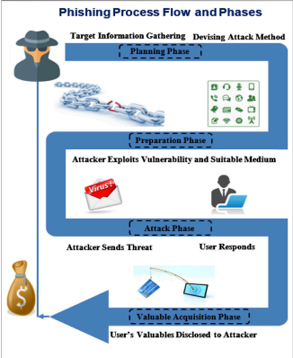
As the primary method of penetration and infiltration and the primary tactic used in social engineering attacks, phishing is one of the direct and key vectors for malware infection, as stated in [24], where over 90% of detected cases and exploits within the year 2018 were some forms of malware/phishing exploit. The number of phishing vectors will increase as technology develops. Malevolent individuals will probably figure out how to exploit these new vectors in even more sophisticated, cutting-edge phishing attacks. Phishing now encompasses world power assaults, cyber warfare, internet fraud, reputational harm, collecting confidential material, embezzlement, and economic crimes. Due to the diverse character of the attack type, which may be inferred from a wide range of sources and research, it is evident that there is yet to be a solution to the phishing exploit.
Figure 4 - General phishing attack process – Adapted from Fig 1, [21]

2.6 Ransomware
Digitalisation and interconnection have made it simpler for hackers to plan and carry out large-scale breaches that target individuals and companies all across the globe. By getting over the security measures put in place and created by organisations, hackers continue to expand the scope of cyberattacks rapidly. To steal sensitive information and demand a ransom from the owner, malicious hackers exploit all possible opportunities within vulnerable organisations and individuals. This is known as the ransomware exploit/attack. As said by A. Kapoor:
Ransomware is a form of malware that infects a computer or multiple computers over a
network, encrypting files and folders and rendering them unusable. Users are then prompted for a ransom, typically to be paid in cryptocurrency. Ransomware is not a new threat, but its use is surging and causing heavy financial losses all over the world. It is a major challenge for cyber-security analysts and Reverse Engineers as typical Ransomware is
not detected by anti-virus software due to its polymorphic nature. [25]
The earliest instances of ransomware surfaced in the 1980s and 1990s. The first ransomware, the AIDS Trojan, was spread through a floppy Disc. Since then, ransomware organisations have grown and caused billions of pounds worth of economic damage. But in recent years, ransomware has become a more severe problem daily. In 2020, the company Sophos [26] reported that around 51% of responding organisations had confirmed that this attack had hit them that year. Which was a drop of 3% since 2017, but according to Sophos, this is due to “a change in tactics from the ransomware actors rather than a reduced focus on this type of attack”[26]. With ransomware being such a massive area of exploitation with numerous different possible attack vectors, there is no natural way to monitor and measure every event that has happened to every organisation due to ransomware. Still, the diagram within [27] gives a proper and rough design to show the evolution of the ransomware attack vector from its first modern origin in 2005:
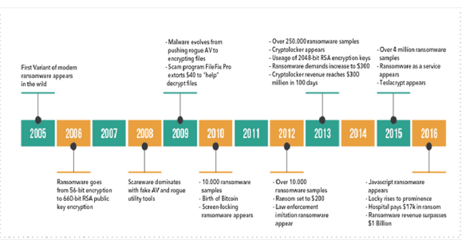
Figure 5 - Evolution of Ransomware - Adapted from Fig 7, [27]
There are two primary classifications of ransomware, Crypto Ransomware and Locker Ransomware. Crypto ransomware is the currently most used ransomware by hackers; this malware infiltrates the victim's system via cunningly designed ways, encrypting any data it discovers.
The intruder publishes a message once the files have been encrypted, informing users that access to the data will be lost until a ransom in digital currencies is paid. The data security and protection threat this specific ransomware poses is now becoming the most significant threat within our cyber domain. [28] This has been confirmed as the most effective method of exploitation within organisations, as the infected user often panics and ends up paying a ransom to retrieve their files. Throughout history, hackers have become more proficient at making it difficult for reverse engineering and decryption to release data without first being paid a ransom. Hackers increasingly mix symmetric and asymmetric encryption methods [29] to make them harder to crack. Because of its quickness, the victim's data is encrypted using a symmetrical approach. The key is then protected using the rogue intruder's public key.
If used correctly, Locker ransomware will encode particular documents that might restrict access to the computer screen and keyboard. However, it is typically simple to get rid of. It can be frequently fixed by restarting the computer in recovery mode or running the internal and built-in antivirus scanning software [30]. There is one significant difference between locker and crypto ransomware. Where crypto ransomware cannot be decoded in full without paying a ransom or with a specialist’s help, locker ransomware typically be resolved by moving the infected drive around.

As stated by Richardson and North:
Locker ransomware only locks the device; the data stored on the device is typically untouched. As a result, if the malware is removed, the data is untouched. Even if the malware cannot be easily removed, the data can often be recovered by moving the storage device, typically a hard drive, to another functioning computer. This makes locker ransomware much less effective in extorting ransom payments. [31]
One of the most pressing issues in the digital world today is ransomware. The belief that businesses regularly back up their digital assets and do a great job of securing them has been dispelled by the assaults' frequency and the publicity they produce. Ransomware attacks have been on the rise in recent years, rising dramatically across all spheres of life and affecting businesses, individuals, and whole sectors. With the consistent increase in our technological dependability and use, the ransomware problem will continue to increase continuously.
It is reasonable to assume that today’s technology does not provide a complete security system to shield both small and large enterprises from the possibility of a ransomware attack. As a result, businesses must regularly spend money on cybersecurity protection and legitimate penetration testing services and periodically update and tune organisational security policies to address emerging threats. Without proper understanding and protection against ransomware, the only option would be to accept the demands and pay the ransom. It is essential that each organisation and individual is aware of the problems and knows never to adhere to the ransom requests.

2.7 Summary of the Literature Review
A number of cyber security challenges, including the types and methods of cyber exploits, the effects they have on individuals and organisations, and the potential for development, are covered in this literature review on modern forms of cyber-exploitation. The assessment demonstrates how complex and intricate assaults have become, with attackers increasingly focused on social engineering, phishing, and ransomware.
The literature review also highlights how severe and pervasive cyberattack impacts may be, affecting not just the individuals and institutions attacked but also society as a whole. With the intention of giving sufficient background and broad knowledge to be utilised within the implementation and demonstration phase, this literature review has concentrated on the most problematic areas that are presently causing significant harm to our contemporary civilization. The fundamental ideas and reviewed material will be applied to the covered cyber-exploits in order to complete a form of implementation. This study will also be utilised to identify future mitigation strategies and maybe even improve security.

2.8 – Researched Tools for Implementation
As more and more ways to carry out implementations become available every day, it is crucial to do fundamental tool research to determine if it will be able to serve as the principal tool for the exploitation of choice. The sheer number of tools available makes it difficult to focus our study, but ultimately, we must choose which ones will operate inside the Kali Linux VM without the need for any extra licences or prohibitive memberships.
For the Social Engineering Implementation there were several Social Media Channels available to use, but the most suitable was Discord , as many real-time exploits happen on this platform as well as the accessibility allows multiple accounts to be connected to each other allowing ease-of access into the demonstration and evidence capture for this exploit. The phishing exploit raises another matter of research as there are numerous suitable options to consider, everything from the Social Engineering Toolkit [32] which contains numerous possible functions to a phishing specific tool such as Social Phish[33] or Zphisher[34].

Unfortunately, during the research phase into the tools a few hurdles were found which were the dependencies that many of these tools had which was a ngrok server licence – ngrok is an online web service that allows dedicated http servers to be created and hosted [35]. Due to the internal terms of service which disabled any account attempting any form of web exploit even through a simulated environment. Figure 6 shows the full conversation after the test account was banned:
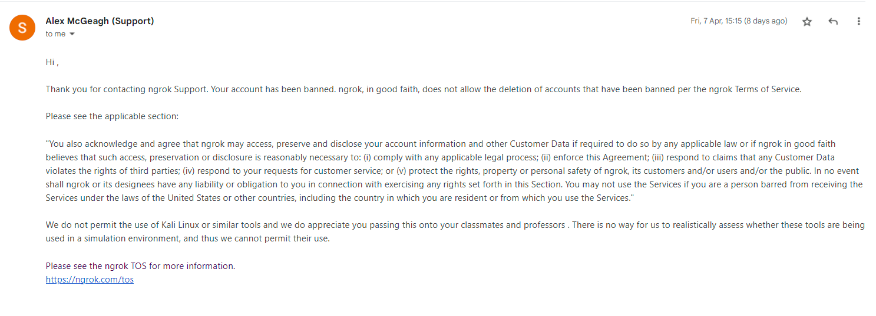
Figure 6 - Email from Ngrok detailing banned account reasons.
Since there were fewer tools available, Zphisher, a comprehensive credential harvesting phishing tool that covers many social media sites and allows for substantial customization, was chosen for this implementation after careful consideration and comparison across numerous tools. Due to its compatibility, suitability, and conformance to the selected exploit's timeframes, this tool was deemed the most suitable.
In light of the Ransomware exploit's unique characteristics and execution, the options for showcasing its implementation were limited. Traditional tools were inadequate as the ransomware had to be downloaded directly onto the target device and not through a specific tool. Nevertheless, a solitary tool, RanSim[35], was at our disposal to exhibit the target machine's vulnerability to different forms of simulated ransomware.

2.9 Conclusion
This report discusses various exploits and attack vectors used to exploit and take advantage of people and organisations. Understanding and research are essential given the constant evolution of our cyberspace, especially concerning cyberterrorism and espionage. It is necessary to modify and improve the security procedures and mechanisms to address the existing exploitations. In addition to using specific software and malware, many attacks also use human weakness, as this review has demonstrated. It is evident that to advance technologically, we must first address the issue of human susceptibility by applying security awareness training and fundamental security knowledge to prevent and recognise phishing scams and social engineering attacks effectively.
Research has been carried out to reveal the inner workings of each targeted exploit and how they've evolved and progressed since the internet's founding. This information analysis will allow for future implementations and demonstrations, ultimately allowing better mitigation strategies to be created and tailored to each exploit. Due to the vast extent and complexity of the many attack vectors, even if human weakness is our domain's primary vulnerability, we must constantly analyse and review our security procedures to guarantee that it remains intact.

3. Research Methodology

3.1 Research Overview
Research and Methodology are key factors within any project to understand and achieve the project’s goals. As said by S. Rajasekar:
Research methodology is a systematic way to solve a problem. It is the science of studying how research is to be carried out. Essentially, the procedures by which researchers go about their work of describing, explaining, and predicting phenomena are called research methodology. It is also defined as the study of methods by which knowledge is gained. It aims to give the work plan of the research. [36]
The methodology is a key factor in achieving a successful research project. This chapter aims to provide an overview of the complete research process recommended to achieve the goals and ambitions outlined in the earlier section. The creation of this methodology will be based on the Saunders Research Onion [37], which gives an outline of example research methods and ways of conducting a proper methodology investigation:
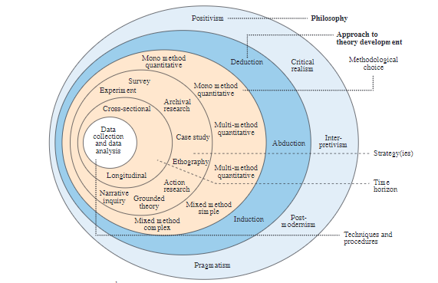
Figure 7 - Adapted from [Fig 1, 33]
The research onion provides a rather laborious description of the fundamental layers or procedures required to construct a successful approach. Setting deadlines, choosing tactics, techniques, and strategies, as well as establishing the main philosophy, are the first steps in the process. Together, these phases transfer the research rationale to the study design, which encompasses the fundamental methods and processes for data collection and analysis.

3.1.1 – Research Process
This research project's objective and aim are to demonstrate and employ a greater understanding of the current state of our Cyber-domain in regard to exploitation standards, and to give a detailed overview and investigation into how the most severe and common attacks are being used to exploit individuals and organisations. The research procedure has already covered a wide variety of topics, and additional research and design will be necessary to implement and produce a sufficient level of detail in the implementation, which will demonstrate the overall susceptibility and vulnerability that our today's cyber-domain. The study has previously included and will continue to contain a combination of both inductive and deductive research. This may range from specific statistical analysis to developing patterns and implementations.

3.1.2 – Research Philosophy
In the previous section, it was stated that the use of both inductive and deductive methods within the project would use a Pragmatism approach within the research philosophy, which includes a mix of qualitative and quantitative data collection. The research philosophy approaches are demonstrated within [38] and [39]which encompasses countless areas to associate with when writing and creating a research article and report:
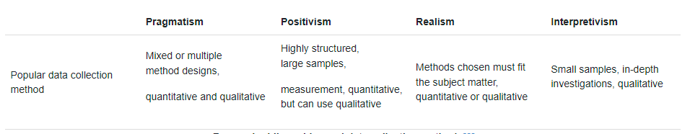
Table 2 - Research philosophies and data collection methods
Pragmatism has both qualitative and quantitative data, that it offers an overview of numerous topics, and that it covers innumerable areas rather than just one single subject. This is one of the impressions that it makes. The scientific school of thought known as pragmatism maintains that ideas are worthy of study only in as much as they lead to the accomplishment of useful goals. In the school of thought known as pragmatism, the research question is regarded as the single most important component in deciding the research philosophy. The nature of the research topic being addressed may determine whether or not pragmatics can successfully combine positivist and interpretative perspectives within a single body of work; nonetheless, this is possible. As a result, this methodology is the best option for the research and additional work done for this report.

3.1.3 Research Methodologies
The approaches that have been used to complete this project have evolved in response to the requirements of the information that has been obtained. In the course of the research process, a variety of investigative case studies, as well as instructive papers and articles, have been compiled. It is safe to state that this research report will use a combination of different research methods. Both the system for doing research that draws on aspects from both quantitative and qualitative research approaches, as well as the phrase that is used to characterise such a strategy, are referred to together as "mixed methods," which is the name of both systems.
The system itself may be referred to as a "mixed-method approach." Compared to doing research using either quantitative or qualitative techniques alone, using a mixed-methodologies approach, which incorporates both quantitative and qualitative methods, may give a more complete and all-encompassing view of the situation. Because the mixed-methods technique combines quantitative and qualitative research, it is used.

3.1.4 Data Collection
This project will employ a mixed-method approach, outlined throughout this section, covering everything from produced informatic tables to timelines and statistical data. The Different resources used and analysed within this project will be discussed and described throughout their use within the specific area. The created table below demonstrates a brief example of the types of research methods and data collection used within each completed section of the research project:
Section/Area of Research | Research Method Used
2.1 Introduction | Qualitative Research – overall state of our cyber-domain  Quantitative Research – review of the previous attack statistics  Action Research – Analysis of the last findings and give understanding
2.2 Cyber-Exploitation/Espionage | Qualitative Research – Literature Review with diagrams  Action Research – Analysis of the last findings and give understanding.
2.3 Types of Cyber-Exploits/Cyber Attacks | Qualitative Research – Literature Review with diagrams  Action Research – Analysis of the last findings and give understanding.
2.4 Social Engineering | Qualitative Research – Literature Review with diagrams  Action Research – Analysis of the last findings and give understanding.
2.5 Phishing Exploitation | Qualitative Research – Review of previously peer-reviewed articles and resources  Quantitative Research – Use of statistics and findings into phishing exploits yearly.  Action Research – Analysis of the last findings and give understanding.
2.6 Ransomware | Qualitative Research – Review of previously peer-reviewed articles and resources  Quantitative Research – Use of statistics and findings into phishing exploit yearly.  Action Research – Analysis of the last findings and give understanding.
Table 3 - Research Methods Used within the Project
Data collection is a vital component of the finished product; each part of data collection must have relevance to the ultimate objective and result, and each piece of the data must be able to be related to the finished project in some way, shape, or form. With each amount of data, the answer to the problem should become clearer until a successful conclusion can be made.

3.1.5 Research Design and Methodology Outline
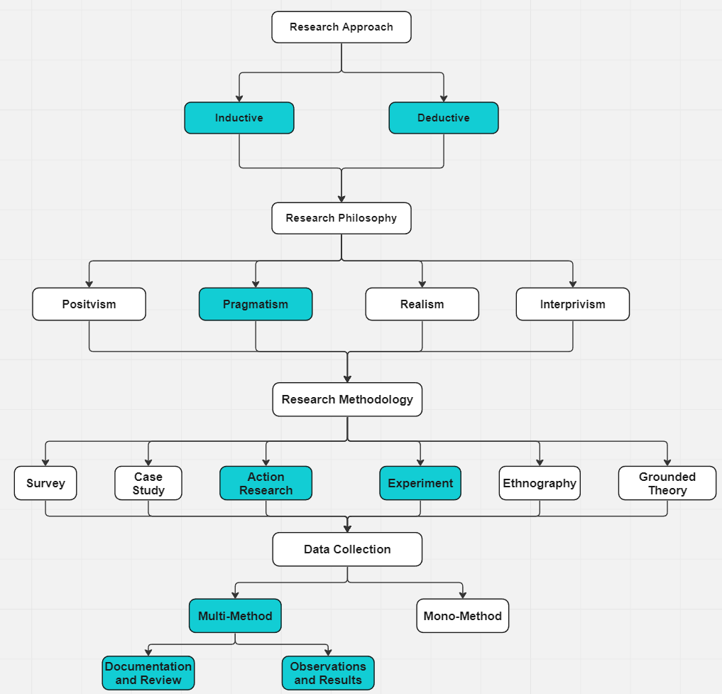
In order to accomplish the goal of the study and to bring together the operations, an action plan is needed. This plan must lay out the methodologies that must be used in order to examine, analyse, and derive the topics of relevance that are necessary to enable effective implementation. With the support of the research design, which provides them with a methodical approach by their side, a researcher is able to continue their trip into the unknown. In order to establish the nature of the investigation that will be carried out, a researcher will choose, among a wide range of possible approaches, the methodology that will serve as the basis for the research project's layout. A brief overview and diagram is provided to give an outlook into the full research methodology design that the project will follow:

Figure 8 - Research Methodology Flowchart
The goal of this project is to follow this framework as accurately as is reasonably possible given the circumstances. Using this design will establish a reliable structure that will guarantee the achievement of the presented study aims in a completed and thoroughly analysed manner. The suggested design will provide a concrete example of what the implementation should cover, and sufficient data will be obtained to arrive at a conclusion and define the project's potential.

3.1.6 Research Deliverables
The purpose of this research project is to build and provide improved information in addition to various strategies for mitigation that may be used to answer the research question. The research associated with the project will be carried out to achieve this objective. The implementations that are provided will, one, give an understanding of how hackers and exploiters use the specified attack in the real world, and two, provide the necessary information required to either identify the exploit before it is implemented or, if it is successfully implemented, how to counteract it. Both of these goals will be accomplished as a result of the project.

3.1.7 Gantt Chart
In order to keep moving forward with a project that has been successful so far, we need to have a timetable that we can adhere to, as well as a backup plan in case everything else falls through. This can be shown in a Gantt Chart. As stated by M. Mulders:
The Gantt Chart is the very insightful graphic representation of the activities that have to be carried out in a plan. The Gantt Chart consists in two parts. The first part is text and figures, and the second part is graphics. The Gantt Chart gives a graphical overview of the activities in a project. It provides direct insight into the status of a project in relation to the throughput time, dependencies, and progress. [40]
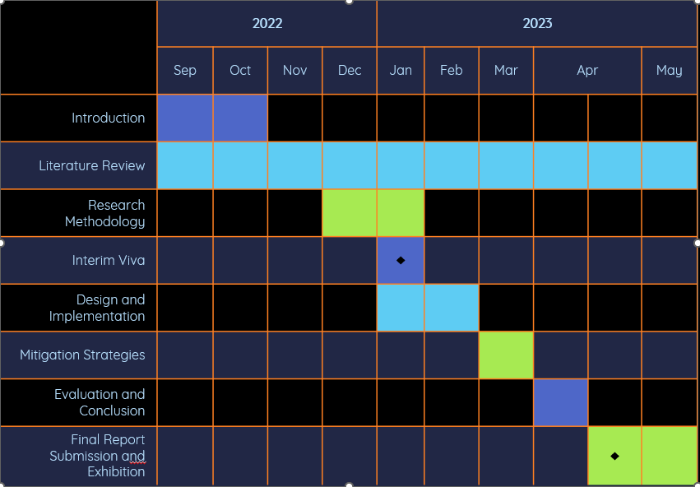
The detailed Gantt chart for the project has been marked with all of the pertinent parts and deadlines using the appropriate colour coding and adequate text headers to indicate clarity.
Figure 10 - Gantt Chart of Project

3.1.8 Contingency Plan
In this project cyber exploits will be implemented, and a backup plan should be prepared to investigate, put into action, and lessen the impact of any possible harm. The first thing that has to be done is to cut power to the impacted systems and launch a comprehensive investigation to figure out how extensive the damage is if it was to exit the simulated environment. After the investigation, urgent action should be made to install security fixes and upgrades to prevent future exploitation of the vulnerability and further damage to internal systems.
Another crucial area to consider is the implementation of these tools and they’re after effect on the target machines if they were to function correctly. Regarding this, if something were to fail, it is essential to identify why it failed and if discovered, document and fix the problem, and if the problem is not discovered then it would be necessary to adjust and find an alternative tool to be used within the implementation or adjust the way the implementation will be conducted.
In the end, mitigating the risk should centre on any flaws or vulnerabilities that made it possible for the exploit to take place, as well as on putting in place measures that will improve the security posture of the compromised systems. If any security issues prevented any of the project’s exploits from being implemented, then relevant adaptation and investigation would be used to identify an alternative to be used.

3.2 Conclusion
This part of the project has covered various subjects and aspects, starting with the approaches and philosophies used for the preliminary research. Creating an appropriate design is essential to guarantee this project’s success. It is obvious that to complete this project successfully, the data collection methods will need to refer to the ultimate goal of the project, and the implementation will need to provide the understanding as well as sufficient data to enable the creation of adequate mitigation strategies that would lead to a concrete conclusion. Both of these requirements need to be met to be successful. This will ensure that a research effort that is both comprehensive and effective will be successful.

4. Design and Implementation

4.1 Overview of the Implementation
To begin the implementation phase, we need a well-structured design and knowledge of the tools and equipment required to finish the successful implementation phase effectively. Only then can we begin the phase. As stated by D. Ensminger:
In recent years, instructional designers have taken a more active role in the change and implementation of innovation. This trend places designers in the role of change agents and implementers of innovations. It also requires that they become more familiar with variables that can influence the implementation of both instructional and non-instructional innovations. [41]
The breadth of complexity involved in a good implementation steadily grows as daily innovations, and new deployments are generated. Many modern developments, especially in technology, could be more stable and of better quality. An outdated technical gadget is more likely to malfunction, have issues, and be difficult to operate. Potential users of such systems would have to pick up new technical skills, which many individuals delegate to a specialised team rather than handling alone. So, a long-term strategy that can be applied to various institutions and organisations is desirable, necessitating a well-thought-out structure and design for the intended implementation.

4.2 Blueprint of the Implementation
During the implementation phase, it was necessary to design an appropriate blueprint and structure of the process that would be carried out throughout the implementation. As stated by L. Rila:
A flowchart is a diagram depicting a process, a system, or a computer algorithm. It is a diagrammatic representation of the solution to a given problem, but, more importantly, it provides a breakdown of the essential steps to solving the problem. When designing and planning a process, flowcharts can help you identify its essential steps and simultaneously offer the bigger picture of the process. [42]
The value of having a design that is both effective and comprehensive Is now of the utmost importance to ensure success with the least amount of risk topology of the planned implementation, it should cover all bases, from the expected outcome to what course of action may need to be taken if an area of the implementation fails. The created topologies of the implementation are shown in Figures 9 - 13. This topology accounts for every planned attack vector and every important decision and includes fallback plans if anything goes wrong. To simplify things and clarify everything, the various functions have been given corresponding colour schemes as listed.

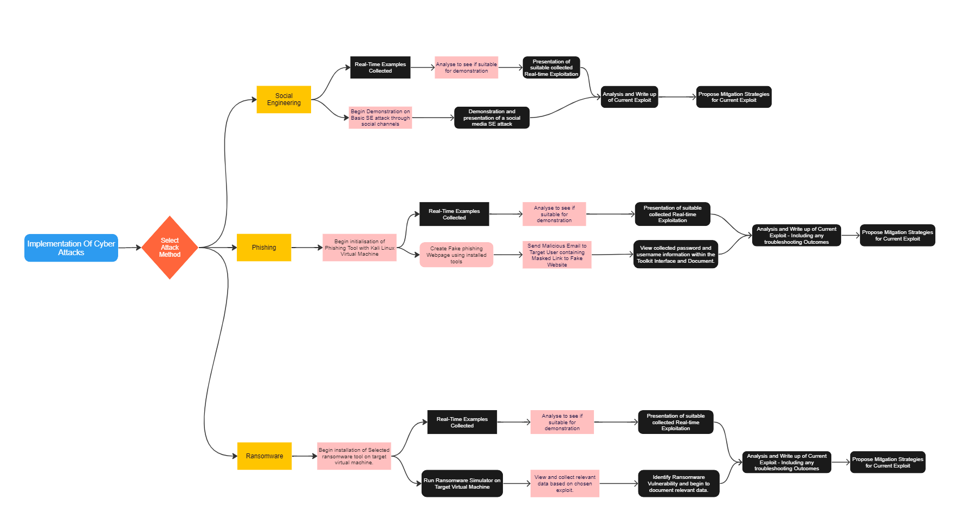
Key
- Decisions
- Actions
- Results
Figure 11 - Full Implementation Blueprint

4.3 Social Engineering Implementation
The goal of social engineering is to exploit weaknesses in target users in order to get access to private data, resources, or infrastructure. Following careful preparation and analysis, the assault portion of a social engineering campaign begins with the execution phase. The social engineer now puts their talents to the test, attempting to convince their victim to provide sensitive information or do an action that weakens their defences. Achieving desired results during implementation calls for meticulous planning, thorough analysis, and flexibility.

4.3.1 Plan of this Implementation
In this section, we'll delve into a diverse real-world implementation scenario, each showcasing a novel perspective on potential social engineering exploits that can be leveraged against IoT devices and platforms. From email to chat systems and social media, we'll explore the latest communication channels that are increasingly vulnerable to cyber threats. The relevant flowchart in Figure 10 is shown below which outlines the flow of this implementation:
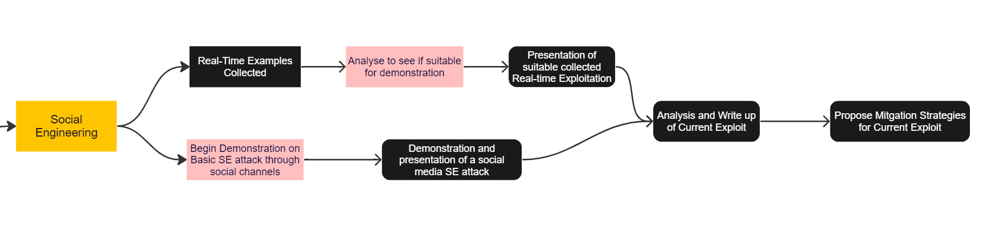
Figure 12 - Social Engineering Implementation
Figure 10 depicts the comprehensive structure of this implementation, which includes a physical implementation as well as real-time exploitation and how they are joined together. Next, all of the pertinent facts discovered or discussed will be compiled in this part, and preparations will be made for the development of mitigation methods. With this implementation being based on a real-time recorded attack by a third party with me as the target.

4.3.2 Implementation
As new social media platforms emerge, the demand for heightened security and awareness has become more pressing than ever. Take, for example, the notorious gaming and social platform, Discord, which has become a hotbed for “scammers” [43] to undertake social engineering attacks, with groups of users collaborating to orchestrate elaborate scams and manipulate unsuspecting victims. Below are outlooks into captured real-time scam across the Discord platform which I personally undertook:
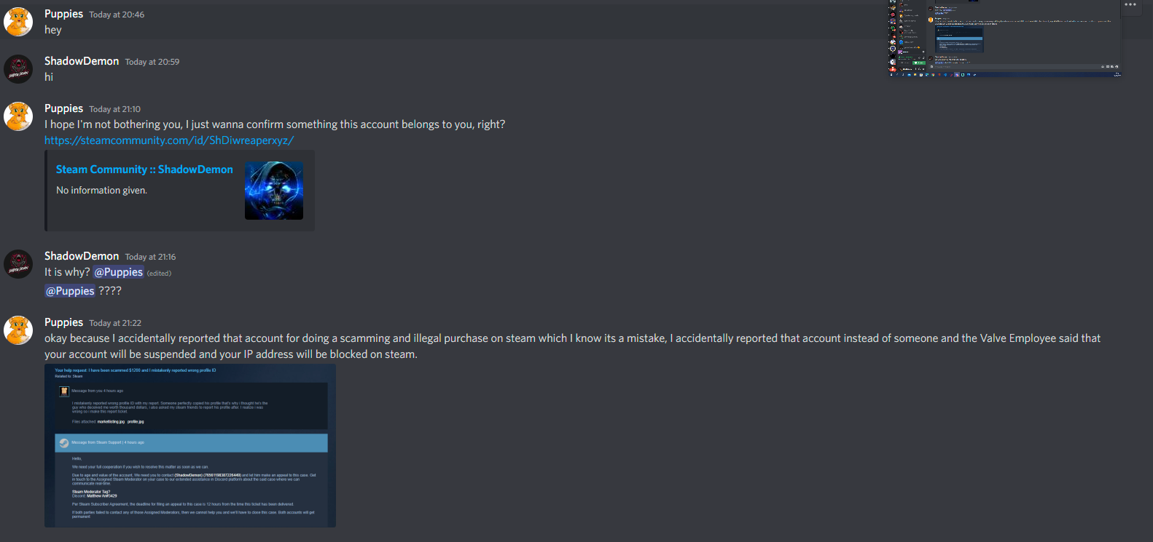
Figure 13 – A Screenshot of First Contact with First Scammer (“Today” refers to events on 12/10/2022)
The scam was layered in many steps with the initial being the first scammer pretending to be a victim with a fake report to the Steam Community (Steam being the biggest PC gaming platform) which led them to try to play the victim to initially get a response from the reported user. Within this scenario I (Discord ID – ShadowDemon) was targeted by both scammers (Discord ID’s – Puppies and Matthew Ann) with the intention of compromising my steam credentials and gaining access to my account.
Figure 11 demonstated the first scammer (Discord Id – Puppies) intitalising contact with the reported victim (which was in this instance me with my Discord Id – ShadowDemon) and begins the process of attempting the scam, with the initial steps of posting public links to online profiles and using a fake support image that that demonstates that the user was reported. The First Scammer conversation continues within Figure 12:
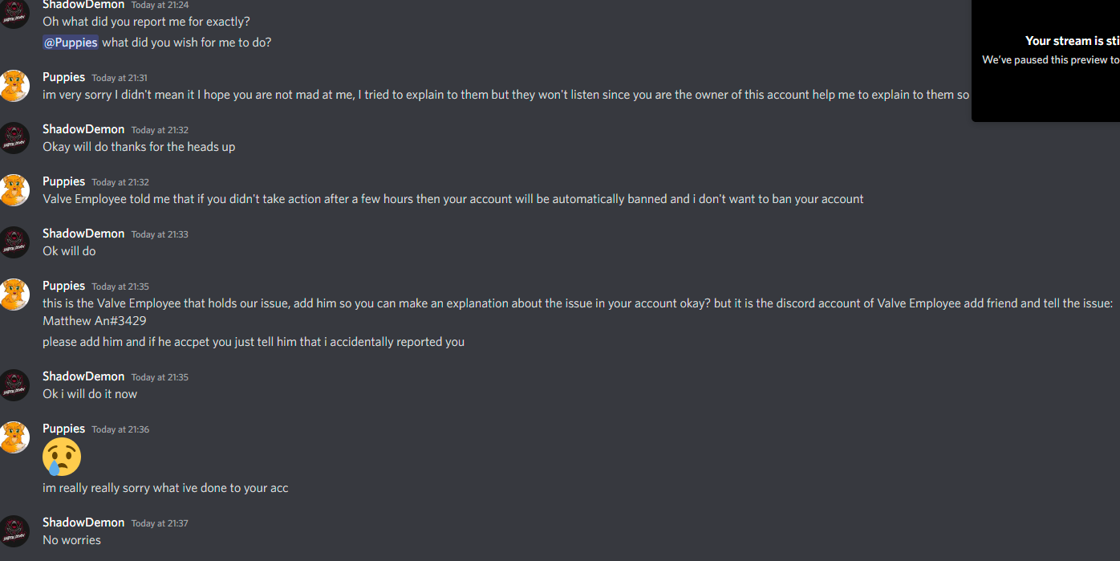
Figure 14 - A Screenshot of Conversation with First Scammer (“Today” refers to events on 12/10/2022)
The converstation continues where the scammer explaines that I (Targeted User) was mistakenly reported for fake account details and illegal activity, and refers me to their accomplis/second scammer(Discord Id – Matthew Ann) where they maskerade as an employess of Steam, in an attempt to cooerce the target user to give relevant creedentials and user verification to the Fake employee. It is also easy to see that the first scammer continues to give off the impression of being absolutely innocent, while making a few glaring grammatical errors, which we will make reference to when we are talking about the tactics that may be used to mitigate the risk in a future section.
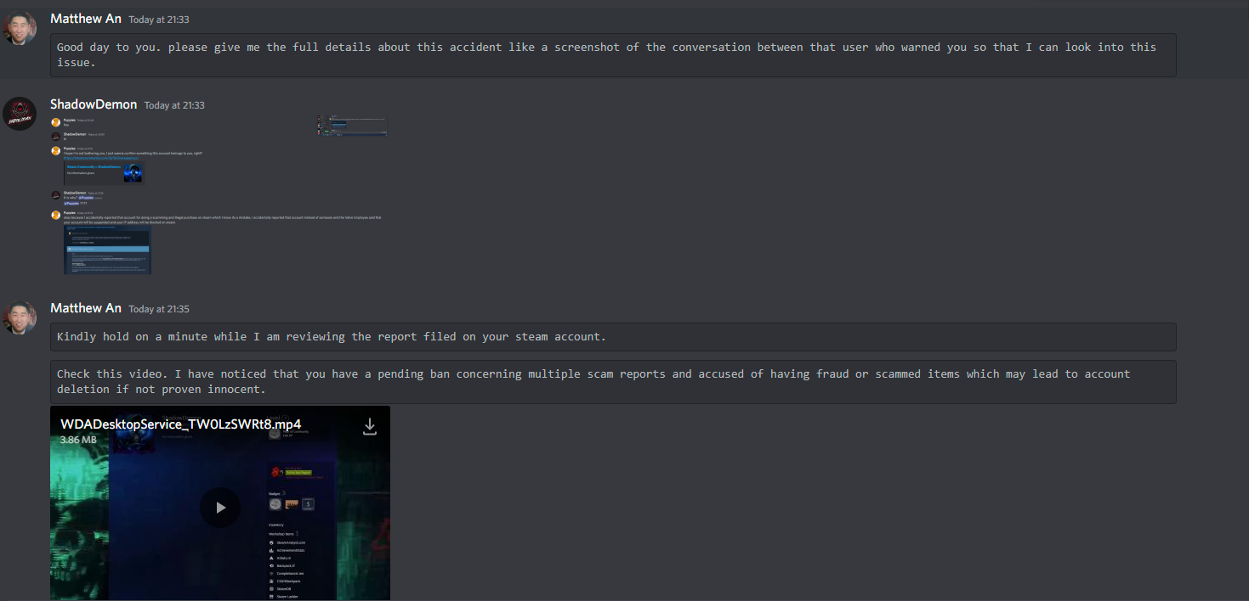
Figure 15 - A screenshot of First contact with Second Scammer (“Today” refers to events on 12/10/2022)
The next intricate phase of this scam attempt was the connection to the second scammer, who is a Fake Valve Employee (Valve = Steam).
As shown in Figure 13, the scammer starts the conversation by trying to determine which of their colleagues has referred you by asking for a screenshot of the first scammer's conversation. After this, the scammer proceeds to show a fake recorded video that shows the account being disabled, which after personal verification was fabricated.
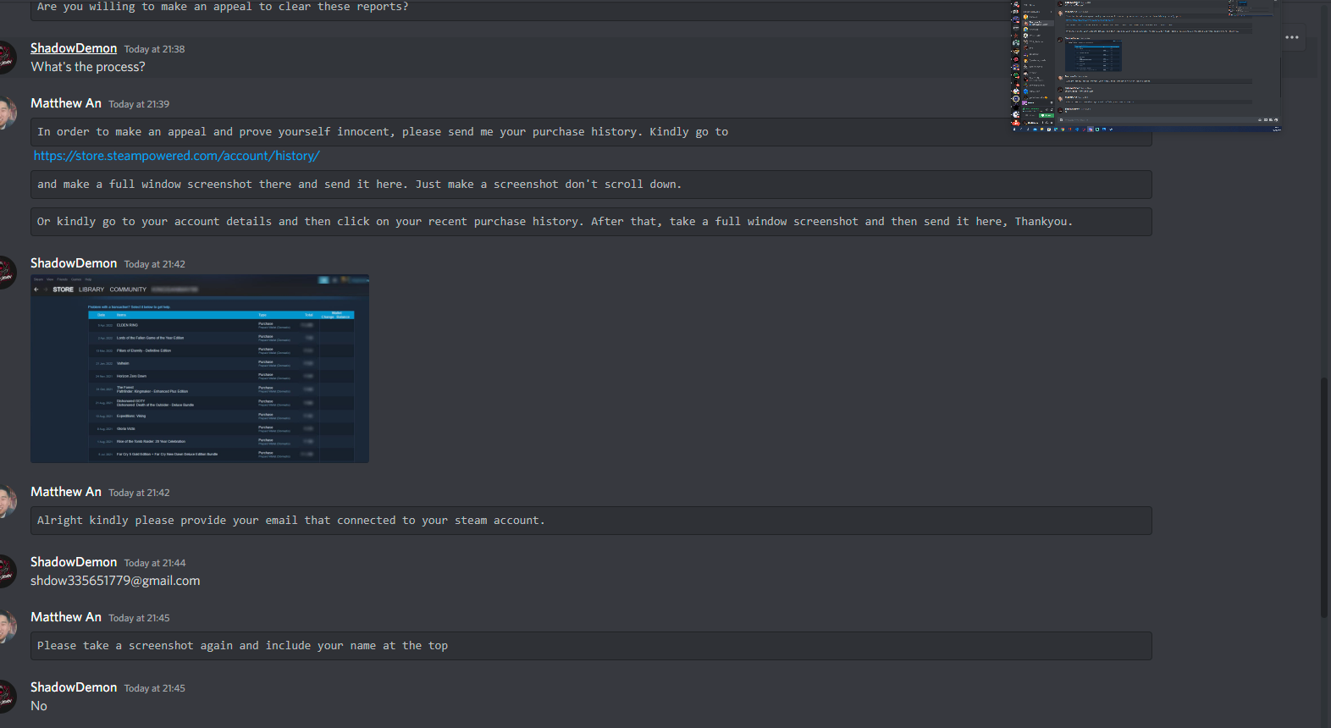
Figure 16 - A screenshot of the Final Conversation with the Second Scammer (“Today” refers to events on 12/10/2022)
The final phase of the scam is to obtain the necessary information in order to compromise the accounts of the targets. This is done by requesting the login email and verification from the user. During this final phase, everything is completed, from taking and receiving screenshots of the user's purchase history to getting approval from two-factor authentication.
All previously mentioned information gathering is demonstrated within Figure 14, where the scammer now asks for a screenshot of the account’s purchase history – which if they were an employee of Steam this would not be required and then proceed to ask for the associated email account, which again should not be needed.

The main purpose of this method is to gain the login email and username to the steam account and then use that email to send a password recovery link to the target’s email for verification and then the scammer gains full access to the account. The username is provided within the purchase history screenshot. This is a prime situation that occurs on a daily basis, thousands of accounts and personal information are being compromised without sufficient understanding into why. In order to avoid these scammers causing any further harm, the relevant information was provided to the Discord Trust and Safety Team and actions were taken against these scammers as shown in Figure 15:
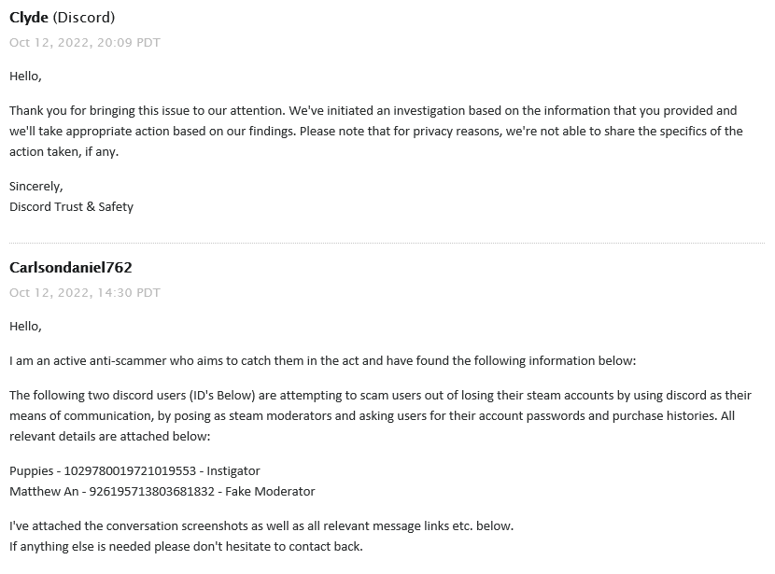
Figure 17 - A Screenshot of Full Report on Scammers

4.4 Phishing Implementation
In the modern digital world, phishing assaults are becoming more prevalent at an alarming rate, and the fallout from these attacks may be catastrophic for both people and corporations. In order for an attack to be carried out effectively via phishing, the perpetrators must first go through a phase known as "implementation," during which they must meticulously prepare and carry out their attack strategy. At this phase, attackers employ various methods and tools to design convincing emails or messages that may deceive unsuspecting users into giving critical information or installing malware. These emails or messages can be sent to users through social engineering or spear phishing.

4.4.1 Plan of the Implementation
We will study the implementation phase of a phishing attack in this part, looking at the processes involved as well as the tools and techniques utilised by individuals carrying out the attack. Everything from a hands-on presentation into the inner workings of the toolkits to real-time scenarios based on email or spear phishing. This implementation will follow a structured plan in order to clearly monitor and deal with any issues that arise, and to collect enough information to successfully mitigation strategies by the end of the completed implementation.
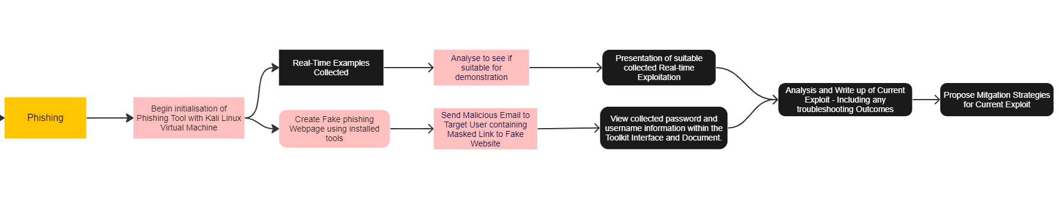
Figure 18 - Phishing Implementation
The entire plan for this phishing implantation is depicted in Figure 16, which includes both real-time examples and the physical implementation which will be conducted, followed by the analysis of the collected results and the suggestion of mitigation strategies for this exploit based on the selected results and research.

4.4.2 Real-time Examples
We will use the tool Zphisher [34] to undertake this implementation for testing purposes. The most common form of phishing in the modern day and age is through email otherwise known as spear phishing, there are countless forms of spear phishing email types, from well-known companies such as Argos or Facebook to random emails giving you some sort of incentive and contact URL’s or details.

Figure 19 - Spear Phishing Email - Finance Assistance Department
A typical situation and an illustration of a traditional spear phishing email using the information mentioned above are shown in Figure 17. It makes repeated efforts to persuade the reader that they are entitled to a cash payment even without completing or submitting any kind of application by using a variety of various indications and extended branches of text. Reviewing and reading the email's text reveals multiple grammatical errors, as well as an incorrect choice of currency.

There are innumerable more clear indications that this email is fake, including the sending email address and any URL links that are included in the text body. All of the information is false. This is just one of the possible email phishing vectors, there are numerous other similar emails that are pretty challenging to identify and compare differences to the original emails. An example of this can be seen with Figures 18 and 19 which are Delivery and Cloud Storage phishing emails.

Figure 20 - Spear-Phishing Email - Cloud Storage
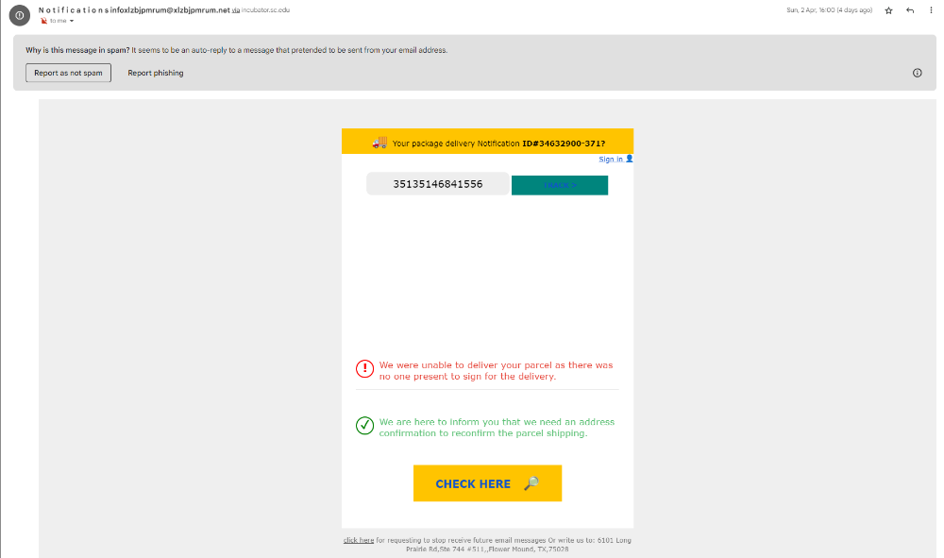
Figure 21 - Spear-Phishing Email - Delivery
However, these outcomes represent only one facet and a singular method of exploiting through phishing. To comprehend potential mitigations, it is essential to grasp the various techniques employed in the process, from inception to fruition.

4.4.3 Physical Implementation
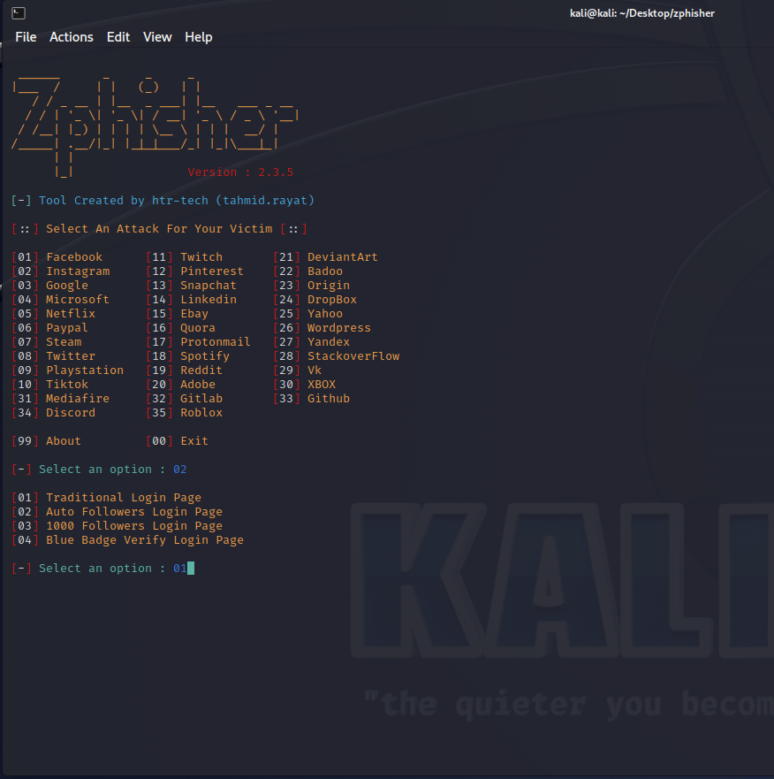
We need to investigate every stage of the phishing attack, analyse it thoroughly, and gain a comprehensive understanding of its intricate mechanisms. The first prime step was to setup all relevant tools needed to conduct this relevant implementation. After thorough research and testing the most suitable tool found for this demonstration was Zphisher [34]– this is a phishing tool used within Kali Linux that encompasses numerous possible attack vectors with the main being credential harvesting attacks. Figure 20 Demonstrates the initial exploit page for further implementation:
Figure 22 - Exploit Setup Page within Kali Linux
Figure 20 demonstrates the initial configuration page within the tool which allows initial selection into the target webpage e.g., Twitter or Instagram which the attacker can decide and then after the target website clone is selected then the login page options are also displayed, in this instance Instagram (02) and a Traditional Login Page (01) were selected. But these were just one set of several availlable combinations.

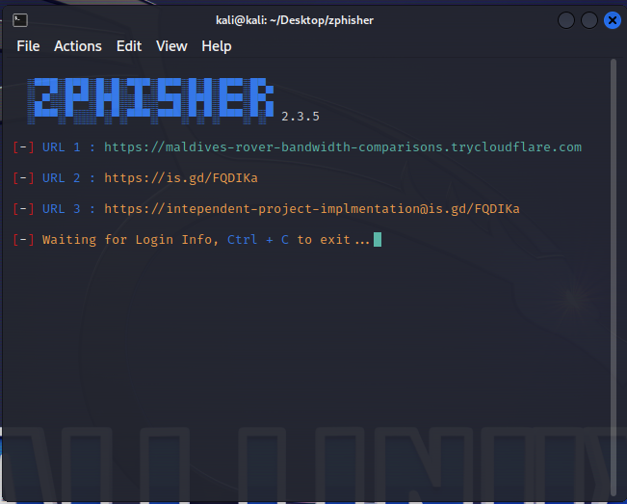
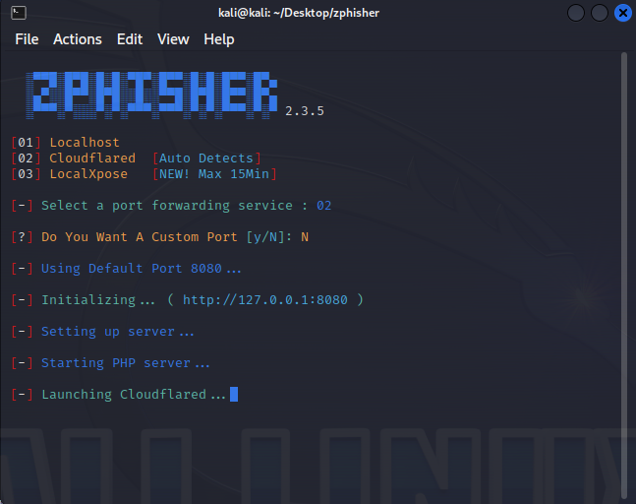
Figure 21 demonstrates the next phase of the tool after initial website selection, which is port and server hosting service selection. This phase the best service to use and the one selected was Cloud flared (02) which is an Auto Detecting Service for Hosting this phishing webpage. And then a custom port could be selected if required but in this scenario the default http port of 8080 was used. Next was the URL Link creation with relevant attachments and email links needing to be created after. The generated URLs are shown in Figure 22:
Figure 23 - Zphisher Service and Port Selection

Figure 24 - Zphisher Generated URL's
Now that the target URL links have been successfully generated, we are able to generate a false phishing email and conceal the necessary link inside an embedded link. Because of this, we are able to disguise the fraudulent link so that it seems like a genuine connection to the individual that we are targeting. The created email and masking of the links can be seen in Figures 23 and 24:
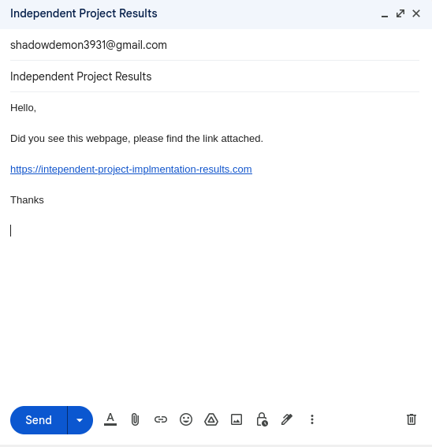
Figure 25 - Created phishing email with Masked Link
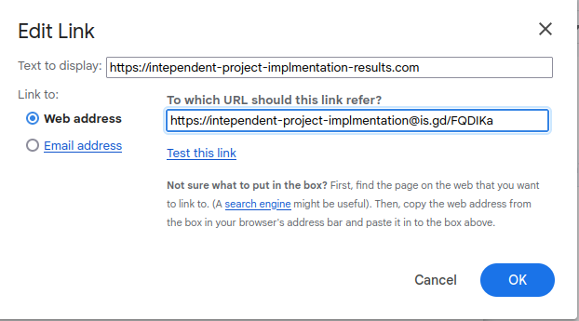
Figure 26 - Masking Email Link

Now that we have successfully written the phishing email and integrated the disguised link, we are in a position to simulate the actions that a target user would do after receiving the fraudulent email. By carrying out this operation, we are able to simulate the possible outcomes and evaluate the data that an unwary user may divulge by interacting with the fake link.

Figure 27 - First phishing email received without error.

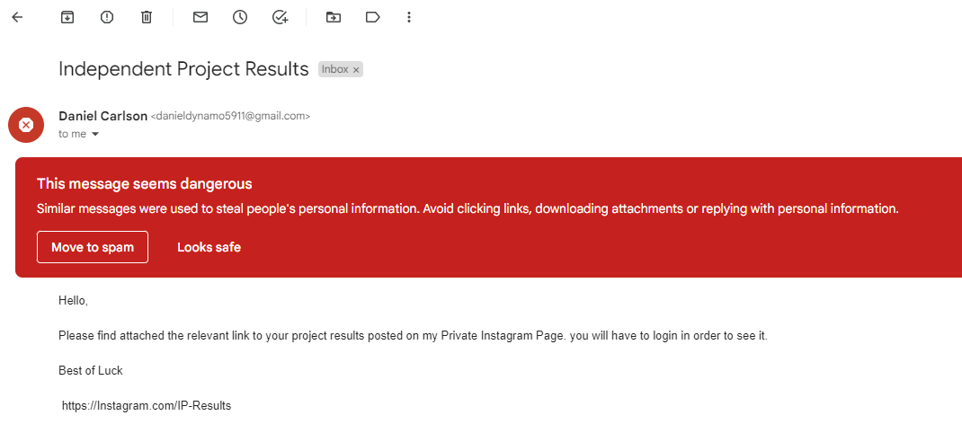
As Demonstrated in Figure 26, the received email has been flagged as a malicious and possible phishing email, giving the user a clear and visible notice to be careful about any attached links within this email. As this is an implementation, we can safely ignore this message and access the link. The compromised and fraudulent webpage is demonstrated in Figure 27:
Figure 28 - Second Email Received with Masked Link


Figure 29 - Fake Generated URL Login Page for Instagram

After successfully establishing a connection and integrating the fake URL in a seamless manner it promts the target to enter their account login info which then, the cutting-edge phishing tool Zphisher's internal graphical user interface (GUI) is deployed to capture the target's sensitive credentials and personal information when entered, and after the target clicks the Login the fake webpage will re-direct to the legitimate platform, the collected information and harvested credentials are demonstrated in Figure 28:

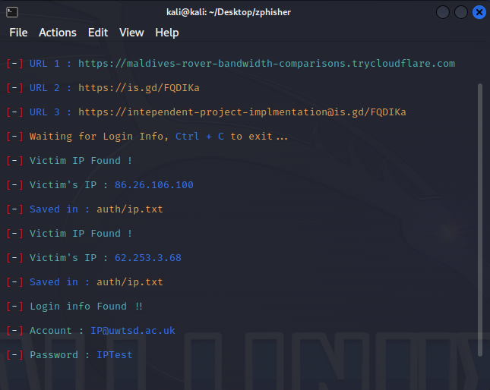
Observe Figure 28 above, which now showcases a comprehensive log of usernames and passwords from all users and devices that accessed the link. The log captures various critical details such as the victim's IP address, entered username, and password, thereby granting the hacker unfettered access to the target's account without their knowledge. This exemplifies a classic credential harvesting phishing attack that can spell disaster for unsuspecting victims.
Figure 30 - Harvested Credentials and Information from URL

4.5 Ransomware Implementation
The execution phase of a ransomware attack is a crucial component in the overall success of a cybercrime. This is where the ransomware is set in motion, and the attacker's objectives come to fruition. The implementation stage involves a myriad of tactics aimed at infecting the target's devices, encrypting their data, and demanding a ransom for the decryption key. Any minor misstep during this critical phase can prove catastrophic, potentially leading to a failed operation. Therefore, meticulous planning and execution are essential to the attacker's success.

4.5.1 Plan of this Implementation
In this section, we will delve into the multifaceted world of ransomware implementation and examine the sophisticated techniques employed by hackers to carry out their attacks. With the possibility and continuation of the evolution of Ransomware and Cyber Exploitation as a whole, the need for understanding and also finding methods as proof testing our personal systems is now becoming crucial to ensure our security while using our Devices.
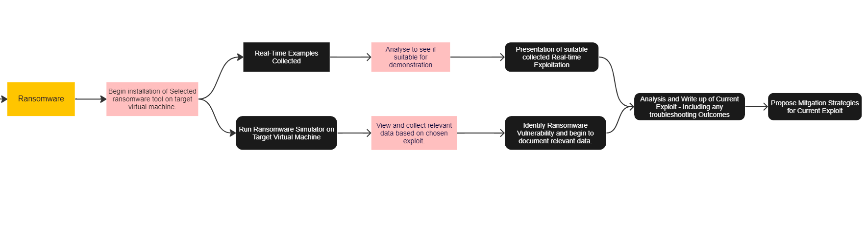
Figure 31 - Ransomware Implementation Plan
The whole architecture of this system is shown in Figure 29, which comprises both the physical implementation and real-time exploitation and vulnerability assessments. We'll also see what a real-world ransomware might look like on a system and how to detect it using a simulator inside a virtual network; this implementation will cover all of these topics. In this last section, we will consolidate all of the relevant information uncovered or addressed thus far and provide the groundwork for the creation of mitigation strategies.

4.5.2 Real-Time Scenarios/Examples
Ransomware is a difficult and complicated attack to deal with, especially without a thorough grasp of how it operates and what damage it may do to a system. In reality, the amount of real-world cases that may be studied is almost infinite as ransomware attacks become more commonplace. Many ransomware attack scenarios do exist, however few of them provide in-depth knowledge on the first message and file structure of an infected machine.
For specialists working to create sensible plans for reducing the harm caused by ransomware attacks, this lack of specific information poses a significant obstacle. Without access to this fine-grained information, it may be difficult to identify the true origins of an attack or to execute the best defences swiftly and effectively. There are countless possible avenues to explore but only few are suitable for demonstration, with many systems being totally decimated after not accepting the demands.
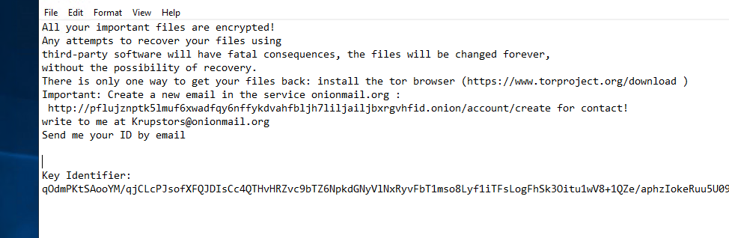
Figure 32 - Server Encrypted with Ransomware - Message of Ransom
Figure 30 shows the initial process and text document that appears when connecting to the compromised device, the entire file system is encrypted without any form of a decryption method without paying some form of ransom, in either Bitcoin or some form of untraceable currency within the Dark Web. The Dark Web is described by J. Saleem:
The dark web is a section of the Internet that is not accessible to search engines and requires an anonymizing browser called Tor. Its hidden network and anonymity pave the way for illegal activities and help cybercriminals to execute well-planned, coordinated, and malicious cyberattacks. [44]

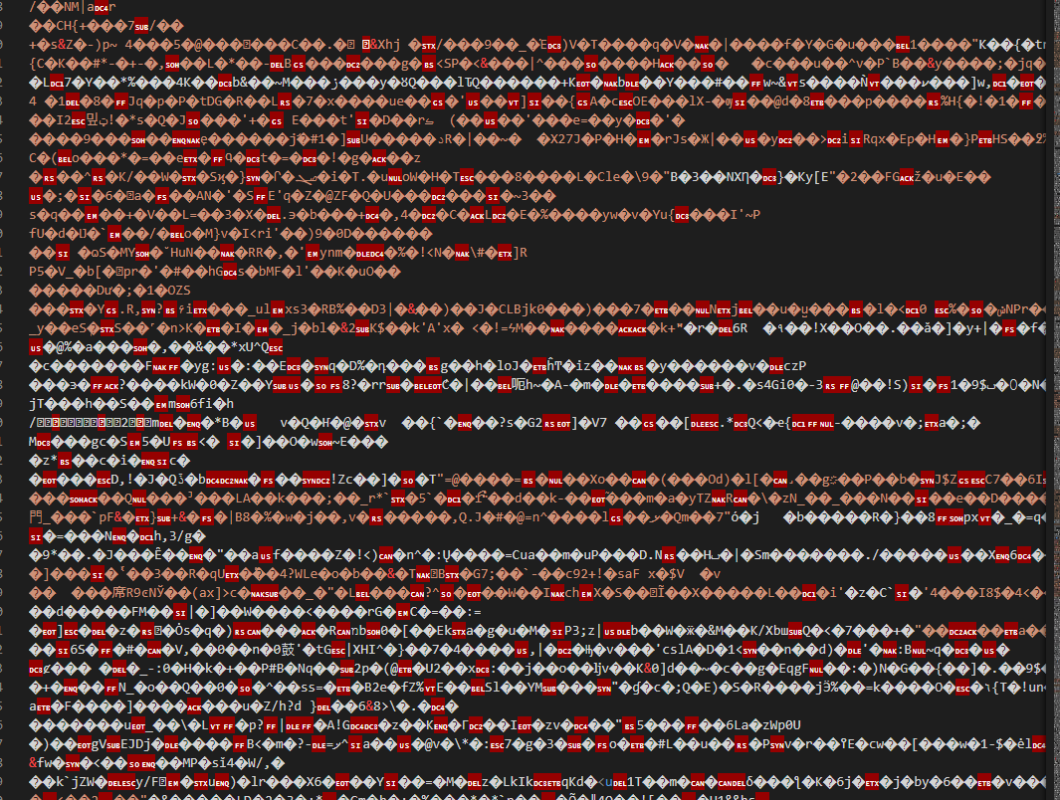
Figure 33 - Encrypted Text within Server
The quintessential leverage point of a ransomware exploit lies in the complete encryption and fortification of the internal system files. Devoid of the peril of forfeiting these files, the perpetrator would be bereft of any gains. Figure 31 showcases a fundamental screenshot of an internal file nestled within the targeted server. Also observe the encrypted text within the file, it's clear that the file's contents are rendered unidentifiable and unrecoverable unless decrypted using the appropriate method.
The reason why many individuals succumb to the requests of various exploiters is due to the peril of data loss and erasure in the event of any personal decryption endeavour. This s why numerous real-time examples are lost and are limited as most are either confidential or are not captured before the system is destroyed or lost. From this we can begin t learn the real problem ransomware can cause on a system and how security against this form of exploit is becoming a priority within modern society.

4.5.3 Physical Implementation
For the physical implementation of ransomware, the aim was to use a testing malware and inject it onto a virtual Windows 10 system that would show the full process of how a ransomware is implemented and displayed onto a target machine/device. After countless hours of research into possible methods into doing this a problem arose where after installation of the malware it would immediately be deleted by internal; windows security as shown in Figure 32 below:
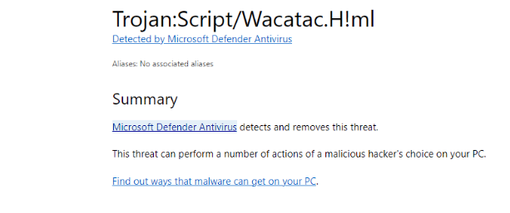
Figure 34 - Detected Ransomware Script being deleted.
Due to countless script and internal code updates even after disabling the Windows Defender Antivirus, the internal coding of Windows prevents installation of this script within a Windows 10 Environment, this can be seen in Figure 33 which shows th response to a submitted question on their forums around malware installation:
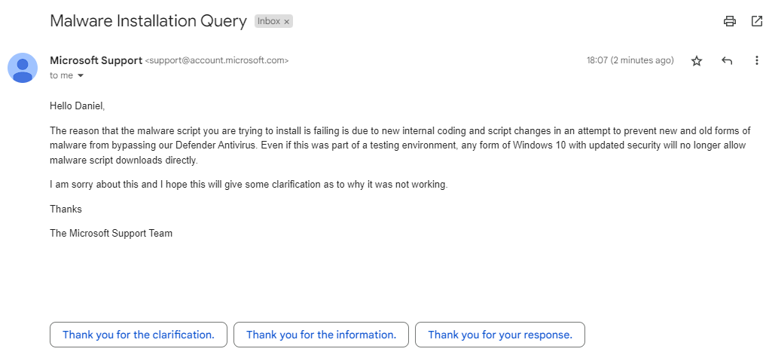
Figure 35 – Microsoft Support Response to Malware Installation

The alternative to use was a multi-vector attack simulator testing tool that demonstrated and used numerous different forms of ransomware temporarily to identify possible vulnerabilities known as Ran Sim [45].

Figure 36 - Ran Sim Start Page on Windows 10 VM
The implementation started with the Ransomware Simulator being installed and prepared for use. Before the full effects of Ran Sim could be realised, however, the system had to be configured and installed from an encrypted location. Figure 31 depicts the primary start page of the Simulator. The purpose of this simulator is to determine whether any of 22 distinct ransomware malwares and a crypto mining scenario constitute a threat to the simulated environment.
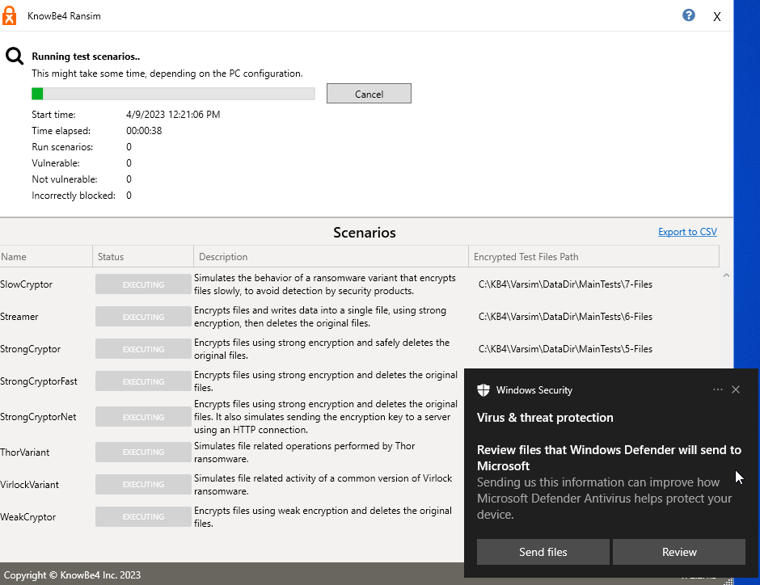
Figure 37 - Initial Scan Beginning with Ransomware Scripts being detected.
Figure 32 demonstrates how the state-of-the-art scanning method starts with the transient installation of malicious or ransomware scripts on the machine under investigation. This helps us find security issues in a timely manner and get rid of the scripts when the scan is done. The malicious scripts and vulnerabilities can be detected and mitigated by the internal windows security as seen in Figure 33, which shows relevant detection of the malicious scripts.
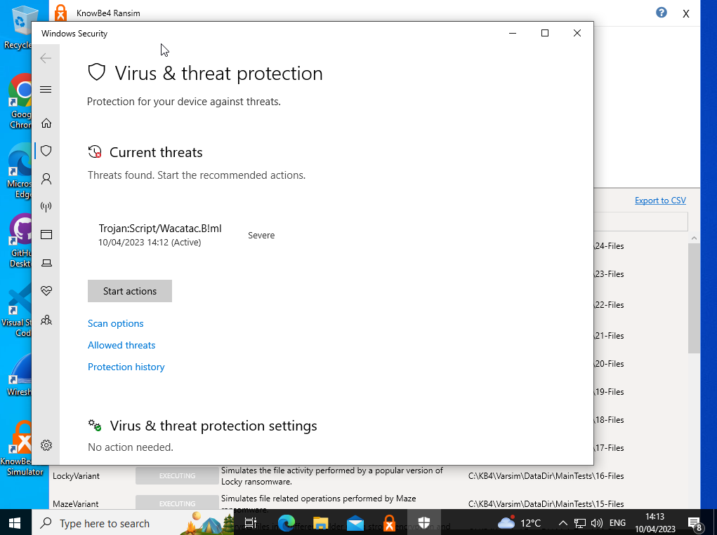
Figure 38 - Detection of Ransomware Scripts by Windows Defender
Several cutting-edge procedures are used during the scan phase. The data produced by the concurrent execution of several malware scripts is dynamically displayed on the Ran Sim user interface. The interface clearly and precisely separates targets into "Vulnerable" and "Not Vulnerable," with color-coding for quick identification. This thorough scan offers priceless insights into the most recent dangers to your system, enabling you to be proactive and protect your priceless data. This is all displayed within Figure 34:
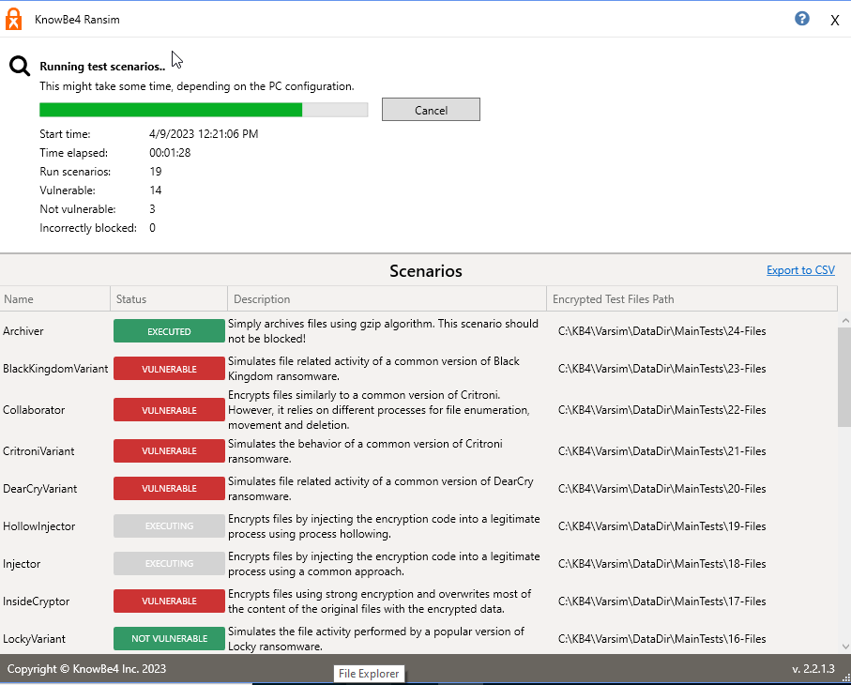
Figure 39 - Detection of Vulnerable and Non-Vulnerable Ransomware
We meticulously collected data and examined the malware insertion inside the simulator throughout the last phase of our implementation. We started a thorough scan to find and run any possible malware scripts, and when the scan was finished, we looked at the findings to see if the system had any flaws or vulnerabilities. The information was then shown in a graph that was simple to read, giving clear insight into the system components that were most vulnerable to attack. The files and areas that were specifically highlighted as possible targets for exploitation were also included in this graph. The detailed graph and outlook within the Simulator are shown within Figure 35:
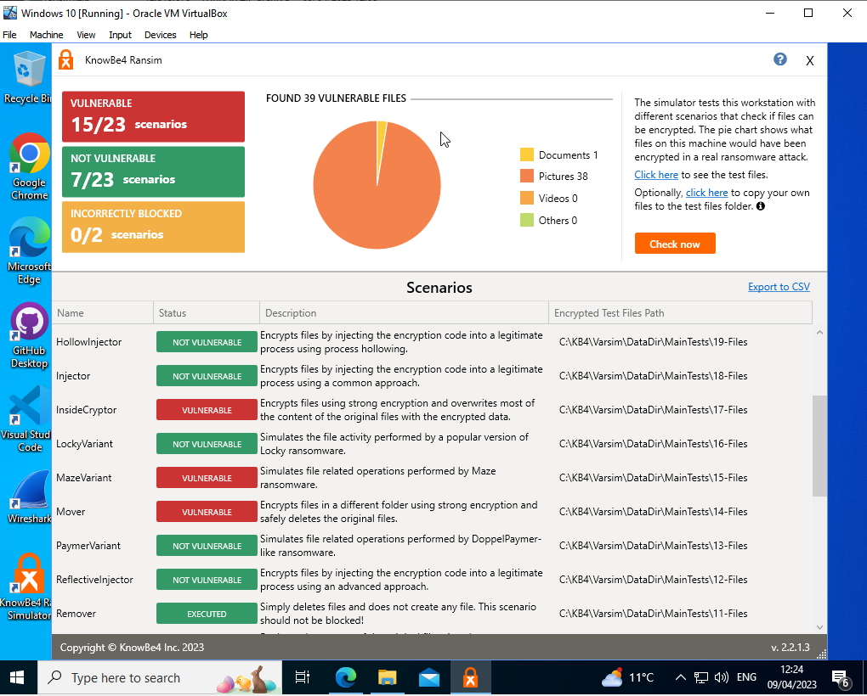
Figure 40 - Results of Completed Ransomware Injection/Implementation
As we can see in Figure 35, the graph has displayed that on this test environment, the device is vulnerable to 15 different forms of ransomware and protected against 7. The ransomwares that are a threat to the device are listed within the Simulator in order for the tester to identify which areas need further focus, including the areas which in this aspect Photos, need addressing in order to reduce the susceptibility to a ransomware exploit.

4.6 Conclusion
In summary, this project phase has extensively explored a range of implementation areas. Through a diverse mix of real-world examples and created scenarios, we have examined various stages of the attack cycle, from initial reconnaissance to physical execution. Leveraging a variety of tools, we have meticulously simulated and demonstrated the techniques and tactics used in these exploits, providing in-depth insight into how they function and how they can be effectively targeted towards unsuspecting victims. By examining the details and evidence gathered through these simulations, we have gained a comprehensive understanding of the tactics used in social engineering attacks and their potential impact on individuals and organizations alike.
Now that we have gathered a comprehensive set of data and gained a deeper understanding of the implementation process, we can move forward with creating and proposing targeted mitigation strategies. These strategies will be specially designed to deal with and lessen people's vulnerability to a broad range of cyber-exploitations. This will include not just the exploits that were used, but also any other vulnerabilities and exploits that we may discover later on or that we have already identified. The goal is to develop effective strategies that will help prevent and mitigate the impact of cyber-attacks, thus enhancing the security and safety of individuals and their digital identity.

5. Mitigation Strategies

5.1 Overview
With countless and developing amounts of information and demonstrations being done within this report , the next important and crucial part is the creation of possible mitigation strategies in order to deal with the covered cyber-exploits as well as enhance cybersecurity in general. In the present era of interconnectivity, technology plays a pivotal role in facilitating the routine operations of both individuals and enterprises. As we continue to embrace technology, the likelihood of cyber threats also increases.
Innovatively speaking, the ramifications of cyber exploits can be quite expensive and disruptive, as they have the potential to compromise the confidentiality, integrity, and availability of vital information and systems. Hence, it is imperative to devise a holistic approach towards cyber exploit mitigation to curtail the ramifications of potential breaches and safeguard against forthcoming perils. In this stage, we engage in the strategic prioritisation of risks, and the suggestion of cutting-edge measures to mitigate exposure to cyber threats with reference to the implemented exploits covered in the previous sections.

5.2 Social Engineering Mitigations
The art of social engineering is a clever ploy employed by malicious actors to influence people into revealing confidential data or undertaking actions that could potentially jeopardise security. To effectively address the hazards linked with social engineering attacks, a comprehensive strategy with multiple facets is necessary. To begin with, it is imperative for organisations to offer consistent training sessions to their workforce regarding the identification and handling of social engineering assaults as well as to specific individuals if they deem it necessary. The proposed training programme ought to encompass cutting-edge subjects like phishing emails, pretexting, and baiting.
In addition, it is recommended that enterprises and individuals incorporate cutting-edge technical measures like spam filters, two-factor authentication, and access controls to curtail the probability of triumphant cyber intrusions. In order to enhance security measures, it is imperative to conduct routine security assessments to detect potential vulnerabilities and opportunities for enhancement. Through the implementation of these measures, organisations can mitigate the probability of succumbing to social engineering attacks and enhance the safeguarding of their confidential data.
These are just a few of the best feasible mitigation ideas that might aid in adhering to and thwarting the threat of social engineering, since we won't be able to recognise them if they occur to us without sufficient knowledge into the tactics and forms of assault.

5.3 Phishing Mitigation Strategies
Phishing attacks have become widespread and a constant menace to organisations all over the world, as hackers continue to utilise more sophisticated ways to trick users who are unaware of the danger and obtain access to important information. To protect themselves from the dangers posed by phishing attacks, businesses need to implement preventative measures against the scams. These preventative measures should include both technology solutions and personnel education and awareness initiatives.
There are countless possibilities to suggest that could have a dramatic impact onto the security of browsing and using application against phishing attacks, everything from specific policies to organisational structure and individual reporting. One possible approach is the implementation of a multi-layered security plan that incorporates both technological restrictions and user education is one method that is efficient and possible. The implementation of email filtering and spam blocking, the utilisation of two-factor authentication, the delivery of routine security awareness training to staff members, and the monitoring and reporting of network traffic for suspicious behaviour can be used to reduce the chance of any suspicious emails reaching individuals.
Even with the software and organisational structure changes the most efficient and proven method that alongside numerus technical approaches user education [46] is the most suitable method that does not require any previous knowledge or experience. As stated by N. Asanka :
Where it is impossible to completely eliminate the end-user from the computer system (for example, in home computer use), some argue that the best possible approach for computer security is to educate the end-users in security prevention. [47]
The efficacy of anti-phishing tactics heavily relies on the ability to detect fraudulent websites and emails accurately and swiftly. Despite the abundance of anti-phishing solutions, many of these tool’s struggle to accurately determine whether a website is engaging in phishing activities. Consequently, there has been a surge in false positive outcomes and even though the technical ways of dealing with phishing are constantly updating, the numerous false positives occurring are leading to the misidentification of real websites against their fake counterpart, thus education is still the most feasible mitigation strategy to the majority of Social Engineering forms including Phishing.

5.4 Ransomware Mitigation Strategies
The increasing frequency of ransomware attacks in recent times has posed a significant challenge to individuals, corporations, and nations alike, with the potential to cause catastrophic consequences. Ransomware attacks involve the utilisation of malware by nefarious individuals to encrypt or limit access to a target's data or systems. The attackers then demand payment from the victim in exchange for the decryption key or the elimination of the restriction. In light of the ever evolving and increasingly sophisticated nature of ransomware attacks, it is imperative that organisations and individuals adopt innovative mitigation strategies to mitigate the risk of an attack and limit the potential fallout in the event of an attack.
With countless new forms of malware arising daily the need for sustainable and evolving mitigation strategies to be suggested and implemented. As previously covered within the implementation and in figures 36 -40 a sustainable and easy method of detecting possible attack avenues on a system is a ransomware simulator which demonstrates and temporarily implements a fake attack to identify any possible vulnerabilities that need to be patched. There are countless other solutions that could be suggested as sufficient defence solutions. With the ransomware defence solutions mainly being split into 2 areas, the User Mode/Level and the Hardware Level as stated in [48]
The hardware realm presents a plethora of possibilities for recommendations, with the foremost being Multi-layered Security. By implementing a comprehensive security strategy that includes firewalls, antivirus software, intrusion detection systems, and security patches and policies, the impact of ransomware attacks can be significantly reduced. According to a study by Y. Chen [49] implemented multi-layered security solutions significantly reduce the risk of successful ransomware attacks and in some forms have actively stopped them entirely.
There are countless methods within the human user level that are essential to know and suggest for future security with the main being education and user file backups. As described by H. Mousab:
When new ransomware came up with new technology or family and target any victim for the first time. Mitigation strategies are capable of doing something. even though the system gets infected the backup can bring the files within hours if it is not damaged too. [50]
In light of the continuously advancing ransomware landscape, the outlined countermeasures remain insufficient to fully mitigate the persistent vulnerability. Sustained learning and development are imperative to effectively combat these challenges and potentially mitigate their effects on individual and institutional frameworks.

6. Evaluation
The independent evaluation phase is a crucial procedure that aids in determining a project's effectiveness and productivity. It entails an objective and methodical evaluation of the project's performance, results, and the completion of objectives. The project's progress, successes, and areas for improvement are all disclosed to decision-makers and examiners during the assessment phase, which also acts as a roadmap for future planning and execution. Additionally, it gives participants the chance to think back on their past experiences and lessons gained and make any necessary improvements to guarantee the project's successful conclusion.
This project has covered numerous different scopes of the cyber security and exploitation sector, from the background and progression of exploitation to the physical demonstration of the researched content, it has delved into numerous possibilities and results have been collected. But has this project been successful and has it achieved what was set out in the initial planning phases? The simple answer is yes, this project has met all of the objectives that were set covering everything from methodology to exploitation mitigation strategies.
The original aim was carefully constructed to ensure smooth integration and alignment with the primary and supporting objectives, extending from the literature review through the methodology. As a result, each section was meticulously executed, with any identified discrepancies being documented within the respective section. Overall, the aim of the project was to provide a greater understanding into cyber-exploitation and give a demonstration into how these exploits are implemented in real-time, and throughout this project this aim has been achieved, the literature review gave a greater understanding into the cyber-domain and the most recent cyber-exploits, and we created a detailed demonstration covering both real-time examples and physical implementation.
Finally, there are a few things I would modify if I were to do this project over again, with the major ones being the demonstration of additional, less prevalent types of social engineering exploitation and other types of phishing, including webcam capture. Assuming I had the opportunity to do this a second time, I would choose a handful of the more uncommon but still frequently used exploitation techniques and assaults since the number of exploits available entailed the fact that the ones covered were just a small portion of those available.

7. Conclusion and Recommendations

7.1 Summary of the Project
This project has comprehensively examined a range of topics in the realm of cyber-exploitation, encompassing not only cyber-espionage but also various forms of exploitation, such as ransomware and phishing with the aim of providing a greater understanding into the realm of cyber-exploitation and how it’s acted upon in real-time. Through a systematic review of whitepapers and peer-reviewed sources, this project has provided a more comprehensive understanding of the extent of recent cyber exploitation, highlighting the threat it poses to organizations and individuals in the absence of any effective mitigation strategies. The subsequent phase involved the identification and evaluation of appropriate methodologies to guide the remainder of the project, with Pragmatism being the chosen approach.
Building on this foundation, the project's next stage was the creation and display of numerous cyber-exploits that were used against target systems. The use of real-world examples and tools that had been thoroughly investigated allowed for a complex and clear understanding of how these exploits were actually put into practice and targeted on specific targets. The modern approach provided a nuanced and in-depth analysis of the real-world applications of cyber-exploits and how they can cause severe harm if not monitored carefully. With this implementation and demonstration completed, relevant mitigation strategies were then suggested to propose possible enhancement for future security against cyber-exploitation in organisations and individuals.
The thorough evaluation of the project's overall success was the next part considered after the completion and execution of the suggested mitigation techniques. The objectives, scope, methods, and results of the project were all be carefully examined as part of this evaluation. The assessment examined how well the project's goals were met and if the intended results materialised.
Additionally, it was crucial to pinpoint any flaws and restrictions that surfaced throughout the project's implementation. These can include difficulties with resource allocation, unanticipated difficulties, or insufficient tools and data availlable. By recognising these problems, possibilities for improvement may be found, and lessons learned can be used to new projects to make sure that comparable ones in the future have a chance to avoid them.

7.2 Conclusion
It is clear from in-depth study and analysis that cyber-attacks offer a serious threat to people, companies, and governments alike. Cybercriminals now have an easier time launching sophisticated assaults that may lead to data breaches, financial losses, and reputational harm as a result of the growing reliance on digital technology and the internet. It is important to remember that not all cyberattacks are created equal, and that a variety of factors can affect how serious and disruptive they are., and that it is clear that social engineering, ransomware, and phishing attacks continue to pose a significant threat to individuals and organizations alike. These types of attacks are constantly evolving and becoming more sophisticated, making them increasingly difficult to detect and prevent.
Overall, the key to successfully mitigating cyber threats is to implement a comprehensive cybersecurity strategy that includes a combination of technical controls, employee education, and incident response planning. The only way to create an operational environment that is exceptionally safe while cyber threats grow rapidly is to define a countermeasure that includes protection, detection, and response capabilities and only by taking a proactive approach to cybersecurity, organizations can minimize their risk of falling victim to social engineering, ransomware, and phishing attacks.
This project promotes the use of many techniques to combat the ongoing danger of cyber-exploitation, highlighting the significance of changing our tactics to guarantee secure online behaviour. The analysis thoroughly examines a variety of contemporary cyber-exploits, illuminating several potential exploitation paths and suggesting matching mitigation tactics at the individual as well as organisational levels. However, the current work only represents a first step towards establishing greater cyber-security due to the continually developing nature of the cyber-domain. However, the knowledge gained from this study generates new research possibilities in the area of cyber-exploitation and serves as an excellent foundation for future studies.

7.3 Recommendations for Further Research
There are many opportunities and directions for study as the cyber-domain develops further. These include the development and targeting of particular viruses and malware as well as testing the effectiveness of brute force assaults as a way to gain access to organisational systems. In light of this, our call for further study focuses on the use of a variety of mitigation methods, both those that have been proposed earlier and those that are now accessible in previous projects. These tactics must be carefully examined and put to the test in the present to determine their efficacy. The importance of this study rests in the fact that there is only a small range of research covering different mitigation measures without demonstrating their relative consequences and effects on systems. This project just briefly describes a few potential mitigation strategies without actually putting them into practise and is only one possibility for further research with countless and expanding possibilities becoming availlable each day.

8. Reflection
Throughout the course of my independent project on cyber-exploitations, I have studied numerous areas within cybersecurity and hacking, learning about the strategies and equipment employed by both attackers and defenders in the digital environment. I have developed a thorough awareness of the intricacies and difficulties involved in protecting digital assets via my work analysing vulnerabilities in online applications and carrying out penetration tests and simulated attacks on numerous simulated networks. I am eager to reflect on the information and abilities I have learned, as well as the issues I found of practical implementation of the covered content in our increasingly linked world, as I enter the reflection portion of my project.

8.1 Technical Reflection
It is plausible to claim that the whole project was a resounding success in light of the facts provided in the parts before. The accomplishment of all goals, which were painstakingly adapted to each element of the project, was necessary for the project's goal to be realised. The main objective of the project was to offer a thorough understanding of modern cyberspace and the most current cyberattacks at the time of the research, as well as to show how these attacks may be used against real-time systems.
The project aimed to provide essential mitigation recommendations in order to advance personal security on an all-encompassing level. The project had multiple aspects and included a variety of elements, such as a literature review, implementation, and mitigation. Each of these components required sufficient consideration and time to guarantee a high-quality result. With regards to this, I believe that the Literature Review in my opinion could have been given a little more time in order to polish it up and give a greater amount of critical analysis and peer-reviewed articles. This could have given an even greater understanding into the different subject areas being covered in that section.
A few issues did develop throughout the project's execution, particularly during the implementation phase. These issues were discussed and described in the relevant parts; the primary issues were the implementation's compatibility and the workarounds required to make the selected tool function. These issues were considered as part of the project's methodology plan's contingency plan in the event that such an issue would arise, and as a result, an efficient strategy was put in place to deal with and fix/adjust these issues. Each issue was addressed using the appropriate workarounds and alternative tools specified in the intended plan, and each solution was recorded in the appropriate area.

8.2 Personal Reflection
Taking on an independent project on my own has been a journey that has stretched me beyond my capabilities, forced me to mature, and helped me learn more about who I am than I could have even imagined possible. During the course of this project, I have run across a number of challenges, gone through times of uncertainty and self-doubt. But in the end, it has turned out to be a great chance for personal development, and I am proud of the person that I have become as a result of going through this process. In my personal reflection, I will discuss the things that this project has taught me, the skills that it has helped me build, and the ways in which it has changed who I am as an individual.
One of the most significant lessons that I've picked up from working on this project on my own is the value of keeping at something until you succeed or perseverance. There were times when I felt difficulty, irritated, and doubtful of my capabilities, and through this my experience with this project has shown me that in order to achieve success, it is frequently necessary to put in a lot of effort, be dedicated, and be ready to face unexpected challenges that can alter the course of the entire project if not handled correctly.
The chance to hone my problem-solving abilities is another element of this independent project that has been quite beneficial to me. I encountered a number of challenges during the process that called for thoughtful solutions. I had to use critical thinking to decide on the best course of action, from coming up with concepts to trying various methods. This project has taught me that addressing and solving problems involves being adaptive, resilient, and open-minded in addition to coming up with a solution. I am thankful for the chance to have developed these abilities via this project since they are applicable to various elements of my life.
Finally, this independent project has helped me understand the value of organisation and time management. I had to efficiently organise and prioritise my tasks in order to finish this project on time and meet all of the deadlines. I discovered how to divide large undertakings into smaller, more achievable goals so that I could go forward without feeling overloaded. I've learned focused attention and tenacity skills through this endeavour that I can carry over to other aspects of my life, such as my academic and career goals. Overall, this experience has been tremendously fulfilling, and I am appreciative of the opportunities it has provided for me to develop myself.

Reference List
[1] M. Albahar, ‘Cyber Attacks and Terrorism: A Twenty-First Century Conundrum’, Sci Eng Ethics, vol. 25, no. 4, pp. 993–1006, Aug. 2019, doi: 10.1007/s11948-016-9864-0.
[2] Antonyan EA and Grishko NA, ‘New Technologies in Cyber Terrorism Countering’, 2020.
[3] A. Heller, ‘Israeli cyber chief: Major attack on water systems thwarted’, May 28, 2020.
[4] L. Shachnow, ‘Uber Users: What You Need to Know about Last Month’s Data Breach’, Boston University, Oct. 11, 2022.
[5] P. A. H. Williams and A. J. Woodward, ‘Cybersecurity vulnerabilities in medical devices: A complex environment and multifaceted problem’, Medical Devices: Evidence and Research, vol. 8. Dove Medical Press Ltd, pp. 305–316, Jul. 20, 2015. doi: 10.2147/MDER.S50048.
[6] ‘Threat Assessment ’, University of Arkansas, Jun. 10, 2020.
[7] K. Tsiknas, D. Taketzis, K. Demertzis, and C. Skianis, ‘Cyber Threats to Industrial IoT: A Survey on Attacks and Countermeasures’, IoT, vol. 2, no. 1, pp. 163–186, Mar. 2021, doi: 10.3390/iot2010009.
[8] Mr Pradeep Nayak, Mohammed Sufiyan, Monisha N S, Moolly Gautami Bhaskar, and Mohan Raju, ‘Review Paper on Cyber Security and Types of Cyber Attacks’, International Journal of Advanced Research in Science, Communication and Technology, pp. 732–735, Aug. 2022, doi: 10.48175/ijarsct-7043.
[9] H. S. Lin, ‘Offensive Cyber Operations and the Use of Force’. [Online]. Available: http://www.microsoft.
[10] Dr. O. A. Onome, ‘Advanced Cyber Exploitation and Mitigation Methodology’, International Journal of Emerging Science and Engineering, vol. 10, no. 4, pp. 8–15, Mar. 2022, doi: 10.35940/ijese.C2525.0310422.
[11] I. Kara, ‘Cyber-Espionage Malware Attacks Detection and Analysis: A Case Study’, Journal of Computer Information Systems, vol. 62, no. 6, pp. 1253–1270, 2022, doi: 10.1080/08874417.2021.2004566.
[12] R. Buchan and I. Navarrete, ‘Cyber Espionage’. doi: 10.1093/OBO/9780199796953-0212.
[13] C. Aungle, ‘Marriott Hotels Suffers Second Data Breach in 2022’, It Security Guru, Jul. 07, 2022.
[14] S. Venkatesha, K. R. Reddy, and B. R. Chandavarkar, ‘Social Engineering Attacks During the COVID-19 Pandemic’, SN Computer Science, vol. 2, no. 2. Springer, Apr. 01, 2021. doi: 10.1007/s42979-020-00443-1.
[15] P. Arntz, ‘Nvidia, the ransomware breach with some plot twists’, Malwarebytes, Mar. 03, 2022.
[16] Z. Wang, H. Zhu, and L. Sun, ‘Social engineering in cybersecurity: Effect mechanisms, human vulnerabilities and attack methods’, IEEE Access, vol. 9, pp. 11895–11910, 2021, doi: 10.1109/ACCESS.2021.3051633.
[17] Z. Wang, L. Sun, and H. Zhu, ‘Defining Social Engineering in Cybersecurity’, IEEE Access, vol. 8, pp. 85094–85115, 2020, doi: 10.1109/ACCESS.2020.2992807.
[18] I. Böhm and S. Lolagar, ‘Open source intelligence’, International Cybersecurity Law Review, vol. 2, no. 2, pp. 317–337, Dec. 2021, doi: 10.1365/s43439-021-00042-7.
[19] D. Kvedar, M. Nettis, and S. P. Fulton, ‘The Use of Formal Social Engineering Techniques to Identify Weaknesses during a Computer Vulnerability Competition’, J. Comput. Sci. Coll., vol. 26, no. 2, pp. 80–87, Dec. 2010.
[20] Z. Alkhalil, C. Hewage, L. Nawaf, and I. Khan, ‘Phishing Attacks: A Recent Comprehensive Study and a New Anatomy’, Frontiers in Computer Science, vol. 3. Frontiers Media S.A., Mar. 09, 2021. doi: 10.3389/fcomp.2021.563060.
[21] A. K. Ghazi-Tehrani and H. N. Pontell, ‘Phishing Evolves: Analyzing the Enduring Cybercrime’, Vict Offender, vol. 16, no. 3, pp. 316–342, 2021, doi: 10.1080/15564886.2020.1829224.
[22] ‘Executive summary 2018 Data Breach Investigations Report’, 2019. [Online]. Available: http://bfy.tw/HJvH
[23] M. Rami, T. L. Thabtah, and Fadi, ‘Tutorial and Critical Analysis of Phishing Websites Methods Original Citation Mohammad’, Comput Sci Rev, vol. 17, pp. 1–24, 2015, [Online]. Available: http://eprints.hud.ac.uk/id/eprint/24236/
[24] ‘ISTR Internet Security Threat Report Volume 23’, 2018.
[25] A. Kapoor, A. Gupta, R. Gupta, S. Tanwar, G. Sharma, and I. E. Davidson, ‘Ransomware detection, avoidance, and mitigation scheme: A review and future directions’, Sustainability (Switzerland), vol. 14, no. 1. MDPI, Jan. 01, 2022. doi: 10.3390/su14010008.
[26] ‘THE STATE OF RANSOMWARE 2020’, 2020.
[27] M. Humayun, N. Z. Jhanjhi, A. Alsayat, and V. Ponnusamy, ‘Internet of things and ransomware: Evolution, mitigation and prevention’, Egyptian Informatics Journal, vol. 22, no. 1. Elsevier B.V., pp. 105–117, Mar. 01, 2021. doi: 10.1016/j.eij.2020.05.003.
[28] I. KARA and M. AYDOS, ‘Cyber Fraud: Detection and Analysis of the Crypto-Ransomware’, in 2020 11th IEEE Annual Ubiquitous Computing, Electronics & Mobile Communication Conference (UEMCON), Oct. 2020, pp. 764–769. doi: 10.1109/UEMCON51285.2020.9298128.
[29] M. B. Yassein, S. Aljawarneh, E. Qawasmeh, W. Mardini, and Y. Khamayseh, ‘Comprehensive study of symmetric key and asymmetric key encryption algorithms’, in 2017 International Conference on Engineering and Technology (ICET), Aug. 2017, pp. 1–7. doi: 10.1109/ICEngTechnol.2017.8308215.
[30] C. Beaman, A. Barkworth, T. D. Akande, S. Hakak, and M. K. Khan, ‘Ransomware: Recent advances, analysis, challenges and future research directions’, Comput Secur, vol. 111, Dec. 2021, doi: 10.1016/j.cose.2021.102490.
[31] R. Richardson and M. M. North, ‘Ransomware: Evolution, Mitigation and Prevention’, 2017. [Online]. Available: https://digitalcommons.kennesaw.edu/facpubs/4276
[32] N. Pavković and L. Perkov, ‘Social Engineering Toolkit — A systematic approach to social engineering’, in 2011 Proceedings of the 34th International Convention MIPRO, May 2011, pp. 1485–1489.
[33] iAmFearless, ‘Phishing got easier with Socialphish’, InfoSec Write-ups, Jun. 04, 2021. https://infosecwriteups.com/phishing-got-easier-with-socialphish-b04dcbab3900 (accessed Apr. 06, 2023).
[34] mohdshariq, ‘Zphisher – Automated Phishing Tool in Kali Linux’, Geeks for Geeks, Apr. 06, 2023. https://www.geeksforgeeks.org/zphisher-automated-phishing-tool-in-kali-linux/ (accessed Apr. 08, 2023).
[35] Ngrok, ‘What is Ngrok?’, 2023. https://ngrok.com (accessed Apr. 15, 2023).
[36] S. Rajasekar, P. Philominathan, and V. Chinnathambi, ‘RESEARCH METHODOLOGY’, 2013.
[37] A. Melnikovas, ‘Towards an explicit research methodology: Adapting research onion model for futures studies’, Journal of Futures Studies, vol. 23, no. 2, pp. 29–44, 2018, doi: 10.6531/JFS.201812_23(2).0003.
[38] M. Saunders, P. Lewis, and A. Thornhill, Research Methods for Business Students, 6th ed. [Online]. Available: www.pearsoned.co.uk/saunders
[39] J. Dudovskiy, ‘Research Philosophy’, Business Research Methodology. https://research-methodology.net/research-philosophy/#_ftn1 (accessed Jan. 12, 2023).
[40] M. Mulders, 101 Management Models, 1st ed. Routledge, 2019. doi: 10.4324/9781003022022.
[41] D. C. Ensminger, D. W. Surry, B. E. Porter, and D. Wright, ‘International Forum of Educational Technology & Society Factors Contributing to the Successful Implementation of Technology Innovations’, Source: Journal of Educational Technology & Society, vol. 7, no. 3, pp. 61–72, 2004, doi: 10.2307/jeductechsoci.7.3.61.
[42] L. Rila, ‘What is the significance of a flowchart?’, University College London. https://www.ucl.ac.uk/culture-online/ask-expert/your-questions-answered/what-significance-flowchart-updated (accessed Mar. 07, 2023).
[43] Cambridge University Press, Cambridge Advanced Learner’s Dictionary, 4th ed. Cambridge University Press, 2013.
[44] J. Saleem, R. Islam, and M. A. Kabir, ‘The Anonymity of the Dark Web: A Survey’, IEEE Access, vol. 10, pp. 33628–33660, 2022, doi: 10.1109/ACCESS.2022.3161547.
[45] KnowBe4, ‘RanSim’, KnowBe4, 2022. https://www.knowbe4.com/ransomware-simulator (accessed Apr. 10, 2023).
[46] W. P. Nmachi and T. Win, ‘Phishing Mitigation Techniques: A Literature Survey’, International Journal of Network Security & Its Applications, vol. 13, no. 2, pp. 63–72, Mar. 2021, doi: 10.5121/ijnsa.2021.13205.
[47] N. A. G. Arachchilage, S. Love, and K. Beznosov, ‘Phishing threat avoidance behaviour: An empirical investigation’, Comput Human Behav, vol. 60, pp. 185–197, Jul. 2016, doi: 10.1016/j.chb.2016.02.065.
[48] T. McIntosh, A. S. M. Kayes, Y. P. P. Chen, A. Ng, and P. Watters, ‘Ransomware Mitigation in the Modern Era: A Comprehensive Review, Research Challenges, and Future Directions’, ACM Computing Surveys, vol. 54, no. 9. Association for Computing Machinery, Dec. 01, 2022. doi: 10.1145/3479393.
[49] Y. Chen, Y. Xie, W. Zhou, and X. Wang, ‘A survey on ransomware: Threats, defenses, and future directions.’, Journal of Network and Computer Applications, vol. 131, pp. 1–22, May 2019, doi: 10.1016/j.jnca.2019.02.015.
[50] M. Hamad and D. Eleyan, ‘Survey On Ransomware Evolution, Prevention, And Mitigation’, LUME, vol. 10, p. 2, 2021, [Online]. Available: www.ijstr.org

