Lab - Building a Simple Network
Topology
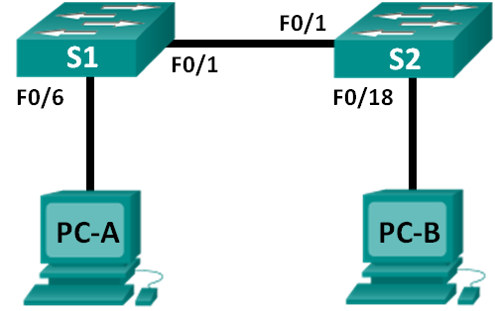
Addressing Table
Device | Interface | IP Address | Subnet Mask
PC-A | NIC | 192.168.1.10 | 255.255.255.0
PC-B | NIC | 192.168.1.11 | 255.255.255.0
Objectives
Part 1: Set Up the Network Topology (Ethernet only)
Part 2: Configure PC Hosts
Part 3: Configure and Verify Basic Switch Settings
Background / Scenario
Networks are constructed of three major components: hosts, switches, and routers. In this lab, you will build a simple network with two hosts and two switches. You will also configure basic settings including hostname, local passwords, and login banner. Use show commands to display the running configuration, IOS version, and interface status. Use the copy command to save device configurations.
You will apply IP addressing for this lab to the PCs to enable communication between these two devices. Use the ping utility to verify connectivity.
Note: The switches used are Cisco Catalyst 2960s with Cisco IOS Release 15.0(2) (lanbasek9 image). Other switches and Cisco IOS versions can be used. Depending on the model and Cisco IOS version, the commands available and output produced might vary from what is shown in the labs.
Note: Make sure that the switches have been erased and have no startup configurations. Refer to Appendix A for the procedure to initialize and reload a switch.
Required Resources
- 2 Switches (Cisco 2960 with Cisco IOS Release 15.0(2) lanbasek9 image or comparable)
- 2 PCs (Windows 7 or 8 with terminal emulation program, such as Tera Term)
- Console cables to configure the Cisco IOS devices via the console ports
- Ethernet cables as shown in the topology
- Set Up the Network Topology (Ethernet only)
In Part 1, you will cable the devices together according to the network topology.
  - Power on the devices.
Power on all devices in the topology. The switches do not have a power switch; they will power on as soon as you plug in the power cord.
  - Connect the two switches.
Connect one end of an Ethernet cable to F0/1 on S1 and the other end of the cable to F0/1 on S2. You should see the lights for F0/1 on both switches turn amber and then green. This indicates that the switches have been connected correctly.
  - Connect the PCs to their respective switches.
    - Connect one end of the second Ethernet cable to the NIC port on PC-A. Connect the other end of the cable to F0/6 on S1. After connecting the PC to the switch, you should see the light for F0/6 turn amber and then green, indicating that PC-A has been connected correctly.
    - Connect one end of the last Ethernet cable to the NIC port on PC-B. Connect the other end of the cable to F0/18 on S2. After connecting the PC to the switch, you should see the light for F0/18 turn amber and then green, indicating that the PC-B has been connected correctly.
  - Visually inspect network connections.
After cabling the network devices, take a moment to carefully verify the connections to minimize the time required to troubleshoot network connectivity issues later.
- Configure PC Hosts
  - Configure static IP address information on the PCs.
    - Click the Windows Start icon and then select Control Panel.
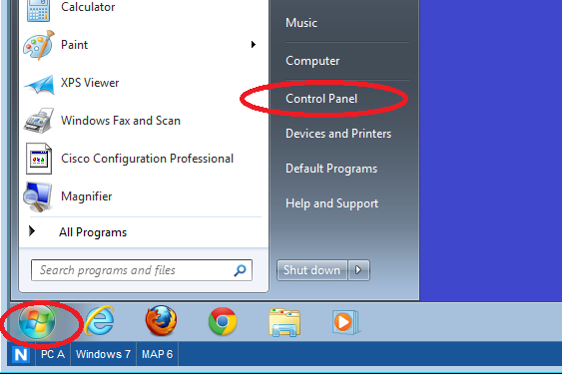
    - In the Network and Internet section, click the View network status and tasks link.
Note: If the Control Panel displays a list of icons, click the drop-down option next to the View by: and change this option to display by Category.
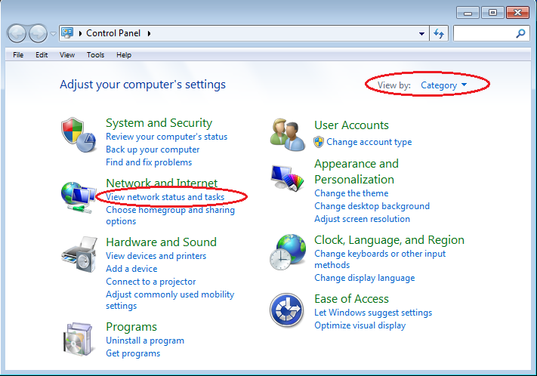
    - In the left pane of the Network and Sharing Center window, click the Change adapter settings link.
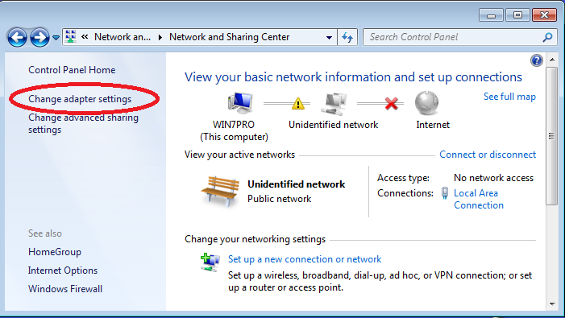

    - The Network Connections window displays the available interfaces on the PC. Right-click the Local Area Connection interface and select Properties.
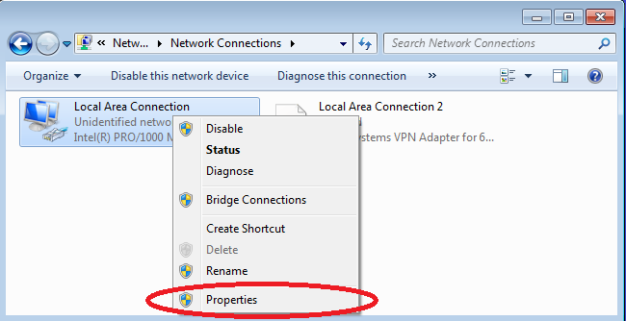
    - Select the Internet Protocol Version 4 (TCP/IPv4) option and then click Properties.
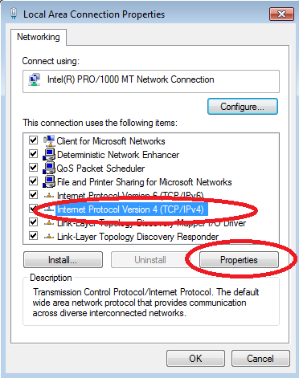
Note: You can also double-click Internet Protocol Version 4 (TCP/IPv4) to display the Properties window.
    - Click the Use the following IP address radio button to manually enter an IP address, subnet mask, and default gateway.
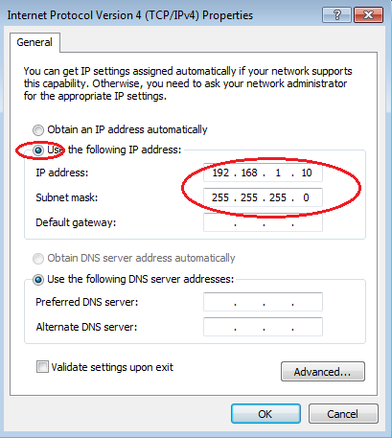
Note: In the above example, the IP address and subnet mask have been entered for PC-A. The default gateway has not been entered, because there is no router attached to the network. Refer to the Addressing Table on page 1 for PC-B’s IP address information.
    - After all the IP information has been entered, click OK. Click OK on the Local Area Connection Properties window to assign the IP address to the LAN adapter.
    - Repeat the previous steps to enter the IP address information for PC-B.
  - Verify PC settings and connectivity.
Use the command prompt (cmd.exe) window to verify the PC settings and connectivity.
    - From PC-A, click the Windows Start icon, type cmd in the Search programs and files box, and then press Enter.
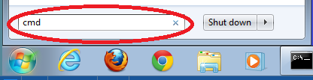

    - The cmd.exe window is where you can enter commands directly to the PC and view the results of those commands. Verify your PC settings by using the ipconfig /all command. This command displays the PC hostname and the IPv4 address information.
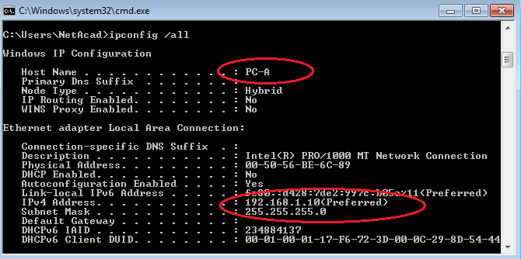
    - Type ping 192.168.1.11 and press Enter.
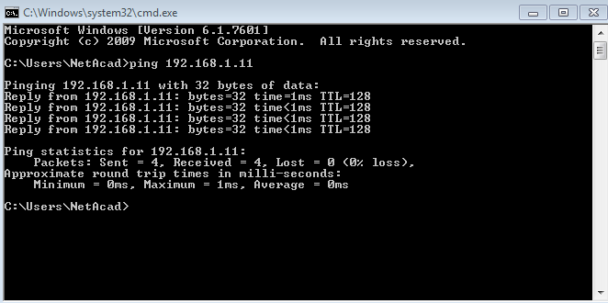
Were the ping results successful? Yes. 4 replies received with less than 1ms response time.
If not, troubleshoot as necessary.
Note: If you did not get a reply from PC-B, try to ping PC-B again. If you still do not get a reply from PC-B, try to ping PC-A from PC-B. If you are unable to get a reply from the remote PC, then have your instructor help you troubleshoot the problem.
- Configure and Verify Basic Switch Settings
  - Console into the switch.
Using Tera Term, establish a console connection to the switch from PC-A.
  - Enter privileged EXEC mode.
You can access all switch commands in privileged EXEC mode. The privileged EXEC command set includes those commands contained in user EXEC mode, as well as the configure command through which access to the remaining command modes are gained. Enter privileged EXEC mode by entering the enable command.
Switch> enable
Switch#
The prompt changed from Switch> to Switch# which indicates privileged EXEC mode.
  - Enter configuration mode.
Use the configuration terminal command to enter configuration mode.
Switch# configure terminal
Enter configuration commands, one per line. End with CNTL/Z.
Switch(config)#
The prompt changed to reflect global configuration mode.
  - Give the switch a name.
Use the hostname command to change the switch name to S1.
Switch(config)# hostname S1
S1(config)#
  - Prevent unwanted DNS lookups.
To prevent the switch from attempting to translate incorrectly entered commands as though they were hostnames, disable the Domain Name System (DNS) lookup.
S1(config)# no ip domain-lookup
S1(config)#
  - Enter local passwords.
To prevent unauthorized access to the switch, passwords must be configured.
S1(config)# enable secret class
S1(config)# line con 0
S1(config-line)# password cisco
S1(config-line)# login
S1(config-line)# exit
S1(config)#
  - Enter a login MOTD banner.
A login banner, known as the message of the day (MOTD) banner, should be configured to warn anyone accessing the switch that unauthorized access will not be tolerated.
The banner motd command requires the use of delimiters to identify the content of the banner message. The delimiting character can be any character as long as it does not occur in the message. For this reason, symbols, such as the #, are often used.

S1(config)# banner motd #
Enter TEXT message. End with the character '#'.
Unauthorized access is strictly prohibited and prosecuted to the full extent of the law. #
S1(config)# exit
S1#
  - Save the configuration.
Use the copy command to save the running configuration to the startup file on non-volatile random access memory (NVRAM).
S1# copy running-config startup-config
Destination filename [startup-config]? [Enter]
Building configuration...
[OK]
S1#
  - Display the current configuration.
The show running-config command displays the entire running configuration, one page at a time. Use the spacebar to advance paging. The commands configured in Steps 1 – 8 are highlighted below.
S1# show running-config
Building configuration...

Current configuration : 1409 bytes
!
! Last configuration change at 03:49:17 UTC Mon Mar 1 1993
!
version 15.0
no service pad
service timestamps debug datetime msec
service timestamps log datetime msec
no service password-encryption
!
hostname S1
!
boot-start-marker
boot-end-marker
!
enable secret 4 06YFDUHH61wAE/kLkDq9BGho1QM5EnRtoyr8cHAUg.2
!
no aaa new-model
system mtu routing 1500
!
!
no ip domain-lookup
!

<output omitted>

!
banner motd ^C
Unauthorized access is strictly prohibited and prosecuted to the full extent of the law. ^C
!
line con 0
password cisco
login
line vty 0 4
login
line vty 5 15
login
!
end

S1#
  - Display the IOS version and other useful switch information.
Use the show version command to display the IOS version that the switch is running, along with other useful information. Again, you will need to use the spacebar to advance through the displayed information.
S1# show version
Cisco IOS Software, C2960 Software (C2960-LANBASEK9-M), Version 15.0(2)SE, RELEASE SOFTWARE (fc1)
Technical Support: http://www.cisco.com/techsupport
Copyright (c) 1986-2012 by Cisco Systems, Inc.
Compiled Sat 28-Jul-12 00:29 by prod_rel_team

ROM: Bootstrap program is C2960 boot loader
BOOTLDR: C2960 Boot Loader (C2960-HBOOT-M) Version 12.2(53r)SEY3, RELEASE SOFTWARE (fc1)

S1 uptime is 1 hour, 38 minutes
System returned to ROM by power-on
System image file is "flash:/c2960-lanbasek9-mz.150-2.SE.bin"

This product contains cryptographic features and is subject to United
States and local country laws governing import, export, transfer and
use. Delivery of Cisco cryptographic products does not imply
third-party authority to import, export, distribute or use encryption.
Importers, exporters, distributors and users are responsible for
compliance with U.S. and local country laws. By using this product you
agree to comply with applicable laws and regulations. If you are unable
to comply with U.S. and local laws, return this product immediately.

A summary of U.S. laws governing Cisco cryptographic products may be found at:
http://www.cisco.com/wwl/export/crypto/tool/stqrg.html

If you require further assistance please contact us by sending email to
export@cisco.com.

cisco WS-C2960-24TT-L (PowerPC405) processor (revision R0) with 65536K bytes of memory.
Processor board ID FCQ1628Y5LE
Last reset from power-on
1 Virtual Ethernet interface
24 FastEthernet interfaces
2 Gigabit Ethernet interfaces
The password-recovery mechanism is enabled.

64K bytes of flash-simulated non-volatile configuration memory.
Base ethernet MAC Address : 0C:D9:96:E2:3D:00
Motherboard assembly number : 73-12600-06
Power supply part number : 341-0097-03
Motherboard serial number : FCQ16270N5G
Power supply serial number : DCA1616884D
Model revision number : R0
Motherboard revision number : A0
Model number : WS-C2960-24TT-L
System serial number : FCQ1628Y5LE
Top Assembly Part Number : 800-32797-02
Top Assembly Revision Number : A0
Version ID : V11
CLEI Code Number : COM3L00BRF
Hardware Board Revision Number : 0x0A

Switch Ports Model SW Version SW Image
------ ----- ----- ---------- ----------
* 1 26 WS-C2960-24TT-L 15.0(2)SE C2960-LANBASEK9-M

Configuration register is 0xF
S1#
  - Display the status of the connected interfaces on the switch.
To check the status of the connected interfaces, use the show ip interface brief command. Press the spacebar to advance to the end of the list.
S1# show ip interface brief
Interface IP-Address OK? Method Status Protocol
Vlan1 unassigned YES unset up up
FastEthernet0/1 unassigned YES unset up up
FastEthernet0/2 unassigned YES unset down down
FastEthernet0/3 unassigned YES unset down down
FastEthernet0/4 unassigned YES unset down down
FastEthernet0/5 unassigned YES unset down down
FastEthernet0/6 unassigned YES unset up up
FastEthernet0/7 unassigned YES unset down down
FastEthernet0/8 unassigned YES unset down down
FastEthernet0/9 unassigned YES unset down down
FastEthernet0/10 unassigned YES unset down down
FastEthernet0/11 unassigned YES unset down down
FastEthernet0/12 unassigned YES unset down down
FastEthernet0/13 unassigned YES unset down down
FastEthernet0/14 unassigned YES unset down down
FastEthernet0/15 unassigned YES unset down down
FastEthernet0/16 unassigned YES unset down down
FastEthernet0/17 unassigned YES unset down down
FastEthernet0/18 unassigned YES unset down down
FastEthernet0/19 unassigned YES unset down down
FastEthernet0/20 unassigned YES unset down down
FastEthernet0/21 unassigned YES unset down down
FastEthernet0/22 unassigned YES unset down down
FastEthernet0/23 unassigned YES unset down down
FastEthernet0/24 unassigned YES unset down down
GigabitEthernet0/1 unassigned YES unset down down
GigabitEthernet0/2 unassigned YES unset down down
S1#
  - Repeat Steps 1 to 12 to configure switch S2.
The only difference for this step is to change the hostname to S2.
  - Record the interface status for the following interfaces.
Interface | S1 |  | S2
Interface | Status | Protocol | Status | Protocol
F0/1 | UP | UP | UP | UP
F0/6 | UP | UP | DOWN | DOWN
F0/18 | DOWN | DOWN | UP | UP
VLAN 1 | Admin DOWN | DOWN | Admin. DOWN | DOWN
Why are some FastEthernet ports on the switches are up and others are down?
The IOS software detected a live cable plugged into the port and changed the port status by default. If the port registered as down then the port was manually placed off line with the shutdown command.
What could prevent a ping from being sent between the PCs?
A Ping failure could result from a cable break, a mis configured port or a hardware failure in the intervening network equipment assuming that the client firewalls permit the protocol.
Note: It may be necessary to disable the PC firewall to ping between PCs.
Appendix A: Initializing and Reloading a Switch
  - Connect to the switch.
Console into the switch and enter privileged EXEC mode.
Switch> enable
Switch#
  - Determine if there have been any virtual local-area networks (VLANs) created.
Use the show flash command to determine if any VLANs have been created on the switch.
Switch# show flash

Directory of flash:/

2 -rwx 1919 Mar 1 1993 00:06:33 +00:00 private-config.text
3 -rwx 1632 Mar 1 1993 00:06:33 +00:00 config.text
4 -rwx 13336 Mar 1 1993 00:06:33 +00:00 multiple-fs
5 -rwx 11607161 Mar 1 1993 02:37:06 +00:00 c2960-lanbasek9-mz.150-2.SE.bin
6 -rwx 616 Mar 1 1993 00:07:13 +00:00 vlan.dat

32514048 bytes total (20886528 bytes free)
Switch#
  - Delete the VLAN file.
    - If the vlan.dat file was found in flash, then delete this file.
Switch# delete vlan.dat
Delete filename [vlan.dat]?
You will be prompted to verify the file name. At this point, you can change the file name or just press Enter if you have entered the name correctly.
    - When you are prompted to delete this file, press Enter to confirm the deletion. (Pressing any other key will abort the deletion.)
Delete flash:/vlan.dat? [confirm]
Switch#
  - Erase the startup configuration file.
Use the erase startup-config command to erase the startup configuration file from NVRAM. When you are prompted to remove the configuration file, press Enter to confirm the erase. (Pressing any other key will abort the operation.)
Switch# erase startup-config
Erasing the nvram filesystem will remove all configuration files! Continue? [confirm]
[OK]
Erase of nvram: complete
Switch#
  - Reload the switch.
Reload the switch to remove any old configuration information from memory. When you are prompted to reload the switch, press Enter to proceed with the reload. (Pressing any other key will abort the reload.)
Switch# reload
Proceed with reload? [confirm]
Note: You may receive a prompt to save the running configuration prior to reloading the switch. Type no and press Enter.
System configuration has been modified. Save? [yes/no]: no
  - Bypass the initial configuration dialog.
After the switch reloads, you should see a prompt to enter the initial configuration dialog. Type no at the prompt and press Enter.
Would you like to enter the initial configuration dialog? [yes/no]: no
Switch>

Reflection (Max word count 200):
Write your reflection based on what you learned from this activity. This could include operation of Switch, configs and testing network connectivity.

With my previous experience with Unix systems, I can conclude that the software is from that source. The operation is simple and revolves around a sequence of keywords that can take additional parameters to perform operations. Knowledge of the keywords is vital for correct configuration of the router. The help key (?) shows valid keywords for command completion but gives no idea about parameter specifications i.e. the set time command: set clock does not show the format of the parameter string or its order of insertion. The command path also seems to use a tree like access path.

Appendices
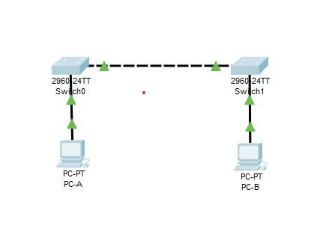
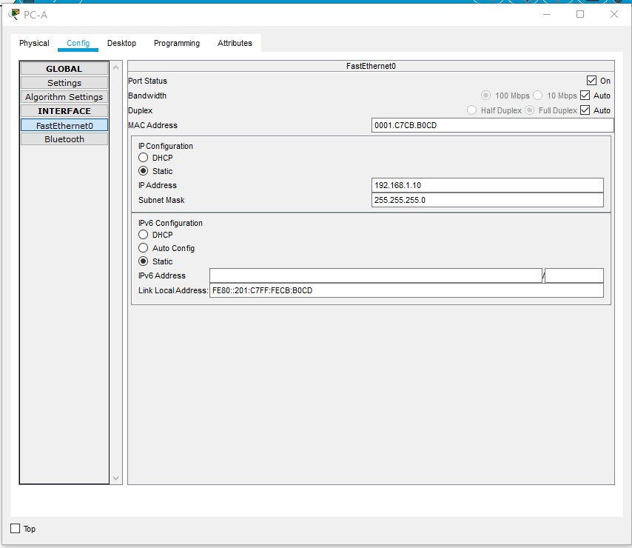
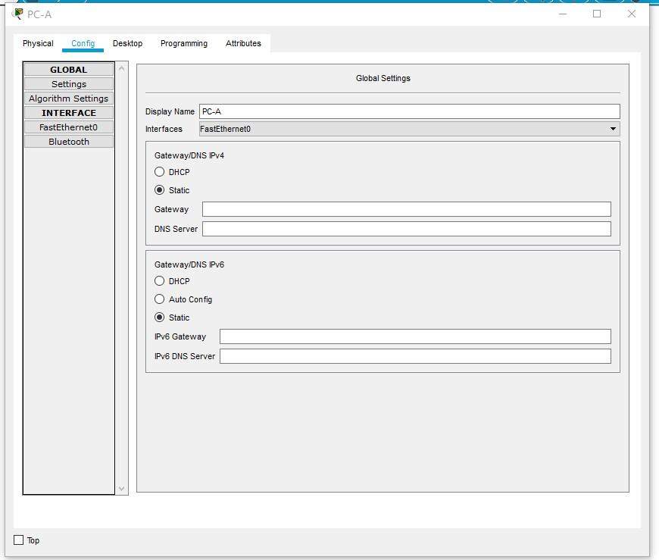
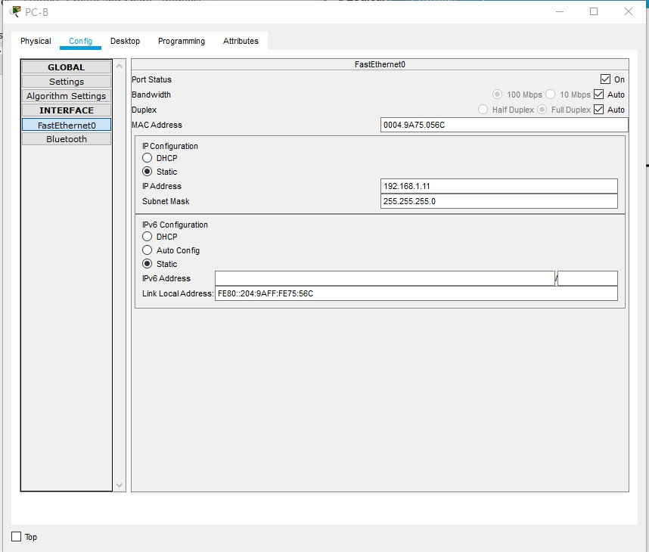

63488K bytes of flash-simulated non-volatile configuration memory.
Base ethernet MAC Address : 00E0.B016.7691
Motherboard assembly number : 73-9832-06
Power supply part number : 341-0097-02
Motherboard serial number : FOC103248MJ
Power supply serial number : DCA102133JA
Model revision number : B0
Motherboard revision number : C0
Model number : WS-C2960-24TT
System serial number : FOC1033Z1EY
Top Assembly Part Number : 800-26671-02
Top Assembly Revision Number : B0
Version ID : V02
CLEI Code Number : COM3K00BRA
Hardware Board Revision Number : 0x01

Switch Ports Model SW Version SW Image
------ ----- ----- ---------- ----------
* 1 26 WS-C2960-24TT 12.2 C2960-LANBASE-M

Configuration register is 0xF

S1#show ip interface brief
Interface IP-Address OK? Method Status Protocol
FastEthernet0/1 unassigned YES manual up up
FastEthernet0/2 unassigned YES manual down down
FastEthernet0/3 unassigned YES manual down down
FastEthernet0/4 unassigned YES manual down down
FastEthernet0/5 unassigned YES manual down down
FastEthernet0/6 unassigned YES manual up up
FastEthernet0/7 unassigned YES manual down down
FastEthernet0/8 unassigned YES manual down down
FastEthernet0/9 unassigned YES manual down down
FastEthernet0/10 unassigned YES manual down down
FastEthernet0/11 unassigned YES manual down down
FastEthernet0/12 unassigned YES manual down down
FastEthernet0/13 unassigned YES manual down down
FastEthernet0/14 unassigned YES manual down down
FastEthernet0/15 unassigned YES manual down down
FastEthernet0/16 unassigned YES manual down down
FastEthernet0/17 unassigned YES manual down down
FastEthernet0/18 unassigned YES manual down down
FastEthernet0/19 unassigned YES manual down down
FastEthernet0/20 unassigned YES manual down down
FastEthernet0/21 unassigned YES manual down down
FastEthernet0/22 unassigned YES manual down down
FastEthernet0/23 unassigned YES manual down down
FastEthernet0/24 unassigned YES manual down down
GigabitEthernet0/1 unassigned YES manual down down
GigabitEthernet0/2 unassigned YES manual down down
Vlan1 unassigned YES manual administratively down down
S1#exit

S1 con0 is now available

Press RETURN to get started.

Unauthorized access is strictly prohibited and prosecuted to the full extent of the law.

User Access Verification

Password:
Password:
Password:

S1>enable
Password:
S1#show flash
Directory of flash:/

1 -rw- 4414921 <no date> c2960-lanbase-mz.122-25.FX.bin
2 -rw- 1271 <no date> config.text

64016384 bytes total (59600192 bytes free)
S1#delete vlan.dat
Delete filename [vlan.dat]?y
Delete flash:/y? [confirm]n
Delete of flash:/y aborted!
S1#show flash
Directory of flash:/

1 -rw- 4414921 <no date> c2960-lanbase-mz.122-25.FX.bin
2 -rw- 1271 <no date> config.text

64016384 bytes total (59600192 bytes free)
S1#erase start
Erasing the nvram filesystem will remove all configuration files! Continue? [confirm]y[OK]
Erase of nvram: complete
%SYS-7-NV_BLOCK_INIT: Initialized the geometry of nvram
S1#reload
Proceed with reload? [confirm]yC2960 Boot Loader (C2960-HBOOT-M) Version 12.2(25r)FX, RELEASE SOFTWARE (fc4)
Cisco WS-C2960-24TT (RC32300) processor (revision C0) with 21039K bytes of memory.
2960-24TT starting...
Base ethernet MAC Address: 00E0.B016.7691
Xmodem file system is available.
Initializing Flash...
flashfs[0]: 1 files, 0 directories
flashfs[0]: 0 orphaned files, 0 orphaned directories
flashfs[0]: Total bytes: 64016384
flashfs[0]: Bytes used: 4414921
flashfs[0]: Bytes available: 59601463
flashfs[0]: flashfs fsck took 1 seconds.
...done Initializing Flash.

Boot Sector Filesystem (bs:) installed, fsid: 3
Parameter Block Filesystem (pb:) installed, fsid: 4

Loading "flash:/c2960-lanbase-mz.122-25.FX.bin"...
########################################################################## [OK]
Restricted Rights Legend

Use, duplication, or disclosure by the Government is
subject to restrictions as set forth in subparagraph
(c) of the Commercial Computer Software - Restricted
Rights clause at FAR sec. 52.227-19 and subparagraph
(c) (1) (ii) of the Rights in Technical Data and Computer
Software clause at DFARS sec. 252.227-7013.

cisco Systems, Inc.
170 West Tasman Drive
San Jose, California 95134-1706

Cisco IOS Software, C2960 Software (C2960-LANBASE-M), Version 12.2(25)FX, RELEASE SOFTWARE (fc1)
Copyright (c) 1986-2005 by Cisco Systems, Inc.
Compiled Wed 12-Oct-05 22:05 by pt_team
Image text-base: 0x80008098, data-base: 0x814129C4

Cisco WS-C2960-24TT (RC32300) processor (revision C0) with 21039K bytes of memory.

24 FastEthernet/IEEE 802.3 interface(s)
2 Gigabit Ethernet/IEEE 802.3 interface(s)

63488K bytes of flash-simulated non-volatile configuration memory.
Base ethernet MAC Address : 00E0.B016.7691
Motherboard assembly number : 73-9832-06
Power supply part number : 341-0097-02
Motherboard serial number : FOC103248MJ
Power supply serial number : DCA102133JA
Model revision number : B0
Motherboard revision number : C0
Model number : WS-C2960-24TT
System serial number : FOC1033Z1EY
Top Assembly Part Number : 800-26671-02
Top Assembly Revision Number : B0
Version ID : V02
CLEI Code Number : COM3K00BRA
Hardware Board Revision Number : 0x01

Switch Ports Model SW Version SW Image
------ ----- ----- ---------- ----------
* 1 26 WS-C2960-24TT 12.2 C2960-LANBASE-M

Cisco IOS Software, C2960 Software (C2960-LANBASE-M), Version 12.2(25)FX, RELEASE SOFTWARE (fc1)
Copyright (c) 1986-2005 by Cisco Systems, Inc.
Compiled Wed 12-Oct-05 22:05 by pt_team

Press RETURN to get started!

%LINK-5-CHANGED: Interface FastEthernet0/1, changed state to up

%LINEPROTO-5-UPDOWN: Line protocol on Interface FastEthernet0/1, changed state to up

%LINK-5-CHANGED: Interface FastEthernet0/6, changed state to up

%LINEPROTO-5-UPDOWN: Line protocol on Interface FastEthernet0/6, changed state to up

Switch>

