

Postgraduate/Distance Learning
Assignment coversheet & feedback form
TO BE USED FOR ALL ESSAY SUBMISSIONS FROM APRIL 2026
THIS COVER SHEET REPLACES ALL PREVIOUS VERSIONS.
YOU MUST SIGN THE AI DECLARATION BEFORE YOU SUBMIT THE ESSAY.

THIS SHEET MUST BE THE FIRST PAGE OF THE ASSIGNMENT YOU ARE SUBMITTING (DO NOT SEND AS A SEPARATE FILE)

For completion by the student:
Student Name: Silvio Marchese Ragona

Student University Email: 2518636@student.uwtsd.ac.uk
Module code:  Module title: Researching Contemporary Cosmologies | Student ID number:  2518636 |  |  | Educational support needs:  No
Assignment title: Essay #2 Project # 6. Entitled: The Eclipsed-Eclipse: How People Recall an Eclipse They Could Not See

Assignment due date: 30th April 2026
This assignment is for the 1st 2nd 3rd 4th 5th 6th module of the degree
Plagiarism declaration:
I confirm that this is my original work and that I have adhered to the University policy on plagiarism.

Artificial Intelligence (AI) declaration:
I confirm that I have not used any AI tools in the research and creation of this assignment. I confirm that I have not presented any AI generated materials as my own work. I confirm I have copies of my drafts, notes, and other resources I used, which I may be asked to provide in evidence.

Signed: S. Marchese Ragona
Date: April 19 2026

Assignment Mark
1st Marker’s Provisional mark
2nd Marker’s/Moderator’s provisional mark
External Examiner’s mark (if relevant)
Final Mark

NB. All marks are provisional until confirmed by the Final Examination Board.

For completion by Marker 1 :
Comments:

Marker’s signature: |  |  | Date:
For completion by Marker 2/Moderator:

Comments:

Marker’s Signature: |  | Date:
External Examiner’s comments (if relevant)

External Examiner’s Signature: |  | Date:

The Eclipsed-Eclipse:
How People Recall an Eclipse They Could Not See
By
Silvio (Sid) Paul Marchese Ragona
Word-Count: 5220

Introduction:
Total solar eclipses are widely recognized as profoundly visual experiences, eliciting a sense of awe and wonder attributed to the sudden appearance of the sun’s corona. On April 8th, 2024, Rochester, NY lay in the path of totality and local leaders, schools, museums, entrepreneurs, and the local population prepared extensively to witness this event. Shortly before the eclipse began, clear skies gave way to thick cloud cover that ultimately obscured the long-awaited spectacle. Cloud covered totality is shown in figure.1.
This eclipsed-eclipse (a title offered by Participant-14) presents a unique opportunity to examine how individuals internalize and remember an event that is anticipated to be a once-in-a-lifetime visual experience but is ultimately hidden from view. Studies of eclipse-induced awe focus on the eclipse being visible, however there is little, if any, work on how people respond to cloud-covered totality or whether the hallmarks of awe such as a perceived vastness and a sense of a diminished self can arise in the absence of observing the eclipse itself. Using written narrative accounts, Likert‑scale measures of emotional response, participant artwork, and a group interview, this project seeks to understand the range of reactions and meaning‑making processes that emerge when totality is present but cannot be seen.

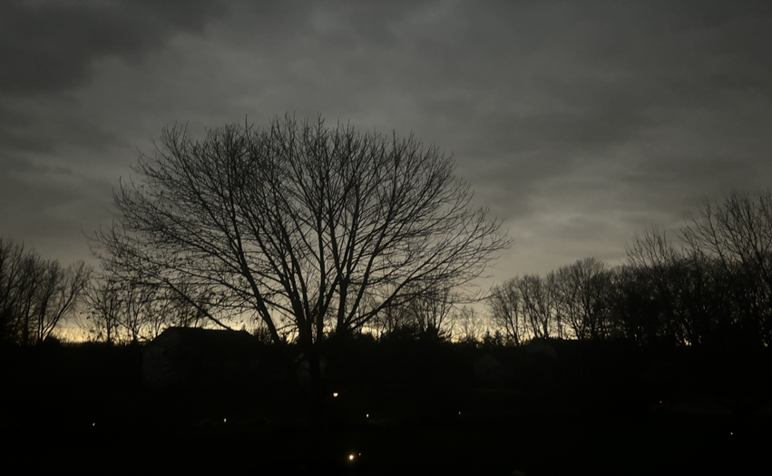
Fig.1. Cloud-covered totality over Rochester, NY, highlighting the 360-degree “sunset” frequently cited by the participants. Image supplied by P-17.
Literature Review:
It is almost impossible to discuss witnessing a total solar eclipse without addressing the sense of awe that it evokes. Awe from an eclipse arises from its perceived vastness, rarity and the need for cognitive accommodation demanded by the event. Recent scholarship has approached eclipse-induced awe from three distinct methodological perspectives; longitudinal self-report, large-scale social media/linguistic analysis and physiological measurements.
Fischer et al. (2025) conducted a NASA-funded mixed methods study examining whether the awe elicited by the April 8th, 2024, total solar eclipse influenced participants sense of science identity and science related activities. Participants reported their feelings of awe as very high during the event (mean 9.1/10) and the sense of awe remained stable, with only a slight decrease six months later (8.5/10). Participants vividly recalled the sudden darkness, the appearance of the solar corona, and the atmospheric changes surrounding totality; some reported being moved to tears. Their qualitative analysis identified five major themes from respondents’ memories: (1) Awe and wonder, (2) social connection, (3) scientific interest, (4) visual and emotional impact and (5) unique experience. Awe was the most prominent theme expressed with words such as “amazing,” “incredible” and “awe-inspiring.” Many emphasized the communal nature of the event, including watching with family, friends and strangers, creating a shared emotional experience. These findings support the widely reported claim that totality is a “life-altering-experience” and the longitudinal data suggest that the eclipse-related awe is both intense and enduring.
Goldy et al. (2022) analyzed 2.89 million Twitter posts of the 2017 total solar eclipse. The study compared users in the path of totality with those who witnessed only a partial eclipse. Their linguistic approach to analysis combined the top-down theory-driven terms drawn from psychological literature (e.g. awe, sublime, transcendent) and bottom-up, data-driven expressions commonly used in the social media postings (amazing, mind-blowing, unreal). The study also tracked pro-social language, such as care, gratitude, love and collective pronouns. This is consistent with prior research linking awe to pro-sociality. Users in totality were twice as likely to use awe-related words and 1.6 times more likely to use positive emotional language while using fewer self-focused pronouns. However, the study did not capture awe-related phrases outside its linguistic model, such as “I felt small.” This omission is noteworthy because the feeling of a “diminished-self” is a well-established component of awe. Bai et al. (2017) demonstrated that awe reliably reduces self-focus and increases collective engagement. In one of their behavioral measures, participants experiencing awe-inducing locations drew themselves approximately 33% smaller than those in a location that did not induce awe. Goldy’s linguistic model which did not include diminished self-expressions such as “I felt small” may therefore underestimate the degree of awe being expressed by the Twitter users in their study.
Russo and Baily (2024) offer a more embodied perspective. Their pilot study, Project AWE, measured a variety of biometric data such as heart rate, heart-rate variability, galvanic skin response to measure emotional arousal (awe, fear, excitement, etc.) and electroencephalography (EEG), a method that records electrical activity in the brain through patterns of neural oscillations (brain waves). The collection of the biometric data intended explore what cannot be put into words, the “ineffability of eclipse-related awe.” The eclipse studied was an annular eclipse, which occurs when the moon is further away from the earth than it would be in a total-eclipse and thus appearing smaller and does not totally block out the sun. A key finding is that awe responses emerged during the partial phase of the eclipse, well before annularity. This challenges the general assumption that awe is tied primarily to the visual climax of the event. At first this appears to contradict Goldy et al.’s findings that partial eclipse observers expressed significantly less awe. However, Goldy et al.’s methodology did not establish a baseline of awe independent of eclipse conditions nor was it designed to detect early phase awe. A plausible explanation is that Project AWE participants were anticipating the full effect of the eclipse, whereas the Twitter users experiencing only a partial eclipse had no expectation of a more dramatic crescendo; for them the partial phase was the entire event.
Despite the methodological differences, the studies of Fischer et al., Goldy et al., and Russo and Baily; share a crucial feature: the eclipse was visible. Participants in Fischer et al. witnessed the sudden darkness and the emergence of the corona; Goldy et al.’s Twitter users saw either totality or a partial eclipse; Russo and Baily’s participants observed the partial phases of the eclipse that triggered awe even before full annularity. Across all three studies, observers encountered many of the awe-eliciting features described by Keltner and Haidt (2003), in particular vastness and beauty.
The studies cited above account for partial eclipses, total, and annular solar eclipses, but none address the experience of a cloud-covered total eclipse, where neither the partial phases that announce the commencement of the event nor totality itself can be seen. A cloud-covered total solar eclipse therefore constitutes a distinct and different phenomenological category. Lacking a formal name, one participant offered a fitting description after witnessing the event: “The eclipsed-eclipse.”
To understand how people navigated this unfamiliar experiential category in real time, social media posts taken on the day of the eclipse and the day after the eclipse were analyzed. This sensitization exercise offered a bottom-up perspective on how residents of Rochester processed a long-awaited event that was ultimately obscured from view. Would awe and wonder still be possible within the eclipsed-eclipse.
Social Media Data: Sensitization Exercise
The sensitizing exercise was based on Herbert Blumer’s notion of sensitizing concepts, used to gain a feel for the emotional landscape before applying predefined boundaries. For privacy reasons, the social media sites are not named, and all posts presented in this report have been paraphrased. This phase was less about generating analyzable data but more focused on language, themes and emotional tone being used by people witnessing the cloud-covered eclipse in Rochester. This preliminary scan highlighted how people made sense of a long-promised celestial event that was ultimately obscured from view by the “famous” Rochester gloom.
Table 1. Visceral same-day social media posts. Mostly short, expressing frustration and disappointment. Eighty posts were analyzed and the table presents a representative selection.
Category | Individual Social Media Posts. (Day of the Eclipse April 8th 2024) | Interpretive Note
Negativity about the Eclipse | - Nothing to see but clouds  - It sucked  - It was the worse  - Too much hype | Immediate, visceral reactions reflecting, unmet expectations, event-focused frustration
Negativity about the Location | - Of course it was cloudy this is Rochester  - Dismal place, happy to leave | Frustration redirected toward place and weather: Invoking local fatalism and resignation
Sarcasm/Humor | - No one went blind  - Where are the 500,000 tourists we were promised? | Humor as a coping strategy Irony expressing disappointment and a sense of being mislead
Positive/ Awe/Pro-Social | - Awe Inspiring  - Loved it  - Cool, clouds or not  - Cool how it got very dark  - Loved so many people coming together | Genuine expressions of awe. Pro-social appreciation, even amid cloud cover.

On the day of the eclipse, the posts were short and visceral, (see Table 1.) expressing frustration about the event and about the location. Some users employed humor to cope with disappointment, while a smaller number expressed awe despite cloud cover (e.g., “cool: clouds or not”). By the following day the emotional tone had shifted markedly as shown in Table 2.
Table 2. The emotional tone of the day after the eclipse shows a shift away from short visceral reactions towards reflection of loss and disappointment as well as awe related words and pro-social commentary. Twenty-six posts were analyzed and the table presents a representative selection.
Category | Individual Social Media Posts. (Day after the Eclipse) | Interpretive Note
Loss/Disappointment | - Comparison is a thief that robs twice. It robs us of the experience we could have had, and it robs of the experience we did have | A reflective recognition of losing the imagined ideal and, in turn, feeling disappointment in the actual experience
Sarcasm/Humor | - No harm in staring up at the Rochester clouds  - Life changing opportunity to shop at Wegmans supermarket | Humor as a coping strategy: Using irony and exaggerated false positives to soften disappointment
Community/Pro-Social | - So glad I experienced it with the love of my life and my community  - We were so lucky to host so many visitors from out of town | Expression of gratitude, belonging and shared experience, all of which are hallmarks of awe and pro-social connections
Positive/ Awe | - We loved the shared experience, magic moments  - I was awestruck by what I saw  - Still very moving and amazing  - Amazing-360° sunset | Continued hallmarks of awe, references to “magic moments” “awestruck” indicative of meaning-making beyond the clouded view

The brief reactive posts were largely absent and replaced with more reflective commentary. Loss and disappointment were reframed not as failures of the event or the city, but as a consequence of expectation itself (e.g., “comparison being a thief that robs twice”). Humor remained present, but the most notable change was the emergence of pro-social posts and the language indicative of awe and shared meaning. These patterns are consistent with Goldy et al.’s findings that the awe elicited from witnessing a total eclipse is accompanied by gratitude, communal orientation, and collective pronoun use. This sensitization exercise provided an initial coding platform and emotional orientation for the subsequent analysis of participant data.

Methodology:
Selection of Participants:
Participants were recruited primarily from personal and professional networks and consisted of individuals who experienced the cloud-covered total solar eclipse in greater Rochester, NY. The intention was not to obtain a demographically representative sample of participants of the local population, but instead the goal was to gather accounts from people who shared the same bounded event to explore how different individuals remembered and made sense of the “eclipsed-eclipse.” A total of twenty-two participants responded, eleven females, ten males and one did not say. Participants ranged in age from their twenties through their eighties, with most falling into fifty-to-seventy age group.
Study Design:
The study employed a multi-faceted, mixed-methods design, grounded in the principle of multi-operationalism put forward by Campbell and Fiske (1959). They argued the benefits of using multiple inquiry techniques to strengthen validity. Denzin (1978) later extended this logic and identified methodological triangulation as a subset of inquiry techniques that use different methodologies to study the same problem. Morse (1991) further refined the categories by distinguishing between sequential and simultaneous forms. In the present study, four complementary modes of inquiry were employed:

1. A narrative questionnaire
2. A Likert-scale for relative emotional measures
3. A drawing-elicitation task
4. One small group interview
Methodologies 1-3 were implemented at the same time and represent a simultaneous-design, sometimes described as within-participant triangulation, because each modality examines the participants experience from a different angle. The addition of the group interview introduced a sequential element extending the design into a broader mixed methods structure. Taken together these components enabled a robust methodological triangulation, reducing the dependence on any single instrument and strengthening the interpretive validity of the findings.
- Questionnaire: Narrative-Section:
The first part of the questionnaire, asked for consent, and demographic information, name, gender, age-decade and how many total solar eclipses they had seen previously. After which a series of open-ended narrative prompts invited participants to describe their experiences of the eclipse in their own words. The open-ended narrative prompts were designed to sequentially lead the participants through the temporal arc of the event, starting with expectations, preparations, the event itself and reflecting back on the entire experience. A full copy of the questionnaire is in Appendix 1.
- Questionnaire: Likert-Scale Emotional Measures:
The second section of the questionnaire consisted of a quantitative Likert-scale, designed to measure emotional responses associated with the eclipse. Participants rated the intensity of emotions such as awe, disappointment, surprise and feeling “cheated.” These measures provided a structured emotional profile of each participant and allowed for triangulation with the qualitative narratives and imagery. Although 5-point and 7-point Likert-scales are common, a 10-point scale was employed in this study for two reasons. First, emotional intensity and feelings are routinely measured on a 1-10 scale. (e.g., pain ratings from 1 = no pain to 10 = unbearable pain). This convention reflects the notion that emotions vary by degrees rather than discrete categories as argued by Reisenzein and Junge 2024. A higher-resolution scale allows the participants to express their emotional feelings with a greater degree of fidelity. A second reason for a 10-point scale is that that it could also be collapsed into broader categories (e.g., 1-5) if needed for simplified analysis or visualization, thus, preserving flexibility without sacrificing sensitivity.
- Drawing-Elicitation Option:
Participants had the option to submit a drawing or sketch representing how they experienced the eclipse, accompanied by a caption and brief description in their own words. The request for the drawing was included in the email that provided the link to the questionnaire. This additional mode of inquiry was included because not all aspects of experience are easily or fully reducible to language. The caption and description ensured that the interpretation of the image was that of the participant rather than the researcher. Instructions for the drawings were intentionally minimal so as not to influence the content and symbolic character of what was depicted. The drawings offered the opportunity for a non-verbal and at times ineffable mode of expression that might be difficult for some participants to articulate in written form.
- Group Interview:
The interview consisted of four participants; one who had witnessed the event alone, two who had participated in a street-organized gathering and one who had observed it with family. This meeting was arranged in a local bar, where the participants regularly meet to discuss volunteer work. To maintain the informal and convivial atmosphere of the session, no digital recordings were made, instead brief notes were taken with occasional requests for clarification or elaboration.
Researcher Positionality: Reflexivity from an Emic Viewpoint.
I occupy an emic position in this study. As a longtime resident of the Rochester area, I experienced the collective anticipation and excitement surrounding this event. In the months leading up to the event, local businesses were printing T-shirts, breweries released commemorative beers, and small pop-up shops emerged to welcome the 500,000 visitors expected to descend on the region. It was impossible not be carried along on the collective excitement even as those quiet voices that everyone that lives in upstate New York knows: “This is Rochester, don’t get your hopes-up.”
My emic-reflexivity acknowledges both my emotional and empathetic involvement with the event and participants and the steps I have taken to ensure that the analysis remains rooted in the participants’ own meaning-making.
Ethics and Risk Assessment:
This research project conforms to the UWTSD Research Ethics and Integrity Policy and the UWTSD Research Data Management Policy. All participants received a Participant Information Sheet (PIS) outlining the purpose of the study, the criteria for participation, and the expected time commitment. The PIS also made clear that participation is entirely voluntary and that participants could withdraw at any point prior to April-15 2026.
There are no anticipated physical, psychological or social risks associated with participation. Personal data collection was kept to minimum; the only demographic questions were name, gender and decade of age. Beyond this no other identifying information was required. All responses were anonymized at the point of collection and individuals were assigned participant codes, such as P-01, P-02 etc. All correspondence and field notes were in written form and no audio or video recordings were collected.
Participants in this study are all adults with full professional and personal commitments, and care was taken not to place unnecessary demands on their limited free-time. The questionnaire is brief and pilot-time-tests showed it took between 10-12 minutes to complete.
Results and Discussion:
General Narrative Overview:
Across twenty-two responses, the narrative accounts of the cloud covered solar eclipse varied widely. Some participants described the moment as spiritual, humbling or evoking a sense of feeling small, whereas others portrayed a more ominous description, describing the event as nightmarish, jolting, creepy and eerie. Others offered far less evocative reflections using words such as: underwhelmed, disheartened, disappointed and in one case, “ho-hum” followed by a description of how enjoyable the party had been. For many in Rochester, preparations had been building for years. By eclipse day it was almost pre-determined that one would either be hosting or attending a celebration. This expectation appeared across nearly all participants, with only one person intentionally seeking solitude for a spiritual experience.
The dominant narrative themes were developed using grounded-theory sensibility, in which coding proceeded from the key words and phrases used by the participants rather than from a predetermined framework (Glaser and Strauss 1967). In this study the categories identified by Fischer et al. (2025), served as a sensitizing guide and were adapted in response to emergent language expressing frustration and disappointment. The four thematic categories that emerged were (1) Awe and Wonder, (2) Frustration and Disappointment, (3) Observational, and (4) Social and Communal Togetherness. It should be noted, however, that nearly all of the participants expressed elements of each theme, but with differing degrees of emphasis. A brief overview of each theme is presented below:
- Awe and Wonder: Many were surprised and awe struck at the effects of an obscured eclipse, such as seeing the moons shadow rush over the clouds at ~ 1000 mph. Several mentioned feeling small or like a spec in the universe. Two participants commented on the apocalyptic sense of the eclipse, one discussed they imagined what it would be like for ancient cultures fearing the end of the world and another participant invoked a telling of the 1941 Isaac Asimov short story entitled Nightfall, in which a civilization experiences darkness only once every 2049 years, collapses into psychological chaos when night finally arrives. Many who expressed high degrees of awe, also reported high degrees disappointment at not seeing the sun’s corona.
- Frustration and Disappointment: Twenty-one of twenty-two participants expressed some form of disappointment. Even those who reported all the hallmarks of awe, still described high levels of disappointment. One participant (P-09) went further saying she was angry that this was just one more thing thrown at her, denying her the experience of feeling small in the universe. Others felt frustrated with the Rochester weather, echoing similar sentiments to the social media posts of the event at the time.
- Observational: Several participants focused less on the emotional aspects and commented on the environmental changes they were witnessing; swift darkness, sudden temperature drop, 360-degree sunrise/sunset, confused animals, silver clouds illuminated from underneath. These observations were more sensory-focused and less emotive in nature.
- Social and Communal Togetherness: Twenty-one of the twenty-two participants attended or hosted an eclipse-party, and many were hosting friends from outside the area of totality. Several commented on their gratitude to be with people they love. The narrative accounts made the social dimension especially clear in light of the fact that this aspect was not captured in the emotional scores and did not consistently appear in the artwork.
This range of responses underscores that even under complete cloud cover, the eclipse was not experienced as single uniform event, instead, it unfolded idiographically as a complex interplay of expectations, sensory perception, and emotions unique to each participant.
Likert-Scale of Emotion:
In addition to the narrative’s accounts, participants were encouraged to fill out a Likert-scale. The questions asked how strongly did you feel each of the following emotions at any point during the event; the results are displayed in Table 3.

Table 3. Displays the self-reported emotional percentages associated at any time during the event.
Rating: | Very-Low  1-2 | Low  3-4 | Moderate  5-6 | High  7-8 | Very-High  9-10
Emotion %
Anticipation | 0.0 | 13.6 | 4.5 | 41 | 41
Concern | 54.5 | 9 | 4.5 | 9 | 22.7
Disappointment | 13.6 | 22.7 | 22.7 | 22.7 | 13.6
Resignation | 4.5 | 22.7 | 22.7 | 22.7 | 27.2
Awe | 4.5 | 13.6 | 13.6 | 31.8 | 36.2
Surprise | 27.2 | 18.2 | 13.6 | 13.6 | 27.2
Cheated | 31.8 | 22.7 | 18.2 | 9 | 18.2

The table shows high and very-high levels of anticipation were reported by 82% of the participants with 68% also reporting high or very-high awe, despite the fact that the sun, moon, and corona were completely obscured. The high degree of anticipation in the results was expected, reflecting participants excitement for the event itself. Although most of the narrative accounts expressed some degree of disappointment or diminished experience, the quantitative rating suggests a more nuanced story. Only 35% reported high or very-high disappointment, 22.7% moderate disappointment and 35% expressing low or very- low disappointment. Surprisingly, when the individual data was examined, the highest rating of disappointment also often appeared alongside the highest ratings of awe. While numerical summaries are provided in the table, the idiographic complexity of the emotional responses suggests that percentage -based groupings may obscure more than they reveal about the lived interplay of emotions, expectations, and interpretations.
Drawing Elicitation Exercise:
The drawing-elicitation was considered optional bonus data for the convergent within-participant triangulation design. Although it was anticipated that some participants might avoid drawing for fear of being judged on their artistic ability, the actual response exceeded expectations. Four participants submitted hand-drawn sketches; two submitted iPad sketches, three submitted AI-generated visualizations of their recollections; and five submitted photographs taken during the event. Most of the photographs depicted eclipse-party scenes, emphasizing the social nature of the day. However, one photograph captured the moment of darkness and 360-degree “sunset” (Fig.1).
Convergent Within-Participant Triangulation:
The narrative accounts, emotional scales and submitted drawings each provide separate windows into the recollection of the eclipsed-eclipse. Rather than averaging responses across the group, the focus of the analysis was ideographically grounded on how the three modalities converged within individual participants across the four thematic categories of (1) Awe and Wonder, (2) Frustration and Disappointment, (3) Observational and (4) Social and Togetherness.

To illustrate the unique nature of each participant’s accounts, several examples are presented below.
Awe and Wonder:
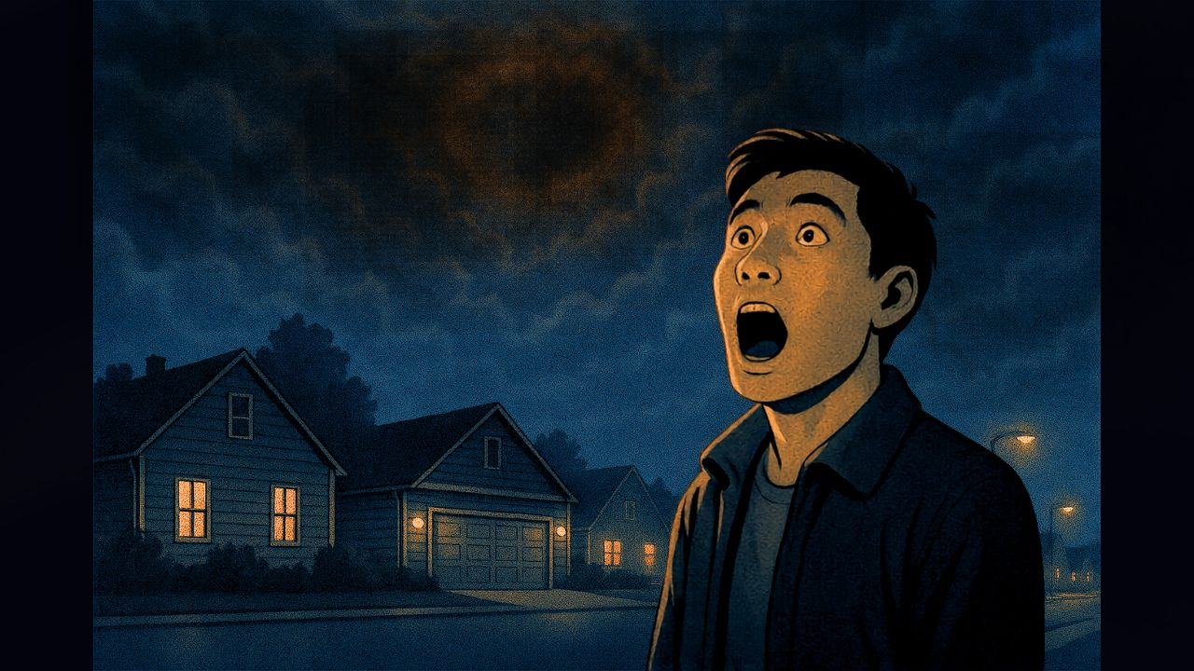
Participant-15 Description of the Image:
Caption: A Moment of Magic Description: Shock and Awe Emotion: Peacefulness

Anticipation | Concern | Disappointment | Resignation | Awe | Surprise | Cheated
4 | 9 | 2 | 8 | 10 | 10 | 2

Fig.2. AI-generated image, with the participant’s description and individual Likert-scale scores for Participant-15.
AI-generated image and Likert-scale emotional rating of Participant-15 are shown in Fig.2. The image depicts him standing alone in a dim street, mouth-open and eyes lifted towards a cloud-covered sky, reflecting the awe and surprise documented in his accompanying Likert scores. In his narrative he described the sudden darkness as “very dark” and “emotionally stilling,” prompting a realization of “how very small we all are.” Across all modalities his account converges on a moment defined less by social presence, despite being at a street-party, and more by awe and a heightened sense of smallness under an obscured totality.

Awe and Wonder/Frustration and Disappointment:
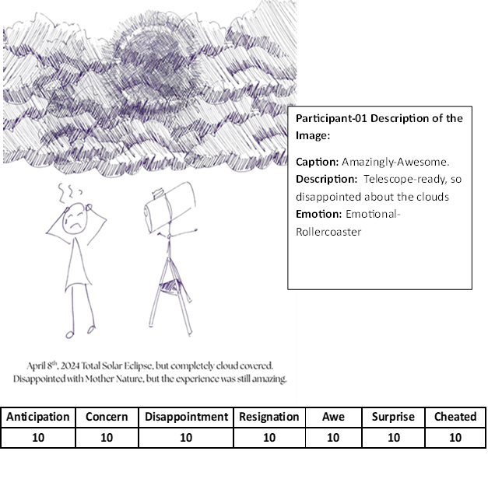
Fig.3. Hand-drawn sketch, with the participant’s description and individual Likert-scale scores for Participant-01.
Participant-01, provided a hand-drawn sketch (Fig.3), and her emotional ratings were at the maximum 10 for every item, reflecting an extreme emotional state as the day unfolded. The drawing centers on a powerful astronomical telescope with “nowhere to point” symbolizing the collapse of extensive preparation and anticipation under an impenetrable cloud layer. Stood to one side is the participant herself depicted alone, with clenched fists and a down-turned mouth, and viable distress, conveying anger and frustration. This is echoed in her narrative description of the clouds, which dissipated 30 minutes after the eclipse had passed. She also remarked “I can see why ancients thought the world was dying.” Across modalities her account converges on a moment of lost opportunity, apparent in the image. Her account spans both the Awe and Wonder category and Frustration and Disappointment category.
Frustration and Disappointment:
For Participant-17, the cloud covered eclipse was shaped by longing, relational meanings and the weight of comparison. He had travelled back to Rochester, his original home town to share the experience with a friend he deeply loves. He witnessed the 2017 total solar eclipse and wanted to recreate the sense of awe that would always be shared in their hearts and memories.

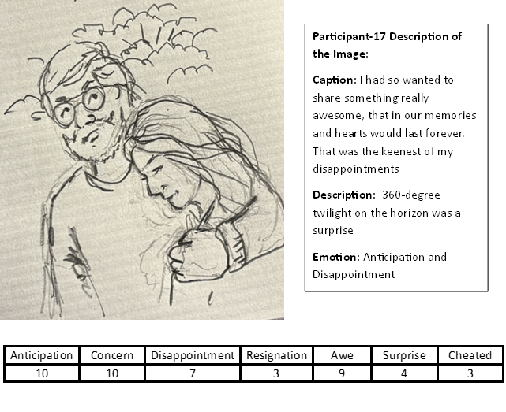Fig.4. Hand-drawn sketch, with the participant’s description and individual Likert-scale scores for Participant-17.

His narrative describes waiting seven years for this moment hoping to share it not only with his special friend but his ailing mother, who passed away earlier than expected. Although he was at a lively party with many friends his sketch (Fig.4) depicts only the two of them, both looking very sad. Across the three modalities, his accounts converge on concern, anticipation and a profound sense of loss, shaped in part by comparison with the 2017 eclipse he witnessed. As observed in the social media accounts (Table 2), “comparison robs twice, it robs us of the experience we could have had, and it robs of the experience we did have.”
Observational:
Participant-14 focused less on emotional tones and more on what he observed around him. He coined the phrase the “Eclipsed-eclipse” and provided an iPad sketch (Fig.5) depicting the overcast sky, with the darkness symbolized by the yellow cones of illumination emanating from street lights. 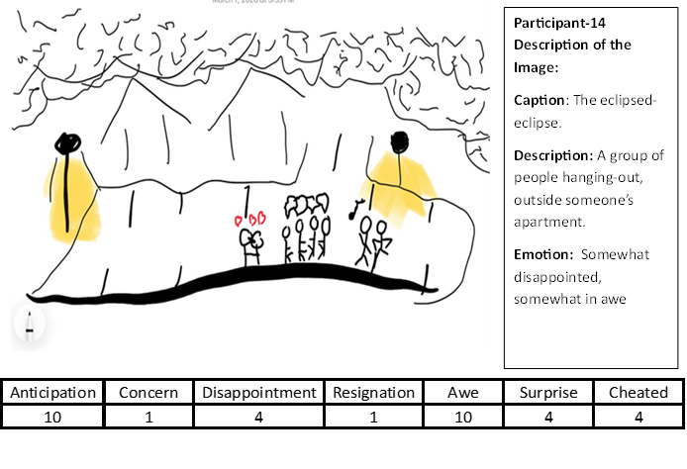Fig.5. iPad sketch, with the participant’s description and individual Likert-scale scores for Participant-14.
He does not draw himself, but instead foregrounds different groups of people around him drawn as stick-figures. In the middle of the image are a couple kissing, denoted by hearts, and to the right of the image two more groups, one group all talking at once denoted by the speech bubbles and two people dancing denoted by a musical note. Unlike the preceding, participants, the image is not centered on himself but on what he sees around him. Like so many others he had a high score of awe (10/10).
Social and Togetherness:
Participant-10 totally ignored the eclipse and centered both his narrative and drawings on the excellent food (Fig. 6). His description of the eclipse was “ho-hum” and his emotional scales were uniformly low, no awe, no surprise. His iPad sketch was of a plate of food. He noted at the time of the eclipse it got cooler and dark with no stars, but was not impressed. While cloud-cover muted the astronomical significance, it foregrounded the pleasure of friends, family and food.
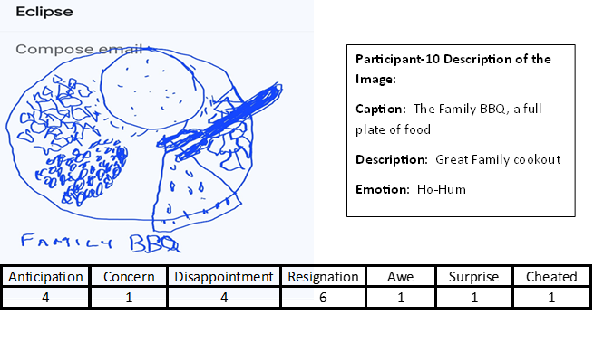
Fig.6. iPad sketch, with the participant’s description and individual Likert-scale scores for Participant-10.
Another participant (P-21) submitted a humorous AI-generated sketch of an eclipse party he spent weeks organizing for people from out-of-state. (Fig. 7). The image shows guests with shoulders hunched and palms turned skyward gesturing where is the eclipse? Despite the humor in the image, his anticipation, awe, and surprise were all rated 10. However, not seeing the Sun’s corona also left him with a strong sense of being cheated 10.

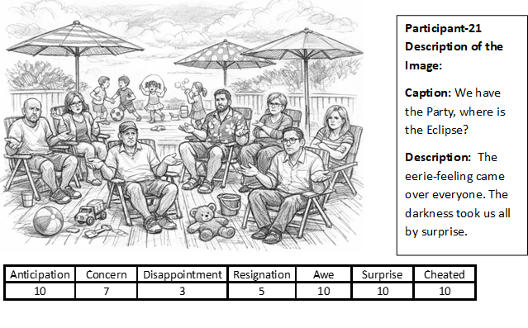Fig.7. AI-generated image, with the participant’s description and individual Likert-scale scores for Participant-21.
The above data highlights the highly individual and emotionally complex accounts of participants as expressed through their narrative, emotional scales and imagery. For most participants a sense of awe was elicited by the sudden plunge into darkness, quick drop in temperature and a 360-degree “sunset” despite the cloud-cover. The use of three different instruments enabled methodological triangulation, thereby reducing the dominance of any single method and allowing the idiographic nature of the experience to be documented.
Group interview:
No individual interviews were conducted, primarily due to the busy schedule of the individuals selected, however one small group interview was conducted and consisted of four participants (P-01 P-05 P-18 P-20). At the start of the meeting, Participant-05 unfolded his AI-generated image (Fig. 8.) and sought group consensus before officially submitting it to the study. He was the only participant in the study to have spent eclipse-day purposely alone so as to experience what he described as a “spiritual-moment.” It was his first AI -generated image and he asked the others whether the depiction of himself alone made him appear lonely, spiritual or simply antisocial. From there the conversation flowed freely with others sketching images on napkins (images not shown) and discussing what prompts they should use if they were to generate their own AI-based imagery.

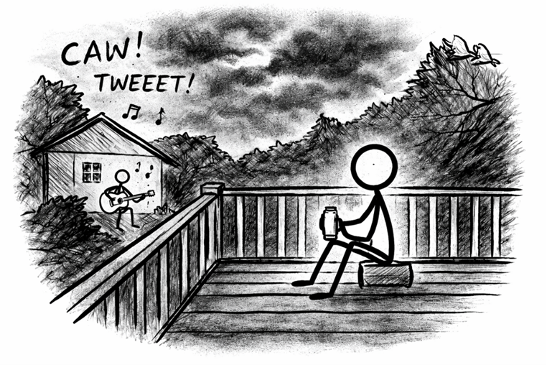

Fig.8. AI-generated image by Participant-05 for a group discussion.
The only question asked of the group was: “Is cloud-covered totality better than a visible partial eclipse? Russo and Baily (2024) indicated that even a partial eclipse was enough to elicit awe. The groups discussion involved some back and forth and no one seemed to have a firm opinion. Their eventual conclusion, was answered with a rhetorical question and answer. “What’s the difference between a cloudy day in Rochester and a partial solar eclipse” Answer: “Nothing!” followed by a round of laughter.
The original intention of the group interview was to add a fourth method of triangulation, to complement the narrative, emotional and visual data. However, because the conversation unfolded in an unstructured and participant-led direction, it quickly became a lively exchange about creating images, comparing drawings and engaging in light-hearted teasing rather than a sustained analytical discussion of the eclipse itself. As a result, the group interview did not function as a formal triangulation method but was a treated as supplemental data that illuminated how image-making became a method of collective expression.
Conclusions:
This study is the first of its kind to examine how people interpret and remember a long-awaited solar eclipse that was ultimately hidden from view by thick cloud cover. Among the twenty-two participants, two-thirds reported the emotion of awe as either high or very-high (see Table 3.), despite the fact that neither the Sun nor Moon were visible. Instead, participants oriented their attention to atmospheric and environmental cues that were produced by the unseen eclipse, such as the swiftly moving lunar shadow, a sudden plunge from day to night, followed by the appearance of a 360-degree “winter-sunset,” the instantaneous drop in temperature and altered behavior of animals.
In addition to awe, participants also described disappointment and frustration and for some a sense of being cheated or unfairly denied something they had long anticipated. However, two years later everyone remembers which eclipse-party they were at and with whom, underscoring the pro-social nature of such an event. Using grounded-theory sensibilities, this study produced thematic categories similar to those reported by Fischer et al. (2025), with the notable difference that disappointment and frustration emerged as a distinct category. The group interview was unstructured and participant-led, with a rapid shift away from discussing the eclipse itself toward exploring how to represent it in sketches and AI prompts. This material was treated as supplemental rather than as part of the methodological triangulation.
While the eclipsed-eclipse was a shared astronomical moment, the subjective experiences varied widely across individuals. Participants reported different emotional reactions, internalized observations differently; even the submitted images revealed distinct experiential framing of the same moment in time. Taken together these findings suggest that an eclipse, even a cloud-covered one, is a highly individualized experience not easily amenable to statistical averaging or any notion of an “average” response. Additionally environmental cues of an eclipse event are sufficient to elicit a range of emotions and memories that extend far beyond the visual spectacle itself.

Bibliography:
13WHAM News, ‘You’re Right — It’s Been Gloomy, Even for Rochester’, 13WHAM ABC, available at: https://13wham.com/news/local/youre-right-its-been-gloomy-even-for-rochester (accessed 10 April 2026).
Asimov, Isaac, ‘Nightfall’, Astounding Science Fiction, September 1941.
Bai, Yang, Laura A. Maruskin, Serena Chen, Amie M. Gordon, Jennifer E. Stellar, Galen D. McNeil, Kaiping Peng, and Dacher Keltner, ‘Awe, the Diminished Self, and Collective Engagement: Universals and Cultural Variations in the Small Self’, Journal of Personality and Social Psychology, 113.2 (2017), 185–209.
Blumer, Herbert, Symbolic Interactionism: Perspective and Method (Englewood Cliffs, NJ: Prentice-Hall, 1969).
Campbell, Donald T., and Donald W. Fiske, ‘Convergent and Discriminant Validation by the Multitrait–Multimethod Matrix’, Psychological Bulletin, 56 (1959), 81–105.
Denzin, Norman K., The Research Act: A Theoretical Introduction to Sociological Methods, 2nd edn (New York: McGraw Hill, 1978).
Eisner, Elliot W., ‘Art and Knowledge’, in Handbook of the Arts in Qualitative Research: Perspectives, Methodologies, Examples, and Issues, ed. by J. Gary Knowles and Ardra L. Cole (London: Sage, 2008), pp. 3–12.
Fischer, Heather A., Victoria Sellers, and Martin Storksdieck, ‘Harnessing the Awe of Eclipses to Enhance Science Engagement’, Frontiers in Astronomy and Space Sciences, 2025, article 1558021.
Glaser, Barney G., and Anselm L. Strauss, The Discovery of Grounded Theory: Strategies for Qualitative Research (Chicago: Aldine, 1967).
Goldy, Sean P., Nickolas M. Jones, and Paul K. Piff, ‘The Social Effects of an Awesome Solar Eclipse’, Psychological Science, 33.9 (2022), 1452–62.
Keltner, Dacher, and Jonathan Haidt, ‘Approaching Awe, a Moral, Spiritual, and Aesthetic Emotion’, Cognition and Emotion, 17.2 (2003), 297–314.
Morse, Janice M., ‘Approaches to Qualitative–Quantitative Methodological Triangulation’, Nursing Research, 40 (1991), 120–23.
Piff, Paul K., Pia Dietze, Matthew Feinberg, Daniel M. Stancato, and Dacher Keltner, ‘Awe, the Small Self, and Prosocial Behavior’, Journal of Personality and Social Psychology, 108.6 (2015), 883–99.
Reisenzein, Rainer, and Michael Junge, ‘Emotions as Magnitudes: A Conceptual Analysis’, Frontiers in Psychology, 15 (2024), 1330873 https://doi.org/10.3389/fpsyg.2024.1330873.
Russo, Kate, and Andrew W. Bailey, ‘Deeper Insights into the Solar Eclipse Experience: Piloting Project AWE’, Bulletin of the American Astronomical Society, 56.3 (2024).

Appendix #1.



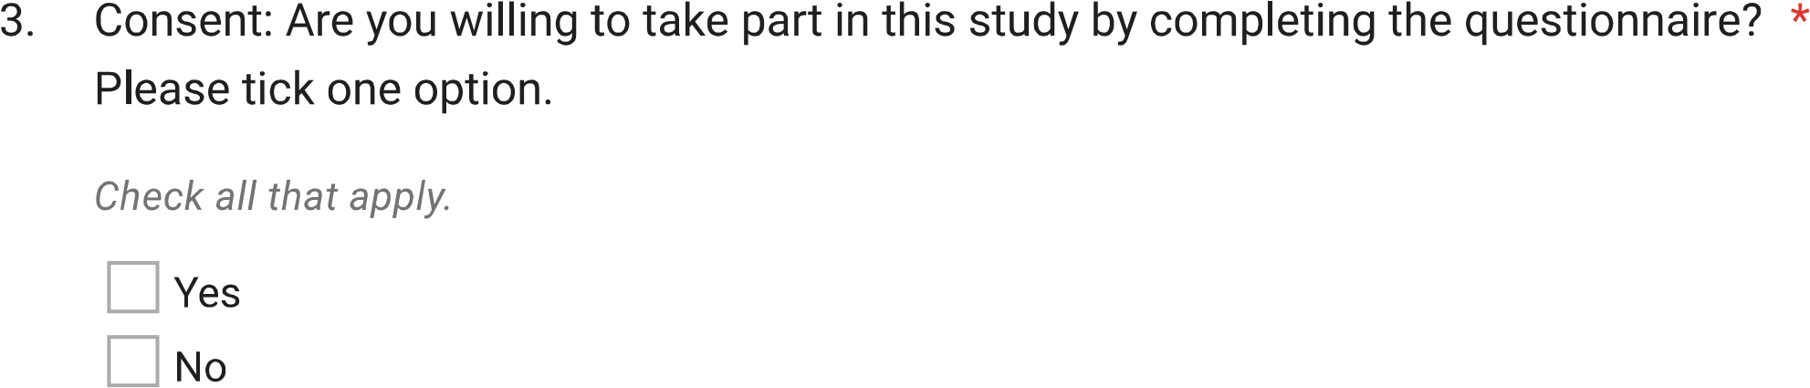



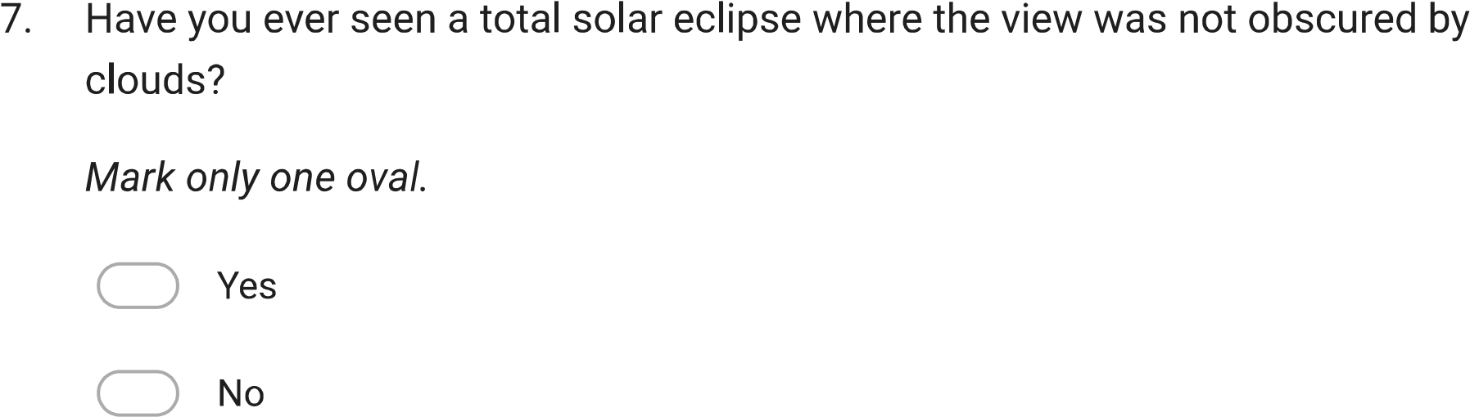

12. Once it became clear that totality would likely be cloud covered, how did you adjust your expectations?

15. Did anything surprise you? Was the experience of cloud covered totality different from what you thought it would be?

19.
19

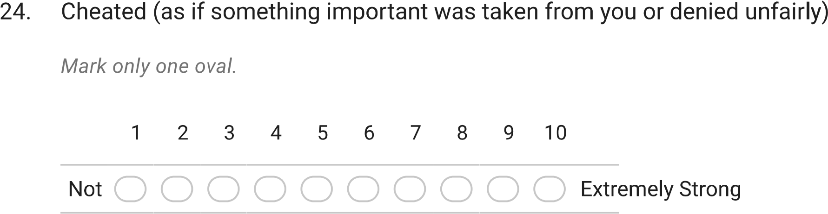



Heather A. Fischer, Victoria Sellers, and Martin Storksdieck, ‘Harnessing the Awe of Eclipses to Enhance Science Engagement’, Frontiers in Astronomy and Space Sciences, 2025, article 1558021.
Fischer, Sellers, and Storksdieck, ‘Harnessing the Awe of Eclipses’, p. 6.
Fischer, Sellers, and Storksdieck, ‘Harnessing the Awe of Eclipses’, p. 6.
Sean P. Goldy, Nickolas M. Jones, and Paul K. Piff, ‘The Social Effects of an Awesome Solar Eclipse’, Psychological Science, 33.9 (2022), 1452–62.
Goldy, Jones, and Piff, ‘The Social Effects of an Awesome Solar Eclipse’, p. 1454.
Paul K. Piff, Pia Dietze, Matthew Feinberg, Daniel M. Stancato, and Dacher Keltner, ‘Awe, the Small Self, and Prosocial Behavior’, Journal of Personality and Social Psychology, 108.6 (2015), 883–99.
Goldy, Jones, and Piff, ‘The Social Effects of an Awesome Solar Eclipse’, p. 1460.
Yang Bai, Laura A. Maruskin, Serena Chen, Amie M. Gordon, Jennifer E. Stellar, Galen D. McNeil, Kaiping Peng, and Dacher Keltner, ‘Awe, the Diminished Self, and Collective Engagement: Universals and Cultural Variations in the Small Self’, Journal of Personality and Social Psychology, 113.2 (2017), 185–209.
Bai et al., ‘Awe, the Diminished Self’, p. 194.
Kate Russo and Andrew W. Bailey, ‘Deeper Insights into the Solar Eclipse Experience: Piloting Project AWE’, Bulletin of the American Astronomical Society, 56.3 (2024).
Dacher Keltner and Jonathan Haidt, ‘Approaching Awe, a Moral, Spiritual, and Aesthetic Emotion’, Cognition and Emotion, 17.2 (2003), 297–314.
Herbert Blumer, Symbolic Interactionism: Perspective and Method (Englewood Cliffs, NJ: Prentice‑Hall, 1969).
13WHAM News, ‘You’re Right — It’s Been Gloomy, Even for Rochester’, 13WHAM ABC, available at: https://13wham.com/news/local/youre-right-its-been-gloomy-even-for-rochester (accessed 10 April 2026).
Goldy, Jones, and Piff, ‘The Social Effects of an Awesome Solar Eclipse’, p. 1454.
Donald T. Campbell and Donald W. Fiske, ‘Convergent and Discriminant Validation by the Multitrait–Multimethod Matrix’, Psychological Bulletin, 56 (1959), 81–105.
Norman K. Denzin, The Research Act: A Theoretical Introduction to Sociological Methods, 2nd edn (New York: McGraw-Hill, 1978).
Janice M. Morse, ‘Approaches to Qualitative–Quantitative Methodological Triangulation’, Nursing Research, 40 (1991), 120–23.
Rainer Reisenzein and Michael Junge, ‘Emotions as Magnitudes: A Conceptual Analysis’, Frontiers in Psychology, 15 (2024), 1330873 <https://doi.org/10.3389/fpsyg.2024.1330873>.
Elliot W. Eisner, ‘Art and Knowledge’, in Handbook of the Arts in Qualitative Research: Perspectives, Methodologies, Examples, and Issues, ed. by J. Gary Knowles and Ardra L. Cole (London: Sage, 2008), pp. 3–12.
Barney G. Glaser and Anselm L. Strauss, The Discovery of Grounded Theory: Strategies for Qualitative Research (Chicago: Aldine, 1967).
Isaac Asimov, ‘Nightfall’, Astounding Science Fiction, September 1941.

