Section 1
A third of 3 billion user are under the age of 18 states Kidron and Rudkin (2017). The last decade has shown that children and teenagers using digital media more and more, including interactive devises and social media (Chassiakos et al. 2016; Ofcom 2019; Open access Government 2019). With children enjoying playing with digital devices (Abdul Aziz 2013; Heider and Jalongo 2015; Kabali et al. 2015). However, it doesn’t come without its challenges argues Kidron and Rudkin (2017).
Popular devises such as tablets, consoles, computers, smart-phone are accessed by children according to Wiseman and Taylor (2014). In a recent report, Ofcom (2019) mentions that 6 out of 10 children, aged 3 - 4 years old are able to access devices online at home or elsewhere. With a tablet being the top device at 49 per cent, whereby 24 per cent of this age group have their own tablet. Which is an increase of 16 per cent over a 4-year period. Furthermore, Ofcom (2019) continues, a desk top computer is only accessed by those at just 4 per cent. There has been an increase of 5 per cent of children accessing mobile phones which takes the statistics up to 20 per cent. 15 per cent use a laptop and 9 per cent Smart TV.
The world of digital is welcomed in the 21st century notes Kidron and Rudkin (2017) and a necessary component for children, and the digital world we live in is here to stay. All children have the right to access the digital world and safely. (Kidron and Rudkin 2017; United Nations Convention on the Rights of the Child no date; NSPCC 2020; Children commission for Wales 2021) However, Marsh and Bishop (2014) recognises peoples’ worries, that play is weakened by technological objects in children’s direct surroundings. Whether we agree or not, Takeuchi (2011) noted children play is changing, and our children of the next generation are going to spend more time in highly digital play devises. For young children to learn and develop, Roopnarine et al. (2015) mentions play is vital for children, in order for them to have experiences, and its viewed as an integral factor in child development. Marsh et al. (2016) referred to digital play as a poorer form of play, whilst Mustola et al. (2016) stated that it is alleged as a non-traditional play. Levin (2015) argued too, that if children don’t have the opportunity to experience those typically play methods, that digital play does not give those quality aspects of play. However, whilst on devises and searching sites, Ofcom (2019) reported children develop their creative skills as well as learning new skills, which can develop into lifelong interests and hobbies.
Therefore, one of the great benefits to digital devises is early learning with introduction to new ideas and knowledge, states Chassiakos et al. (2016). As well as increased chances and openings, to learn about those positive messages of health promotions, support and information. As children construct their own learning Piaget (1896), therefore if children are introduced to digital devises at an early age, this becomes the norm for them. In the past American Academy of Pediatrics (2016) would discourage screen time for children 18 months plus, however they now recommend that children aged 18-24 months to view those high-quality programming sites. Furthermore, Heitner (2014) mentions, the use of digital media, should be used for a positive experience, as this can support children with creativity. However, (Agger and Shelton 2007; Levin 2015; Shaheen 2014) argued that children are not going to gain those social and cultural values whilst playing with digital games.
Ofcom (2019) reported, 51 per cent of children aged 3-4 in 2019 where able to access YouTube, compared just to 37 per cent in 2016, this is evident that children of a young age are confident with devises and using digital media more and more. Ofcom (2019) continued, that there had been a vast increase of this age group watching videos on demand, this has almost doubled in 4 years taking the statistic up to 65 per cent, compared to 29 per cent back in 2015.
As children are active learners, hands on practice and independent Vygotsky (1978), children levels of skills are assessed, and therefore this is used to see what skills are required next. Children have the opportunity with the ‘more knowledgeable other’ to use the internet or other devises, to enhance their learning. As well as a child liaises with their peers in order to achieve a set goal. Furthermore, the Welsh Government (2018) Digital Competence Framework supports with children’s different levels of learning and developing those vital digital skills. Young children, from the beginning are given play environment and materials from their parents, notes Johnson (1986) and Roopnarine (2011) therefore the parents or carers are those who influence children’s learning and development.
Following the Donaldson review (2015) and recommendations, the new curriculum for Wales 2022 features a Digital Competence Framework and takes in consideration those children with additional learning needs, with a supporting document Routes to Learning Digital Competence. To support children’s learning, and feedback directly to parents and carers, there should be an increase on digital media. Therefore, as it has become apparent from various report that media devises are on the increase there are Legislation’s is in place to ensure children are kept safe. The Social Services and Wellbeing Act 2014 is responsible for child protection and provide the legal framework. In a recent report Kidron and Rudkin (2017) recommended when making those policy decisions, that Government should align policy interventions with the needs of childhood development milestones, as well and keeping safe in a digital environment.
Chassiakos et al. (2016) states that evidence shows there are both benefits and risk. The more children use media devises, Ofcom (2019) mentions it is increasing the critical understanding, and this is essential to avoid those potential risks. Online safety and the risk should be taught in schools as part of the curriculum notes The Royal College of Paediatrics and Child Health (2018) and in order to cover those issues such as wellbeing and self-esteem; body image and mental health which children often observe when accessing the digital world, therefore this learning should be embedded. Kidron and Rudkin (2017) states for children to make good choices in their life, both on and off screen, it is the responsibility of teachers, parents and carers. Heitner (2014) notes that parents should be good role models and offer mentorship. Similar to Bandura (1977) a child copies the adult, this applies on and off screen, therefore it is vital that adults are good role models. Healthy Children (2020) agrees and notes children are growing up in an era of media devises, threfore parents should act as good role models when using devises. However, Kidron and Rudkin (2017) argues, these cannot be fulfilled unless tools and strategies are in place and age appropriate. Children who play with digitals devises at home have positive learning outcomes notes Plowman et al. (2012) as it supports children’s acquisition of operation skills, as well as their knowledge and understanding of media and information communication technology in everyday life.
However, Chassiakos et al. (2016) notes that the messages are not all positives, children and teenagers are in danger of exposure to inappropriate and inaccurate content, which can compromise privacy and confidentiality. Along with risks such as higher occurrence of obesity and depression and those negative effects on sleep, attention and learning. However, Child Net (2018) argues that digital devices are an excellent way for learning and creativity with the whole family, and this can provide enjoyment and entertainment.
Welsh Government (2021) continues to work with multi agencies to protect children rights in Wales. This includes protecting children rights whilst online states United Nations Convention on the Rights of the Child (no date). From a recent report Children’s Commissioner for Wales, (2021) states children and young people mentioned that cyberbullying needs to be monitored, but also those who are behind they cyberbullying, action needs to be taken, as when it is reported and nothing happens the children and young people feel undervalued. Furthermore, Kidron and Rudkin (2017) notes that those who provide digital platforms and services should act upon the recommendation.
A recent Estyn annual report (2020) stated that prior to the pandemic, there was a vast diffidence between schools and staff members, on their knowledge and experience with regards to digital technology. Furthermore, it was evident that those who had invested in training were better placed that those who had not embarked on professional development. However, during the pandemic, schools have reflected on digital learning and now appreciate that traditional teaching along with digital learning can support the pupils learning and especially those with additional learning needs. Kidron and Rudkin (2017) argues that policy makers should ensure that there is training for frontline practitioners who are responsible for children and safeguarding.
Takeuchi (2011) noted whether parents are worried about the amount of time children spend on digital devises. Due to busy life styles, parents give children devices whilst they engage in other activities. Furthermore, Kidron and Rudkin (2017) argues that children and adults are not aware of the implications and risks this comes with. Whereby parents may believe that children are looking and engaging in age-appropriate sites. Ofcom, 2019 less than half of these parents are not aware how to use parental control settings on tablets or smartphones. As parents wanted to keep children safe online therefore 62 per cent of 3 – 4-year-olds sought advice. This ranged from 29 per cent of parents asking the school for advice whereas 37 per cent took advice from family or friends and 12 per cent looked online. 86 per cent of parent’s, feel that they have a good balance between doing other things and screen time for their children aged 3 – 4-year-olds, states Ofcom (2019). However, Kidron and Rudkin (2017) argues, children at a young age use devises, and start to be more independent, however children aged 3 – 4-year-old are not able to independently self-manage time. Furthermore, Child net (2018) states parents and carers that this causes conflict within the family when managing screen time. Guidance has been produced by The Royal College of Paediatrics and Child Health (2019), this does not state the amount of time, however suggestions that 1 hour before bed devises should be avoided. Furthermore, the focus is on time, and that it does not impede or replace exercise, sleep, food or family time.
Children’s rights and wellbeing are central as many schools developed a Children’s Rights Approach stated the Children commission for Wales (2021). This means that children have to right to be safe and not suffer discrimination and their privacy is safe too and be listened too. Online abuse can happen via the internet via media devises such as mobile phones, iPads; lap tops; tablets. (Department for Education, 2018; Department of Health, 2017; Scottish Government, 2014; Welsh Government, 2018). However, raising children in this digital world can cause a lot of parent anxiety, as they worry about children using social media notes Heitner (2014). As some children are shown to be distressed when a friend doesn’t respond to a message straight away or doesn’t like their photo on social media. Therefore, Healthy children, (2020) In order to ensure that balance of online time and screen time, is to set boundaries in line with recommendations as mentioned in A healthy Family Media Use Plan. This supports with implementation of those consistent rules for media use, and supports with family communication. To ensure children grow into healthy adults, and ensuring good sleeps patterns and an appropriate amount of physical exercise, parents are encouraged to develop individual and personalised Family Media Use Plan. Healthy children (2020) continued this supports with those unhealthy habits and behaviors which can have a negative effect on academic performance, health and wellbeing, social and person development.
Therefore, to conclude, it is vital to get the balance right, notes Chassiakos et al. (2016) as well as promoting and maintaining satisfactory physical activity, eating those healthy nutritional meals, keeping up with good hygiene and sleeping well. The protection for children in paramount for all, including Government (2021). The legislation Protection of Children 1978 has been updated in 2021, to ensure children are protected in many ways, to keep them safe in the digital world.
Section 2 – Parent / Carer Leaflet
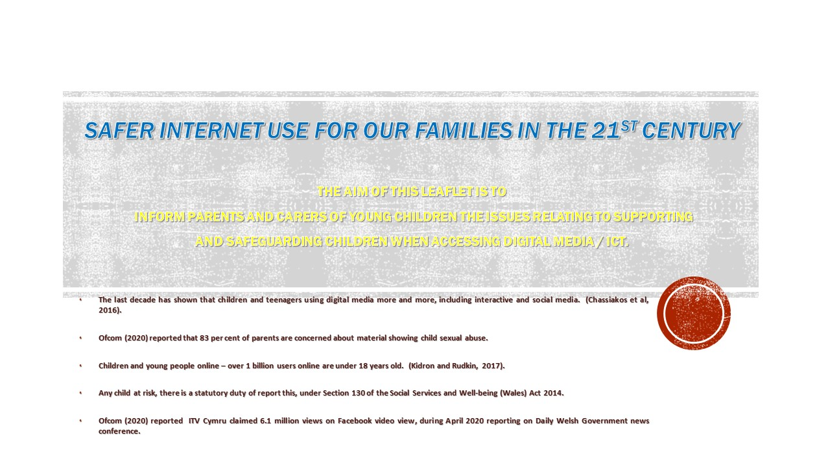

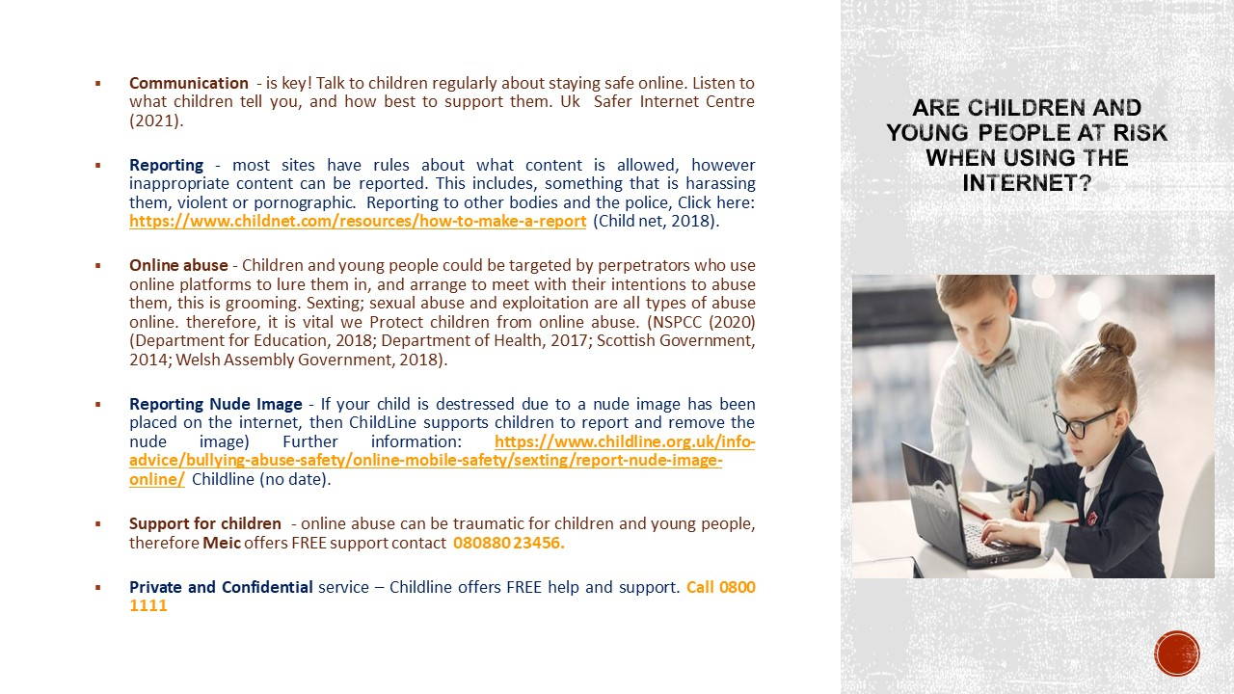

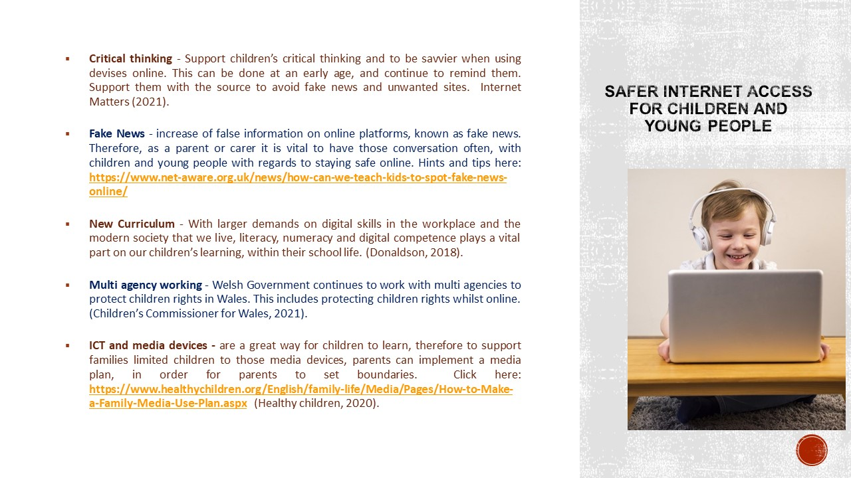

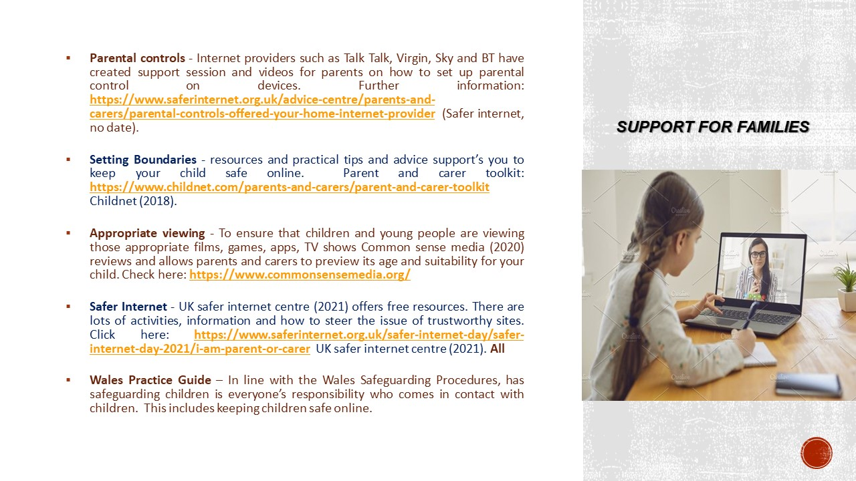

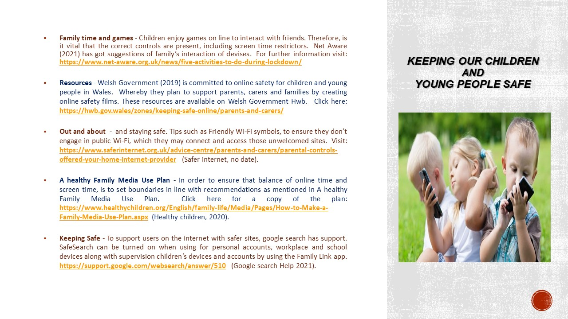

Section 3 Activity Plan for Digital Literacy Skills
Activity Plan for Digital Literacy Skills- Introducing children to photography and prints.
Number of children:  9 | Age of children:  3 – 4-year-olds | Number of adults:  2
Location:  The nursery environment, indoors and outdoors | Preparation time:  1 hour –  Setting up activity to ensure it is inviting for children to have the opportunity to participate in photography, printing and framing. | Activity time:  The activity can be carried out over a two-week period, ensuring all children have had an opportunity to participate with the camera and activity
Resources:
- “Real” Digital cameras
- Empty Photo frames. A range of different sizes - portrait, landscape, A3, A4, A5 and textures, plastic, wood, shells, mirror, diamante, jewels, material
- Lap top and Printer
- Paper – white / colour
- Card – various colours
- Photo Albums
- Scrap books
- Magazines
- Photo frames with prints. A range of different sizes, textures
- Materials to make frames. Cardboard, paper, wood, plastic, scissors, pens, jewels, glue, material, wool, string

Links to digital literacy/competence outcomes:
This cross-curricular photography activity, gives children the opportunity to take and review the images. However, the main focus is on well-being and Cultural Diversity, Personal and Social Development, and Digital Competency.
Digital Competence Framework
Digital Competence Framework Guidance Strands Page 5
Strands
Citizenship - Health and Well-being
Interacting and collaborating - Storing and sharing
Producing - Planning sourcing and searching
Data and computational thinking - Problem solving and modelling
Literacy – make scrapbook with their own photographs and use captions. Explore books, printing, cameras
Numeracy – size of prints, frames, paper, cardboard, shape, patterns and numbers, download and reworking images for children to explore.

Details of the activity:
Introducing children to photography and prints.
The practitioners are responsible for setting up an area to invite children to take part in photography. Various props available, and practitioners allow the children to makes choices.
Children have the opportunity to use real digital cameras within the nursery environment, indoors and outdoors.
As children are inquisitive and curious, it is vital to allow plenty of time for children to explore the nursery environment and take photos, developing their technique and skills. Therefore, the children have the opportunity to participate, if they choose over the two-week period.
The activity is planned to include all children, including those with individual needs. The practitioners are available to support those requiring help. The practitioners encourage children to take photos of what interests them, this could be there friends, toys, items, garden, flowers, insects etc, within the nursery environment (indoors or outdoors).
Opportunities to communicate with children. Practitioners question the children with, ‘what they like’ and ‘why’ along with supporting with the camera, if required.
Once they have taken the pictures, they have an opportunity to transfer the photos from the camera onto the laptop.
The children can decide to print their 3 favourite pictures. Once printed, the children have the opportunity to frame, place in scrap books, place on the wall, include in photo album.

Section 4

The activity plan in part three of the portfolio, is to promote the digital literacy and the competence of a group of young children when accessing information and communication technology. Technology is advancing at an astonishing rate, and the world is changing rapidly, Welsh Government (2019). Ager (2021) notes that to our younger generation, that technology is becoming the norm to our children.
Moving forward into the twenty first century not only is literacy and numeracy vital for children’s development but digital literacy or digital competence play an equal part in children’s learning Donaldson (2015). Therefore, hence why I decided on the activity to introduce children to photography and prints. The Photography activity allows children the opportunities to be: ambitious, capable learners; enterprising, creative contributors; ethical, informed citizens; healthy, confident individuals as noted Donaldson (2015).
The Welsh Government (2008) Education for Sustainable Development and Global Citizenship links to the activity plan with the information computer technology. Giving children experiences and learning opportunities to develop Digital skills in the 21st Century. The activity plan includes Articles from the United Nations Convention on the Rights of the Child (no date) ensuring children are protected, but also have the opportunity to play and be kept safe.
The photography activity covers all aspects of Digital Competency as Welsh Government (2018) states, they are committed to ensure all learners in Wales, receive high standard and literacy and numeracy and become more digitally and bilingually competent, this contributes the learner to be enterprising, creative and critical thinkers.
Welsh Government Hwb (no date) supports children and young people with digital technology to support them to become digital literate. Therefore, children become for independent using the Hwb and able to access during school time but also able to use the platform at home.
The overall photography activity was to support children to be creative and use technologies and systems as well as gaining those skills, knowledge and attitudes, which all contribute towards Digital literacy. The activity outcomes are linked to Digital Competence framework (2018). Technology is vital for children within their play mentions Ager (2021) as this supports learning and development prior to using it in a more formal way.
There are four main strands of the Digital Competence Framework therefore I have focused on one element which is Citizenship and within that strand, I critical evaluate health and well-being as this is one of the outcomes.
Many theorists, over the Years, such as Froebel, Steiner, McMillian sisters believed in order to enhance children learning, they would learn better from the natural outdoor environment notes Davies and Hamilton, (2018). However, a mixture of the indoors and outdoors environment is better, argued Waite (2011), and this would support them to learn and develop. Furthermore, Education Inspectorates recongise those great benefits of embedding outdoor learning, notes Marchant et al. (2019), like it is in the early years and within the curriculum.
Within the activity the children are given the opportunity to explore the environment with the cameras, following the practitioners informing the children, how to use the camera in order for them to reach their full potential, and to be confident when taking photos. However, to enhance this photography activity, there could be more opportunities for children to explore with the camera in the natural outdoors.
Free flow play allows the child choice, and to play freely states Bruce (2014) and the children are able to take ownership and make decisions and predictions. Furthermore, the photography activity is set up over a two-week period, and the children are able to play freely with the digital cameras.
To support children with additional learning needs, once the child has taken the photos, these can be placed onto the computer, then the child could go and point or collect the item that matches the photograph. This would fit with the Digital Competence Framework Strands Routes for Learning (2018). Whereby it is individual for each learner and broken down into small steps to support them in a creative way, when using technology.
Children are able to increase their learning, they have the opportunity to upload the photos from the camera onto the laptop, as outlined within the Digital Competence Framework (2018). The role of the practitioners is to support those who require help; therefore, the activity is inclusive to all. Children should have the opportunity to engage in technology, Ager (2021) states, therefore it is our responsibility to teach and support them. As mentioned in the activity, children are inquisitive and curious therefore it is vital to allow plenty of time for the children to explore with the camera to take photos. However, consideration needs to be given for those children that may be on the risk register or not given consent for photographs, in line with the Welsh Government (2020) All Wales Safeguarding Procedures. Therefore, practitioners would be aware of those who have given consent for photographs, in line with the settings Policy and Procedures Welsh Government (2021). However, in some situations, the parents / carer may have given permission for internal photographs, this would be outlined in the consent form. However, if other children take pictures of children, the practitioner can delete the image from the camera and or computer. Ensuring the photographs have been deleted completely, as sometimes this can be automatically backed up on the computer, as mentioned in the Microsoft guidance (2021).
The cross-curricular photography activity, gives children the opportunity to take and review the images. However, the main focus is on well-being and Cultural Diversity, Personal and Social Development and Digital Competency, and to ensure that practitioners embed Digital Competency in everyday practice.
Once the children have taken the photographs they are uploaded onto the computer, and can be printed. Here they have the opportunity to make a scrap book, place the photographs on the wall, and or make frames for the images.
The role of the adult is responsible for setting up an area that is inviting to children to take part in photography activity. Offer support to those who require it. Frobel (Cited: Bruce 2012) believed that the children should be able to play freely, and have the freedom to explore. Whilst the practitioners focus on what the children are achieving. Therefore, the role of the adult observes and focus and praise the children for their achievement and what they can do, this builds confidence and self-esteem. Rather than emphasis on what they cannot do.
Practitioners need to encourage and support children using information and communication technology states Dong and Xu (2020) and believes that information and communication technology is beneficial for young children. Ager (2021) notes that practitioners should talk to children about technology and act as good positive role models, to ensure children use and learn technology. Therefore, children will be motivated to use new technology develop a positive attitude.
Digital cameras and laptops along with other electronics and digital toys are now classed as information and communication technology notes Palaiologou (2016) as they contain a computer or microcontroller. Therefore, the photography activity compliments information and communication technology. Children learn and develop from information and communication technology (Clements & Sarama, 2003; Siraj-Blatchford & Whitebread, 2003; Yelland, 2007), as this is an essential tool contribute towards the learning and development.
Furthermore, (Aldhafeeri, Palaiologou, & Folorunsho, 2016; Edwards, 2016; Hu & Yelland, 2017; Kerckaert, Vanderlinde, & Braak, 2015; Weng & Li, 2018) states that policymakers, educator and teachers have a great interest in integrating information and communication technology into the classroom however incorporating this into the classroom practice has not been generally found in many countries.
Therefore, to support children with information and communication technology, Donaldson (2015) and Hu & Yelland (2017) state it is vital to train teachers and practitioners, and provide them with the knowledge and skills on information and communication technology integration. However, practitioners in wales, are able to call on support from Digital Pioneer Schools Welsh Government (2018) to implement the Digital Competence Framework, this was set up in response to the needs of the professionals.
The vision of 21st-century skills is that those digital skills are needed states Van Larr et al. (2017) and Chalkiadaki (2018) in order to contribute in the knowledge-based workforce. However, Van Larr et al. (2017) noted employees should take ownership of their own learning.
Therefore, to conclude, within the activity plan, the children have an opportunity to explore with photography within the nursery environment. It was apparent through research and evidence, to include digital devises into teaching at an early age. With the New Curriculum 2022, children will be able to learn and become Digital literate, whilst practitioners have support via the Hwb.

Reference List

Abdul Aziz, N. A. (2013). Children’s interaction with tablet applications: Gestures and interface design. International Journal of Computer and Information Technology, 2(3), 447–450.
Agger, B., & Shelton, B. (2007). Fast families, virtual children: A critical sociology of families and schooling. Boulder, CO: Paradigm.
Aldhafeeri, F., Palaiologou, I., & Folorunsho, A. (2023). Integration of digital technologies into playbased pedagogy in Kuwaiti early childhood education: Teachers’ views, attitudes and aptitudes. International Journal of Early Years Education, 24(3), 342–360. doi:10.1080/09669760.2023.1172477
American Academy of Pediatrics (2021) The beginning of the End of the Screen Time Wars. Available at: https://slate.com/technology/2023/10/the-american-academy-of-pediatrics-new-screen-time-guidelines.html (Accessed: 23 February 2021).
Chalkiadaki, A., 2018. A systematic literature review of 21st century skills and competencies in primary education. International Journal of Instruction, 11(3), pp.1-.
Chassiakos, Y. l., Radesky, j., Christakis, D, Moreno, M. A., and Cross, C. (2023) ‘Children and Adolescents and Digital Media’, American Academy of Pediatrics, 138, 5 http://pediatrics.aappublications.org/content/pediatrics/138/5/e20232593.full.pdf [Accessed: 23.2.21].
Childline (no date) Online, on the phone, anytime. Available at: https://www.childline.org.uk/ (Accessed: 23 February 2021).
Childline (no date) Report nude image online. Available at: https://www.childline.org.uk/info-advice/bullying-abuse-safety/online-mobile-safety/sexting/report-nude-image-online/ (Accessed: 23 February, 2021).
Child Net (2018) How to make a report. Available at: https://www.childnet.com/resources/how-to-make-a-report (Accessed: 23 February 2021).
Child Net (2018) Parent and carer toolkit. Available at: https://www.childnet.com/parents-and-carers/parent-and-carer-toolkit (Accessed: 23 February 2021).
Child net International (2018) Screen time and health balance. Available at: https://www.childnet.com/parents-and-carers/hot-topics/screen-time-boundaries (Accessed: 23 February 2021).
Children’s Commissioner for Wales (2021) Don’t worry I’m here for you. Available at: https://www.childcomwales.org.uk/dont-worry-im-here-for-you-childrens-experiences-of-cyberbullying-in-wales-3/ (Accessed: 23 February 2021).
Children’s Commissioner for Wales (2021) Children’s rights in a digital world. Available at: https://www.childcomwales.org.uk/our-work/sallys-blog/childrens-rights-digital-world/ (Accessed: 23 February 2021).
Clements, D. H., & Sarama, J. (2003). Young children and technology: What does the research say? Young Children, 58(6), 34–35. Cordes, C., & Miller, E. (Eds.).
Commonsense Media (no date) Reviews for what your kids want to watch (before they watch it). Available at: https://www.commonsensemedia.org/ (Accessed: 23 February 2021).
Davies, R. and Hamilton, P., 2018. Assessing learning in the early years’ outdoor classroom: examining challenges in practice. Education 3-13, 46(1), pp.117-129.
Devorah Heitner (2017) The Challenges of Raising a Digital Native: TEDxNaperville [video]. Available at: https://www.youtube.com/watch?v=eRQdAOrqvGg (Accessed: 23 February 2021).
Donaldson (2015) Successful Futures Independent Review of Curriculum and Assessment Arrangements in Wales. Available at: https://gov.wales/sites/default/files/publications/2018-03/successful-futures.pdf (Accessed: 23 February 2021).
Dong, C. and Xu, Q., 2020. Pre-service early childhood teachers’ attitudes and intentions: young children’s use of ICT. Journal of Early Childhood Teacher Education, pp.1-23.
Edwards, S. (2016). New concepts of play and the problem of technology, digital media and popular-culture integration with play-based learning in early childhood education. Technology, Pedagogy and Education, 25(4), 513–532. doi:10.1080/1475939X.2015.1108929
Estyn (2020) Estyn annual remit. Available at: https://gov.wales/estyn-annual-remit-2020-2021-html (Accessed 23 February 2021).
Google Search Help (2021) How safe search works. Available at: https://support.google.com/websearch/answer/510 (Accessed: 23 February 2021).
Health Children (2020) How to make a family media use plan. Available at: https://www.healthychildren.org/English/family-life/Media/Pages/How-to-Make-a-Family-Media-Use-Plan.aspx (Accessed: 23 February, 2021).
Heider, K., & Jalongo, M. R. (2015). Young children and families in the information age: Applications of technology in early childhood education. New York: Springer.
Hrastinski, S. and Ekman Rising, M., 2020. Communities, networks and ICT professional development across schools in close physical proximity. Technology, Pedagogy and Education, 29(2), pp.219-229.
Hu, X., & Yelland, N. (2017). An investigation of preservice early childhood teachers’ adoption of ICT in a teaching practicum context in Hong Kong. Journal of Early Childhood Teacher Education, 38(3), 259–274. doi:10.1080/10901027.2017.1335664
Image of children on smart phone [image] Available at: https://www.pinterest.co.uk/pin/669840144550215482/ (Accessed: 23 February 2021).
Image of boy on laptop [image] Available at: https://www.pinterest.co.uk/pin/449374869073723628/ (Accessed: 23 February 2021).
Image of girl and boy on lap top [image] Available at: https://www.pinterest.co.uk/pin/35043703340058401/ (Accessed: 23 February 2021).
Image of girl at laptop [image] Available at: https://www.pinterest.co.uk/pin/240942648803556935/ (Accessed: 23 February 2021).
Internet Matters (2021) Helping parents keep their children safe online. Available at: https://www.internetmatters.org/ (Accessed: 23 February 2021).
Johnson, J. E. (1986). Attitudes toward play and beliefs about development. In B. Mergen (Ed.), Cultural dimensions of play, games, and sports (pp. 89–101). Champaign, IL: Human Kinetics Publishers, Inc.
Kabali, H. K., Irigoyen, M. M., Nunez-Davis, R., Budacki, J. G., Mohanty, S. H., Leister, K. P., & Bonner, R. L. (2015). Exposure and use of mobile me.
Kerckaert, S., Vanderlinde, R., & Braak, J. (2015). The role of ICT in early childhood education: Scale development and research on ICT use and influencing factors. European Early Childhood Education Research Journal, 23(2), 183–199. doi:10.1080/1350293X.2015.1023804
Kidron, B. and Rudkin, A. (2017). Digital Childhood: Addressing childhood development milestones in the digital environment.
Learning Theories (2020) social learning theory bandura. Available at: https://www.learning-theories.com/social-learning-theory-bandura.html (Accessed: 23 February 2021).
Levin, D. E. (2015). Technology play cthatoncerns. In D. P. Fromberg & D. Bergen (Eds.), Play from birth to twelve: Contexts, perspectives, and meanings (pp. 225–232). New York: Routledge.
Marchant, E., Todd, C., Cooksey, R., Dredge, S., Jones, H., Reynolds, D., Stratton, G., Dwyer, R., Lyons, R. and Brophy, S., 2019. Curriculum-based outdoor learning for children aged 9-11: A qualitative analysis of pupils’ and teachers’ views. PloS one, 14(5), p.e0212242
Marsh, J., & Bishop, J. C. (2014). Changing play: Play, media and commercial culture from the 1950s to the present day. Berkshire: Open University Press/ McGrawHill.
Meic (2021) Someone on your side. Available at: https://www.meiccymru.org/ (Accessed: 23 February 2021).
Microsoft (2021) duplicate and similar photo cleaner free. Available at: https://www.microsoft.com/en-us/p/duplicate-and-similar-photo-cleaner-free/9nw8xn81mj9f?activetab=pivot:overviewtab (Accessed: 23 February 2021).
Mustola, M., Koivula, M., Turja, L., & Laakso, M. L. (2023) Reconsidering passivity and activity in children’s digital play. New Media & Society. https://doi.org/10.1177/1461444823661550.
Net Aware (2021) five activities to do during lockdown. Available at: https://www.net-aware.org.uk/news/five-activities-to-do-during-lockdown/ (Accessed: 23 February 2021).
Net Aware (2021) how can we teach kids to spot fake news online. Available at: https://www.net-aware.org.uk/news/how-can-we-teach-kids-to-spot-fake-news-online/ Accessed: 23 February 2021).
NSPCC (2020) Child abuse and neglect. Available at: https://learning.nspcc.org.uk/child-abuse-and-neglect/online-abuse (Accessed: 23 February 2021).
Ofcom (2019) Children and parents: Media use and attitudes report 2019. Available at: https://www.ofcom.org.uk/__data/assets/pdf_file/0023/190623/children-media-use-attitudes-2019-report.pdf (Accessed: 23 February 2021).
Open Access Government (2018) technology in education is hindering students interpersonal skills. Available at: https://www.openaccessgovernment.org/technology-in-education-is-hindering-students-interpersonal-skills/43696/ (Accessed: 23 February 2021).
Open Access Government (2019) Young children are using digital devices more than ever before. Available at: https://www.openaccessgovernment.org/young-children-digital-devices/69201/ (Accessed: 23 February 2021).
Orben, A. and Przybylski, A.K., 2019. The association between adolescent well-being and digital technology use. Nature Human Behaviour, 3(2), pp.173-182.
02 (2021) online safety tools and tips. Available at: https://www.o2.co.uk/help/online-safety/tools-and-tips (Accessed: 23 February 2021).
Ofcom (2020) Internet users’ experience of potential online harms: summary of survey research. Available at: https://www.ofcom.org.uk/__data/assets/pdf_file/0024/196413/concerns-and-experiences-online-harms-2020-chart-pack.pdf (Accessed: 23 February 2021).
Palaiologou, I. (2016). Teachers’ dispositions towards the role of digital devices in play-based pedagogy in early childhood education. Early Years, 36(3), 305–321. doi:10.1080/09575146.2023.1174823
Pentagonplay (2018) Psychology learning through play. Available at: https://www.pentagonplay.co.uk/news-and-info/psychology-learning-through-play (Accessed: 23 February 2021).
Plowman, L., Stevenson, O., Stephen, C., & McPake, J. (2012). Preschool children’s learning with technology at home. Computers & Education, 59(1), 30–37.

Research GTE (2020) Pre-service early childhood teachers’ attitudes and intentions: young children’s use of ICT. Available at:
https://www.researchgate.net/profile/Chuanmei-Dong/publication/339206999_Pre-service_early_childhood_teachers%27_attitudes_and_intentions_young_children%27s_use_of_ICT/links/5f8e583a92851c14bcd549a2/Pre-service-early-childhood-teachers-attitudes-and-intentions-young-childrens-use-of-ICT.pdf (Accessed: 23 February 2021).
Roopnarine, J. L., Patte, M., Johnson, J. E., & Kuschner, D. (Eds.). (2015). International perspectives on children’s play. Berkshire: Open University Press.
Roopnarine, J. L. (2011). Cultural variations in beliefs about play, parent–child play, and children’s play: Meaning for childhood development. In A. D. Pellegrini (Ed.), The oxford handbook of the development of play. New York: Oxford University Press. https:// doi.org/10.1093/oxfordhb/9780195393002.013.0003.
Royal College of Paediatrics and child health (2018). Impact of social media and screen-use on young people’s health. Available at: https://www.rcpch.ac.uk/sites/default/files/2019-08/rcpch_response_to_social_media_and_screentime_consultation_0.pdf (Accessed: 23 February 2021).
Royal College of Paediatrics and child health (2019) New screen time research published. Available at: https://www.rcpch.ac.uk/news-events/news/new-screen-time-research-published-rcpch-responds (Accessed: 23 February 2021).
Safer internet (no date) parental controls offered your home internet provider. Available at: https://www.saferinternet.org.uk/advice-centre/parents-and-carers/parental-controls-offered-your-home-internet-provider (Accessed: 23 February 2021).
Siraj-Blatchford, J., & Whitebread, D. (2003). Supporting ICT in the early years. Maidenhead: Open University Press.
Shaheen, S. (2014). How child’s play impacts executive function— related behaviors. Applied Neuropsychology: Child, 3(3), 182– 187. https://doi.org/10.1080/22322965.2013.839612.
Social Care Wales (2020). Wales Safeguarding Procedures. [Mobile app]. Version 1.07. Available at: https://eur01.safelinks.protection.outlook.com/?url=https%3A%2F%2Fplay.google.com%2Fstore%2Fapps%2Fdetails%3Fid%3Dcom.socialcarewales.safeguarding&data=02%7C01%7C%7Cb3789363fb5e4400225f08d869d294b9%7C4e0f11f9046e45059cb8db2152311e21%7C0%7C0%7C637375700442375714&sdata=maaqnW%2FJN6fcUjxPUsa%2BnV8zbLH7WjQQs7IcyNrq0Kk%3D&reserved=0. (Accessed: 23 February 2021).
Takeuchi, L. (2011). Families matter: Designing media for a digital age. New York: The Joan Ganz Cooney Center at Sesame Workshop.
Teach Early Years (2021) ICT in the Early Years. Available at: https://www.teachearlyyears.com/learning-and-development/view/ict-in-the-early-years (Accessed: 23 February 2021).
Tina Bruce (2014) Play Theory. Available at: https://www.studymode.com/essays/Tina-Bruce-Play-Theory-52379525.html (Accessed: 23 February 2021).
UK safer Internet Centre (2021) I am parent or carer. Available at: https://www.saferinternet.org.uk/safer-internet-day/safer-internet-day-2021/i-am-parent-or-carer (Accessed: 23 February 2021).
UNICEF (no date) The United Nations Convention on the Rights of the Child. Available at: https://www.unicef.org.uk/what-we-do/un-convention-child-rights/. (Accessed: 23 February 2021).
Van Laar, E., Van Deursen, A.J., Van Dijk, J.A. and De Haan, J., 2017. The relation between 21st-century skills and digital skills: A systematic literature review. Computers in human behavior, 72, pp.577-588.
Vygotsky, L. S. (1978). Mind and society. Cambridge, MA: Harvard University Press.
Waite, S. (2011), ‘Making a difference: Learning on a grand scale’, in Waite, S. (ed.), Children Learning Outside the Classroom: From Birth to Eleven, pp. 201 – 212. London: Sage Publications Limited.
Wiseman, C. and Taylor, L. (2014). 6 Digital harmony or digital dissonance? Developing literacy skills in the new technological age. Challenge and Change for the Early Years Workforce: Working with Children from Birth to 8, p.99.
Welsh Government (no date) Hwb. Available at: https://hwb.gov.wales/ (Accessed: 23 February 2021).
Welsh Government (2008) Digital competence framework curriculum for Wales 2008 version. Available at: https://hwb.gov.wales/curriculum-for-wales-2008/digital-competence-framework-curriculum-for-wales-2008-version/ (Accessed: 23 February 2021).
Welsh Government (2008) Education for Sustainable Development and Global Citizenship. Available at: https://hwb.gov.wales/storage/eaf467e6-30fe-45c9-93ef-cb30f31f1c90/common-understanding-for-school.pdf (Accessed: 23 February 2021).
Welsh Government (2015). Curriculum for Wales. Available at: https://gov.wales/sites/default/files/publications/2018-02/foundation-phase-framework-revised-2015.pdf (Accessed: 10 October 2020).
Welsh Government (2018) Digital competence framework guidance. Available at: https://hwb.gov.wales/api/storage/337437b8-cfe3-4305-ae32-f47ad82f3e76/digital-competence-framework-guidance-2018.pdf (Accessed: 23 February 2021).
Welsh Government (2019) The four purposes of the curriculum for Wales. Available at: https://gov.wales/sites/default/files/publications/2018-03/the-four-purposes-of-the-curriculum-for-wales.pdf (Accessed: 23 February 2021).
Welsh Government (2020) Cross curriculum for Wales. Available at: https://hwb.gov.wales/curriculum-for-wales/cross-curricular-skills-frameworks/digital-competence-framework/ (Accessed: 23 February 2021).
Welsh Government (2021) National minimum standards NMS guidance related childcare. Available at: https://gov.wales/national-minimum-standards-nms-and-guidance-regulated-childcare (Accessed: 23 February 2021).
Weng, J., & Li, H. (2018). Early technology education in China: A case study of Shanghai. Early Child Development and Care, 1–12. doi:10.1080/03004430.2018.1542383
Yelland, N. (2007). Shift to the future: Rethinking learning with new technologies in education. New York, N.Y.: Routledge.

