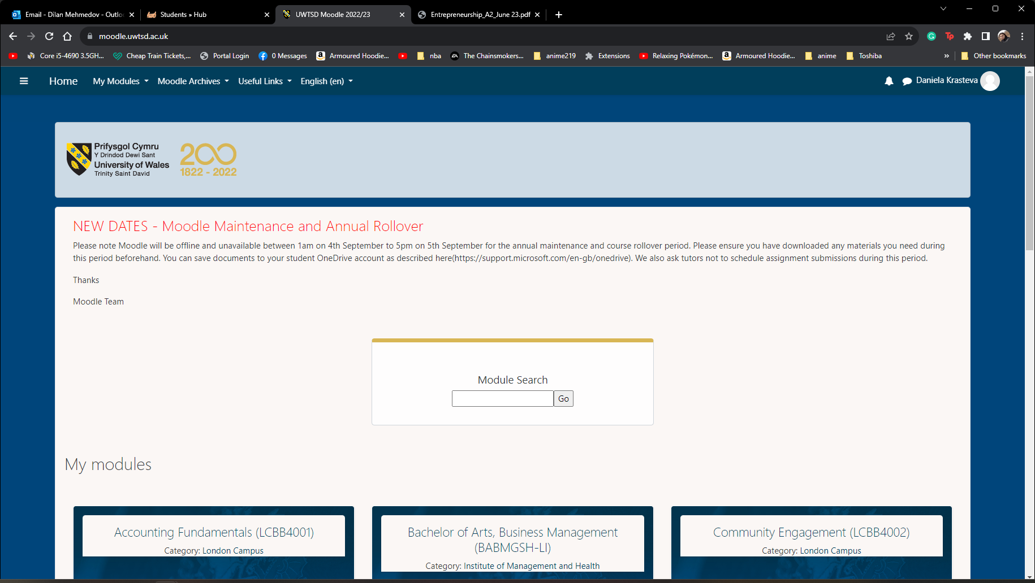
BA Business Management
Module: Project Management
Module code: LCBB5005
Lecturer: Sadeque Shaikh
Assignment Title: Component 2: Coursework: Essay
Student number: 2124368
Student name: Daniela Ivanova Krasteva

Table of Contents
Introduction 3
Body 3
1. Success or Failure of the KGX1 Project 3
2. Lessons Learned from the KGX1 Project 5
3. Recommendations for Future IT Sector Projects: Insights from KGX1 8
Conclusion 10
References 11

Introduction
The Google-led KGX1 project is a ground-breaking initiative describing a trailblazing fusion of innovation and sustainability in the center of King's Cross, London. This innovative office, which seeks to be an architectural wonder, shows Google's commitment to driving technological boundaries while taking environmental responsibility seriously (Wuni and Shen, 2020). Disseminated over an extensive area, KGX1 is more than just a building; it's a sign of Google's dedication to creating a vibrant, state-of-the-art workplace. The project highlights sustainability in both its construction and operation by employing eco-friendly materials and advanced technologies. KGX1, a corporate campus that epitomizes environmental consciousness, launches new benchmarks for energy effectiveness and green building techniques (Vrchota et al., 2021).
In addition to its architectural value, KGX1 is a hub for collaboration, with advanced areas developed to promote creativity and innovation among its workers. The initiative aims to deliver an ecosystem that encourages both professional accomplishment and a good work atmosphere, from collaborative workplaces to recreational areas created to enhance worker well-being. The objective of this comprehensive evaluation is to discuss the project's sophistication and determine if it was successful or unsuccessful in light of the UK's future IT industry. The analysis delves into the lessons that were explored during the KGX1 endeavor and presents solid advice that may be utilized for similar projects in the future.

Body

1. Success or Failure of the KGX1 Project
The KGX1 project, envisioned as Google's headquarters in King's Cross, London, has appeared as a vibrant triumph, evident via a thorough analysis of key performance indicators (KPIs) and further insights. The project's triumphs span multiple dimensions, providing a blueprint for the future of the IT sector in the UK (Singh and Sharma, 2020).
a. Innovation and Sustainability
Innovation and sustainability form the bedrock of KGX1's success. The project's commitment to eco-friendly practices is underscored by KPIs such as the percentage of eco-friendly materials used and energy efficiency ratings. This commitment aligns seamlessly with the broader trajectory of the IT sector, increasingly prioritizing environmental consciousness. A deeper dive into the specific eco-friendly materials employed reveals a conscientious selection process, considering factors such as recyclability and low environmental impact (Mathar et al., 2020). Furthermore, understanding the sourcing of these materials and the technologies contributing to energy efficiency unveils the intricate planning that positions KGX1 as a sustainability trailblazer.
The KGX1 project doesn't merely adhere to sustainable practices but pioneers them, setting benchmarks for future IT endeavors. By meticulously measuring and enhancing eco-friendly elements, KGX1 not only meets current standards but anticipates future sustainability challenges, positioning itself as a model for environmentally conscious construction in the IT sector (La Paz and López, 2023).
b. Comprehensive Scope
The success of KGX1 is further accentuated by its comprehensive scope, as indicated by KPIs like employee satisfaction surveys and ancillary facility utilization rates. The project recognizes that success extends beyond architectural brilliance and cutting-edge technology—it encompasses the overall well-being and satisfaction of its workforce. Quantitative measurements through employee satisfaction surveys provide invaluable insights into the effectiveness of the work environment. The positive correlation between ancillary facility usage rates and employee-centric workspace design emphasizes the project's commitment to creating a holistic and engaging workplace (Kumar et al., 2023).
Delving deeper into specific ancillary facilities and analysing employee feedback nuances provides a nuanced understanding of KGX1's impact on productivity. For instance, assessing the popularity of recreational spaces or collaborative areas sheds light on the project's ability to foster a vibrant and collaborative corporate culture. This comprehensive approach ensures that success is not confined to the physical structure but extends to the human experience within the workspace (Kissi et al., 2019).
c. Adaptive Project Planning
The adaptability and resilience of the KGX1 project are evident in its approach to adaptive project planning. Analysing time variance and the frequency of adjustments to the adaptive plan reveals the project's dynamic nature and its capacity to navigate unforeseen challenges. Instances of adaptive planning provide a window into the project's responsiveness, showcasing a proactive stance in the face of complexities (Khlaifat et al., 2019).
A detailed examination of the reasons necessitating adjustments and the resultant outcomes delivers valuable lessons for future projects. KGX1's capability to pivot when required establishes a strategic agility that is crucial in the rapidly changing landscape of the IT sector. KGX1 is an example of a project that not only fulfills but exceeds anticipations because it embraces transformation and learns from impediments (Eligator, 2023).
d. Financial Prudence
KGX1's performance is largely attributed to its prudent financial management, as demonstrated by its influential resource allocation and budget variance evaluation. An analytical method for resource allocation and consumption patterns shows a strategic path toward economic sustainability. Preserving KGX1's financial restrictions is a critical element of the project's long-term viability, not just a formality (Albtoush et al., 2022). KGX1's commitment to prudent resource management is seen in its quantitative strategy for financial management. Through the enactment of a comprehensive economic sustainability examination, the project not only ensures its rapid success but also lays the groundwork for long-term financial resilience, thereby demonstrating itself as a role model for other ambitious IT projects (Eligator, 2023).
Due to this, the KGX1 project is a shining example of success and offers guidance for the development of the UK's IT industry going forward. KGX1 surpasses expectations by prioritizing creativity, sustainability, all-encompassing scope, flexible project planning, and prudent financial management. The project's incorporation of these components highlights the significance of a comprehensive and forward-thinking strategy in influencing the future of large-scale architectural initiatives and provides insightful lessons for the development of the IT industry (Khlaifat et al., 2019).

2. Lessons Learned from the KGX1 Project
In the trajectory of KGX1's success, certain pivotal lessons have emerged, offering profound insights for the future of IT sector projects. These lessons are rooted in cross-disciplinary collaboration, proactive risk management, and employee engagement—critical facets that have contributed significantly to KGX1's triumph (Kissi et al., 2019).
a. Cross-disciplinary Collaboration
The success of KGX1 is intricately tied to the effectiveness of cross-disciplinary collaboration. Monitoring the number of collaborative sessions and utilizing an innovation index provides a quantitative measure of this success. However, delving deeper into specific collaborative initiatives is crucial to unravel the dynamics that propelled the project forward. Examining the impact of these initiatives on innovation unveils a narrative of diverse perspectives converging to create a fertile ground for groundbreaking ideas (Kumar et al., 2023).
In KGX1, collaboration was not merely a checkbox in the project plan; it was a cultural ethos. Upon closer inspection, it becomes clear that different viewpoints were purposefully incorporated into the project's design. Collaboration between engineers and architects, data scientists and environmental specialists, and other professionals created an atmosphere where each discipline made a distinct contribution to the project's success. This thorough investigation guarantees a sophisticated comprehension of the cooperative dynamics, highlighting the significance of deliberate attempts to combine disparate skill sets and viewpoints for improved innovation (La Paz and López, 2023).
The triumph of interdisciplinary cooperation at KGX1 makes a strong statement: projects gain when boundaries between disciplines are removed. Future IT initiatives should place a high priority on developing a collaborative environment that is not only welcomed but also deeply embedded in the project's design, as this will serve as a fertile ground for creative problem-solving (Mathar et al., 2020).
b. Proactive Risk Management
A portion of KGX1's success can be ascribed to its proactive approach to risk management. A framework for comprehending the project's resilience in the durability of uncertainty is provided by measuring the frequency of unanticipated disruptions and assessing the efficacy of risk mitigation techniques. An in-depth examination of particular risks encountered, and the mitigation strategies implemented demonstrates the project's capacity to manage obstacles with a strategic foresight that keeps disruptions from getting worse (Singh and Sharma, 2020).
At KGX1, risk management was approached anticipatorily rather than reactively. Whether it was a change in regulations, an unexpected environmental factor, or a technological challenge, each risk was addressed with a customized plan. The project's ability to avoid disruptions is a result of the careful planning and flexibility that is ingrained in its risk management system (Vrchota et al., 2021).
This proactive approach to risk management is an important lesson for projects in the IT sector going forward. Unexpected difficulties are given in a technological environment that is changing quickly. It is essential to be able to recognize, evaluate, and reduce risks before they become more serious. In order to ensure a more resilient and adaptable project lifecycle, future projects should prioritize a comprehensive risk management strategy that extends beyond risk identification to include efficient mitigation measures (Singh and Sharma, 2020).
c. Employee Engagement
Beyond its physical building, KGX1's success is largely dependent on how happy and engaged its employees are. Measuring employee participation rates and the rate at which feedback is implemented yields concrete information about how well employee engagement programs are working. A closer look at the methods used to collect feedback, how management handles employee concerns, and how this affects employee satisfaction reveals the human-centered strategy that drives the project's success (Wuni and Shen, 2020).
KGX1 realized that an engaged and driven workforce is a great asset that also serves as a spark for creativity and efficiency. In order to receive feedback, there are certain methods and procedures as well and they can act as strategic windows into the labour force’s pulse. The responsiveness of management to staff concerns guaranteed a symbiotic connection, promoting a surrounding where staff felt heard and valued (Vrchota et al., 2021).
In the future, the holistic method of workforce engagement can act as a compelling lesson. Employee satisfaction is not a peripheral concern but an integral component of project success. Future IT projects should prioritize mechanisms for ongoing feedback, ensuring a continuous dialogue that not only identifies concerns but incorporates them into the project's evolution. By placing employees at the center of the project narrative, organizations can create an environment where innovation and productivity flourish (Singh and Sharma, 2020).
The lessons learned from the KGX1 project provide a roadmap for future IT sector endeavours. Cross-disciplinary collaboration, proactive risk management, and employee engagement are not mere checkboxes but integral components that can define the success or failure of a project. As the IT sector continues to evolve, projects should heed these lessons, recognizing the importance of collaboration, anticipating, and mitigating risks, and prioritizing the well-being and engagement of their workforce. In doing so, the legacy of projects like KGX1 can be not just architectural marvels but beacons of success that resonate across disciplines and industries (La Paz and López, 2023).

3. Recommendations for Future IT Sector Projects: Insights from KGX1
a. Prioritize Sustainability
Prioritizing sustainability emerges as a pivotal recommendation for upcoming IT sector projects. Establishing Key Performance Indicators (KPIs) related to carbon footprint reduction and sustainability certification attainment signifies a commitment to environmental responsibility. Delving into the technologies and strategies employed for carbon footprint reduction is crucial for a comprehensive understanding (Khlaifat et al., 2019). Analysing the challenges faced in implementing these technologies and their impact on sustainability goals will provide valuable insights. Examining KGX1's experience in integrating renewable energy sources and sustainable construction materials sheds light on the practical aspects of incorporating environmentally conscious practices (Kumar et al., 2023).
Moreover, obtaining sustainability certifications is an admirable goal. Scrutinizing the steps taken by KGX1 to attain these certifications, whether through green building standards, waste reduction measures, or energy-efficient technologies, offers practical insights for future projects aiming to achieve similar milestones in environmental responsibility (Kissi et al., 2019).
b. Embrace Comprehensive Scope
The recommendation to embrace a comprehensive scope extends beyond the physical dimensions of a project to encompass creating an environment conducive to employee well-being and productivity. Utilizing KPIs such as ancillary facility usage rates and employee retention rates provides ongoing insights into the success of this approach. A detailed analysis of specific ancillary facilities and their impact on employee well-being enhances the recommendation (Mathar et al., 2020).
KGX1's success in creating a well-rounded and employee-centric workspace is evident in its ancillary facilities. Analysing the popularity and effectiveness of collaborative spaces, recreational areas, and relaxation zones contributes to a nuanced understanding of their impact on employee satisfaction and overall project success (Singh and Sharma, 2020).
Employee retention rates are a reflection of the project's ability to create a workplace that fosters professional growth and fulfilment. Examining the factors contributing to high retention rates, such as career development initiatives and a positive corporate culture, strengthens the recommendation to embrace a comprehensive scope beyond the core project objectives (Mathar et al., 2020).
c. Proactive Risk Management
The recommendation to prioritize proactive risk management stems from KGX1's success in navigating uncertainties with agility and resilience. Monitoring the speed of risk identification and the effectiveness of contingency plans is crucial for continuous improvement. A detailed analysis of the evolution of risk management strategies throughout the project, their adaptation to changing circumstances, and their impact on project outcomes enriches this recommendation (Singh and Sharma, 2020).
KGX1's proactive risk management involved early identification of potential risks, development of comprehensive mitigation strategies, and continuous adaptation to evolving circumstances. Examining specific instances where risks were successfully identified and mitigated provides valuable insights into effective risk management. Understanding the dynamic nature of risk management strategies ensures that future projects are equipped to handle known risks and are adaptable to unforeseen challenges (Mathar et al., 2020).

Conclusion
In conclusion, the KGX1 project, meticulously evaluated through Key Performance Indicators (KPIs) and enriched insights, unequivocally establishes itself as a triumph for the future IT sector of the UK. The integration of specific KPIs not only imparts a quantitative dimension to the assessment but also fosters a profound and nuanced comprehension of the project's far-reaching impact. The lessons learned rooted in cross-disciplinary collaboration, proactive risk management, and employee engagement; contribute to a comprehensive understanding of the project's success.
Moreover, the strategic recommendations drawn from KGX1's achievements provide a forward-looking framework for future IT endeavors. Prioritizing sustainability, embracing a comprehensive scope that prioritizes employee well-being, and adopting proactive risk management strategies emerge as essential imperatives. As the IT sector continues to evolve, the legacy of KGX1 stands as a beacon, guiding future projects towards success through a holistic, innovative, and environmentally conscious approach. This detailed analysis not only celebrates KGX1's achievements but lays the groundwork for a future where IT projects seamlessly integrate technological innovation with sustainability, employee satisfaction, and proactive risk mitigation.

References
Albtoush, A.F., Doh, S.I., Rahman, R.A. and Al-Momani, A.H., 2022. Critical success factors of construction projects in Jordan: An empirical investigation. Asian Journal of Civil Engineering, 23(7), pp.1087-1099.
Eligator, R., 2023. Avoiding heavy-handed recommendations. The Journal of the Acoustical Society of America, 153(3_supplement), pp. A349-A349.
Khlaifat, D.M., Alyagoub, R.E., Sweis, R.J., and Sweis, G.J., 2019. Factors leading to construction projects' failure in Jordon. International Journal of Construction Management, 19(1), pp.65-78.
Kissi, E., Agyekum, K., Baiden, B.K., Tannor, R.A., Asamoah, G.E. and Andam, E.T., 2019. Impact of project monitoring and evaluation practices on construction project success criteria in Ghana. Built Environment Project and Asset Management, 9(3), pp.364-382.
Kumar, V., Pandey, A. and Singh, R., 2023. Project success and critical success factors of construction projects: project practitioners’ perspectives. Organization, Technology and Management in Construction: an International Journal, 15(1), pp.1-22.
La Paz, A.I. and López, R.I., 2023. Recommendation method for customized IT project management. Procedia Computer Science, 219, pp.1938-1945.
Mathar, H., Assaf, S., Hassanain, M.A., Abdallah, A. and Sayed, A.M., 2020. Critical success factors for large building construction projects: Perception of consultants and contractors. Built Environment Project and Asset Management, 10(3), pp.349-367.
Singh, M. and Sharma, S., 2020. Critical success factors in construction projects. Int. J. Recent Technol. Eng, 8(5).
Vrchota, J., Řehoř, P., Maříková, M. and Pech, M., 2021. Critical success factors of the project management in relation to industry 4.0 for sustainability of projects. Sustainability, 13(1), p.281.
Wuni, I.Y. and Shen, G.Q., 2020. Critical success factors for modular integrated construction projects: A review. Building research & information, 48(7), pp.763-784.

