
Name: Javaria Irfan Hafiza
Student number :2504716
Module code: BMHP5016
Module: Principles of Health and Social Care Practice
Title: Component 2: Written Assignment (Report)
Lecturer’s Name: Kennedy Obohwemu

Table of Contents
Introduction: 3
Definition of PCC 3
Relevant theories 4
Ethical Fundamentals 5
Evaluation of partnership working 6
Relevant Policies and Legislation 7
Recommendation 8
Conclusion 9
Abstract: 9
Reference 11

Introduction:
Two fundamental concepts in health and social care are person-centred care (PCC) and partnership working (PW). Identifying a person’s needs, preferences, beliefs and choices and involving them in decisions concerning their care and treatment are important elements of PCC. To provide comprehensive care, professionals, patients and relevant services work together. The Care Quality Commission (CQC, 2025) states that person-centred care should reflect people’s needs and preferences and involve them in planning and reviewing their care.
The purpose of this report is to evaluate the relationship between PCC and PW and examine how they work together in health and social care practice. The report will initially define PCC and discuss its main benefits and limitations. It will then critically examine a relevant theory or model that supports person-centred practice and analyse the ethical fundamentals of health and social care. Furthermore, the report will evaluate partnership working and explore how it can be effectively applied in an acute hospital setting considering how patients and different health and social care professionals work together to provide effective care. Relevant legislation, policies and professional standards relating to PCC and PW will also be examined. Finally, the report will provide recommendations for the future development of person-centred care and partnership working in the UK.NHS England (2023) highlights the importance of collaboration and partnership in providing personalised and joined-up health and care services.

Definition of PCC
PCC focuses on treating each patient as an individual by understanding their needs, values and preferences and involving them in decisions about their care. Rather than focusing only on a patient’s health problem or medical condition, it recognises the patient as an individual. Giusti et al. (2020) found that PCC involves respecting patients, providing appropriate information, involving them in decisions and considering their physical, psychological and social needs. In an acute hospital setting, healthcare professionals should consider each patient’s circumstances when planning treatment and support and ensure that patients understand the care they receive.
PCC can provide several benefits. When patients’ views are heard, they may feel respected and valued, which can improve their experience and satisfaction with care. Evidence from acute care suggests that person-centred interventions can also have positive effects on patient outcomes, although the strength of evidence varies between interventions (Klancnik Gruden et al, 2021). PCC can also promote open communication and shared decision-making, allowing patients to express concerns and ask questions about their treatment. This can help patients in an acute hospital make informed decisions about their care and take a more active role in their recovery. Considering patients’ needs when reviewing treatment and planning discharge can also help maintain individualised care throughout their hospital stay.
However, PCC can be difficult to implement consistently. Time pressures, staffing shortages and limited resources may make it challenging for hospital staff to provide fully individualised care. Resistance to changing established routines can also affect implementation. Raban et al. (2023) identified staffing constraints and insufficient resources as important barriers to implementing health and social care standards. Therefore, effective PCC requires organisational support, adequate resources and staff commitment to improving established practices.

Relevant theories
Two relevant theories that underpin PCC are Bronfenbrenner’s Ecological Model of Human Development and Maslow’s Hierarchy of Needs. Bronfenbrenner’s model explains how people are influenced by their relationships, environment and wider social systems. In an acute hospital, family support, communication with healthcare professionals and teamwork between hospital teams can influence a patient’s recovery. This supports PCC because care should consider the individual’s circumstances rather than focusing only on their medical condition. Bronfenbrenner’s (1979) theory highlights the influence of relationships and environmental factors on individual development. However, the model does not explain exactly how PCC should be delivered, so professionals must apply its principles to individual care plans.

(Figure 1)
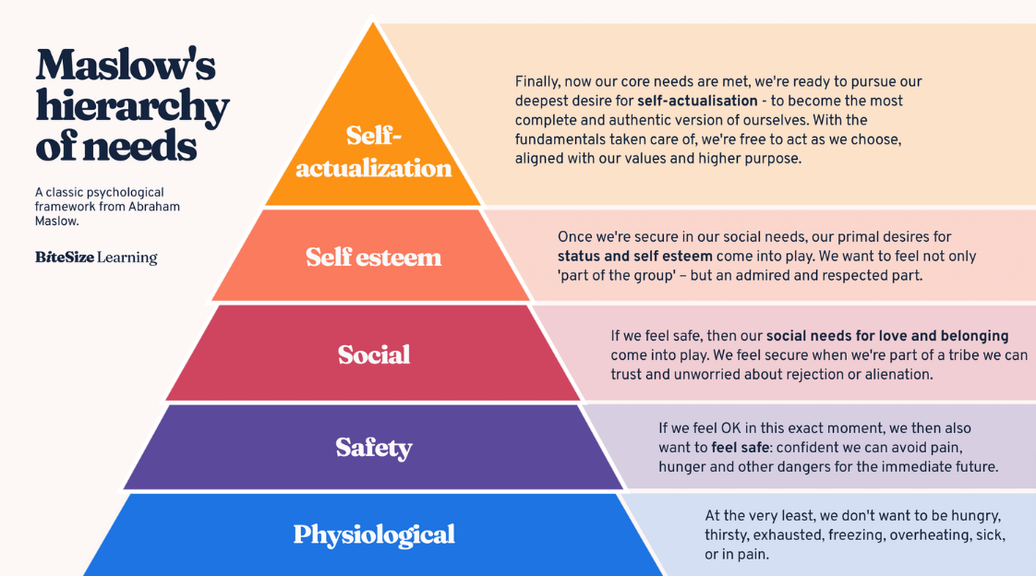
(BiteSize Learning, 2026)
Figure 1 (Maslow’s Hierarchy of Needs)

Maslow’s Hierarchy of Needs explains that people have different needs, from basic physical requirements to psychological needs such as safety, self-esteem and personal growth. In an acute hospital, staff should meet patients’ basic needs, provide safe treatment and respect their choices and dignity. Maslow (1943) argued that human motivation is influenced by different levels of needs. This supports PCC by encouraging staff to consider patients’ wider needs alongside their medical treatment. However, needs may not follow a fixed order, particularly during emergencies. Although a synthesis of the two ideas shows how Bronfenbrenner helps staff understand patients' settings and Maslow help them identify individual needs, a critical study demonstrates that both theories have limits. When combined, they can direct PCC, but standard care must be adjusted to the specific needs of each patient.

Ethical Fundamentals
Ethical principles guide healthcare professionals in providing safe, fair and respectful care. The four main principles are autonomy, beneficence, non-maleficence and justice. Autonomy is about letting patients make their own choices. Beneficence means we always try to do what is best for them, while non-maleficence means making sure we don't cause any harm. Finally, justice is about treating everyone fairly and making sure they can all get the care they need. These principles support PCC by respecting patients’ choices and PW by encouraging professionals to work together.
The General Medical Council (GMC, 2020) emphasises that patients should receive understandable information and be involved in decisions about their treatment. The Nursing and Midwifery Council (NMC, 2018) also requires nurses to respect patients’ dignity, choices and safety. These responsibilities are particularly important in an acute hospital, where patients may need to make difficult treatment decisions.
For example, a patient may refuse recommended treatment because they are concerned about its side effects. The doctor may believe the treatment will improve the patient’s condition, while the patient may prioritise avoiding potential harm. This creates an ethical dilemma between autonomy and beneficence. Healthcare professionals should listen to the patient’s concerns and explain the benefits, risks and alternatives. NICE (2021) recommends shared decision-making, which considers patients’ preferences alongside available evidence. If the patient has the capacity to make the decision and understands the relevant information, their informed choice should generally be respected, even when professionals disagree.
PW can help the healthcare team discuss the available options and provide consistent information. Although family members may offer valuable support, their views should not automatically override the informed decision of a patient who has capacity. This demonstrates that ethical care requires professionals to balance clinical recommendations with patients’ rights and preferences while communicating respectfully.

Evaluation of partnership working
PW means health and social care professionals and organisations working together to meet patients’ needs. Integrated Care Systems (ICSs) bring NHS services, local authorities and other organisations together to plan and improve care in local areas. The King’s Fund (2022) explains that ICSs aim to reduce gaps between services by encouraging organisations to work together.
PW is especially important when patients are preparing to leave hospital. For example, when an older patient is admitted after a fall, doctors, nurses, physiotherapists and social workers can work together to assess their needs. They may check whether the patient can move around safely, discuss what help is needed at home and arrange support before discharge. This can help the patient return home safely and avoid gaps in care. The Care Quality Commission (CQC, 2022) highlights the importance of services working together to improve people’s experiences and outcomes.
However, working in partnership is not always easy. Staff shortages and limited resources can delay assessments or support at home. Problems can also occur when professionals are unsure about their responsibilities. For example, if community care staff do not receive the discharge plan on time, the patient may return home without the help they need. This could affect their safety and increase the chance of returning to hospital.
Overall, PW can help services provide better-coordinated care by bringing different professionals’ knowledge and skills together. However, simply bringing organisations together does not guarantee good results. Professionals need to understand their responsibilities, share information promptly and have enough resources to meet patients’ needs. In acute hospitals, these actions can make discharge safer and help patients take part in decisions about their care.

Relevant Policies and Legislation
The Care Act 2014 promotes individual well-being and involvement in decisions about care (UK Government, 2014). Staff members in an acute hospital may assess patients’ care and support needs and involve them in discharge planning. However, patients’ independence and well-being may be affected by delayed discharge due to a lack of social care services.
The Health and Social Care Act 2012 supports cooperation between health and social care organisations (UK Government, 2012). For example, hospital staff could work together with relevant services to coordinate a patient’s medical care. However, poor communication or unclear responsibilities might result in gaps in support, reducing the effectiveness of PW.
The Health and Care Act 2022 established integrated care boards (ICBs) and integrated care partnerships to strengthen collaboration across health and care services (UK Government, 2022). For example, to improve care planning, hospitals could work together with local authorities. However, collaboration may be difficult due to competing priorities and limited resources. Overall, these laws provide a foundation for PCC and PW; however, good practice cannot be guaranteed by legislation alone. Furthermore, adequate staffing, clear communication and patients’ meaningful involvement in decision-making are necessary for successful implementation.

Recommendation
Gaps in PCC and PW caused by staff shortages, inconsistent communication and inadequate patient involvement should be addressed by acute hospitals. Staff members should receive ongoing training in communication, shared decision-making and respecting patients’ individual preferences. Abbott et al. (2021) discuss challenges in delivering PCC in acute care. However, staff shortages and limited training time may restrict participation.

To improve information sharing between hospital and community teams, hospitals should use secure digital care records. Although digital exclusion, confidentiality risks and incompatible systems could hinder progress, patients should also be supported in understanding their care plans. Improved communication between nurses, doctors, patients, families and community professionals may strengthen discharge planning, although competing priorities may cause difficulties in decision-making.

De Lange, Heyns and Filmalter (2024) highlight the importance of person-centred handover practices. To encourage consistent practice, hospitals should review their policies on patient involvement, information sharing and discharge planning. Further research and regular patient feedback should assess whether these changes improve care experiences and outcomes. However, implementation may be hindered by a lack of funding and limited staff time. Therefore, to develop PCC and PW throughout UK health and social care systems, hospital management should provide sufficient resources and assess the effectiveness of these changes.

Conclusion
To sum everything up, in acute hospital settings, PCC and PW are essential to delivering secure, effective, and respectful treatment. PCC, its advantages and disadvantages, relevant theories, ethical principles, and the significance of cooperation between social workers and health care providers are all addressed in this report. Furthermore, it has covered how individual needs and combined services are supported by the Care Act of 2014, the Health and Social Care Act of 2012, and the Health and Care Act of 2022. However, these concepts may not be completely implemented due to staffing shortages, limited resources, and insufficient interaction.
The outcomes highlight the necessity of improving communication, including patients in decision-making, and strengthening relationships between hospital employees, patients, families, and community services. Regular staff training, secure digital care records, improved teamwork, developing policies, and more research to evaluate changes are among the suggestions that were made. sufficient funds and managerial assistance are essential, even though implementation may be difficult. All things taken into account, combining PCC and PW can enhance patient outcomes, honour personal choices, and provide improved care coordination.

Abstract:
With a particular focus on their implementation in an acute hospital context, this report examines the significance of person-centred care (PCC) and partnership working (PW) in health and social care. It examines at how PCC helps patients feel appreciated and involved in decisions regarding their medical care by supporting their unique needs, preferences, beliefs, and choices. The report also takes into account the advantages and drawbacks of PCC, such as higher levels of patient satisfaction and the difficulties imposed on by shortages of staff, time limitations, and limited resources. It examines at relevant ideas, ethical principles, and laws that protect the rights of patients and direct professional conduct.
The analysis also evaluates how PW promotes information sharing, responsibility collaboration, and efficient care delivery among medical professionals, social services, patients, and families. It requires taking into account issues including poor communication, conflicting priorities, and uncertain roles in addition to considering the role that Integrated Care Systems (ICSs) play in improving coordination among providers. The findings highlight that PCC and PW are closely connected and are essential for safe, inclusive and effective care. The report recommends strengthening staff training, improving communication, expanding the use of secure digital care records and increasing patient involvement in care planning. These improvements could help overcome existing barriers and support more consistent, high-quality care.

Reference
Abbott, R. A., Cheeseman, D., Hemsley, A. and Thompson Coon, J. (2021) ‘Can person-centred care for people living with dementia be delivered in the acute care setting?’, Age and Ageing, 50(4), pp. 1077–1080. doi: 10.1093/ageing/afab065.

BiteSize Learning (2026) Maslow’s Hierarchy of Needs Explained + Pyramid Diagram. Available at: https://www.bitesizelearning.co.uk/resources/maslows-hierarchy-of-needs-theory
(Accessed: 11 October 2026).

Bronfenbrenner, U. (1979) The Ecology of Human Development: Experiments by Nature and Design. Cambridge, MA: Harvard University Press.

Care Quality Commission (CQC) (2022) Collaboration and system working. Available at: https://www.cqc.org.uk/publications/major-report/soc201920_4h_system-working
(Accessed: 10 October 2026).

Care Quality Commission (CQC) (2025) Regulation 9: Person-centred care. Available at: https://www.cqc.org.uk/guidance-regulation/providers/regulations-service-providers-and-managers/health-social-care-act/regulation-9
(Accessed: 8 October 2026).

De Lange, S., Heyns, T. and Filmalter, C. (2024) ‘Clinical practice guidelines for person-centred handover practices in emergency departments: a scoping review’, BMJ Open, 14(10), e082677. doi: 10.1136/bmjopen-2023-082677.

General Medical Council (GMC) (2020) Good medical practice. Manchester: GMC. Available at: https://www.gmc-uk.org/ethical-guidance/ethical-guidance-for-doctors/good-medical-practice
(Accessed: 7 October 2026).

Giusti, A. et al. (2020) ‘The empirical evidence underpinning the concept and practice of person-centred care for serious illness: a systematic review’, BMJ Global Health, 5(12), e003330. doi: 10.1136/bmjgh-2020-003330.

Klancnik Gruden, M., Turk, E., McCormack, B. and Stiglic, G. (2021) ‘Impact of person-centered interventions on patient outcomes in acute care settings: A systematic review’, Journal of Nursing Care Quality, 36(1), pp. E14–E21. doi: 10.1097/NCQ.0000000000000486.

Maslow, A. H. (1943) ‘A theory of human motivation’, Psychological Review, 50(4), pp. 370–396. doi: 10.1037/h0054346.

National Institute for Health and Care Excellence (NICE) (2021) Shared decision-making. NICE Guideline [NG197]. London: NICE. Available at: https://www.nice.org.uk/guidance/ng197
(Accessed: 7 October 2026).

Nursing and Midwifery Council (NMC) (2018) The Code: Professional standards of practice and behaviour for nurses, midwives and nursing associates. London: NMC. Available at: https://www.nmc.org.uk/standards/code/
(Accessed: 7 October 2026).

Raban, L. Z. et al. (2023) ‘Determinants of regulatory compliance in health and social care’, British Journal of General Practice, 73(735), pp. 450–451.

The King’s Fund (2022) Integrated care systems explained: Making sense of systems, places and neighbourhoods. Available at: https://www.kingsfund.org.uk/insight-and-analysis/long-reads/integrated-care-systems-explained
(Accessed: 10 October 2026).

UK Government (2012) Health and Social Care Act 2012. Available at: https://www.legislation.gov.uk/ukpga/2012/7/contents
(Accessed: 11 October 2026).

UK Government (2014) Care Act 2014. Available at: https://www.legislation.gov.uk/ukpga/2014/23/contents
(Accessed: 11 October 2026).

UK Government (2022) Health and Care Act 2022. Available at: https://www.legislation.gov.uk/ukpga/2022/31/contents
(Accessed: 11 October 2026).

NHS England (2023) Working in partnership with people and communities: statutory guidance. Available at: https://www.england.nhs.uk/publication/working-in-partnership-with-people-and-communities-statutory-guidance/
(Accessed: 8 October 2026).

