

Skills for the Workplace
Module Assignment Submission
Student Name: | Stephen Smith
Student Number: | 1811431
Module No: | BMSK6001
Module Title: | Leadership Skills for the Workplace

Statement of Confirmation of Authenticity
By the act of making this submission, the student declares that this is the work of the student named above. The work has not, in whole or in part, been knowingly presented elsewhere for assessment, or where assessment has been built on a previous assessment, this has been identified. Where materials have been used from other sources it has been properly acknowledged. If this statement is untrue, the student acknowledges that an assessment offence has been committed.
Attention is drawn to the plagiarism and unfair practice policies of both the University and of ILM.

Contents
Introduction 2
1.0 Leadership or Management? 3
1.1 Types of Leaders 3
2.0 Leadership Theories 5
2.1 Hersey and Blanchard Situational Leadership Theory (1972) 5
2.2 Tuckman’s Team-Development Model (1965) 7
2.3 Daniel Goleman Situational Leadership Theory (2000) 8
2.4 Alternative viewpoints regarding Situational Leadership. 9
3.0 Evaluation of Students leadership style 10
Conclusion 12
References 13
Appendix A: Situational Leadership Self-Assessment 17
Appendix B: Returns for leadership questionnaire by LE, JR, FP, GS and SO 19
Appendix C: Table 1: Results of Situational Leadership Questionnaire by LE, JR, FP, GS and SO 20

Introduction
The Oxford English Dictionary defines leadership as ‘the action of leading a group of people or an organisation’.
Forbes writer Kevin Kruse (2013) explains that ‘Leadership is a process of social influence, which maximizes the efforts of others, towards the achievement of a goal’, Northouse (2007) states that leadership is ‘a process whereby an individual influences a group of individuals to achieve a common goal’ and Yukl (2013) explains that ‘Leadership is the process of influencing others to understand and agree about what needs to be done and how to do it, and the process of facilitating individual and collective efforts to accomplish shared objectives’.
There are common key phrases in these three summaries of leadership which the student is going to explore throughout this paper. Fundamentally, all three quotes explain that leadership is a process of influencing other people though provision of a meaningful direction to achieve a common goal or objective. The implication, although not specifically stated, is that the other people or groups, the followers, would be employees, colleagues, or peers.
The paper is going to start by defining what a leader is and the differences between a leader and a manager. This paper is based primarily on leadership so management will only be briefly considered. The student will look at the difference between assigned and emergent leaders with assigned leaders being in place due to their standing or position within an organisation and emergent leaders who evolve into the typecast of a leader. The paper will then critically analyse two leadership theories and highlight a link between leadership and team formation.
The student has worked in managerial capacities for 10 years and understands that he has established his own leadership/management style during that time. The student feels that he is a strong leader and motivator of others, able to take-charge when needed but also can develop and empower others. To verify this notion, the student will undertake a self-assessment questionnaire to categorise what his actual leadership style is and then, through reflection, compare that to any pre-conceived self-assumptions. To further understand his own leadership style, and to remove any bias, the student is also going to utilise peer assessment of his leadership style from work colleagues and compare their opinions to his own findings to assess his ability to set direction, motivate, delegate, and empower others.
For the assignment, workplace examples and reflections are going to be based on the student’s role as a Regional Manager within Kingdom Security Services ltd which is a facilities company that provides security officers to multiple retail supermarkets throughout the UK. The regional manager acts as a direct line manager for 7 Area Managers, each of whom remotely manage approximately 100 security guards and 40 to 50 supermarkets. Regional managers within Kingdom Services have responsibility for collaborating the efforts of their team with other departments such as recruitment, HR, training as well as overseeing call centre functions.

1.0 Leadership or Management?
Although leadership and management can complement each other, natural leaders do not necessarily make good managers and good managers are not automatically good leaders. Leadership and management are regularly intertwined, this BA Hons degree is an apt example, the course is called Leadership and Management. To be a successful leader or a successful manager, one must understand the differences.
‘Managing people involves understanding the strengths and weaknesses of individuals within a work team and assigning people tasks for optimal efficiency.’ (Bobinski, 2004). ‘Leadership is the art of motivating a group of people to act toward achieving a common goal’ (Ward 2020).
Go2HR (N.D) summarises ‘the main difference between leaders and managers is that leaders have people follow them while managers have people who work for them’
In its simplicity, management is about regulating people, situations and processes through administrative and procedural actions, being the boss, whereas leadership is about setting direction and influencing others to achieve a common goal or objective.
According to Morgan (2020), a leader is ‘someone who can see how things can be improved and who rallies people to move toward that better vision’
Difference between a Boss and Leader
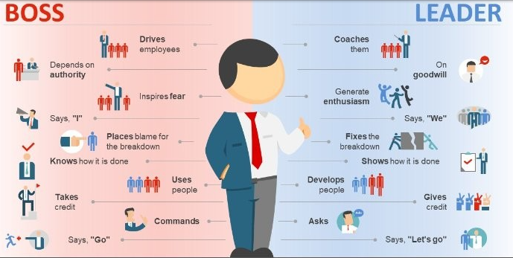
(LinkedIn, 2017)

1.1 Types of Leaders
According to Hanna, Smith, Kirkman and Griffin (2020), over the last several decades there has been an increase in the attention of examining informal and formal leadership approaches and Dublin (2019) explains that there are two types of leaders, those who are appointed into leadership positions and those who develop into leaders over time.
Assigned Leaders
According to Kokemuller (N.D), ‘Assigned leaders are appointed to a formal management or supervisor position’. This means that their leadership is based on their position within an organisation, it is a leadership position inherited with certain job roles. This could include Team Leaders, Departmental Managers, Project Managers, or Chief Executive Officers. Assigned leaders are anyone whos’ job role gives them status. An example of an assigned leader can be illustrated using Toms Hanks’ character, Captain Miller, in the fictional movie based in World War 2, Saving Private Ryan (Rodat, 1998). During the Movie there is a discussion amongst the squad and Captain Miller explains that prior to being enlisted into the military he was a basketball coach and made a living telling people what to do. As a result the military decided to make him a Captain. This is an example of assigned leadership, the position did not develop over time, he was placed into a leadership role simply because he was educated.
Emergent Leaders
The second type of leadership, emergent, is an ‘ascription of informal leadership responsibilities among team members is a dynamic phenomenon that comes into place through social interactions’ (Gerpott, Lehmann-Willenbrock, Voelpel & Vugt, 2019). Emergent leaders are informal and regardless of their official title or position with an organisation, they are perceived by others as influential and show initiative. This status emerges over time and the person can be often tasked with additional responsibilities outside of their primary role. Emerging leadership can be shown using Mel Gibson’s character in the movie adaptation of the 13th century Scottish war for independence, Braveheart (Wallace, 1995). The movie is based on the true story of Sir William Walace who became one of the main leaders in the fight against the tyranny from the King of England, Edward I. Although adapted for cinematic entertainment, the movie closely follows the leadership development of Wallace, starting off as a mere landowner but them moving from English stronghold to stronghold building up followers as he went. This is an example of emergent leadership, it developed over a period of 8 years and continued even beyond his execution in 1305.

Regardless of the type of leader the person is, be it assigned or emergent, for them to be successful they must be motivated as the rationale behind their motivation may influence their effectiveness as a leader. According to Cebollero (2014) there are 2 types of motivation, Internal motivation known as intrinsic and motivation from external factors knows as extrinsic.
Extrinsic motivation is based on reward such as salary, bonus’, status, praise, position or even an upgrade to a more luxurious office. Dubois-Maahs (2019) explains that extrinsic motivation is important because for most, extrinsic motivation is the form of a pay-check for the job they do and although people would prefer doing something that they love, getting paid is the basis for work and the salary allows the person to pursue their preferred activities outside of work. Indeed (2012) states that a major benefit of extrinsic motivating factors work very well for short-term goals.
Intrinsic motivation is the internal drive that a person has that encourages them to perform to their best. Harpine (2015) explains that one person cannot motivate another, not truly, and the most powerful motivation must come from within. Adair (2006) supports this notion by stating that a person ‘is motivated when he or she wants to do something’. In contrary, there are a plethora of online sources that list the ability to motivate as a key quality of a leader, Considering Harpine and Adair state that motivation cannot be given to another person and that motivation is there when the person actively wants to do something, it leaves the question as to why so many sources, such as Ward (see 1.1) list being a motivator as one of the purposes of a leader. The student concludes that the leader’s role is to encourage the follower to motivate themselves and not to do the motivating. This would be achieved though their leadership style which will be discussed in Section 2.

2.0 Leadership Theories
‘While there are dozens of leadership theories and psychology, there are a few that are more well-known. Understanding psychological and social impacts of effective leadership will help you determine the kind of leader you want to be.’ (WGU, 2020)
The origins of leadership theories such as the Great Man Theory (Carlyle 1841) date back almost two hundred years, however, its only since the 1970s that theories became more developed. Cherry (2019) explains ‘People have long been interested in leadership throughout human history, but it has only been relatively recently that a number of formal leadership theories have emerged’.
One of the most academically recognised and recycled theories of leadership is situational awareness which has been interpreted and adapted many times. The fundamental characteristic of situational leadership is that the leader can adapt his or her leadership style, according to the situation, but to be able to do that, the leader must understand emotional intelligence (Tavarnessi, 2019). Landry (2019) defines emotional intelligence as ‘ability to understand and manage your own emotions, as well as recognize and influence the emotions of those around you’ and psychologist Daniel Goleman, who ‘ introduced millions of people to the idea and concept of emotional intelligence’ (Riopel, 2020) stresses ‘The most effective leaders are all alike in one crucial way: they all have a high degree of what has come to be known as emotional intelligence.’ (Goleman, 2004)
Emotional intelligence is crucial when determining which style of situational leadership to employ, not just to get the task completed, but to effectively encourage followers and to not allow their own emotions or frustrations to damage the dynamic of the team. Emotional intelligence feeds into every leadership style to allow the leader to understand how his or her emotions can affect their behaviour and thus effect the emotions and behaviours of others. Behaviours due to negative effect of emotions would hinder any team or task and make the work of the leader a lot harder. Corrado (2017) states ‘Low emotional intelligence has negative effects in the workplace – dragging down morale and reducing productivity’ contrasted by Castro, Gomes, and De Sousa (2012) who confirm that ‘emotionally intelligent leaders who are better at self-controlling against external strain events are more likely to act positively and constructively when faced with frustrations.’

2.1 Hersey and Blanchard Situational Leadership Theory (1972)
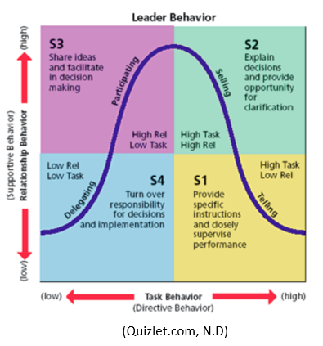
The Situational Leadership Theory was originally proposed by Hersey and Blanchard in 1972 and in summary, refers to a type of leader who can adopt different styles of leadership depending on the present situation. As observed in section 1.2, there is an array of different leadership styles and each style is not necessarily appropriate for every situation or task, this is where the situational leadership theory is relevant. Cherry (2020) explains ‘The situational theory of leadership suggests that no single leadership style is best. Instead, it depends on which type of leadership and strategies are best suited to the task’, St Thomas University (2014) adds ‘Situational Leadership is flexible. It adapts to the existing work environment and the needs of the organisation’ and Wolf (2021) states ‘Different levels of expertise require different management styles. So, too, can different situations or tasks’
Blanchard (1994) states ‘54 percent of leaders use only one leadership style, regardless of the situation, which means that 50 percent of the time, leaders are using the wrong leadership style to meet the needs of their people.’ As suggested, half of the time a leader is using the wrong leadership style so the intimation is that a more successful leader will have the ability to adapt their leadership style and employ it based on the situation consciously and effectively. Therefore, situational leadership, according to leadership studies (N.D) would provide the leader with the ‘highest probability of success.’
As alluded to in the introduction, leadership is about achieving a goal or objective and Situational Leadership allows this to happen though four adaptive approaches of a leader: Telling, Selling, Participating and Delegating.

Telling
Interchangeable with directing, guiding or directly supervising followers. The leader will make decisions regarding the completion of the task and be specific in their instruction whilst maintaining close supervision. The passage of communication is direct from the leader to the follower and would likely be an assigned leader. An example of this leadership method can be observed within the military. The leader would be the person who held rank, the instructions or mission would be specific, and the communication channel would be direct and one-way. The telling method is autocratic and according to Hussain (2014), a leader who displays authoritative qualities would be much more successful during a crisis.
A general example of this style of leadership can be explained using a work recruitment event. Hypothetically, a company has just been asked to step in for a competitor who failed to deliver a service, the opportunity for future company growth rests in the successful provisions of services so an immediate increase of staffing levels would be needed. The recruitment even would be business critical and as such deemed a crisis. This situation calls for a telling leader who would take charge and directly instruct people what they had to do, specifically how they had to do it and precisely when it had to be done as there would be little room for error.
Action Centred Leadership Model…...
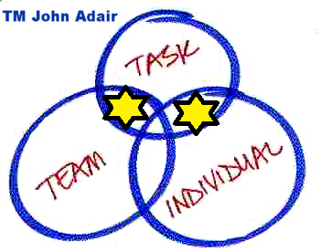
Selling
Also referred to as explaining or convincing is about getting the followers to buy-in to an idea or task by offering their own ideas with the aim of achieving cooperation from others. A selling leader does not simply focus on the task but equally on the individuals or relationship. John Adair’s Action Centred Leadership (1973) would place selling in the overlap between task and individual or between task and team. In this style, the decision making still belongs to the leader, but they also allow the follower opportunity to discuss why the task needs to be completed and how it fits into the bigger picture.
(Business Balls, N.D)
Using the same recruitment event to exemplify a selling leader. The event may not be business critical and more of a regular routine that would hinder employees who have been drafted in to help. The selling leader would be able to encourage and motivate the team to increase enthusiasm by selling the event to them by showcasing what benefits the event will bring for everyone within the wider business.
Participating
Different from the first two styles, participating is follower-driven as opposed to leader-driven meaning that although the leader may have an input in the decision-making process, the decisions are generally left to the followers. The focus for a participating leader is weighted heavily towards building relationships with the followers and less task focussed. In those circumstances, the group members will have the competences and abilities to complete the tasks but will lack motivation or confidence and may be unwilling to take responsibility themselves.
An example of a participating leader can be a different approach to the same recruitment event. For this scenario, the responsibility for planning the event is passed onto the team as opposed to the leader. The leader would generally allow the team to plan and make the decisions but may step in when required, if for example the planning was behind schedule or over budget.
Delegating
Delegating or empowering is best used for leading highly skilled group members who are already intrinsically motivated to complete the task. This style is also leadership driven the same as participating but the difference with delegating is that the leader gives a significant level of freedom to the followers to complete the task or parts of a task as they see fit. The leader will empower, his or her followers and according to Lee, Willis, and Tian (2018) this will give team members a ‘greater sense of autonomy or control in their work, they feel that their job has meaning, and it aligns with their values, that they are competent in their abilities, and that they can make a difference’.
Referring to the recruitment event scenario, the delegatory leader will split tasks amongst the group and allow each person to fulfil their part of the plan and fit into the bigger picture. Whilst the leader may set SMART objectives, it is the follower who then has the responsibility to deliver. In this example the leader will give person A an objective that they are responsible for advertising the event, Person B is responsible for refreshments, Person C is responsible for booking the venue and person D is responsible for arranging items such as desks and computer equipment.

2.2 Tuckman’s Team-Development Model (1965)
In 1965, Bruce Tuckman published his team development model, Forming, Storming, Norming and Performing. Chapman (2017) explains a link between Tuckman and the Hersey Blanchard Situational Leadership model and explains that each leadership style is relevant to a different phase of Tuckman’s Model. Andia (1999) support this by writing ‘In a group or team, the effective leader must understand what’s going on in the group (or what’s likely to go on). Anticipate future problems and concerns and behave in ways that will facilitate the group’s development and productivity’.
Tuckman’s Model of Team Development Diagram Hersey and Blanchard’s Situational Leadership Model
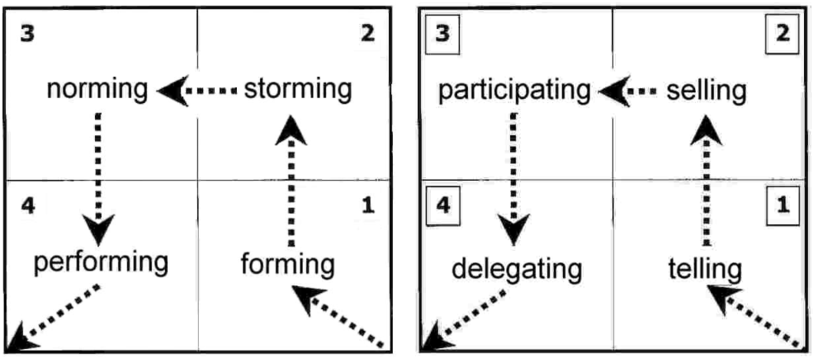(Business Balls.com, 2017)
As illustrated, during the team forming stage a leader will have to utilise an authoritative telling style so that the team has direction. During the storming phase, where the team members are trying to establish themselves and the most likely stage for any conflict, the leader needs to adopt a convincing or selling style to keep everyone’s focus on the task. When the team starts to normalise, the leader can take a lesser hands-on approach and settling into participating with the team and then to finally excel and perform well as a team, the leader takes a metaphorical step back and starts adopting a delegatory leadership style.
Goleman’s Situational Leadership

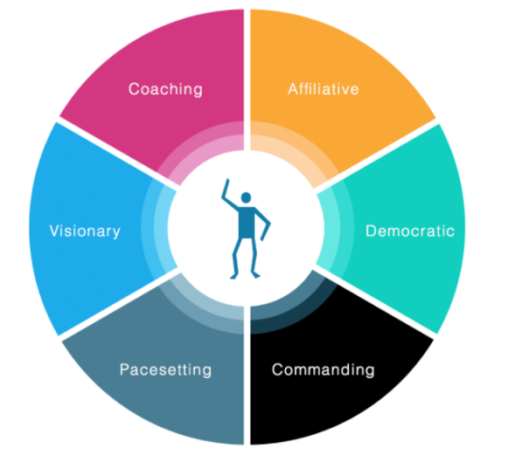
2.3 Daniel Goleman Situational Leadership Theory (2000)
‘Daniel Goleman incorporates the concept of emotional intelligence into the theory of situational leadership’ (Baunsgaard, 2020). Goleman has identified six categories of situational leadership and suggest for which type of situation each one is applied.
Commanding
Commanding or coercive leadership is like Hersey and Blanchard’s Telling leadership style in that is it a directive based autocratic leadership style. According to Lindberg (N.D) this style of leader ‘makes all the decisions and gives orders to his or her team without explanation’. Like telling, commanding leadership is best kept for crisis situations or implementing change quickly. The major drawback of this style, according to Mindtools (N.D), is that when abused it can have a negative effect on the team. (IntenseMinimalism.com, 2015)

Visionary
A visionary leader is a mixture of a selling and a telling leader as defined in 2.1. The visionary is authoritative whist being able to help others to visualise the goals but maintains control by giving direct instructions. Benincassa (2012) explains that visionary leadership works best when a team needs a new direction, but it is not likely to work if the team are more experienced than the leader.
Coaching
Goleman’s coaching is a style that does not feature in Hersey and Blanchard, and one would assume that the reason Goleman has included this is his expertise in Emotional Intelligence, because any coach needs to understand emotions. According to Cwalina (2015) the main characteristic of a coaching leader is that they ‘develop people for the future’. A Coaching leadership style is there to help improve a person’s workplace performance. Lee (2020) explains that a coaching leadership style facilitates better communication and collaboration between leader and follower due to the style being supportive and not judgemental. However, a coaching style can fail is the follower is not willing to be coached. In that scenario a more authoritative style, such as commanding, would be more suited. Els (2021) adds that coaching may not be suitable in an organisation who has a top-down dictator culture.
Affiliative
Affiliative leadership ‘puts people first, concentrating on creation a harmonious working environment and building emotional bonds’ (Sands, 2020). The affiliative style is an optimistic and positive leadership style and is best used when there is tension or conflict within a team as it will help repair broken relationship. The style can also help motivate followers during difficult times. Emotional intelligence plays a very big part in this style of leadership.
Pacesetting
‘Pacesetting is a style of leadership when a leader leads from the front, constantly sets high standards for their team and expects them to exceed with minimal management.’ (Sharma, N.D). Pacesetting is a highly intense style of leadership that requires a highly skilled and motivated workforce. The leader will instil a culture within the team that they need to perform to the same standard of level as the leader. An example of a pacesetter from the students workplace is one of the other Regional Managers who has worked for the organisation for almost 20 years and the business is very high on his list of priorities. The regional manager is highly dedicated, but it has been observed that he allows his personal and family time to be adversely affected by his dedication to the organisation, he has a work comes first mentality. Although his work ethos has secured him his position as a regional manager, he expects every member of his team to have the same mentality and has shown frustration when members of his team do not follow his example. A pacesetting leader can be successful if the whole ream has the same drive, but it can also be a toxic and negative style and can result in burn-out and staff turnover.
Democratic
Democratic leaders listen to people and make decisions based in the input of their team or group (Ilone, 2021). Essentially, democratic leadership is participative with all members of the team having a voice and able to influence the decision making. According to Goleman, Boyatzis and McKee, ‘Democratic leadership works best when the leader is uncertain about what direction to take’. ACQ notes (2021) lists some downsides to democratic leadership, particularly when group members cannot make contributions due to a lack of knowledge or expertise. There is also a possibility for communication breakdown if goals are unclear.

As with other situational leadership models, the most important aspect of the Goleman model is that each style will suit a different situation or task and an effective leaver should be able to select the most appropriate. (Casali, 2015)
Goleman’s 6 Situational Leadership Styles
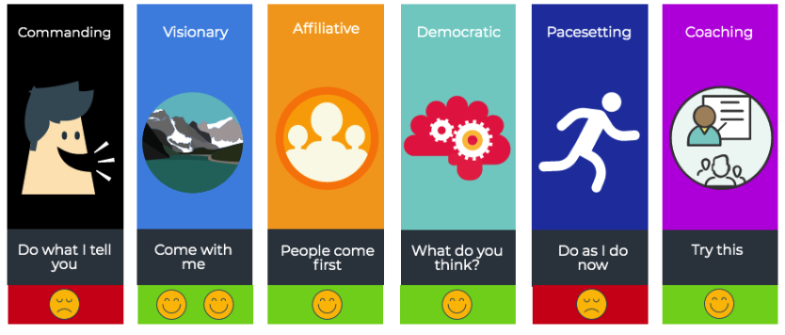
(Secretsoftheirsuccess.com, N.D)

2.4 Alternative viewpoints regarding Situational Leadership.
Although Situational Leadership is among the most widely known theories in management, Thompson and Vecchio (2009) make a counter argument by claiming that although popular management textbooks include situation leadership theory, there is a lack of practical evidence-based use of situational leadership within management training programs and the critique of the theory is completed by academics and scholars as opposed to a practical work-based setting. Blank, Green and Weitzel (1990) also present the same reasoning by stating that situational leadership theory has ‘mixed empirical validation’, meaning questionable accuracy of testing and potential lack of supporting evidence of research, rather than relying solely on theoretical applications.

3.0 Evaluation of Students leadership style
The student has completed a situational leadership self-assessment which can be found in appendix A. The results suggest that the student is 50% a participating leader, 25% Telling, 25% selling and 0% Delegating.
Upon reflection and considering the definition of each situational leadership style as already examined, the student agrees with the results of the questionnaire. Within the workplace, the student rarely delegates task and gets his team involved in most decisions that affect the team. With regards to day-to-day tasks, the student has been recognised for getting closely involved in his teams’ efforts. An example of this can be observed with something as insignificant as the seating plan within the office; the three other regional managers sit together on the senior management desks whereas the student will sit at the perceived lesser desks amongst his team. The result of 50% participative leader, the student feels is very accurate. Another interesting fact, the 3 questions marked affirmatively equating to the 25% telling style are all questions relating to under performance or conflict within the team. This shows that the student can adopt an authoritative persona when required. The final 25% selling style is also as a result to situations where performance has a potential to drop. The 3 affirmative questions suggest that the student can recognise any potential issues before the materialise and is able to get the buy-in from the team to solve problems before they become hindering. With a majority participative and equal telling and selling styles, the student concludes that he is an effective situational leader within the workplace.
Although the student has attempted to be as objective and accurate as possible, the student recognises that self-assessments are not necessarily 100% accurate due to the potential for self-identified behaviours differing from that perceived by others. Brown and Harris (2013) define self-assessment as a ‘descriptive and evaluative act carried out by a student concerning his or her own work’. The structural aspect of a self-assessment is that it needs to be an honest evaluation and should be free from emotion. Zenger and Folkman (2020) combat any emotional pollution and discuss the benefit of conducting 360-degree reviews which utilises feedback from a person’s colleagues, managers and subordinates to get a well-rounded objective evaluation from difference sources.
Andrade (2019) explains that a study of 112 students studying the accuracy of self-assessment of their own work, resulted in students assessing their own work at a higher standard than the assessment carried out by their professor and Turpentine (2001) states that in 17% of cases, peer-assessment differed from the results of self-assessment when considering leadership skills.
Therefore, to validate his own assessment, the student has asked 5 colleagues to also complete the same questionnaire based on their perception of how he would act as a leader in each of the given situations.
LE, JR and FP are managers who reports directly to the student, GS is a manager from a different operational department which the student collaborates with daily. GS is on the same tier and has the same responsibility and authority level as the student and SO is the students line manager. Their answers to the questionnaire can be found in Appendix B and table 1 in Appendix C. The results are very similar to that which the student self-assessed.
Diagram 1: Results from Peer Review Questionnaire
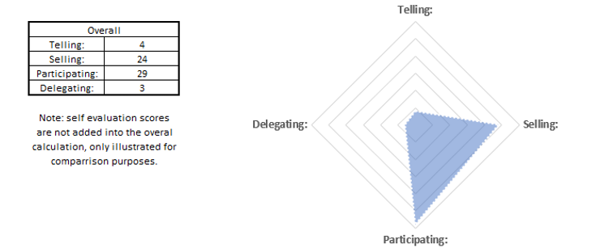
GS was the only person out of the 5 colleagues who scored any questions in the delegating category. The student believes that this anomaly is due to the reason that GS has never managed nor been managed by the student whereas the other four participants are. GS and the student are of equal rank within the business and although work very closely together, are based in different departments so the insight as to the way the student leads his team is from an external perspective. The student also feels that GS may have chosen these answers based on the business’ ideology of a regional manager, which by nature can be very authoritative, and not necessarily the actual leadership displayed by the student. By conclusion, it is suggested that the student may be lacking in his delegatory skillset.
The telling style was also very low scoring with only 2 participants scoring within this category and there is further mitigation to this. When JR was first appointed as an Area Manager, he struggled to fit into the role, as such his probationary period was extended. During this time, the student spent extra time with JR coaching and developing him into the role. Therefore, JR would have been exposed to a lot more direction from the student that the others. FP was the only other person who scored a question in the telling category and for that particular question, the self-assessment answer is the same, this is due to the scenario in question 9 is based on the team not understanding goals, therefore a potential crisis which would need more of an active input from a telling leader. The evaluation of the telling category answers suggest that the student has a firm grasp of the ability to set direction when needed.
Selling and participating are both very similar in scores and as can be seen in diagram 1, are considerably more dominant leadership traits and in line with the student’s self-assessment. The results show that the student has an apt ability to motivate and empower members of his team though his situational leadership style and his hands-on approach to leadership.

Conclusion
This assignment has defined what leadership is in that it is a process to enable others to bring about a result or change. In a workplace context, the change could be physical change such as driving a new process or a psychological change such as amendments to work ethos or culture. The difference between a leader and a manger has been considered and although the concepts do regularly blend, the difference needs to be understood. ‘All Leaders Manager but not all Managers Lead’. (Trainingzone, 2005)
The student has examined the two different ways in which a person can become a leader, either assigned or emergent. Assigned leaders inherit leadership responsibilities due to their job role or position within an organisation such as management or supervisory roles whereas an emergent leader develops into their leadership capacity over time.
The student has critically analysed Hersey and Blanchard’s Situational Leadership Model and made links between the Model and Tuckman’s Team Development. The student has reviewed Goleman’s adaptation of situation leadership which includes his expertise on emotional intelligence.
The student has then evaluated his own leadership style though the use of self-assessment and 360-degree feedback. The results from the peer assessments correlate to the students results and that is that he is predominantly a participative leader but can also utilise telling and selling styles when situations dictate. From the feedback, the student is lacking in delegatory leadership skills and will try to build more delegation into his work.
Leadership styles are a factor in every business and affect both employee performance and efficiency of operations. (Indeed, 2021)
Tom Hanks as Assigned Leader Captain Miller  in Saving Private Ryan (Rodat, 1998)  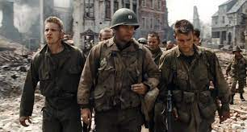  (IMDB, N.D) | Mel Gibson as Emergent Leader William Wallace  In Braveheart (Wallace, 1995)    (Cinemablend, N.D)

Asif Sadique MBE (2021), or the institute of Leadership and Management, writes ‘Leaders were once taught that they must have all the right answers, say all the right things and approach challenging situations with readymade solutions. But what’s important now is to have leaders who will show vulnerability. Leaders who can go into conversations without all the answers – but with a willingness to explore potential solutions with their teams’

References
Acqnotes.com. (2021). Program Management: Democratic Leadership Style. [Online]. Available at: https:// acqnotes.co /acqnote/careerfields/democratic-leadership-style. (Accessed 17.07.21)
Adair, J. (1973). Action Centred Leadership. London:McGraw-Hill
Adair, J. (2006). Leadership and Motivation. London: KoganPage
Andia, L. (1999). Tuckman and Hersey/Blanchard, ‘Performance Improvement’. Vol.38. no.4. pp.20-23.
Andrade, H. (2019). A Critical Review of Research on Student Self-Assessment. [Online]. Available at: https://www.frontiersin.org/articles/10.3389/feduc.2019.00087/full. (Accessed 14.07.21)
Baunsgaard, V. (2020). What is Situational Leadership Theory?. [Online]. Available at: https://managemagazine. com/article-bank/what-is-situational-leadership-theory-definitions-examples/. (Accessed 17.07.21)
Benincasa, R. (2012). 6 Leadership Styles and When you should use them. [Online]. Available at: https://www.teamstrength.net/6-leadership-styles-when-you-should-use-them/. (Accessed 17.07.21)
Blanchard, K. (1994). One Minute Manager. New York:HarperCollins
Blank, W. Green, S. Weitzel, J. (1990). ‘A test of the situational leadership theory’. Personnel Psychology. Issue 43. pp.579-597.
Bobinski, D. (2004). The difference Between Management and Leadership. [Online]. Available at: https://www. management-issues.com/opinion/1125/the-difference-between-management-leadership/. (Accessed 16.07.21)
Brown, G. Harris, L. (2014). ‘Student self-assessment’. Sage Handbook of Research on Classroom Assessment. Pp.367-393. CA:Sage
Businessballs.com. (N.D). Adair’s Action Centred Leadership Model. [Image]. Available at: https://www. businessballs.com/local/images/action.jpg. (Accessed 17.07.21)
Businessballs.com. (N.D). Hersey and Blanchard’s Situational Leadership. [Image]. Available at: https://www. businessballs.com/local/pix/businessballs/sitlead1.jpg. (Accessed 17.07.21)
Businessballs.com. (N.D). Tuckman’s Model of Team Development. [Image]. Available at: https://www. businessballs.com/local/pix/businessballs/forming.jpg. (Accessed 17.07.21)
Cartyle, T. Sorrensen, D. Kinser, B. (1841). On Heroes, Hero-Worship and the Heroic in History. New Haven: Yale University Press
Casali, E. (2015). The Six Styles of Leadership. [Online]. Available at: https://intenseminimalism.com/2015/the-six-styles-of-leadership/. (Accessed 17.07.21)
Castro, F. Gomes, J. De Sousa, F. (2012). ‘Do Intelligent Leaders Make a Difference? The Effect of a Leader's Emotional Intelligence on Followers' Creativity’, Creativity and Innovation Management. Vol.21. Issue.2. pp.171-182.
Cebollero, C. (2014). 2 Types of Motivation Explained. [Online]. Available at: https://www.ems1.com/ems-management/articles/2-types-of-motivation-explained-6HNgKoJGBA3YYAR9/. (Accessed 16.07.21)
Cherry, K. (2019). The Major Leadership Theories. [Online]. Available at: https://www.verywellmind.com /leadership-theories-2795323. (Accessed 06.07.21)
Cherry, K. (2020). The situational Theory of Leadership. [Online]. Available at: https://www.verywellmind.com/ what-is-the-situational-theory-of-leadership-2795321. (Accessed 11.07.21)
Cinemablend. (N.D). Mel gibson as William Wallace in Braveheart. [Image]. Available at: https://img.cinemablend.com/filter:scale/quill/0/f/4/f/d/1/0f4fd19ac606fa9f7c99430fd8ecb0127cb5350e.jpg?mw=600. (Accessed 18.07.21)
Corrado, M. (2017). A Lack of Emotional Intelligence in Leadership is Detrimental. [Online]. Available at: https://www.Aseonline.org/News/Articles/ArtMID/628/ArticleID/1236/A-Lack-of-Emotional-Intelligence-in-Leadership-is-Detrimental. (Accessed 13.07.21)
Cwalina, W. Drzewiecka, M. (2015). Goleman’s Theory of Leadership. [Online]. Available at: https://www.researchgate.net/profile/Wojciech-Cwalina/publication/302412911_Ideal_president_like_ideal_boss _Looking_for_preferences_of_political_leadership_style_Cross-Cultural_study_in_Goleman's_typology/links/5730 64bc08aeb1c73d1466a7/Ideal-president-like-ideal-boss-Looking-for-preferences-of-political-leadership-style-Cross -cultural-study-in-Golemans-typology.pdf. (Accessed 17.07.21)
Dublin, R. (2019). Assigned Leadership Versus Emergent Leadership. [Online]. Available at: https://sites.psu.edu/leadership/ 2019/05/22/assigned-leadership-versus-emergent-leadership/. (Accessed 16.07.21)
DuBois-Maahs, J. (2019). What is Extrinsic Motivation and How Does it Help Us?. [Online]. Available at: https://thriveglobal.com/stories/what-is-extrinsic-motivation-and-how-does-it-help-us/. (Accessed 17.07.21)
Els, S. (2021). Workplace Coaching: 4 Common Problems. [Online]. Available at: https://iconnect-online.com/4-performance-coaching-problems/. (Accessed 17.07.21)
Gerpott, F. Lehmann-Willenbrock, N. Voelpel, S. & Vugt, M. (2019). Its not jst what is said, but when it’s said. ‘Academy of Management Journal’. Vol.62. No.3. p.717.
Go2HR. (N.D). Understanding the Differences: Leadership vs Management. [Online]. Available at: https://www. go2hr.ca/retention-engagement/understanding-the-differences-leadership-vs-management. (Accessed 17.07.21)
Goleman, D. (2000). ‘Leadership that Gets Results’, Harvard Business Review. March 2000 Edition. MA:HBP
Goleman, D. (2004). ‘What makes a Leader?’, Harvard Business Review. January 2004 Edition. MA:HBP
Goleman, D. Royatzis, R. McKee, A. (2013). Primal Leadership. Boston:HBR Press
Hanna, A. Smith, T. Kirkman, B. Griffin, R. (2020). The Emergence of Emergent Leadership: A Comprehensive Framework and Directions for Future Research, ‘Journal of Management’. Vol.7. Issue.1. pp76-104.
Harine, E. (2015). Group-Centred Prevention in Mental Health. New York:Springer
Hersey, P. Blanchard, K. (1972). Management of organizational behaviour, 2nd ed. New Jersey:Pearson
Hussain, A. (2014). ‘Impact of Leadership Styles on Crisis Management’, European Journal of Business and Management. Vol.6. issue.2. pp.37-44.
Ilone, J. (2021). 6 Leadership Syles from Daline Goleman, the Author of the Leadership that Gets Results. [Online]. Available at: https://www.business-powerhouse.com/6-leadership-styles-from-daniel-goleman-author-of-leadership -that-gets-results. (Accessed 17.07.21)
IMDB. (N.D). Tom Hanks as Captain Miller in Saving Private Ryan. [Image]. Available at: https://m.media-amazon.com/images/M/MV5BMzRhNmM1NTctY2NlYy00MTJmLWFlYzgtZTkxZjhlYjZmNDczXkEyXkFqcGdeQXVyOTc5MDI5NjE@._V1_.jpg. (Accessed 18.07.12)
Indeed. (2012). Extrinsic Vs. Intrinsic Motivation. [Online]. Available at: https://uk.indeed.com/career-advice/career-development/extrinsic-intrinsic-motivation. (Accessed 16.07.21)
Indeed. (2021). Situational Leadership Theory: Definition, Styles and Maturity Levels. [Online]. Available at: https://www.indeed.com/career-advice/career-development/situational-leadership-theory. (Accessed 11.07.21)
IntenseMinimalism.com. (2015). The Six Styles of Leadership. [Image]. Available at: https://i2.wp.com/intense minimalism.com/wp-content/uploads/2015/05/the-six-styles-of-leadership-goleman.png? (Accessed 17.07.21)
Kokemuller, N. (N.D). What Is the Difference Between Assigned Leadership & Emergent Leadership?. [Online]. Available at: https://yourbusiness.azcentral.com/difference-between-assigned-leadership-emergent-leadership-22565.html. (Accessed 16.07.21)
Kruse, K. (2013). What is Leadership. [Online]. Available at: https://www.forbes.com/sites/ kevinkruse/2013/04/09/what-is-leadership/?sh=1dc56aa75b90. (Accessed 06.07.21)
Landry, L. (2019). Why emotional intelligence is important in Leadership. [Online]. Available at: https://online.hbs.edu/blog/post/emotional-intelligence-in-leadership. (Accessed 13.07.21)
Leadership Studies. (N.D). The Four Leadership styles of Situational Leadership. [Online]. Available at: https:// situational.com/blog/the-four-leadership-styles-of-situational-leadership/. (Accessed 12.07.21)
Lee, A. Willis, S. Tian, A. (2018). ‘When Empowering Employees Works and When it Doesn’t’. Harvard Business Review. March 2018 edition. MA:HBP
Lee, S. (2020). What is coaching Leadership?. [Online]. Available at: https://torch.io/blog/what-is-coaching-leadership/. (Accessed 17.07.21)
Lindberg, C. (N.D). The siz Leadership Stypes by Daniel Goleman. [Online]. Available at: https://www.leadershipahoy.com/the-six-leadership-styles-by-daniel-goleman/. (Accessed 17.07.21)
LinkedIn. (2017). Difference Between a Boss and a Leader Diagram. [Image]. Available at: https://media-exp3.licdn.com/dms/image/C5112AQGksR5fyrvNaQ/article-cover_image-shrink_600_2000/0/1520183796130?e= 1631750400&v=beta&t=qYFWbghEREQyKvMTaduKgXSWZoy2q7LmZiBYDytuwAI. (Accessed 17.07.21)
Mindtools. (N.D). Six emotional Leadership Styles. [Online]. Available at: https://www.nzequestrian.org.nz/wp-content/uploads/Six-Emotional-Leadership-Styles.pdf. (Accessed 17.07.21)
Morgan, J. (2020). What is Leadership and who is a Leader. [Online]. Available at: https://www.chieflearningofficer.com/2020/01/06/what-is-leadership-and-who-is-a-leader/. (Accessed 06.07.21)
Northouse, G. (2007). Leadership Theory and Practice. 3rd edition. CA:Sage
Oxford English Dictionary. (2020). Oxford English Dictionary. Oxford:Oxford University Press
Quizlet.com. (N.D). Hersey & Blanchard Situational Leadership Diagram. [Image]. Available at: https://o.quizlet.com/ mj8v9WbdR5NmQfA0v51aBA.png. (Accessed 17.07.21)
Riopel, L. (2020). Goleman and other Key Names in Emotional Intelligence. [Online]. Available at: https://positivepsychology.com/emotional-intelligence-goleman-research/. (Accessed 13.07.21)
Rodat, R. (1998). Saving Private Ryan. Directed By Stephen Spielberg. [Feature Film]. CA:DreamWorks
Sadiq, A. (2021). Why human leadership is key to delivering equity and inclusion. [Online]. Available at: https:// www.institutelm.com/resourceLibrary/why-human-leadership-is-key-to-delivering-equity-and-inclusion.html. (Accessed 18.07.21)
Sands, L. (2020). The six Styles of Leadership: Where do you fit?. [Online]. Available at: https://www.breathehr.com/en-gb/blog/topic/business-leadership/the-six-styles-of-leadership-where-do-you-fit. (Accessed 17.07.21)
Secretsoftheirsuccess.com. (N.D). Daniel Goleman’s Six Styles of Leadership. [Online Image]. Available at:
https://i1.wp.com/ secretstotheirsuccess.com / wp-content / uploads / 2017 / 09 / Snip20190603_12.png?w=884. (Accessed 17.07.21)
Sharma, S. (N.D). What is Pacesetting Leadership. [Online]. Available at: https://taskworld.com/blog/what-is-pacesetting-leadership-4-real-world-examples/. (Accessed 17.007.21)
St Thomas University. (2014). What is Situational Leadership. [Online]. Available at: https://online.stu.edu/articles/ education/what-is-situational-leadership.aspx. (Accessed 12.07.21)
Tavarnessi, G. (2019). Using situational Leadership to Manage Different Types of Conversation. [Online]. Available at: https://www.skillgym.com/2019/03/using-situational-leadership-to-manage-different-types-of-conversations/. (Accessed 13.07.21)
Thompson, G. Vecchio, R. (2009). ‘Seasonal Leadership theory’, The Leadership Quarterly. Issue 20. p.837.
Trainingzone.co.ul. (2005). The way I see it, All Leaders Manager, but not all Managers Lead. [Online]. Available at: https://www.trainingzone.co.uk/lead/culture/the-way-i-see-it-all-leaders-manage-but-not-all-managers-lead. (Accessed 18.07.21)
Tuckman, B. (1965). ‘Developmental Sequence in Small Groups’, Psychological Bulletin. Vol.63. pp.384-399.
Turrentine, C. (2001). ‘A Comparison of Self-Assessment and Peer Assessment of Leadership Skills’, NASPA. Vol.38. Issue.3.
Wallace, R. (1995). Braveheart. Directed By Mel Gibson. [Feature Flm]. FL:20th Century Fox
Ward, S. (2020). What is Leadership? [Online]. Available at: https://www.thebalancesmb.com/leadership-definition-2948275. (Accessed 17.07.21)
Western Governors University. (2020). Leadership theories and styles. [Online]. Available at: https://www.wgu.edu /blog/leadership-theories-styles2004.html. (Accessed 10.07.21)
Wolf, J. (2021). Situational Leadership Examples and how to Develop this Management Style. [Online]. Availlible at: https://www.betterup.com/blog/situational-leadership-examples. (Accessed 12.07.21)
Yukl, G. (2013). Leadership in Organizations. 8th Edition. p.7. New York
Zenger, J. Folkman, J. (2020). ‘What makes a 360-Degree Review successful?’. Harvard Business Review. December 2020 edition. MA:HBP

Appendix A: Situational Leadership Self-Assessment
Self-assessment questions: Read through the Situation questions and then choose the response (only one) from the corresponding Alternative Action statements that most appeals to you or that you feel seems the most characteristic of you. In some cases none of the responses may be appealing or characteristic of you. Nonetheless, please select the statement that you prefer or feel suits you best.

Situation | Alternative Action
1. Your group is not responding lately to your friendly conversation and obvious concern for their welfare. Their performance is declining rapidly. | - Emphasize the use of uniform procedures and the necessity for task accomplishment.  - Make yourself available for discussion but do not push your involvement.  - Talk with them and then set goals.  - Intentionally do not intervene.
2. The observable performance of your group is increasing. You have been making sure that all members were aware of their responsibilities and expected standards of performance. | - Engage in friendly interaction, but continue to make sure that all members are aware of their responsibilities and expected standards of performance.  - Take no definite action.  - Do what you can to make the group feel important and involved.  - Emphasize the importance of deadlines and tasks.
3. Members of your group are unable to solve a problem themselves. You have normally left them alone. Group performance and interpersonal relations have been good. | - Work with the group and together engage in program solving.  - Let the group work it out.  - Act quickly and firmly to correct and redirect.  - Encourage the group to work on the problem and be supportive of their efforts.
4. You are considering a change. Your group has a fine record of accomplishment. They respect the need for change. | - Allow group involvement in developing the change, but do not be too directive.  - Announce changes and them implement with close supervision.  - Allow the group to formulate its own directive.  - Incorporate group recommendations, but you direct the change.
5. The performance of your group has been dropping during the last few months. Members have been unconcerned with meeting objectives. Redefining roles and responsibilities has helped it the past. They have continually needed reminding to have their tasks done on time. | - Allow the group to formulate its own direction.  - Incorporate group recommendations, but see that objectives are met.  - Redefine roles and responsibilities and supervise carefully.  - Allow group involvement in determining roles and responsibilities but do not be too directive.
6. You stepped into an efficiently run group. The previous leader tightly controlled the situation. You want to maintain a productive situation, but would like to begin having more time building interpersonal relationships among members. | - Do what you can do to make the group feel important and involved.  - Emphasize the importance of deadlines and tasks.  - Intentionally do not intervene.  - Get the group involved in decision-making, but see that objectives are met.
7. You are considering changing to a structure that will be new to your group. Members of the group have made suggestions about needed change. The group has been productive and demonstrated flexibility. | - Define the change and supervise carefully.  - Participate with the group in developing the change but allow members to organize the implementation.  - Be willing to make changes as recommended, but maintain control of the implementation.  - Be supportive in discussing the situation with the group but not too directive.
8. Group performance and interpersonal relations are good. You feel somewhat unsure about your lack of direction in the group. | - Leave the group alone.  - Discuss the situation with the group and then you initiate necessary changes.  - Redefine goals and supervise carefully.  D. Allow group involvement in setting goal, but don’t push.
9. You have been appointed to give leadership to a study group that is far overdue in making requested recommendations for change. The group is not clear on its goals. Attendance at sessions has been poor. Their meetings have turned into social gatherings. Potentially they  have the talent necessary to help. | - Let the group work out its problems.  - Incorporate group recommendations, but see that objectives are met.  - Redefine goals and supervise carefully.  D. Allow group involvement in setting goals, but do not push.
10. Your group, usually able to take responsibility, is not responding to your recent redefining of job responsibilities as a result of one member leaving the city. | - Allow group involvement in redefining standards but don’t take control.  - Redefine standards and supervise carefully.  - Avoid confrontation by not applying pressure, leave situation alone.  D. Incorporate group recommendations, but see that new job responsibilities are met.
11. You have been promoted to a leadership position. The previous leader was involved in the affairs of the group. The group has adequately handled its tasks and direction. Interpersonal relationships in the group are good. | - Take steps to direct the group towards working in a well-defined manner.  - Involve the group in decision-making and reinforce good contributions.  - Discuss past performance with the group and then you examine the need for new practice.  D. Continue to leave the group alone.
12. Recent information indicates some internal difficulties among group members. The group has a remarkable record of accomplishment. Members have effectively maintained long- range goals. The have worked in harmony for the past year. All are well qualified for the  tasks. | - Try out your solution with the group and examine the need for new procedures.  - Allow group members to work it out themselves.  - Act quickly and firmly to correct and redirect.  Participate in problem discussion while providing support for group members.  D. Participate in problem discussion while providing support for group members.
Scoring your self-assessment: Circle the responses from your self-assessment Situation questions on the scoring sheet below. Add up each column to determine your preferred leadership style according to the Hersey and Blanchard model.

SITUATIONS | ALTERNATIVE ACTIONS
SITUATIONS | 1 | A | C | B | D
SITUATIONS | 2 | D | A | C | B
SITUATIONS | 3 | C | A | D | B
SITUATIONS | 4 | B | D | A | C
SITUATIONS | 5 | C | B | D | A
SITUATIONS | 6 | B | D | A | C
SITUATIONS | 7 | A | C | B | D
SITUATIONS | 8 | C | B | D | A
SITUATIONS | 9 | C | B | D | A
SITUATIONS | 10 | B | D | A | C
SITUATIONS | 11 | A | C | B | D
SITUATIONS | 12 | C | A | D | B
 | Total: | 3 | 3 | 6 | 0
 | Leadership Style | Telling  (Directing) | Selling  (Coaching) | Participating  (Facilitating) | Delegating  (Observing)

Appendix B: Returns for leadership questionnaire by LE, JR, FP, GS and SO

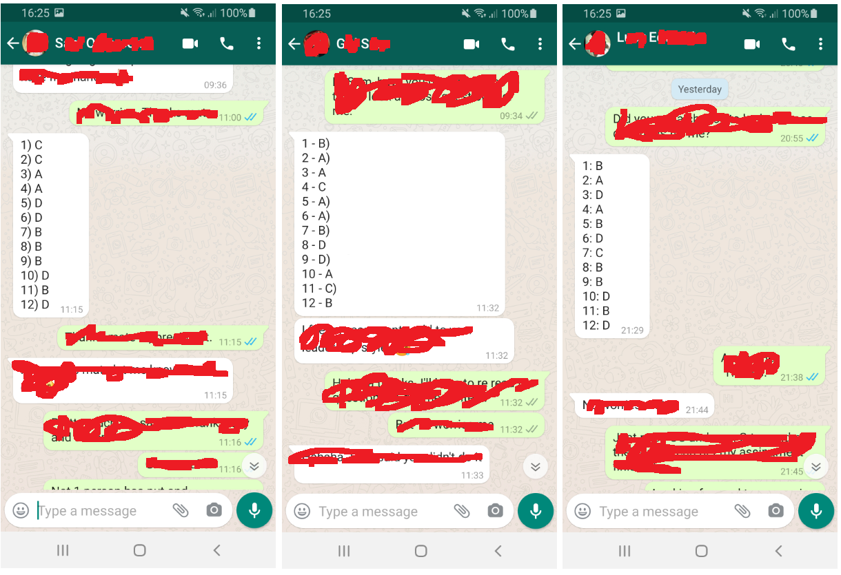
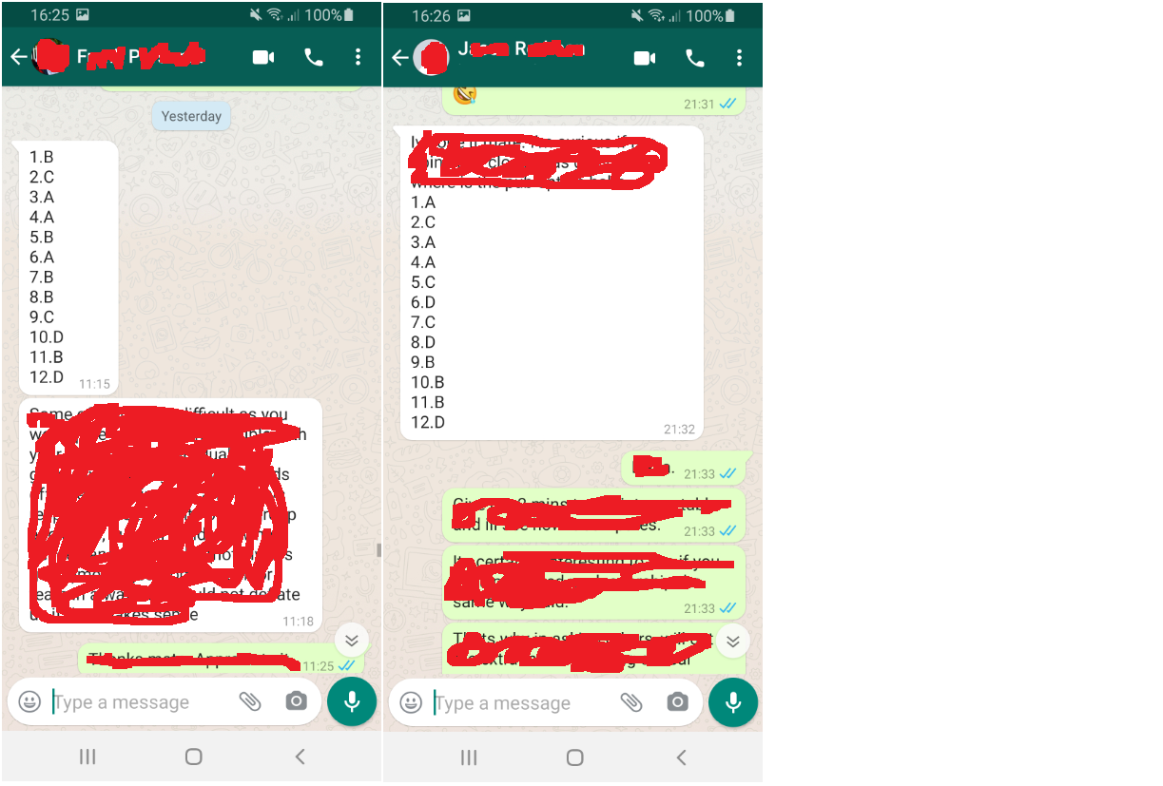

Appendix C: Table 1: Results of Situational Leadership Questionnaire by LE, JR, FP, GS and SO



