HOTEL FACILITIES –
HOUSEKEEPING
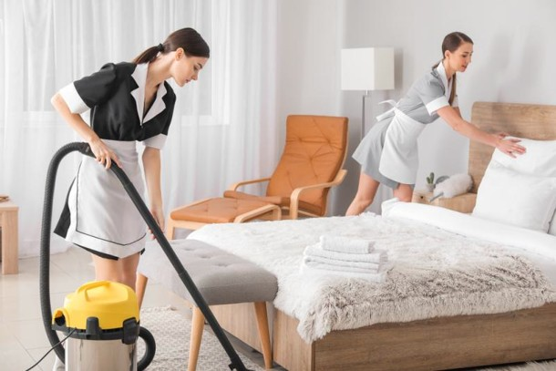
Student: Adriana Ghiocel-Ioaniciu
Student number:2127376
Lecturer: Lisa-Marie Bassler
Module code: BMIH5008
ACKNOWLEDGEMENT: I confirm that I have not used any AI tools in the research and creation of this assignment. I confirm that I have not presented any AI-generated materials as my own work. I confirm I have copies of my drafts, notes, and other resources I used, which I may be asked to provide in evidence.

Contents
Part 1 3
INTRODUCTION 3
1.Description 4
2. Feelings 5
3. Evaluation 5
4. Analysis 5
5.Conclusison 6
6.Action plan 6
Part 2 7
Hotel feedback 7
Part 3 13
Tutor feedback 13
Part 4 17
Reflection on hotel and academic tutor feedback 17
1.1Understand the feedback 17
1.2 Impact of the feedback 18
1.3 Action steps to grow 19
1.4 Conclusion 20
References 21

Part 1

INTRODUCTION

The expression "hospitality" refers to the act of welcoming and entertaining strangers or guests in a friendly and generous manner, whether for social or business purposes. The impression that we get from this definition is that of a place where people can be cared for, like a house that is open to the public and the host who welcomes them with open arms.( Jones, Thomas J. A., and Jones 2007)
The position of room attendant stands out among the many precarious jobs that are available in the tourism industry due to the extremely difficult working conditions, low wages, high accident rate, occupational diseases, and low social recognition that are associated with the job. (Alcalde-González 2021).
The housekeeping staff plays a crucial role in maintaining the cleanliness, health, and comfort of the Morgan Hotel Swansea for its guests. It ensures that the guest rooms, public areas, and facilities meet high standards, which helps the hotel's reputation and makes guests overall satisfied.The housekeeping department has a direct impact on both guests and the hotel.The communication of housekeeping standards is not only a matter of courtesy, but also of quality and safety within the organisation. To avoid misunderstandings, disappointments, and potential hazards, it is important to provide your guests with information regarding what they can anticipate from your housekeeping service.(Anon,2023)
Given that guests place a high priority on the cleanliness of the hotel, their feedback has the potential to cause significant harm to the hotel's reputation if it does not live up to their expectations. The quality of your housekeeping can be a surefire way to gain an advantage, improve the overall experience of your guests, and boost your organization's bottom line.
Morgan Hotel Swansea had a laundry room and an iron press as well. They don’t need any companies to help them, and this is a good thing because they save a lot of money. Their ability to effectively manage the laundry process allows them to guarantee a consistent supply of clean linens, which contributes to the overall satisfaction and comfort of the guests.
In addition, the housekeeping department is responsible for the inventory management of the hotel as well as the monitoring of the supplies that are provided to the rooms. They make certain that the necessary items, such as cleaning supplies, toiletries, and other items, are adequately stocked, which enables operations to run smoothly. As a result of this attention to detail, guests are guaranteed to receive all of the essential amenities, which contributes to an overall improvement in their experience.
The purpose of this assignment is to demonstrate how the housekeeping department operates and its significance to the hotel industry.
I will use the Gibbs model to explore my experiences in housekeeping during my placement.
Gibbs' Reflective Cycle is a popular model for reflection, serving as a structured method to enable individuals to think systematically about their experiences during a specific situation.(Main,Paul 2023)
The manager of the housekeeping department showed me how to enter all of the work that the staff had done into the system while I was doing my placement.my time spent working in the housekeeping allowed me to develop some skills like :patience ,resilience and attention to details ,all of which are attributes that are necessary for any position in hospitality industry .
My experience in housekeeping from another hotel where I worked will be shared with as part of this assignment

1.Description

During my time in housekeeping, I had a few unpleasant experiences with guests. I had three types of rooms: departures, stay and change. My bad experience was in the change room. The rule in housekeeping is to do all departures rooms first. Once I have finished with all the departures, I start making changes to stays and adjusting the details for guests who don’t require any updates. They put the ‘do not disturb ‘card on the door if they don’t need to clean the room . When I arrived at my last room, I knocked on the door a few times but got no answer . I decided to go in, and when I tried to turn the light on, I heard the customer shouting at me about why I had disturbed him, even though he didn't have a card on the door.I've apologised. I went out. I told my manager about this. After me, the guest left the card on the door. I finished my shift, and when I went to sign out, my manager received a call from reception. She informed me that a guest in their room needed new towels. I go back, take the towels, knock on the door, and he shouts from the room to leave them outside the door.

2. Feelings

Feelings are a response to how different parts of your body are feeling, and they are a part of everyone.
I was surprised by the guest's reaction, given that he had not placed his card on the door to avoid being disturbed . I realised that some people don’t care if they have a bad reaction to someone else, even if it is their fault . I was frustrated and angry at the same time because I was forced to go back and give him towels, even though I had been there the first time, and he had said he didn’t need anything.

3. Evaluation

Positive aspects :
In this situation, remain calm, and I apologise to the guest that it wasn’t my fault
I spoke with my manager about this situation.
Negative aspects :
I was unprepared for such a strong reaction from a guest.

4. Analysis

To act, it is essential to first conduct a thorough analysis of each situation.
Problems with guests can occur on a regular basis due to the fact that some individuals are having a bad day or are not concerned about other people; therefore, the staff needs to be ready to handle any situation that may arise. If I am not able to effectively solve problems, then that thing may have a negative impact on the hotel because of the feedback received from guests.
One of the challenges that I faced in my job was what I experienced with this guest.

5.Conclusison

This thing that happened in the housekeeping department taught me a lot about how to be polite, talk to people, and keep my emotions in check in a real hotel setting. My biggest takeaway was how important it is to always act professionally, even if people are rude or difficult to deal with. I learnt from this that not every interaction will be good, but how I react is more important than the issue itself. I feel more confident and emotionally mature now because of this experience. As I thought about it, part of working in the hotel industry is learning how to deal with things that can't be planned for and still provide excellent service.
This experience has given me more confidence in my ability to handle unexpected situations professionally while still upholding the high standard of service at the hotel.

6.Action plan

After going through all these experiences, I have come to the realisation that in order to be able to participate in the hotel industry, I need to have a plan of action. There are a lot of things that I need to learn, and in order to do so, I need to figure out some rules and steps that I need to follow.
- Respect the verbal refuse from guest and note that to know to avoid the confusion during the shift .
If the guest refuses the service ,just respect his decision but all time tell him if he changes his mind ,let us to know
- Communicate with supervisor, manager or reception immediately
Let someone to know about the guest decision ,especially if the guest was rude because if they will call to reception for clean towels or suppliers the team will know the service was refused not ignored .
- Deliver the service politely and promptly
If the guest call to the reception for clean stuff or suppliers ,even he refuse when the service was offered its important to remain professional and and helpful .
- Reflect and learn
Ask colleagues how they react in a situation like that and learn from them.Ask the manager or supervisor for an advice how to react if I will have in future same situation.

Part 2

Hotel feedback

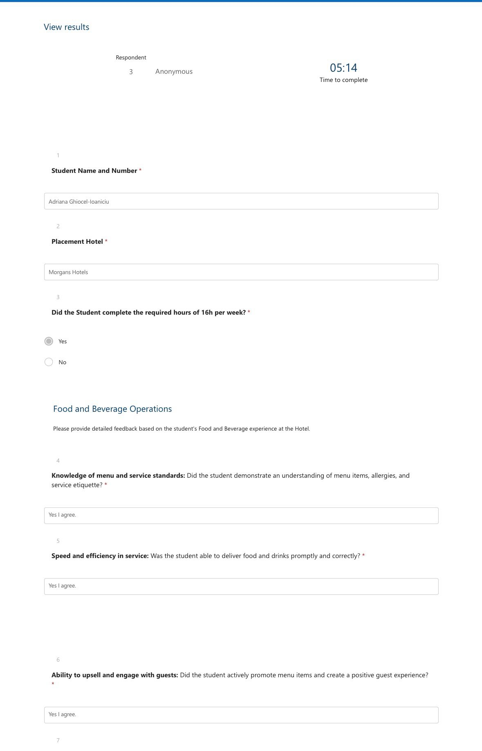
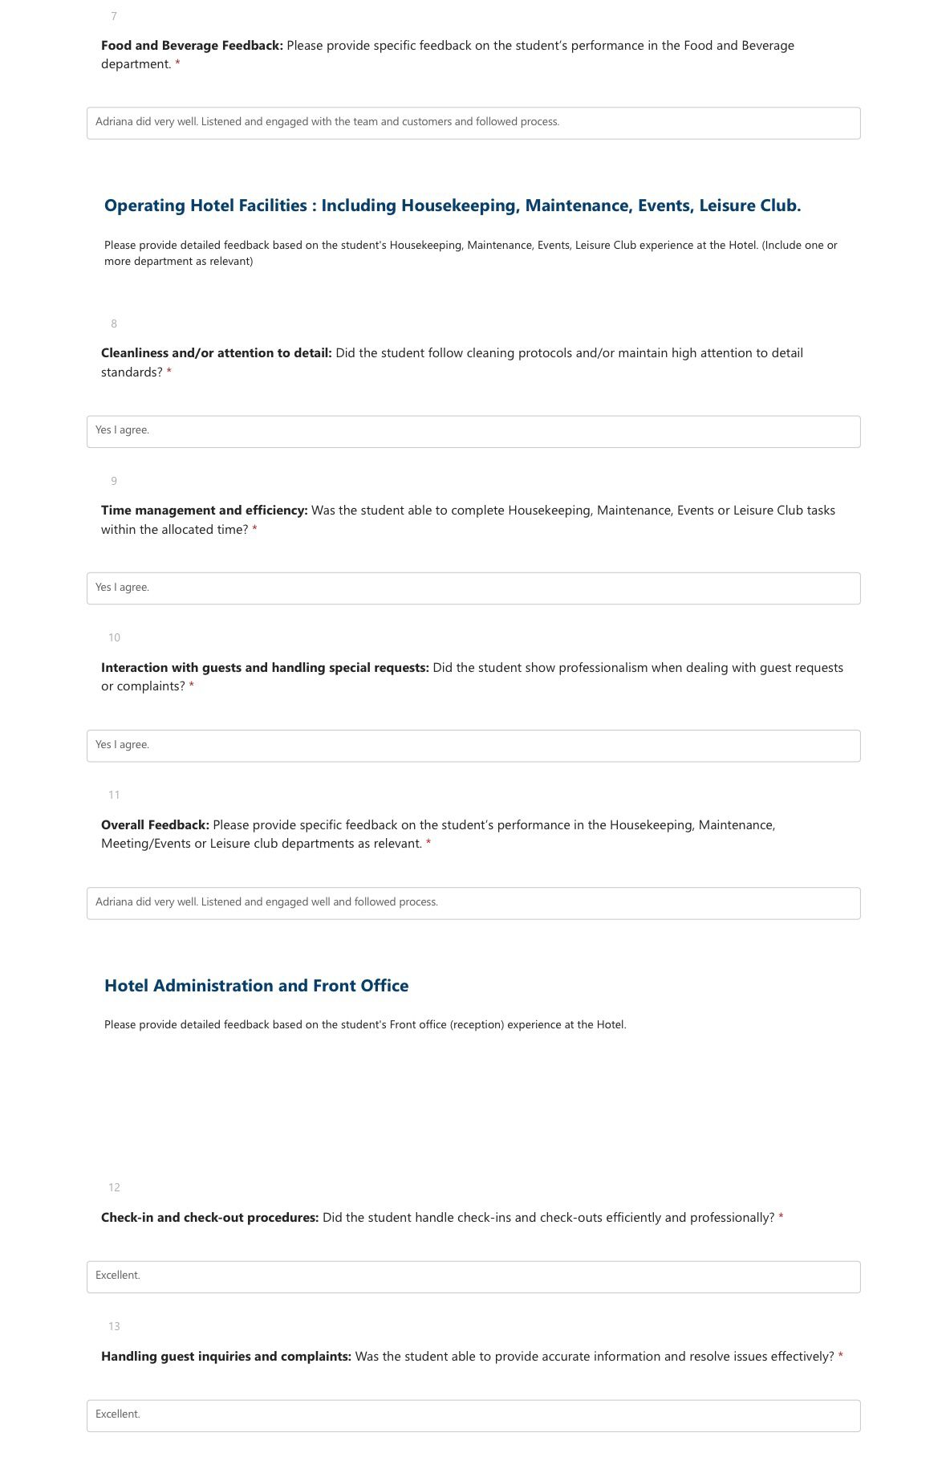
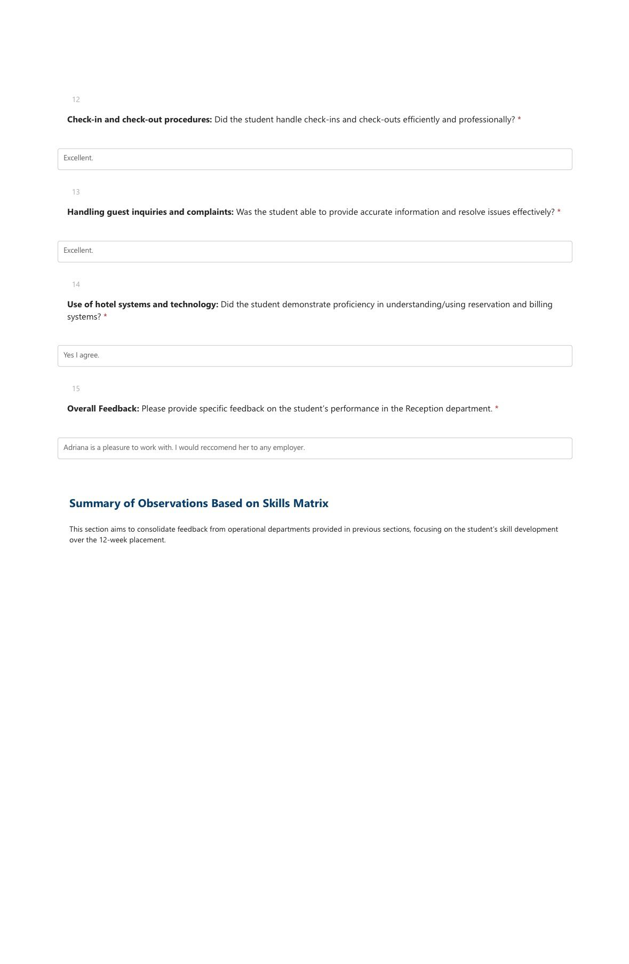
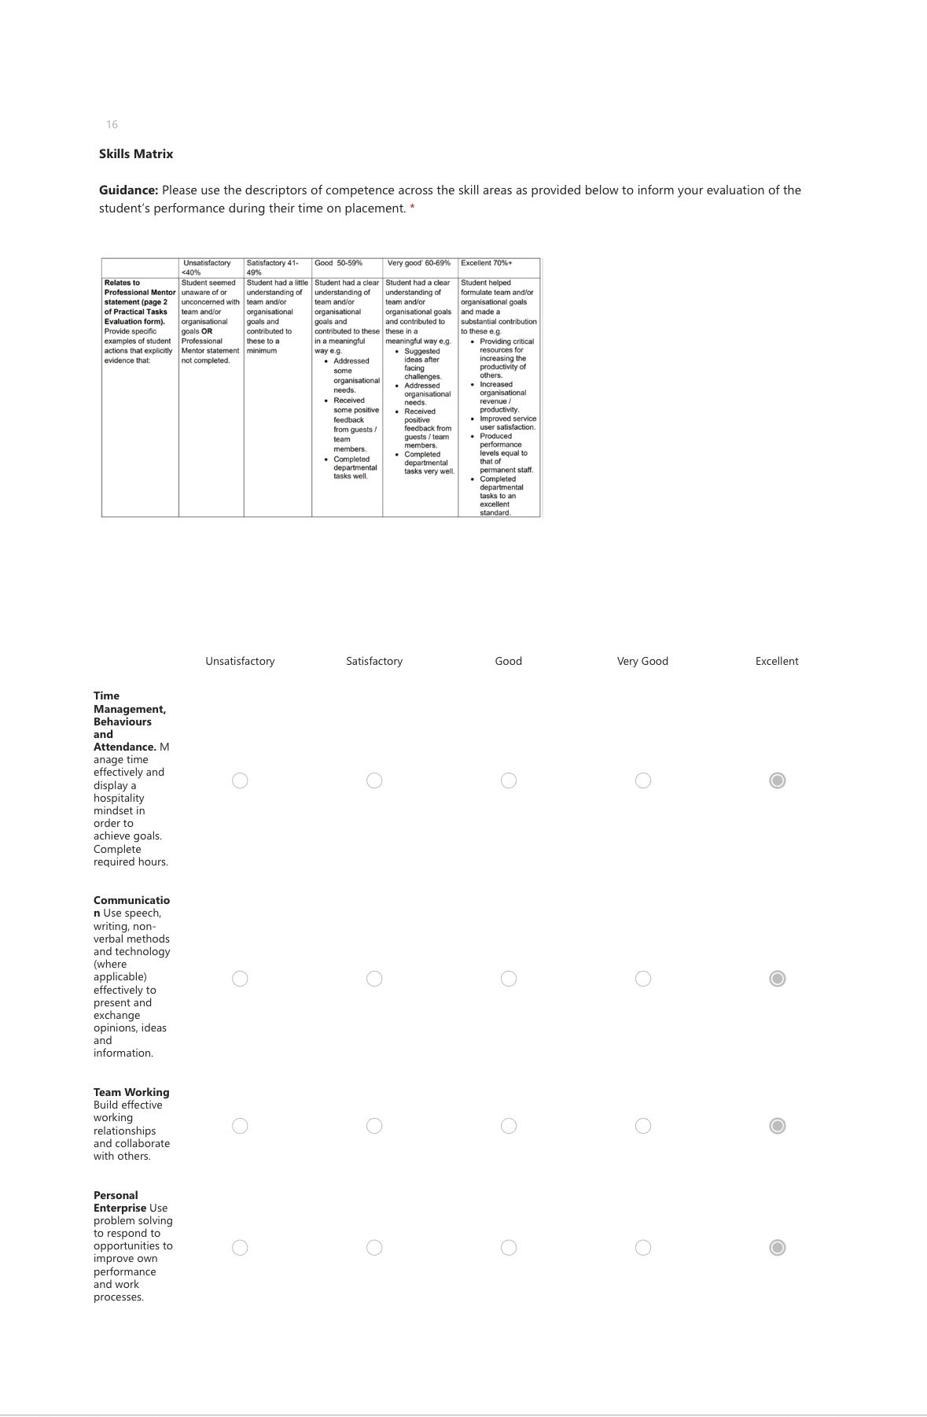
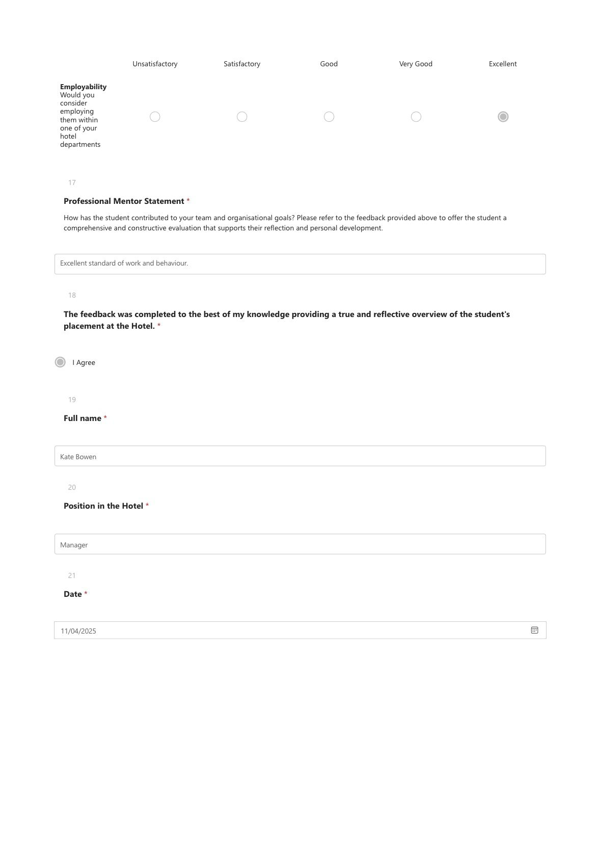

Part 3

Tutor feedback

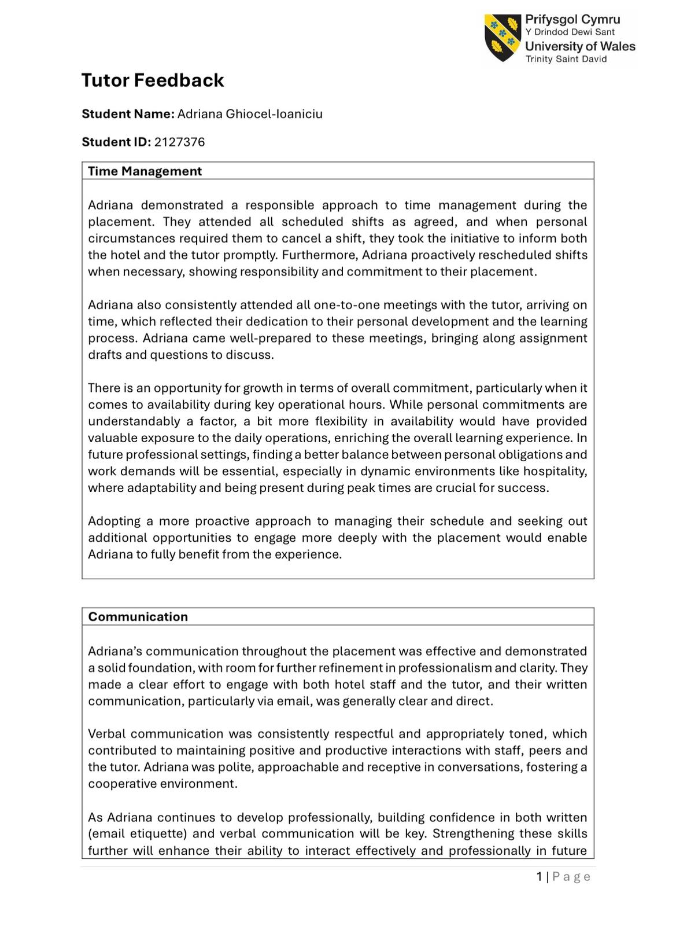

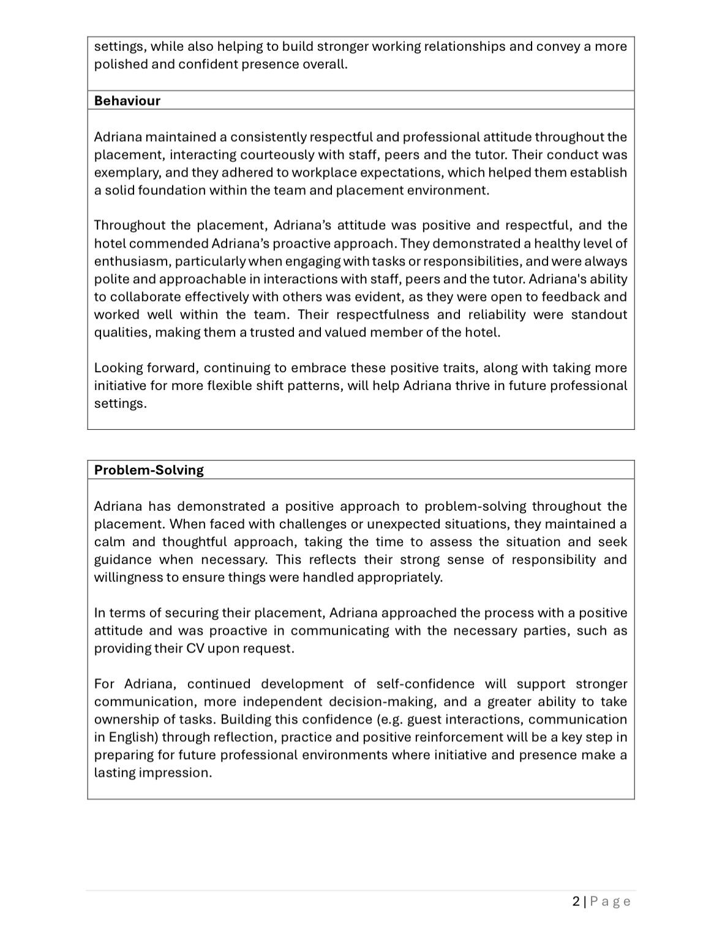



Part 4

Reflection on hotel and academic tutor feedback

While I was working in the housekeeping department, I received feedback from both my hotel mentor and my academic tutor. This reflection will focus on the comments I received from both . Specifically, the objective is to gain an understanding of how my performance was evaluated in a work setting, as well as to identify both my strengths and areas in which I may improve. Cleaning is a vital component of the hospitality sector since it has a direct impact on the level of happiness and comfort that guests enjoy, as well as the entire experience. I was given feedback that touched on important topics such as managing time effectively, paying attention to details, working well with others, and being professional. Positive comments highlighted my dependability, cleanliness standards, and courteous approach, while constructive feedback underlined the need to enhance my confidence and efficiency. I am grateful for both types of input. Taking these comments into consideration will assist me in gaining a better understanding of how to further enhance my talents, increase the amount of initiative I take, and evolve into a hospitality worker who is more self-assured and capable. It is a great tool that guides both my personal and professional development moving forward, and I am grateful for feedback.

Understand the feedback

I was able to demonstrate a strong sense of responsibility in the duties that I was responsible for daily, according to the information provided by my hotel mentor. I made certain that the guest rooms were meticulously cleaned, which included adhering to the instructions in a very careful manner and maintaining a high level of hygiene standards. I was frequently praised for my attention to detail, and I was also acknowledged for my dependability and punctuality to the point where I was recognised for these qualities. In addition, I was praised for my punctuality and dependability. In addition to being always willing to lend a helping hand, I was also able to effectively collaborate with the other members of the housekeeping team.
However, despite this, the feedback did bring to light a few deficiencies that need to be addressed. One of the most significant aspects was the speed with which I completed the tasks that were assigned to me. Although I was extremely thorough, there were times when I took longer than expected to finish cleaning rooms. This was the case even though I was extremely thorough. When dealing with a busy hotel environment that has limited timetables, this can be a challenging situation to manage. It was also brought up that my self-assurance was a concern that was concerned. Even though I was aware of what I was supposed to do, there were times when I gave the impression of being uncertain or hesitant. This was especially true when I was confronted with responsibilities that were unfamiliar to me. It was pointed out to me by my academic tutor that I could improve my confidence in discussing what I had learnt and in asking more questions, even though I was present at meetings and turned in my work on time.

1.2 Impact of the feedback

I felt that the feedback I received had a significant impact on how I perceive myself as a professional in the hospitality industry. The qualities that I have developed, particularly my dependability, positive attitude, and attention to cleanliness, left me feeling proud of myself. These skills are not only necessary in the housekeeping department, but they can also be applied to other positions within the profession. A feeling of accomplishment came over me when I realised that both my mentor and my tutor had acknowledged the efforts that I had committed.
However, the feedback helped me understand this part of myself. My housekeeping experience has taught me that speed and confidence are as important as accuracy. Hospitality management requires the ability to work quickly without sacrificing quality. Time management is crucial. After hearing the comments about confidence, I realised I sometimes overrely on reassurance or approval before acting. Because of my hectic work environment, I must trust my training and take initiative when needed.Feedback is guidance, I concluded after thinking about it. It helps me grow by showing how others view my work. I'm more motivated to improve now that I know where I need to.

1.3 Action steps to grow

- Improve communjcation skills
I will continue to work on improving my communication skills, particularly when it comes to interacting with guests in conditions that are unexpected. It will be easier for me to appear more confident and professional if I practise using phrases that are clear and polite and if I use body language that is calm. In addition, I intend to enhance my English language skills by engaging in hands-on practice and soliciting feedback from my peers or professors

- Build More Confidence in Handling Difficult Situations
Increase your belief in your ability to deal with challenging circumstances.I plan to reflect on previous experiences and think about how I could respond even better the next time I am confronted with guests who are unhappy or demanding. This will help me become more confident when I am in those situations. In addition to this, I will seek advice from more experienced staff members and be willing to observe how they handle challenges that are comparable to mine.
- Continue Learning Hotel Procedures
I will make an effort to gain a better understanding of the policies of the hotel as well as the expectations of the guests, including how to handle problems such as lost property, special requests, and complaints from guests. In the future, I will be better prepared to take on more responsibility thanks to this knowledge.

1.4 Conclusion

During my housekeeping placement, getting feedback from both my tutor and my hotel mentor was a big part of how I learnt. What I learnt helped me understand how I did and what I need to work on. The feedback pointed out my strengths, like how professional I am, how positive I am, how much I respect others, and how well I can follow directions. People also said nice things about how reliable I was, how well I communicated with the team, and how responsible I was during my shifts.
The feedback made me think about how far I've come and encouraged me to keep getting better. It made me remember how important it is to learn from mistakes and be willing to take advice if you want to move up in this industry.

References

Main, Paul. “Gibbs’ Reflective Cycle.” Structural Learning, 9 May 2023, www.structural-learning.com/post/gibbs-reflective-cycle. Accessed 2 Apr. 2025.
Jones, Thomas J. A., and Jones. Professional Management of Housekeeping Operations, John Wiley & Sons, Inc., 2007. ProQuest Ebook Central, http://ebookcentral.proquest.com/lib/trinity/detail.action?docID=315165. Accessed 15 Apr 2025.
Alcalde-González, Verna, et al. “No Clean Rooms, No Hotel Business: Subversion Tactics in Las Kellys’ Struggle for Dignity in Hotel Housekeeping.” Annals of Tourism Research, vol. 91, Nov. 2021, p. 103315, https://doi.org/10.1016/j.annals.2021.103315. Accessed 15 Apr.2025.

“How Can You Communicate Housekeeping Standards to Guests?” Linkedin.com, 2023,
www.linkedin.com/advice/1/how-can-you-communicate-housekeeping-standards-vls5c
. Accessed 22 Apr. 2025.
“Feelings and Emotions.” BBC Bitesize, www.bbc.co.uk/bitesize/articles/z4q4bdm.
Accessed 7 May 2025.
hitesh. “The Role of the Housekeeping Department in a Hotel.” Aaft.edu.in, 2025, aaft.edu.in/blog/what-is-the-role-of-the-housekeeping-department-in-a-hotel.
Accessed 8 May 2025.
“Housekeeping and the Real Impact on Your Hotel’s Reputation - Booking Factory.” Www.bookingfactory.io, www.bookingfactory.io/blog/housekeeping-and-the-real-impact-on-your-hotels-reputation
. Accessed 8 May 2025.

