Wild Flora of Wales

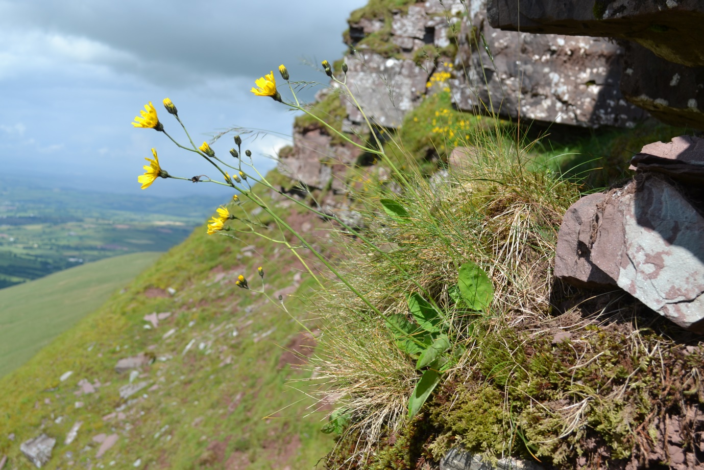
(Rich, 2015)

Contents

List of tables and figures – Page 2

Abstract – Page 3

Background – Pages 4-5

Literature Review – Pages 6-11

Research Methodology – Page 12

References – Pages 13-14

List of figures

Cover Image: Hieracium attenboroughianum - Attenborough’s Hawkweed (Rich, 2014) Available at: https://ntpressoffice.wordpress.com/2015/02/06/plant-hunters-new-discovery-named-after-sir-david-attenborough/
Figure 1: Trends in species grouped by ecosystem function (Oliver et al, 2015). Available at: https://media.nature.com/lw926/nature-assets/ncomms/2015/151208/ncomms10122/images/ncomms10122-f1.jpg
Figure 2: Net balance of species trends across ecosystem functions (Oliver et al, 2015). Available at: https://media.nature.com/lw926/nature-assets/ncomms/2015/151208/ncomms10122/images/ncomms10122-f2.jpg
Figure 3: Balance of declining species versus new arrivals grouped by ecosystem function (Oliver et al, 2015). Available at: https://www.nature.com/articles/ncomms10122
Figure 4: Number of established non-native species arriving through different pathways against date of first arrival (Roy et al, 2015). Available at: file:///C:/Users/lynne/Downloads/2012_-_NNSIP_Final_report.pdf
Figures 5 (a and b): Maps of Great Britain illustrating the spread of Fallopia japonica over the last century (BSBI, 2019). Available at: http://bsbi.org/maps?taxonid=2cd4p9h.vr0#style=N4IgDghgTgLglvA9gOwLLQNYFMoGUYCeANlgM4gBcA2qAGyWgAMlIAZnESQCYDGcUPEiAA0IAKwt2nLL36CsIAL6LhyAK6dVGogF1RyCAFsFFEIYIACUlhjxkAc3KKgA
Figure 6: Rhododendron growth from seedling to mature plant (Forestry Commision, no date). Available at: https://www.forestry.gov.uk/images/sunw_rho_g1.gif/$FILE/sunw_rho_g1.gif
Figure 7: Interactions among multiple drivers of honeybee loss (Potts et al, 2010). Available at: https://ars.els-cdn.com/content/image/1-s2.0-S0169534710000364-gr1b3.jpg
Figure 8: Mean ± SE abundance of (a) honeybees, (b) wild bees and (c) hoverflies observed visiting blueberry flowers during 15 min observational samples (Blauuw and Issacs, 2014).
Figure 9: GloNAF world map of naturilised species (GloNAF, 2018). Available at: https://glonaf.org/wp-content/uploads/Frontpage/Weltkarte-1-1024x540-1024x540.png
Figure 10: The Connection to Nature Index (CNI) (Hayhow et al, 2016). Available at: http://www.mammal.org.uk/wp-content/uploads/2016/09/State-of-Nature-UK-report_20-Sept.pdf

Abstract

Decline in wild flora of wales:
What can we do and why should we care?

The flora of Wales has changed considerably especially in the last century. Anthropogenic activity is the primary cause for this change, as well as key issues relating to changing trends in flora distribution. This report will look at individual threats to biodiversity and the decline in native flora. The environment and its interactions are all interlinked, but not fully understood.
Native plants support native wildlife, and are important habitats for pollinators. Security of pollinating species is vital in achieving food security, and for conservation of wildflowers. Invasive plant species have had a significant impact on our landscape, as well as biodiversity here. There are also economic and human health impacts, which will be addressed.
Diversity is key to resilience of an ecosystem. This research proposal is to identify barriers which may be relevant in this field preventing positive biodiversity in ecosystems. Is education lacking, do we need to provide more education and encourage youngsters from a young age. After all, with growing population they are the future of tomorrow, should we be implementing studies into the local environment at a young age, and will this help to install respect and knowledge of the environment.

Background
Although native plant species may be decreasing this does not necessarily mean the proportion of species providing a niche for a particular ecosystem is declining. There are offsets with new introduction aiding in carbon sequestrion and decomposition as can be seen in Figure 1 (Oliver et al, 2015).
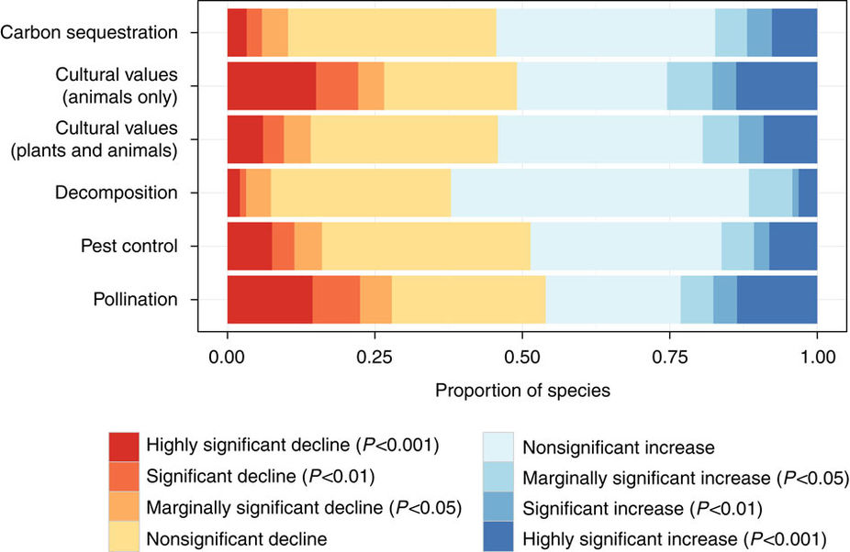
Figure 1: Trends in species grouped by ecosystem function (Oliver et al, 2015)

Figure 2 shows that ecosystem function for pollination had the most significant decline, followed by pest control in plants. Other functions were offset with increases in proportion of species.
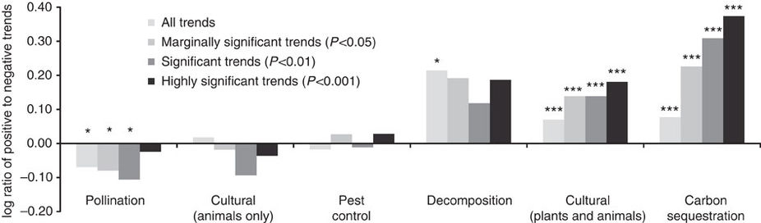
Figure 2: Net balance of species trends across ecosystem functions (Oliver et al, 2015)

Negative trends, and declines can be seen in pollination and pest control species in Figures 1, 2 and 3. However, there are positive trends for other group with carbon sequestration having the highest significant trend.
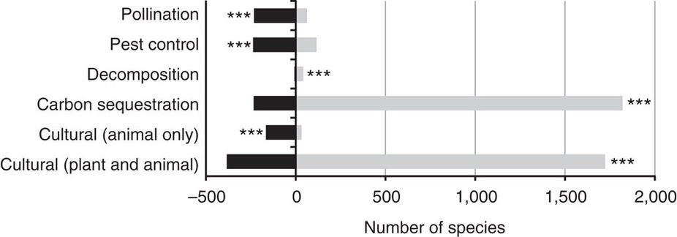
Figure 3: Balance of declining species versus new arrivals grouped by ecosystem function (Oliver et al, 2015)
The decline in biodiversity increases the risk of loss, especially when accompanied by increasing unpredictable weather events, or environmental constraints (Oliver et al, 2015). Another important reason in conservation of native plants, especially those utilised by other insects as a source of nectar, is to maintain a diverse genetic pool.
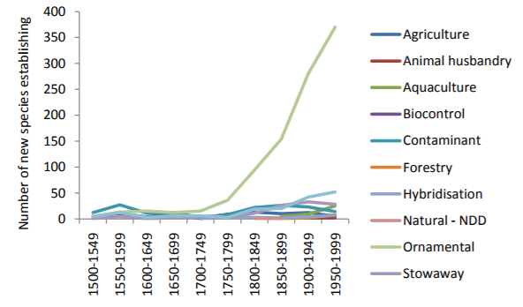
Figure 4: Number of established non-native species arriving through different pathways against date of first arrival (Roy et al, 2015)
Figure 4 clearly shows above that the vast majority of new species which have established in the UK have been imported for ornamental value (Roy et al, 2015). A sharp rise can be seen from 1800, when plant hunters and travel became more prevalent. There was also the development of a terrarium around this time which enabled the survival of many more plants than before.
21% of vascular plant species in Europe are classified as threatened, as reported by the World Conservation Union (European Communities, 2008). The main threats for the decline in plant diversity in Europe are:
- Habitat loss and degradation
- Introductions of invasive alien species
- Pollution and disease
- Climate change
Nitrogen disposition is another cause for concern, and more than 90% of the woodland in Britain is affected by atmospheric pollution, growing in altered conditions. (Plantlife, 2012).
The State of Wales Report 2016 highlights the change in biodiversity of plants. It highlights that pollinators and pest control species are the two main losses without having an increase to offset the balance in non-native species taking up the specific ecosystem function (Hayhow et al, 2016).

Literature review
The decline in our native flora, has a direct impact on our ecosystems, and our ability to achieve food security. This research proposal is to ascertain the main barriers to conservation of our native flora, the importance of biodiversity and to find out what can be done to protect our native flora.
Invasive plants
Many plants were introduced in the Victorian era when plant hunting along with travel was most rife. Many exotic plants were collected. An example of this is Japanese Knotweed (Fallopia japonica) which was written about by William Robinson a notable Irish horticulturist, who recommended planting it in clumps (Leapman, 2010). He would subsequently, in later editions of books note the spread of this ornamental ‘beauty’, and its difficulty to eradicate. Fallopia japonica was introduced from Japan early nineteenth century, for its ornamental value and for use as cattle fodder (Garden Organic, 2007).
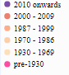
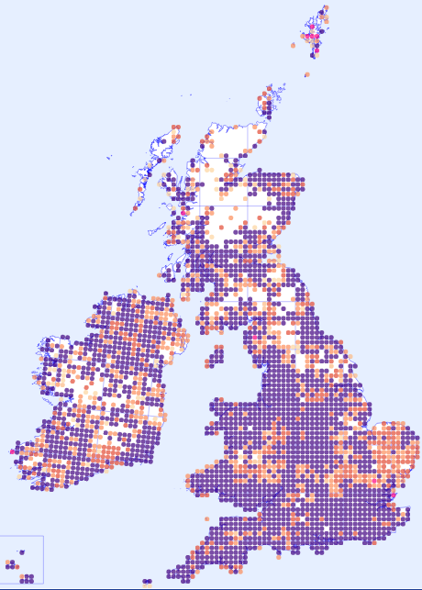
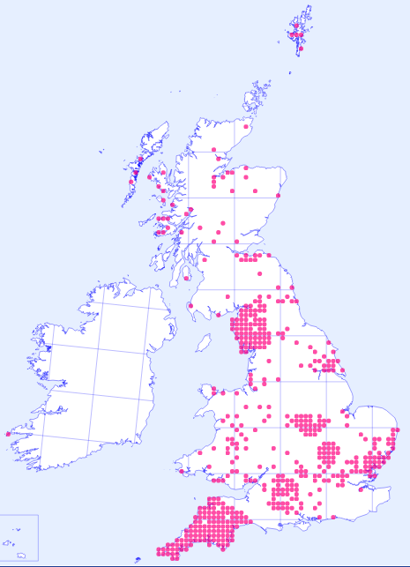

Figures 5: Maps of Great Britain illustrating the spread of Fallopia japonica over the last century (BSBI, 2019):
- Pre-1930 distribution b) All distribution Pre-1930 to 2010 onwards
These maps demonstrate the spread of this invasive non-native plant in Great Britain, which seems to show no signs of it slowing. In its native habitat of Japan, it is a pioneer species of volcanic larva (Garden Organic, 2007). It is kept in control by emissions of ash, along with natural enemies residing in its native habitat. Fallopia japonica is also classified as a controlled waste under the Environment protection act 1990 (Wilson, 2016).
Ways to eradicate Fallopia japonica including the use of glyphosate, mechanical removal and soil screening. More recently a natural enemy Aphalara itadori biological control. It has been introduced in pilot areas in England and Wales to help combat this problematic weed (CABI, 2018). Although the introduction of any non-native biological control will need to be monitored carefully to prevent it becoming a pest itself.
The economical cost of invasive non-native species in Wales has been estimated at a cost of 7 billion GBP to welsh government (Phlorum, 2014) so there is a clear need to set up provisions to help combat this problem which has shown no sign of slowing down in the last century.
Rhododendron ponticum is another invasive weed which is having many negative effects on our native plants. “It has been shown to reduce the numbers of earthworms, birds and plants and regenerative capacity of a site, leading to a reduction in the biodiversity of the area” (Forestry Commision, no date)
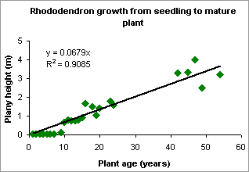
Figure 6: Rhododendron growth from seedling to mature plant (Forestry Commision, no date)
Figure 6 illustrates the size these plants can reach over time, almost 5 metres in 50 years. These mature plants smother ground cover plants, and act as seed sources for establishment of new plants. They also prevent the establishment of trees (Forestry Commision, no date).
Non-native plants have negative impacts not just on our environment, but also health and social impacts. An example of this is Giant Hogweed (Heracleum mantegazzianum) from South West Asia; It has phytotoxic sap which can damage human skin, making it a health hazard (Hill et al, 2011). Giant Hogweed is another Victorian import, recommended by William Robinson for its bold foliage, and was even used in planting at Buckingham Palace (Leapman, 2010).
Some invasive plants which were once thought to be okay living alongside our native ones are now taking over. They compete with native plants. The Great Britain Invasive Non-Native Species Strategy, first published in 2008. (GOV, 2015) and this includes in it Part 2, Schedule 9 of the Wildlife and Countryside Act 1981, listings non-native alien species (Welsh Government, 2017). The Conservation of Habitats and Species Regulations 2010 is another piece of EU legislation which aims to combat barriers in obtaining rich and diverse ecosystems.
Non-native species are also known to cause problems for road and railway networks. An example of this is Buddleja davidii, introduced as an ornamental plant in the late nineteenth century from China. It escaped from our gardens, and is now a common site along scrub land, railways, and can also cause structural damage. It is also quick to spread and was responsible for destruction of protected chalk grassland (Gupta, 2014).
However, Invasive plants have also had a positive effect, providing a food source for pollinators, an example of this is Himalayan Balsam (Himalayan Balsam Wales, no date)
Pollinators
This decline in both flora and pollinators and can pose a threat to food security with our growing population.
The loss in our native wildflowers has also been directly correlated with the loss of pollinating insects, such as bees. Pollinators are crucial for wild plant communities and agricultural productivity and their decline may have far reaching impacts including reducing the stability of an ecosystem, along with negative economic impacts and threats to human welfare. In the UK animal-pollinated plants have declined more than either wind pollinated and self-pollinating plant species (Potts et al, 2010). There are of course other factors to take into consideration such as environmental pressures, and pests and pathogens, which is illustrated by Potts et al in Figure 7 below.
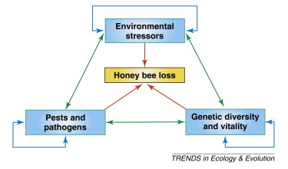
Figure 7. Interactions among multiple drivers of honeybee loss (Potts et al, 2010)
A study into the effects of creating wildflower plantings, and pollinating insects in crop production over four years determined that wild pollinating species had increased threefold over a four-year period, as can be seen in Figure 8 below (Blauuw and Issacs, 2014).

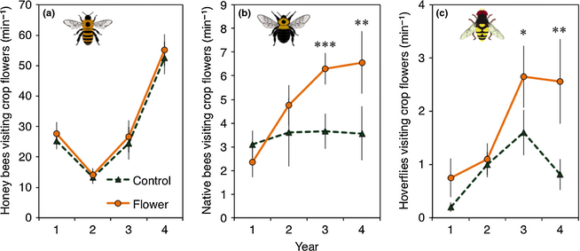
Figure 8: Mean ± SE abundance of (a) honeybees, (b) wild bees and (c) hoverflies observed visiting blueberry flowers during 15 min observational samples (Blauuw and Issacs, 2014).
Figure 8 on the previous page illustrates the time needed for establishment of plants before a positive impact may be witnessed. Attracting hoverflies also acts as a natural biological control for pests such as aphids also, which is a positive thing for agriculture here in Wales.
Nature reserves help to protect native species, by acting as barrier to invasive species, flora and fauna.
Climate change
Climate Change and anthropogenic activity (Burns et al, 2016)
Climate change is altering the distribution of certain plants, and their ability to cope with their changing environment is crucial to their conservation.
Climate change ecology is still relatively new, increases in temperature and carbon dioxide may be positive for plant life. However, climate change and the influence on species diversity is going to have broad ranges against taxon or plant species (Bellard et al, 2012).
Pesticides
The use of pesticides, especially during agricultural intensification has had a significant impact on native plants, as well as important pollinators. An example of which is the correlation between the use of neonicotinoids and honeybee colony losses, which are responsible for pollinating 90% of commercial crops in England and Wales. (Benjamin, 2015)
Legislation
In current political times, the loom of Brexit opens a chance to reform, or adopt different types of legislation currently used in the EU. The UK must develop their own policy to replace The Common Agricultural Policy, and there is call for development of a British Ecosystem Services Policy (Hodge, 2016).
UK Biodiversity Action Plan (UK BAP) was first drafted in 1994, acting on the Convention on Biological Diversity (CBD) at Rio de Janeiro in 1992. Biological resources were accounted, and plans were put in place for conservation of these resouces. These plains aim to contribute to preventing the decline of biodiversity (JNCC, 2015).
Government policy is also going to be important driver as the UK exits the EU. With current political uncertainty regarding legislations to be adopted or reformed by the EU could enable more specific and validated reasoning. Although across the EU, and globally it is still vital that we share information, and aid one another in addressing the global problem of biodiversity which currently exists.
Increased population will mean increased pressure on the environment and the need for food security. This should be done in a sustainable way to prevent further degradation of our already fragile ecosystem. Agriculture and food production are vital.

Global action
Global Naturalized Alien Flora (GloNAF) is a worldwide database which holds information on the distribution and naturalisation of non-native species. Europe has one of the highest numbers of non-native alien species which have naturalised (Pyšek et al, 2017).
“13,168 plant species, corresponding to 3.9% of the extant global vascular flora, or approximately the size of the native European flora, have become naturalized somewhere
on the globe as a result of human activity” (GloNAF, 2018).
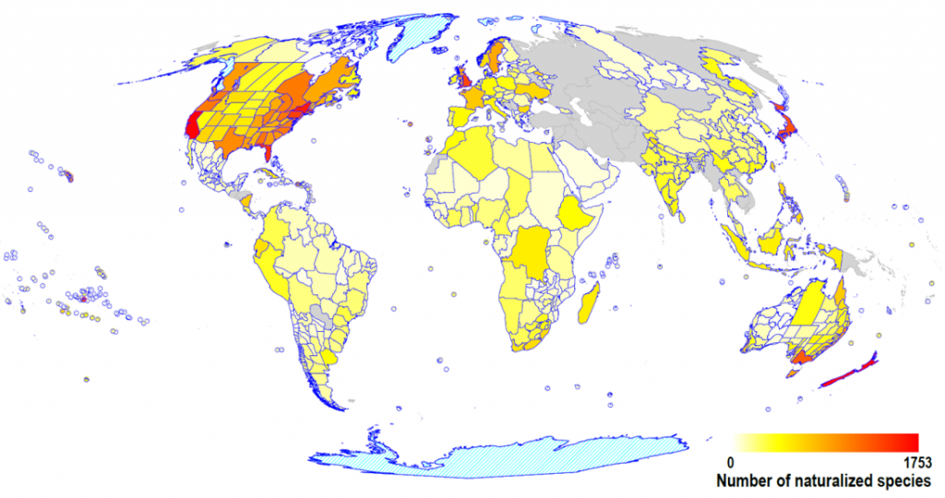
Figure 10: GloNAF world map of naturilised species (GloNAF, 2018)
This map shows the distribution of naturalised species, with red areas being those with the highest number of non-native alien species which have naturalised.
A recent report which expanded across five continents concluded that having a diverse range of plants at single locations and across landscapes could support highly functioning ecosystems, while the decrease in diversity, or monoculture is seen as having detrimental effects to ecosystems (Utrecht University, 2017).

Educational
Connection to nature is a study into how children are connected to nature, as can be seen in Figure 9.
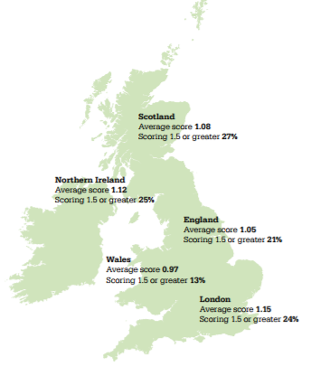
Figure 9: The Connection to Nature Index (CNI) (Hayhow et al, 2016).
From this map, it states that Wales has the poorest average score across the UK, 0.97. This is surprising considering the vast richness of nature and wilderness here in Wales. This map highlights a possible intervention which could be undertaken by new government policy, or by changes to the education syllabus for children in Wales. An outreach programme to help those most in need the connection to nature could be established here.
Fields of horticulture/environmental were seen to be taken up by those with little qualifications in the past and there had been a decrease in take up, although increased interest is aiming to engage and help record the changes in the flora here is wales.

Research Methodology:
Maps will enable the discovery of distribution of a wide range of plants, analysis can be made on the trends of change, and any patterns. Climate change may also have an impact on distribution of some species. Maps I will be accessing include from the Botanical Society of Britain and Ireland (BSBI), these are available for access online from BSBI.org (BSBI, 2018).
Biodiversity of native hedgerows, and the state on them in Wales has had increasing interest in recent years, partially as a result to establishing action plans to aid conservation as discussed before. The mapping of hedgerows if often done voluntarily and anyone can help (Imperial College London, 2016). This does bring up ethics in ensuring correct identification and sensitive gathering of information to form a database.
Mapping of species distribution across Wales is a time consuming and labourious task, often relying on many volunteers, such as Hedgerow Survey. The surveys today are a crucial aid in monitoring changes in distribution of native and non-native plants.
Journals which are available online and at the library will also form part of the research methodology with gathering in quantitative date to assess species richness and decline in Wales.
To understand from another perspective, I plan to interview some experts within the field; Including garden designers (possibly at the Cardiff RHS show) and lecturers. Qualiative information would be gathered, deriving on their field of expertise, and length of time in this field, and I would pose questions including: What they think are the main problems resulting in the decline of our native flora? are what they feel the barriers (if any) are to conservation of these fragile plants/ecosystems? I’d also like to find out their personal views on the state of nature here in Wales. I hope these interviews will help form a bigger picture, and suggest a variety of views as to what areas they feel need to be improved which could aim to combat decline in biodiversity of native plants; whether this being more research, increasing awareness or improving education or legislation.
There appears to be a lack of widespread knowledge regarding invasive plants. Could Better teaching knowledge into native/non-native invasive alien plants aid in the conservation of native plants, and species diversity. This will be addressed also.
Increasing awareness and through education can prevent injury from harmful weeds such as Giant Hogweed. Also, there should be a drive for removal of these damaging plants which are wind pollinated. These compete with our native plants, their large size taking up large areas, shading out light for ground cover plants. They may also have a negative impact by degradation the aesthetic appeal of a naturally beautiful area. Furthermore, people may be put off visiting these areas in case on injury, due to the dangers related with it.
Engaging youngsters could help to stimulate increased awareness and respect of the environment. This outreach was highlighted in the state of wales report, which reported Wales as having the least knowledge of nature by young children, this is something which could be addressed.
References
Bellard, C.; Bertelsmeier, C.; Keadkey, P.; Thiller, W. and Courchamp, F. (2012) Impacts of climate change on the future of biodiversity. Ecoll Lett. Available at: https://www.ncbi.nlm.nih.gov/pmc/articles/PMC3880584/ (Accessed on 5/1/18)
Benjamin, A. (2015) Pesticides linked to bee decline for first time in a countrywide field study. The Guardian. Available at: https://www.theguardian.com/environment/2015/aug/20/pesticides-neonicotinoids-linked-bee-decline-first-time-large-scale-field-study (Accessed on 5/1/18)
Blaauw, B. R. and Isaacs, R. (2014) Flower plantings increase wild bee abundance and the pollination services provided to a pollination-dependent crop. J Appl Ecol, 51: 890–898. doi:10.1111/1365-2664.12257. Available at: http://onlinelibrary.wiley.com/doi/10.1111/1365-2664.12257/full (Accessed on 6/1/18)
BSBI (2018) Distribution data – Fallopia japonica. Available at: http://bsbi.org/maps?taxonid=2cd4p9h.vr0#style=N4IgDghgTgLglvA9gOwLLQNYFMoGUYCeANlgM4gBcA2qAGyWgAMlIAZnESQCYDGcUPEiAA0IAKwt2nLL36CsIAL6LhyAK6dVGogF1RyCAFsFFEIYIACUlhjxkAc3KKgA (Accessed on 30/12/17)
Burns, F.; Eaton, M.A.; Barlow, K.E.; Beckmann, B.C.; Brereton, T.; Brooks, D.R.; Brown, P.M.J.; Fulaij, N.A.; Gent, T.; Henderson, I.; Noble, D.G.; Parsons, M.; Powney, G.D.; Roy, H.E.; Stroh, P.; Walker, K.; Wilkinson, J.W.; Wotton, S.R.; Gregory, R.D (2016) Agricultural Management and Climatic Change Are the Major Drivers of Biodiversity Change in the UK. PLoS ONE 11(3): e0151595. Available at: http://journals.plos.org/plosone/article?id=10.1371/journal.pone.0151595 (Accessed on 7/1/18)
CABI (2018) Establishing the psyllid: field studies for the biological control of Japanese knotweed. Available at: https://www.cabi.org/projects/project/32999/ (Accessed on 4/1/18)
European Communities (2008) LIFE and endangered plants Conserving Europe’s threatened flora. Office for Official Publications of the European Communities: Luxembourg. Available at: http://ec.europa.eu/environment/life/publications/lifepublications/lifefocus/documents/plants.pdf (Accessed on 7/1/18)
Forestry Commission (no date) Rhododendron Control. Crown. Available at: https://www.forestry.gov.uk/fr/rhododendroncontrol (Accessed on 5/1/18)
Garden Organic (2007) Japanese knotweed. Available at: https://www.gardenorganic.org.uk/weeds/japanese-knotweed (Accessed on 6/1/18)
GloNAF (2018) Global Naturalized Alien Flora. Available at: https://glonaf.org/ (Accessed on 7/1/18)
GOV (2015) The Great Britain Invasive Non-native Species Strategy. August 2015. Available at: https://www.gov.uk/government/uploads/system/uploads/attachment_data/file/455526/gb-non-native-species-strategy-pb14324.pdf (Accessed on 5/1/18)
Gupta, T (2014) Buddleia: The plant that dominates Britain's railways. BBC News. Available at: http://www.bbc.co.uk/news/magazine-28196221 (Accessed on 4/1/18)
Hayhow, D.B et al (2016) State of Nature 2016. The State of Nature partnership. Available at: http://www.mammal.org.uk/wp-content/uploads/2016/09/State-of-Nature-UK-report_20-Sept.pdf (Accessed on 4/1/18)
Hill, M., Pergl, J., and Perglova, I. (2011) Giant Hogweed, Heracleum mantegazzianum. Available at: http://www.nonnativespecies.org/factsheet/downloadFactsheet.cfm?speciesId=1705 (Accessed on 30/12/17)
Himalayan balsam Wales (no date) What about the bees?! Available at: http://himalayanbalsamwales.co.uk/himalayan-balsam/what-about-the-bees/ (Accessed on 30/12/17)
Hodge, I. (2016) Towards a British Ecosystem Services Policy. Contributed Paper prepared for presentation at the 90th Annual Conference of the Agricultural Economics Society, Royal Dublin Society, Dublin, Ireland 24-26 April 2017. Available at: http://www.aes.ac.uk/upload_area/member_documents/Ian%20_Hodge_Hodge%20Towards%20a%20BESP%2024-3-17.pdf (Accessed on 7/1/18)
Imperial College London (2016) OPAL Biodiversity Survey. Available at: https://www.opalexplorenature.org/biodiversitysurvey (Accessed on 30/12/17)
JNCC (2015) The UK Biodiversity Action Plan (UK BAP) 1992–2012. Available at: http://jncc.defra.gov.uk/page-5155 (Accessed on 5/1/18)
Leapman, M. (2010) Japanese knotweed in Cornwall: Victorian gardeners loved the tall, leafy newcomer but now it is recognised as the most invasive and damaging weed in the country. The Telegraph. UK. Available at: http://www.telegraph.co.uk/gardening/7410934/Japanese-Knotweed-curse-of-the-alien-species.html (Accessed on 4/1/18)
Oliver, T.H., Isaac N.J.B, August, T.A,, Woodcock, B.A., Roy, D.B. and Bullock, J.M. (2015) Declining resilience of ecosystem functions under biodiversity loss. Nature Communications 6, Article number: 10122. Available at: https://www.nature.com/articles/ncomms10122 (Accessed on 5/1/18)
Phlorum (2014) Japanese Knotweed and other Invasives Cost Welsh Government £7 Billion. Available at: http://www.phlorum.com/blog/2014/01/13/japanese-knotweed-invasive-non-native-species-welsh-government/ (Accessed on 30/12/17)
Plantlife (2012) Forestry Recommissioned: Revitalising the woodlands of Wales. Plantlife: Salisbury. Available at: https://www.plantlife.org.uk/application/files/7714/8155/8104/W_WR_Web.pdf (Accessed on 5/1/18)
Potts, S.G, Biesmeijer, J.C, Kremen, C., Neumann, P., Schweiger, O., Kunin, E. (2010) Global pollinator declines: trends, impacts and drivers. Trends in Ecology & Evolution: Elsevier. Available at: https://www.sciencedirect.com/science/article/pii/S0169534710000364#fig2 (Accessed on 4/1/18)
Pyšek P., Pergl J., Essl F., Lenzner B., Dawson W., Kreft H., Weigelt P., Winter M., Kartesz J., Nishino M., Antonova L. A., Barcelona J. F., Cabezas F. J., Cárdenas D., Cárdenas-Toro J., Castańo N., Chacón E., Chatelain C., Dullinger S., Ebel A. L., Figueiredo E., Fuentes N., Genovesi P., Groom Q. J., Henderson L., Inderjit, Kupriyanov A., Masciadri S., Maurel N., Meerman J., Morozova O., Moser D., Nickrent D., Nowak P. M., Pagad S., Patzelt A., Pelser P. B., Seebens H., Shu W., Thomas J., Velayos M., Weber E., Wieringa J. J., Baptiste M. P. & van Kleunen M. (2017) Naturalized alien flora of the world: species diversity, taxonomic and phylogenetic patterns, geographic distribution and global hotspots of plant invasion. Preslia 89: 203–274. Available at: http://www.preslia.cz/P173Pysek.pdf (Accessed on 7/1/18)
Roy, E.H et al (2015) Non-Native Species in Great Britain: establishment, detection and reporting to inform effective decision making. Available at: file:///C:/Users/lynne/Downloads/2012_-_NNSIP_Final_report.pdf (Accessed on 7/1/18)
Utrecht University (2017) Scientists used data from fifteen different countries on five continents. Nature publication: 'Plant diversity is crucial for successful ecosystem'. Available at: https://www.uu.nl/en/news/nature-publication-plant-diversity-is-crucial-for-successful-ecosystem (Accessed on 5/1/18)
Welsh Government (2017) Code of Practice for Species Control Provisions in Wales: How Species Control Agreements and Species Control Orders should be applied in Wales. Available to download at: http://www.nonnativespecies.org/index.cfm?pageid=67 (Accessed on 4/1/18)
Wilson, M. (2016) Japanese knotweed: the global menace — and a possible solution. Financial Times Limited. Available at: https://www.ft.com/content/e1b7d4ea-e61a-11e5-a09b-1f8b0d268c39 (Accessed on 5/1/18)

