Author: | Charles Gill | Student Number: | 0250767
Module: | Database and Application Development | Programme: | BSc (Hons) Software Engineering
Reference: | ACCA5026 (pt2) | Lecturer: | Divya Chidambaram
Date: | 08/01/24

Design and Implementation of a Centralised Relational Database System for MelodyHwb

Contents
Section 1. Overview 3
1.1 General 3
1.2 Purpose 3
1.3 Report Sections 3
1.4 Definitions 3
Section 2. Main body 4
2.1 Subsection 1 4
2.1.1 Sub-sub section 4
2.1.2 Sub-sub section 4
2.1.3 Sub-sub section 4
2.2 Subsection 2 4
2.2.1 Sub sub section 4
2.2.2 Sub sub section 4
2.2.3 Results 4
2.3 Subsection 3 4
2.4 Subsection 4 5
Section 3. Other Functions within Code 6
References 7
Section 4. Appendix 8

Overview

General
To implement a centralized relational database and associated IT systems, MelodyHwb aiming to streamline their operations, enhance customer satisfaction, and establish themselves as a leading music store. This document proposes a solution to enable effective inventory management, efficient sales and order processing, personalized customer interactions, seamless service scheduling, and data-driven decision-making.

Purpose
This document provides a design for a Microsoft SQL Server database (using SQL statements) that implements the backend database system for MelodyHwb.
  - It provides examples of a suitable schema design following relational database rules.
  - The database’s realistic records entered using Insert statements. The data entered should be used to test the functionality of the primary key, foreign key, and check constraints.
  - Code to test transaction rollback and commit operations by creating a transaction to handle the action(s) needed to process a customer order and update inventory levels in a single transaction.

Report Sections
Section 2 point …:
- Contains the database schema
- The table descriptions
- SQL code for entering and testing primary keys foreign keys and checking constraints.

Definitions

Main body

Database schema
The initial schema for the database is provided below:
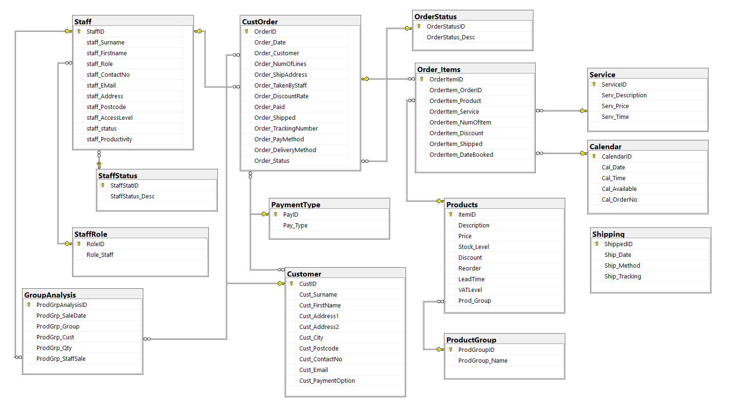

SQL code for the database
The SQL code to create the database is included as a zip file containing all the commands to create the database and the tables without data. This is provided alongside this document.

The tables

Customer
The Customer table contains their name, address and contact details. Their email address is included for advertising purposes.
Another field included is payment type, which allows for auto-population for future purchases.
Another field that could be implemented would be one for social media details.
Another field that could be implemented is a descriptor of their purchasing history, encoded in some form.
Note: This has not been implemented in this version, as there is a table named group analysis that contains an overall sales group record which can be polled easily and that includes the customer ID so that if a product range has a sales drive then this table will include customers who have bought from this range. See GroupAnalysis table below.

Staff
The staff table again includes Staff name, address, contact details but also records an access level (for future use), Role, status and productivity.
The Role field could ultimately be used for access rights to different parts of the overall system, and possibly linked to salaries.
The status would be used for when staff leave or are on a break but helps retain database integrity when staff leave, as the account can just be marked as disabled. See Staff Status table below.
Productivity could be a simple count of transactions or other work performed within the system. However, it may have to be recorded by time also to provide better metrics. It is only included here as a placeholder for such a feature.

StaffStatus
A simple table that just contains the status of the staff member. Active, Disabled, suspended or parental leave are types included.

StaffRole
Another simple table that describes the staff’s role within the business. Designed to ultimately be used for controlled access to the system. Manager, Supervisor, Technician, Sales and Admin are examples of entries included initially.

CustOrder
This table can be imagined as the header to an invoice, it includes fields for Custoimer number and OrderDate, which are self explanatory. It also includes No of lines, which details the number of products purchased. These lines are then recorded in a separate table which indexes back to this table.
There are also fields for whether a discount has been applied to the order overall, and Boolean fields for paid or shipped. Another field includes the option to record any shipping tracking codes.
Payment method and shipping method is also recorded and an order status field. The order status links to another table (OrderStatus) that is described below.

OrderItems
This table lists the products bought against a particular order and indexes back to the CustOrder table. This table also indexes back to the Products table mentioned below and the Service table. This allows Service or repair work to be performed as the product or the service fields can be null.
Other fields include No of items ( for multiple purchases of one item), shipped, which is to allow a provision for where one item in an order has been shipped (or provided at store) but other items may not have been shipped.
There is also a field for date-booked, which would be taken from the Calendar table (see below) that holds any bookings for the technicians to service or repair instruments.

OrderStatus
A simple table that describes the status of the order. Examples would be Pending, Shipped, Part Shipped, Paid, Complete or Cancelled.

Products
The products table contains information about products that MelodyHwb can provide. There is a description, price, VAT rate as a basic set of fields.
The stock level, reorder and lead time fields are used toward the stock control system where any order transactions can simply reduce the stock quantity.
As a future enhancement there should be a supplier field (linked to a supplier table) which could then auto-generate the order from the supplier. Ultimately, the re-order level could be auto-adjusted by the system depending on the supplier, lead time and current sales. It would initially ne manually controlled until an amount of data has been passed through the system to base this auto feature.
The product Group field is there to link to the ProductGroup table that contains genres of products. This is the starting point of breaking sales down into areas. This helps the business to understand where their main business is or where they need to promote further. This is then linked to the Group Analysis table that provides counts of groups being sold and to who.

ProductGroup
A simple table that describes the group that a product belongs to. Examples are Strings, Brass, woodwind, Service and repair. How this is used is described above.

GroupAnalysis
This table is one method for gaining an insight into the areas of the business that are selling. It does this by recording a list of Product groups sold alongside Date Customer and Staff. This means that sales of groups can be set against a date range for predicting sales trends, customers so that advertising can be tailored and Staff so that metrics can be gleaned about their areas of expertise.

Service
Another simple table that describes the services that MelodyHwb provide.

Calendar
This table has been implemented in a way where all the timeslots are kept in the table and then when a date is booked, it is marked as used. The actual date for the customer is recorded in the item list, but the Calendar records the Order number to index back to the order that has booked the slot and thereby the customer.

SQL code

Create Tables
After creating the database with
CREATE DATABASE [MelodyHwb]
CONTAINMENT = NONE

The tables were created with
CREATE TABLE [dbo].[Customer](
[CustID] [int] NOT NULL,
[Cust_Surname] [varchar](50) NOT NULL,
[Cust_FirstName] [varchar](50) NOT NULL,
[Cust_Address1] [varchar](50) NOT NULL,
[Cust_Address2] [varchar](50) NULL,
[Cust_City] [varchar](50) NOT NULL,
[Cust_Postcode] [varchar](50) NULL,
[Cust_ContactNo] [varchar](50) NULL,
[Cust_Email] [varchar](50) NULL,
[Cust_PaymentOption] [int] NOT NULL,

Insert records
To Insert records
INSERT INTO MelodyHwb.dbo.Customer (ID, c1) VALUES (“Smethington”, “Samantha”, “15 High St”,,”Selseyville”,”SE12 1AB”,”01234 567890”,SamSmeth@anemail.com,1);

Create Primary keys
Create primary Key
CONSTRAINT [PK_Customer] PRIMARY KEY CLUSTERED

Create Foreign keys
An example of creating a foreign key is found below:
alter table Order_Items
add constraint FK_OrderService
foreign key (OrderItem_Service)
references Service(ServiceID);
This alters the Order_Items table to constrain the Service field of that table to the contents of the Service table using the ServiceID field. Therefore, the OrderItem_Service field has to be of the same type (int) as the primary key of the table it is linking to – Table Service – Field ServiceID.

Rollback and commit
Code to check rollback and commit follows:
SELECT * from Customer
DECLARE @CustCount int
BEGIN transaction addCust
INSERT INTO Customer VALUES (“Smethington”, “Samantha”, “15 High St”,,”Selseyville”,”SE12 1AB”,”01234 567890”,”SamSmeth@anemail.com”,1)
SELECT @CustCount=COUNT(*)FROM Customer WHERE email='SamSmeth@anemail.com'
IF @CustCount>1
BEGIN
ROLLBACK transaction addCust
PRINT 'A Customer with that name already exists'
END
ELSE
BEGIN
COMMIT transaction addCust
PRINT 'New Customer added successfully'
END

SELECT * FROM books

References
There are no sources in the current document.

