My Podcast Pitch



Hi my name is Kerris and I am the founder of Your IVF Journey where I will be delivering podcasts to your ears.

Infertility is something which is not spoke enough and most importantly not spoken about out loud, leaving not only woman but men to feel very alone. The NHS believed that 1 in 7 couples suffer with infertility, compared to about 84% of couples that have regular sex unprotected and will naturally conceive (National Health Service, 2020).

This podcast is for anyone suffering with fertility so that they dont feel alone. Studies have found that ladies that suffer with infertility turn to online support for comfort due to feeling stigmatised and embarrassed. Women tend to turn to journals of other woman stories and discussion boards. to find common explanations and peace of mind. By exchanging advise and positive thoughts with one another can keep a positive state of mind (Billett and Sawyer, 2019, pp.28-85).

I have been battering with infertility for 13 years and can honestly say I have been silent about my story for last 10 years. For that reason I want to introduce a weekly podcast, for woman to voice their stories and have the comfort of hearing other woman stories, so that they no longer feel alone. I will be leading the podcast speaking to other woman and men that have battled with infertility also discussing their individual experiences.

Episode 1
I will be telling my story of infertility and how it has impacted mine and my partners life. I will be bringing a special guest who has also been though infertility and her success story after numerous tests, miscarriages and failed IVF treatments. Then I will finish the episode telling the listeners about the amazing saving scheme.
Episode 2
This podcast will be a discussion of all the facts about infertility and treatments. I will be pointing out the low success rate of IVF in the UK, despite 27,918 couples underwent fertility treatment in 2010 (Goundry, Finlay and Llewellyn, 2013, p.1). The following will be discussed:
- What's causes infertility? Goundry, Finlay and Llewellyn did a study in 2013 and found that young people need a better understanding of the consequences of not curing untreated sexually transmitted infections and how it can lead to infertility. Now this didn’t surprise me one at all because this is exactly the reason why I am dealing with infertility now. Young people would benefit from more education in order to improve their understanding of the long-term consequences of untreated STIs, which leads to infertility.

The podcast will conduct of 4 episodes delivered on a weekly basis for the first season and hopefully there will be a second season if this season goes well.
The podcast will be aired on YouTube and the money that I will raised by the views will be donated to woman who are struggling to fund their IVF. On the podcast I will be organising a saving scheme where people can pay a monthly payment and will take it in turn to have a pay-out to go towards their IVF treatment. This will help those that cannot afford pay for their treatment straightway. Particpants can take turns of having their pay out every month. This will be discussed in the first episode.


- Facts about IVF treatment in the UK and how IVF treatments have dropped due woman being forced to go private, which is not cheap, because of the long waiting lists. The fact that the NHS only allow a certain amount of IVF treatments at any one given time and there is a restriction to how may free treatments your allowed. Also, depending on where in the country will determine how quick you can get your treatment (Reproductive Health Matters,1999, p.156) Which is insane! What happen to equal rights?

Episode 3
This podcast is all about men and how they deal with infertility and being in a relationship dealing with infertility. 50% of couples in the UK has infertility issues due to men in the relationship (Agarwal et al., 2021).


Episode 4
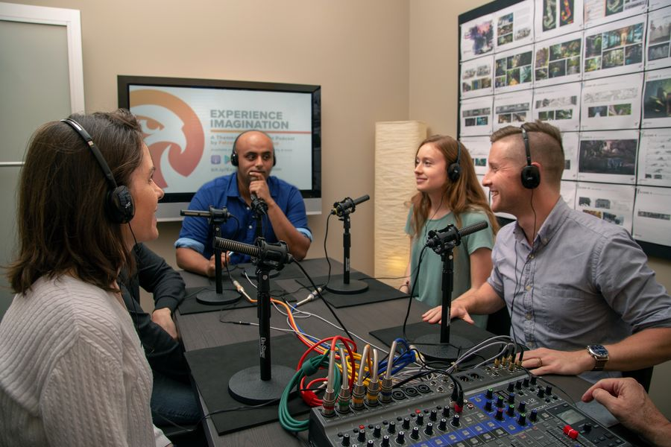
Here is a chance for the listeners to interact and ask me my two female's friends and my two male friends any questions and concerns they may have via a live telephone call which will be aired. Allowing the audience to tell the stories and share any advice they have learned in this hard journey we have all faced.
.

Page Break

Reference
- Agarwal, A., Baskaran, S., Parekh, N., Cho, C., Henkel, R., Vij, S., Arafa, M., Panner Selvam, M. and Shah, R. (2021). Male infertility. The Lancet, 397(10271), pp.319
- Billett, P. and Sawyer, A. (2019). Infertility and Intimacy in an Online Community. London: Palgrave Macmillan UK, pp.28 85.
- Goundry, A., Finlay, E. and Llewellyn, C. (2013). ‘Talking about links between sexually transmitted infections and infertility with college and university students from SE England, UK: a qualitative study’. Reproductive Health, 10(1), p.1. Available at: <https://reproductive-health-journal.biomedcentral.com/track/pdf/10.1186/1742-4755-10-47.pdf> (Accessed 15 November 2021).
- National Health Service (2020) Infertility. Available at: Infertility - NHS (www.nhs.uk) (Accessed: 09 November 2021).
- Reproductive Health Matters. (1999) ‘Unequal access to infertility treatment: UK’. 7(13), p.156. Available at: https://www-jstor-org.ezproxy.uwtsd.ac.uk/stable/3775723?sid=primo&seq=1#metadata_info_tab_contents. (Accessed 30 November 2021).

