Accounting Fundamentals
Exam

Student: Dimitar Gadov
Student Number: 1913486
Tutor’s Name: Widin Bongasu Sha’ven
Module: Accounting Fundamentals
Module Number: LCBB4001
2021

“In submitting this work, I affirm that my work adheres to the scholarly and intellectual standards of honesty and integrity. I affirm that this work is my work only and that in the preparation of this work I have not consulted any person. I affirm that I have not plagiarised or misrepresented the ideas or language of someone else as my own and that I have fully and accurately attributed any ideas or text of others to the sources and documented each source”.
Question 1
a)
Break Even point= Fixed costs / Contribution per unit
Contribution per unit= Selling price – Variable cost
Contribution per unit = £11- £6 = £5
Break Even Point in units = 350,000/5 = 70,000 units
Break Even point revenue = Fixed cost/ Contribution margin
Contribution margin = Contribution per unit / Selling price
Break Even point in revenue = 350,000/ (5/11) = £770,000

b)
Target sales in units = (Fixed costs + Target profit) / Contribution per unit
Expected Profit = (75,000 – 70,000) x 5 = £25,000

c)
New selling price = £13
New variable costs = £7 (£6 + £1)
New contribution = £13 - £7 = £6
New fixed costs - £350,000 + £10,000 = £360,000
New sales – 80,000 units
New Break-even point = 360,000 / 6 = 60,000 units
New Break-even point revenue = 360,000 / (6/11) = £660,000
New Expected Profit = (80,000 – 60,000) x 6 = £120,000

d)
The break-even analysis is used since 19th century and till now it has been enlarged, modified and upgraded in order to decrease or precise its limitations and make it adjustable to the business solutions. The concept of that method is not including only the mathematical result and formulas, but its essence is a “continual way of thinking”, which people in an organization are using to resolve different problems inside it. (Cafferky, 2010, p.1)
Practically, the breakeven analysis gives information what should be the lowest level of sales, which the firm has to secure to prevent loss and be beneficial. It is based on classified producing cost between fixed and variable cost of the company. (Tsorakidis, 2008, p.5)
This evaluation method is very easy to use and understand, good for making strategic decisions and widely spread over the business world. However, it has its limitations. First of all, there are only two types of costs- variable and fixed, but in reality some of product expenses may be neither. In that case we cannot calculate the break-even point. Another weakness is that the analysis can be used only for a short period of time, because it is not including important parts, such as: increasing return, law of margin utility or diminishing, which are directly related to the price of the product and estimation of fixed and variable costs. Also it presumes that the final price of a product is constant, which is not practically true and doesn’t take under consideration the changes on the market field. Furthermore, it supposes that all the fabricated products have been sold and in fact, it does not consider the inventory. As a sum, break even analysis shows static and limited view of point as connection between cost, earnings and volume. (Shrotriya, 2019)

Question 2
a)
Management accounting helps decision taking in a company by supplying managers with applicable data and materials, also evaluation of the costs, advantages and disadvantages, and the accomplishment as a whole. It focuses on financial information, such as: monetary information, cost-related issues and other; and non-financial information like: planned security aims and further updates or workers’ relationships. (Tappura, 2015)
According to Chartered Institute of Management Accountants (CIMA), the management accounting is a sum of recognition, collection, evaluation, composition, explanation and presenting of data, which is used by administration to organize, assess and manage to guarantee relevant operation. It also incorporates financial statement for shareholders as creditors, debtors, governmental and customs authorities. (Dyson, 2010, p.9)
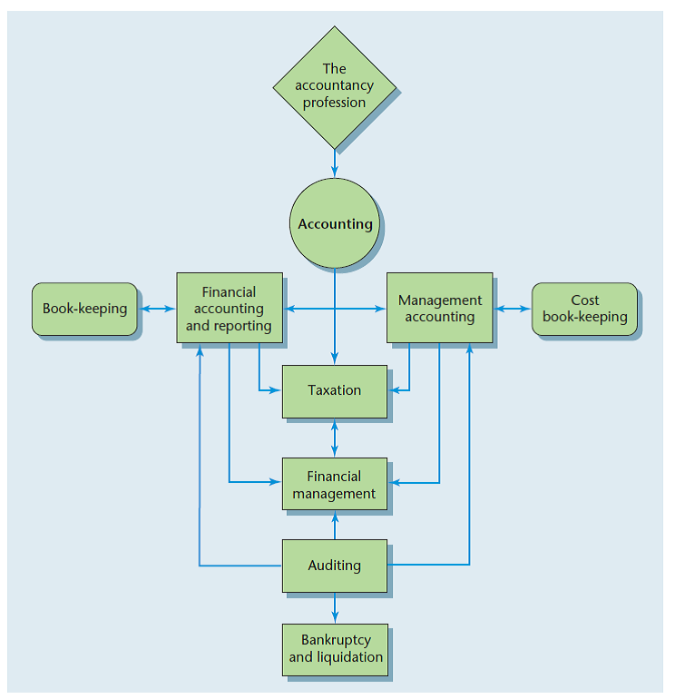
Source: RTS | College Group Online, (2019), The main branches of accounting
Management accounting(MA) is very important because its use is widely spread- even junior managers should know how to report and receive information regarding departmental performance, for example. The main purpose of that type of accounting is to provide data for use inside the organization. (Dyson, 2010, p.271)
However, it is very similar to financial accounting, but with some differences. First of all, MA’s data is used within the institution- it is private and it is non-monetary - it cannot be transferred financially. Other main differences are that management accounting is including as quantitative, as qualitative data, detailed information and financial and non-financial data. Also there is no mandatory professional obligation encasing that accounting. Furthermore, both past and planned data are comprehended in the MA, but mainly is forward looking and help planning the future of the entity. (Dyson,2010, p.272)
Management accounting is the integral part of the administration. It includes recognition, creation, presentation, explanation and application of the necessary information. (Dyson,2010, p.9) Main functions of MA, according to Dyson, are:

Strategic planning is not the main purpose of MA, but collecting and performing data, needed for the team. Control imply what was happened and what actions were taken in order to perform the plan. The cost accounting includes sum of organization’s occurring cost and revenue, their documentation and balance in double-entry system and dealing with the information. Decision making is one of the main purpose of management accounting, but the managers themselves should take that decisions, which depends of many factors. An aim of financial management is to discover the finances needed for organizing specifications of the company. Auditing requires inspection and authentication of accounting figures and statements. (Dyson, 2010, pp.274-278)
Financial Accounting is the procedure of recognizing, estimating and communicating financial facts of the organization to authorize perception and decision making. General purpose of financial accounting is to meet the interests for all stakeholders in the institution, such as: owners, employees, investors, suppliers, customers, governmental agencies and so on; collect financial information and show it in specific reports. These statements are well regulated by law, but not so detailed as these in management accounting and also are not private, but public. Also financial reports are made on annual basis for past period of time and into fiscal terms. (Weetman, 2013, p.6-18)

b)
The idea of management accounting is gathering and introducing business fiscal information, which is helping for decision-making procedure. It allows companies to personalize methods for their own best use. (Jaf, 2015)
Management accounting has various of techniques, which can help to a manager in the process of decision-making.
Break-even point analysis represents that point whether there is no profit and no loss for the company. It is important for the business because it can be found a point where from the benefit begin. It ca be calculated very easily even by junior manager and shows correlation between volume, cost and profit for a particular action. (Atrill, 2018, pp257-260)
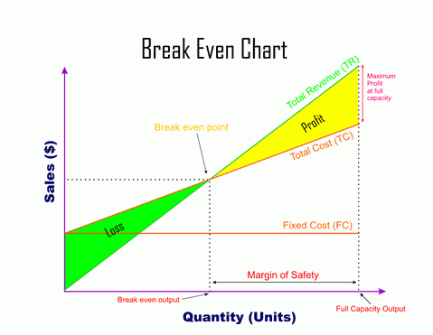
Source: DineshBakshi, (2021) “Breakeven Charts”

Budgeting is another method of management accounting. Budgets and their determination are very important for administration in order to run the business in the right way. They are integral section of planning structure, controlling and auditing operation. To expand the strategy, budgeting includes five actions: initiate mission and objectives; create a position analysis; recognize and evaluate strategic options; choose the right alternative and prepare a plan; perform, review and do a control. (Atrill,2019 , pp327-328)
Capital investment appraisal includes making funding in something, which brings financial value at some point in time. It is very important for the business as earn huge amount of assets. Investments are specific, expensive to be stopped and take long time to be obtained. There are few techniques, used by managers to assess investment chances: payback period, accounting rate of return, net present value and internal rate of return. However, all of methods have their advantages and disadvantages and every company choose normally one of them for their evaluation. (Atrill,2018, pp.367-370)

Reference:
Cafferky M., Wentworth J., (2010) “Breakeven Analysis: The Definitive Guide to Cost-Volume Profit Analysis”, 1st edition, New York: Business Expert Press
Tsorakidis N., et al (2008) “Break Even Analysis”, 1st edition BusinessSumup, available at: https://books.google.bg/books?hl=en&lr=&id=QYGq6Sy17pgC&oi=fnd&pg=PA5&dq=Tsorakidis+N,+Papadoulos+S,+Zerres+M,+Zerres+C+(2008)+Break-even+analysis.+BusinessSumup.&ots=DM0m2KC-l-&sig=MHdDdwYjVz5Tn3QBahwVMjJtXf8&redir_esc=y#v=onepage&q&f=false
Shrotriya V., (2019) “Break Even Analysis: The Concept and its utility”, International Journal of Research and Analytical Reviews (IJRAR), Volume 6, Issue 1, p.73
Tappura S., et al (2015) “A management accounting perspective on safety”, Safety Science, Volume 71, part B, pp 151-159, doi.org/10.1016/j.ssci.2014.01.011
Dyson J., (2010) “Accounting for non-accounting students”, 8th edition, Pearson Prentice Hall
RTS | College Group Online, (2019), The main branches of accounting [Photo], available at: https://rtse.yolasite.com/introduction-to-accounting.php
Weetman P., (2013) “Financial Accounting”, 6th edition, Pearson Education
Jaf S., et al (2015) “Impact of Management Accounting Techniques on Achieve Competitive Advantage”, Vol.6, No.4 , pp. 84-98
DineshBakshi (2021), “Breakeven Charts”, [Photo], available at: https://www.dineshbakshi.com/igcse-business-studies/operations-management/revision-notes/440-break-even-charts
Atrill P., (2018) “Accounting and finance for non-specialists”, 11th edition, Pearson Education Limited

