Leadership and the Individual

UWTSD MSc Policing (Operational and Strategic Leadership)

Submitted by: Jason James UWTSD 2015818

Module: BMPO7005 Leadership and the Individual

Assignment Title: Leadership Reflection

Submission Deadline: 3 May 2022

Word Count: 5268

Number of Pages: 25

Task: Provide a 5,000-word reflective review of your personal leadership successes and/or personal challenges. This reflective review can be about leadership situations that you have been a part of that impacted individuals under your influence.

“This is to certify that the work I am submitting is my own. All external references
and sources are clearly acknowledged and identified within the contents. I am aware
of the UWTSD regulation concerning plagiarism and collusion. No substantial part(s)
of the work submitted here has also been submitted by me in other assessments for
accredited courses of study, and I acknowledge that if this has been done an
appropriate reduction in the mark I might otherwise have received will be made”.

- Description

This paper on Leadership and the Individual attempts to highlight the multitude of leadership challenges that confront operational police commanders in the ever-evolving complex public order, public safety environment. It will follow the Gibbs Reflective Cycle to give a structure and a well-versed framework to recall the experience and systematically examine the leadership aspects and behaviours encountered.

Description of the experience
Feelings and thoughts about the experience
Evaluation of the experience, both good and bad
Analysis to make sense of the situation
Conclusion about what you learned and what you could have done differently
Action plan for how you would deal with similar situations in the future, or general changes you might find appropriate.
(Gibbs, 1988)

The focus of the paper will be a personal reflective examination on the leadership role of the public order commanders in what developed to be a highly controversial event and widely reviewed set of command decisions. The event in question was an international football match between Wales and England to be played at the Principality Stadium, Cardiff. The bitter sporting rivalry between the two nations was magnified in this UEFA European Football Championship qualifier that could ultimately result in qualification for the elite tournament. The complexities of this fixture were more than a simple sporting rivalry between two competitive sporting nations, there were recent inter club rivalries that had culminated in large scale violence and disorder resulting in sections of each nations supporters having to be robustly managed to prevent elements of each attacking one another.

In order to effectively command and control events of this magnitude the police service has for some time adopted the joint emergency services Gold, Silver, Bronze (GSB) hierarchical structure of command that broadly follows the strategic (gold), tactical (silver), operational (bronze) framework. Due to the high profile and significance of the fixture the force appointed Assistant Chief Constable S to take the role as gold commander, Chief Superintendent T was appointed as the silver commander, and I, along with two other Chief Inspectors were the appointed bronze commanders with geographic or functional responsibility. Chief Inspector A took on the functional role of match commander based inside the Principality stadium taking responsibility for all policing maters on the stadium footprint. Chief Inspector B had ownership of the west of the city, whilst I oversaw the policing command for the east of the city.

In the lead up to the fixture a series of multi-agency planning meetings had taken place, chaired by the highly experienced silver commander Chief Superintendent T, structured on the National Decision Model (NDM).

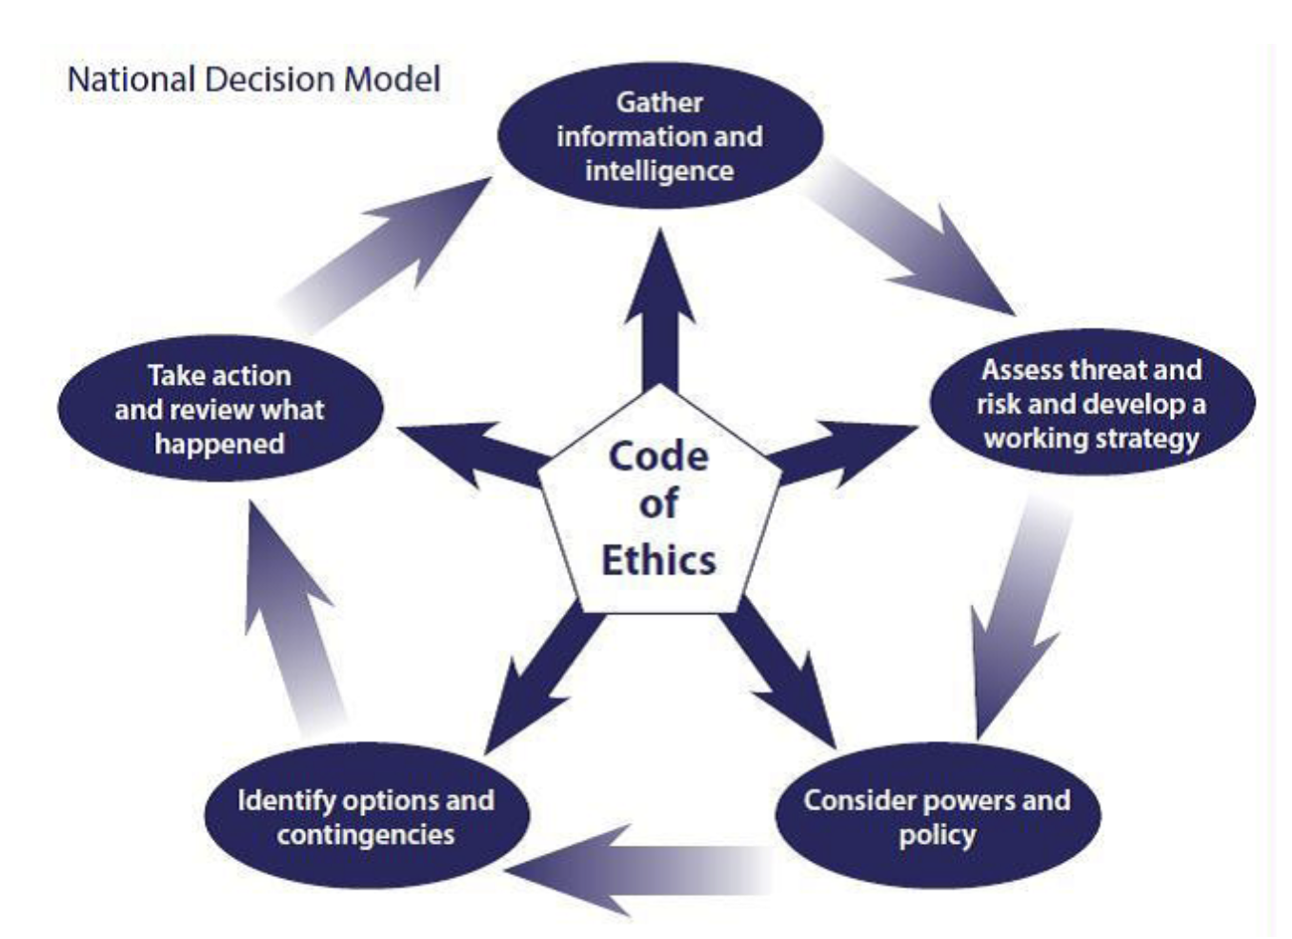

Across the specialist operations disciplines of Firearms, Public Order, Counter-Terrorism and Operational management, a consistent NDM is used. The NDM is coached to all police officers and staff, whatever their rank or role, it enables both fast time decision making and slow time problem-solving. The NDM (College of Policing, 2013) was a constant thread through all the decisions made in the planning and operational phases of the operation. The NDM has six key elements, each of which are essential to ethical leadership and transparent decision making in any operation and proved critical in this fixture.

- Information and Intelligence: During this stage the decision maker defines the situation and clarifies matters relating to any initial information and intelligence.

- Assess threat and risk and develop a working strategy: This analytical stage involves assessing the situation, including any specific threat, the risk of harm and the potential for benefits.

- Powers and policy: This involves consideration of powers, policies and legislation that could apply in this particular situation.

- Options and contingencies: This stage involves considering the different ways to make a particular decision (or resolve a situation) with the least risk of harm.

- Action and review: This stage has two distinct steps. At the action step, decision makers are required to make and implement appropriate decisions. The review step requires decision makers to review and reflect on what happened once an incident is over.

- The Code of Ethics: The Code of Ethics sets out the policing principles that members of the police service are expected to uphold and the standards of behaviour they are expected to meet.

The policing operation had transferred from planning to the operational phase. On the day of the fixture, I conducted a series of briefings to my resources including my police support units (PSU), who were made up of officers from South Wales Police, Gwent Police and the Police Service of Northern Ireland. I heavily emphasised throughout each briefing the opportunity to enhance the reputation we in the South Wales Force had achieved, following the temporary closure of Wembley stadium resulting in a significant number of high profile fixtures being played in Cardiff’s Principality stadium. The South Wales force made up of 3000 officers had managed what the Metropolitan Police had managed with 30,000 officers at their disposal, successfully hosting and policing multiple football cup finals and play off fixtures.

The ‘Meet and Greet’ style of policing was fast becoming a trademark of the South Wales Police public order policing brand; I was proud to be a prominent leader in this evolving aspect of policing. I had played a significant role in the development of this engaging style of policing following academic research and feedback from football supporters who found the Metropolitan Police style of public order policing to be unwelcoming and non-communicative.

Throughout the planning phases of this and previous operations I adopted a democratic leadership style to take those public order teams on a journey, to embrace the open, welcoming, communicative, meet & greet style of policing. Law (2016) references the Tannenbaum–Schmidt continuum and notes that the type of leadership that is practical and desirable in any given situation will depend on three types of force: forces in the leader namely the leaders self-confidence, personal philosophy; forces in the followers including their experience and willingness to take responsibility; and forces in the situation including the nature of the problem and time pressures.

When I consider my application of this style of leadership, I was a vastly experienced public order officer, now commander with over 20 years of experience, yet heralding a new philosophy to public order policing. This was not welcomed by all, particularly those who had experienced the old school autocratic approach, very much based on the ‘don’t think’ just ‘get it done’ approach. Bennis and Nanus describe the value of passionate and shared valued of a leader.

A leader can marshal many sources of ideas and energy by announcing a personal set of values that may encourage those who share the values and inspire those who are uncommitted. Such statements assign priorities to actions that followers perceive as a promise by the leader to give attention to certain especially worthy options. Values determine the choices people make or, at least, values are ascribed to the choices made by them. If values are not spelled out or acted upon by the leader, followers will assume they need not remain committed to them (Bennis & Nanus, 1985).

My style of leadership was not appropriate in every circumstance and a more authoritarian approach was often required in operational situations yet was always supported with reference to the NDM.

The initial events of the day unfolded with predicted outcomes, that being over one hundred and fifty thousand supporters flocking to my area of responsibility namely the west of city where the greatest concentration of pubs and bars could be found. English supporters appeared to be putting aside inter club rivalries and adopted a collaborative approach to their pre match rituals.

The same could not be said of the Welsh contingent with large, segregated gatherings of regional groups and clear club identities and alliances on display with team colours and flags. The vast majority of Welsh fans were engaging with English supporters singing and drinking in the city’s bars and in several locations spilling out onto the roadway requiring police intervention to close roads due the sheer volume of supporters on the highway.

It was some three hours before kick-off when the silver commander informed me of a large contingent of Welsh, Swansea City supporters located at Churchill Way approximately one kilometre from the greatest concentration of other Welsh and English fans in St Mary’s Street. Upon attendance at the bar housing the Swansea City supporters it became immediately apparent that a large number were heavily intoxicated and were stood outside singing anti-English and anti-Cardiff City songs. The clear inference I drew from this behaviour was that this group of three hundred plus supporters were intent on confrontation, indeed even at this early stage they had been involved in a number of hostile interactions and altercations with passers-by.

I was acutely aware that my tactical decision making combined with my leadership style in managing this group of supporters could have ramifications on the entire policing operation. My feelings and leadership development in this area typified Kolb’s experimental learning cycle having touched all four of the elements. Kolb will state that this perspective on learning is labelled experimental for two reasons. The first being to tie it clearly to its intellectual origins in the work of Dewey, Lewin and Piaget. The second being the undeniable role that experience plays in the learning process (Kolb, 1984). Kolb’s theory is best known through the four-stage model of experiential learning which he calls “The Lewinian Model of Action Research and Laboratory Training” (Kolb, 1974b)

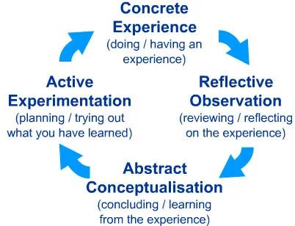

In these particular circumstances my personal previous ‘Concrete Experience’ was based on many years of dealing with challenging and often hostile football supporters. My ‘Reflective Observation’ was a combination of the tried and tested, directing leadership style, dictating times of departure, routes to the stadium and the manner in which the supporters would travel. Conversely, I was aware of the newly adopted ‘meet and greet’ consultative, style of public order policing that I personally championed. The ‘Abstract Conceptualisation’ of my actions involved a personal reflection of my past decisions alongside the actual and potential ramifications of the approach I would adopt on this occasion. ‘Active experimentation,’ whilst I have experience of both approaches this was quickly evolving into a hostile situation that required a policing intervention and decisive leadership. The definition of police leadership has been described as “The ability to make a split-second decision and take control of a potentially high-voltage situation that evolves on the street.”
(Walsh & Gennaro, 2018)
When I consider the legitimate power beholden to me in this situation, I was clearly in a position of having the requisite expertise in terms of policing powers and legislation to impose conditions on these supporters. The power of ‘reward’ was also a possibility whereby I could afford the supporters safe passage to the stadium and a segregated area within the stadium. This was a real consideration given the level of hostility on display and would have been similar to a ‘coercive’ approach. The impending decision was ultimately one that did not necessarily require me to deviate from my preferred style of leadership that had worked so well in recent high profile, FA and league cup finals. Ultimately, I adopted a combination of a ‘moral’ and ‘referent’ approach to gain understanding from my resources, colleagues and the supporters themselves. Hollander describes the idiosyncrasies of leadership styles and the impact on those who follow.

Leadership involves the possession of qualities that lead the people in groups to want to follow the leader's directives, either because they feel obligated to do so, or because they desire to do so. In other words, leadership is a characteristic that is conferred upon a leader by followers. It involves the ability of a leader to engage the active, voluntary, and willing cooperation of their followers. Leadership is, therefore, a process of influence that ‘depends more on persuasion than on coercion.
(Hollander, 1958)

Leadership in any guise is about context and situation and the progression of the day's events highlight these many styles, charting the challenges of leading through difficult circumstances, structures and legislation.

In order to achieve this balance my decisions and the overall policing operation would pay due regard to the Police Code of Ethics which sets and defines the exemplary standards of behavior for everyone who works in policing (College of Policing, 2014) and the overriding legislative backbone of the Human Rights Act 1998. I also acknowledge the wide discretion available in the choice of measures to be used. Indeed, the various articles contained within the European Convention on Human Rights sit above UK domestic legislation and focus on the rights of the individual. (European Convention on Human Rights, 1998).

I personally consulted with my team and having prescribed certain parameters I tasked the PSU commanders along with the dedicated football officers to liaise with the identified leaders within the supporter’s group and come to a mutually agreeable time and route to walk to the stadium. This was quickly achieved, and I contacted the silver commander to outline my proposed plans to escort this hostile group of supporters to the stadium. It was at this point in time that my plans had to be realigned to follow the directive given by the silver commander. In our conversation he gave the direction that this group of supporters be escorted on foot, not to the stadium but to the location of the large gathering of both Welsh and English supporters at St Mary’s Street and at this point they would be released from the police escort. This I felt would undoubtedly result in disorder and a violent confrontation between the respective sets of supporters if the integrity of the police escort was not maintained.

Despite my objections and a heated exchange of views all conducted over a recorded phone line the silver commander with limited explanation reaffirmed his decision, and whilst he documented my alternative viewpoint, I duly accepted his command decision. I ensured this decision was communicated to my resources, the directive was subsequently conveyed to the supporters under escort with a clear message that they should refrain from their confrontational and insulting rhetoric.

I had worked with the silver commander for a number of years, and he was well respected in the field of public order, yet despite this I could not let this decision stand without further challenge and an attempt to change his mind. I recontacted him directly and despite my reasoned argument and articulation of the NDM he remained resolute in his chosen strategy.

What followed were as set of circumstances that I had earlier described to the silver commander and were entirely inevitable and more importantly completely avoidable had he reversed his decision. There was immediate disorder and violence between both English and Welsh supporters and the previously escorted group of supporters who had continued with their insulting and abusive chanting whilst under police escort. The group had to be protected by my resources to prevent large scale disorder and significant violence erupting. This group were then escorted to central square where they were contained as a collective. This three hundred strong group, all with tickets for the match were contained at this location until the vast majority of other supporters entered the stadium and I was able to relay the information that the stadium management would not permit them access to the stadium. Whilst not permitted access to the stadium they were free to leave the containment but could only do so in small numbers and understandably challenged my decisions and the basis of its legality. After a number of hours and after the match had started the group eventually accepted the nature of the situation and boarded their transport where they were safely conveyed back to Swansea.

What followed on from this set of events was significant media interest in the adopted police tactics of containment (referred to as kettling by the media) and a legal challenge to our decision making and subsequent actions. I was well sighted on the media coverage of the 2011, G20 protests in London where the Metropolitan police service had adopted similar tactics to contain large numbers of protestors. The BBC (bbc.co.uk, 2011) reported on the Metropolitan police service who had been widely criticised for their use of these tactics and the subsequent Judicial Review in the High Court who ruled the forces actions to contain the protestors was deemed unlawful.

A Judicial Review was sort by a legal team acting on behalf of the group of supporters to challenge the legitimacy of our actions. This placed significant pressure on myself as a commander, with this event behind me the following weeks I was taking command of the three home fixtures of the Rugby six nations again with the media spotlight on policing strategy and tactics.

- Feelings

Throughout the initial phase of the operation, I felt that I was true to my beliefs and policing philosophy with a no surprises, democratic approach to my leadership. I felt that this philosophy was adopted by those resources under my command and broadly accepted by those impacted or influenced by this policing style and tone. We as individuals all have our own set of idea’s, beliefs, values and opinions that inform our decision making process and I pride myself in the confident yet balanced manner in which I deal with a difference of opinion or conflict. In this situation I was duty bound to follow a lawful direction given by an individual both senior in rank and having greater influence due to their position in the GSB command structure.

When I consider my personal feelings based on the research conducted by Hertzberg, et al., (2017), I note their research attempted to disentangle the interrelations between objective events, the feelings expressed by individuals and the resulting effects on those subjects. When considering the categorisation described by Hertzberg et al., my fundamental goal was that of ‘achievement’ to deliver a safe and secure event that was able to enhance the reputation of the force and the capital city. The effects of the day’s events left me with a feeling of disempowerment and failings in my leadership as I felt there were alternative solutions to those prescribed by the silver commander.

- Evaluation

In my personal reflection and evaluation of my command and leadership, I reflect upon my pride in representing the force in critical area of policing and ensured my level of competence and professionalism was subject to continual review, feedback and continued professional development. I had always sort feedback from subordinates, peers and senior commanders to critically analyse my performance and seek ways to improve my leadership.

The silver commander a Chief Superintendent with almost thirty years of policing experience and is well respected in the public order policing environment, presented me with an unconventional direction to a an already volatile situation. When initially evaluating his action’s, I have drawn comparison to the model of Situational Leadership Theory as developed by Dr. Paul Hersey and Kenneth Blanchard (2018). Of the four styles of leadership (1. Directing, 2. Coaching, 3. Supporting, 4. Delegating) the Chief Superintendent clearly displayed the characteristics of the ‘Directing leader’ with an autocratic approach directing me without sufficient explanation or prior consultation. This approach is consistent with a leader who does not want to show weakness directing their resources with little opportunity for collective contribution or feedback. However, I was conscious that this did not follow his traditional leadership style of high competence and commitment.
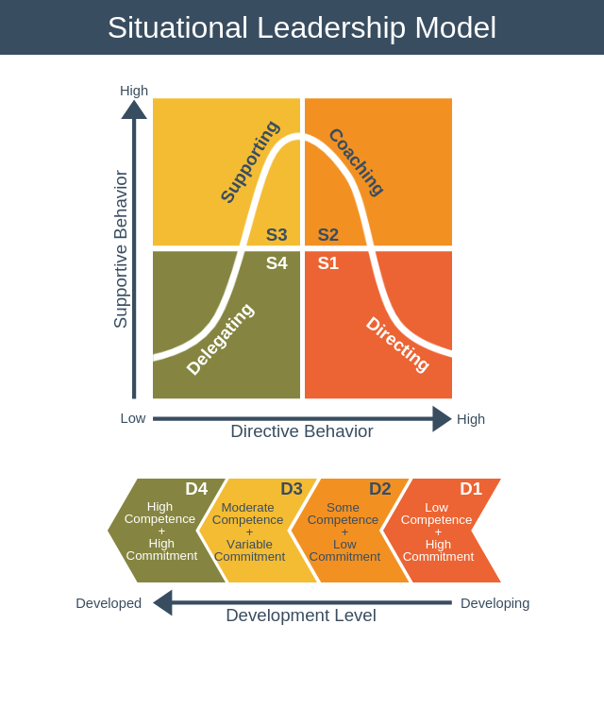
(Hersey and Blanchard, 2018)

- Analysis

Law (A Dictionary of Business and Management, 2016) references the Tannenbaum–Schmidt continuum and notes that the type of leadership that is practical and desirable in any given situation will depend on three types of force: forces in the leader namely the leaders self-confidence, personal philosophy; forces in the followers including their experience and willingness to take responsibility; and forces in the situation including the nature of the problem and time pressures.

When I attempt to critically analyse the decision making and leadership approach adopted by the silver commander in isolation, his authoritarian style telling me of his decision sits at the lower end of Tannenbaum and Schmidt continuum. Much to my frustration and categoric disagreement at the time, the silver commander could not be persuaded to change his decision. However, when I was subsequently made aware of the additional information and interdependencies this decision sits more in the ‘consultative’ or ‘joint’ decision on the leadership continuum. Prior to the group of supporters moving from the licenced premises the silver commander in consultation with the stadium safety officer discussed the situation involving the hostile supporters and the potential for disorder within the stadium. The stadium safety officer who has primacy over police within the stadium, was without a quarter of his safety stewards and was not in a position to segregate this hostile group of Welsh supporters, due to the 74,000-seater stadium being at full capacity.

This presented the silver commander with a difficult decision; did he allow this hostile group of 300 supporters to be protected by police en-route to the stadium thereby displacing a potentially violent confrontation to the management of the stadium safety officer and his stewards with limited training and powers. A decision had to be made quickly and ethically, ultimately there was a collapsing time frame to kick off and these hostile supporters all had match tickets that they had obtained legally thereby permitting them access to the stadium. The decision to allow all sections of supporters to interact in an environment that had a far greater concentration of policing control would immediately test the supporter’s ability to collaboratively engage with others pre, during and post match.

Whilst my initial thoughts were that the silver commander had both failed to consider alternative options and the range of democratic to authoritarian styles as highlighted by Tannenbaum and Schmidt (1958) were stark and on personal reflection were frequently dictated by a multitude of factors. He had also failed to clearly articulate his thoughts and rationale for his decisions as outlined above, another authoritarian characteristic on display.

However, when debriefing the day’s event with the silver commander it was apparent that the reasons and rationale for that decision could not be disclosed prior to this point. Legal advice obtained provided prior to those events prevented this disclosure and disclosure of the anticipated outcome would have compromised the legitimacy and legality of the policing operation. Therefore, my initial frustrations were quickly diminished with the disclosure of this information and therefore had a greater personal appreciation of longer-term solutions, partnership working and individual responsibility.

- Conclusion
Adair (2006) stipulated that the efficiency and effectiveness of a leader can be characterised by their ability to develop and assist their team to meet three distinct area’s of need. Adair highlighted three overlapping yet independent aspects to his Action Centred Leadership philosophy, Team, Individual and Task.

The silver commander's decision was in my initial interpretation lacking in both the team and task element with a decision that I believed to be strategically and tactically floored and failed to be both fully rationalised and communicated. Yet in hindsight this decision was justified and took proportionate consideration of all three elements of Adair's philosophy.

My acceptance of the directive from my leader in this situation was understandably one of disbelief and a subsequent personal and private challenge to his decision. I saw the task as being one of complete folly that would present significant threat of disorder and risk of injury to my resources thereby having little consideration for the team. As an individual I considered my reputation as a leader and well-respected public order commander. This strategy appeared fatally floored, and I anticipated that in relaying this directive to my resources they would feel incredulous and potentially challenge this decision in a similar manner to myself. Whilst I disagreed with the decision, this was an evolving situation and I had recorded my views on the event log. When I consider the manner in which I delivered the message to my resources I was a directing leader with an unwavering autocratic approach, I disagreed with the decision by silver, but I needed my team committed to the task and fully focused on their role and not questioning command decisions. I thought to myself that they must be questioning, ‘Why as their leader am I allowing this to occur’ and they were very aware of my change in leadership style in the delivery of the message. As documented above I usually adopted a democratic approach, carefully considering the views and shared knowledge of those within my command structure. Those commanders fully appreciated that this was not the time to enter a consultation and they subsequently delivered the directive to their staff with the upmost professionalism and commitment.

Maslow’s Hierarchy of Needs (Williams, 1988) are divided into five distinct needs these being, physiological needs, safety needs, love and belonging, esteem and self-actualisation. Esteem needs are the fourth level in Maslow’s hierarchy and include self-worth, accomplishment and respect. Maslow classified esteem needs into two categories: (i) esteem for oneself (dignity, achievement, mastery, independence) and (ii) the desire for reputation or respect from others (e.g., status, prestige). Maslow indicated that the need for respect or reputation is most important for children and adolescents and precedes real self-esteem or dignity. When I reflect upon the personal learning from this event I consider my need for respect, and the impact upon my reputation, were most definitely in my thought process and how this could be damaged by the actions of another. The learning for me was to not deviate from having the confidence to challenge the decisions of my leaders, peers and subordinates alike to in order to maintain that transparent and ethical leadership process. However, the greatest learning was to understand that I will not always be in receipt of all the information or intelligence, therefore not appreciative of the bigger picture thereby not affording me knowledge to make that broader overarching decision. The ability to accept this something I have adapted to well over the years and as I have progressed to a gold and silver commander myself it is something I am conscious of when relaying information and decisions to my colleagues.

When I analyse the personal aspects that went well in the operation, I consider my ability to communicate clear concise information and direction regardless of the task complexity and personal views was a real positive. I note that my leadership style and decision-making characteristics varied greatly dependent on the circumstances. Leadership is not an exact science and, there are a multiplicity of interrelated factors that influence the decisions and actions of people (Mullins & Christy, 2016) and whilst I now have the benefit of hindsight to consider what could have been done differently the law courts ultimately made a ruling on the decisions made and resulted in a positive outcome for policing in the UK and vindication for the difficult decision taken by the silver commander on the day.

- Action Plan

The events of the day and the decision making process were subject to significant internal and external legal and media scrutiny. Our lengthy commanders’ reports, log of events, transcription of phone conversations, CCTV and video footage were all disclosed to the police (defence) and supporters (plaintiff) legal teams where the case was taken to the High Court for Judicial Review. The case was presented to the High Court Judges, the same individuals who ruled at against the Metropolitan Police case of containment the year before. However, on this occasion the court ruled that the circumstances were proportionate and justifiable and had a firm legal basis on which to take the action that was taken on the day.

As a leader and an organisation there must always be a current and continuous appreciation of the changes in society to reflect the decisions we make and the impact upon the public to who which we serve and follow the ‘Principles of Public Life’ (Nolan, 1995). Legislation will always be the backbone of the British model of policing as Sir Robert Peel outlined in the ‘Peelian Principles’ (gov.uk, 2012) but only if combined with the support and consent of the public. So, whilst the legal power is there to be exercised, so importantly is the discretion to deal with incidents with the benefit of personal, professional, experience and knowledge.

I strive to be a leader who provokes thought, inspires innovation, is open to new ways of operating and progress. Fleming (2015) accurately articulates this is highlighting that complexity is all around us, and the better leaders will recognise this, and recognise this requires updated ways of operation, and not simply reverting to pre-existing leadership models that are simply not designed for the challenges of policing a modern society.

Bibliography
Adair, J. (2006). Leadership and Motivation. London: Kogan Page Ltd.
BBC News. (2011). bbc.co.uk. Retrieved February 14, 2022, from https://www.bbc.co.uk/news/uk-england-london-13077619
Bennis, W., & Nanus, B. (1985). The Strategies for Taking Charge (1 ed.). New York: Harper & Row.
College of Policing. (2013). National Decision Model. Coventry: College of Policing.
College of Policing. (2014). Code of Ethics. Coventry: College of Policing Limited.
European Convention on Human Rights. (1998, c.42). The Human Rights Act. Retrieved February 10, 2022, from https://www.legislation.gov.uk/ukpga/1998/42/contents
Fleming , J. (2015). Police Leadership - Rising to the Top. Oxford: Oxford University Press.
Gibbs, G. (1988). Learning by Doing; A Guide to teaching and learning methods. Oxford: Oxford Further education Unit.
gov.uk. (2012, December 12). Dedfintion of Policing by Censent. Retrieved from GOV.UK: https://www.gov.uk/government/publications/policing-by-consent/definition-of-policing-by-consent
Hersey, P., & Blanchard, K. (2018). Expert Programme Management. Retrieved February 1, 2022, from https://expertprogrammanagement.com/2018/11/situational-leadership-model/
Hertzberg, F., Mausner, B., & Synderman, B. B. (2017). Motivation to Work (3 ed.). New York: Routledge.
Hollander, E. P. (1958). Conformity, status, and idiosyncrasy credit. Psychological Review, 65(27), 117.
Kolb, D. (1974b). Experiential Learning; Experience as the source of learning and development. In P. Hall (Ed.). NJ: Englewood Cliffs.
Kolb, D. (1984). Experiential learning: experience as the source of learning and development. Retrieved February 12, 2022, from Experiential learning: experience as the source of learning and development: http://www.learningfromexperience.com/images/uploads/process-of-experiential-learning.pdf
Law, J. (2016). A Dictionary of Business and Management (6 ed.). Oxford: Oxford University Press.
Maslow, A. H. (1943). A Therory of Human Morivation. Ontario: York University.
Mullins, L. J., & Christy, G. (2016). Management and Organisational Behaviour. Harlow: Pearson Education Ltd.
Nolan, L. (1995). The Seven Principles of Public Life. London: United Kingdom Government Publications.
Tannenbaum, R., & Schmidt, W. H. (1958). How to Choose a Leradership Pattern. Harvard Business Review, XXXV1(2), 483-491.
Walsh, W. F., & Gennaro, V. F. (2018). Police Leadership and Administration. New York: Taylor & Francis Group.
Williams , A. (1988). The Right to be Human. A Biagraphy of Abraham Maslow, 113(10), 120.

