Module code: BMSW4011
Managing Enterprise in the 21st Century

Business Name: A Touch of Spice Indian Restaurant
Task 1
Student name: Mohammed Sundar Ali
Student ID: 2313857
Table of Contents
Concept of the company 3
Company name and ownership 3
Mission statement 4
Business Aims 4
Business Objectives 4
Legal Identity 4
Marketing and PR Plan 5
7 P’s 5
Human Resource Strategy 5
Sources of Finance 6
Cash flow forecast 6
SWOT Analysis 7
References 9

Concept of the company
A Touch of Spice is an Indian cuisine-based restaurant which will be operating in Bristol. It will serve healthy Indian cuisine options with a blend of relevant contemporary tastes. Moreover, high-quality food with exceptional ambience will be delivered at competitive prices.
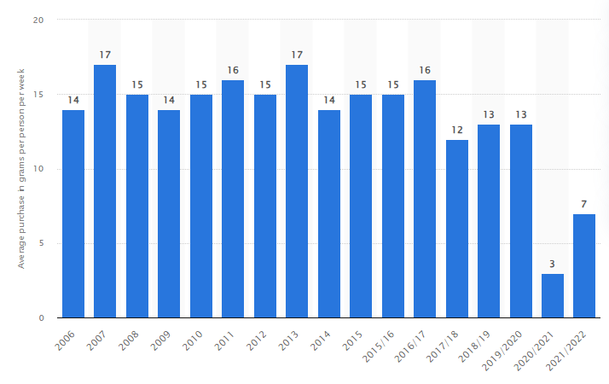
Figure 1: Demand for Indian Food in the UK
(Source: Statista, 2022)

Company name and ownership
A Touch of Spice will provide healthy Indian Cuisine in a contemporary style at competitive prices.


Mission statement
We provide exceptional Indian Cuisine to our customers with fresh and healthy ingredients and blend it with contemporary style. Culture, community and sustainability are the core values of our business.

Business Aims
The main aim of the business is to provide healthy and organic cuisine to customers at competitive prices and further generate higher sales and profit.

Business Objectives
- To elevate the consumer base by 35% by the end of the first year.
- To gain a 5-point rating in most of the trusted online review sites about hotels and restaurants.
- To generate a revenue of 100,000 GBP by the end of 1st year.
- To run the business systems and processes with highly sustainable approaches.

Legal Identity
As a legal identity, A Touch of Spice will be using a Limited Company structure (Tao et al., 2022). It will help them reduce financial risk and further will help them gain diverse tax benefits. All these factors will maximise the elevens of the people and process management aspects positively (Perácek and Kassaj, 2023).

Marketing and PR Plan
The target market is a crucial part of the business plan and helps analyse the major strategies that can be used to cater for the potential audience positively (Han and Kang, 2020). The target audience for A Touch of Spice will be medium to high-income professionals who fall in the age range of 25 to 50 years old. In addition, the audience should be well-versed with Indian cuisine taste and different digital payment and social media channels.

7 P’s
It is a crucial framework that helps in maximising the effectiveness of marketing strategies and further helps in achieving business goals and objectives positively (‌Blythe, 2019). As a part of the product Indian restaurants will be focusing on delivering healthy Indian Cuisine dishes by adhering to sustainable approaches. As a part of pricing strategies cost leadership strategies going to be used (Ali and Anwar, 2021). For the place, both online and offline channels will be used which will be comprised of online websites and offline restaurants. For the promotional strategies Billboards, social media and digital marketing strategies will be chosen as per the needs and requirements of the organisation. The people will be hired and provided with ongoing training related to food and sustainability knowledge (Arthur et al., 2022). As a part of the process quality control measures will be taken into consideration so that they can provide quality food to their potential customers. Above all the physical evidence process is crucial for maximising customer loyalty and brand visibility (Rane et al., 2023). Therefore, relevant social media channels will be taken into consideration including Instagram, Facebook, YouTube and more. It will help in strengthening the social media credibility of Indian Restaurants.

Human Resource Strategy
Human resource strategies is a crucial part of the business and help in maximising the effectiveness of the people and process management aspects effectively (Holbeche, 2022). In this case, different professional social media, recruitment strategies and more will be used as per the needs and requirements of the organisation. It will be comprised of a General manager, Chef head, kitchen staff, marketing manager, account manager and more.
Organisational chart
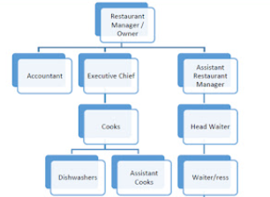
Figure 2: Organisational chart for Indian Restaurant
(Source: Developed by the learner)

Sources of Finance
Sources of finance are crucial for running a business as it helps in executing the development task effectively and further achieving them as per the set deadline (Govindaras et al., 2023). For the above business idea, an initial cost of 200,000 GBP will be required. In this case, angel investors, loans, crowdfunding, UK government scheme will be considered as the fund source and further relevant business development activities will be executed with higher sophistication. This will help A Touch of Spice mitigate the risk of financial burnout and further will help them strengthen their position in the highly competitive restaurant industry of London, UK.

Cash flow forecast
The formulation support and the presence of a positive cash flow concept have been initiated to provide structural details about the business liquidity involvement approach which is accountable for the feasibility value (Paolone, 2020). With the support of general accounting principles including the Going Concern initiative, the application of this particular budget has been initiated with the consideration of market positioning (Atrill and McLaney, 2018). The level of this particular detail mainly indicates the volume of business cash inflow and outflow with 12 months of support which can be applied for identifying the net cash flow positioning or the liquidity approach purpose.

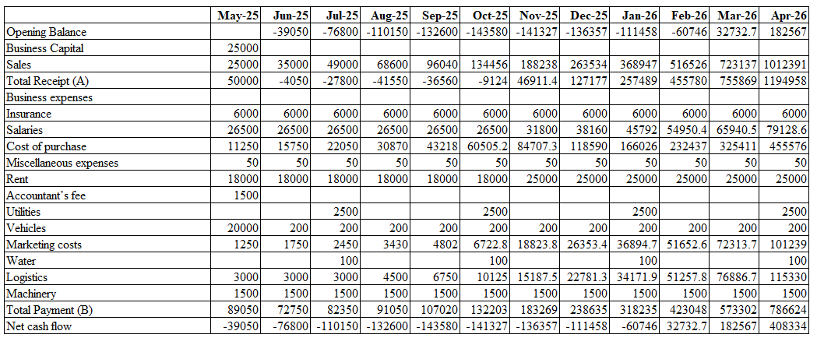

SWOT Analysis
Strengths | Weaknesses
- A Touch of Spice is a limited company and it will help in mitigating financial and legal risks to a great extent (Bishop, 2020).  - The chosen location is Bristol where demand for Indian Cuisine is very high.  - Healthy and organic Indian cuisine made up of fresh ingredients is the USP of the brand. | - Limited online presence is one of the major weaknesses of the brand currently which they need to focus on to a large extent (Rabbanee et al., 2020).
Opportunities | Threats
- Growing need and demand for Indian cuisine and restaurants will help them in maximising the effectiveness of their business expansion strategies in the future and further will help them expand all over the UK and worldwide. | - After the coronavirus pandemic, the government of the UK has become highly strict with the Food and Safety and Sustainability Act which could be a potential threat for the company (Legislation.gov.uk, 2024).
Table 1: SWOT analysis
(Source: Developed by the learner)

References
Ali, B.J. and Anwar, G., 2021. Marketing Strategy: Pricing strategies and its influence on consumer purchasing decision. Ali, BJ, & Anwar, G.(2021). Marketing Strategy: Pricing strategies and its influence on consumer purchasing decision. International journal of Rural Development, Environment and Health Research, 5(2), pp.26-39.
Arthur, R.I., Skerritt, D.J., Schuhbauer, A., Ebrahim, N., Friend, R.M. and Sumaila, U.R., 2022. Small‐scale fisheries and local food systems: Transformations, threats and opportunities. Fish and Fisheries, 23(1), pp.109-124.
Atrill, P. and McLaney, E. 2018. Accounting and Finance for Non-Specialists. 11th Ed. Harlow: Pearson
Bishop, D., 2020. Firm size and workplace learning processes: a study of the restaurant sector. European Journal of Training and Development, 44(2/3), pp.305-320.
‌Blythe, J. 2019. Essentials of marketing communications. 7th edn. Harlow: Financial Times/ Prentice Hall.
Govindaras, B., Wern, T.S., Kaur, S., Haslin, I.A. and Ramasamy, R.K., 2023. Sustainable environment to prevent burnout and attrition in project management. Sustainability, 15(3), p.2364.
Han, S. and Kang, E., 2020. The marketing strategy to stimulate customer's interest in art-gallery business plan. Journal of Distribution Science, 18(8), pp.47-54.
Holbeche, L., 2022. Aligning human resources and business strategy. Routledge.
Legislation.gov.uk. 2024. Food Safety Act 1990. [online] Available at: https://www.legislation.gov.uk/ukpga/1990/16/contents [Accessed 6 May 2024].
Paolone, F., 2020. Accounting, Cash Flow and Value Relevance. Springer International Publishing.
Perácek, T. and Kassaj, M., 2023. The influence of jurisprudence on the formation of relations between the manager and the limited liability company. Juridical Trib., 13, p.43.
Rabbanee, F.K., Roy, R. and Spence, M.T., 2020. Factors affecting consumer engagement on online social networks: self-congruity, brand attachment, and self-extension tendency. European Journal of Marketing, 54(6), pp.1407-1431.
Rane, N.L., Achari, A. and Choudhary, S.P., 2023. Enhancing customer loyalty through quality of service: Effective strategies to improve customer satisfaction, experience, relationship, and engagement. International Research Journal of Modernization in Engineering Technology and Science, 5(5), pp.427-452.
Statista. 2022. Eating out: Indian food consumption in the UK-2022 | Statista. [online] Available at: https://www.statista.com/statistics/284566/weekly-consumption-of-indian-food-eaten-out-in-the-united-kingdom-uk/#:~:text=Weekly%20consumption%20of%20Indian%20food,Kingdom%20(UK)%202006%2D2022&text=In%202021%2F2022%2C%20an%20average,week%20in%20the%20United%20Kingdom. [Accessed 6 May 2024].
Tao, Z., Zhang, Z. and Shangkun, L., 2022. Digital economy, entrepreneurship, and high-quality economic development: Empirical evidence from urban China. Frontiers of Economics in China, 17(3), p.393.

Module code: BMSW4011
Managing Enterprise in the 21st Century

Business Name: Indian restaurant
Task 2
Student name: Mohammed Sundar Ali
Student ID: 2313857
Table of Contents
Task 2 Individual reflection 3

Task 2 Individual reflection
The above assignment has helped me to learn different aspects of business ideation and further has helped me understand different elements of business development. It also has helped me develop different industry within the restaurant industry in the UK. It has also supported in analysis of how consumer behaviour plays a crucial role in defining business operational systems and processes. A deep understanding of the role of audience persona and their impact on the growth and development of the business growth and profitability in the best possible manner. In addition to that, aspects of business structure and legal identity and their contribution to the organisational success to a large extent. For example, during the assignment, A Touch of Spice considered the Limited Company structure. It will help them in minimising the financial risk to a large extent. While compiling the assignment I have understood the concepts of the 7P marketing mix. I have found that the seven components of the marketing mix play a crucial role in optimising people and process management effectively. I have also assessed the importance of financial sources and cash flow structure. It plays a crucial role in minimising financial burnout and further helps in maximising the chances of organisational success. A comprehensive understanding of human resources management and their effect on optimising recruitment and selection strategies has been assessed positively. Moreover, I have analysed the suitable organisational chart that can be followed throughout the business and development process. Based on the current situation a SWOT analysis has been developed. The above framework has helped me find the strengths and weaknesses of the business concepts and how that will help the business in grabbing future opportunities and mitigating potential threats.
In the process of business ideation, I have demonstrated some of the leading entrepreneurial skills. For example, Innovation and creativity is an integral part of that. It has helped me in finding a suitable organisation strategy, 7P marketing mix and financial strategies by considering the current market need and demand. Moreover, I have constantly used effective decision-making capability and further developed a business idea which comprised all the relevant components required to make A Touch of Spice a successful business in the restaurant industry of the UK. Moreover, I have extensively used my critical thinking skills to analyse current consumer behaviour and current market demand and developed a consumer persona with high-level precision. It will positively contribute in maximising the overall productivity of people and the process management process and further achieve the aims and objectives decided in the business development plan. Such knowledge, entrepreneurial skills and overall experiences during the above business plan development plan will help me gain a better edge in my future professional career. In addition, it will help me in starting my venture in the future and further achieve my personal, professional and professional goals in the best possible manner.

