The Relationship Between Art and Film
Artworks are human creation, and the artist lives in both history and society. As a result, the artwork will relate, in some way, to other works. (Bordwell, D., Thompson, K. and Smith, J. 2024)
Art and cinema have been intertwined by filmmakers and artists in media for decades. While film is often seen as a separate medium, it frequently draws inspiration from traditional art forms, artistic movements, and paying homage to the artists themselves. Art pieces in film are often seen used as a means of reflecting themes, foreshadowing events or to build upon characters. Films have been made a medium to document the lives of famous artists, exploring their creative career and struggles, as well as artistic styles, with many films having been created entirely in the style of different artists, visualising their art beyond the canvas and onto our screens. Additionally, concept art is also a way that film directors visualise their films, characters and settings before filming; this is often used in storyboards and character designs. By looking at how films include artworks, depict artists, and adopt artistic styles, we can better understand the ways in which visual art influences storytelling and cinematic expression.

Storyboarding
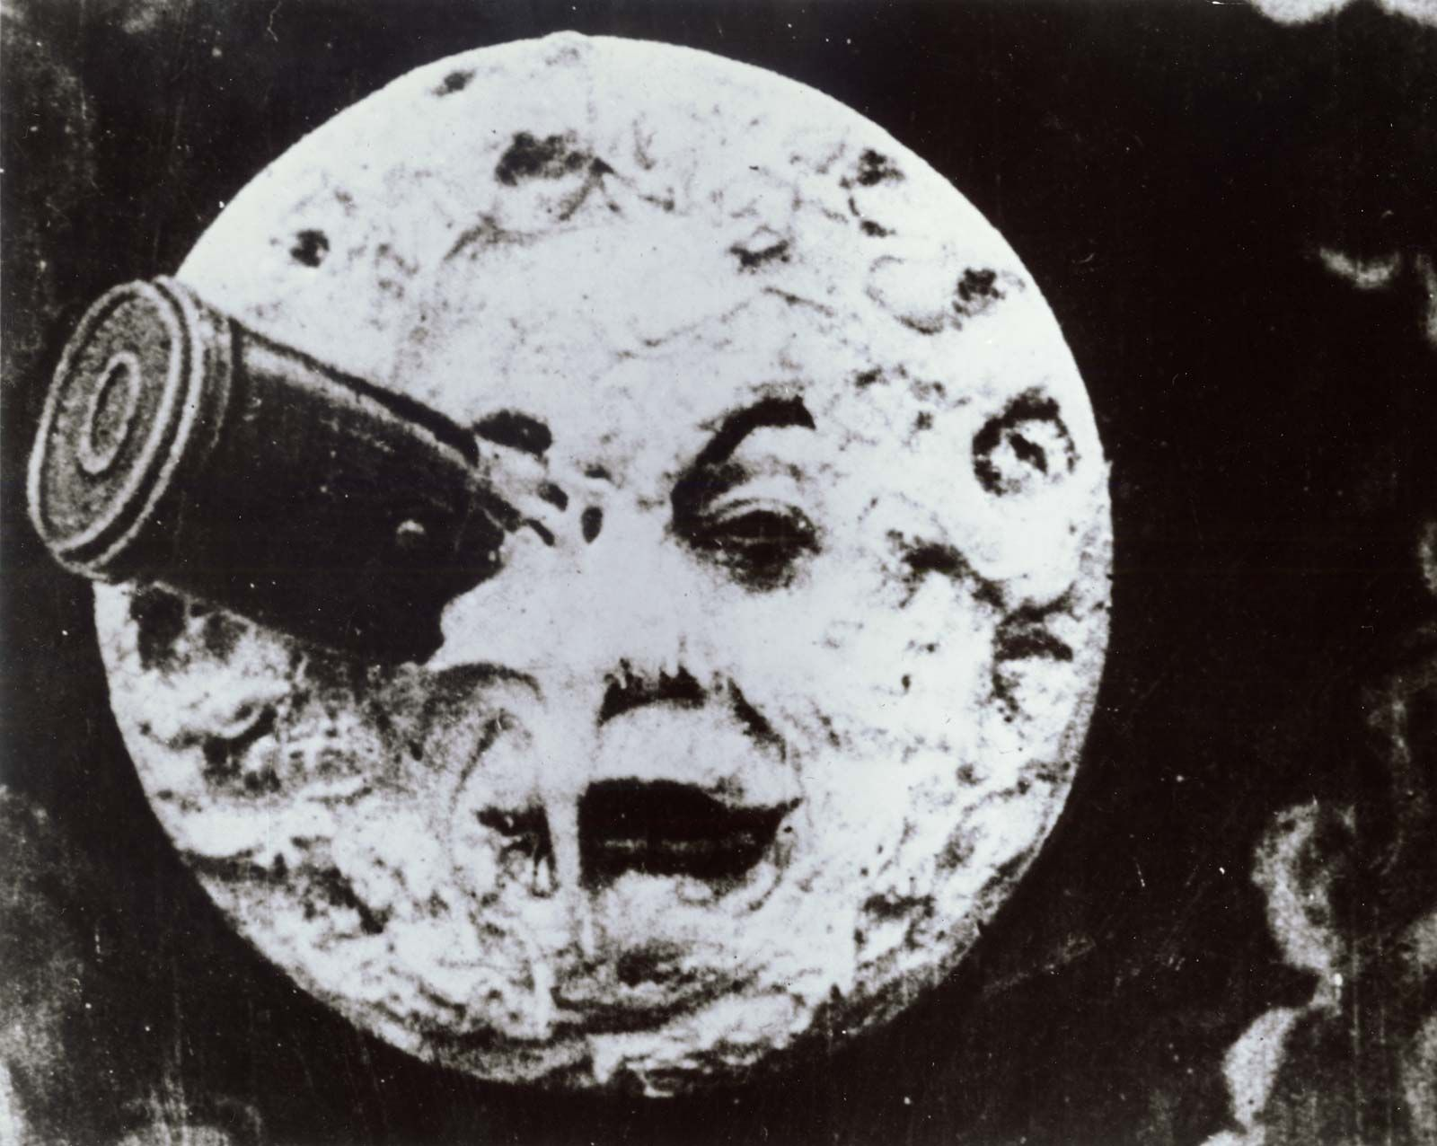

Le Voyage dans la Lune, (1902)

To start off by discussing storyboarding, there are some names that must be mentioned. In the late-nineteenth-, early-twentieth-century, George Méliès was a French actor, film director and theatrical set designer whose films contributed to the history of storyboards and animation with some famous examples of his work including Cinderella (1899), Joan of Arc (1902), and, most memorable for the rocket landing in the eye of the man in the moon, Trip to the Moon (1902). Other names which paved the way are Felix Messmer, the creator of the famous cat character Felix the Cat (1914), and Max Fleischer, creator of the Betty Boop cartoon series of the 1930’s. Amongst these names is also Ub Iwerks, designer of Oswald Rabbit and known for his work with Walt Disney Animation Studios, and Tex Avery, notable for his inventive cartoon creations at MGM and his work with Warner Brothers in both Bugs Bunny and Porky Pig in the 1940’s.

Each of these animated cartoons began as a drawing or series of drawings, just as so many popular cartoon characters like Popeye and Krazy Kat started as that prime example of a storyboard. (Hart, J. (John P. and Hart, J. (John P, 2013, p3)

Disney and his conceptual artists refined the use of storyboarding as the essential method of previsualising a story (with rough inspirational sketches first, next workbook sketches in colour, then sequential animation renderings, and finally painting the approved production cels), so that all creative personnel knew exactly how each sequence would pertain to the overall storyline.
Moving away from the animation aspects of storyboarding and towards cinema, David O. Selznick, producer of ‘Gone With The Wind’ (1939), insisted on careful preplanning in the form of storyboards for every major scene of the four-hour long film. This came to fruition in the form of the extensive use of matte paintings and composite photography, most of these compositional pieces to the credit of art director and American filmmaker William Cameron Menzies.
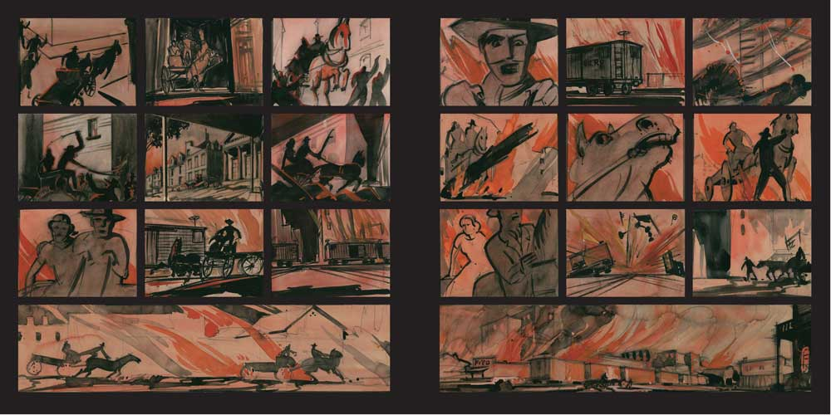Gone With The Wind storyboard, (1939)

Concept Art
Concept artists draw inspiration from various artistic movements, historical paintings, and even contemporary fine art to shape their films. For example, the landscapes of ‘The Lord of the Rings’ films were heavily influenced by Romanticism, while ‘Blade Runner 2049’ used concept art that echoed the surrealist and brutalist aesthetics. By blending fine art with cinematic vision, concept art serves as the crucial first step in turning an artistic idea into a cinematic experience.
Concept art often begins as simple sketches of pencil illustrations which are then further refined and developed later on in a film’s production. Most of our favourite movies often have extensive amounts of conceptual art and preplanned visuals behind them without us ever looking into them. The artists behind these pieces are, essentially, the backbone of these famous, iconic looks and aesthetics that are attributed to cinema’s most well-known franchises.
One of the biggest names in conceptual art is Syd Mead. Crowned the “visual futurist”, he is a concept artist known for his designs for some of the most recognisable science-fiction films such as Blade Runner, Aliens, and Tron.
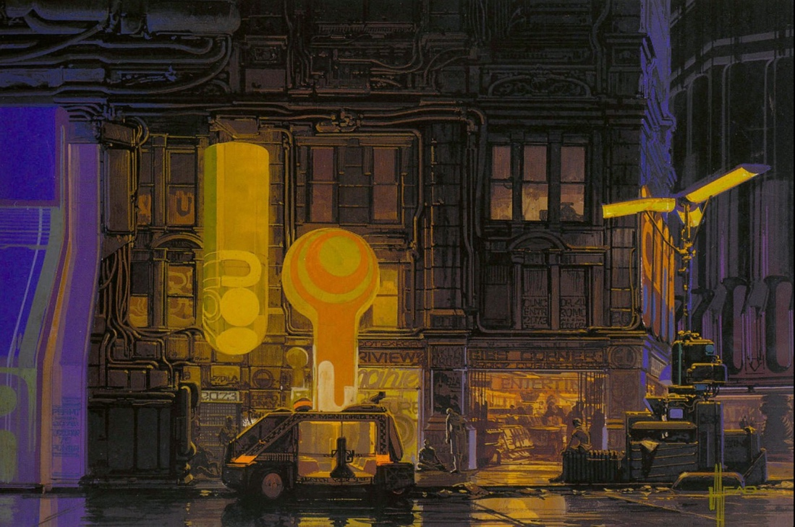
Blade Runner concept art, Syd Mead (1982)
Another recognisable name is Alan Lee, known for his conceptual art in the production of ‘The Lord of The Rings’. An example of Lee’s work is his early ideas for Khazad-Dûm, an ancient subterranean complex in Middle-earth; his first sketch of a scene where the Roots of The Mountain are shown whilst we follow Gandalf and the Balrog down a chasm was a tonal pencil piece, this was later developed digitally, adding colour, depth and atmosphere. (Russell, G. 2003, p.19)
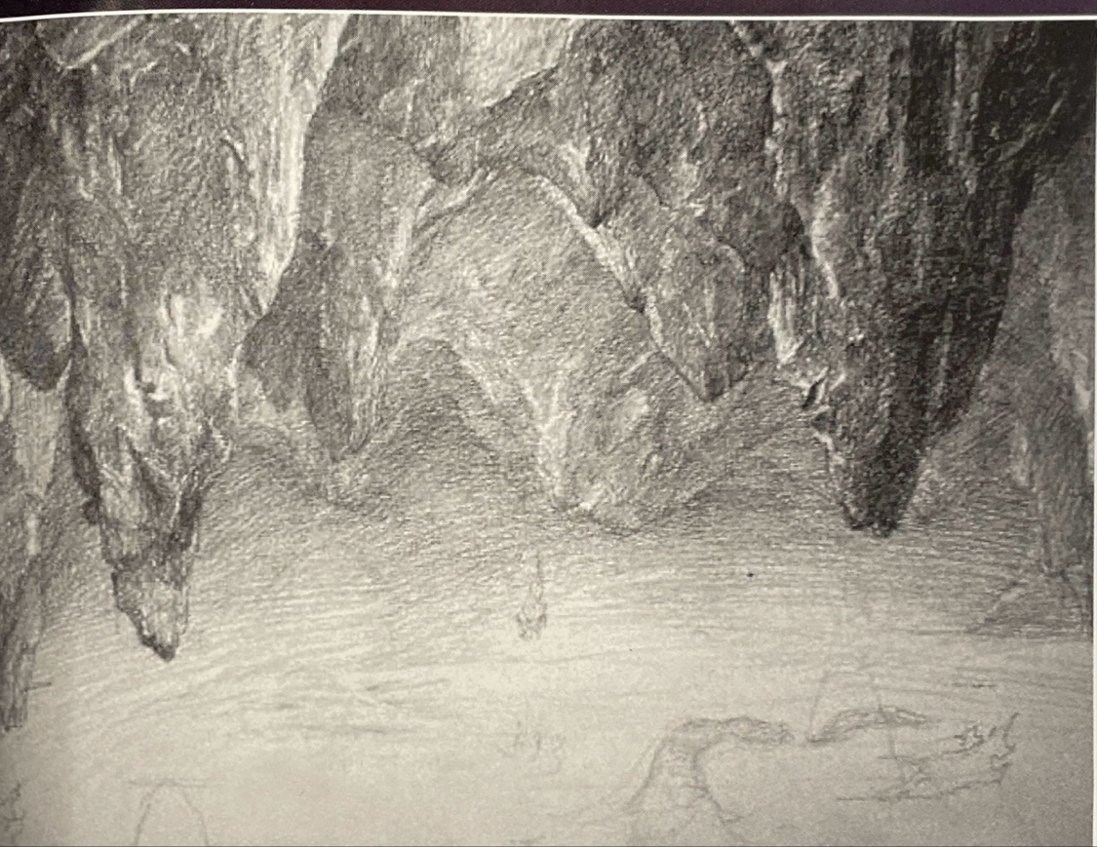
Khazad-Dûm concept sketch, Alan Lee (2002)
Additionally, the more technical aspects of a film’s look can be experimented with through conceptual art. Another example from The Lord of The Rings are colour studies done for Fangorn. Artist Paul Lasaine explained

“These ‘Fangorn with Merry and Pippin’ paintings were done to show how Fangorn could look creepy as well as beautiful and lush simply by changing the colour of the light.” (Russell, G. 2003, p.35)
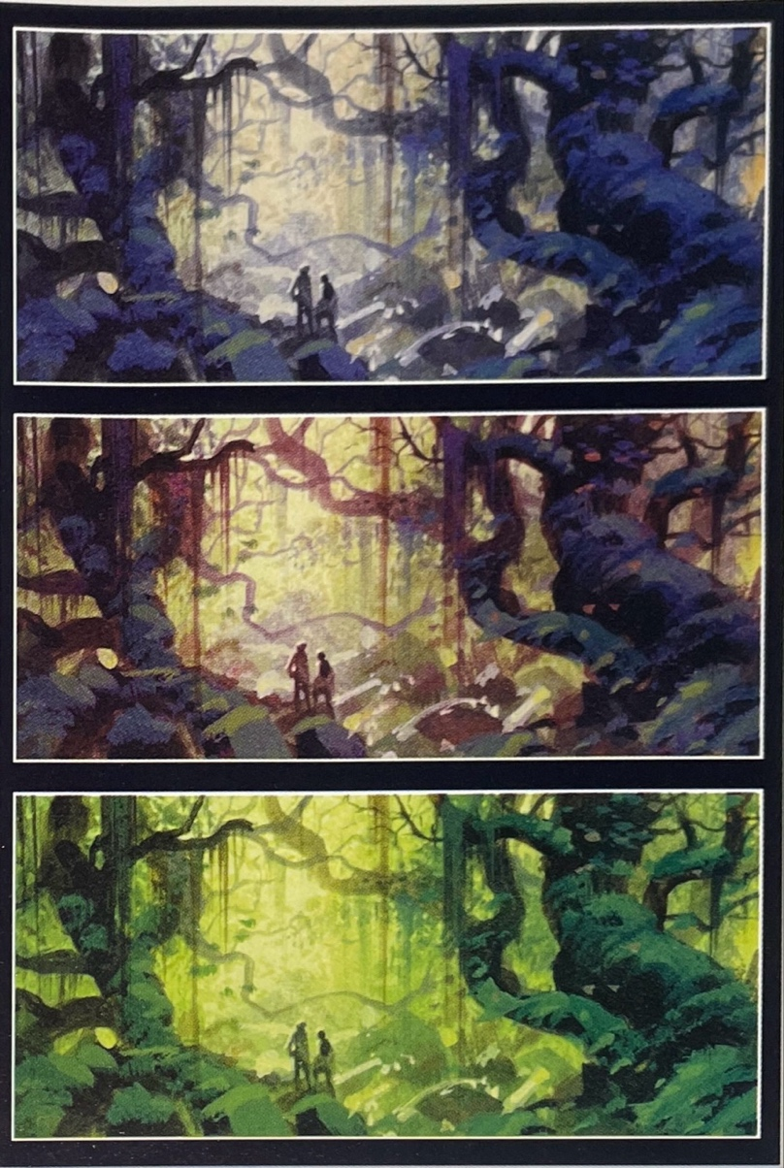
Fangorn, Paul Lasaine (2002)
Artworks Seen in Film
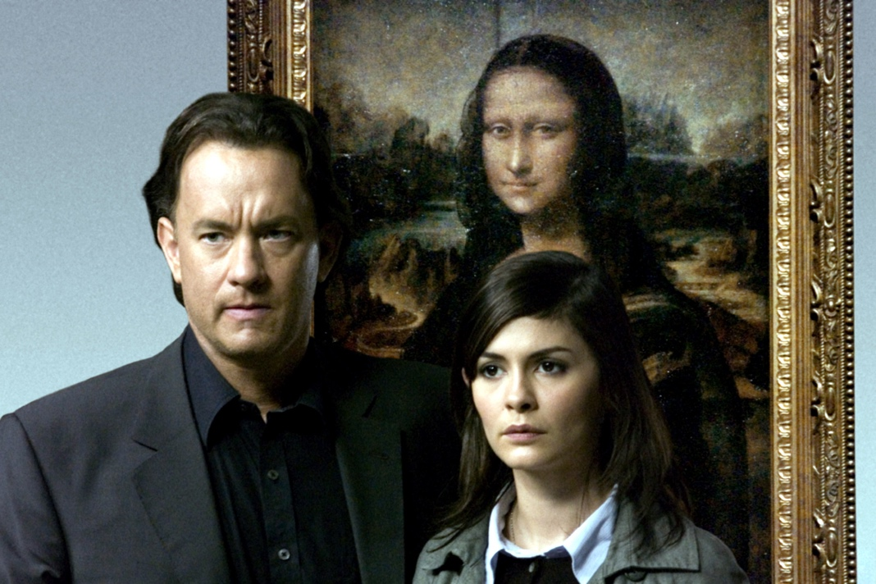
The Da Vinci Code (2006)
Artwork in film acts as a layer of meaning with filmmakers often incorporating artworks into their films, not only as background decoration, but as narrative and symbolic tools that can reflect a character's mindset, highlight the film’s themes, or foreshadow events.
One of the most famous examples of this is the use of The Mona Lisa in ‘The Da Vinci Code’ (2006), the painting plays a significant role within the story, with the artwork itself being central to the narrative's mystery and symbolism, including claims of hidden messages and coded clues.
Another example of this can be seen the ‘Skyfall’ (2012) from the James Bond franchise. Several famous paintings are featured prominently in the movie, although the painting shown most is J.M.W. Turner’s ‘The Fighting Temeraire’. The painting depicts the HMS Temeraire, being towed towards its final berth in Rotherhithe in 1838 to be broken up for scrap after its great role in the Battle of Trafalgar. Its placement in the film is deliberate and can be viewed as a reflection of Bond’s character perhaps outgrowing his position as Agent 007.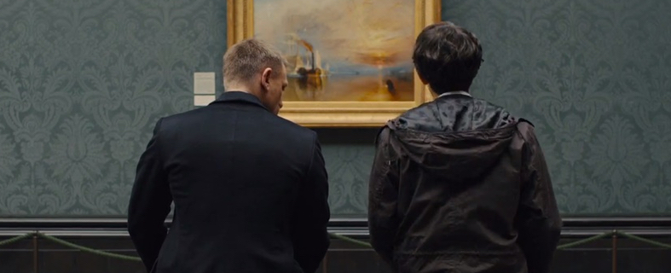The Fighting Temeraire in Skyfall (2012)
Finally, in The Fablemans (2022), artworks are used by Ford, played by David Lynch, to deliver advice to another character, Sammy. Ford uses the two paintings in his office, one of these being Frederic Remington’s ‘Fight for the Waterhole’, to speak on horizons and the rule of thirds, his advice being “When the horizon’s at the bottom, it’s interesting. When the horizon’s at the top, it’s interesting. When the horizon’s in the middle, it’s boring as shit.” Alongside Sammy, this lesson is also taught to the audience, bridging the gap in our minds between simply watching a movie or viewing a piece of art and seeing its director's or artist’s deliberate artistic decisions.
Fight for the Waterhole in The Fablemans (2022)

Artist Biographical Films
Rembrandt (1936)
Many films have been made to explore the lives of famous artists and highlight both the successes and struggles within their creative careers.
The first known artist biopic is generally considered to be ‘Rembrandt’ made in 1936. This movie follows the life of 17th-century Dutch painter Rembrandt van Rijn after the death of his wife as he faces tough times, of which eventually lead him to bankruptcy.
“Alexander Korda’s film Rembrandt provides a parallel between its topic and presentation, in that both the motion picture and the painter sought to humanize their subjects ... The production sets aside the typical birth-life-death formula found in countless movie biographies, and instead examines how the man’s individualism spread among his life and work.” (Eggert, 2009)

Some of the more famous biographical artist films include ‘At Eternity’s Gate’, which highlights Vincent Van Gogh’s final years of life, exploring the theory that his death was caused by manslaughter rather than suicide. The director, Julian Schnabel, as a painter himself, injects each frame of the film with light and colour and works well to capture Van Gogh’s love of and desire to make his art.
A final example is the 2014 biographical drama directed by Tim burton, ‘Big Eyes’. This film tells the true story of the painter Margret Keane in her legal battle against her husband who wrongfully takes credit for her art. The movie has moments where scenes mimics Keane’s paintings, with character’s eyes growing in size, sprinkling the film with that signature unsettling Burton-esque feel.
Big Eyes (2014)

Conclusion
The relationship between art and film is undeniable with artists, paintings, visual styles, and concept art shaping cinematic storytelling for decades. Film has shown to serve as a continuation of artistic tradition through its direct references to famous works, biographical explorations of artists, and the essential role of concept art in pre-production. By looking closely at these connections, we gain a deeper appreciation for how the visual arts influence and enrich the medium of film and cinema.

Bibliography
Bordwell, D., Thompson, K. and Smith, J. (2024) Film art : an introduction. Thirteenth edition. New York, NY: McGraw Hill LLC.

Hart, J. (John P. and Hart, J. (John P. (2013) The art of the storyboard : a filmmaker’s introduction. 2nd ed. Burlington, Massachusetts ; Focal Press.
Russell, G. (2003) The lord of the rings : the art of The two towers. London: HarperCollins.

HuntingBond. (2018) Fighting The Past. https://huntingbond.com/fighting-temeraire-james-bond/
Eggert, B. (2009) Rembrandt. Deep Focus Review. https://www.deepfocusreview.com/definitives/rembrandt/
Ng, V. (2019). Review: At Eternity’s Gate. Rough Cut. https://roughcutfilm.com/2019/02/12/review-at-eternitys-gate/

