
BA Business and Management
Learning and Collaboration for Global Citizenship
Module code: BMSP4015D
Bogdan Capraru 2520282
Portfolio on
A Portfolio of Learning Objectives, Reflection, and Career Development
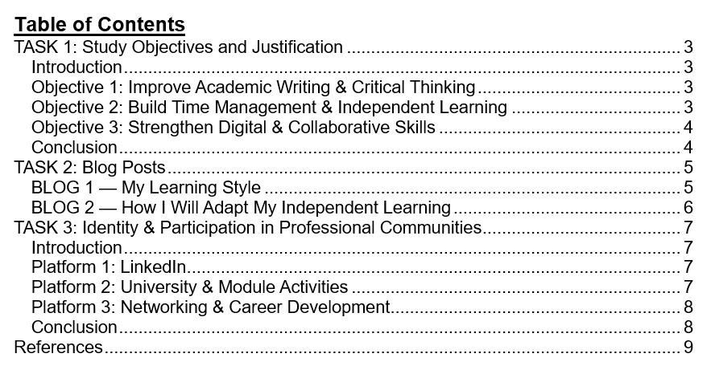

TASK 1: Study Objectives and Justification

Introduction
I am establishing goals to help in my academic and professional growth. A definite set of goals will assist me in enhancing my competencies and aid my development. These goals will improve my education and equip me for the future challenges.

Objective 1: Improve Academic Writing & Critical Thinking
The goal is to enhance my academic writing and thinking. Business students need to write academic texts, as they help to convey ideas in a clear and logical way. Stella Cottrell in Study Skills Handbook argues that writing is useful in the process of organising thoughts and building strong points. Effective writing involves being clear, and this is essential in business reports, essays and presentations (Woldt and Nenad, 2021). Academic success is also very dependent on critical thinking. It enhances my analytical, judgemental and sound decision-making skills. According to Bloom's Taxonomy, thinking progresses in a progressive level of thinking using certain levels of cognition like remembering, understanding, analysing, and evaluating. Through these skills, I will be able to sharpen my decision-making skills in the workplace. These competencies aid in the employability process through enhancing the reasoning and judgement.

Objective 2: Build Time Management & Independent Learning
The second one is the development of time management and independent learning. Time management is essential to success in the university since it assists in balancing between college and personal life. Time management helps eliminate stress and maximise output. The Adult Learning Theory of Knowles underlines the fact that adults are the best learners when they are self-directed and autonomous (Best and Williams, 2021). This involves being accountable to my learning, being goal-orientated, and keeping track. Covey's Time Management Matrix assists in making priority tasks and divides urgent emergency academic tasks and important ones. Time management will result in positive academic performance, as well as improve the learning experience. The relationship between time management and better academic performance has been researched. I would meet the deadline and at the same time deliver the high-quality work.

Objective 3: Strengthen Digital & Collaborative Skills
The third goal is to enhance my online and teamwork capabilities. Both the university and business environments require digital literacy. In the contemporary world, students are learning, researching and collaborating online with the use of digital skills. The Jisc Digital Capabilities Framework identifies the significance of digital literacy in contemporary education (Almont et al., 2021). The framework highlights the fact that being digitally competent is important to enable students to succeed in their academic and career settings. It is also significant to collaborate, as they are prepared to work as a team in a workplace. Tuckman's Model: The Tuckman model is a model that is used to explain the development of groups in four steps, which are forming, storming, norming and performing. Such phases assist learners to be aware of the dynamics of working as a team and enhance teamwork skills.

Conclusion
These are the aims that will steer my development in terms of skills during my studies. They will help me to learn, enhance my confidence, and become more employable in the future.

TASK 2: Blog Posts

BLOG 1 — My Learning Style
Introduction
I have just done a learning style test that has made me realise my best learning styles. The score showed that I am a pragmatist. This implies that I like to study through the practise of applying theory to a real-life situation (Gouvea Silva et al., 2024). This outcome did not come as a complete surprise to me because I have never been fond of abstract concepts but practical applications of concepts.
What is the result?
Pragmatists are best learners through trial of theories in practical circumstances. The learning cycle created by Kolb (1984) also deals with active experimentation. This is my learning style because I like trial and error to learn and apply it (Hung et al., 2023). Nevertheless, the types of critique learning, which are argued to be, are not so effective as it is assumed. They also recommend the learner employ a number of strategies to ensure that they can be flexible and enhance general learning.
Research interpretation
To enhance my learning, I need to pay attention to the application of theory to practical cases, testing of new concepts, and evaluation of my experience. This will increase my problem-solving capabilities and make me more interested in learning new complex concepts and so on.
Conclusion
Finally, the knowledge of my learning style as a pragmatist will aid me in preparing my studies in a more effective manner. By prioritising the application of theory to practise, I will be able to optimise my learning process and performance in school.

BLOG 2 — How I Will Adapt My Independent Learning
Introduction
Continuing on my findings on Blog 1, I intend to modify my independent learning to enhance my studying behaviour. As I tend to learn best when I can apply the knowledge in practise, I will begin to use planning tools, including Notion, Trello, and Outlook. These aids will guide me to prepare my tasks.
What changes will I make?
I will also enrol in study skills seminars to enhance my study skills and time management. The Pomodoro technique that entails concentration work and brief intervals between work will also be adopted. This approach will assist me in being productive and being focused.
Support I need
To facilitate my learning, I will also consult academic advisors during the meetings so as to clear my doubts and get advice on how to better my studies. I will also use peer study groups where I will discuss course materials with the other students and cooperate.
Gibbs’ Reflective Cycle
In a bid to reflect on it, I will rely on Gibbs' Reflective Cycle that will enable me to sort out my learning experiences and improve them (Ocampo et al., 2025). This model would develop critical thinking of what has been good and what could be done differently in future learning contexts.
Conclusion
Finally, the ability to adjust my independent learning with the help of digital tools, workshops and collaborating with peers will have a positive influence on my academic achievement. These strategies will help me to manage the learning process.

TASK 3: Identity & Participation in Professional Communities

Introduction
It is important to develop a professional image in order to succeed and develop in the professional sphere. Professional identity is powerful and can make one stand out, and the opportunity for career growth is developed. In the modern competitive professional environment, it is important to create a unique professional image (Fitzgerald, 2020). The development of a professional image online is also becoming quite relevant, and online channels are becoming an important part of personal careers.

Platform 1: LinkedIn
LinkedIn is a potent tool for establishing a career. To attract a good profile, I will make sure my profile contains a professional photo, an attractive headline, and a well-written About section. This will assist in bringing out my skills, experiences and aspirations. I will also undertake content development through posts of industry knowledge, informative articles, and personal success, which will make me an active participant in my industry. LinkedIn networking will also provide the benefit of increasing my network by connecting with business professionals. By becoming a member of the industry groups, I will be able to get into a discussion and follow the trends (Khan et al., 2024). I will also present my university projects and coursework, which will prove my academic abilities and practical experience. The relevance of personal branding when developing a professional image. The effective use of LinkedIn will increase my presence as a professional on the Internet.

Platform 2: University & Module Activities
Another platform for building my professional identity is university and coursework activities. In an illustration, my experience with the Sustainable Enterprise Management is associated with the possibility to implement sustainable business concepts. I will use the coursework projects to show my problem-solving, research, and analytical skills. Teamwork behaviour through working on projects in groups will enable me to demonstrate my leadership behaviour (Moodi et al., 2023). Being an effective team player will not only add professional identity to me, but it will also advance my interpersonal skills that are needed in the workplace. Such activities will enable me to put into practise what I have learnt in a real-world environment, and this will further improve my skill set.

Platform 3: Networking & Career Development
To develop a professional identity, networking and career development are necessary. I will also attend university events like workshops and networking so that I can be exposed to the job market professionals. Joining or volunteering in university societies will be a good experience and will assist me to develop my network. Part-time jobs or internships will provide me with practical experience, as I will be able to use my theoretical knowledge in practise (Romasanta et al., 2020). The membership of professional bodies, e.g., the Chartered Institute of Marketing (CIM), for students of marketing, will assist me in broadening my network and prove that I am interested in the industry.

Conclusion
These are the steps that will contribute to the development of my professional identity and increase employability. Through LinkedIn, university activities and networking, I will acquire the much-needed skills. Such undertakings will also bring about global citizenship through a network of professionals with different backgrounds. These contacts will equip me with the future career prospects.

References
Almont, T., Bujan, L., Joachim, C., Joguet, G., Vestris, M., Houpert, R., Rodriguez, R. E., Carmenate, J., Gutierrez, B., Galán, Y., Kleinebreil, L., Mésenge, C., Huyghe, É., & Véronique-Baudin, J. (2021). Collaborative digital platform France - Cuba: Oncorehabilitation in reproductive and sexual health. BMC Medical Education, 21(1), 337. https://doi.org/10.1186/s12909-021-02774-w
Best, S., & Williams, S. J. (2021). What have we learnt about the sourcing of personal protective equipment during pandemics? Leadership and management in healthcare supply chain management: A scoping review. Frontiers in Public Health, 9, 765501. https://doi.org/10.3389/fpubh.2021.765501
Fitzgerald, A. (2020). Professional identity: A concept analysis. Nursing Forum, 55(3), 447–472. https://doi.org/10.1111/nuf.12450
Gouvea Silva, G., Costa, C. D. D. S., Gonçalves, B. C., Vianney Cidrão Nunes, L., Dos Santos, E. R., Lopes, S. M. M., Lima, A. R. A., Brienze, V. M. S., Bizotto, T. S. G., & André, J. C. (2024). Learning styles of medical students, surgical residents, medical staff, and general surgery teachers when learning surgery: Protocol for a scoping review. JMIR Research Protocols, 13, e57229. https://doi.org/10.2196/57229
Hung, L. Y., Wang, S. M., & Yeh, T. K. (2023). Kolb's experiential learning theory and marine debris education: Effects of different stages on learning. Marine Pollution Bulletin, 191, 114933. https://doi.org/10.1016/j.marpolbul.2023.114933
Khan, R., Akhund, R., Allahwasaya, A., Wang, R., Chen, H., Gillis, A., & McMullin, J. L. (2024). LinkedIn usage trends among surgeons at a large academic institute. Journal of Surgical Research, 295, 770–775. https://doi.org/10.1016/j.jss.2023.11.069
Moodi, S., Mehrbakhsh, Z., Amtaeh, F., & Moghasemi, S. (2023). Comparing the self-awareness and problem-solving skills training on sexual desire of newly married women: A field trial study. Journal of Education and Health Promotion, 12, 226. https://doi.org/10.4103/jehp.jehp_739_22
Ocampo, F. A., McIntyre, B. G., Massey, D., & Saunders, R. (2025). Nursing student reflections on a research internship: A reflective discussion following the Gibbs' reflective cycle. Nurse Education Today, 145, 106481. https://doi.org/10.1016/j.nedt.2024.106481
Romasanta, A. K. S., van der Sijde, P. C., Smit, M. J., de Esch, I. J. P., Jahnke, W., & van Muijlwijk-Koezen, J. E. (2020). Career development in fragment-based drug discovery. Drug Discovery Today: Technologies, 37, 107–116. https://doi.org/10.1016/j.ddtec.2020.10.001
Woldt, J. L., & Nenad, M. W. (2021). Reflective writing in dental education to improve critical thinking and learning: A systematic review. Journal of Dental Education, 85(6), 778–785. https://doi.org/10.1002/jdd.12561

