Jessica Hazelden

Café Braz – Community Hub

Table of Contents
Reflective Commentary 3
Evidence 5
Employee Well-Being Strategy 6
Café Braz’s Values Statement 9
References 10
Appendices 11

Reflective Commentary
My voluntary placement at Café Braz, a local community hub café, has been a beneficial experience, professionally, and personally. The café provides a safe space and welcome environment where people can meet, drink/eat, and have the opportunity to talk openly. The goal is to provide a safe space for social interaction, community building and emotional support. This reflective log is based on my experience, and using the Gibb’s Reflective Cycle (1988), aims to provide an insight into my development, challenges, and the lessons I’ve learnt.
Description
The community hub café I worked at was designed to provide a space where people can connect with others, share stories, and find emotional support when/if needed. As a volunteer, my duties involved not only preparing and serving food and drinks but also engaging with customers, offering them a welcoming and friendly atmosphere. Another big part of my role was actively listening to community members who came in, some of which would be looking for general emotional support or simply companionship. I often engaged in conversations, offering a listening ear to those who needed it, and learning the importance of being present in those moments.
Feelings
At the beginning of my placement, I felt slightly nervous. I was looking forward to helping and contributing to the café itself, but I wasn’t sure how I would handle any possible emotional demands that the job may have entailed, particularly if I would connect with people who could have been going through something difficult. There were times where I felt moved by the personal stories shared with me, and sometimes I also felt emotionally exhausted by the weight of those conversations. However, there was a deep sense of satisfaction, especially when I could see that just by my being present and listening, or having a general chat, had a positive impact. Over time, I became more comfortable with the emotional aspects of the role and developed a good connection with regular customers of the café.
Evaluation
Reflecting on my experience, I realise how different this role iss from any previous jobs I’ve had. The café isn’t just a place to serve food and drinks, it’s a space for emotional interaction and social engagement that is important to many members of the community. One thing I found most impactful was learning to actively listen and engage with people. To begin with I wasn’t sure how much my listening would make a difference, but I quickly saw that for many people, simply having someone to talk to had a really big impact on their day. This aspect of the work helped me develop essential skills, particularly in active listening, empathy, and interpersonal communication.
On the other hand, a challenge I faced was managing situations when there was tension between customers. There were one or two disagreements or misunderstandings that happened between customers who were discussing something important to them and a conflict of interest arose, and I initially found it difficult to know how to address that situation. I was unsure of how to intervene or whether it was appropriate for me to get involved at all. However, my colleagues stayed calm and, in those situations, and I was able to learn from their approach to conflict resolution. I now feel better equipped and more confident on how to handle those type of situations, although I am still aware of areas where I could improve my skills, particularly on how to de-escalate tense situations or discussions and whether it’s appropriate for me to do so.
Analysis
Using Gibb’s Reflective Cycle (1988), I can recognise the skills I have developed and the challenges I faced. The role required me to build both professional and emotional skills, especially in active listening. At first, I underestimated the power of listening and the importance of emotional support in a community setting. Research suggests that spaces like community cafés play an essential role in promoting mental health and well-being, providing people with a sense of belonging and connection (Dunlap, 2013). This aligns with my experience, as I was able to see first hand how the café provided much more than just food and drink, it also gave people an opportunity to feel heard and supported.
Interpersonal skills were crucial in this role. I needed to adapt my communication style depending on who I was interacting with. Some people just wanted a quick chat about the weather, and others needed someone to just listen to their struggles. I learned the importance of being aware and adjusting my approach accordingly. Conflict resolution also became a key skill as I dealt with moments of tension. While I wasn’t always sure how to handle these situations, I can see the importance of remaining calm, listening to both sides, and offering a neutral and unbiased presence to help resolve conflicts.
Conclusion
Reflecting on my time at the Café Braz, I feel that the experience has been very rewarding. It gave me an opportunity to develop key skills such as active listening and effective communication. These skills are not only valuable in a volunteer setting but in many professional environments where empathy and strong interpersonal skills are important (Heath & Bryant, 2018). I’ve learned how crucial it is to create spaces where individuals feel safe to open up and share if they need to.
The emotional support I provided and received in return from the community made me see how much value there is in simply offering someone a space to talk. I also appreciated how important it is to approach each interaction with empathy (Rifkin, 2016), as the café isn’t just a place for food but somewhere that mental health is supported. Research on volunteering suggests that these kinds of spaces can have a significant positive impact on both the volunteers and the people they serve (Griffiths & Tuckett, 2019), and I saw this for myself.
Action Plan
I have been offered a more permanent role in Café Braz and plan to build on the skills I have already developed. If I were to encounter similar situations I would approach them with more confidence. Through reflection, I can see that being present and offering support without feeling the need to fix everything is of great importance to.
I also aim to further improve my conflict management skills. Although I think made some progress in this area, I believe that more training in conflict resolution strategies could help me handle those kind of situations better in the future. Additionally, I want to continue practicing active listening and empathy in both professional and personal settings, as these skills are very important to building strong, supportive relationships.

Evidence
Pictures
The café is small and quaint, and provides a really welcoming environment, as well as a designated area for anybody who specifically would like to chat. This made differentiating customers a lot easier in certain situations when I wasn’t entirely sure if emotional support was needed, which in turn helped me to realise I was actually very good at gauging when people were in need of someone to listen to them.
*ALL PEOPLE HAVE GIVEN CONSENT TO BE SHOWN IN PICTURES*
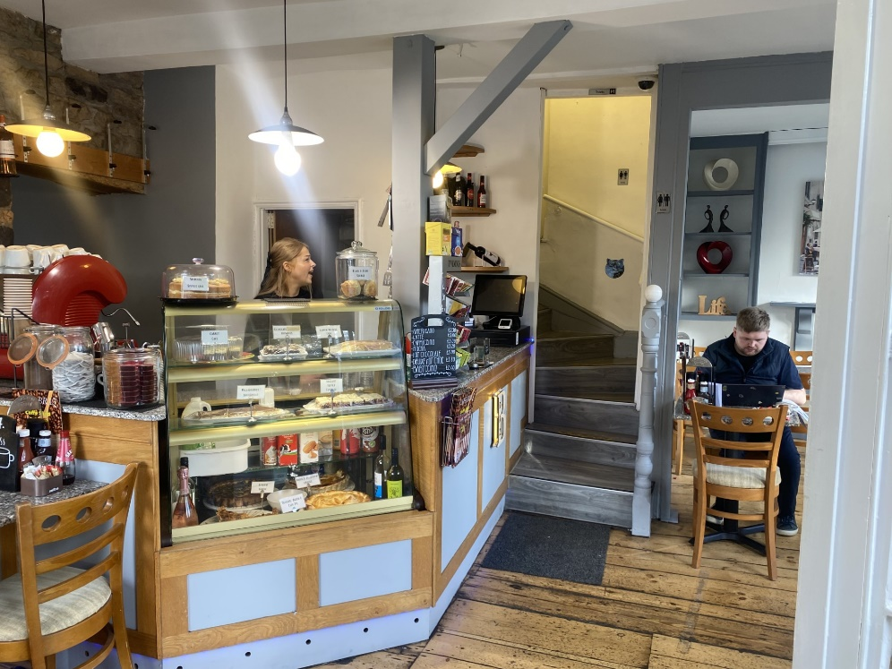
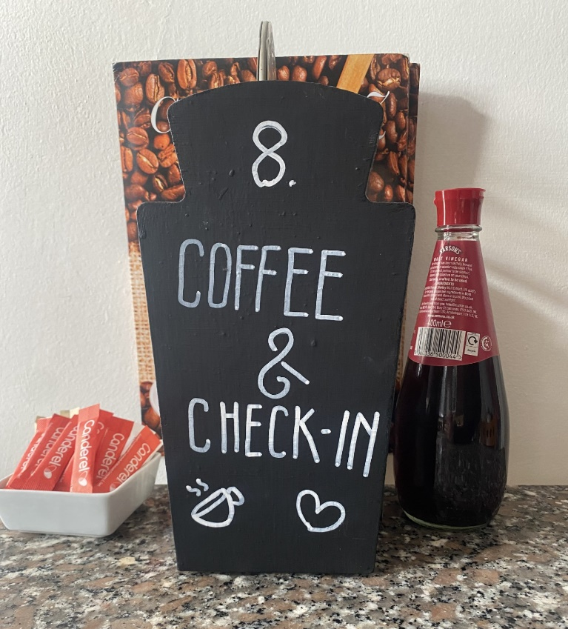

Employee Well-Being Strategy
Café Braz’s well-being strategy helped me to feel like they really care about their staff’s mental and physical health as well as their customers. They made it clear to me that their thought process on this was that as staff, we are unable to provide the emotional support for our customers if we are not also looked after and listened to. Well-Being strategy attached -

1. Introduction: The Importance of Well-Being in a Café Braz
In a community hub café like ours, employees often wear many hats: they provide hospitality services, offer emotional support, engage in active listening, and help build a sense of community. These responsibilities, while rewarding, can also lead to physical and emotional strain. Given the Braz’s focus on offering a welcoming space for individuals, ensuring employee well-being is crucial to creating a positive environment for both employees and customers. This strategy is designed to address the unique needs of employees working in such a setting by focusing on physical health, mental health, emotional resilience, and work-life balance.
2. Objectives of the Well-Being Strategy
- Promote Physical Health: Ensure employees are able to stay physically healthy, energised, and productive throughout their shifts.
- Support Mental Health: Provide a safe space for employees to manage the emotional demands of the job, including the challenges of active listening, conflict resolution, and dealing with sensitive issues.
- Enhance Job Satisfaction: Create an environment where employees feel valued, supported, and recognised for their contributions to the café and the community.
- Encourage Work-Life Balance: Provide strategies to ensure employees are able to maintain a healthy balance between work and personal life, avoiding burnout and promoting long-term well-being.
3. Key Components of the Well-Being Strategy
A. Mental Health Support
- Training in Emotional Resilience and Active Listening: Given the emotional nature of the work, employees will be trained in techniques for emotional resilience, active listening, and boundary-setting. This will help them manage emotional labour effectively and avoid burnout from interacting with individuals experiencing emotional distress.
- Peer Support System: Establish a peer support network within the Braz where employees can share experiences, challenges, and coping strategies. This system fosters a sense of camaraderie and reduces feelings of isolation.
B. Physical Health and Workplace Comfort
- Ergonomic Workplace Design: Ensure that the physical setup of the café promotes good posture and reduces physical strain. Provide standing mats, and workstations that are designed to minimise discomfort during long hours.
- Regular Breaks and Rotation: Schedule regular breaks to prevent fatigue, particularly for employees who are on their feet for extended periods. A rotating schedule of tasks, such as switching between customer service, food preparation, and cleaning, can help prevent monotony and reduce the strain from repetitive tasks.
- Access to Healthy Snacks and Beverages: Offer employees free access to healthy snacks, fresh fruits, and beverages (like water, herbal teas, and juices) during their shifts. Providing nutritious options ensures employees stay energized and hydrated.
C. Mental and Emotional Well-Being
- Encouraging Open Communication: Cultivate a workplace culture where employees feel comfortable expressing their thoughts and feelings. Regular check-ins with supervisors, informal meetings, or team-building activities can encourage open communication.
- Recognition and Appreciation: Celebrate employee achievements and milestones, whether it's through formal awards, informal shout-outs, or simple gestures like a thank-you note or a team lunch. Recognising the emotional labour employees provide by being supportive to customers can make them feel valued and appreciated.
D. Work-Life Balance
- Flexible Scheduling: Allow for flexible working hours or shift swaps to help employees balance their work commitments with personal or family needs. Offering part-time options or the ability to adjust work hours can help alleviate stress, particularly for those with caregiving responsibilities.
- Paid Time Off (PTO) and Mental Health Days: Provide employees with a generous amount of paid time off (PTO) that can be used for vacations, personal days, or mental health days. Encourage employees to take regular breaks to recharge and prevent burnout.
- Encourage Vacation Use: Ensure that employees are taking their scheduled vacation time and not working overtime or under pressure to constantly be available. This prevents burnout and fosters a culture of self-care.
E. Professional Development and Career Growth
- Opportunities for Training and Advancement: Offer training programs that can enhance employees' skills, both within the café setting (such as customer service or food safety training) and in broader areas (such as leadership, conflict management, and mental health awareness).
- Career Pathways: Provide clear career development pathways within the organisation. Offering opportunities for advancement helps employees feel they have room to grow, which in turn boosts motivation and job satisfaction.
- Mentorship and Coaching: Pair employees with mentors who can offer guidance and support, particularly for new hires or those who are experiencing challenges in managing the emotional demands of the job.
4. Implementation and Evaluation
To ensure the success of this well-being strategy, regular evaluation is essential. This can be achieved by:
- Employee Surveys and Feedback: Conduct regular surveys or hold feedback sessions where employees can express their satisfaction with the current well-being initiatives and provide suggestions for improvement.
- Well-Being Metrics: Track key metrics related to employee well-being, such as job satisfaction, absenteeism rates, turnover rates, and use of wellness programs. These metrics can help gauge the effectiveness of the well-being strategy and identify areas for improvement.
- Regular Check-ins with Leadership: Supervisors and managers should have regular check-ins with employees to assess their well-being and to ensure that support is being provided in line with the strategy.

Café Braz’s Values Statement
This café’s values helped me to understand how important it is to be able to use active listening skills in an environment where mental health is deemed important in the community as an entirety.

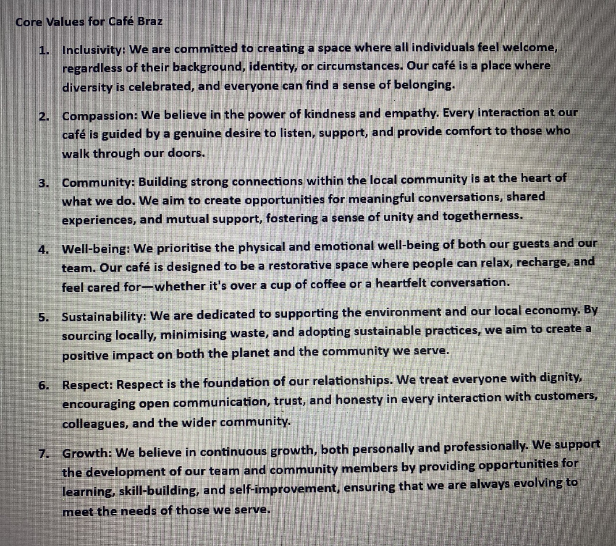

References
Dunlap, D. W. (2013). The importance of community engagement in fostering mental health.
Social Science & Medicine, 89, 41-47.
Gibbs, G. (1988). Learning by doing: A guide to teaching and learning methods. Further
Education Unit.
Griffiths, C. L., & Tuckett, A. G. (2019). Volunteering and well-being: The effects of
volunteering on physical and mental health in community settings. Health & Social Care in the Community, 27(6), 1812-1821.
Heath, C., & Bryant, J. (2018). Emotional labor and the delivery of support services:
Understanding volunteer experiences in social care. Journal of Applied Social Psychology, 48(12), 708-718.
Rifkin, J. (2016). The age of empathy: Nature’s lessons for a kinder society. Penguin.

Appendices
Information Form
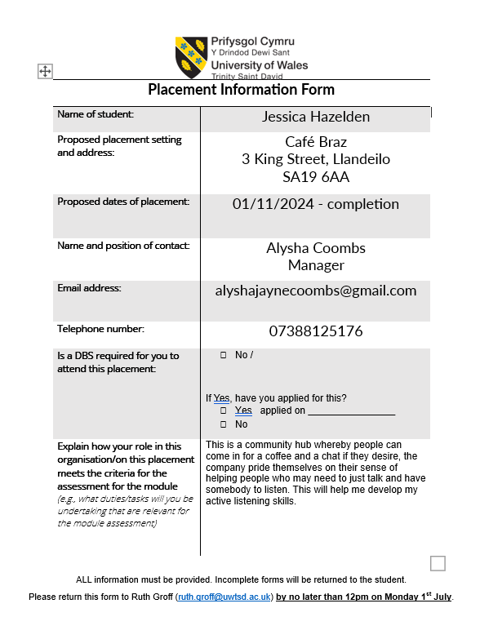

*I do not have physical confirmation of my work placement acceptance as I went in person to speak with the manager and did not receive any correspondence, I also did not receive confirmation from my module lead – who accepted my work placement – as this was done face to face.

Hours Completed
I have completed 120 hours of voluntary work at Café Braz.

