Name: Jared Nickson
Student Number: 2305434
Student Email: 2305434@Student.Uwtsd.ac.uk
Assignment Title: Group Presentation (with supporting material)
Module code: ACCA4027
Module Title: Contemporary Challenges: Making A Difference

My presentation YouTube link:
https://www.youtube.com/watch?v=xjDHDzPAS1o
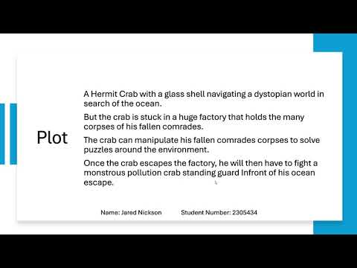

My presentation link: (References are shown in the PowerPoint using squared brackets)
Group Presentation my slides - Jared Nickson

Link to the Full presentation:
https://www.youtube.com/watch?v=We_AM_oSqbc
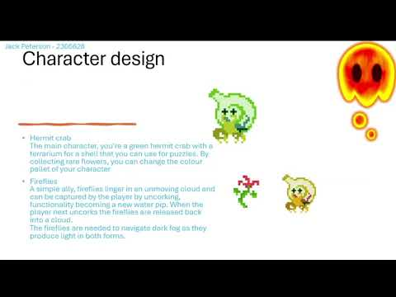

Screenshots of my own section of slides:
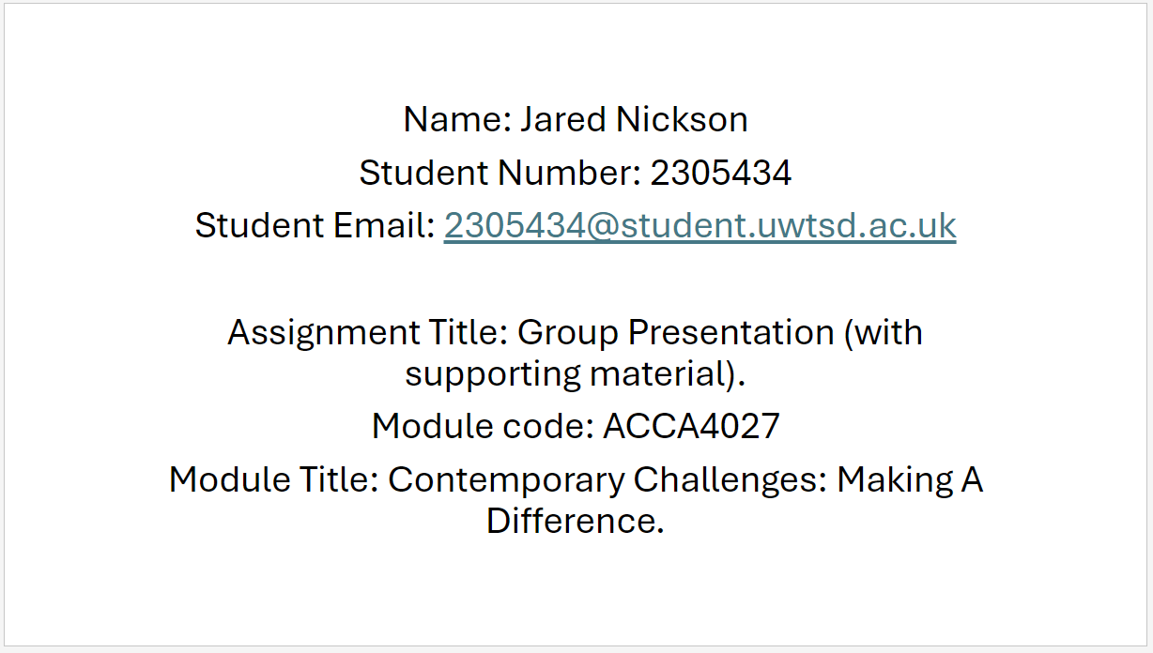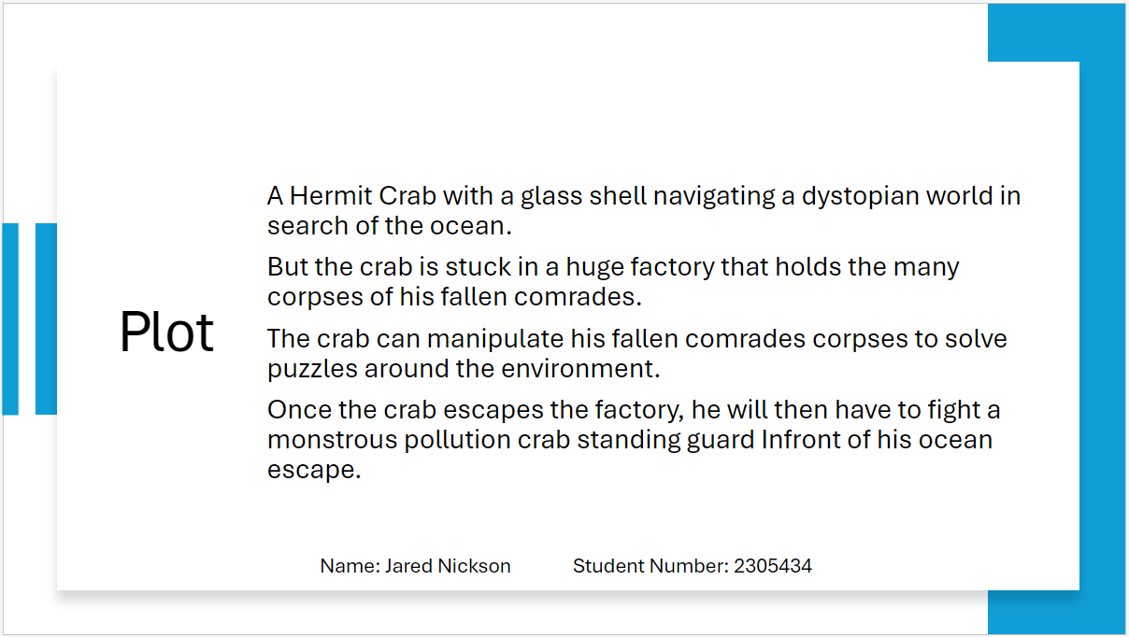
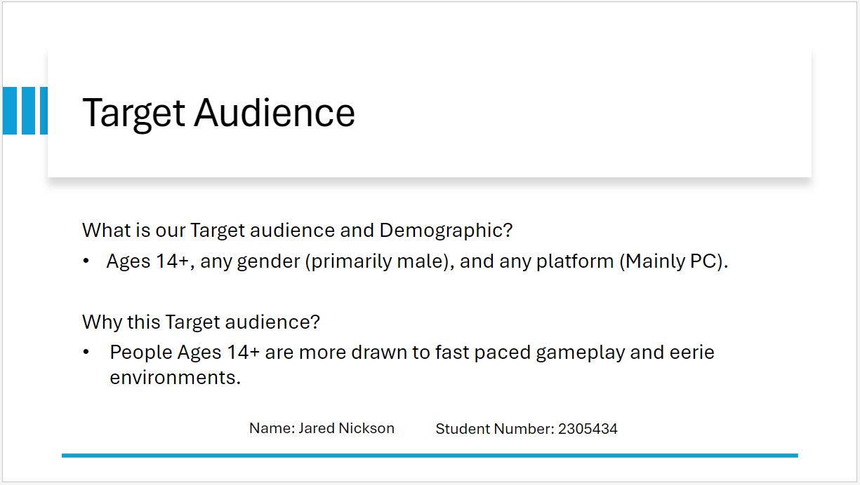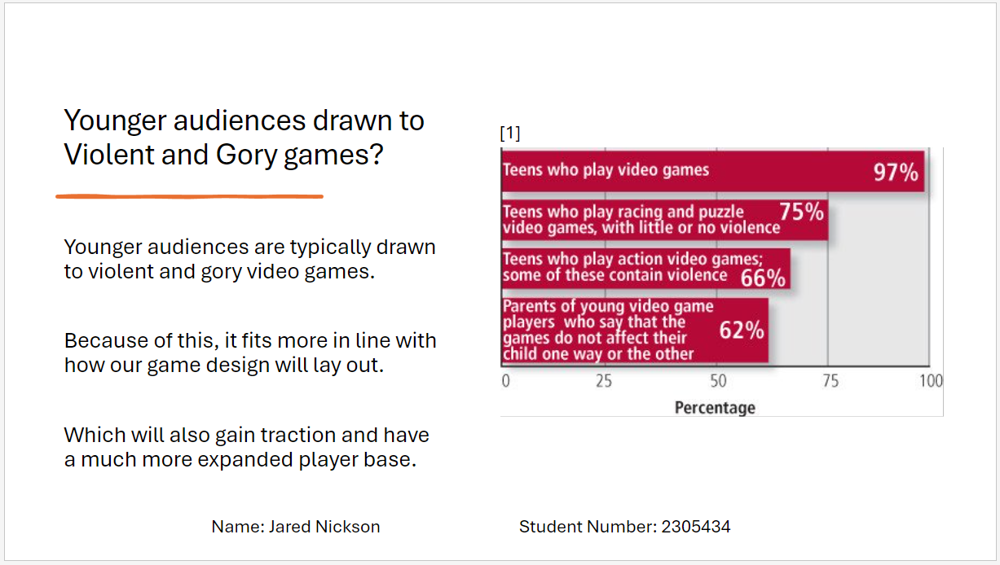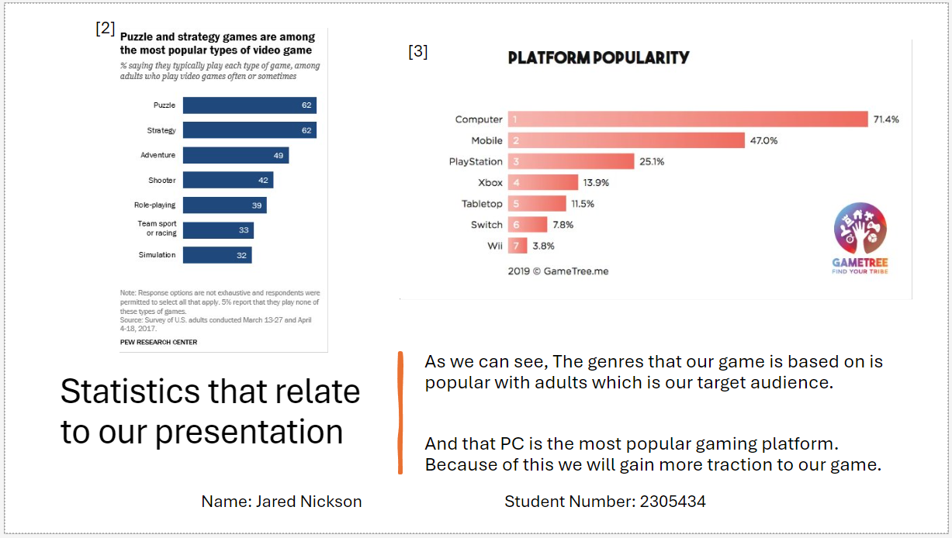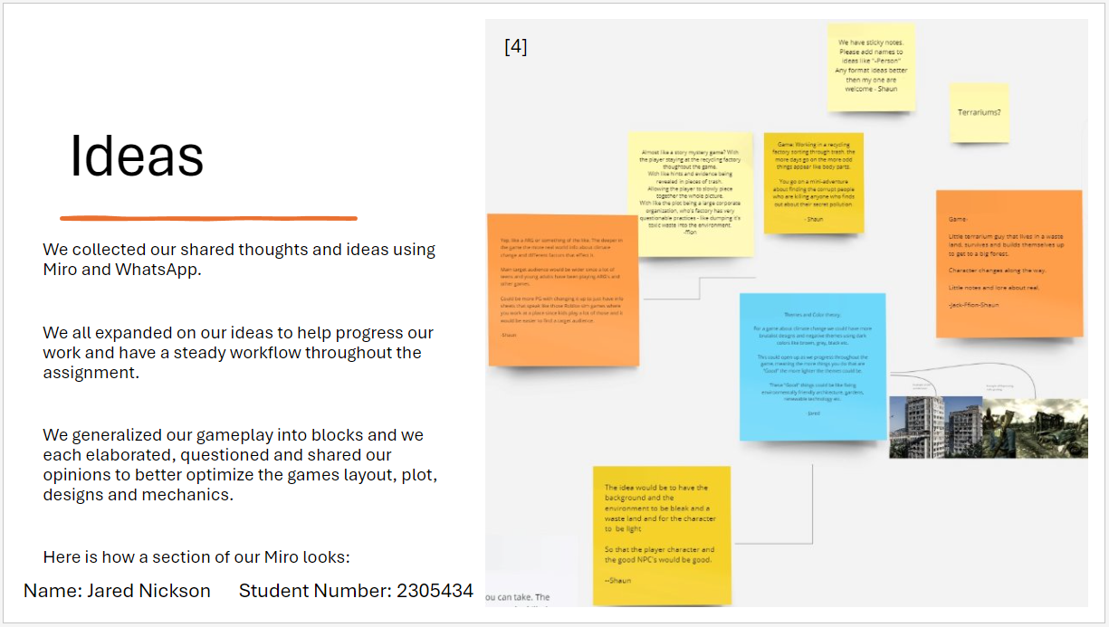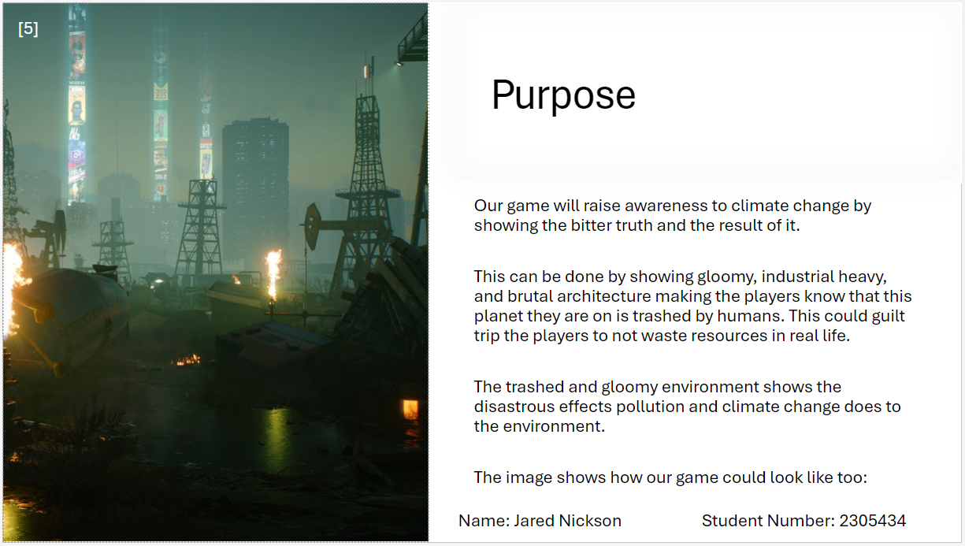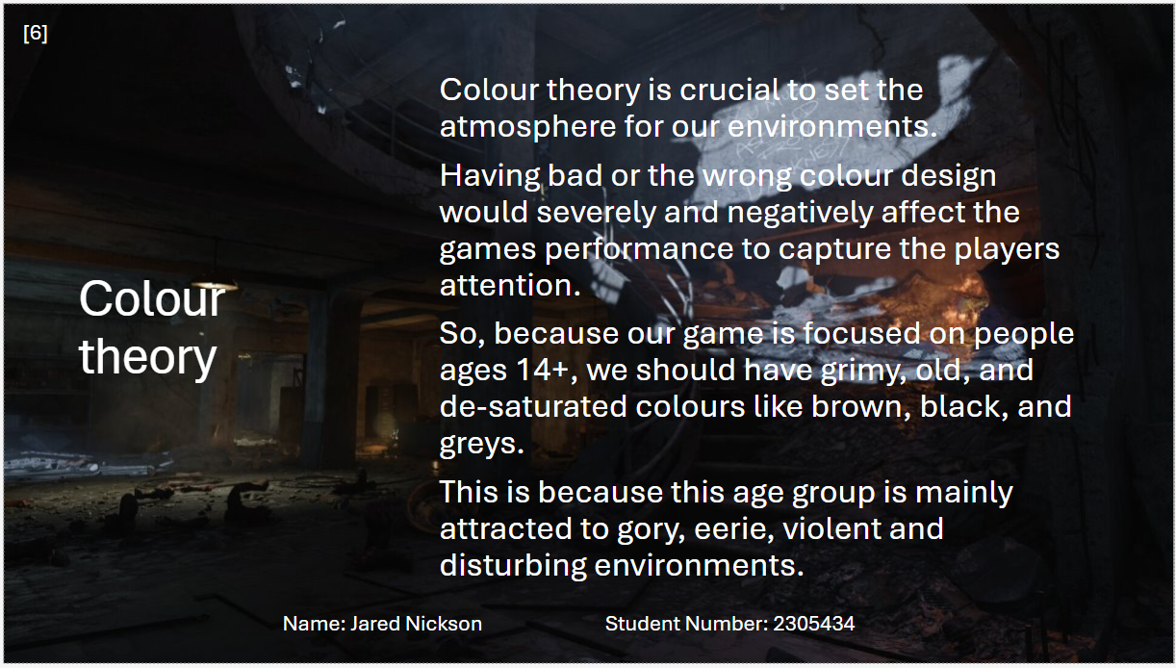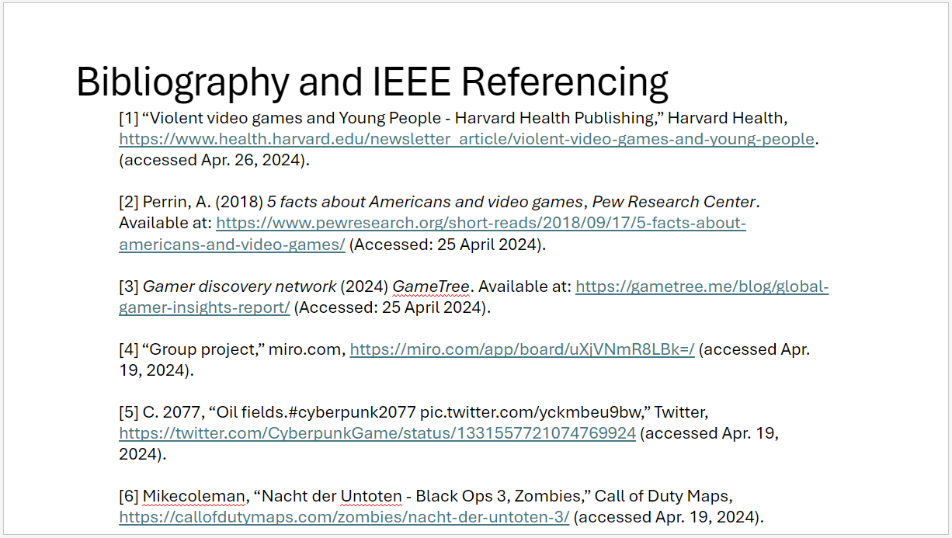

Here is my additional work and research I conducted on Miro: (References are shown with squared brackets)

I expanded on the plot, and I simplify it for the presentation:
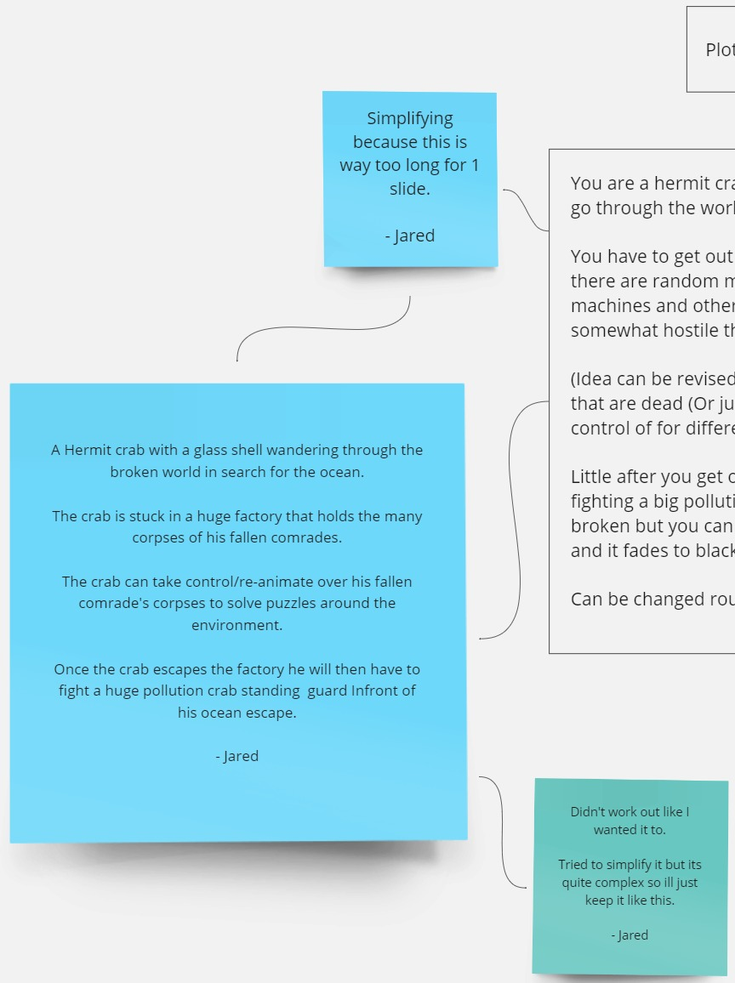

I state my preferred role for the project which I stayed with:
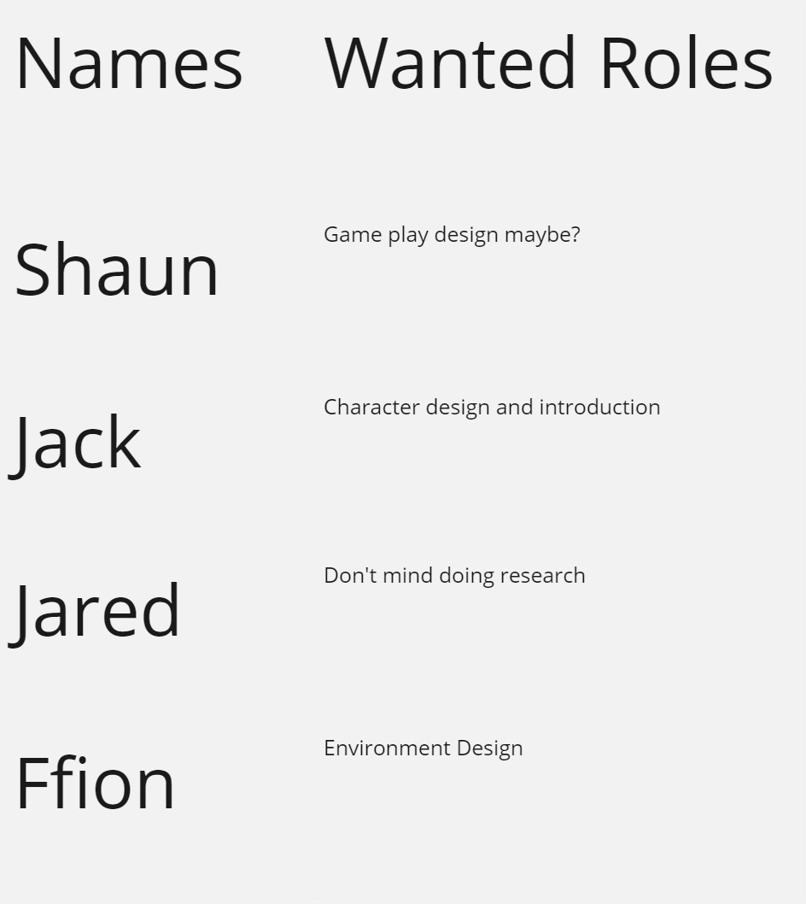

I share my ideas and respond to what someone said:
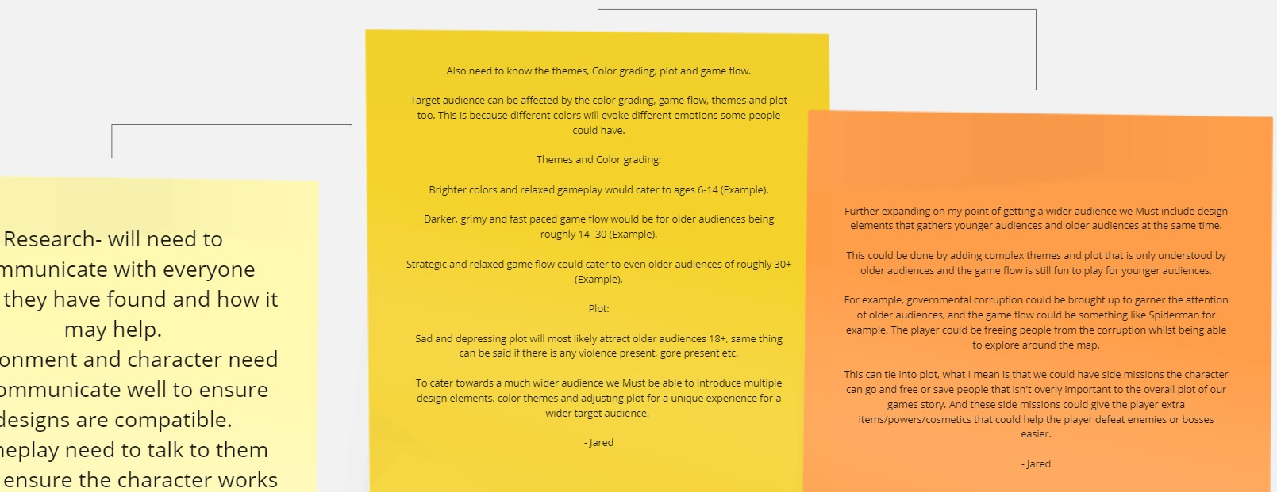

I share my ideas about how our games colour grading and themes could be, and I show examples and references to how they could look:
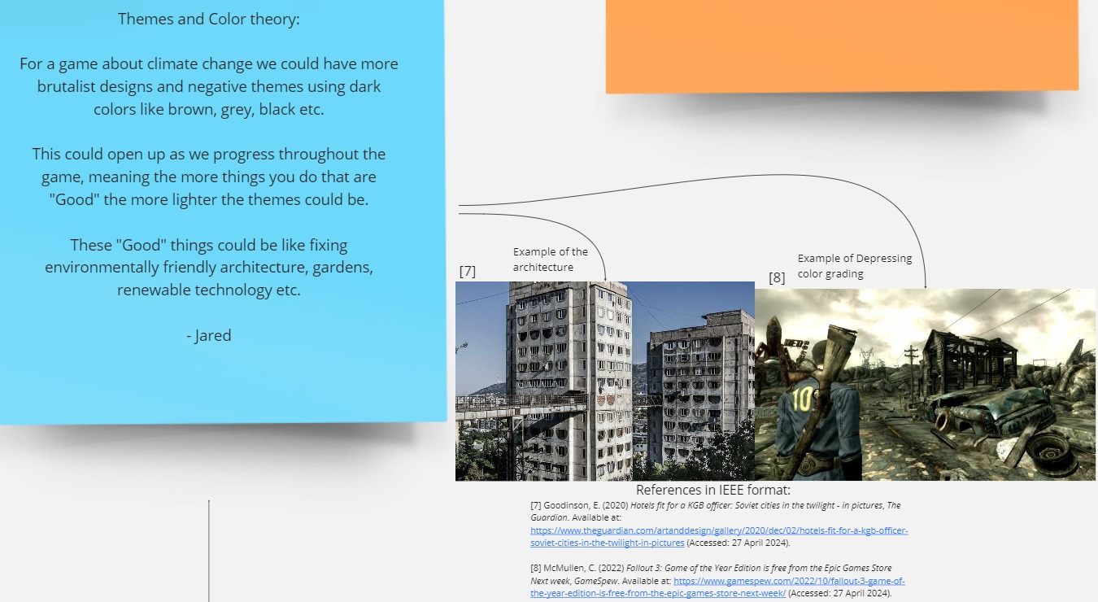
Here I discuss about what I and someone should talk about when mentioning colour theory as I am doing the research which must also cover colour theory:
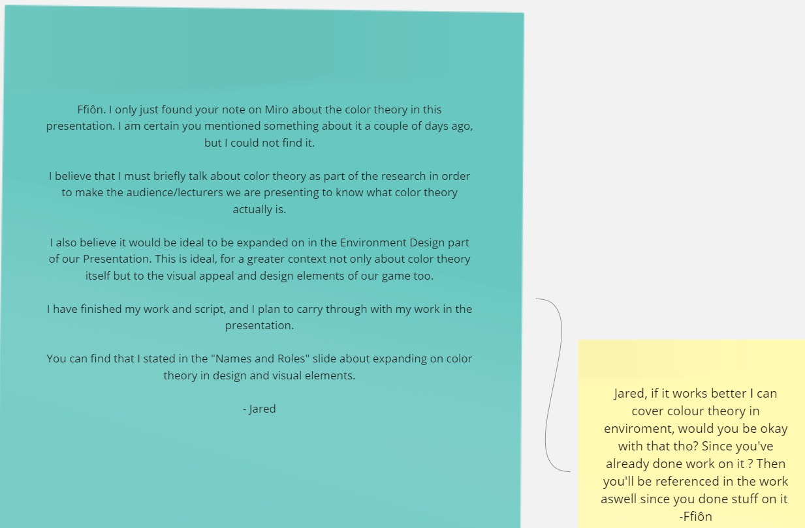

My Script:
Slide 1:
Hi, I am Jared, I will be going over the research aspects of our presentation.

Slide 2:
The plot consists of: A Hermit Crab with a glass shell navigating a dystopian world in search of the ocean. But the crab is stuck in a huge factory that holds the many corpses of his fallen comrades. The crab can manipulate his fallen comrades corpses to solve puzzles around the environment. Once the crab escapes the factory, he will then have to fight a monstrous pollution crab standing guard Infront of his ocean escape.

Slide 3:
Our target audience is aimed at people aged 14+, any gender predominantly male, and any gaming platform primarily pc.
Why this target audience you may ask.
People within this age group are more likely drawn to the eerie, gory, and unsettling environments and fast paced gameplay.

Slide 4:
Younger and older audiences are typically drawn to violent and gory video games compared to different age groups. Because of this, it fits more in line with how our game design will be laid out. Which will gain traction and have a much more expanded player base.

Slide 5:
As we can see, the genres our game is based on are popular with adults, which is most of our intended target audience. We can see that PC gaming is the most popular gaming platform. Because of this we will additionally get increased traction to our game.

Slide 6:
We collected our shared thoughts and ideas using Miro and WhatsApp. We all expanded on our ideas to help progress our work and have a steady workflow throughout the assignment.
We generalized our gameplay into blocks and we each elaborated, questioned, and shared our opinions to better perfect and optimize the games layout, plot, designs, and mechanics.
Here is how a section of our Miro looks:

Slide 7:
Our game will raise awareness of climate change by showing the bitter truth and the result of it.
This can be done by showing gloomy, industrial heavy, and brutal architecture making the players know that the planet they are on is trashed by humans. This could guilt trip our target audience to not waste resources in real life.
The trashed and gloomy environment shows the disastrous consequences pollution and climate change have on the environment.
The image here also shows how our game could look like too:

Slide 8:
Colour theory is crucial to set the atmosphere for our environments.
Having bad or the wrong colour design would severely and negatively affect the games performance to capture the players attention.
So, because our game is focused on people ages 14+, we must have grimy, old, and de-saturated colours like brown, black, and greys.
This is because this age group is attracted to the gory, eerie, violent, and disturbing environments.

Slide 9:
And here is my Bibliography and references in I triple E format:

What went wrong and what I could have done to get better work if I were to do this again?
I honestly do not think that I have done much wrong or bad during this assignment. The only things I can think of is that during the easter holidays we initially were to all meetup to chat about our progress on this assignment every week on Mondays and Fridays. We only did this for the first week of easter and we mostly forgot about meeting up on the next week, plus some of us were busy with doing other things.
So instead of meeting up, we messaged on WhatsApp if we had any problems to talk about or to help someone else, and everyone was quick to respond. I found this much easier and laid back compared to setting up a meeting and pressuring people to be on time for our meetings.
That is the only problem I can think of. There were some minor problems but those are hardly worth mentioning here.

Bibliography and IEEE References: (References are found on the PowerPoint)
Below is part of the PowerPoint Presentation:

[1] “Violent video games and Young People - Harvard Health Publishing,” Harvard Health, https://www.health.harvard.edu/newsletter_article/violent-video-games-and-young-people. (accessed Apr. 26, 2024).

[2] Perrin, A. (2018) 5 facts about Americans and video games, Pew Research Center. Available at: https://www.pewresearch.org/short-reads/2018/09/17/5-facts-about-americans-and-video-games/ (Accessed: 25 April 2024).

[3] Gamer discovery network (2024) GameTree. Available at: https://gametree.me/blog/global-gamer-insights-report/ (Accessed: 25 April 2024).

[4] “Group project,” miro.com, https://miro.com/app/board/uXjVNmR8LBk=/ (accessed Apr. 19, 2024).

[5] C. 2077, “Oil fields.#cyberpunk2077 pic.twitter.com/yckmbeu9bw,” Twitter, https://twitter.com/CyberpunkGame/status/1331557721074769924 (accessed Apr. 19, 2024).

[6] Mikecoleman, “Nacht der Untoten - Black Ops 3, Zombies,” Call of Duty Maps, https://callofdutymaps.com/zombies/nacht-der-untoten-3/ (accessed Apr. 19, 2024).

Below is from the Miro:

[7] Goodinson, E. (2020) Hotels fit for a KGB officer: Soviet cities in the twilight - in pictures, The Guardian. Available at: https://www.theguardian.com/artanddesign/gallery/2020/dec/02/hotels-fit-for-a-kgb-officer-soviet-cities-in-the-twilight-in-pictures (Accessed: 27 April 2024).

[8] McMullen, C. (2022) Fallout 3: Game of the Year Edition is free from the Epic Games Store Next week, GameSpew. Available at: https://www.gamespew.com/2022/10/fallout-3-game-of-the-year-edition-is-free-from-the-epic-games-store-next-week/ (Accessed: 27 April 2024).

