
Digital Skill and Research
Sharmin Rahman
Student ID: 1809328
Submitted To: Anupam Mazumder
Contents

1.Introduction----------------------------------------------------------------------2
2.Technology and modern technology------------------------------------------2
3.Effectiveness of using modern technology-----------------------------------2
4.How social media can be used as a tool for marketing,
information gathering and communication-----------------------------------4
5.Creating own professional online presence-----------------------------------5
6.Conclusion-------------------------------------------------------------------------7
7. References-----------------------------------------------------------------------8

Digital skill and research

Introduction
Modern technology benefits life in many ways. It makes life more smooth and easy. Modern technologies are simply advancement of old technologies. There are many advantages of modern technology, which makes life much easier that saves time. Humans have developed technology in such a way that is beneficial. For example, people had to travel a very long distance to send letters and it was also time consuming. After introducing e-mail, telegraph, internet the communication has been easier than before. Social media and easy access to internet browsing have made the world smaller.

Technology and modern technology
"Modern technology is all about efficiency and speed; it is about ensuring face-to-face communication, connecting you to your healthcare provider and empowering you by giving you more access and control to the kind of care you get as well as service you receive." said by Mukram Bagoro.
Technology is the way we apply scientific knowledge for practical purposes. It includes machines but also includes techniques and processes. Technology is an integration of techniques, procedures, skills and methods, which makes life easier. Modern technology is all about speed and proficiency. The uses of technological instruments make works easy, fast and perfect. Examples can be found in daily life. Modern technology is providing face-to-face communications, ensuring arrival at office on time or helping to record data of calorie intake on daily basis.
Technological advancements are seen through the use of machines that can read blood pressure, sugar levels or give suggestions on dietary plans. Facebook, twitter, e-mail, whatsapp have changed the communicative ways also. Each and every moves of life are now made with the help of technological instruments.

Effectiveness of using modern technology
Modern civilization is thankful to modern technology. Now-a-days technology has been a part of education, harvest process, factories, communication and so on. Most of the time technological use is making works easier.
Technological development changed the way of treating patients in a traditional way, which is considered comparatively slower and uncertain. The new devices, which are being introduced in healthcare, are artificial intelligence, virtual reality and robotics. "Healthcare now is at similar point to when smartphones first launched" said by chief executive of insurer Health iQ, Jilani Gulam. Following some examples of the miracles of technological advancement on healthcare progress.
Robotic operation: The day is not far when surgeons will be able to perform robotic operations. The devices, which will be used have characteristics such as smaller processors, longer battery life, cheaper storage efficiency on micro elements.
Patient tracker: Patients can be now tracked by the hospitals; that was once impossible. It improved time management.
Fitness monitors: Calorie reader and fitness monitoring applications are famous now a days. People are getting used to use these applications desiring to have a more healthy life.
Virtual visit from doctors: It has been very easy for patients to give a visit to doctors. Because of that travelling hassles has been lessened and time has been saved. These applications save lives of many people. Patients can connect with medical staff and talk to them even about blood oxygenation, sugar and pressure.
Phobia treatment: A very effective way of treatment for psychological problems is virtual reality. Virtual reality is being used for treatment of "Arachnophobia". It is extreme phobia of spiders. People can be died for this phobia. Study shows that virtual reality treatment gave ease to arachnophobes.
Implantable monitoring system: Implantable monitoring system depends on the internet of things. The monitoring systems are internet connectable. Implantable glucose monitoring systems can be accessed through internet, which provides data on glucose reading. Again pacemaker data collection can be accessed through applications on mobile phones.
Virtual headsets: Virtual headsets are being used for the patients to recover limb injuries. The problems related to psychology, are treated widely using virtual reality. Human brain releases different hormones in different situations. So these headsets can create situations, which can make brain release specific hormones. In this process brain are stimulated and hormones inside body can cure disease naturally.
Artificial organ implantation: Organs like kidney, pancreas and heart are not only implantable, but also implantation does not need donor. Because artificial heart and kidney have been invented. Dr. Shuvo Roy has invented implantable kidney with the help of technology. He is a professor of UCSF bioengineering department. A team, including Willem Johan Kolff, invented implantable heart. That means technological development can save many peoples' lives.
Cloud computing in keeping details: Cloud computing is being very popular nowadays. People are using cloud computing frequently. It lessens computer loads. IN hospitals patients' records are being saved by cloud computing.
Social connectivity: With the proliferation of internet, communication is not considered as a problem today. Technological uses in communication sector are making people familiar to other cultures, making bonds more strong in case of distance relationship or helping people to overcome the obstacles of time and space. Facebook, instagram, twitter are examples of them. These social applications are helping people to get better treatments or better healthcare feedbacks. Even people can advertise different kinds of healthcare products though these social networking. Babylon, LIVI, GP Online these are some names of online healthcare applications. These have lessened peoples' works, travel cost and even saved many lives.

However, some technological misuse or overuse making some troubles as well. First of all, the uncontrolled use of social media is making each and every person lonely. This overuse is one of the reasons of the members of the families falling apart. Since family bondage is decreasing people are getting more frustrated. This is one of the passive reasons why rate of suicide and divorce are high in modern society.
Use of internet is peoples' individual freedom. But making of atomic bombs and using them are not ones individual freedom. Technologies are making nations strong which is one of the reasons of probabilities of war are increasing. Nations have powerful weapons, which have made them fearless and sometimes aggressive. That means the technology has upgraded the civilization and this technology is being used to destroy mankind. Technological aggression is taking away peace and friendship from the world. Cruelty is being spread all over the world because of these weapons.
The NHS was hit by the cyber attack, by using hacking tool as a cyber weapon. The data shared by patients and medical professionals could be exposed. But fortunately it was recovered. That means internet misusers took the disadvantage of the accessibility of records.

How social media can be used as a tool for marketing, information gathering and communication
Social media are virtual networking websites, which facilitate the creation and sharing of ideas, information and other forms of expressions. The first social media site was created in 1997 named 'six degrees'. The purpose was to make communication stronger. Although using social media seems a new trend, today's networking sites are fruits of long-term efforts for centuries. Because, people were always concern about communication with their friends and families. But today use of social media is not confined only among the relations. It has spread over the millions of people of the world.

Today's social media is stronger than before. Social media is consists of Facebook, YouTube, twitter, snap chat, whatsapp, printerest, instagram and many more. Social media can be used for many useful purposes. They can be used to educate young people, as they show more interest in social media platforms. Since social media has the power of draw attention of a huge group of people, many important social messages can be conveyed through social media. It can also play an important role in spreading social awareness.

Social media provides marketers a way to communicate with customers and potential consumers. Marketing is the action of promoting a product or good, which is based on exchange relationship. It creates a comfortable and easy accessible environment where marketers and customers can discuss their problems and specific needs. Social media has created many work sources for the unemployed people. It has opened a window for the people who are unable to work outside home. That means it has increased self-employment. For example, a marketer's you-tube channel can be discussed. A you-tuber creates a channel by using internet. He/she can use his/her potential to make a you-tube content. It can be a dance or a song or an instrument play or just product advertisement. Through a channel they can get exposure to a huge amount of consumers. That means a you-tuber just need a channel and a camera to expose his/her product or content.
Many healthcare products are being sold by advertising in these social media applications. A lot of pages advertise articles about different types of therapies, treatments and medicines. It is easy for general people to know benefits of different medicines or natural elements. It helps them to make conscious about their health.

Creating own professional online presence
There are a lot of online social applications such as facebook, instagram, linkedIn and many more. All of them don't work similarly but the similarity among them is creating social connectivity. It is very easy to get to know about other people and their life style using these applications. These online applications made easy advertising for various businesses. In this era it is very important to have an online social account. Following the online account of a professional healthcare facebook page and an instagram account.
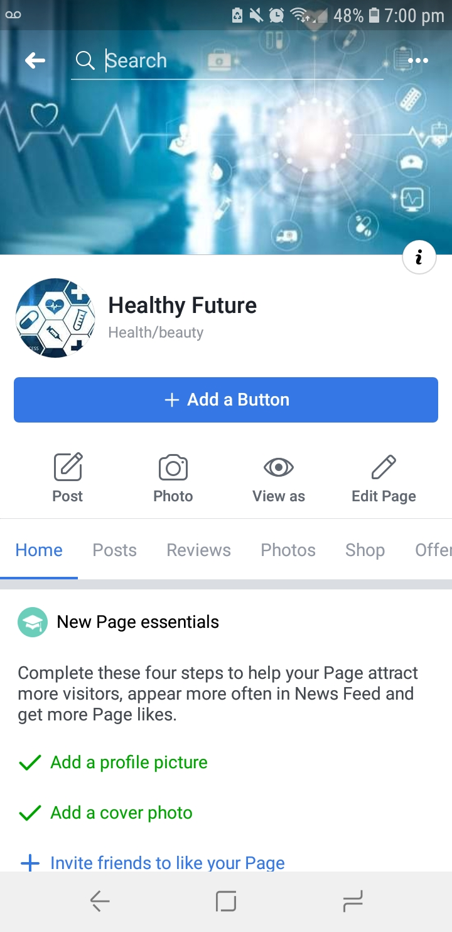

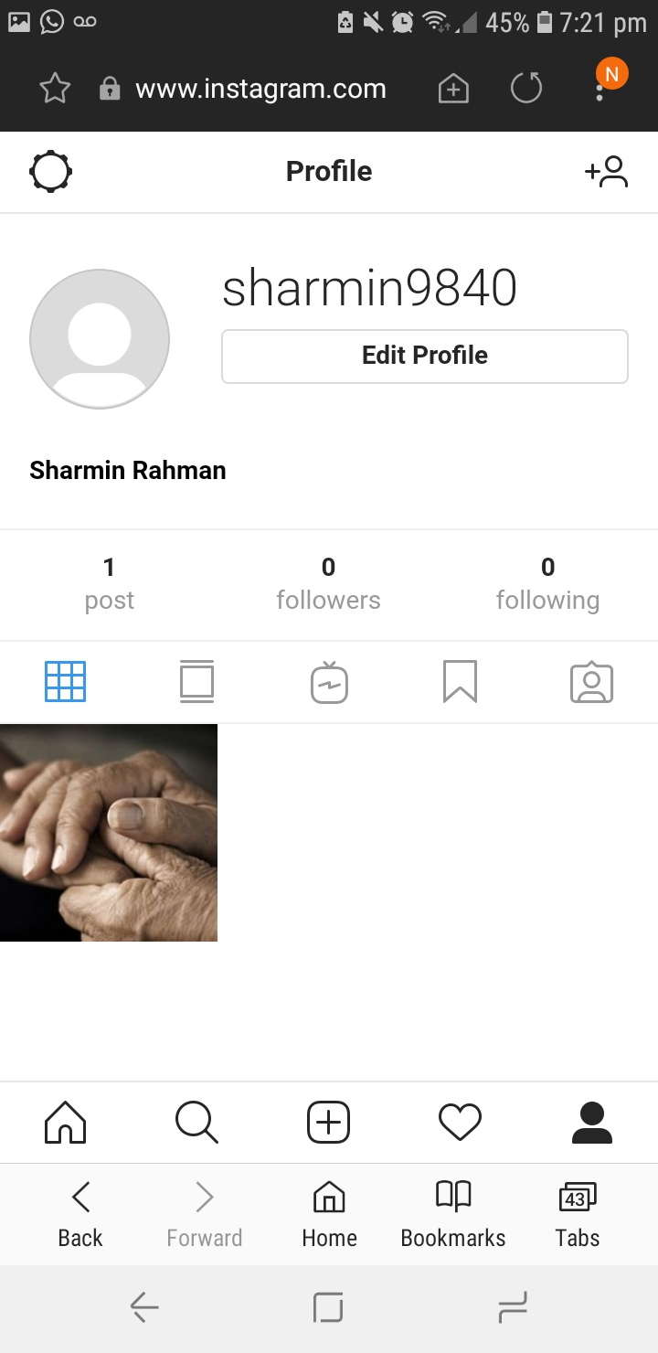

Conclusion
Modern technology has opened many doors for human. Advanced technologies have profound effect on mankind. Accept having some disadvantages, there is no doubt that digital inventions are mere blessings. The blessings depend on the intention of users. But the sectors, which has been changed unrecognizably is the healthcare sector. Because, uses of modern technologies have changed the whole process of treatment. Newer instruments and processes are being introduced on daily basis. They help people to keep in good health. Because of the modern technological use in medical sector, death rate has been reduced a lot than before. People are getting healthier day by day and average age also has been increased a lot. Moreover, the connectivity over internet can acknowledge people about health. But people need good intension to use them. Law enforcement needed to be stronger to defend all kind of mischievous activity over online so that general people can trust on this blessing of modern world.
References
www.telegraph.co.uk
https://www.information-age.com

